Name: Phani Kumar
Batch: June 01, 2022
Tutor: Raham Shaik
Project: Configuration through Ansible.
Project:
- Created 3 instances one Amazon Linux (Master node) and one ubuntu and red hat Linux
- Added user and created password in all servers
- Changed password authentication to yes and provided sudo privilege to user created in sudoers file (visudo)
- Then restarted sshd service.
- Logged in as ansible user in master node, installed ansible and generated ssh keys and copied to nodes (Redhat and ubuntu)
- In etc/ansible/hosts added ipaddress of nodes [target] name of group
- Used ping module to test Ansible and after successful run you can see the below output.
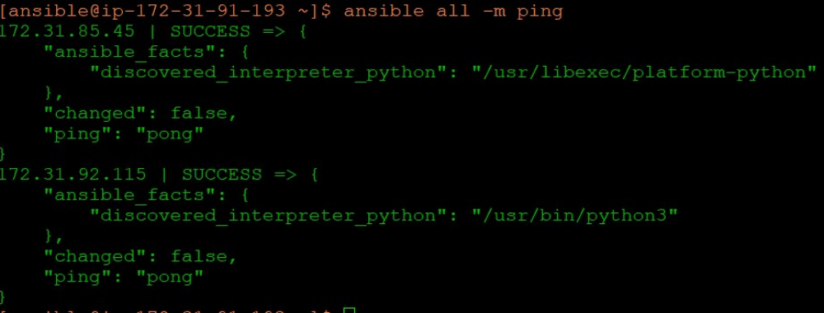
- Created ansible playbook for installation in os family as per requirement
- Playbook was run and the task was completed. (Ansible-playbook task.yml)
- Installed git, Tree & httpd in Redhat
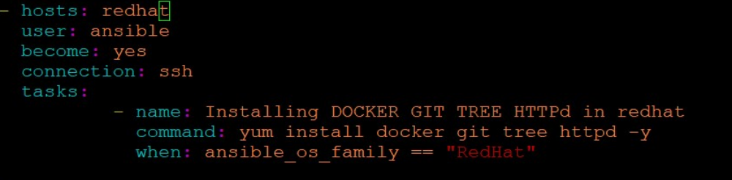

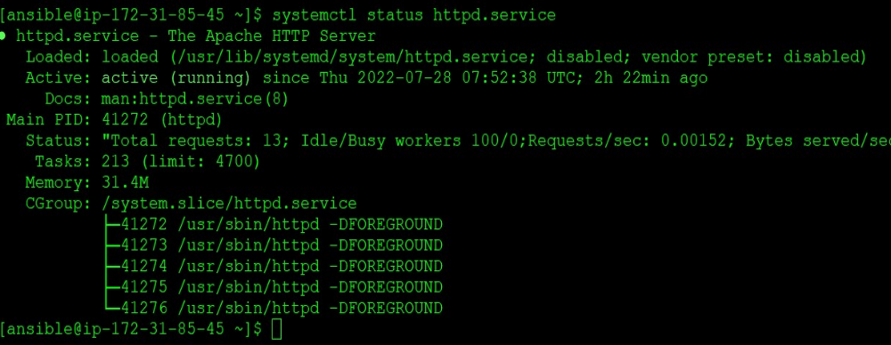
As docker is not supported in redhat podman is installed

In ubuntu server:
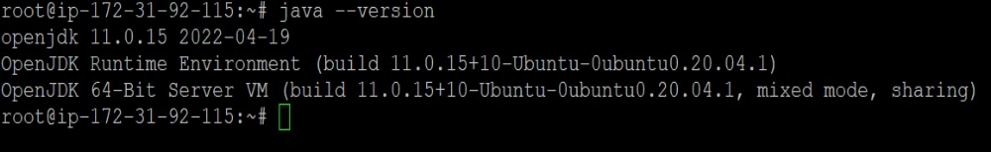
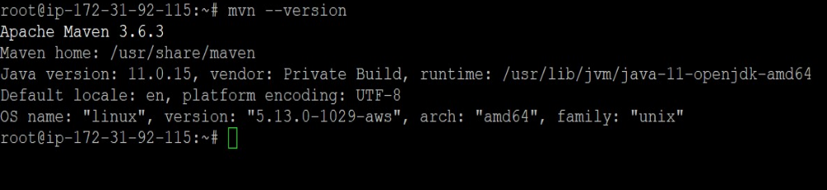
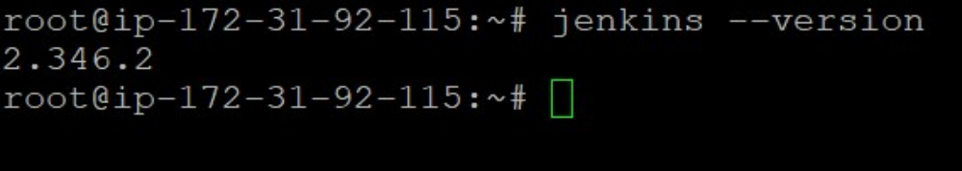

Jenkins connection through port:8080
