# Java

## Arrays

* Is a container object -> holds a fixed number of values of a single type.
* Length of the array -> decided during the array creation. Once created -> length is fixed.
* 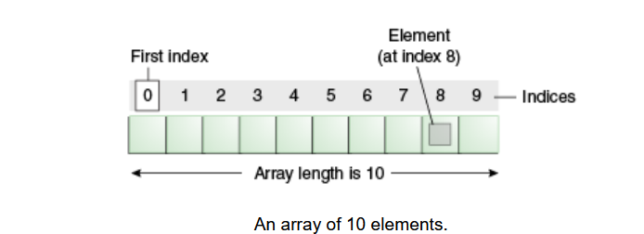
* Element: Is each item in the array, is accessed by its numerical index.