Jeroen P. Broks

The official guide through:



This guide has been provided free of charge, and may only be distributed in unmodified form under the following conditions. Quotes from this guide should be properly credited. The guide comes “as is” and under no circumstances can the author be held responsible for the content it contains. The original .odt “source” file should only be distributed through Jeroen's own official channels, the PDF file may be freely distributed when all these conditions are met.

Grammar and spelling errors should be reported on the issue tracker on GitHub https://github.com/PhantasarProductions/dyrt.net/issues

When you are interested in translating this guide (or the game itself), please contact Jeroen P. Broks

DISCLAIMER: I will try to avoid spoilers, however I will NOT guarantee this guide is completely without them! So if you don't want the storyline spoiled, don't read further on than you need.

Table of Contents
How to use this guide 5
CHAPTER 1: THE DARK SERVANTS 9
1.1 – Xenor Bushes (kid Irravonia) 10
Boss Fight: Big Mama Slime 10
1.2 - Xenor Bushes – West 11
1.3 – Exams Ruins 12
Boss Fight: Big Tiger 16
1.4 – Xenor Bushes – North 17
1.5 – The human city of Doubline 18
1.6 – Queen Shanda's Dungeons 19
Boss Fight: Jeracko – Round #1 23
1.7 – Mysterious Crypt 24
Boss fight: Big Scorpion 25
1.8 – Weniaria's Temple 26
Boss Fight – Shadow Sweeper 27
1.9 – Zoraman Prison 28
Boss Fight: Dark Servant 30
CHAPTER 2: THE FOUR DRAGONS 31
2.1 – Dragon Crack Forest 32
2.2 – Red Dragon's Lair 33
Boss Fight: Red Guardian 35
Boss Fight: The Red Dragon 36
2.3 – Iskarderiu Forest 37
2.4 – Elfish Imperial Castle 38
2.5 – White Dragon's Lair 38
Boss Fight: White Guardian 40
Boss Fight: White Dragon 40
2.6 – Green Dragon's Lair 41
Boss Fight: Green Guardian 42
Boss Fight: Green Dragon 42
2.7 – The Sheck-Lock encounter 43
Boss Fight: Sheck-Lock (Round #1) 43
2.8 – The Black Dragon Cave 44
Boss Fight: Black Guardian 45
Boss fight: Black Dragon 45
Boss Fight: Rondomo (Round #1) 46
CHAPTER 3: PEOPLE LONG FORGOTTEN 47
3.1 – Naked Rocks 48
Boss Fight: Crystal 49
3.2 – The Grass Plains 51
3.3 – Azquakunda Prison 51
Boss Fight: Aldarus (Round #1) 53
3.4 – Yasathar's Temple 54
Boss Fight: Mountain King 54
3.5 – The Mixed City of Gagolton 55
3.6 – The Mines of Airom 55
Boss Fight: Kirana (Round #3) 57
3.7 – Gagolton – What? 57
3.8 – Independence Bushes 58
3.9 – The Elvish city of Independence 58
3.10 – The Marshes 59
Boss Fight: Sheck-Lock (Round #2) 59
Boss Fight: Big Salamander 60
3.11 – Aziëlla Azbanella Pyèra Fradique, daughter of the house of Gandron 61
CHAPTER 4: REVELATIONS 62
4.1 Rayal Palace 63
4.2 – Rayal Palace by night 63
4.3 – Team Eric 65
4.3.1 – The Lost City of Fruskbrando 65
Boss Fight: Big DemonAir 65
4.3.2 – Malabia's Caves 66
4.3.3 – Malabia's Temple 67
4.4 – Team Rebecca 68
4.4.1 – The Phelynx Town of Felixium 68
4.4.2 – Purple Forest 69
4.4.3 – Frundarmon's Mansion 69
Boss Fight: Frundarmon 71
4.5 – Jennifer's Story 72
4.6 – The Dark Storage 72
4.6.1 – Dark Storage: Aldarus 73
Boss Fight: Giant Squid 73
Boss Fight: Aldarus (round #2) 74
4.6.2 – Dark Storage: Jeracko 75
Boss Fight: Super Hag 76
Boss Fight: Jeracko (round #2) 76
4.6.3 – Dark Storage: Kirana 77
Boss Fight: Grwol 78
Boss Fight: Kirana (round #2) 79
4.6.4 – Dark Storage: Rondomo 79
Boss Fight: Smile 80
Boss Fight: Rondomo (Round #2) 80
4.6.5 – Dark Storage: Main Section 81
Boss Fight: The Order of Onyx 82
4.7 – Frendor Bushes 83
Boss Fight: Sheck-Lock (Round #3) 83
4.8 – The Black Prison 84
Boss Fight: Mort 86
CHAPTER 5: THE RUINS OF DYRT 87
5.1 – Zondra's Grave 87
5.2 – Mermaid Harbor & Dyrt Beach 88
5.3 – Wastelands 88
5.4 – Forest 89
5.5 – The City of Umerington 89
5.6 – Lord Dzgjymza's Keep 90
Boss Fight: Dark Servant 92
Boss Fight: Lord Dzgjymza 93
SIDEQUESTS 96
SQ1 – The Mad House 96
Boss Fight: Creep 97
SQ6 – The Black Orbs 98
Boss fight: Juggernaut 99
NEW GAME+ 100
NGP1 – The Lost Ark 100
Boss Fight: Ocean Goblin 101
NGP2 – The halls of music 102
Boss fight: The King 103
EXCLUSIVE DUNGEONS 104
XCL1 – Botanica 104
Boss Fight: Audrey 105
XCL2 – Science Facility 106
Boss Fight: Experimental Human Replica Unit (ExHuRU) 108
XCL3 – Sugarland 108
Boss fight: Turbo Candy 109
BACKGROUND 110
The World Called Phantasar, the history in short. 110
Why is Merya constantly cracking jokes clearly related to sex? 112
Why does Seelah Gandra hate her father? 113
What exactly is this “Harmony” the Elves believe in? 114

How to use this guide

Hi folks;
Welcome to this official guide to The Secrets of Dyrt .NET edition. This guide is created by the same guy who created the game itself, so you will get to know all the stuff the game contains... (or not 😜).

Now what is always important is that you shouldn't be using a guide for every single move you make. Puzzling things out yourself is the entire challenge, after all. However, being a gamer (and I mean a “true gamer”. Not people who play those content-less games that come with millions of DLCs) myself, I am fully aware that it's sometimes hard, or next to impossible to always capture what the game creators had in mind. And that's where my guide can help you, so you can take a look into the warped and twisted chaos that is my mind.

This guide is therefore really written in a short reference style. The first things you need to take note of when using this guide are the big transparent purple numbers written in the lower left corner of your game screen in most locations you'll visit over the course of the game:
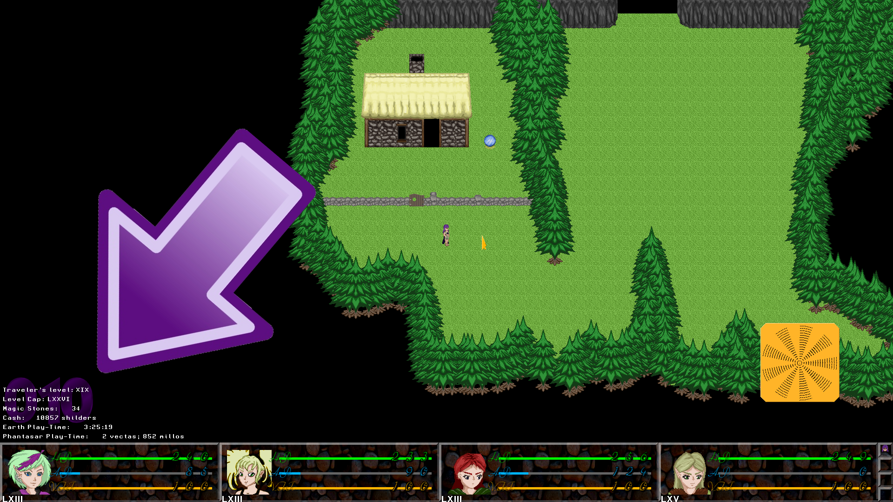
The way these numbers are presented are so “well hidden”, because you don't need them in normal gameplay, however when you are using this guide, or when you need to report bugs these numbers can be vital. They represent the number of the location within the map you are in. When you tell me these location numbers to report a bug they will help me to quickly find back the location in which the bug took place, which can be handy for me for replicating the bug. In the context of this guide they will help me to tell you in which location I am. And especially when explaining puzzles you can now easily trace where you need to be, as I will always refer to these numbers, and then it can look like this:

001: Go North;
Switch the 2nd lever on the right
Exit South
002: A door should have been opened now
Go through that door

So as you see, I'll do this acting by action, put every action on a new line, and whenever I am just giving extra information it will be written in italic style. Very important to note as that the numbers are merely the numbers as they are stored in the map file used to bring that dungeon/location/whatever into the game. Most dungeons will start at either 000 or 001 and count up, but some dungeons have a by far more complicated set up and then the numbers may look entirely random.
Note: It is possible you see parts of the actions I'm discussing on a light blue background, like you see here. That means that the part being discussed is entirely optional.

Lastly it may be possible I prefix an action with a name of one of the playable characters, like so:
001: Walk to the table
IRRAVONIA: Examine the stuff on the table
In the example above it means that this can only be done by Irravonia, so that means you gotta put her into the lead if she isn't already in the lead. For an experienced player it's quite often obvious who to put in the lead for certain actions, and you can put somebody in the lead by right clicking their portraits at the bottom of the screen. This even works on characters who are battle-wise not on the front line.

One last thing are the roman numbers below all characters' faces on the status bar below:
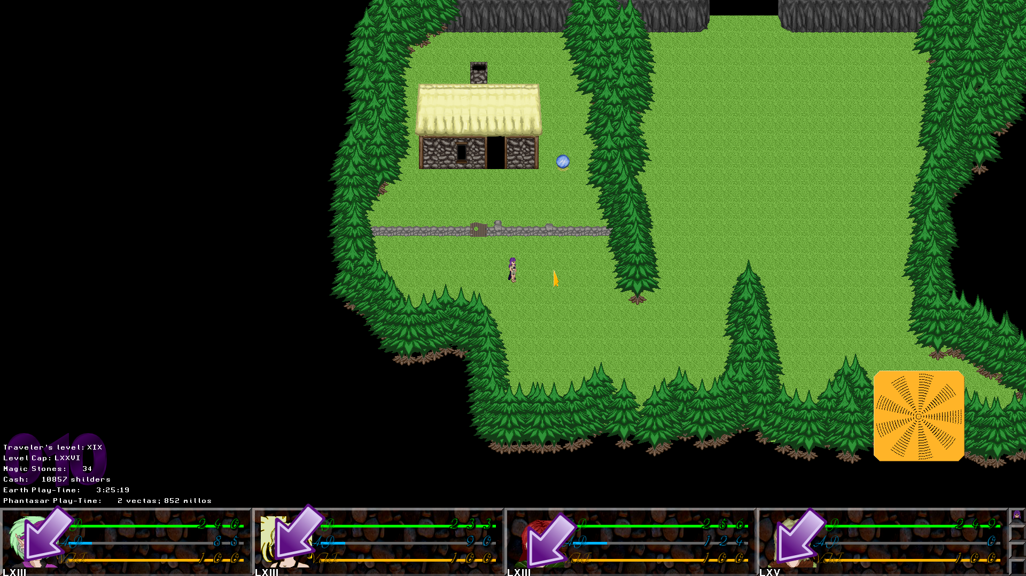
They are nothing more but the characters' experience levels, like you can find in nearly all RPG games. The only difference is that this game displays them in roman numbers in stead of Arabic numbers that you are used to see. I = 1, V = 5, X = 10, L = 50, C = 100, D = 500 and M=1000, and it's just a matter of adding them all up, except when a lower value comes before a bigger value then the lower value is subtracted... so IX = 9 and XI = 11. You got that?
What is important to know about this game is that the level cap is flexible. This has been done to keep people who think overgrinding is the “pro” way to win an RPG game from doing that what it actually is... CHEATING! Buying a cheat device or using cheat software is a quicker way to do this, peeps! In order to increase the level cap you will need to find traveler's emblems. They look like eagle's heads.

Whenever you pick one up, the level cap will increase with 5 levels in the easy mode, 4 levels in the casual mode and 3 levels in the hard mode. Although, grinding levels forever is a kind of cheating, I do recommend to pick these things up whenever you find them, as later in the game you may get in trouble if you don't. (Yeah I know the people who completed Final Fantasy X without using the sphere grid now smell a challenge in completing the game without picking any of these up (aside from the two times the game forces you to) and see if they can complete the game this way. I honestly do not know if this is possible, and I personally ain't gonna try, and this guide will not be written for challenges like that, and if you wanna try it and dedicate a guide to it... be my guest).
At the start of each level and boss fight, I will make a note of my own levels when I got there. There are not really recommendations, but rather a kind of references. If my levels are higher than your level cap at that point, it simply means you missed some traveler's emblems.
One tip, every dungeon contains at least ONE traveler's emblem (most only one), and some bonus dungeons even more, and there are a few bonus emblems in non-dungeon locations. In this guide I will make note of all of them. Some are found all out in the open, while some are pretty well hidden (TIP! Once Merya joined your group, use her scan ability to find secret passages in the dungeons in which you missed them).

Now in this guide I will put the mandatory stuff first, and the sidequests apart. I may make notice when certain sidequests are unlocked, though. There are three kinds of sidequests. The regular sidequests, the Game Jolt exclusive sidequests that only unlock if you have a certain number of achievements on Game Jolt on ANY of my games. And New Game+ sidequests that are only accessible during a New Game+. As with all games featuring a New Game+, this only unlocks if you won the entire game at least ONCE.
There is of course, also “The True Abyss”, about which I will provide some information in a dedicated section.

This guide is written with only the CASUAL mode in mind, so if you play either the easy or the hard mode, things may turn out a bit different. Please note, you cannot change the difficulty settings after the game has begun. This is because the differences between the three modes are very big and sometimes even quite complex. It's not just enemies getting harder or easier... The rules on each mode are very significantly different. The number of items you can take with you will be lower or higher, some spells and abilities can be learned sooner or later, experiences granted or needed will be different, well in short... you can see them almost as three separate games.

Well, talked enough already! LET'S GET READY TO RUMBLE!

CHAPTER 1: THE DARK SERVANTS

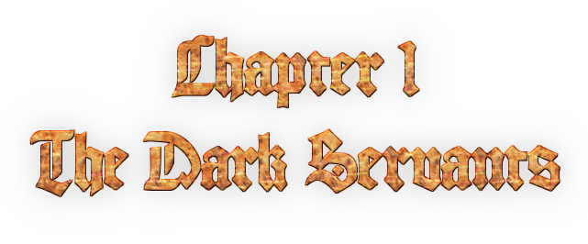
In this chapter you will see how Eric and Irravonia met each other and get to know a bit as well about Brendor and Seelah Gandra. This chapter is a kind of a prologue, although one mission will already contain vital clues for the rest of the story.

Until the last dungeon, this entire chapter is based on flashbacks while the characters recount their tales about what happened to them prior to being thrown in the prison where the game begins. In the last mission you'll be freed and have to escape the prison in order to complete this chapter.

Important is that this chapter follows a 'one-way' flow, meaning you cannot yet get back to locations you've visited before, like normal for an RPG game. You will however gain access to the world map as soon as this chapter ends, and then you'll finally get “free movement”.

The game will start when Irravonia tells a story about herself when she was a little girl. Well, let's get this show on the road, shall we?

1.1 – Xenor Bushes (kid Irravonia)
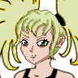
I

This dungeon is just easy walk from East to West, so no need to go into the deep of that. You can use the red orb at the start to save your game, and I recommend you do so. The first thing you'll find is your first travel emblem, well pick it up, and make your way through the dungeon. It's not hard to find.

At the end of the dungeon Irravonia will be attacked by some blue slimes, the number of them depends on your chosen difficulty, immediately after that fight Irravonia will meet the “Big Mama Slime”

Boss Fight: Big Mama Slime
I
You cannot win this fight, and don't even try it. The boss might waste some turns before it attacks you, but any attack it does will always do too much damage and know you out. Don't worry, this is supposed to happen, and the story will continue right after you've been KO'ed.

This will end this dungeon, follow the scenario and the game will continue in the next dungeon.

1.2 - Xenor Bushes – West

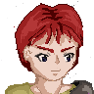
II | I

This is also only a small dungeon, so no need to go into the deep of all actions. Just make your way to the West and when you arrive there you'll automatically advance to the next dungeon.
Don't forget to pick up the traveler's emblem directly to the North as you start this dungeon.

A few notes:
- Irravonia is now an adult Fairy and that means she now has access to her first spells.
- She's also equipped now with a wand instead of a silly branch. The type of attack she does is really dependent on this.
- Eric will normally always start one level higher than Irravonia.

There are no boss fights in this dungeon, so this should be an easy passthrough.

1.3 – Exams Ruins
 | 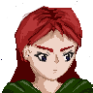
II | VII

This is the first serious dungeon of the game, and in which I'll give some point wise guidelines as will be the standard for most of this guide. Since only Eric and Rebecca are being tested in this exam, Irravonia is not available during the course of this dungeon.
Examiner Zack will explain your task. Open the door up front by finding the switch in the back of the dungeon, and fight the monster behind it, needless to say it's a boss, and yes, this time you must win the fight.

Rebecca will always start five levels higher than Eric (as a kind of indicator she outclasses him as a warrior) even when her level tops the current level cap in the process. This is also the first dungeon in which the traveler's emblem has been hidden in a secret room.

Well, as soon as the game gives you control over your heroes, let's get this show on the road.

001: Now it doesn't really matter which of the open doors you take, but to make things easier on me, I chose the left one.
Exit through the left door North
002: To the east there's a secret passage. If you go in there you'll find the traveler's emblem
Exit North (you can examine the swords if you like, but your heroes will only say that they are too old to do anything with).
003: Exit North
005: You can save your game if you desire and move on to the next room, North
006: Now you'll be in a puzzle room. There are six possible solutions, but which solution is correct depends on the number imprinted on the plaque on the North wall.
So read that plaque first
If it says “I” the solution is this: | 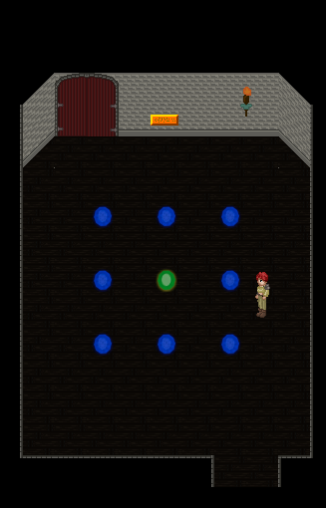
If it says “II” the solution is this: | 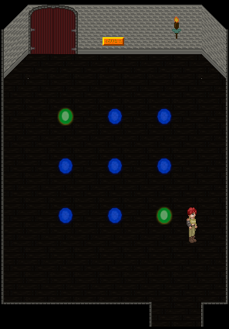
If it says “III” the solution is this: | 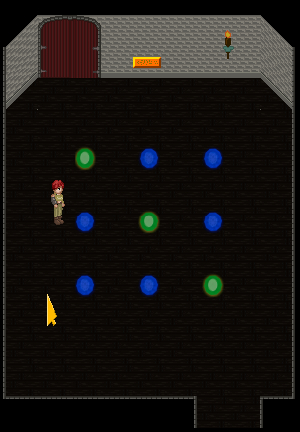
It it says “IV” the solution is this: | 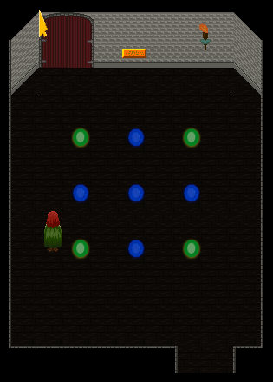
If it says “V” the solution is this | 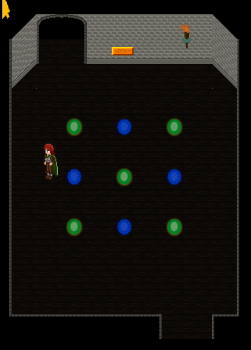
If it says “VI” the solution is this | 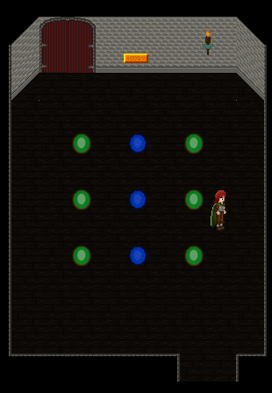
Completing this puzzle will earn you the achievement “Die! Die! We all pass away!” This as a reference to the stop-motion movie “The Corpse Bride”, and a pun to the fact that a “die” is also a game object, and the solution that is valid is based on how the eyes of a die are (on most dice) set.
Exit North
007: Flip the switch. This will open the door in area 001.
Both to the left and the right of the switch are secret passages leading to one big room together where (depending on the difficulty you chose) can be a lot of treasure.
Exit South x3
003: Once again, it doesn't really matter if you take the left or the right exit to the south. I picked the right this time.
Exit South through the most right exit
004 There's a secret passage directly to the East leading to treasure, in case you need it.
Exit South
001 Hit the middle door North, which should be open now
008: Fight the boss

Boss Fight: Big Tiger
III | VII
Since this is the first boss fight you have to win you shouldn't expect anything spectacular. Please note that neither Eric nor Rebecca have healing spells so you are reliant on your items, but (unless you play the hard mode) it's likely you won't need them. Unless you play the hard mode it's likely that Rebecca obtained “Double Power Strike” by now, and well, I guess you got the perfect opportunity to try it out now.

Well if you won this fight you win this dungeon and go on to the next, hey, way to go there 😉

1.4 – Xenor Bushes – North
IV | II | VIII

I don't really have to go into the deep of this, as all you need to do is make your way all the way North until you reach Doubline, and this dungeon is very very short and doesn't contain any bosses at all.

Of course, don't forget to take the traveler's emblem located on the small island here.

Now if you wonder about that stone fence to the North-East, if you play the New Game+ that fence will be removed and then that road gives access to the special New Game+ sidequest “The Lost Ark”. See the “New Game+” section for more information about that. In a normal playthrough, don't bother about it.

1.5 – The human city of Doubline
V | III | VIII

Welcome to the first city you will be able to pass through as you are on your quest. Mind the girl with the er... sexy clothes. She is a merchant can can sell you nice items you may need on the road. Other than that there's not much to do here yet.

When you are ready to move on and to complete the mission the “Queen of the Forgotten Realm” has in store for you, speak to the man (Arjan) to the west of town and he will bring you to the castle of the queen, and from there you can go to the dungeons.

1.6 – Queen Shanda's Dungeons
 |  |  | 
V | III | VIII | XV

This is a one-time dungeon. You cannot leave it until it's been completed, and once completed you can never come back here. During your stay here you'll also have company of Queen Shanda, but she will leave the party permanently once you completed this mission.

Shanda will not be able to gain experience points, and will therefore never gain a level, unless you count her royal status but that is just for fun as she won't gain anything from that. Shanda will be level XXX in the easy mode, level XV in the casual mode (hence her having level XV in my playthrough for this guide) and level X in the hard mode.
One tip for combat. The ghosts have a crapload of power, and may kill all your characters one by one but instantly, and they dodge nearly everything. They are as undead being vulnerable to healing. Yes that will hurt them. And Irravonia's magic, neither for her wand nor her spells will miss them. And since they only got 1 HP, anything that hurts them, kills them.

Well let's just get this show on the road.

001: Exit South
002: Make your way South
At the end go East
And at the end North
At the end of this route exit North
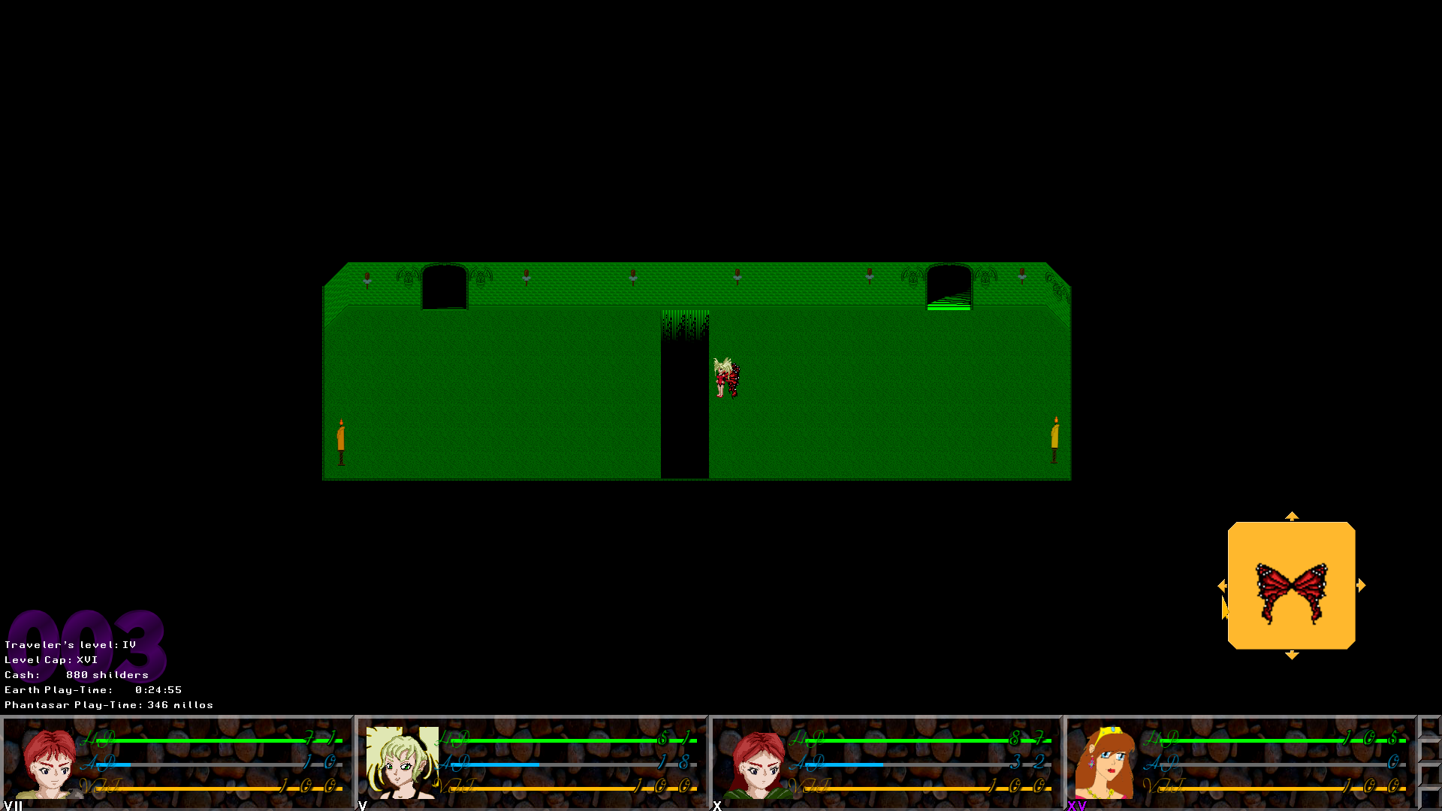
003: Upon arrival here you will get explained how Irravonia can fly over small gaps.
Stand as close to the gap as possible, as demonstrated in the screenshot
IRRAVONIA: Now click the left arrow on the wing shield you see when have Irravonia in the lead and she will fly over the gap.
From here hit the stairs.
004: You can see the traveler's emblem here. Because this is a one-time dungeon, picking it up is mandatory.
IRRAVONIA: Cross the gap with Irravonia's flying ability
Go East
IRRAVONIA: Cross the gap to reach the emblem
Pick it up
IRRAVONIA: Cross over the gap south
Go West
IRRAVONIA: Cross the gap one more time
Hit the Eastern exit to move on
005: Save the game if you desire and hit the most western stairway
006: I think it's already clear to you that Irravonia is the one to get you through this particular floor. Before you do anything, keep in mind she can only move 64 pixels by flying, and also only in straight lines and not diagonally. There are few trapdoors in the way the puzzle has been set up (in a figurative sense, as I didn't place in literal traps).
IRRAVONIA: Fly South
IRRAVONIA: Fly West
IRRAVONIA: Fly South
Move all the way South
IRRAVONIA: Fly East x3
Move all the way East
IRRAVONIA: Fly North x2
IRRAVONIA: Fly West
IRRAVONIA: Fly North
Exit North
007: Another one of this kind, but no matter, it shouldn't be that hard, trust me!
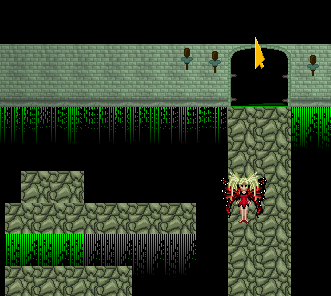
Move to the position were I placed Irravonia in the screenshot above.

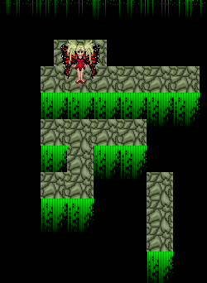
IRRAVONIA: From this position, fly South
IRRAVONIA: It doesn't matter if you do it from the Northern or Southern way, just fly West
IRRAVONIA: Fly West
Go all the way South
IRRAVONIA: Fly South
Go all the way East
IRRAVONIA: And fly South from there
Walk all the way East
IRRAVONIA: Fly North
IRRAVONIA: Fly East
Go all the way North
IRRAVONIA: Fly WEST (not North, although it may look tempting if you don't look well)
IRRAVONIA: Fly North and exit North
008: Save if you want (I recommend you to) and hit the next stairway

Boss Fight: Jeracko – Round #1
X | IX | XI | XV
Now your chosen difficulty setting will decide how many orcs will be assisting Jeracko. It can be a good idea to get rid of them first and then focus on Jeracko himself. He's pretty strong so be prepared to heal a lot. He is weak to wind, and Irravonia should be exploiting that.
The move “Jeracko Spin” can cause confusion over the entire party, which can be a bit bothersome, but is not super dangerous.

With defeating Jeracko this dungeon is completed. That also means that Shanda will now leave the party forever.

1.7 – Mysterious Crypt
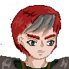
XXXVIII

Brendor will have to do this dungeon alone. Don't worry, the enemies were adapted to that. His level will be higher than your level cap would actually allow (unless you play in Hard Mode as it's possible there your cap is already higher). So that means he won't be able to gain any regular experience points. Let's just get this show on the road.
000: Make your way north
The man here is a merchant. Buy stuff if you need to
Exit North
001: You cannot yet get to the swords, nor to the traveler's emblem. You may already have seen that Irravonia is required to acquire both. That means that you'll have to return here later in the game when you have Irravonia at your disposal if you want them.
Exit North
002: Go East, at the end South, and you'll see the stairs... Hit them
003: You can see three plaques here. They all contain a part of the riddle you need to solve later in this place. If you want to give this riddle a try without using this guide, I'd say read them first!
When you are ready hid the stairs down
004: Walk to the cracked wall up North, and you'll get a little tutorial about how Brendor can break weak walls.
Click the shield with the Hammer on the screen and Brendor will do so (that is, if he's close enough to the cracked wall).
Exit North
005: Break the wall to reveal a savespot and save the game if you want
Attack the boss.

Boss fight: Big Scorpion
XXXVIII
This fight is not that hard, but you should be aware that this boss can poison you. Now Brendor is blessed with a pretty high resistence against poison, but he's not immune. Other than that this fight should not offer a serious problem.
005: Exit North
006: Just follow the way to find the crack in the wall
Break it
Exit North from here
007: Now if you remember the plaques in area 003, you must have figured out how this works. One plaque mentioned “square” the other “root”, and one was a poem about the number “nine” so “square-root-nine”. Well √ 9 = 3. So that solves it, right?
Flip the 3rd switch from the left
Hit the stairs most east
008: Walk to the rubble to end this dungeon.

1.8 – Weniaria's Temple

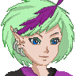
XX | XXXVIII

You will have Seelah Gandra and Brendor as characters to do this. The level Seelah Gandra starts the game with is always the maximum possible level based on your collected Traveler's Emblems so far. If you found them all (like I did) that means that will be XXV in the easy mode, XX in the casual mode and XV in the hard mode.

Now this place has the main hall, which will remain accessible later in the game as well (although it will only unlock once you've passed through “Iskarderiu Forest”), the rest of the dungeon will be permanently locked once you've completed this. So this is a bit debatable as one-time dungeon, I suppose.
001: Walk closer to the statue and Brendor and Seelah Gandra will talk about it.
Examine the statue
Directly west of the statue is a secret passage in which you can find a traveler's emblem.
Hit the door.
002: You can see the stairs upstairs. Quickest way to go is to just click them. (If you don't see them, move a bit east. This is dependent on how big your screen is).
003: Make your way to the Southern part of this floor
There's a switch to the West. Hit it!
Go back North
Hit the stairs up
004: Save the game if you want (or need) and hit the stairway up.
005: Just follow the corridor and hit the stairway up at the end.
006: I don't have to explain this, eh? Just find the stairs up and hit them. If you're screen is big enough you can already see them and click them. 😜😜
007: Attack that ugly thing over there, will ya?

Boss Fight – Shadow Sweeper
XXIII | XXXVIII
This is not a strong boss, but it can still be, depending on how many traveler's emblems you found before entering the temple, and thus determining at what level Seelah Gandra began the game dangerous for her to be here, but Brendor's got her back, so overall this is not hard. Please note, like all other monsters, this boss counts as undead, meaning that healing magic and healing items will hurt it in stead of heal it.
Now this guy doesn't seem aware of its undead status and desperately try to heal itself (which is a bit of a hint to the negative effect of healing on undead enemies).

Cheesy win: If you are playing the New Game+, cast “Shine” on it. That only works in the New Game+ though.

Hit the stairs back down to complete this mission.

1.9 – Zoraman Prison

XI | X | XXXVIII | XXIII | XIII
For the time being we got our group complete now (as the other three won't join prior to chapter 3). And we're also in present tense now and no longer working by telling stories.

This is the last dungeon of the first chapter also, and very likely also the longest. So, let's get this show on the road, eh?

999: Exit North
006: Go East
Flip the switch to the South
A door opens to the North, revealing a stairway down. Hit it
005: Technically more ways to do this, but this is the way way I took!
East
South
West and hit the door north
IRRAVONIA: Fly over the gap
Grab the traveler's emblem
IRRAVONIA: And fly back to make your way back to the corridor
East
South
West
South
Flip the Switch
And now anyway you can think up to go North will do
Hit the stairs leading DOWN
004: Save your game and hit the stairs down
003: North
Around the corner east
At the far end North
West
Flip the switch
Just click the area west of here, past the wall, and your hero will walk to it and take any required detours on their own accord.
Hit the stairs
002: East
Go to the Southern part of this floor
East
Hit the switch North
All the way West
North and hit the stairs.
001: The portal up North leads to Botanica, which is a Game Jolt exclusive dungeon. These are optional dungeons you can take on to enjoy combat and get unique treasures if you've had enough achievements in ANY game of mine. It's up to you to take it on or not, but beware that the strength of the enemies in these dungeons is overall higher than in regular dungeons. Read the Game Jolt Exclusive section for more information.
Save the game if you desire and hit the stairway down
000: Go south and the hooded child will stop you and fight you.

Boss Fight: Dark Servant

XIV | XIII | XXXVIII | XXV | XVI
Due to the spoiler sensitivity of this boss, I won't mention it by its in-game name. This boss's AI configuration is based on your difficulty settings more than most other bosses. It's a spell caster, so you should expect a lot of damage from spells. Irravonia may be the weakest character now, but she is the one with the highest resistance (which is your protection against magic attacks), and she may even randomly block one of the four base elements. You may do extra damage by casting fire spells, and since this boss is undead, healing will have negative effects.

When you defeat this boss the first chapter will be completed. Exit South to leave this dungeon.

You will end up on the world map. You can now only visit Doubline, this prison and the mysterious crypt where Brendor began the game. The latter can be a good idea to visit now so you can use Irravonia to claim the traveler's emblem and the two swords you couldn't get before. Equip those swords on Eric and Rebecca respectively.

When you are ready to move forward in the game, set course to Dragon Crack Forest to start chapter 2.

CHAPTER 2: THE FOUR DRAGONS
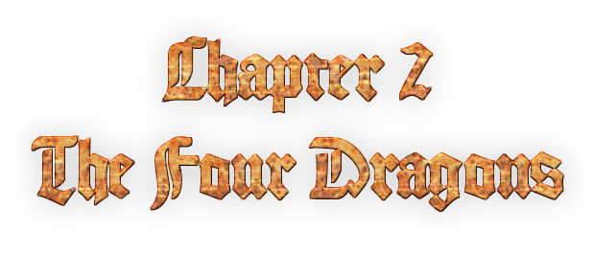
During this chapter you will play most of the time with the five characters you have. Dernor and Merya will make the introduction halfway this chapter in the story line, but neither of them will join the party, yet.

Like the name says, this chapter is about dragons. They are friendly and will unlock Eric's ability, allowing him to do magic for the remainder of the game.

2.1 – Dragon Crack Forest

XVIII | XVII | XXXVIII | XXVII | XIX

This is only a quick dungeon without any boss fights or anything. You may want to look well, as except for Eric and Rebecca (who can find theirs in the Mysterious Crypt) you may find a better weapon for all your characters (although in Irravonia's case “better” is a matter of perception as it depends on the enemy she faces what is “better”).

This dungeon will give access to a one-time-dungeon you can't leave once you reached it, so make sure you are prepared.

001: The first thing you want to do is check out the trees to the East. A secret passage may be found there and your reward for discovering it is a traveler's emblem. I suppose you want it.
Exit South
002: You may see a chest east of here, and even be able to click it. If you do so your hero will walk to it and claim the “Flame Wand” that is inside. When equipped on Irravonia she will cast flame spells whenever you make her do a regular attack (this won't add to her Fire Magic Skills though).
The exit is on the southern section of this area, go there and exit south
003: You can reach the chest on the west by either clicking it so your hero takes the long way around or by making Irravonia fly to it. The chest contains a “Slashing Whip” which is a better weapon for Seelah Gandra
You can reach the chest on the east by either clicking it so your hero takes the long way around or by making Seelah Gandra use her whip to hook on to the pole nearby. Since this is (for now) optional this ability of hers has not yet been explained in a tutorial. The chest contains a Sledge which is a better weapon for Brendor.
Make your way to the South, and at the end exit West

The dungeon ends here, and you will end up in the Red Dragon's Cave.

2.2 – Red Dragon's Lair
XVIII | XVII | XXXVIII | XXVII | XIX

Well, this is another one-time-dungeon, and also the last one of the game. This is also the dungeon with the most complex architecture of the game (it took me a long time to design it properly, so you'd better appreciate it).

If you don't want to play this with a walkthrough, but want to riddle it out yourself I can give you a hint. There are cubes hidden in the dungeon, remember well how many there are of each color. Look for all of them

Oh, you don't appreciate my hard work, and you prefer the shortcut? Okay, okay, here goes:

001: Exit North
002: Pick up the traveler's emblem. Since this is a one-time-dungeon picking it up is mandatory this time.
Go North
Exit North
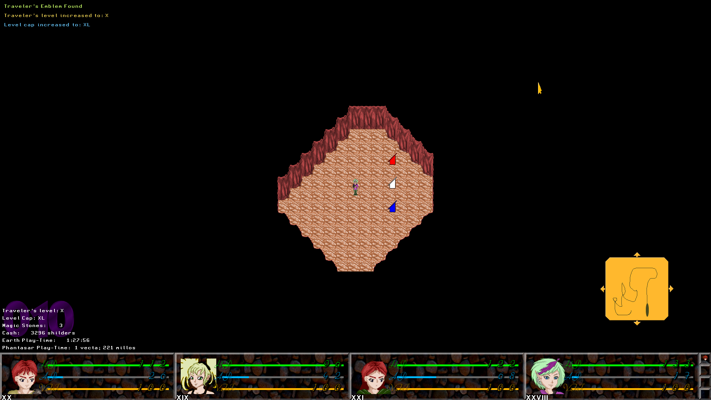
003: You see three tablets, examine one of them. Any one of them will do.
The code is: 219
Solving the puzzle will immediately engate a boss fight.

Boss Fight: Red Guardian

XX | XVII | XXXVIII | XXVII | XIX
This boss is completely dedicated to the element of fire, so I think it goes without saying that trying to use any fire spells on it is completely useless (in fact, that'll only heal it). It's weakness is actually frost, but unless you are now playing in New Game+ mode, that information is useless, as none of your characters will have any spells of that element at their disposal right now.

Although it's possible Irravonia unlocked the spell “Splash” by now (she'll be able to unlock it when her water magic level is level V or higher, regardless of your chosen difficulty setting), she may be too weak as a magician right now to do any serious damage with that.

So it may be a good idea to have Eric, Brendor, Rebecca and Seelah Gandra as your main team here. Although Eric, Brendor and Rebecca cannot hurt it in its weakess (well in the New Game+ Eric can, but that's useless in the normal playthrough) they do physical damage and that's worth a lot. Rebecca should most of all use “Double Power Strike” or if she has it “Triple Power Strike”. Seelah Gandra's main task is of course to take care of the healing, but be prepared for it that you may be on low HP when she cannot help you with spells, so a good item supply is desirable.

When Seelah Gandra is granted a turn but has nobody to heal at the specific time, I recommend you to make her guard, as doing so will recover 20 AP, and that can just be the AP she needs to save your butt with healing spells.

When this fight is over you'll immediately be brought to a new section of this cave you could not reach before. All rooms you could access before are now no longer accessible.

011: Save your game if you want, and exit North
012: Exit North (The room to the west is only meant for if you feel too weak to face the dragon itself yet to allow you to train yourself up a bit. Of course as far as you current level cap allows you to).
014: Meet the dragon.

Boss Fight: The Red Dragon
XX
Eric has to fight the dragon alone, and due to him not having special abilities or anything yet, that can be a littlebit bothersome. It is really depending on your current level and preparations in general how much chance you're going to make.

It's physical attacks are by far more dangerous than his spells. If Eric has “Quick Strike” already you may (if the timing is on your side, and that requires a bit of luck) be able to cancel the Dragon's attack with that (only works if the dragon is between “COM” and “ACT”). The physical attacks often do 50+ damage, so that's what you need to keep in mind when it comes to healing.

Cheesy method: Frost delivers you a very quick... Unfortunately that only helps you in the New Game+, unless you have the luck you obtained an icicle somewhere.

When you win this fight there are a few things to be taken in order.

First of all, now that Eric has the power of the Red Dragon, he can perform fire magic. Just attack a random enemy and his first spell will be unlocked, and then he can work this out similar to how Irravonia can learn new spells.
Second, after this fight, you'll be back in Dragon Crack Forest. Just exit West to get back on the worldmap and you'll see two locations have been opened. “Crossroads” and “Iskarderiu Forest”. The former is a kind of hub in which you can enjoy combat, and when you exit it West, the city of Xenor (hometown of Eric, Irravonia and Rebecca) will be unlocked as well as the dungeon this trio passed through during chapter 1 (except of course for Shanda's Dungeons). When exiting it to the South you can unlock the Fairy Village of Frendor (where Irravonia originally comes from). The Crossroads also provide entrance to the secret dungeon “The Madhouse”, and “The Madhouse” in turn can provide access to the Game Jolt Exclusive dungeon “The Science Facility” providing you are logged in with the game on Game Jolt and have enough achievement points.

When you mainly want to concentrate on the game's main story, Iskarderiu Forest is your next stop.

2.3 – Iskarderiu Forest

XXV | XXIV | XXXIX | XXXII | XXV
First of all, ignore the red egg like thing to the North. It's of no use to you in this stage of the game.

Second this is just a regular walkthrough dungeon and you may have noticed there are several more of those around. There are no bosses or anything, but what can be interesting to note is that there are chests containing better armor for all characters all over the place, so maybe you wanna look for those.

There's not much use going into the details, I'm sure you can find the way.

When you found the other side of this dungeon and exit it from there, you'll find three new locations on the world map.

First of all the city of Iskarderiu, which is Seelah Gandra's hometown (for now), there is nothing to do there except for chatting with the Elves and buying stuff at the stores if you desire. Visiting this location is entirely optional, though.

Second, you will be able to visit Weniaria's Temple again. Except for the priest being able to upgrade Seelah Gandra's priest powers in exchange for magic stones there is nothing much there either.

Lastly there's the Elfish Imperial Castle, and that's your next stop.

(Oh yeah, before I forget, the traveler's emblem here is located just before the exit. You can't miss it).

2.4 – Elfish Imperial Castle
XXVIII | XXVI | XL | XXXIV | XXVIII

Now there's not much to do here except to speak to the emperor, and that's the man standing in front of the big chair, but I guess that was obvious.

He will send you to the Hidden Bush, which only serves as a kind of connection hub. All you can do in that bush is go North to get into the White Dragon's Lair and South to get into the Green Dragon's Lair.... The order in which you do this is up to you, I went white first, but if you prefer to go for Green first it's all cool with me.

2.5 – White Dragon's Lair

XXVIII | XXVI | XL | XXXIV | XXVIII

Now this cave is more straight on than the Red Dragon's Lair. Pay mind to the icy floors. Once you step on them you cannot stop walking into the direction were going until you're off or blocked by something. Please note that any pre-calculated routes you set up will immediately be terminated due to this effect.

Perhaps it's quite obvious, but you may wanna try flame magic on nearly all enemies here. It seems to be pretty effective for some “odd” reason. 😜

000: There's a secret passage to the East. In it is a traveler's emblem.
Exit North
001: Go West over the icy floors
South
Exit West
002: Now you can decide yourself what you want to do. Either you can follow the corridor or you can make Brendor smash the North wall in order to create yourself a shortcut (the wall at the end of the shortcut will also need to be broken by Brendor).
At the end of the corridor exit North
003: Now this is a puzzle location (for that reason you also won't get random encounters here), I'll name a direction and you walk into that direction onto the ice and wait until the character stops. Then you read my next direction, and so I'll guide you all the way through this puzlle, ok?
North
West
North
East
South
West
North
Well, that brings you to the end of the puzzle.
Flip the switch!

Boss Fight: White Guardian

XXIX | XXVII | XL | XXXV | XXIX
I guess the shape of a snowman kinda gave it away, but this guy is weak to fire. It will NOT instantly kill him like his smaller counterparts, though. Still fire magic can still get you somewhere. By now Rebecca should also be able to use Triple Power Strike, and I suggest you use it.

Basically this is just a hack-'n-slash boss and heal if you need to.

004: Save the game if you desire
Follow the corridor to the North
Exit West
005: North and Exit East
(As before in the Red Dragon's cave, you can use this room to train up if you feel too weak, but frankly, you shouldn't need it).
006: Face the Dragon

Boss Fight: White Dragon
XXIX
This fight is similar to the fight with the Red Dragon, however, now Eric has magic at his disposal and Fire Magic even, the element this dragon is weak against. Use that as much as you can and heal if you must. Don't forget that you can recover 20 AP if you are running out of AP byguarding.

000: Exit South to leave this dungeon.
What goes (of course) without saying is that Eric will now learn to use Frost magic, and his first spell in that category can now be unlocked.

2.6 – Green Dragon's Lair

XXIX | XXVII | XL | XXXV | XXIX
This dungeon is set up in a big space, and this may get you out of encounters half-way. Well, perhaps all for the better. Just exit South to get into that big room.

Now there are four notes in this floor, plus the traveler's emblem. The notes will tell you not to drink from a certain flask as the content is poisonous. Having read all these notes will make the puzzle that follows here a lot easier, because the more notes you miss the more guessing work you'll have later.

When you read all the notes, go to the big stone table directly South of the entrance and examine it. Then all flasks the notes told you about will be marked with a skull, after that the skulls will disappear and the flasks will swap with each other. The number of swap moves and the speed on which this happens is dependent on your difficulty settings. In the easy mode only a few swaps and slow moves, in the hard mode, many swaps and fast movement. After that pick the only flask that is not poisonous and the boss battle should begin. Pick the wrong one and you'll die, making the game reset to the start of this dungeon.

NOTE! The only non-poison flask is different each game, and how the flasks move is also random, so I have no way of telling which flask will be the correct one by means of a written guide, so be sharp, okay!

Boss Fight: Green Guardian

XXX | XXVII | XL | XXXV | XXIX
Don't even bother curing the poison status as soon as it's inflicted onto you. Nearly all attacks this bugger does will poison you. Just focus on the attack and heal when you need. It's extremely weak to fire attacks, so Eric and Irravonia should both go crazy with their fire spells. If you have any brimstones, Seelah Gandra may be a good one to use them if her services as a healer are not immediately required and if she has enough AP to cope with any situation.

002: Go South and exit South.
(Yes, I know, this room is shaped like a flask. It did come up to you I did that on purpose giving this dragon is based on poison?)
003: Exit East (As always you can use this room to train if you need, but I doubt that will be necessary).
004: Face the dragon.

Boss Fight: Green Dragon
XXXI
Now a lot of attacks will inflict poison. Don't waste your time curing the poison status, as you're likely you'll get it again the next turn anyway. Just heal if you really must. The dragon has a very great weakness to fire, even more than the white dragon, so use it

Of course with the power of the green dragon Eric will learn new magic. The green dragon gives him the power to poison the enemy. What is also good to note is that if you work out the power of this dragon well Eric can also learn “Neutralize Poison” and “Vitalize” (the latter heals the entire party), so work this one out, I'd say.
000: Exit North

2.7 – The Sheck-Lock encounter
Now if you've completed both dragon caves you will find a man dressed in black who calls himself “Sheck-Lock”. He is the (self-proclaimed) King of Crime. Just walk to him and you'll get yourself into a boss fight.

Boss Fight: Sheck-Lock (Round #1)
XXXI | XXIX | XL | XXXVI | XXX
All he can do is attack you with his crystal blade, however the effects of that blade are different each time he uses it. This can make the outcome of this battle rather unpredictable. Keep a good eye on your HP, as it can drop to 1 as an immediate result of this attack.

Now what is handy to know is that you can poison him. If only just fought the Green Dragon and don't have “Poison Cloud” visible in Eric's spell list yet, then just attack him and Eric will promptly learn and use it. In poisoned state Sheck-Lock will lose HP every time he passes the COM point, and since he has no way of curing it, that will seal his doom over a certain number of turns. How many turns depends on the number of damage you do with other attacks, and on the difficulty setting. In the easy mode the poison will work faster on him than in the hard mode. You gotta keep that in mind.

2.8 – The Black Dragon Cave

XXXII | XXIX | XLI | XXXVI | XXXI

This is the last dragon cave. Upon your arrival you will first meet Dernor and Merya, who are taking a break here. They will not yet join the party though.
After that you can just take on the Dragon cave, and you know the basic drill now. Making your way through, solving a puzzle, beating the guardian and eventually the dragon himself so Eric can get his forth (and last) magic group, which is the element of darkness.
After beating the dragon you have one more fight which ends this chapter.

So let's get this show on the road,eh?

000: Use the save spot if you want and exit West
001: Walk to the first intersection
Go North
IRRAVONIA: Fly over
Get the traveler's emblem
IRRAVONIA: Fly back
Go back to the intersection
Go West
Exit West
002: Follow the way
At the end exit South
003: All the way to the South
Exit East
004: East
SEELAH GANDRA: You can use Seelah Gandra's whip in order to reach the pole at the other side of the gap, from there you can just follow the path to claim the content in the chest (Onyx), and once again use the whip to get over the next gap and you're back where you began.
Follow the way North
Exit North
005: Save your game at the save spot if you desire and exit North
006: Now this is just a memory game. Find the two matching tiles. When you found them all the puzzle will count as solved an the boss fight will engage. I cannot help you here, as the puzzle is randomly generated and as such different in every playthrough.

Boss Fight: Black Guardian

XXXV | XXXII | XLII | XXXIX | XXXIV
This guardian can be a bit of a pain, and this fight is likely to take awhile and it has very strong spells at its disposal, so keep a good eye on your healing. It has a high magic defense also. Rebecca can do a lot with her multi-power strikes here.

Cheesy method: If you have a sacred powder, use that on it and you'll win instantly.

007: Save the game if you desire and exit South
008: Take the east road and exit North
009: Face the dragon

Boss fight: Black Dragon
XXXVIII
This dragon can be pain due to its high defenses, so whatever you do, you won't deal much damage. To compensate this dragon has less HP, and so this fight can still be short. Keep an eye on your HP though

Cheesy method: Use sacred powder on the dragon → You win.

000: Save your game if you desire and exit East

Boss Fight: Rondomo (Round #1)
XXXIX | XLIV
You cannot win this fight and don't even try. Rondomo has infinite HP. When he knows you out the chapter will end and chapter 3 will begin. Of course if you let Eric attack him Darkness will unlock, for what that's worth, but hey, it's handy for later in the game, eh?

When you manage to keep yourself standing for too long Rondomo will eventually come up with a super attack and knock both Eric and Brendor out at once.

CHAPTER 3: PEOPLE LONG FORGOTTEN
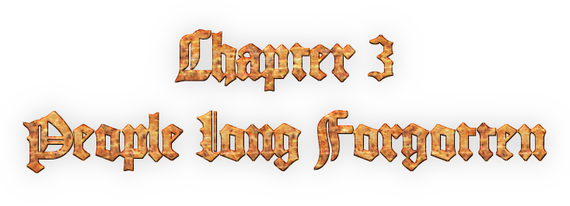
You will begin this chapter at the far end of the Naked Rocks, with only Seelah Gandra and Irravonia at your disposal. Rebecca will soon rejoin the group with Dernor and Merya. Don't worry about Eric and Brendor, they too will come back. At the very end of this chapter the last character, Aziëlla, will join making the group complete.

In this chapter we'll dive a bit deeper in the mysteries that you are facing and of course, the quest for clues.

Good luck.

3.1 – Naked Rocks

XLIV | XXXV

Now technically this dungeon contains three maps. The coast map, the cave section, and the Jennifer's hut. I just basically merged up together in a way that makes the illusion it's one. Therefore there are TWO traveler's emblems to gain here. Good, to know, eh?

When it comes to your enemies, the Crocs are your foremost concern, as they can be very nasty. Also note that based on your chosen difficulty you may find better equipment for both girls here.

001: Save the game if you desire (I recommend you to as the save spot will (as this is a blue one) also put Irravonia's HP back to the maximum)
Exit North
002: A traveler's emblem is hidden behind the stone pillar north-east. Take it.
Go East
The fissure to the South contains (unless you play hard mode) two chests, one contains a “Mistress” which is a better weapon for Seelah Gandra, the other contains a “Water Wand” which will make Irravonia cast water spells whenever you make her do a normal attack. May not be the best weapon to use here, but ya never know, maybe somewhere else?
At the far east is an exit to the South. Hit it!
003: Save the game if you want and exit South
004: Upon your arrival the game will explain how Seelah Gandra can use her whip to hook on things over gaps and swing over (similar to how grappling hooks in a few other RPG games work).
SEELAH GANDRA: Hook over to the West
Take the traveler's emblem
Exit South
005: IRRAVONIA: Fly West
Get the Healing Herb from the chest
IRRAVONIA: Fly back East
Stand in the center before the gap to the South
SEELAH GANDRA: From here use your whip to the South... You may not see it (unless the size of your screen is beyond extremely large) but there is a hook spot there.
Exit West
006: Now you can rely on both Seelah Gandra's whip hook ability or Irravonia's flying ability to reach the chest to the west (in the hard mode it won't be there). It contains a “Bishop's Robe” which is better armor for Seelah Gandra. In order to get back you can only rely on Irravonia though.
Southern way East
SEELAH GANDRA: Hook over the gap to the South
Follow the way
Exit East
007: Save the game if you desire
Fight the boss

Boss Fight: Crystal

XLV | XXXVII
Now it's very important that you know what you are doing in this particular fight, as just trying to damage it and heal when you need is NOT gonna get you anywhere in the particular fight.
Seelah Gandra is except for healing when needed completely useless in this fight, so make her guard overall and cast healing spells if you need them, but if you do this well, the occasions are rare (with a little luck even non-existent).
Irravonia is the star in this fight. The boss uses four elements. Fire, Wind, Water and Earth. It is by default immune to all, but it has to charge up. After charging it will attack you with the chosen element, but it will be very extremely weak against the opposing element, and Irravonia must it it with that element after the charge. The charge will be undone and it will need to charge again (strike twice before it could charge again is pointless). Never use the element it charged with, so if it's charged with fire don't attack it with fire, as that will heal it to full HP. Always the opposing element. So if charged with fire, attack with water and vice versa, and when charged with earth attach with wind and vice versa.
If you are lucky you never need to heal at all... It's depending on the chosen difficulty how long it takes to take this crystal down, but it will fall eventually.
Important is that Irravonia has unlocked Splash by now (which she can once water is level V or higher) or else you may have a littlebit of trouble when it's charged with fire.
007: Exit South
008: The chest contains a Magic Fashion Dress. Better armor for Irravonia (the chest is not presentin the hard mode).
SEELAH GANDRA: Hook over the gap (if she refuses, try to “hug” the south wall).
You can see the next gap from here. Walk to it.
IRRAVONIA: Fly over it
Exit North
009: Go East and follow the corridor until you reach the next gap.
Now you may see a cracked wall behind you. Yes, Brendor can break it, but unfortunately he's not available at this particular moment. However after you've got him back in your party you may want to bring him here to break that wall so you can claim the treasure it hides. It's a better hammer for Brendor you'll find in there.
SEELAH GANDRA: Hook over to the South, and you'll see that Seelah Gandra will cross two gaps now. Well since the pole was on the other side of the second gap, she didn't have much of a choice.
From here you can see the exit South. Click it to get outta here.
010: You are outside the caves now and you'll see a small house with a woman standing in front of it. Speak to this woman, and you'll find out that she's blind and that her name is Jennifer. She may just be here for no particular reason at this moment, but trust me, remember her, as she will play a more important role later in the game.
011: Exit the house
010: Save if you desire
Get out of the front yard and go East and you'll meet up with Rebecca, Dernor and Merya. They will all three join the party.
Exit East to complete this dungeon.

3.2 – The Grass Plains

 |  |  | 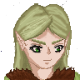 | 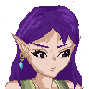
XLV | XXXVIII | XXXIX | XLVII | XVII

This might well be the most simplistic dungeon in the entire game as it's just one big open field. Just make your way South and eventually you'll find the exit at the South. The traveler's emblem is somewhere in the center.
Now that you got two new friends with each their own unique qualities, why not give them both a go. Merya can steal from the enemy, analyze them to find their strengths and weaknesses, and when she really is trained out she can do more nasty things the enemy won't like. She's weak, but she's still very useful. Dernor can try to charm enemies who that are either animals or plants. Doing so will allow him to unlock new abilities, so give it a go!

3.3 – Azquakunda Prison

XLVI | XXXIX | XXXIX | XLVII | XVII
Aquakunda Prison basically contains two parts. The way up, and the way down. Sounds obvious, but once you reach the top, the way back is being locked so you need to go down the other way. Well, I think it's obvious, but you'll find Eric and Brendor at the top who'll rejoin the party once you found them, and no you cannot complete this dungeon without them. Once at the bottom, a boss will await you, and Eric must face him alone.
Let's just get this show on the road.
000: Exit North x2
002: Upon arrival the game will explain how Merya can scan the area for secret passages.
MERYA: Scan the area (if she doesn't find anything, move a little bit more to the South)
Pass through the secret passage to the East
Hit the stairway leading up
003: South
The traveler's emblem is located in the hidden room directly south of you. The two passages leading to it are on both the West and East sides of the “block”. Merya can find them easily.
Make your way to the South of this floor
East
Enter the cell to flip the Switch
Leave the cell and go all the way back to the North of this floor
Hit the stairway up
004: South
The treasure chest to the West contains a Large Bat. A better weapon for Dernor.
Make your way South
At the far South go East
Hit the secret passage East (yes, Merya can find it if she scans the area for it).
All the way North
Flip the switch.
Now unless you have a really small screen you should see that the barrier towards the room with the gap has now been removed.
Click left of that gap so your hero will walk to it
SEELAH GANDRA: Hook over to the other side.
Please note that is is a one way go, so once you do this there is no way back.
Hit the stairs
005: Flip the switch
Enter the cell
Here you will find Eric and Brendor who will both rejoin the party.
Exit the cell
Hit the stairway on the East part on this floor
006: The chests in both cells contain a Knight's Sword. A better sword for the Sylvertin twins. Since Eric is going to face the next boss alone, make sure he's equipped with one.
BRENDOR: In the west part of this floor you can see a cracked wall. Destroy it!
This will reveal a stairway down. Hit it
007: West then South
East
Flip the Switch North
Go back to the intersection
Hit the stairway down (If you wanna know the chest contains a Potion)
008: Now if you care about the long away around, take that long way around then you will find four Warrior's Vests (Better armor for: Eric, Brendor, Rebecca and Dernor), although one of them is in a secret passage and a Healing Herb. From the end there's a shortcut back which Seelah Gandra can use with her whip hook-on ability. It may require some searching to find the right spot to do it, but it will work, unless you can see that the proper spot is marked 😜
Hit the stairway down
001: Hah! You may have been wondering when you came here before what that gap and pole were for, eh? Well, I guess now you know.
SEELAH GANDRA: Hook over to the West
Exit South
000: ERIC: Walk South and face Aldarus

Boss Fight: Aldarus (Round #1)

XXXIX
What is important to note is that Aldarus' stats have always been adapted to Eric's in this fight, so endless level grinding is NOT GONNA HELP YOU AT ALL in this particular fight.
Now you may want to poison him. Aldarus will whenever he's about to enter his move mostly get struck by the effects of poison multiple times, so this can make the duration of this fight significantly shorter. Overall this fight should not cause you too much trouble, although you need to watch out of his “Aldarus Severing Strike”. If you can survive that, you can basically survive anything. But mostly you won't so cancel that move with “Quick Strike” whenever he's planning to use it.
000: Exit South to complete this dungeon.

3.4 – Yasathar's Temple
This is just a quick scenario hub with no random enemies, but it DOES feature a boss.
You can go either left or right (it can be a bit hard to see but there is a way. I was facing a few issues here). From there you can make it all the way north until the scenario triggers. That scenario ends in a boss fight.

Boss Fight: Mountain King
XLIV | XLI | XLIV | XLVIII | XLII | XLIX | XXI
In this entire fight Irravonia will be running the show, and the others must assist her.

This boss is slow and inaccurate, but any blow that does hit is so strong it will be instant KO no matter what level you have. It's defenses are insanely high not to mention the amount of HP it has.

However it's extremely weak to wind, so Irravonia will have to case “Breeze” like crazy and it will die eventually.

Now Seelah Gandra should be present and have “Raise Dead” by now, and having a fair stock of Phoenixes is also handy as you will immediately have to revive anyone who gets KO'ed (especially if it happens to be Irravonia). Don't waste time, AP or items on healing, since all blows are instant KO anyway. If you have the chance, “Quick Hit” from Eric and Rebecca can cancel when it moves from COM to ACT as well as Merya's “Intimidate”.

This boss is not hard at all, don't allow yourself to be intimidated by the crap-load of damage it does. It's actually pretty easy (even in the Hard mode). You just have to know the secret to beating it.
Once you won this fight, you can just leave the temple and Gagolton will be unlocked as your next location.

3.5 – The Mixed City of Gagolton

L | XLVII | XLVIII | LIII | LVII | LIV | XXXII

Now the first thing you'll see is that there are a lot of treasures here, among which even a traveler's emblem, but all of them are placed that way that somebody is in the way, and now you cannot push them aside or anything, so you'll have to deal with it that you cannot claim ANY OF THEM AT ALL.
Perhaps it's also frustrating that even the save spot has been blocked that way. Oh well, bad luck. It will later be revealed why this city has been designed this way, but for now I won't.
For now, all you can do is check out the merchant stand to make sure you have the newest equipment, and speak to the pink-haired girl in the west part of town. This girl is named Kara and she'll ask you to guide her through the mines of Airom. Although she'll go with you, she's not available as a playable character. Once you've spoken with Kara, just leave the city and go to the mines.

3.6 – The Mines of Airom

L | XLVII | XLVIII | LIII | LVII | LIV | XXXII
Now contrary to what you've seen so far the mines are one big room (this is because these Mines where designed with TeddyBear which doesn't support the multi-layer setup that Kthura has, so as a result the conversion went like that. Why the conversion? Well, that has to do because this map was copied into Star Story for a cameo mission and back then I wasn't planning to recreate Dyrt, but to keep Dyrt and Star Story canon on this point I had to keep the maps identical, so that's why... At least as far as this dungeon is concerned). This is also why the combat gauge will refill, but how quickly depends on your difficulty settings and traveler's level.

> Optionally pick the most Western road North, and follow the corridor until you see a railway going through the South wall. Well guessed, that is a secret passage. In it you'll find a traveler's emblem. Claim it and make you way entirely back to the entrance.
SEELAH GANDRA: Hook over to get over the gap to the west
Follow the corridor until you see a gap that you cannot get over, as there are no hook spots for Seelah Gandra to use her whip on, and it's too far for Irravonia to fly over.
BRENDOR: Never fear a tiny bit West from here you'll find a weak wall. Break it and the way that gets revealed now allows you got get past this.
Move on
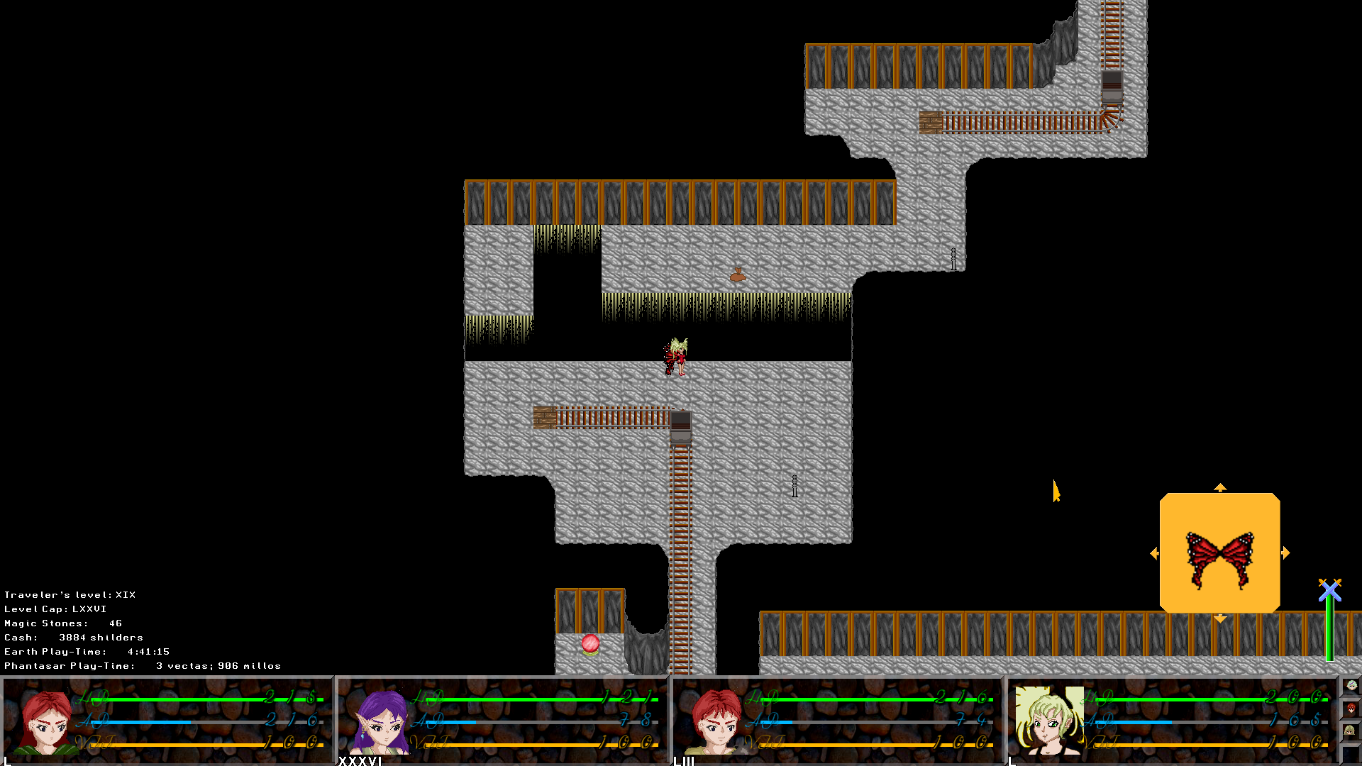
When you find yourself in the situation as shown above, “hug” the gap and go as far was as you can.
IRRAVONIA: Fly to the North
Now move two “tiles” North
SEELAH GANDRA: Hook to the East
That little “alcove” to the west of the end of the rail track is a secret passage. Some treasure can be found there.
Go North and keep following the track.
I guess it's only obvious that if there's any treasure on that “isle” that you can use Irravonia to claim it.
Sooner or later you'll reach the end of the track and here “Kara” will show you her true identity.

Boss Fight: Kirana (Round #3)
LV | LII | LI | LVII | LII | LIX | XXXVIII
It would actually surprise you how easy Kirana is. In fact when it comes to the fights against the Order of Onyx, this might well be the easiest fight of them all.

She is eager to use “Demon Soul Breaker” whenever one or characters is on full HP, which turns all characters to 1 HP. This looks like a serious problem, but this is actually her weakness. She only becomes dangerous when nobody as at full HP. So have Seelah Gandra on your front row, so she can make sure at least one character is at full HP. Merya could be a good choice to have on the front row all the time, as she is due to her low HP the easiest to have on full HP all the time.

Now Kirana is also vulnerable to poison so I suggest that either Eric or Dernor or Merya fulfills the job of poisoning her. When you can keep at least one character on full HP all the time, and you managed to poison her, she's pretty much doomed.
When you win this fight, you'll automatically leave this dungeon.

3.7 – Gagolton – What?
When you arrive here you'll see that the entire town is deserted. This will make Dernor suggest to go to Independence and that location will immediately unlock as a result.
Now that everybody is gone, all treasures that were blocked before, including the traveler's emblem are right there for the taking.
Also the house on the North-East will now also allow you access to the basement (if you went there before the owner of the house would stop you, but now that he's gone). A note there will unlock the side-quest “The Abyss”. Furthermore if you have enough points on my game on Game Jolt that same basement will allow you access to the Game Jolt Exclusive dungeon “Sugar Land”.

3.8 – Independence Bushes

LIX | LV | LIII | LXI | LVII | LXII | XLIII
001: To the east of the girl, there's a secret passage hiding a traveler's emblem. Take it!
Exit North
002: The game will now tell you about the Black Orbs. You can safely pick it up if you desire. They are part of a side quest which will lead eventually to to the ultimate boss of all bosses: Juggernaut. Please read the side-quest section for more information about that.
Take the road to the East and keep following it
As soon as you can, exit East
003: Take the Northern way to the East and follow it (southern way leads to a Healing Herb in case you care)
At the end exit North, and you'll be back on the world map and the City of Independence will be unlocked.

3.9 – The Elvish city of Independence

LX | LVI | LIII | LXII | LVIII | LXIII | XLIV
Upon arrival you'll have one of the longest parts of scenario of the entire game. Sit it out.

IMPORTANT NOTE! During this scenario Seelah Gandra will assume the name of Scyndi Scorpio, and be called “Scyndi” from now on. This is by the way also the name with which you'll find her addressed if you really dig through the Phantasar Lore (which is quite big, actually. This game only shows a small fraction of it), and in this Guide I will from this point onward also only address her as “Scyndi”. This won't change any of her stats or abilities in the field nor in combat, yet it's important to take note of, to prevent further confusion.
After all the scenario the game continue in the city which will from this point on just be a normal city like any other with NPC characters you can speak to and a merchant and a few stone master, yeah well the regular stuff. Just get what you think you need, and leave the city (the exit is to the South), and you can go to the next location, which happens to be: The Marshes.

3.10 – The Marshes
LX | LVI | LIII | LXII | LVIII | LXIII | XLIV
Well, at first look this may look like a regular passthrough dungeon, but it's not. Of course, you'll first have a go with your old “friend”, Sheck-Lock. And after that you will need to get through the dungeons relying a lot of Dernor's ability see see through the “illusions of nature”, and there's also another boss further on. As said, the temple of Hando Stillor is here, and since Scyndi happens to be a priestess (and Hando Stillor also being her great-great-grandfather) she will obtain the power to use his powers in combat, giving her a new magic group with some handy spells to unlock. This is by the way the last dungeon of this chapter (although the chapter does not end immediately upon completion).

Boss Fight: Sheck-Lock (Round #2)
LX | LVI | LIII | LXII | LVIII | LXIII | XLIV
This fight is actually in most aspects the same as the previous encounter with Sheck-Lock, except for the fact that you got two more allies now who may try something with him, and that his Crystal Blade has a few more possible effects.

Normally Rebecca should have Quatro Power Strike by now, and I suggest you use it, and he can also still be poisoned.
000: Exit South
001: Upon your arrival in this place Dernor will explain about how he can see through the illusions of nature, and a system tutorial will follow. Just put Dernor in the lead and move a bit south and you will see how it works.
You can see how you can cross the shallow and exit South
002: Now not all barriers are illusions. Some are REAL!
IRRAVONIA: Fly over the water to get to the East
Go South
DERNOR: If you put him in the lead the way to the isle on the West will soon be clear
SCYNDI: You can use your whip to get into a secret area to the South. Merya can mark the spot for you.
Take the traveler's emblem here (and there's also a Black Orb for that side-quest should wanna go for that).
SCYNDI: From the west you can whip your way back North. The spot is less obvious than it looks. The picture below shows where you need to stand to hook back North.
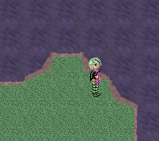
You will have to go back to the West Island
Exit West
003: DERNOR: Go West to challenge the boss. (Yes, only Dernor can do this).

Boss Fight: Big Salamander
LX | LVI | LIII | LXII | LVIII | LXIII | XLIV
This is pretty much a hack-and-slah kind of boss. You should be aware of the disease status it constantly puts on you as that blocks off your possibility to heal yourself.
It is weak most of all to lightning, but none of your character has that ability yet (unless you are playing the New Game+ where Scyndi can do that). If you have however some eels you may want to use them in this particular fight.
003: Exit West
004: SCYNDI: You need to hook over to the South. Merya can mark the spot for you from where to use your whip.
West and at the end North
DERNOR: No it's not a dead end ahead. You can just move on.
Continue North
IRRAVONIA: Fly over the next shallow
DERNOR: There's a passage to the West. With Dernor in the lead you can find it more easily. Hit it!
005: Enter the temple
006: Examine the stone table with the man lying on it, to complete this mission. As Scyndi gets bestowed now with the power of Hando Stillor, she'll be able to unlock “Mental Gymnastics” now and gain more spells in this magic group. The party will exit this dungeon automatically.

3.11 – Aziëlla Azbanella Pyèra Fradique, daughter of the house of Gandron

Go back to Independence and Trixia will tell you Aziëlla has arrived. Go North and Exit North and you will meet her and she'll immediately join the party ending this chapter in the process.

When you are ready to proceed to the forth chapter, speak to her soldier in order to travel to the kingdom of Aeria. But please note: This is for the time being a one way ride, as once you arrived in Aeria you cannot go back for quite a long time, so if there's anything you still wanna do before leaving do it now. Of course, this no-return is not permanent, as you can (and even must) come back here later in the game, but it's gonna take a loooong while before you get to that point.

CHAPTER 4: REVELATIONS
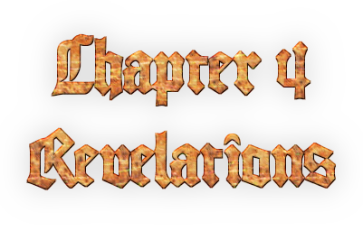
In this chapter a few things that were a mystery so far will be revealed, but that will happen over time, and I am not gonna tell you WHAT is gonna be revealed.
Of course, say “hello” to your new friend, Aziëlla, for she will stick with you for the remainder of the game as a full party member making your group complete at last.
Basically this chapter can be divided in a few sub parts.
In the first part you will only be dealing with some scenario in which Aziëlla's king will inform you on some very important things. In this party you will also have a small solo part with Eric, but that doesn't involve any fighting.
After that the group will be split in two teams. Team Eric and Team Rebecca. Eric will have two dungeons, and Eric take Irravonia, Brendor and Aziëlla with him. Team Rebecca will also have two dungeons and she will take Dernor, Scyndi and Merya with her.

When both teams have done their stuff the party will reunite and then you will have the Dark Storage mission which contains actually four dungeons and a main hub, and can be seen as a section on its own.
After that some stuff will happen, and I'm gonna be vague here, as anything I say about that would be a mega spoiler. Suffice it to say that when you've done that part, the stage is set of the final part, and thus chapter 4 ends there.
Let's get ready to rumble.

4.1 Rayal Palace
 |  |  |  |  |  |  | 
LXII | LIX | LV | LXIV | LXI | LXV | XLVII | LII
Now before you go see the king, you may want to check out this castle. First of all, just north of the South-East corner is a secret passage in the West wall, leading to a traveler's emblem. I guess you didn't want to miss it.
Now if you go to the South West and enter the corridor North, first door East you'll meet a soldier named Scharum. He'll challenge the character who is in the lead to a duel, and if you win you can unlock a new move. If Eric manages to defeat Scharum he'll gain “Triple Power Strike”, and this can make him a bit more equal with his sister I guess. Irravonia will if she defeats Scharum gain learn “Magic Strike”. Brendor will learn “Focus”, and the same goes for Rebecca. Scyndi will learn “Pray” which can come quite in handy as it recovers quite a lot of AP. Dernor will learn “Mother Nature”, and Dernor can also learn another move once he defeats Scharum, which is “Raven's Peck”, however that move also requires him to have a Raven charmed, however the order in which he does that is irrelevant, as long as he does both, the move is his. Merya can learn “Follow Me” which places all her allies directly on the COM position (except the ones who are dead, paralyzed, sleeping or already moving from COM to ACT). Aziëlla can learn Triple Bolt, which can be compared to “Triple Power Strike” when it comes to the general effect. Now it needs to be noted that Scharum is pretty strong, and you may not be able to beat him yet, so you may wanna come back for him later, but you can always give it a try right. (If you lose Scharum will just claim victory and nothing more will happen. You will leave the fight with 1 HP, but as the save spot here recovers all HP, I don't think it really matters).
When you are ready to see the king, just take the North corridor from the entrance and you'll get to meet him. Speak to him and hear him out, and the game will immediately advance to the next section.

4.2 – Rayal Palace by night
LXII
Now you will be in the castle.
IMPORTANT NOTE! There is a bug in this section of which I am totally in the dark what causes it, but it can cause the game to get in a kind of “frozen” state. As there is apparently nothing at all that could cause this bug from being triggered I am looking for a needle in a haystack, but the bug is so impossible to find that waiting until this one is fixed would lead me to never being able to release the game at all. So that's why I still decided to release the game even with a bug this crucial in it. Not to mention it happens randomly. SAVE YOUR GAME AT THIS POINT! This way you can be sure that if this cockroach is triggered, you don't have to do too much again! This is the last point where you can save before the bug triggers.
→ Leave the bedroom
Go North in the corridor
Around the corner East and you'll notice a crack in the wall. Pass through it
→ Hit the house you see in the next part.
Inside you'll meet the Oracle. After she's done with her story the bug can trigger. If you immediately see a part of the castle and no way to move, it has happened, and then all you can do is quit the game and load the savegame. If you stay in the Oracle's house and can move around, congrats then the bug didn't trigger.
Leave the house
→ Exit South to get back into the castle.
→ Go back to your bedroom, and this section will end.

Now the game will make you choose which team you want to play first. It doesn't matter as you need to do both anyway. For this guide I'll start with team Eric, simply because it's the most logical thing to do.

4.3 – Team Eric
Team Eric has the following members:
- Eric
- Irravonia
- Brendor
- Aziëlla
You will start in the audience chamber of Rayal Palace. When you leave the palace two locations will be unlocked here in Aeria. The capital of Rayal, all you can do there is visit the market square so you can update your equipment, buy items if you need and bank your money.
The game will continue as soon as you enter the lost city of Fruskbrando.

4.3.1 – The Lost City of Fruskbrando

LXII | LIX | LV | LII
This is a big “one room” dungeon, and basically there's not much to say about it. Just follow your path until you find the boss.

Boss Fight: Big DemonAir
LXIV | LXI | LVI | LIII
This is pretty much a straight-forward hack-'n-slash kind of boss. Irravonia can show off with her earth magic as it's weak to that. Now that you don't have Scyndi at your disposal Irravonia and Aziëlla may have to take care of that, but their spells are not half as strong as Scyndi's. This can force you to rely on your items.
Once you've beaten the boss you can grab the traveler's emblem and exit this place South.

4.3.2 – Malabia's Caves

LXXX | LXXVII | LXVIII | LXXIII

Now this is more of a puzzle dungeon, although there are encounters here. There is no boss fight in this place though.

000: Aziëlla will start how she can hit far away target with her crossbow.
AZIËLLA: Well stand at the correct spot for the target and fire away to open the door.
NOTE: Nope you really cannot get to the traveler's emblem at this point, and don't even try. You really have to come back for that later once the group is reunited, so Scyndi can retrieve it for you.
001: Go West and follow the road until you are in the northern part of this room.
AZIËLLA: Go into the big alcolve and shoot the left target to open the door. Optionally you can shoot the right one as well to create a bridge which can serve as a shortcut
Go to the exit and hit it
002: There are several ones of these puzzles in this dungeon. Touch one button and the button itself and those close to it will change color. The puzzle is solved as soon as all buttons are green.
IMPORTANT NOTE! As soon as your hero touches the button it reacts regardless if you clicked it, and the pathfinder is merciless here. Keep that in mind or you may mess things up.
Touch the 2nd button from the left and the 1st button from the right
Hit the exit to the next room
003: Go West and then North
Stand to the North side of that gap-with-the-isle
AZIËLLA: From here shoot the target
Hit the exit to the next room
004: Just touch ALL the buttons in random order ONCE.
Exit North
005: Follow the road and exit East (due to the complex setup in the script to make this possible it will NOT work to click the exit right away, so you'll have to do this kinda in stage form).
006: Save the game if you desire and exit East
007: Go to the most South-East part of this room
IRRAVONIA: Fly over the first gap
AZIËLLA: Stand at the correct position to shoot the target (mind the stalagmite, as Aziëlla can NOT shoot through it).
IRRAVONIA: Fly back
Go to the North-West
Exit North
008: Exit East to complete this dungeon

Huh, what, oh you want to solve that puzzle? Sure, fine with me, but it's completely optional, and is not required to complete this dungeon.... Yeah, sneaky, huh. Well if you are sure you want to solve that puzzle, I'll name the left column A, the center B and the right C, and the top row 1, center row 2, and the bottom row 3. Then touch them in this order:
- C2
- A3
- A1
- C3
- B2
- C2
- C1
This will open the door. So you can hit it.
009: Claim the black orb, 10K shilders and the Ambrosia
Exit South
008: And now you can still exit East here.

4.3.3 – Malabia's Temple
This is nothing more but a scenario hub. As soon as the scenario outside ends enter the temple and examine the statue and the mission for Team Eric ends.

4.4 – Team Rebecca

Team Rebecca has the following members:
- Rebecca
- Scyndi
- Dernor
- Merya
You will start the mission of Team Rebecca on the beach of Cat-Island. All you can do is leave it and head for Felixium.

4.4.1 – The Phelynx Town of Felixium
LXI | LXIV | LXV | XLVII

Upon arrival you'll first get to sit out some important scenario. Take good note of it as the full mission will now get clear for these four. Once you're heard it all out, leave Tigerion's house, and do some shopping if you need as all the stuff a town provides is here.
Make sure Scyndi prays to the statue of Thrur, the Phelynx god of Thunder, and he will bestow his power over her, giving her the power to cast lightning spells in battle, and.... you're going to need them.

When you are ready for action, leave the city and head for the Purple Forest.

4.4.2 – Purple Forest
LXI | LXIV | LXV | XLVII
Not much to say about this forest as it's just one big forest you need to get through. The exit is at the North-West of the forest. The forest is a bit of a maze, but not one that's hard to navigate through. There's an unlimited supply of monsters here, so I hope you are not in a hurry.

4.4.3 – Frundarmon's Mansion
LXXV | LXXVII | LXXXI | LXIII
Fundarmon's mansion is a one-of-a-kind dungeon in this game. At has fixed encounters in stead of random encounters, and this is the only dungeon in the game where this trouble is taken, but that is because this is kind of a scenario driven dungeon more than others. Also once the boss has been defeated all encounters will be deactivated turning this place in a combat-free zone (now beating the boss will by the way also complete this dungeon, and the entire part for Team Rebecca).

The children of Frundarmon can be found all over the mansion, and since they are all undead they are all vulnerable to healing magic. Except for the Phelynx kid, all kids have a weakness for lightning, however how much that will help you can differ per kid. In the normal game this is not really useful, but in the New Game+ Scyndi will have light magic which kills all kids (and even the boss) instantly.

Frundarmon's mansion also hides the entrance to the secret dungeon Frundarmon's basement, but as you need Irravonia to get through the place it's no use looking for that now.
Let's get moving, shall we?

001: Lobby
Attack the kid guarding the North exit
Pass through North
→ 1st Floor Corridor
Now what is nice to note is that the traveler's emblem is in the most western room, but Irravonia is required to retrieve it, so that is useless now.
Kill the kids guarding the door
Pass through the door they guarded
→ Storage
Flip the switch and go back to the corridor
→ 1st Floor Corridor
Hit the stairs
002: 2nd Floor Corridor
Kill the kids who attack you upon your arrival
Hit the most western doorway
→ Bedroom
Kill the kids awaiting you here
Checkout the cabinet and you will get questions about the genders of the kids. Please note the order is different each playthrough as well as the question if a kid of a certain race is a boy or a girl, so watch the questions well. The Elvish kid is a girl. The Phelynx kid is a girl. The Fairy Kid is a girl. The human kid is a boy. And the Befindo kid is a boy. If you take this in mind you should be able to answer all the questions correct and open a doorway in the process.
Go back to the corridor
→ 2nd Floor Corridor
Now it may be nice to know that the way south leads to the study. All that is there is a save spot, but still, it could come in handy, I think.
Kill the kids guarding the stairs
Hit the stairs.
003: And face Frundarmon

Boss Fight: Frundarmon
LXXVI | LXXVIII | LXXXI | LXIV
Now all Frundarmon can do is summon undead kids into the fight, and the turns in which he doesn't summon a new kid, he just wastes it with “Observation”. On the moment the boss is KO'ed, the curse on the kids is lifted, and the kids will slowly fade away, which means that their HP goes down over time until they will fall as well.

Now before anything, try to steal from him to obtain an Ambrosia, and then go at full force at him, and don't waste too much time and trying to get rid of the kids around him, unless there are too much. Especially in the hard mode, where Frundarmon wastes very little turns, the number of kids can soon get too much to handle.

Cheesy method: If you have a sacred powder, use it on him → you win.
Cheesy Method: In New Game+ make Scyndi cast Shine or any other light based spell. → you win.
Winning this fight will instantly end this dungeon and the entire mission of Team Rebecca.

Now if you did both parts both teams will automatically return to Rayal Palace in order to report to the king, and also re-unite. They will also mention Jennifer, the blind woman whom Scyndi and Irravonia met when they escaped the Naked Rocks at the start of chapter 3 (I told ya she'd be important later). From this point on you can (and even must) return to Delisto. You can do so by speaking to the soldier on the beach.

Before you do so however, I do recommend to use Scyndi to claim the Traveler's Emblem in Malabia's cave, as you couldn't do it before. And to use Irravonia's to do the same in Frundarmon's Mansion. You can now also if you desire take on Frundarmon's basement, but I won't discuss that here. Check the sidequests section for more information about that.

Oh yeah, and visit Malabia's temple and make Scyndi pray to the statue in order to allow her to cast light magic. You'll thank yourself for doing so. Also as Malabia is a higher kind of god, she can (unless you play hard mode) grand more power by default if you worked out the other gods (in other words, the higher average the level of your other gods, the higher level she begins on Scyndi. In the Hard Mode she'll always start at level I though).

4.5 – Jennifer's Story
Just go to Jennifer's house and speak to Jennifer and she will now reveal some very important stuff about the story. She won't reveal everything, though, but she gives a very important hint about your enemy which you should definitely remember.
She will also reveal the Dark Storage to you, and with that your next target is set.

4.6 – The Dark Storage
Now, this place is split up in five sections. Four upper floors and main basement. Each of the upper floors belongs to a member of the Order of Onyx. From left to right Aldarus (blue section), Jeracko (green section), Kirana (pink section) and Rondomo (Purple/Burgundy section). Each of these sections act as a dungeon on their own. Each of these sections have a monstrous boss halfway, and the order member themselves at the end of the section.

Now what is very important is that Merya steals the four keys the Onyx members carry while you fight them (you cannot win the fight against them as long as she didn't do that). Once you've defeated all four order members and thus obtaining their keys you can go for the main basement where you can complete this whole mission.

Since the four sections are actually dungeons on their own (literally actually as I even put them as such in the database, but I cheated around a bit in order to obfuscate that) I will give them each their own section. Now the order in which you take them on is entirely up to you, as long as you take them all, but for this guide it was the easier way to go to take them all on from left to right. So Aldarus, Jeracko, Kirana and Rondomo... in that order. Well and the main section's basements (in which the access to the Game Jolt exclusive Dungeon Mörker Forest is also hidden) comes last, of course.
Let's get this show on the road, shall we?

4.6.1 – Dark Storage: Aldarus

LXXXIII | LXXXI | LXXI | LXXIX | LXXVII | LXXXII | LXV | LXXVI
100: Exit North
101: MERYA: Scan for secret passages. You'll find one to the East
Use that secret passage
Exit North
102: MERYA: Scan for secret passages and you may find a marker to the West
SCYNDI: Hook West from here and a new area will be exposed to you
Get the traveler's emblem from here
Hook back East
Exit North
103: Move forward and face the boss

Boss Fight: Giant Squid
LXXXIV | LXXXI | LXXI | LXXIX | LXXVIII | LXXXIII | LXVI | LXXVII
Now this a kind of hack-'n-slash boss, but it should be cool to note that as an aquatic type of enemy it's weak to electricity. Scyndi should be able now to cast lightning spells (you didn't forget to pray at Thrur's statue before you left Felixium, I hope), so if you don't need her for healing, that's the way to go.

A spell to watch out for is Kyodo no Tsunami. A water based attack that always does 75% of your max HP as damage, no matter what your magic resistance is. The attack is however influenced when characters are either weak or resistant to water attacks.
103: Exit North
104: Just follow the way and exit North
105: Go to the North-East of this room
SCYNDI: There's a secret room to the west here (you don't need Merya to scan for it, do you?) and Scyndi can use her whip to hook to the pole west
Exit North
106: You may want to save first. And when you are ready speak to Aldarus to engage the boss fight.

Boss Fight: Aldarus (round #2)
LXXXVI | LXXXIII | LXXIII | LXXXII | LXXXI | LXXXV | LXVIII | LXXVIII
First of all, make it your priority to get Merya to steal his key. Once you've done that, this fight is more or less similar to your previous encounter with him, with the big difference now that Eric doesn't have to face him alone, but that you have your entire party at your disposal this time.
Aldarus is actually the easiest of the four Order of Onyx members to beat. Just keep and eye on your HP and you'll do fine. Try to prevent him from doing Lay on Hands, as it can heal him up quite a lot, and Aldarus Severing Strike can do major damage.
Just like before he can be poisoned.
106: Go North
Stand on the teleporter to be warped back to the entrance of this section
100: Exit Downstairs to get into the main hall, and from there you can continue.

4.6.2 – Dark Storage: Jeracko
LXXXIX | LXXXVI | LXXV | LXXXIV | LXXXIV | LXXXVIII | LXX | LXXX
200: Exit upstairs
201: IRRAVONIA: Fly East
Go to the most South-West corner of this isle
IRRAVONIA: Fly West
Go to the most South-West corner of this isle
IRRAVONIA: Fly South
IRRAVONIA: Fly East
All the way East
IRRAVONIA: Fly North
All the way North
IRRAVONIA: Fly West
Exit North
202: Follow the platform
IRRAVONIA: Fly East x2
And now this can be a bit interesting. Stand beside the 2nd candle from the South
SCYNDI: Hook East
Grab the traveler's emblem
SCYNDI: Hook back to the West (you can use Merya to see from where to do this)
The location of the hook-spot will however carry you too far
IRRAVONIA: Fly East x2
Go North
Exit North

Boss Fight: Super Hag
XC | LXXXVIII | LXXV | LXXXVI | LXXXVI | LXXXIX | LXXI | LXXXI
The Super Hag is weak to light, however due to her high magic resistance not something that is easy to exploit with Scyndi's light magic, but try Aziëlla's Blessed Arrow in stead.... It will likely finish her off in one blow.

The hag herself is a master of curses and other nasty stuff, so if you don't wanna do it the cheesy way (or if you think Aziëlla is a useless character, which has proven to be a pretty noobish mistake) you can be in for a very annoying ride.
203: Save if you want and exit North
204: Just exit this room to the North
205: In case you wanna know. The chest North contains a Healing Herb
IRRAVONIA: Fly East
SCYNDI: From the center of this platform hook East
IRRAVONIA: Fly West x2
Exit North
206: Save if you desire and speak to Jeracko to engage the boss fight

Boss Fight: Jeracko (round #2)
XC | LXXXIX | LXXVI | LXXXVIII | LXXXVII | XC | LXXIII | LXXXIV
Jeracko will fight in the same style as before, so nothing new here. He only doesn't have any orcs to help him this time. Merya should steal a key from him as you can't win this fight as long as she hasn't done that. Irravonia should go crazy with wind magic, and have Scyndi ready for the healing. He is very strong, and that can be pretty bothersome.
206: Use the teleporter in the room beside this one to get back to the start
200: Go downstairs to get back in the main hall

4.6.3 – Dark Storage: Kirana
XCIV | XCII | LXXVIII | XC | XC | XCIII | LXXV | LXXXV
300: Exit Upstairs
301: Again
302: Follow the corridor
BRENDOR: Break the North wall
If you care to now, if you go East, you'll find the traveler's emblem.
Exit North
303: Stand at this position
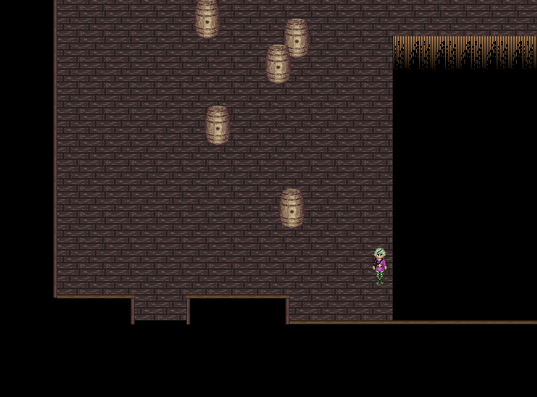
SCYNDI: Hook East from here (no Merya will this time NOT be able to mark the spot for you, HA HA).
304: SCYNDI: Hook West

Boss Fight: Grwol
XCV | XCIII | LXXVIII | XCI | XCI | XCIII | LXXVI | LXXXVI
This is overall an easy fight, attack if you can and heal if you must.
It's resistant to ALL elements, so magic may not help much, except maybe Blast and Devastate which Scyndi may have learned if you've worked out her level with Hando Stillor a lot.
The “Shout” move which moves everybody back to the starting point of the gauge is annoying, but not really a threat.
304: SCYNDI: Hook West
Exit North
305: Make your way to the East (Treasure chests are: a healing herb and 1600 shilders)
BRENDOR: Break the wall North
Exit North (Chest = Ambrosia)
306: Now you can take the long way around, or you can make Irravonia fly over the gap for a shortcut, but you must know from which position to fly. Shall I show you?
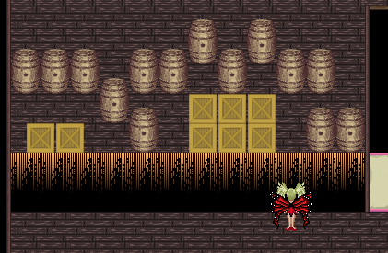
Exit North
307: Go to the Northern part of this room and save your game if you desire
Speak to Kirana to engage the fight

Boss Fight: Kirana (round #2)
XCVII | XCV | LXXVIII | XCIII | XCIV | XCVI | LXXIX | LXXXVI
As always Merya should start stealing. This time Kirana won't be so eager to use Demon Soul Breaker whenever somebody is at full HP, and that makes her more unpredictable and less easy to control, which makes this fight actually harder. She's completely immune to all elements making most attacking magic entirely useless, so physical attacks will have to do the job.

You can poison her, which helps a lot. I advice to have Aziëlla to cast the Hyper spell over Rebecca and after that a Permanence. This will speed things up.

Make use of the fact you can see what she's planning to do while between COM and ACT, as she can come up with really powerful spells that leave you little chance of survival, and canceling those can be a VERY GOOD IDEA!!!
307: Use the teleporter to get outta here
300: Exit Downstairs to get into the main hall.

4.6.4 – Dark Storage: Rondomo
XCIX | XCVI | LXXXII | XCVI | XCVII | XCVIII | LXXXI | XC
400: Exit Upstairs x3
403: Go South
At the end East
At the end North
Exit North
404: Yeah, this page has been found, folks!
Walk to the big hole in the floor
IRRAVONIA: You can optionally fly to the center of his hole and an isle will be revealed. This Isle contains a traveler's emblem
Exit North
405: Go North and face the boss

Boss Fight: Smile
CI | XCVII | LXXXII | XCVII | XCVIII | XCVI | LXXXII | XCI
This might well be the most annoying boss in the entire game. You can with most attacks do no more than 1 HP damage, which can be frustrating, although that is compensated with a very low amount of HP. It also casts a lot of spells which are rather slowing you down than actually threatening you, so all in all this can be a very frustrating fight.

Cheesy method: Make Aziëlla perform a normal attack → You win!

405: Save if you want and exit North
406: Follow the corridor and exit North at the end
407: The tiles around the pit are memory tiles, so the object is easy, find all matching tiles, and once you manage to do that the barrier will open.
Exit North
408: Save if you want and DO NOT STEP ONTO THE TELEPORTER!!!!!
All the way North and speak to Rondomo to engage the fight!

Boss Fight: Rondomo (Round #2)
CI | XCVII | LXXXII | XCVII | XCVIII | XCVI | LXXXII | XCI
Well, this time it's for real, folks. No losing, but winning. As always Merya must first steal his key. Don't EVER try to cancel him, as he'll make you pay for that. Keep a good eye on your HP and heal in time. He can be poisoned and Rebecca should be using her strongest attacks. Perhaps Aziëlla can power her up at little. Watch out for his status changing attacks.
408: Go back South and step onto the teleporter now
400: Step onto the teleporter to get back in the main section!

4.6.5 – Dark Storage: Main Section
CVI | CIII | LXXXVI | CI | CIII | CIII | LXXXV | XCVI
As soon as you arrive here after getting the keys from all four members of the order of Onyx you will first get a cutscene. Once that cutscene has passed the heroes will have manage to open the door.
Note there are no more random encounters in this place, but there is one more boss fight ahead, and you ain't gonna like it!
000: Go downstairs here.
001: Exit North
002: The entrance to the Game Jolt exclusive dungeon Mörker Forest is located here. However the amount of achievement points required to enter is quite high, so it's very well possible the gate will remain closed for you.
Exit North
003: And hey look who's waiting for you here.... Yup, you gotta take them on all at once this time. Good luck!

Boss Fight: The Order of Onyx
CVI | CIII | LXXXVI | CI | CIII | CIII | LXXXV | XCVI
All four at once, yeah, I hope you saw that one coming sooner or later. And don't have the illusion they are any weaker as they were before, because... they are not.

Now Merya doesn't have to steal keys from them anymore, but you may still wanna try to let her steal.

In basic goes, ladies first. If any of the men are hurt, even if it's only 1 HP, Kirana will use a superhealing spell which puts everybody on full HP also healing any negative status. However she neglects to check her own HP, so focus all your attacks on her first. Oh, and poison her, that saves you a lot of trouble. Should any of the men die before she is struck down, she'll instantly kill you all, so don't even try that.
Also take note that if you expect any kind of group attacks to be learned any moment to NOT USE NORMAL ATTACKS WITH THAT CHARACTER! Kirana's AI will make no difference between planned or unplanned attacks. It can therefore also be a good idea NOT to put Aziëlla on the front rank as long as Kirana is still up.

Once Kirana is down you can take down the men in any order you like. Jeracko is the only one who is completely immune to poison, so poisoning both Aldarus and Rondomo can be a good idea. As always Irravonia should go crazy with wind attacks on Jeracko.

As before NEVER CANCEL RONDOMO or he'll counter with a move you won't like.

And as a side note, as soon as Aldarus dies, Rebecca can unlock her “Lay on hands” spell. This has a bit to do with the bond she feels with Aldarus, as both have a common goal, even though it led them to be enemies.
003: Now you cannot exit south (if and you let Scyndi try it you'll get her to break the fourth wall), so exit North
004: If you paid attention you'll see that Eric silently left the party. This is not a bug, you'll find out soon enough why this is.
Read the plaque on the wall
Exit South
003: You'll find Kirana here. Speak to her and hear her out. Scyndi and Irravonia will force her to join you (hence “May the forced be with you” as achievement name. I like puns).
Exit South x2
001: Exit Upstairs
000: Exit South to conclude this mission.

4.7 – Frendor Bushes
Now officially Kirana only accompanies you during the course of this dungeon, but she can used as a full party member until the moment the Black Prison is completed (however the Black Prison is a solo mission for Merya). Kirana cannot be put up as leader and you cannot switch her to the back. She cannot level up either, and you cannot see her statistics. In the easy mode she has level CCC (300), in the casual mode has level CL (150) and in the hard mode she has level C (100).
Now she does not have the really terrible spells at her disposal now such as Demon Soul Breaker (come on, that would be overkill), but she has some powerful spells nonetheless that can make this mission easier. So you may as well use them.
Now the exit is in the South West, and this is just a kind of a forest maze dungeon, and the traveler's emblem is at the start, so I won't go that much into the deep. Of course, except for the boss fight at the start I suppose.

Boss Fight: Sheck-Lock (Round #3)
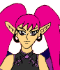
CL | CXIX | XCIX | CVII | CXIX | CXIX | C | CIX
Well, this fight is much the same as before. He has a few more nasty effects on his crystal blade and... that's all. You may once again try to poison him.

Once difference with his former meetings is that cancel effects will be countered this time. Be aware of that!

Now what is nice to note is that this is the last time you meet him in the game and that he'll become a stone master from this point on who can try Merya's rogue skills.

4.8 – The Black Prison
CVI
This is this chapter's final dungeon. As soon as you complete this dungeon chapter 4 will end and then only chapter 5 remains.

This is another one of a kind dungeons were all rules are different than normal. First of all, Merya is alone in this particular dungeon, however she won't get in any random encounters. She will have to fight a boss though.

Now the object is easy. She must get through this dungeon without getting seen by the guards. When the guards see her they kill her on the spot, which resets the floor she's on, so it's not that much of a big deal, but you gotta be alert, nonetheless.
These things must be kept in mind:
- The guards can only see in a straight line. So if you are not in that line they'll ignore you
- Unless you get too close then they'll always kill you. Stay out of a 32 pixel radius at least.
- They can not see very far. 5x32 pixels only. If you are outside that range but still standing in front of them, they'll ignore you.
- Remember Merya's ability to scan for secret passages. Sometimes she must pass through secret passages in order to get past a guard.
Let's get this show on the road, eh?
000: Enter the building
001: If you look well you can see a cracked wall on the west side of the passage. That is where the traveler's emblem is hidden. Since Merya is alone you cannot get it right away, but make a note of it, so Brendor can retrieve it later in the game.
Exit North
002: Sit out the tutorial
Go South
At the end East
At the end North
Exit North
003: Enter the most left way south
Once you are in, just click the most right way and Merya will automatically find her way through
Click the stairs
004: Save if you want, and hit the stairs down
005: Walk to this spot
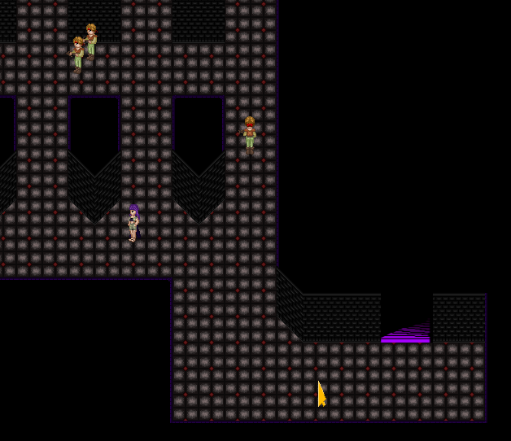
From here North
2nd way East
At the end all the way North
West
4th way South
You should be next to the skeleton now
West
2nd way to the North
At the end West
Hit the stairs
006: South
2nd way East
Enter the first cell
Click the cell next to it and Merya will automatically find the secret passage leading to it
Pass through another secret passage to the corridor but watch out as the guard is standing pretty close. One missclick and you're done for.
Go North and make sure you keep “hugging” the East wall
1st way East
Enter the cell
From here you can click the stairs and Merya will do the rest
007: Mort will welcome you and you will instantly go a level up (unless Merya has already reached the current level cap).
Save the game if you want
Speak to Mort to get the battle started

Boss Fight: Mort
CVII
Mort statistics are always adapted to Merya's, and the difficulty settings have been taken in mind also. Mostly Merya should be able to kill him in one or two blows, but watch out, as Mort has a few nasty tricks upon his sleeve.
007: Flip the switch behind the spot where Mort used to be
Enter the cell that opens
Speak to Eric and he'll join you (not that it matter, but hey, I had to it it right, eh?)
Leave the cell and hit the stairway up.

This will end this dungeon and this chapter (and on this moment Kirana will also officially leave the group permanently). Sit out the scenario, and move on to the final chapter.

CHAPTER 5: THE RUINS OF DYRT
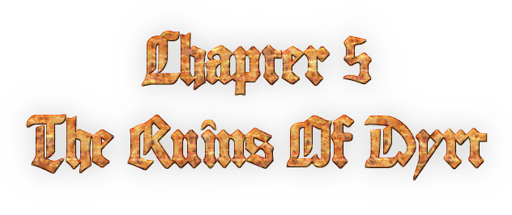
First of all Eric will have a slight power up. He'll be shown in blue clothes for the remainder of the game, and he'll have alternate equipment (the game will explain why that is, so I don't have to add spoilers in this guide explaining that). Aside from jewels, he cannot wear the regular equipment anymore. So you don't have to keep him in mind either at weapons stores (there is only one place where better equipment can be bought though). Eric can however get a better armor by beating one of the sealed bosses (see “sealed boss” section for more info about that).
By passing this point Eric will also be able to unlock the spell “Yasathar's Blessing”.
As the name of the chapter suggests, now you are going to Dyrt. This may be the shortest chapter of all, as (optional stuff not counted) there are only three dungeons, and a town in the last part of the game, with a total of two more bosses. Shouldn't be too hard, right?

You will start this chapter in Rayal Palace with only the male characters in your group (the girls will be back soon enough). You need to go back to Delisto and there the new location Zondra's Grave will be unlocked.

5.1 – Zondra's Grave
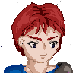
CXX | CIII | CXXV
You will see a grave with a man standing next to it. Talk to that man and hear him out. That's all you have to do. After that go to Xenor Bushes where the girls are waiting for you and rejoin the party.

5.2 – Mermaid Harbor & Dyrt Beach
CXX | CXXVI | CIII | CXXIV | CXXVI | CXXV | CVII | CXIV
I'll take these two locations together.
First of all upon entering this place you'll be able to unlock the Red Temple sidequest which unlocks the sealed bosses, and which also (if you've been working out REALLY REALLY well) may grand access to the Game Jolt exclusive dungeon The Underworld.
Now in order to get moving speak to Ariel (the one on closest to the water) and she will bring you to Dyrt where you start on the beach

You can if you want speak to the Aquillian girl sitting on the rock here, but you don't have to. There is also a traveler's emblem here. Take it.

Save the game if you desire and exit North

5.3 – Wastelands
CXX | CXXVI | CIII | CXXIV | CXXVI | CXXV | CVII | CXIV
I think you know the drill with dungeons like these by now (I guess I put them in way too much). The exit is at the North side. Find your way through. Don't forget the traveler's emblem which you can see already upon entering this place.

5.4 – Forest
CXXIII | CXXVIII | CV | CXXVII | CXXIX | CXXVIII | CIX | CXVI
Well, another one, and the very last one of these in the entire game... promise. (easy promise to make with only one dungeon ahead, well that is optional stuff not counted).
First of all, the North route is a dead end, but at the very end is the place where the traveler's emblem of this dungeon is located, meaning you may wanna go there anyway. The East route really leads into the dungeon. It may be a nasty one, but the exit is in the North-East section.

5.5 – The City of Umerington
CXXCI | CXXXV | CIX | CXXXIV | CXXXVII | CXXXIV | CXVI | CXXII
Although this is a dungeon, this is also a full-fledged city with a bank and merchants. And it really is worth the trouble to seek out the weapons and armor merchants (which are two different merchants here. That was due to the stock limits merchants have in my database), as they sell the best weapons and armor you can find in the game (not counting the stuff optional bosses can drop that is, well, that goes for the weapons at least).

Now contrary to the forest and the wastelands the encounter bar will not refill itself so when it's empty you can move around freely, and if you can make Rebecca scare the monsters away, all cool (although you if you missed some emblems and didn't do any of the sidequests you may not be able to do that right away).

Umerington also hides the entrance to the last optional dungeon, the Death Caves, see the sidequests section for more information about that.

In the North-East of town you may find a Dark Servant named Jürgen. He may sell you a Traveler's Emblem for 10,000 shilders.

The North-East is also the place where you must leave this city in order to unlock the final dungeon of the game. Lord Dzgjymza's Keep.

5.6 – Lord Dzgjymza's Keep
CXXCI | CXXXV | CIX | CXXXIV | CXXXVII | CXXXIV | CXVII | CXXIII
This is the final dungeon of the game, and also one that is not just a passthrough like the other dungeons in the place were. This dungeon has actually been set up with a bit of an architect in my mind (although laws of physics be damned, but hey considering how this “keep” came to be I could damn them), and there is some active puzzling, two boss fights (final boss included... or three, considering the way the final boss works).
And one of the most important revelations of the story line, that was still a mystery so far (or did you manage to deduce it already?) will take place here.
Of course, finishing this dungeon will mean the game will end, so if you've any sidequests left to do, do them before completing this dungeon.

Well, without further ado, let's get this show on the road.
000: Exit North
001: You may see some statues here. You may examine them if you please.
Take either one of the stairways... It doesn't matter which one.
002: Now this is a kind of “circular” (well, square shaped, but you got what I mean, I hope) corridor, correcting to six bedrooms. To all the members of the order of Onyx (of which there's a fifth member named “Wanda” who doesn't make an appearance in the game, but she does play a role in the prequel novels), and four of them have a puzzle. Solving them all will open the big door in area 001.
You an take these rooms on in any order. For this guide I'll use the order in which they are numbered, so check it all well if you plan to use this guide.
003: Wanda's bedroom
There is nothing you can do here. Just leave this room. It's only there for lore reasons.
004: Lord Dzgjymza's bedroom
There's a save spot here. It also recovers lost HP and VIT.
That is all there's here, though
005: Jeracko's bedroom
IRRAVONIA: Fly over the gap
Flip the switch
IRRAVONIA: Fly back
Exit the room.
006: Rondomo's bedroom
Like before this is a memory game, although the tiles are now more “randomly” set (random as that I picked random spots without giving it too much thought. It's not that the random number generator was used here).
You know the drill find all matching tiles. As soon as you found them all you can exit this room.
007: Aldarus' bedroom
SCYNDI: Hook East
Flip the switch
SCYNDI: And back
Exit this room
008: Kirana's bedroom
BRENDOR: Break the wall
Flip the switch
Exit East

Once you've flipped all switches and solved Rondomo's memory puzzle just go back to room 002 and hit the stairs down!
001: Hit the center door
009: Save the game if you desire
Speak to the Dark Servant to engage the boss fight

Boss Fight: Dark Servant
CXXXV | CXXXVIII | CXXII | CXXXVII | CXL | CXXXVII | CXIX | CXXV
Of course I didn't call this boss by name out of spoiler prevention.
This boss has a very dedicated AI. It will use “Study” to copy the base statistics and ability of one of your playable characters. This can only be done by those on front. Make sure who could be a treat as an opponent and who could not be. Then it will use their abilities against you for three turns and study another.

Now the boss is extremely weak for light attacks. Now the fact this is an undead enemy won't help that much as damage through healing spells have been capped (yes, to prevent instant kill cheesy escapes. This boss is too important for the plot for those kind of cheesy tricks) and the cap is too low to bother.

Don't ever cancel the moves as that will be countered with Ultimate Soul Breaker which puts all your HP to 1 and also all you AP to 0. And it should be noted that Aziëlla and Eric cancel in their normal attacks by default (Eric due to his Blue Moon sword). All weapons dropped by sealed bosses also have this effect with the exception for Irravonia's Catastrophe and Dernor's Homerun. Of course, when the attack takes place when the boss is not between COM and ACT the cancel effect won't work and then you can safely go for this. Aziëlla's auto ability “Intercepting Shot” also known as “Oh no, you don't” is not a thread as it won't cause this counter effect.

As this is the last boss before the grand finale, I guess you may expect something from it.
The boss will drop a traveler's emblem upon defeat.
And now time to work towards the grand finale, LET'S GO!
009: The right door is open. Well, hit it!
010: Examine the person lying on the plateau, and the last crucial revelations about the plot will be done. Hear the story out, and exit this room.
009: The door to the left is now open. Hit it.
010: And there he is: Lord Dzgjymza. Speak to him to engage the fight!

Boss Fight: Lord Dzgjymza
CXLVIII | CXLVIII | CXLVIII | CXLVIII | CXLVIII | CXLVIII | CXLVIII | CXLVIII
This fight has two rounds. Round #1 is just a matter of survival. If you can survive 5 turns the fight temprorarily stops for some scenario and will then ignite again in round #2.

Now Lord Dzjymza will always use these moves in this order.
Round #1:
Turn #1:Observe (in the hard mode “Demon Soul Breaker”)
Turn #2:Curse (always on Eric, in the hard mode on the entire front row)
Turn #3:Death (always on Eric, in the hard mode on the entire front row)
Turn #4: Dispell Magic
Turn #5: Ultimate Soul Breaker
And after that it will terminate the fight (in the “always on Eric” I must note that if Eric is not on the front row or if he's KO'ed on the moment Lord Dzgjymza enters his move, he will pick a random character in stead).

In round #2, you actually must fight, but please note that none of the characters can bring his HP lower than 1, however Eric is still able to “Coup de Grace” him ending this fight when his HP is low, thus fulfilling the requirement that only Eric can kill Lord Dzgjymza.
Lord Dzgjymza's stats and HP are based on that of the party on the moment the fight begins, so whatever tactic you had in mind, level grinding is NOT going to help.

Here Lord Dgjymza will also follow a pattern of the same moves
Turn #1: Observe (in the hard mode “Demon Soul Breaker”)
Turn #2: Either “Flame”, “Breeze”, “Splash” or “Rock”.
Turn #3: Vanish
Turn #4: Charge (in the hard mode “Ultimate Soul Breaker”)
Turn #5: Day of Judgment
Turn #6: Recover
Turn #7: Demon Soul Breaker
Turn #8: Malefaction
Turn #9: Either “Fireblast”, “Hurricane”, “Quake” or “Tsunami”
Turn #10: Blunt

Now important again is to NEVER CANCEL him (in both rounds) as he will come back with Ultimate Soul Breaker. And it's also recommended not to use Merya's BackStab as that will increase the speed with which he moves over the time gauge.
Once you've won this fight, the CONGRATULATIONS, as you won The Secrets of Dyrt.NET
Sit out the scenario that follows.

This will also unlock the New Game+, which offers a few things that make you more powerful than before, and which also features four extra secret dungeons you could not access in the normal playthrough....

SIDEQUESTS
Side-quests are quests that are entirely optional. In this particular section of the guide I will limit myself to the side-quests that are always available (providing you are far enough in the game), so without the need of a Game Jolt account or requiring to be in the New Game+. The Sealed Bosses will get their own section though, although you need to complete a side-quest noted here in order to be able to go for those.

Now basically every chapter, except for chapter 1 has a side-quest, and the final chapter even has two. They are: The Madhouse (unlocked in chapter 2), The Abyss (unlocked in chapter 3), Frundarmon's Basement (unlocked in chapter 4) and the Caves of Death (unlocked in chapter 5), and there's as extra the Red Temple (also unlocked in chapter 5) with which you can gain access to the sealed bosses.

The sidequests do no fulfill any role in the story line at all, you can skip them completely, however doing them can get you some nice rewards. If they are worth it is up to you.

SQ1 – The Mad House
XLIV | XLIII | LXXI | XLIII | XLIV
- Can be unlocked: After completing the Red Dragon's Cave
- How to get there: Go to the Crossroads and take the way East. A secret passage here hides the entrance
- Reward: Traveler's Emblem
- Extra remark: This dungeon also hides the entrance to the Exclusing Dungeon: Science Facility.

The Mad House is a place where nothing is as it seems. Also note, once you enter the house you can only leave it by completing it. And logic is non-existent in this place!
→ Enter the house
001: Exit North
002: Exit North (chest = magic disc)
Should you have been in the Science Facility there will be two exits North here, then you must take the most eastern exit North.
003: IRRAVONIA: Fly East and hit the eastern exit South.
004: I hope this room doesn't scare you, and yes it adepts based on your current party members.
Make your way South
Exit South
005: Go back the way you came
006: Save the game if you want and go North.... BANZAÏ!

Boss Fight: Creep
XLIV | XLIII | LXXI | XLIII | XLIV
How hard this guy is depends on when you get here, I guess... Since this side-quest comes quite early in the game, you shouldn't expect too much.
Cheesy method: If you have anything that can do light damage, use it → you win!
006: Exit North
007: Entering this room earns you the achievement “I'm going slightly mad” as a mark you completed the side quest. Claim the traveler's emblem as your reward
Exit South
→ You'll find yourself outside the house again. You can use exit West to get back to the regular game.

SQ2 – The Abyss
CVI | CII | XCIII | CIV | CXI | CVI | LXVI
- Can be unlocked: After Gagolton gets deserted
- How to get there: Read the note in the basement of the house NE in Gagolton and the location will be unlocked on the world map
- Reward: Unlock “The True Abyss” in the main menu (See “The True Abyss” section).

Now I cannot guide you through the Abyss in anyway, as the maps in the Abyss are randomly generated. As a basic rule it goes for all floors than you must find a blue orb and touching it will get you to the next floor. Only the entrance floor, floor 005 and floor 010 are always the same. On floor 005 you'll merely find a savespot, and on floor 10 you will meet a boss. When you touch the exit on floor 010 you'll get back onto the worldmap.

Boss Fight: Super Pink
CVII | CIII | XCIV | CV | CXII | CVII | LXVII
Physical attacks are pretty much useless here. You'll have to work with magic. Cast your most powerfull spells and you should win this fight in a jiffy.

After the defeating the boss there's another traveler's emblem. Well, and that should be it, right?

SQ4 – Frundarmon's basement
CXXIX | CXXV | CIX | CXVII | CXXV | CXX | LXXXIV | CXIII
- Can be unlocked: After both teams completed their mission in full in chapter 4
- How to get there: Enter Frundarmon's mansion again. All kids will be gone, but that doesn't matter. Go to the corridor on the 1st floor and then there's a secret passage on the South-West of the corridor. You can use Merya to mark the spot if you like. In this passage is a stairway leading to the dungeon
- Reward: Many different kind of jewels which raise protection against several things.
NOTE! Now you already can enter this place while you are still fighting the children during Team Rebecca's mission, but very soon you'll find a gap only Irravonia, who is then not present in the party, can cross. Scyndi will even mention then that you need “Butterfly's help” to get over there. In other words coming here while you are still fighting the children is pretty pointless. (And the first encounters will only come when you've gone past that point also).

000: Hit the Northern exit to the right of the red seal
001: IRRAVONIA: Fly over the gap
Exit North
002: Follow the corridor and exit North
003: All the way East and a little bit North to get the traveler's emblem
SCYNDI: You need to hook over the gap, but due to the position of the hook spot you'll always get them both (and back has the same issue).
IRRAVONIA: Fly South to get between the gaps
East
Hit the exit here
004: SCYNDI: Hook East (This is a one-way-ride, so once you did that, the only way out is completing the dungeon!)
Save your game if you desire
Hit the exit North
005: If you want the content of that chest on that isle (Ambrosia), Irravonia can reach it if you fly to it from the North side of the gap.
Make your way to the North-Eastern section of this room, and exit North
006: There are multiple routes here, but which one you take doesn't matter at all, so you da boss.
Both ways lead to the exit to the South. Hit it!
007: And CHAAAAAARGE!!!!

Boss fight: Lich King
CXXIX | CXXV | CIX | CXVII | CXXV | CXX | LXXXIV | CXIII
High amount of HP and very nasty attacks can make this battle hard and long lasting (unless you are overpowered).
Cheesy method: If you have an item or spells that heals up to 100% of max HP and you can manage to use it on this boss → you win
(Nope, Ambrosia won't work since you can only use it on the playable characters and not on the boss. HA HA!)
007: Save the game if you want
Hit the eastern exit North
008: Just follow the way and hit the exit as soon as you find it (easy enough, trust me).
009: You can just go the entire way around, or you can go a bit West and make Irravonia fly over the gorge as a short cut. Anyway you need to Exit South at the end
000: Congratulations, you finished this dungeon. Doing so will lead to an achievement and an instant level up on all characters (providing the current level cap allows it).
BEFORE YOU GET OVER THE GAP HIT THE 2ND EXIT FROM THE RIGHT TO THE NORTH!
010: Open all treasure chests to get your rewards and exit this room
000: SCYNDI: Hook west
And hit the stairs to get outta here!

d

SQ6 – The Black Orbs
For this sidequest I am not gonna talk in levels, as they do not matter anyway.
This sidequest will ultimately lead to Juggernaut, the strongest boss in the game. And also the most time consuming one to beat, so don't even try about doing this if you are in a hurry, or when you expect your mommy to come with a reason why you must quit playing. Don't say I didn't warn you.

This side-quest begins after beating Kirana in the mines of Airom. In Gagolton you may have seen a room heavily guarded and the guards even making clear that entering the room they guard holds the penalty of death. Well, that is (of course) for a reason, when you find out what they guard. After all inhabitants of Gagolton have disappeared though those guards will have disappeared as well, as thus you can then enter the room they are guarding. Not much to do there initially as all you see is a door and six holes in the wall. These holes are sockets in which you must place a black orb each. So six black orbs are required to open this door.

The black orbs can be found all over the game, but only in locations you can unlock AFTER Gagolton gets deserted.
- Halfway the Independence Bushes. This one is impossible to miss since the party even makes note of its presence
- The Marshes area 002. In the secret passage you can enter by using Scyndi's whip hook ability you can find the traveler's emblem of that dungeon and the black orb is lying next to it.
- At the far end in Malabia's cave. If you solve the 3x3 button puzzle this orb is kind of your reward.
- Frundarmon's mansion, next to the traveler's emblem. You need Irravonia to retrieve it
- In the Cave of Death. Finish the dungeon first in order to open the black market. Inside the black market room is a secret passage to the East. There you can find the orb.
- In Lord Dzgjymza's keep in the entrance hall. East of the savespot is a secret passage. That's where the orb can be found.

Now once you found all these orbs return to Gagolton, and then you must go to the hall with the six sockets. Click them all, and your character will automatically put the orb in, and once you've filled all sockets the door will open. Enter the room it leads to and you will instantly get into a fight with Juggernaut.

Boss fight: Juggernaut
∞ | ∞ | ∞ | ∞ | ∞ | ∞ | ∞ | ∞
The reason why I put in “∞” for levels is because levels don't matter in this fight. Level I or level M (not that that is possible) Juggernaut will kill you all the same, unless you are properly prepared. All his attacks are set it to to do more damage than your max HP is, and yes it increases and lowers based on the max HP each character has.
The trick lies in making sure your resistance against each element is as high as you can get it, as all of Juggernaut's attacks are based on an element, and that is his “weakness”. The magic based characters like Eric, Irravonia and Scyndi already got some powerups on this department, for the other characters jewels and stone masters will have to help out here.

Also note that Juggernaut has approx 2 billion (!!) HP, so this is gonna take awhile.

And NEVER and I repeat NEVER cancel any of Juggernaut's moves (Aziëlla's “Intercepting shot” as the only exception) or Juggernaut will immediately counter with “Armageddon” killing the entire party in one shot and no you cannot defend yourself against that one.

Killing Juggernaut will “Lord Dzgjymza's Pendant” which is the game's best equippable item. All characters can equip it and it raises all stats with 500 points, and raises all elemental defenses and resistance against status changes like crazy. Question is if you still need it if you can defeat Juggernaut. You will also get the achievement “Bright Eyes”, and that gives you something to show off to your friends, eh?

NEW GAME+
In the New Game+, you can play the game with a few power ups.
First, Eric and Scyndi will have all their magic skill groups unlocked at the start of the game, even though that doesn't make sense scenario wise. Second the level cap increase on traveler's emblems is +1, so in stead of the 5, 4, 3 setting in the normal game, based on your chosen difficulty setting it's now 6, 5, 3. Also gaining skill levels will get you a tiny bit extra EXP on your regular level now. A kind of balancing has been brought in here. Rebecca will gain more per level than Irravonia, but this is to balance out the fact that Rebecca has only one skill group and Irravonia has five.

Now each chapter (except chapter 5) also have an extra optional dungeon now. Chapter 1 has “The Lost Ark” (you may be able to miss it, but if you do, you can still go there in chapter 2), Chapter 2 has “The Hall of Music”, Chapter 3 has “Thief's Den”, and Chapter 4 has “Digitopia”. Completing these will get you a representative in the Hall of Heroes which unlocks on Delisto as soon as you found your first representative.

NGP1 – The Lost Ark
VI | II | IX
The Lost Ark is not a very special dungeon, yet it's a good place to gain EXP and it does also feature an optional boss. Now there are some bonuses that require the presence of characters you may not have in your party the first time you come here, and I suppose that can be quite bothersome.

The entrance of The Lost Ark is in the Xenor Bushes North. When you come there during the New Game+ you can find the entrance at the start of that dungeon (in the normal game the passage is blocked with a stone fence, but in the New Game+ that fence has “magically” disappeared).

000: Save the game if you desire and exit East
001: BRENDOR: should break the wall near the East
SCYNDI: can hook over to the west in order to get to the traveler's emblem
SCYNDI: can then hook south to get back in the main part.
Yeah, the first time you may come here you likely have neither of them in your party, so that will mean then you'll have to come back here later if you want that emblem 😜😜😁
Head all the way East
Exit South
002: In case you care, the two treasure chests contain a Mysterious Potion and a Banana respectively.
Exit East
003: All the way East and exit East
004: Now Scyndi can hook to the south and that would be the shortcut.... When you don't have her in your party yet, I'm afraid you'll have to go the long way around, sorry.
At the end exit South
005: Boss time

Boss Fight: Ocean Goblin
XII | X | XV
Overall this guy is not so much different from the Aqua Goblins you've fought before, only a stronger version. Although he does have “Ultimate Soul Breaker” and that can be nasty as it not only reduces all HP to 1, but all AP to 0 as well (it does however also give extra exp to all your skill groups, based on the number of AP taken away from you, although it never passes the maximum so never giving a level up right away, but still it can help as much as it can hurt).
I would really suggest to try to poison him, and to make Rebecca go crazy with her strongest attacks whenever the fight allows you to go that way.

Cheesy method: If you have any thunder based attack use it → you win!

(Don't come mailing to me saying “You need Scyndi/Seelah Gandra for that” because I know. Why do you think I chose that particular weakness. Yup, to mock you!) 😁😁😜😜 (I'm EEEEVIL!)
005: Exit South
006: You may save the game if you want, but mind the color of the save spot. Blue! Blue save spots have the characteristic to make you respawn on that particular spot on a whipeout, and although every town has a blue spot, it would be nasty if you died before reaching Doubline (although I don't deem that likely if you've come so far in this place).
Exit East
007: Follow the corridor and exit North
008: Yeah, really, I was evil again. If you have Scyndi with you, you can take the shortcut, but if she isn't you gotta taken the long way around
Exit North
009: Just follow the corridor and hit the exit at the end. No shortcuts this time in any way.
010: Congratulations, you've made it to the end of this dungeon.
Save your game if you want
The treasure chests contain an Ambrosia and a Banana.
Speak to the woman here (Diane Foxey) to complete the dungeon. You'll automatically be warped back to the Xenor Bushes North.

Diane Foxey will now move to the Hall of Heroes which will be unlocked on the Delisto World Map. You may not be able to visit her if you did this dungeon during chapter 1, as the World Map will only be accessible after completing that chapter. Read the Hall of Heroes section for more information.

NGP2 – The halls of music
LXXIV | LXXIV | LXXV | LXXIV | LXXVII
In order to unlock the Halls of Music you must, of course, be playing the New Game+, and you must have unlocked Xenor (which you can do by exiting the Crossroads to the West). Here you'll find a dog. As Scyndi (Seelah Gandra) can understand animal language she can hear out a dog that will be in Xenor (only in the New Game+) and it will tell you about this place unlocking it on the world map.

001: Exit North
002: Exit North
003: There's a secret passage here, and DON'T TELL ME YOU NEED ANY DIRECTIONS AT ALL ON HOW TO FIND IT! It contains the traveler's emblem. Take it.
Exit South
002: Exit East
004: Follow the corridor
At the end exit East
005: I know this room may lag unless you've an extremely fast system. I tried my best to optimize it. It's only this room, so please grin and bear it.
Stand in the center of the 2nd “niche” from the right
SEELAH GANDRA/SCYNDI: Hook over to the North from here
Exit North
006: Move North and face the boss

Boss fight: The King
XLIV | XLIII | LXXI | XLIII | XLIV
I need to be careful about this boss, as everything I may say here is a spoiler. Keep a good eye on your HP and attack when all your might. This boss may also heal you at some times, but that does by no means imply it's not a threat.
006: Exit North
007: Cross the room to the South-West
Hit the exit
008: Speak to Geoffrey Handle in order to complete this dungeon.

NGP3 – Thief's Den
CXXXVII | CXXXIII | CXV | CXVI | CXXXV | CXXVII | XCIII | CXIX
In order to get here you'll need to be in the New Game+ of course. The dungeon can be unlocked when you go back to Gagolton after Aziëlla joined the party. You'll find a male Fairy (named Gulliver) here. Speaking to him will unlock this place on the world map.
001: Save the game if you want and hit the most western exit North
002: Head East
IRRAVONIA: Fly North
Claim the traveler's emblem
IRRAVONIA: Fly South
Hit the Western way North
Follow the corridor
Exit North
003: Follow the way, and hit the North exit at the end
004: Face the boss

Boss Fight: Jesse
CXXXVII | CXXXIII | CXV | CXVI | CXXXV | CXXVII | XCIII | CXIX
Before I get any odd questions, this boss is named after a criminal from the U.S. who by the way also makes his appearance in fictional western stories.

Well, as a boss, he may be rather annoying than a serious threat. Although he can get you some nasty status changes, he is in the first place a thief and will steal your money and goods in the first place. Now in the hard mode, stolen stuff cannot be recovered, but in the other difficulty settings it can, and as a boss, he won't run away (like his underlings you may have met on your way here easily do), meaning that you shouldn't worry about the stuff he steals from you.

What you should watch out for is Disembowel and Break Stab which can reduce the HP of a character to 1 (nice to know about Disembowel is that it can backfire). However it's quite easy to heal up against that.

004: Exit North
005: Speak to the Elfish girl here to complete this dungeon.

NGP4 – Digitopia
CXXXI | CXXVII | CXI | CXIX | CXXV | CXXII | LXXXVI | CXV
Once you've completed the two split team missions in chapter 4, go to Felixium and you will find me (yes, me) near the statue of Thrur. Speak to me and I will unlock the location for you on the world map of Cat Island.
Please note, once you enter the place, the only way out is completing it, and the enemies here are quite terrible.

000: Hit the teleporter path north
001: Follow the path to the intersection
Left? Right? Doesn't matter you'd always come to the same spot anyway.
When you reach the teleporter pad, hit it!
002: IRRAVONIA: Fly North
IRRAVONIA: Fly East
South, around the corner West and go to the West end
IRRAVONIA: Fly West x2
Go North
IRRAVONIA: Fly North
Go East
IRRAVONIA: At the far end fly South
All the way South and hit the teleporter
003: IRRAVONIA: Fly North
Stand where I placed Scyndi on the screenshot below
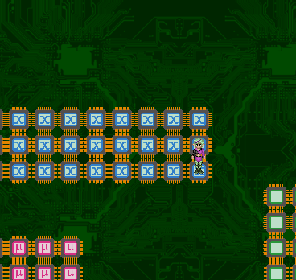
SCYNDI: Hook South
Head East around the corner North to get to the exit
004: SCYNDI: Hook East
SCYNDI: Hook South
SCYNDI: Hook West
SCYNDI: Hook North
SCYNDI: Hook East
Save the game if you desire and hit the exit
005: Head west and face the bosses

Boss Fight: The CGA Brothers
CXXXII | CXXVIII | CXII | CXX | CXXVI | CXXIII | LXXXVII | CXVI
There are two of them looking in the two most common palettes used in the time of the Color Graphics Adapter (CGA). Red-Yellow-Green (which I'll nickname RYG) and Magenta-Cyan-White (which I'll nickname MCW). RYG has the power of fire, earth and wind, and is therefore weak against frost attacks, and will absorb fire and earth and wind. MCW is well based in Darkness, water and frost magic and is therefore weak against fire.

Do NOT cancel their attacks as that will result only in Ultimate Soul Breaker.
Best way to go is to hit them in their weaknesses, and to make Rebecca use her most powerfull attacks.

d

EXCLUSIVE DUNGEONS
In the current version these dungeons are accessible through a portal with the Game Jolt logo near it (I can not rule out this may change in the future). These dungeons are by default blocked and will automatically open if you have a certain score based on the achievements you gathered in ANY game of mine. The current version shows a Game Jolt logo as that is where those achievements are currently stored on-line, but like I said, there's no telling about the future. This because I have no influence on how Game Jolt's future will be, I am looking for some self-reliant ways to get things done, however this is still in the brainstorming stage, and I didn't want to delay an as good as finished game for something that can take months at least to do well. Don't worry, I will make sure that if future versions no longer user Game Jolt for this, you will be able to synchronize the Game Jolt data... Well no full promises, but I will try what I can.

Each chapter has one dungeon added to the game, but please note, will the first one nearly always open up, the ones you can find later in the game can have some pretty high requirements, as then you really need to have played other games of mine as well (TIP! Cynthia Johnson in particular can score big)

The dungeons are: Botanica (chapter 1), Science Facility (chapter 2), Sugarland (chapter 3), Mörker Forest (chapter 4) and the Underworld (chapter 5).

Please note that these dungeons may all be significantly harder than the dungeons you normally find, so make sure you are well-prepared.

XCL1 – Botanica
XXV | XXV | LXXI | XXXI | XXVIII
The entrance of Botanica is located at floor 001 of Zoraman Prison, and the requirements to enter the place are so low that if you logged in at all the door will likely already open.
This is the only place where you can score the Aloe Vera, which is a pretty good healing item. If Dernor is in your group he can charm all three versions of the flowers that form your enemies here.

001: Look well, a bit hidden under the giant leaves is the traveler's emblem of this dungeon.
Exit South
002: Keep going South, the passage leads under the leaves.
IRRAVONIA: Fly over the gorge to the South
Exit South
003: Get into the passage under the leaves South
Get out under the leaves to the East
Pass under the leaves to the East
Exit East
004: If you need it, there's a save spot to the South
Pass under the leaves to the North-East
Exit North
005: Go North and face the boss

Boss Fight: Audrey
XVIII | XVII | LXXI | XL | XL
Well, if you've seen what the other plants can do, Audrey can do it all.
Cheesy method: Use a fire based spell → you win!
005: Exit West
002: SEELAH GANDRA/SCYNDI: Hook over the gorge to the west
Pass under the leaves to the North
Exit North
001: Exit this place through the portal to get back to Zoraman Prison.

XCL2 – Science Facility
XLVIII | XLVII | LXXI | XLVII | XLVIII
This dungeon is hidden in the Mad-House, which is a also a secret dungeon by itself.
The Mad House can be found by visiting the Crossroads and taking the east road and finding the secret passage there. If you enter the Mad House and exit the first room South (yes, the way you came) you'll find yourself in a new room and here you can find the portal.

Now the science facility is actually copied from Star Story, and serves as a cameo mission, just as how Star Story has some dungeons copied from the original Dyrt game as secret cameo.

Due to you now being in a high-tech world (which Phantasar normally isn't) this place gives you access to high-tech items that can really be helpful on your quest. There are multiple traveler's emblems in this place, and the aurinas enemies drop are worth a lot of money in shops. Please note, once you are in the only way out is through.... Be aware of this. This dungeon as multiple exits though.

Now about most floors I don't need to elaborate, as you just need to find the exit (recognizable by the automated sliding doors) to advance to the next floor, and that the entire dungeon long. I will therefore only mention those floors were some special situations apply.

005: Now it LOOKS easy.... Just clicking the “other door” and the hero will make his or her way all way to it, but here's the rub... I “hid” the first of traveler's emblems halfway the route and you'll miss it when you do this.... I know, I'm evil....
006: There's a savespot here, and the northern room does contain some treasure. The optional boss you could find in Star Story is NOT present here. It is NOT possible to leave the dungeon from this floor.
012: To the North is a secret passage that will open as soon as you come near it. Other than that this is just a normal floor like all others.
999: Don't be intimidated by the number, as this floor only connects floor 12 and 13, but as this was a hub room with vital importance to the scenario in Star Story, I placed it outside the normal numbering.
Defeat the Cyber-Astrilopup (it's NOT a boss fight... If you have frost attacks. Use them).
You can use the blue teleport path to go back to the Mad House (which you will have to complete (again) in order to get in the new game). You can also hit the next door to get further in the dungeon. If the door doesn't open it means you need to get a few more achievements in any of my games. What must be noted is that on floor 013 and above the variety of enemies will increase and some can cause you significantly more trouble if unprepared.
016: North of where Rebecca is positioned in the screenshot below is the exit to floor 017
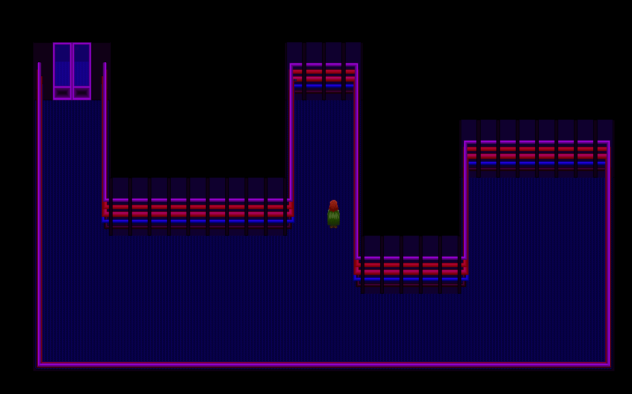
017: Only one door opens. Just like in Star Story that's the 3rd door from the left.

018: Save if you want and head North. Speak to the guy here to engage in a boss fight. (You must do his, as the door to the next section will otherwise NOT open).

Boss Fight: Experimental Human Replica Unit (ExHuRU)
LXX | LXX | LXXV | LXX | LXXIII
It will really depend on the moment you get here how much resistance you can expect from this guy. He's competely immune to status effects, and has a few powerful attacks. So keep an eye on your HP and cancel whenever you can.
018: If you desire to save, walk back and use the savespot there
Not the North you'll find another transporter pad, you can use it to return to the madhouse, however you can also continue North in order to finish the place.
024: This is the finish room. (No, those who played Star Story, you cannot enter the chambers of “the mole” in this game, it really ends here, ok?). You can claim another traveler's emblem (and if you get close to it also the achievement “I wish I could forget all about the facility”) and use the transporter to get to the madhouse.

XCL3 – Sugarland
XCVII | XCVI | LXXXVI | XCVII | CI | XCVIII | L
The entrance to Sugarland can be found in Gagolton after the city has been deserted. Enter the most North-Eastern house and go to its basement and you'll find the passage, it will of course only be open if you have enough achievement points.
There are certain items you can only find here, like Fudge, Chocolate bar and Chewing Gum.
001: Exit East
002: SEELAH GANDRA/SCYNDI: Hook South
Exit South
003: Take the most EASTERN way SOUTH
At the end Exit West
004: Make your way West
Exit West
005: Kill the Boss

Boss fight: Turbo Candy
XCIX | XCVII | LXXXVII | XCVIII | CIII | XCIX | LII
Turbo Candy is nothing more or less than a more powerful version of the Candy enemies you've been fighting so far. How many assistants she has depends on your chosen difficulty setting. Overall this is a pretty straight-forward fight.
005: Exit West
002: Getting here will get you the “Sweet Dreams are made of these” achievement for completing this dungeon. Take the traveler's emblem as your reward.
SEELAH GANDRA/SCYNDI: Hook west
Exit West
001: Step into the portal to get back to Gagolton
d

BACKGROUND
A few background things that are nice to know about the Phantasar Lore and which may help you to understand the story a bit better.

The World Called Phantasar, the history in short.
Phantasar is a magical world, and wasn't created by nature, but by god-like creatures called “The Spirata”. Yoyendo came to this world and here he created the Elves who would inhabit the continent which would eventually bear the name Delisto, but back then it didn't have a name. Yoyendo created 100 Elves in the Garden of Creation. 50 males and 50 females. Moriquo was the first life-form and the first Elf of the first generation. Yuleria was the 100th Elf of the first generation, therefore the youngest of these Elves. All of them were born in the form of a young adult, and for human standards looking like they were in their early twenties or max in their very early thirties, and never age. All these elves would eventually get children and these children did age and would eventually die but of course they also gave birth to the next generation and so the entire civilization of the Elves came to be what it was by the events in which the story begins.
Rosetta, a female Elf, you find originally in Gagolton, but who would after the attack on the city be found in Independence, is one of the Elves of the first generation. She has the unique ability to learn any language by merely hearing a correctly constructed sentence of at least 10 words in that new language. Dyrt doesn't elaborate at all about that ability, however some novels of mine in which she also appears do, and in Star Story in which Phantasar was included as a cameo world, Rosetta can help you understand the local language of Phantasar which Wendicka and friends do (naturally) not understand.

Now the Elves had a civilization that was not entirely free of crime and conflict had overall a pretty peaceful existence. However, when Yasathar came to Phantasar and created the Befindos a fatal mistake was made. The Befindos were immortal and although they did bear children, they never died, or almost never, as immortality only denotes you won't die of old age, it's not the same as invincibility (at least not in the definition going on most fantasy worlds including Phantasar. Some language purists are claim it immortality and invincibility are the same thing or that invincibility is just a trait of immortality). The Befindos initially had a peaceful existence, although they never could really see eye-to-eye with the Vulpi (a kind of anthropomorphic foxes) with whom they shared their kingdom. Murders were rare and sometimes a Befindo died in an accident, but that was it. You see the problem? Right, soon the kingdom of Aeria became too small as there was not enough food to feed all Befindos, nor enough space to house them all. This resulted into a big civil war.
This would eventually lead to the king of the Befindo's sending out his army led by Captain Quayaro to seek out new lands for the Befindos to live. However, the lands Quayaro would find were already inhabited by the Elves. Quayaro deemed them “monsters” and attempted to murder them all, and that was the start of what would be known as the Befindo War.
The Befindo god Yasathar who was good friends with the Elvish God Yoyendo was beyond furious and punished the Befindos. He removed their immortality, although those who stayed in Aeria did at least keep their wings. Those who went with Quayaro, including Quayaro himself lost their wings and became human. This was considered the biggest embarrassment in Befindo history as for a Befindo their majestic wings are their pride (insulting a Befindo's wings is signing your own death warrant). Quayaro however did, either unwittingly, but most likely forcefully (does the word “propaganda” ring a bell?) explain the punishment the wrong way and kept the war against the Elves going. And when “king” Quayaro (he proclaimed himself king of the new lands which he dubbed “Delisto” after his died son) eventually died (of old age, to make it worse) his successors did not do that much better. The war would last for almost ten thousand years, if not longer.

Eventually Weniaria would be born as the daughter of a human father and an Elfish mother, which is normally deemed impossible due to the many physical and genetic differences between the two races (Elves may look a lot like humans on the outside, but on the inside they do absolutely not), however many Elves of the First Generation believe that the two were taken to the Garden of Creation by Yoyendo, and it's deemed impossible to have sex there without creating offspring and that even the genetic differences between human and Elf would not hinder that at all. This because a child of both races who hate each other with passion could be the key to re-unite them. And Weniaria would eventually do that. She secretly visited the battlefield every time a big fight had taken place to see if near-death soldiers, either human or Elf, could still be saved. This led to something she never expected herself. Both humans and Elves came to exalt her as “The Mysterious Healer”, and both races came to realize the stupidity of the entire war, of which at the time of Weniaria nobody actually knew how it came to be in the first place. The humans who had two kingdoms now, feared Weniaria would bring the war to an end, and Weniaria was eventually murdered at their orders.
Weniaria however was revived by Yoyendo and she became the Goddess of Healing. Except for Yoyendo himself all Elvish Gods used to be mortal and were revived as Gods after their deaths as a mortal. Weniaria became more than just a goddess of healing, but she became also the symbol of peace being possible between humans and Elves, and they even decided to reset their counting of years on the year in which she was born, meaning that the year 1 on the Phantasarian calendar is the year in which Weniaria was born (as the Phantasarian calender does start on the year 1, just like the Gegorian calendar by the way. So before the year 1 A.D. came the year 1 B.C. The year 0 never existed. Same goes for the calendar on Phantasar).

The novel “Weniaria” tells you more about Wenaria's life. It's sequel novel “The madness called -love-” (in Dutch “De Waanzin die -liefde- heet”) tells you more about the period that came next, and this is also the period most vital to the story of the Dyrt, as this novel tells you how Lord Dzgjymza came to be and how and why he became so dangerous. It also tells you some more background about the Order of Onyx. The game doesn't go into the deep of that but the Order of Onyx had five members and not four. The fifth member was a Befindo Spy named Wandalina, nicknamed Wanda. Wanda was forced to drink a magic potion that made her completely obedient to every order she was given. Wanda got herself killed, and this caused Lord Dzgjymza to make the other members immortal and invincible. Since she died in the events that took place long before the events in the game, she is only briefly mentioned at a few times in the storyline.

After Lord Dzgjymza drove the Delisto and Kokonora to their ruin and Dyrt sunk to the bottom of the ocean, the realms of men became chaotic. In Kokonora in particular the law of the jungle came to apply. This period would last another ten thousand years and then Nostramantu would come. He would rebel against the people in charge of the chaos. In this process he would under the influence of the Mana Cave, which held the power of Lord Dzgjymza and was a scar of his madness, Nostramantu and his followers would become Fairies and defeat the mad humans. As Nostramantu also involved the Elves and the Dwarves (who had also come to be by now) into this fight this led to another war which would last for ten thousand years, and this is known as the giant “Racial War”. The game “The Fairy Tale REVAMPED” tells the story of Jake and Marrilona who would eventually have to face Nostramantu.

The game of Dyrt.NET takes place 200 years after the defeat of Nostramantu. Marrilona who is a playable character in The Fairy Tale is the aunt (Fairies live longer than humans do) of Irravonia. Seelah Gandra aka Scyndi Scorpio is the great-great-granddaughter of Hando Stillor, who also happens to be a playable character in TFTREVAMPED.

I can also reveal to you that the king of the Befindos, whom you meet in the game, never got children, and eventually adopted Aziëlla as his daughter, so she would become princess in the process and gain the right to take over the throne. Some novels of mine that take place in later time period depict her as queen. And like Merya said “that girl is full of surprises”, and that denoted also who her reign would be. As a queen, Aziëlla has been both praised and criticized like no monarch before her. Aziëlla would also be the last monarch the Befindos ever had, as in order to prevent a coup she “dethroned” herself by calling out a republic herself and candidate herself for presidency and she challenged all political parties to present a candidate too, and they all took the “bait”. Aziëlla turned out to be extremely popular under the people as she won the first presidential elections without much effort, and fearing the people would cause an uproar, they did accept her victory (with great reluctance) and as such Aziëlla would be the first president of Aeria. Like Merya said “that girl is full of surprises”.

Why is Merya constantly cracking jokes clearly related to sex?
THAT is a rather tragic story and not as much as a laughable matter as you may initially think it is. The game doesn't elaborate on it, however in the novels this is more clearly explained.

Although the sexual senses of Elves are mostly better developed than that of humans, it can happen that Elves in their puberty still engage into this adventure at a too young age not quite being ready for that. Merya and her back-then boy-friend made this mistake. And you can guess it, what was supposed to be a wonderful experience turned out to be a kind of a disappointment. Merya's boy-friend could not take it and scolded Merya like hell, although of course, the blame belonged to both. Everybody who knew that boy knew he would in a very short time come to his senses and apologize to her. However that moment could never come as before he could even put his clothes back on he was in the mouth of a monster ending his life as the monster's meal. Merya saw this happening right before her eyes. She couldn't take it, and she tried to force the monster to eat her as well, however as the monster had one good meal already, and was no longer hungry he only deemed Merya as an annoyance and knocked her out. She was found by Dernor later who nursed her.
Merya's experience turned into a trauma. She got pretty much neurotic in her desire to prove she's a true hot chick who knows how to satisfy men. Driving men to their orgasms became a kind of an obsession for her... call it an addiction if you want to. She always tries to seek out men in order to have sex with them, ignoring her own feelings only caring about theirs, all due to that experience. Now during the events of Dyrt, she still has a bit of control over this, but in events after this story this would take more drastic manners even coming to the point she would eventually be locked up in the temple of Amora, the Goddess of Love and Lust, so the priests there could take her into rehabilitation. It's there she meets a human male who turns out to be gay, but despite that he loves her, but not as a woman, but as a person, so in a non-romantic and also non-sexual way. This experience would be a turning point for Merya in how to deal with the past.
It is, by the way, also this trauma that made Merya join the Drop-Out clan.

Why does Seelah Gandra hate her father?
Put short, because he mentally abused her.
Seelah Gandra is the oldest of two daughters, her full name is Seelah Gandra I, where her younger sister is Seelah Gandra II. Seelah Gandra did at a very young age to openly reject the life philosophy the Elves live by: “The Harmony”. This is NOT a religion, it's only a way of life, but rejecting it, can lead to terrible consequences as the Elvish society did give it a kind of “holy” status. As a result Seelah Gandra was constantly in a fight with her old man who is a firm believer of the teachings of The Harmony. Now for Seelah Gandra things got worse as her mother died when she was only 60 years old (which is approx 6 or 7 recalculated to human age), leaving her father as her only parent. Seelah Gandra now also became to hate The Harmony because of disagreement with the teachings itself, but also as her old man rather motivated her to reject the teachings than that he could get that out of her head. Things pretty much escalated.
She was forced to the training to be a priestess of Weniaria, and although Seelah Gandra has always been devoted to the Goddess, she was not really cut out for priesthood, so the training was a nightmare to her, leading to more frustration between her and her old man, and in the end even to her ditching class, and less and less coming home.
She was actually already considering to pack her bags and to live among the humans. Not the best place for an Elf to live (as the humans are overall pretty prejudiced against Elves, and she already knew that this step could also lead to a lot of sexual harassment, but everything was better than staying home). It never got that far, as she was still only planning this the day she ran in Brendor when trying to save the temple of Weniaria and starting the adventure that would eventually driver into Dernor's arms falling in love with him and becoming a Drop-Out, which would turn out to be the best thing she's ever done, assuming the new identity of Scyndi Scorpio.
Now Seelah Gandra has most hatred against her father, however she actually hates the entire Elvish community, as nobody was really understanding on the way she was and seeing her for what she is, also ignoring her qualities, as it will turn out (and some novels she plays an important role it show this even more) Seelah Gandra is actually a hard worker and pretty selfless by nature, always willing the help if she can, especially to those she regards as “friends”, even endangering her own life if that is what it takes.
By the way Seelah Gandra's younger sister is not mentioned in the game, but will eventually also take join the Drop-Outs and assume the name of Alice Elumi.

Now like Irravonia (and Dernor too) correctly deduced, Seelah Gandra's aggressive, or even downright threatening behavior at the start of the game is not the way she truly is, but rather a kind of “shield” as her horrible experiences made her initially unable to trust anybody but herself. Brendor and Dernor may well be the first who managed to do this. Dernor of course because she fell in love with him, but also due to his calm nature in general, and Brendor has the natural kind of “perfect feeling” in how to approach people in general, and he especially manages well in his approach to young women without them falling in love with him or anything. It's an ability he is well aware of, but cannot really explain himself.

What exactly is this “Harmony” the Elves believe in?
Well, I said it before, it is NOT a religion, although its status is almost as such. The Harmony does however co-exist next to the Elvish religion. The Harmony is believed to be invented by Weniaria, which I can already say that this is not true, as Weniaria never invented anything of the sort. Those who read the novel “Weniaria” should also have seen that Weniaria never did such a thing. At the end of the novel “The Madness called -love-” I hinted towards the inventors of the Harmony. However according the first leader of the Drop-Out Tribe Laurinn Shadowgirl, the inventors of the Harmony were also the first Drop-Outs (the Drop-Outs have existed almost as long as the Harmony does, however there have never been a tribe until Hando Stillor and Laurinn Shadorgirl brought them together).
The Harmony is a well-intended guideline to live a good life and nothing more than that. But they say the road to Hell is paved with good intentions. The Harmony was soon after its inception taken out of its context and became a very strict set of rules that really brought the Elves in a very strict disciplined life.
A few rules of the Harmony:
- No lying. This actually includes telling fictional stories, even if you make it clear the story is entirely fictional.
- Work hard
- Don't eat meat as hunting disturbs the peace of nature.
- Elves do not fall in love nor do they have sexual desires. They simply “mate” because it's the holy duty in the Harmony to make sure you reproduce yourself, and nothing more than that. (This rule is one most ridiculed by those who defy the Harmony).
- Entertainment is a waste of time in which you could have served the harmony.
- Gossip is shameful, don't do it. (Although rule in which the non-believers deem the Harmony pretty hypocrite, given how the followers of the Harmony treat the Drop-Outs. And also shown by who Seelah Gandra's old man treats his own daughter).
- Pregnant women are the carriers of life. Protect them at all costs.
- Only sleep as long as is required to get enough rest and no more.
Now much of these rules appear pretty trivial, but are actually enforced in a way that is downright inhumane. Those who defied the Harmony were quite often outcasts, hence the name Drop-Outs which was given to them out of disgust, but which the Drop-Outs themselves soon adopted as an honorable title. The Drop-Outs themselves dubbed the followers of the Harmony “The Stiffs” as a reference how they are “as stiff as the dead”, and how they lack “life”.

The naming system the “Stiffs” have is also described in the Harmony as “You shall carry on the legacy of your parents”, however this has lead to many kind of sub-rules and eventually resulted into a naming system of which the Drop-Outs say that the Stiffs even lost their identity. Seelah Gandra as a female Elf, got in accordance to the rules of the Harmony the first name of her mother and her father, in that order. The order is defined by her gender. The name of the parent with the same gender comes first, meaning that if she was a boy she would have been named Gandra Seelah in stead. And when siblings of the same gender are born out of the same parents they simply get I and II and III etc suffixed to their names. The Drop-Outs swore to never copy their own names into the names of their children and for their surnames they chose that you have to earn it. For example a Drop-Out girl who does not make an appearance in the game, but she does in the novels is called “Cida Applepie” (In the Dutch novels that's “Cida Appeltaart”). She got her surname because her apple pie is famous and it's said to be that delicious that even people who hate apple pie with passion would love to eat hers. Dernor Woodlock earned his surname due to his affiliation with nature, and Merya the Magpie due to her skills as a rogue and thief (even though the Drop-Outs know why that real magpies do not do such things). Scyndi Scorpio, the name Seelah Gandra takes on, chose the name “Scorpio” herself due to Irravonia naming her “Little Scorpion”... You can still say she earned her surname since Irravonia gave it to her, and it's not stated those who give you the name must be an Elf (since Irravonia is a Fairy, after all).

The language of Phantasar
It is implied the characters on Phantasar spoke English, but that is of course not true. In Star Story you'll find this out the hard way when you unlock the Phantasar side-quests, as Wendicka and friends will initially be unable to understand anybody at all well until they are enchanted by Rosetta enabling them to converse in this language.

The language of Phantasar is a language that is spoken by the majority of the Phantasarian population. It does has its own script, and if you've seen the strange marks in the Phantasar missions I guess it's clear they have their own script. The script can even be seen in game, at the end of the Mysterious Crypt. The message on the floor says “Teros dâr Dyrt, pozor!” Which almost literally translates to “Enemies of Dyrt, beware”.
Another nice one and easy to understand is what Irravonia says when you speak to her in Star Story prior to learning the language: “Yo! Ty bâ dâ Îrâvônyâ. Wîk bâ tü?”. I don't think “Yo” needs any translation. “Ty” means “I” or “me”. “bâ” is the verb “to be” and it won't change in the present tense. “dâ” is “the” and “Îrâvônyâ” is, of course, how you spell Irravonia's name in the spelling rules of Phantasar. Pronounced as “Ir – rah – von – ya”. “Wîk” means “Who” and “tü” means “you”. So literally translated it means “Yo! I am the Irravonia. Who are you?” Now in English using “the” before a person's name is not very common, but in the language of Phantasar it is the way of speaking. Well exception would be “Tîm nym bâ Îrâvônyâ” which literally means “My name is Irravonia”.

The language comes with its own spelling rules and even its own grammar rules. It would therefore be a mistake to think by these simple sentences that it's just English with words replaced as that is definitely NOT the case. The present continuous is absolutely NOT common in the language of Phantasar and the perfect tense is actually non-existent, and in stead you just you the past tense. The verbs “shall” and “will” are also non-existent in the language of Phantasar, in stead they have a specific form to replace these verbs.
“Ty gâgâ vyr tîmêto Hys” → “I am going home”
“Ty gâgâa vyr tîmêto Hys” → “I will go home” / “I shall go home”.
More literally it's “I go to my house” and “I will go to my house”. Please note that “Hys” is written with a capital letter. All nouns start in this language with a capital letter, pretty similar as in the German language.

The language also features 6 cases, in which the first case is used when none of the others apply, 2nd case is used when speaking of possessions. 3rd case is used for a direct object. The 4th case is used for the indirect object (please note that in German it's the other way around when it comes to case 3 and 4). the 5th and 6th case are used with prepositions (unless that leads to an indirect object as then the 4th case applies), in which 5th case is used when there is no movement and the 6th when there is movement. Comparable with how “in” and “into” are used in the English language.
Dâ Fêm → The woman (1st case)
Dâr Mîn → The man (2nd case)
Dâl Bo → The boy (3rd case)
Dâk Mîssy → The girl (4th case)
Dât Hüm → The human (5th case)
Dâto Êlf → The Elf (6th case)

A few other nice words:
Ty → I
Tü → you (single/informal)
U → you (formal)
Ho → He
Shy → She
Hît → It
Sho → He/She (deemed unofficial but is tolerated when you speak of somebody whose gender is unknown. Officially you'd be using “hît” then, but most people of Phantasar deem that unrespectful as it sounds like you are talking about an object).
Wu → We
Ju → you (plural/informal)
Zu → They
Now to turn these into their possessive forms just suffix them with an 'm' and put a ^ on the last vowel. Exception might be “hît” though. “Tîm Hys” → my house. “Hôm Hys” → his house. “Shîm Hys” → Her house. Etc. Please note that cases DO apply here, and when not in the 1st case, you add the “ê” plus the suffixes you saw above with “dâ”.

Now another nice note is that adjectives are always placed BEHIND the noun....
“Dâ Mîssy bôle” → “The beautiful girl”

There is a lot more to tell about this language, and I really need to work out a good lesson package, but it's hard to find out where to begin. The language is not as hard as it looks.

Hâp wêl, fy tü wêns tê lârnâ dâl Tôlky dâr Fântâsâr. Hît nât bâ dîffy. Hît bâa frosakâ fy âls dâr Mîn kân sprâk dyol Tôlky.

A few astronomy facts about Phantasar
- Phantasar is part of the solar system called “Quandanora”
- Phantasar spins the the opposite direction when compared to Earth. As a result the sun rises in the West and sets in the East on Phantasar (like Merya mentions), contrary to where the sun rises and sets on Earth.
- Phantasar has three moons. Lunar, Lundi and Mono.
- The Befindo's named the biggest planet of Quandanora after their supreme god Yasathar. The planet Yasathar is a gas giant with characteristics that are very similar to Jupiter, and the Befindo's are pretty sure that the planet protects them from stuff floating into space which could threaten Phantasar.
- Phantasar's size and speed is not exactly the same as on Earth. As a result the Phantasarian calendar has a leap year every five years in stead of four.
- On Phantasar there are also people who believe in astrology much to the chagrin of astronomers who deem it bullshit.
- Phantasar is not exactly a natural planet, and due to that some things on Phantasar are sometimes happening differently what should actually be happening of a planet of that kind under the circumstances. This has to do with the magic on this planet, and most astronomers are pretty well aware of that. This did lead them to the false believe that magic energy is required to make life on a planet possible.
d

