# Part 2, Integration

## a: Arrival time:

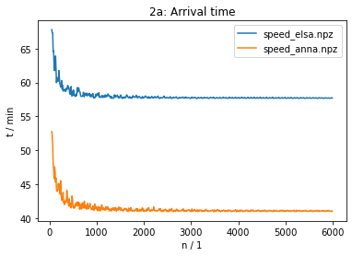

As you can see in the plot the time doesn’t really change 2000 subintervals. The times are:

* Anna: 41 min
* Elsa: 58 min

## c: total electricity consumption:

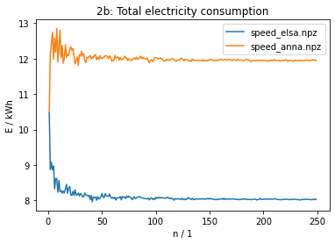

The plot shows that after n = 200 the total Energy Consumption doesn’t really change. The Energy consumption is:

* Elsa: 8.0 kWh
* Anna: 11.9 kWh

## c: Convergence study

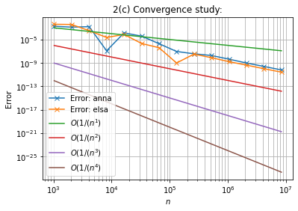

For n >= 10^6 the Errors are parallel to the line 1/n². That means for a big enough n the Error get smaller by n² what matches with the theory.