In [5]:
import pandas as pd import numpy as np
import matplotlib.pyplot as plt import seaborn as sns
from sklearn.metrics import accuracy_score from sklearn.datasets import load_iris
from sklearn.model_selection import train_test_split from sklearn.naive_bayes import GaussianNB

In [7]:
iris = load_iris()

In [11]:
data = pd.DataFrame(iris.data)

In [17]: | data
Out[17]: |  | sepal length | sepal width | petal length | petal width | class
 | 0 | 5.1 | 3.5 | 1.4 | 0.2 | Iris-setosa
 | 1 | 4.9 | 3.0 | 1.4 | 0.2 | Iris-setosa
 | 2 | 4.7 | 3.2 | 1.3 | 0.2 | Iris-setosa
 | 3 | 4.6 | 3.1 | 1.5 | 0.2 | Iris-setosa
 | 4 | 5.0 | 3.6 | 1.4 | 0.2 | Iris-setosa
 | ... | ... | ... | ... | ... | ...
 | 145 | 6.7 | 3.0 | 5.2 | 2.3 | Iris-virginica
 | 146 | 6.3 | 2.5 | 5.0 | 1.9 | Iris-virginica
 | 147 | 6.5 | 3.0 | 5.2 | 2.0 | Iris-virginica
 | 148 | 6.2 | 3.4 | 5.4 | 2.3 | Iris-virginica
 | 149 | 5.9 | 3.0 | 5.1 | 1.8 | Iris-virginica

150 rows × 5 columns

In [19]:
data.isnull().sum()
Out[19]: sepal length 0
sepal width 0
petal length 0
petal width 0
class 0
dtype: int64

In [21]:
X = iris.data
y = iris.target

In [25]:
X = data.drop(['class'], axis=1)
y = data.drop(['sepal length', 'sepal width', 'petal length', 'petal wid print(X)
print(y)
print(X.shape) print(y.shape)

 | sepal | length | sepal | width | petal | length | petal | width
0 |  | 5.1 |  | 3.5 |  | 1.4 |  | 0.2
1 |  | 4.9 |  | 3.0 |  | 1.4 |  | 0.2
2 |  | 4.7 |  | 3.2 |  | 1.3 |  | 0.2
3 |  | 4.6 |  | 3.1 |  | 1.5 |  | 0.2
4 |  | 5.0 |  | 3.6 |  | 1.4 |  | 0.2
.. |  | ... |  | ... |  | ... |  | ...
145 |  | 6.7 |  | 3.0 |  | 5.2 |  | 2.3
146 |  | 6.3 |  | 2.5 |  | 5.0 |  | 1.9
147 |  | 6.5 |  | 3.0 |  | 5.2 |  | 2.0
148 |  | 6.2 |  | 3.4 |  | 5.4 |  | 2.3
149 |  | 5.9 |  | 3.0 |  | 5.1 |  | 1.8

[150 rows x 4 columns]
class
- Iris-setosa
- Iris-setosa
- Iris-setosa
- Iris-setosa
- Iris-setosa
.. ...
- Iris-virginica
- Iris-virginica
- Iris-virginica
- Iris-virginica
- Iris-virginica

[150 rows x 1 columns]
(150, 4)
(150, 1)

In [27]:
from sklearn.model_selection import train_test_split
X_train, X_test, y_train, y_test = train_test_split(X, y, test_size=0.2, sh print(X_train.shape)
print(X_test.shape) print(y_train.shape) print(y_test.shape)

(120, 4)
(30, 4)
(120, 1)
(30, 1)

In [29]:
from sklearn.naive_bayes import GaussianNB model = GaussianNB()
model.fit(X_train, y_train)

Out[29]:
C:\Users\System21\anaconda3\Lib\site-packages\sklearn\utils\validation.py: 1184: DataConversionWarning: A column-vector y was passed when a 1d array was expected. Please change the shape of y to (n_samples, ), for example u sing ravel().

y = column_or_1d(y, warn=True)
▾ GaussianNB
GaussianNB()

In [31]:
y_pred = model.predict(X_test) model.score(X_test,y_test)

Out[31]: 1.0

In [34]:
from sklearn.metrics import accuracy_score, confusion_matrix, ConfusionMatr print(accuracy_score(y_test, y_pred))

1.0

In [36]:
cm = confusion_matrix(y_test, y_pred)
disp = ConfusionMatrixDisplay(confusion_matrix = cm) print("Confusion matrix:")
print(cm)

Confusion matrix:
[[12 | 0 | 0]
[ 0 | 10 | 0]
[ 0 | 0 | 8]]

In [38]:
disp.plot() plt.show()

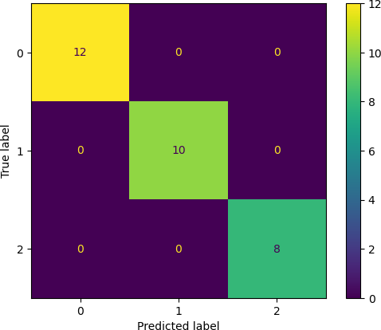

In [40]:
def get_confusion_matrix_values(y_true, y_pred): cm = confusion_matrix(y_true, y_pred)
return(cm[0][0], cm[0][1], cm[1][0], cm[1][1])

TP, FP, FN, TN = get_confusion_matrix_values(y_test, y_pred) print("TP: ", TP)
print("FP: ", FP)
print("FN: ", FN)
print("TN: ", TN)

TP: | 12
FP: | 0
FN: | 0
TN: | 10

In [42]:
print("The Accuracy is ", (TP+TN)/(TP+TN+FP+FN)) print("The precision is ", TP/(TP+FP))
print("Error Rate:",1-(TP+TN)/(TP+TN+FP+FN)) print("The recall is ", TP/(TP+FN))

The Accuracy is 1.0 The precision is 1.0 error rate: 0.0
The recall is 1.0

