import pandas as pd
import seaborn as sns
import matplotlib.pyplot as plt
titanic = sns.load_dataset('titanic')
titanic.head()
survived pclass sex age sibsp parch fare embarked class \
0 0 3 male 22.0 1 0 7.2500 S Third
1 1 1 female 38.0 1 0 71.2833 C First
2 1 3 female 26.0 0 0 7.9250 S Third
3 1 1 female 35.0 1 0 53.1000 S First
4 0 3 male 35.0 0 0 8.0500 S Third
who adult_male deck embark_town alive alone
0 man True NaN Southampton no False
1 woman False C Cherbourg yes False
2 woman False NaN Southampton yes True
3 woman False C Southampton yes False
4 man True NaN Southampton no True
titanic.info()
<class 'pandas.core.frame.DataFrame'>
RangeIndex: 891 entries, 0 to 890
Data columns (total 15 columns):
# Column Non-Null Count Dtype
--- ------ -------------- -----
0 survived 891 non-null int64
1 pclass 891 non-null int64
2 sex 891 non-null object
3 age 714 non-null float64
4 sibsp 891 non-null int64
5 parch 891 non-null int64
6 fare 891 non-null float64
7 embarked 889 non-null object
8 class 891 non-null category
9 who 891 non-null object
10 adult_male 891 non-null bool
11 deck 203 non-null category
12 embark_town 889 non-null object
13 alive 891 non-null object
14 alone 891 non-null bool
dtypes: bool(2), category(2), float64(2), int64(4), object(5)
memory usage: 80.7+ KB
sns.countplot(x='survived',data=titanic)
plt.title("Survival Count")
plt.show()
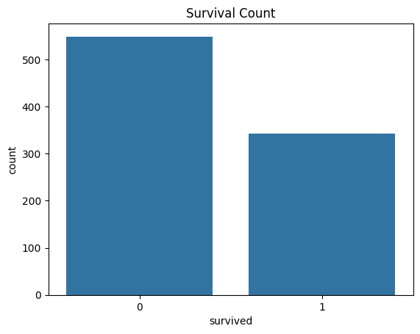
sns.countplot(x='sex',hue='survived',data=titanic)
plt.title('Survival by Gender')
plt.show()
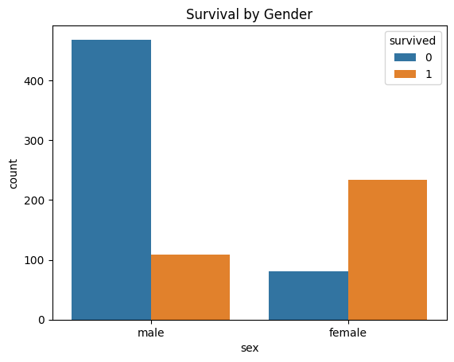
sns.countplot(x='pclass',hue='survived',data=titanic)
plt.title('Survival by Passenger')
plt.show()
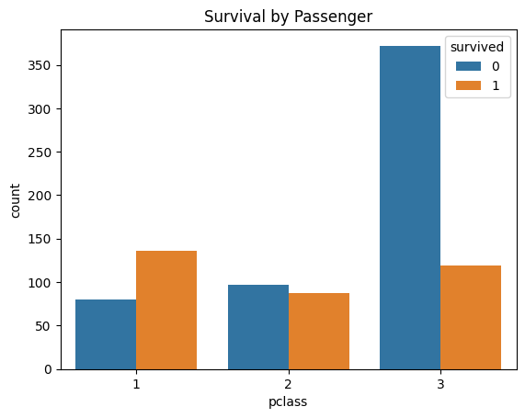
sns.histplot(titanic['age'].dropna(),bins=30,kde=True)
plt.title()
sns.histplot(titanic['fare'],bins=30,kde=True)
plt.title('Fare Distribution')
plt.xlabel("Fare")
plt.ylabel("Count")
plt.show()
