import pandas as pd
import matplotlib.pyplot as plt
df = pd.read_csv(r"C:\Users\ASUS\Downloads\student_info.csv")
#enter your dataset path
df
student_id name gender age grade_level math_score \
0 S1 Student_1 Other 17 10.0 NaN
1 S2 Student_2 Male 17 12.0 99.0
2 S3 Student_3 Other 17 NaN 59.0
3 S4 Student_4 Other 17 12.0 70.0
4 S5 Student_5 Male 15 9.0 NaN
.. ... ... ... ... ... ...
995 S996 Student_996 Female 15 10.0 76.0
996 S997 Student_997 Female 17 12.0 83.0
997 S998 Student_998 Other 16 10.0 60.0
998 S999 Student_999 Other 17 9.0 94.0
999 S1000 Student_1000 Male 17 9.0 96.0
reading_score writing_score attendance_rate parent_education \
0 61.0 90 94.660002 Master's
1 70.0 91 93.173227 Bachelor's
2 60.0 99 NaN PhD
3 NaN 69 96.419620 PhD
4 77.0 94 91.332105 PhD
.. ... ... ... ...
995 75.0 55 94.127440 Bachelor's
996 68.0 98 86.911592 Bachelor's
997 77.0 92 80.139645 PhD
998 66.0 97 88.069619 PhD
999 92.0 93 84.695088 PhD
study_hours internet_access lunch_type extra_activities \
0 4.120192 Yes Free or reduced NaN
1 2.886505 No Free or reduced No
2 1.909926 No Free or reduced No
3 1.664740 No Standard No
4 2.330918 Yes Free or reduced No
.. ... ... ... ...
995 2.212263 Yes Free or reduced No
996 3.552898 No Free or reduced Yes
997 2.400027 No Free or reduced No
998 4.713490 No Free or reduced Yes
999 1.262504 No Free or reduced Yes
final_result
0 Fail
1 Pass
2 Fail
3 Pass
4 Pass
.. ...
995 Fail
996 Fail
997 Pass
998 Pass
999 Pass
[1000 rows x 15 columns]
df.isnull().sum()
student_id 0
name 0
gender 0
age 0
grade_level 10
math_score 9
reading_score 10
writing_score 0
attendance_rate 18
parent_education 14
study_hours 15
internet_access 13
lunch_type 0
extra_activities 11
final_result 0
dtype: int64
df.dropna()
student_id name gender age grade_level math_score \
1 S2 Student_2 Male 17 12.0 99.0
6 S7 Student_7 Other 16 9.0 76.0
7 S8 Student_8 Female 16 11.0 89.0
8 S9 Student_9 Other 17 12.0 51.0
11 S12 Student_12 Other 16 10.0 80.0
.. ... ... ... ... ... ...
995 S996 Student_996 Female 15 10.0 76.0
996 S997 Student_997 Female 17 12.0 83.0
997 S998 Student_998 Other 16 10.0 60.0
998 S999 Student_999 Other 17 9.0 94.0
999 S1000 Student_1000 Male 17 9.0 96.0
reading_score writing_score attendance_rate parent_education \
1 70.0 91 93.173227 Bachelor's
6 66.0 88 97.967729 Bachelor's
7 69.0 98 87.990376 PhD
8 90.0 72 86.535894 High School
11 55.0 96 96.019614 High School
.. ... ... ... ...
995 75.0 55 94.127440 Bachelor's
996 68.0 98 86.911592 Bachelor's
997 77.0 92 80.139645 PhD
998 66.0 97 88.069619 PhD
999 92.0 93 84.695088 PhD
study_hours internet_access lunch_type extra_activities \
1 2.886505 No Free or reduced No
6 2.372107 Yes Free or reduced No
7 4.952496 No Standard Yes
8 2.940922 No Standard No
11 2.841421 No Free or reduced Yes
.. ... ... ... ...
995 2.212263 Yes Free or reduced No
996 3.552898 No Free or reduced Yes
997 2.400027 No Free or reduced No
998 4.713490 No Free or reduced Yes
999 1.262504 No Free or reduced Yes
final_result
1 Pass
6 Pass
7 Pass
8 Pass
11 Pass
.. ...
995 Fail
996 Fail
997 Pass
998 Pass
999 Pass
[916 rows x 15 columns]
math_score_mean = df["math_score"].mean()
#Storinng mean into new variable
math_score_mean
np.float64(75.14228052472251)
df["math_score"] = df["math_score"].fillna(math_score_mean)
#replacing the null values in column with mean of that column
df
student_id name gender age grade_level math_score \
0 S1 Student_1 Other 17 10.0 75.142281
1 S2 Student_2 Male 17 12.0 99.000000
2 S3 Student_3 Other 17 NaN 59.000000
3 S4 Student_4 Other 17 12.0 70.000000
4 S5 Student_5 Male 15 9.0 75.142281
.. ... ... ... ... ... ...
995 S996 Student_996 Female 15 10.0 76.000000
996 S997 Student_997 Female 17 12.0 83.000000
997 S998 Student_998 Other 16 10.0 60.000000
998 S999 Student_999 Other 17 9.0 94.000000
999 S1000 Student_1000 Male 17 9.0 96.000000
reading_score writing_score attendance_rate parent_education \
0 61.0 90 94.660002 Master's
1 70.0 91 93.173227 Bachelor's
2 60.0 99 NaN PhD
3 NaN 69 96.419620 PhD
4 77.0 94 91.332105 PhD
.. ... ... ... ...
995 75.0 55 94.127440 Bachelor's
996 68.0 98 86.911592 Bachelor's
997 77.0 92 80.139645 PhD
998 66.0 97 88.069619 PhD
999 92.0 93 84.695088 PhD
study_hours internet_access lunch_type extra_activities \
0 4.120192 Yes Free or reduced NaN
1 2.886505 No Free or reduced No
2 1.909926 No Free or reduced No
3 1.664740 No Standard No
4 2.330918 Yes Free or reduced No
.. ... ... ... ...
995 2.212263 Yes Free or reduced No
996 3.552898 No Free or reduced Yes
997 2.400027 No Free or reduced No
998 4.713490 No Free or reduced Yes
999 1.262504 No Free or reduced Yes
final_result
0 Fail
1 Pass
2 Fail
3 Pass
4 Pass
.. ...
995 Fail
996 Fail
997 Pass
998 Pass
999 Pass
[1000 rows x 15 columns]
df.boxplot()
plt.show()
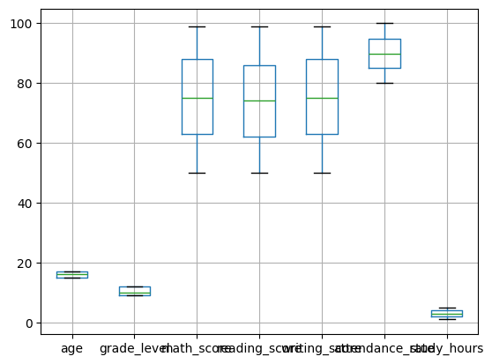
newdf = df[df['math_score'] > 70]
#for removing outliers / plotting above or below specific value
newdf
student_id name gender age grade_level math_score \
0 S1 Student_1 Other 17 10.0 75.142281
1 S2 Student_2 Male 17 12.0 99.000000
4 S5 Student_5 Male 15 9.0 75.142281
6 S7 Student_7 Other 16 9.0 76.000000
7 S8 Student_8 Female 16 11.0 89.000000
.. ... ... ... ... ... ...
993 S994 Student_994 Other 15 9.0 85.000000
995 S996 Student_996 Female 15 10.0 76.000000
996 S997 Student_997 Female 17 12.0 83.000000
998 S999 Student_999 Other 17 9.0 94.000000
999 S1000 Student_1000 Male 17 9.0 96.000000
reading_score writing_score attendance_rate parent_education \
0 61.0 90 94.660002 Master's
1 70.0 91 93.173227 Bachelor's
4 77.0 94 91.332105 PhD
6 66.0 88 97.967729 Bachelor's
7 69.0 98 87.990376 PhD
.. ... ... ... ...
993 58.0 73 97.150612 High School
995 75.0 55 94.127440 Bachelor's
996 68.0 98 86.911592 Bachelor's
998 66.0 97 88.069619 PhD
999 92.0 93 84.695088 PhD
study_hours internet_access lunch_type extra_activities \
0 4.120192 Yes Free or reduced NaN
1 2.886505 No Free or reduced No
4 2.330918 Yes Free or reduced No
6 2.372107 Yes Free or reduced No
7 4.952496 No Standard Yes
.. ... ... ... ...
993 4.925686 No Free or reduced Yes
995 2.212263 Yes Free or reduced No
996 3.552898 No Free or reduced Yes
998 4.713490 No Free or reduced Yes
999 1.262504 No Free or reduced Yes
final_result
0 Fail
1 Pass
4 Pass
6 Pass
7 Pass
.. ...
993 Fail
995 Fail
996 Fail
998 Pass
999 Pass
[598 rows x 15 columns]
newdf.boxplot()
plt.show()
#display plot after specifying range
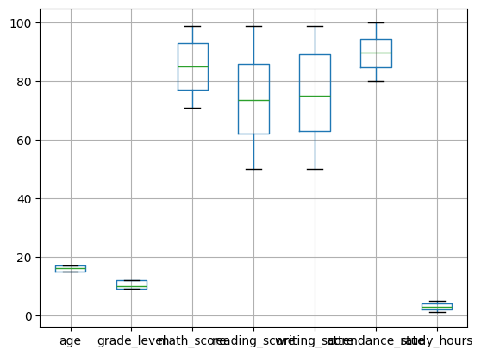
df.info()
<class 'pandas.core.frame.DataFrame'>
RangeIndex: 1000 entries, 0 to 999
Data columns (total 15 columns):
# Column Non-Null Count Dtype
--- ------ -------------- -----
0 student_id 1000 non-null object
1 name 1000 non-null object
2 gender 1000 non-null object
3 age 1000 non-null int64
4 grade_level 990 non-null float64
5 math_score 1000 non-null float64
6 reading_score 990 non-null float64
7 writing_score 1000 non-null int64
8 attendance_rate 982 non-null float64
9 parent_education 986 non-null object
10 study_hours 985 non-null float64
11 internet_access 987 non-null object
12 lunch_type 1000 non-null object
13 extra_activities 989 non-null object
14 final_result 1000 non-null object
dtypes: float64(5), int64(2), object(8)
memory usage: 117.3+ KB
df['study_hours'].dropna()
#dropping null values
0 4.120192
1 2.886505
2 1.909926
3 1.664740
4 2.330918
...
995 2.212263
996 3.552898
997 2.400027
998 4.713490
999 1.262504
Name: study_hours, Length: 985, dtype: float64
study_mean = df['study_hours'].mean()
df['study_hours'] = df["study_hours"].fillna(study_mean)
#replacing null values with mean
df
student_id name gender age grade_level math_score \
0 S1 Student_1 Other 17 10.0 75.142281
1 S2 Student_2 Male 17 12.0 99.000000
2 S3 Student_3 Other 17 NaN 59.000000
3 S4 Student_4 Other 17 12.0 70.000000
4 S5 Student_5 Male 15 9.0 75.142281
.. ... ... ... ... ... ...
995 S996 Student_996 Female 15 10.0 76.000000
996 S997 Student_997 Female 17 12.0 83.000000
997 S998 Student_998 Other 16 10.0 60.000000
998 S999 Student_999 Other 17 9.0 94.000000
999 S1000 Student_1000 Male 17 9.0 96.000000
reading_score writing_score attendance_rate parent_education \
0 61.0 90 94.660002 Master's
1 70.0 91 93.173227 Bachelor's
2 60.0 99 NaN PhD
3 NaN 69 96.419620 PhD
4 77.0 94 91.332105 PhD
.. ... ... ... ...
995 75.0 55 94.127440 Bachelor's
996 68.0 98 86.911592 Bachelor's
997 77.0 92 80.139645 PhD
998 66.0 97 88.069619 PhD
999 92.0 93 84.695088 PhD
study_hours internet_access lunch_type extra_activities \
0 4.120192 Yes Free or reduced NaN
1 2.886505 No Free or reduced No
2 1.909926 No Free or reduced No
3 1.664740 No Standard No
4 2.330918 Yes Free or reduced No
.. ... ... ... ...
995 2.212263 Yes Free or reduced No
996 3.552898 No Free or reduced Yes
997 2.400027 No Free or reduced No
998 4.713490 No Free or reduced Yes
999 1.262504 No Free or reduced Yes
final_result
0 Fail
1 Pass
2 Fail
3 Pass
4 Pass
.. ...
995 Fail
996 Fail
997 Pass
998 Pass
999 Pass
[1000 rows x 15 columns]
df['study_hours'].astype(int)
#converting the data type
0 4
1 2
2 1
3 1
4 2
..
995 2
996 3
997 2
998 4
999 1
Name: study_hours, Length: 1000, dtype: int64

