In [1]:
import pandas as pd import numpy as np import seaborn as sns
import matplotlib.pyplot as plt

In [2]:
sns.set(style="whitegrid")
www.princexml.com
--------------------------------------------
This document was created with Prince, a great way of getting web content onto paper.

In [3]:
iris = sns.load_dataset('iris')

In [4]:
print("First 5 Rows of Dataset:")
First 5 Rows of Dataset:

In [5]:
print(iris.head())

 | sepal_length | sepal_width | petal_length | petal_width | species
0 | 5.1 | 3.5 | 1.4 | 0.2 | setosa
1 | 4.9 | 3.0 | 1.4 | 0.2 | setosa
2 | 4.7 | 3.2 | 1.3 | 0.2 | setosa
3 | 4.6 | 3.1 | 1.5 | 0.2 | setosa
4 | 5.0 | 3.6 | 1.4 | 0.2 | setosa

In [6]:
print("\n ")
print("Dataset Information")
print(" ")

Dataset Information

In [7]:
print("Shape of dataset:", iris.shape)
Shape of dataset: (150, 5)

In [8]:
print("\nColumns in dataset:") print(iris.columns)

Columns in dataset:
Index(['sepal_length', 'sepal_width', 'petal_length', 'petal_width', 'species'],
dtype='object')

In [9]:
print("\nData Types:") print(iris.dtypes)

Data Types: sepal_length float64 sepal_width float64 petal_length float64 petal_width float64
species object dtype: object

In [10]:
print("\nMissing Values:") print(iris.isnull().sum())

Missing Values: sepal_length 0
sepal_width 0
petal_length 0
petal_width 0
species 0
dtype: int64

In [11]:
print("\n ")
print("Statistical Summary")
print(" ")

Statistical Summary

In [12]:
print(iris.describe())

 | sepal_length | sepal_width | petal_length | petal_width
count | 150.000000 | 150.000000 | 150.000000 | 150.000000
mean | 5.843333 | 3.057333 | 3.758000 | 1.199333
std | 0.828066 | 0.435866 | 1.765298 | 0.762238
min | 4.300000 | 2.000000 | 1.000000 | 0.100000
25% | 5.100000 | 2.800000 | 1.600000 | 0.300000
50% | 5.800000 | 3.000000 | 4.350000 | 1.300000
75% | 6.400000 | 3.300000 | 5.100000 | 1.800000
max | 7.900000 | 4.400000 | 6.900000 | 2.500000

In [13]:
print("\n ")
print("Features and Their Types") print(" ")

Features and Their Types

In [14]:
feature_types = {}

In [15]:
for col in iris.columns:
if iris[col].dtype == 'object': feature_types[col] = "Nominal (Categorical)"
else:
feature_types[col] = "Numeric"

In [16]:
for feature, ftype in feature_types.items(): print(f"{feature} → {ftype}")

sepal_length → Numeric sepal_width → Numeric petal_length → Numeric petal_width → Numeric
species → Nominal (Categorical)

In [17]:
print("\n ")
print("Histogram Visualization")

print(" ")

Histogram Visualization

In [19]:
for col in iris.columns[:-1]: plt.figure(figsize=(6,4))

<Figure size 600x400 with 0 Axes>
<Figure size 600x400 with 0 Axes>
<Figure size 600x400 with 0 Axes>
<Figure size 600x400 with 0 Axes>

In [24]:
sns.histplot(iris[col], kde=True, bins=20)

Out[24]:

In [27]:

Out[27]:
<Axes: xlabel='petal_width', ylabel='Count'>
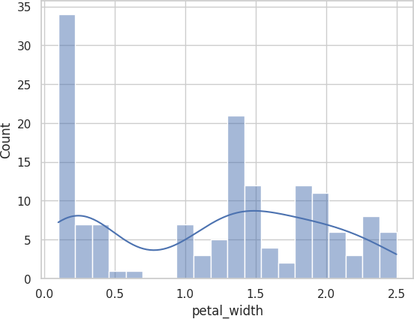
plt.title(f"Histogram of {col}") plt.xlabel(col) plt.ylabel("Frequency")

Text(0, 0.5, 'Frequency')

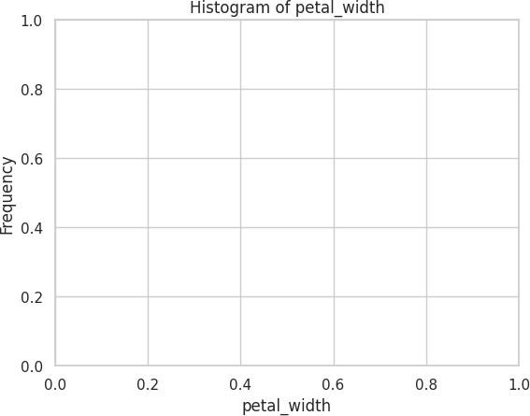

In [28]:
plt.show()

In [29]:
iris.hist(figsize=(12,8))

Out[29]:
array([[<Axes: title={'center': 'sepal_length'}>,
<Axes: title={'center': 'sepal_width'}>], [<Axes: title={'center': 'petal_length'}>,
<Axes: title={'center': 'petal_width'}>]], dtype=object)

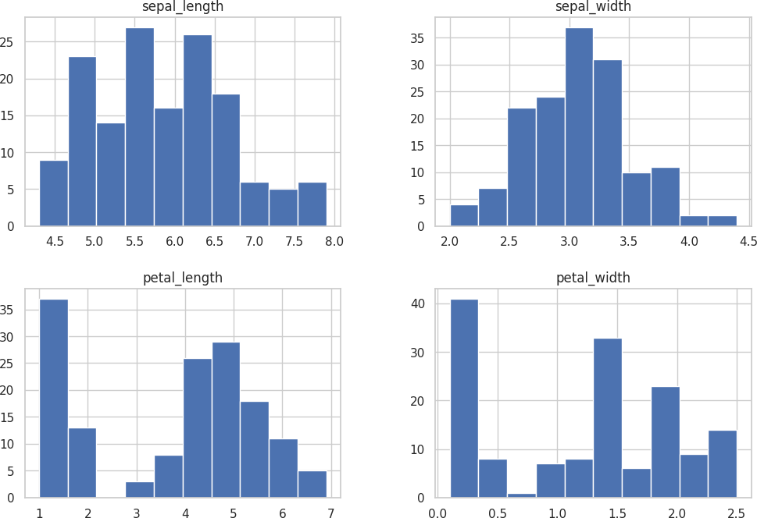

In [30]:
plt.suptitle("Combined Histograms of Iris Features", fontsize=16)

Out[30]: Text(0.5, 0.98, 'Combined Histograms of Iris Features')
<Figure size 640x480 with 0 Axes>

In [42]:
print("\n ")
print("Boxplot Visualization")
print(" ")

Boxplot Visualization

In [43]:
for col in iris.columns[:-1]: plt.figure(figsize=(6,4)) sns.boxplot(y=iris[col]) plt.title(f"Boxplot of {col}") plt.show()

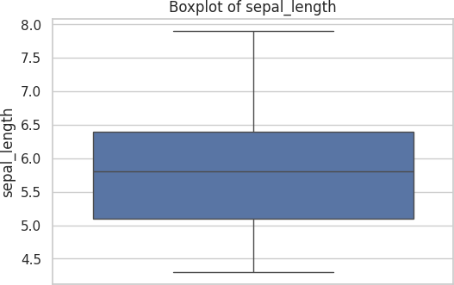
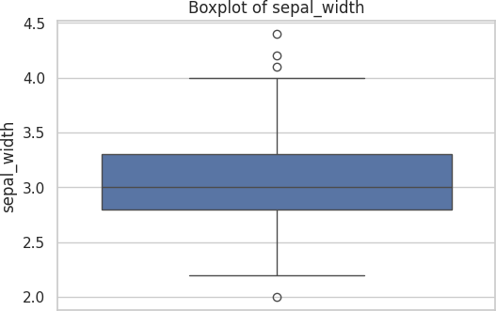

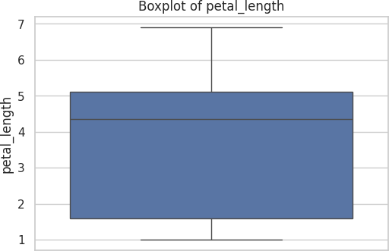
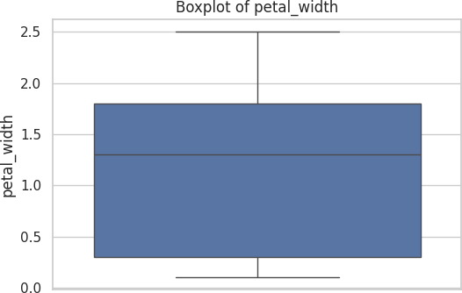

In [44]:
plt.figure(figsize=(10,6)) sns.boxplot(data=iris)
plt.title("Combined Boxplot of All Features") plt.show()

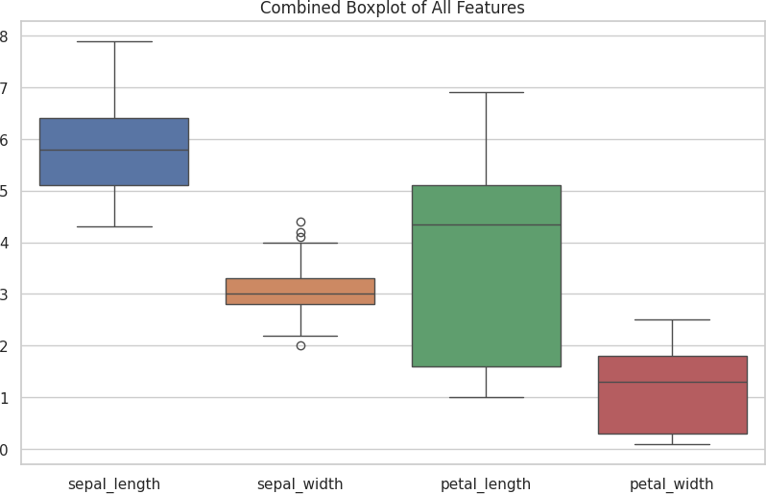

In [45]:
for col in iris.columns[:-1]: plt.figure(figsize=(6,4)) sns.boxplot(x="species", y=col, data=iris) plt.title(f"{col} vs Species")
plt.show()

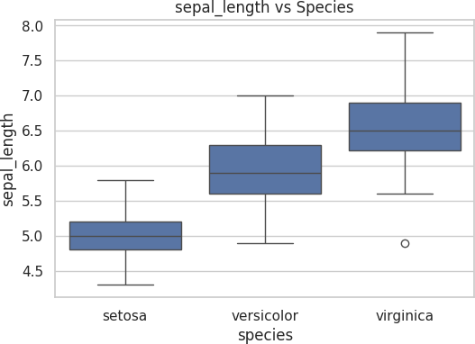
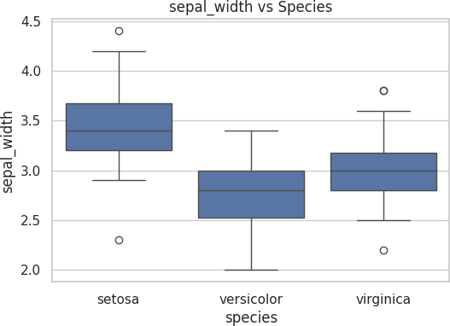

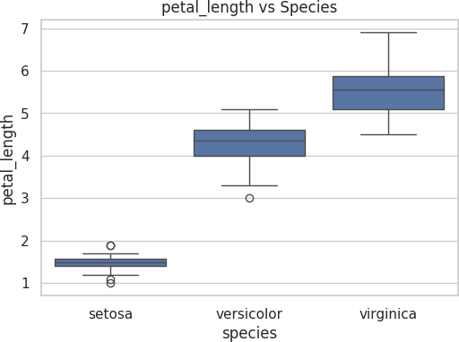
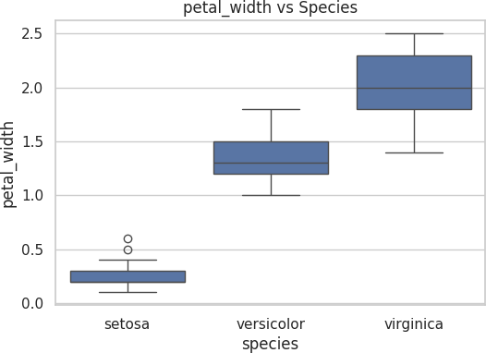

In [46]:
print("\n ")
print("Outlier Detection using IQR Method") print(" ")

Outlier Detection using IQR Method

In [47]:
for col in iris.columns[:-1]:
Q1 = iris[col].quantile(0.25) Q3 = iris[col].quantile(0.75) IQR = Q3 - Q1

In [49]:
lower_bound = Q1 - 1.5 * IQR upper_bound = Q3 + 1.5 * IQR

In [51]:
outliers = iris[(iris[col] < lower_bound) | (iris[col] > upper_bound)]

In [52]:
print(f"\nFeature: {col}")
print(f"Number of outliers: {len(outliers)}")

Feature: petal_width Number of outliers: 0

In [53]:
print("\n ")
print("Distribution Comparison") print(" ")

Distribution Comparison

In [54]:
for col in iris.columns[:-1]: print(f"\nFeature: {col}") print(f"Mean: {iris[col].mean():.2f}")
print(f"Median: {iris[col].median():.2f}") print(f"Standard Deviation: {iris[col].std():.2f}")

Feature: sepal_length Mean: 5.84
Median: 5.80
Standard Deviation: 0.83

Feature: sepal_width Mean: 3.06
Median: 3.00
Standard Deviation: 0.44

Feature: petal_length Mean: 3.76
Median: 4.35
Standard Deviation: 1.77

Feature: petal_width Mean: 1.20
Median: 1.30
Standard Deviation: 0.76

In [ ]:

