

深 度 学 习 原 理
实 验 报 告

实验名称：从零开始训练NanoGPT
姓 名：张翰宸 2311009（贡献最高）
何孝纬 2312410（贡献次之）
专 业：智能科学与技术

人工智能学院
2026年2月

该实验报告中，由基础实验训练过程及结果，顶刊实验复现及结果和算法分析三部分组成
跳转链接为： 基础实验训练误差随迭代次数的变化曲线
提高实验训练误差随迭代次数的变化曲线
问题3的回答
组内成员为：张翰宸，何孝纬两位同学，其中张翰宸同学的贡献最高，何孝纬次之（贡献排序两人均已知晓）

一、实验过程
经由老师允许，我在实验室的双卡3090上训练nanogpt。
- 首先我克隆了仓库到本地：git clone https://github.com/karpathy/nanoGPT
- 接着我下载了相关库pip install torch numpy transformers datasets tiktoken wandb tqdm
- 首先使用shakespeare数据集进行调试
数据集下载文件：python data/shakespeare_char/prepare.py
模型训练文件：python train.py config/train_shakespeare_char.py
观察到目前只在单卡上进行训练
训练结果：
step 5000: train loss 0.6204, val loss 1.7273
iter 5000: loss 0.8195, time 4292.53ms, mfu 10.03%
运行python sample.py --out_dir=out-shakespeare-char将生成一些文本：
ANGELO:
And I will kiss your master about me:
You are not all already but foul and very weeping.

ISABELLA:
What's a mazon that?

ANGELO:
Nay, I have no longer misters, I heard it.

ISABELLA:
Besides, my lord, my lord. For all the matter has but baissest,
If I should not perform your brother Gloucester,--
And that it shall be, my lord, my lord Captain blood
To kill thrust for the great shame of all of my soul.

CAPULET:
Why, so I still it, are a man a gentleman to thee.

ANTIGONUS:
I am not a w
---------------

Men your knees, my soul were you so a change.

DUKE OF YORK:
Art thou so false? what will I have much from these?
Think me this my thumb will shall be beholdy.

DUKE OF YORK:
This is it so; it is done, in expected:
I content; and now my lord, to entreat me with beauty.

DUKE OF AUMERLE:
Seven that I may speak to the king, come I see
The midst thou and not within my force of mine.

DUCHESS OF YORK:
Commend me with this time some English king!

A PhOebus; a brother doth hold the letters of her see
---------------

Men take my way. Their fellows in him: not this, I can do
take him to act his hand: but make a thought of worsing
That stout the coronation, cold begins
He bring to him.

FLORIZEL:
A lord, too fellow!

CAMILLO:
Gentle fellow, bring him.

CAMILLO:
Ay, if that stick for Hermione shall be spoken,
To the end of a devil of crimes him.
Ah, how comes him, sir, as I thrive, and they are here begun,
As his new love of Marcius' belly about
And taken him more for ever. What!
How canst you think? who is thi
---------------

可以看到由于数据集比较小，模型也不大，字符级的分词，生成的文本并不是非常可读，但确实有一些莎士比亚风味。
- 接着尝试运行nanoGPT。
在下载数据上会稍微碰到一些困难，在国内是ping不到huggingface的网站的，需要设置镜像：# export HF_ENDPOINT=https://hf-mirror.com。
然后在prepare.py文件中，需改成load_dataset("Skylion007/openwebtext")，huggingface官网是没有openwebtext这个数据集的。
下载中几经波折，因文件过大网速过慢，导致难免有中断，但Hugging Face 的 hf_hub_download 和 datasets 库默认支持断点续传，所以终端再运行不会从头开始下整个文件。
- 下载完成后进入分词阶段：用的tiktoken分词，但很尴尬分到一半发现硬盘不够了（原始剩下84GB空间，因为觉得数据量20-30G应该够，可能是由于分词占用了很大的空间）解决方式是：删除原始 .parquet 文件以及一些其他可删除的缓存，另外在征得老师同意下删掉了一个已毕业学长的文件夹（第一次用sudo rm-rf，下手的那一刻有些颤颤巍巍）
分词完成后自动执行命令：writing /home/zhc/nanoGPT/data/openwebtext/train.bin，这个任务是将分词后的训练数据写入一个二进制文件 train.bin，训练时直接用 np.fromfile() 快速加载到内存
写到一半又有出现问题：可能是内存不够，也有可能是存储不够。清理内存和cashe之后重新执行脚本
- 接着下载Tmux，它允许在一个终端窗口中创建、访问和控制多个终端会话。即使断开 SSH 连接，会话仍在后台运行，重新连接后可以恢复工作状态。
创建一个名为“0”的程序：tmux attach -t 0，这样程序就跑在后台了。
- 注册了一个wandb的账号，用于记录记录超参数、指标、损失。在wandb上创建一个项目，之后将wandb-login，输入API即可。在运行wandb的过程中碰到一个小插曲，看到mfu、lr、iter长时间不更新，后了解到应该是log步设置太大的原因（2000步上传一次）
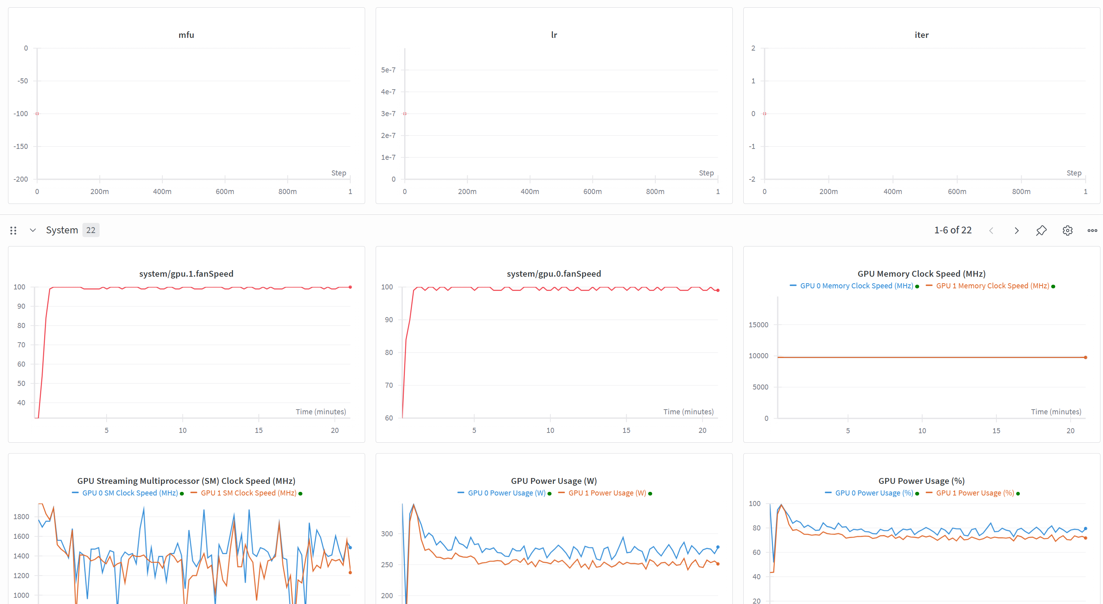
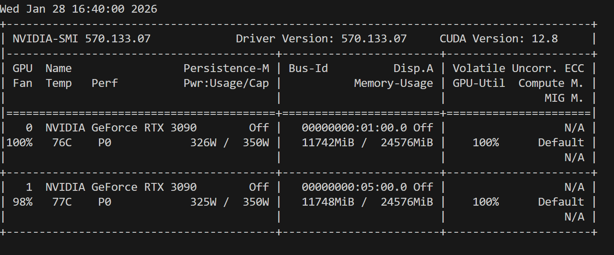
- torchrun --standalone --nproc_per_node=2 train.py config/train_gpt2.py
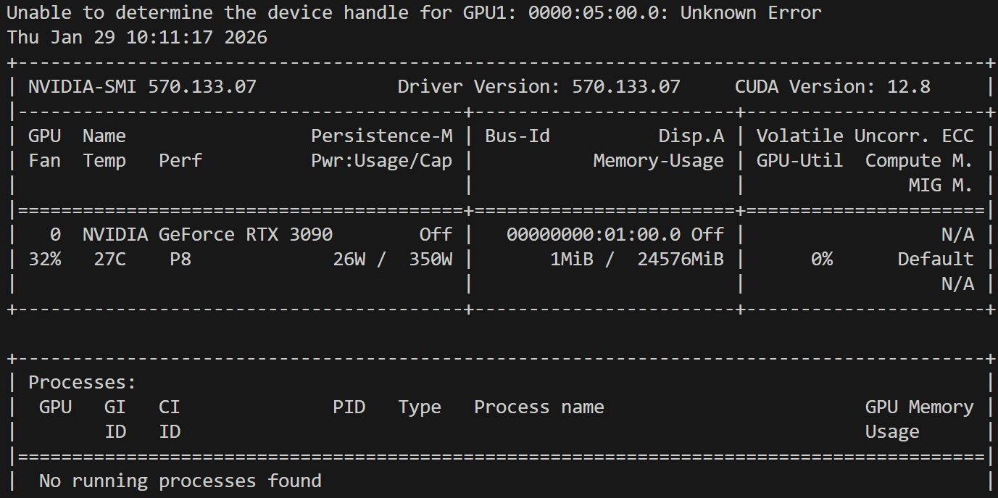
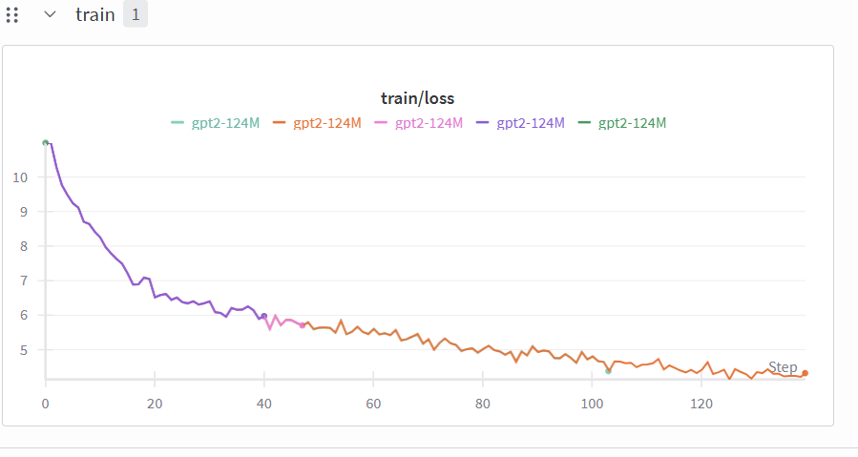
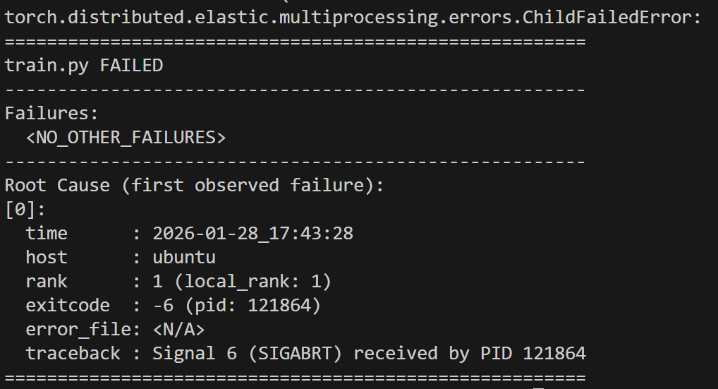
- 但还是碰到问题了，可能由于实验室显卡不太稳定，总过跑了5次，尝试了各种改进，显卡最长坚持2小时就会掉驱动（可能），nvidia-smi检测不到，但重启就好了，事实上显存占用不高，可能是3090年纪大了。以下图片是训练记录和报错截图。

- 经商讨决定从autoDL上租赁服务器。因为autoDL非常贴心的配好了conda环境，也有终端，所以命令都一样的。但是碰到了一些其他问题：一开始下数据下到系统盘了，导致系统盘满了。检查时发现：已经在autodl-tmp（也就是数据盘）执行命令了，但运行位置不等于默认缓存位置，代码里调用的第三方库（Hugging Face datasets）有它自己的想法，Hugging Face 库的设计逻辑是：“我下载的数据可能以后别的项目也要用，为了防止重复下载，我要把它存在一个全局公共区域”。结果：Linux 系统中，这个“全局公共区域”默认就是系统盘的 /root/.cache 目录。不会因为我在数据盘里运行代码，就自动把这个全局设置改掉。

解决办法：创建一个缓存目录mkdir -p /root/autodl-tmp/hf_cache
之后将环境变量写入配置文件 (~/.bashrc)：echo 'export HF_HOME=/root/autodl-tmp/hf_cache' >> ~/.bashrc
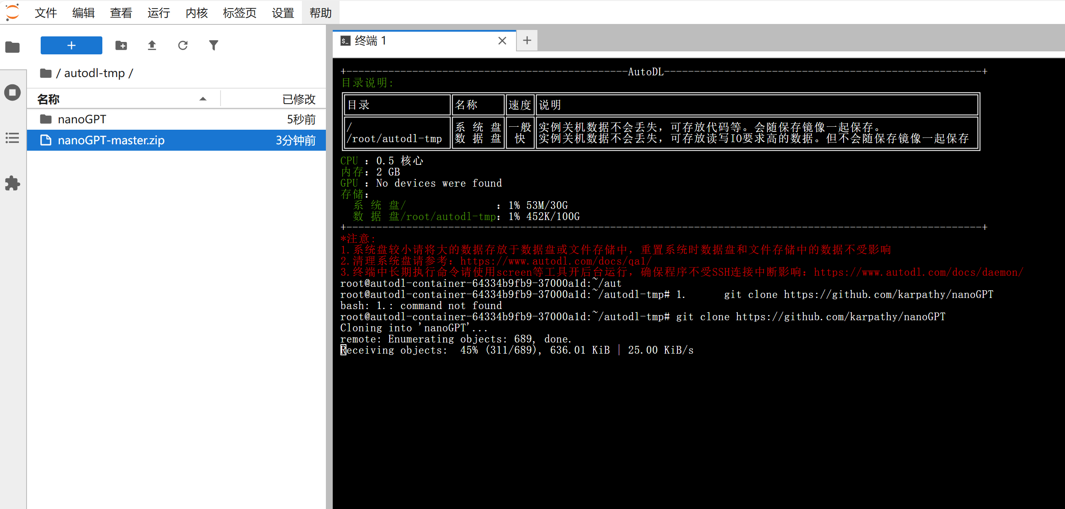
- 但在切分token这一步还是卡住了，总是莫名其妙被killed，原因可能是我在下载数据的时候是不带GPU开机，内存只分配了2GB，而下载数据和token切分是在一个脚本里。因此我打算关机，带GPU启动再来一次，然后很不巧的是这时候没GPU了，只能克隆到另外一台主机上。
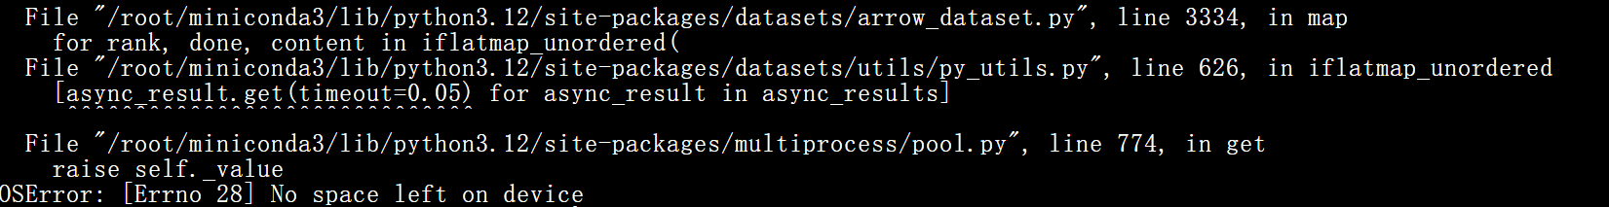
之后又碰到没有存储空间的问题，于是又关机进行扩容。
在分词的过程中发现是通过CPU进行分词的，而存储的使用也是呈现阶段式的，分词非常占用空间，虽然数据可能只有17GB，但缓存占用可能要150GB左右
下载完数据后通过以下命令清理缓存：

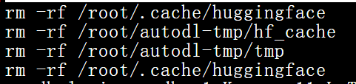
- 准备好数据终于又可以开始训练了，这里用nohup来记录后台（懒得装tmux了）：
nohup python train.py config/train_gpt2.py \
--dtype=bfloat16 \
--compile=True \
--wandb_log=True \
--wandb_project=nanoGPT \
--wandb_run_name='5090-run-01' \
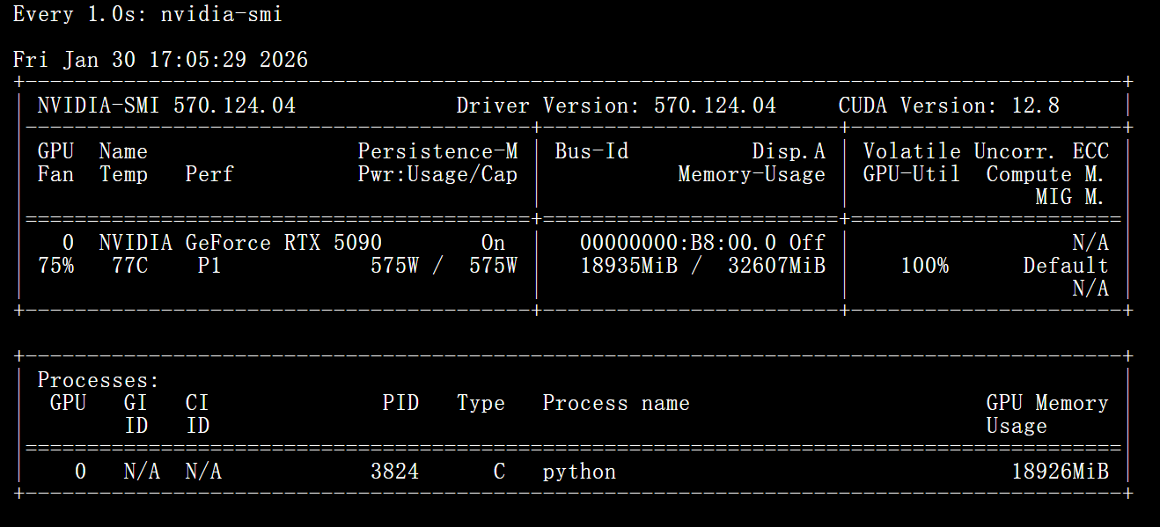
> train.log 2>&1 &

- 我在训练过程中发现，内存消耗是不断增长的，担心有内存泄露问题。Ai说：的代码在训练过程中，会不断地从硬盘（train.bin）读取大量的数据。np.memmap 是一种内存映射文件的方法。
Linux 的机制： Linux 系统有一个原则：“空闲的内存就是浪费的内存”。 当你不断读取 train.bin 时，Linux 会把读过的文件内容保留在物理内存（RAM）中，这被称为 Page Cache（页面缓存）。这样下次你再读这部分数据时，速度会飞快。
现象： 你会看到内存使用量持续上涨，直到几乎占满（比如 90% 以上）。
为什么没问题？ 这些被缓存占用的内存属于“可回收”内存。如果你的程序（或者其他程序）真的需要申请内存进行计算，Linux 会立刻把这些缓存丢掉，腾出空间。
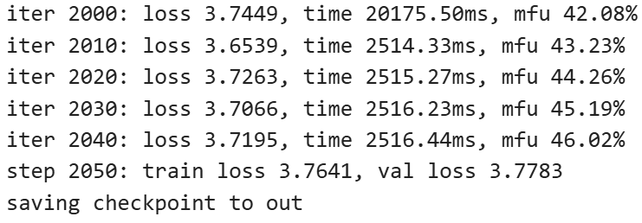
- 在实验过程中发现，其实在验证花的时间比较多，由于是初次跑，验证的间隔设的比较小，每跑50次就会做一次验证，下次可以优化。

- 总共训练2万次迭代，batchsize=24，20次梯度积累（相当于480batchsize），其实这个batchsize对5090一张32GB显存的卡来说太小了，实际占用维持在19GB左右，可以开大一些。
最后结果：
iter 19950: loss 2.9989, time 20089.15ms, mfu 42.17%
iter 19960: loss 3.0512, time 2509.38ms, mfu 43.32%
iter 19970: loss 3.0015, time 2509.33ms, mfu 44.35%
iter 19980: loss 3.0229, time 2510.32ms, mfu 45.28%
iter 19990: loss 2.9647, time 2511.93ms, mfu 46.11%
step 20000: train loss 3.0468, val loss 3.0536
对照github上的参考，总体超出预期（在两万轮的情况下）。
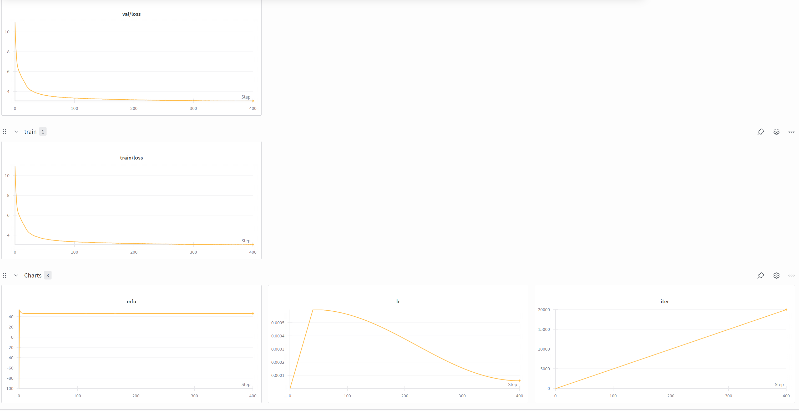
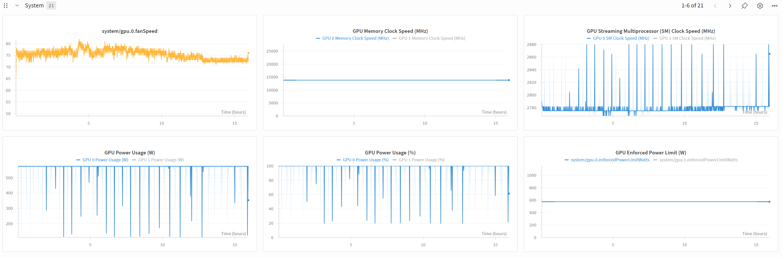
运行sample文件，一开始经历了编译，之后输出：python sample.py \
--init_from=gpt2-xl \
--start="What is the answer to life, the universe, and everything?" \
--num_samples=5 --max_new_tokens=100
What is the answer to life, the universe, and everything?

One possibility is that they have a universe-wide perspective that allows for no contradictions. And, if so, then why is there contradiction?

Another possibility is that the universe is one big joke. They are not the only joke in the universe. But it is not an empty universe.

Hence the problems with the universe's Big Bang theory, which tells us that the universe started out in a singularity with a zero initial mass. The Big Bang is essentially consistent with
---------------
What is the answer to life, the universe, and everything? Probably not. Quantum physics is a mystery. It's not settled. So if you're interested in the answer to life, the universe, and everything, you're probably not interested in quantum physics.

"The people who learn quantum physics as a university undergraduate, they go out and do their PhD, but they don't really understand quantum physics. They're more interested in quantum mechanics, which is why we have a Nobel Prize in physics. That's why you have a Nobel Prize in physics
---------------
What is the answer to life, the universe, and everything?

Can a dog be made to love us?

Are there aliens out there?

If the bible is the word of god, what is the problem?

If Christ was the Son of God, why didn't he save all those who died in his name?

Does the bible really talk about a god who created the heavens and earth?

Is it true that the bible says that a virgin would be "blessed through childbearing" and would give
---------------
What is the answer to life, the universe, and everything? In The Origin of Life, David Deutsch and Max Tegmark seek the answer by tackling some of the most difficult questions in science. Based on the first full-length biography of Michael Faraday, this original and provocative book deals with not only the origin of the universe and life, but also the question of why we are here. Deutsch and Tegmark tell how the discoveries of modern biology and genetics, and the success of modern physics and cosmology have led to the ultimate laws of nature and
---------------
What is the answer to life, the universe, and everything? This question has vexed philosophers in all times and cultures.

From ancient Greece to 16th-century Italy, philosophers and theologians sought the answer to this question. Some came to a conclusion; most came to a different one.

Many of the best known of these thinkers were Bacon, Descartes, Newton, Leibniz, Leibniz's collaborator Gottfried Leibniz, and English philosopher Richard Swinburne. (The latter two, like
---------------

二、提高部分
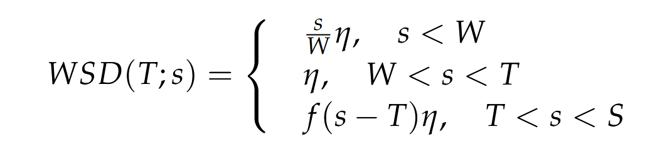
在提高部分，选择的是来自清华大学的MiniCPM¹：主要考虑到：1.文章中提到的WSD策略比较好复现，在nanoGPT中learning rate是通过调取函数获得的，只要对函数修改一下不改变其他代码，难度比较低。2.该论文有比较完备的GitHub仓库，也有面壁智能这样一家公司背书，具有一定可靠性。
论文创新点：该论文提出了一中新的学习率调整策略，LRS包含三个阶段：预热阶段、稳定训练阶段和衰减阶段。论文认为：大模型通常需要大量参数更新才能收敛。长时间维持较高学习率有助于模型在早期快速探索参数空间，避免陷入局部最优或过早收敛。而作者又通过实验说明，衰减的步骤是十分重要的，可以避免模型震荡，因此在最后10%快速衰减。
代码修改：
改进前：
def get_lr(it):
# 1) linear warmup for warmup_iters steps
if it < warmup_iters:
return learning_rate * (it + 1) / (warmup_iters + 1)
# 2) if it > lr_decay_iters, return min learning rate
if it > lr_decay_iters:
return min_lr
# 3) in between, use cosine decay down to min learning rate
decay_ratio = (it - warmup_iters) / (lr_decay_iters - warmup_iters)
assert 0 <= decay_ratio <= 1
coeff = 0.5 * (1.0 + math.cos(math.pi * decay_ratio)) # coeff ranges 0..1
return min_lr + coeff * (learning_rate - min_lr)
改进后：
def get_lr(it):
# Calculate when the decay phase starts (e.g., at 90% of training)
decay_start_iter = int(max_iters * (1 - wsd_decay_ratio))

# 1) Linear Warmup (Same as before)
if it < warmup_iters:
return learning_rate * (it + 1) / (warmup_iters + 1)

# 2) Stable Phase
# Keep learning rate constant and high for the majority of training
if it < decay_start_iter:
return learning_rate

# 3) Decay Phase (Rapid Annealing)
# If we are past the max_iters, just return min_lr
if it >= max_iters:
return min_lr

# Calculate progress strictly within the decay window
decay_length = max_iters - decay_start_iter
decay_progress = (it - decay_start_iter) / decay_length

assert 0 <= decay_progress <= 1

# Use Cosine annealing for the rapid decay phase
coeff = 0.5 * (1.0 + math.cos(math.pi * decay_progress))
return min_lr + coeff * (learning_rate - min_lr)
# ### [MiniCPM WSD Modification] END ###
实验结果显示：
iter 19900: loss 2.8423, time 2488.54ms, mfu 52.21%
iter 19910: loss 3.2047, time 2488.34ms, mfu 52.40%
iter 19920: loss 2.9452, time 2487.55ms, mfu 52.58%
iter 19930: loss 2.8737, time 2486.91ms, mfu 52.73%
iter 19940: loss 2.9567, time 2487.39ms, mfu 52.87%
iter 19950: loss 3.0611, time 2487.32ms, mfu 53.00%
iter 19960: loss 2.8815, time 2486.69ms, mfu 53.12%
iter 19970: loss 2.9937, time 2484.76ms, mfu 53.22%
iter 19980: loss 2.9467, time 2484.93ms, mfu 53.32%
iter 19990: loss 2.9400, time 2485.88ms, mfu 53.41%
step 20000: train loss 3.0210, val loss 3.0320
saving checkpoint to out
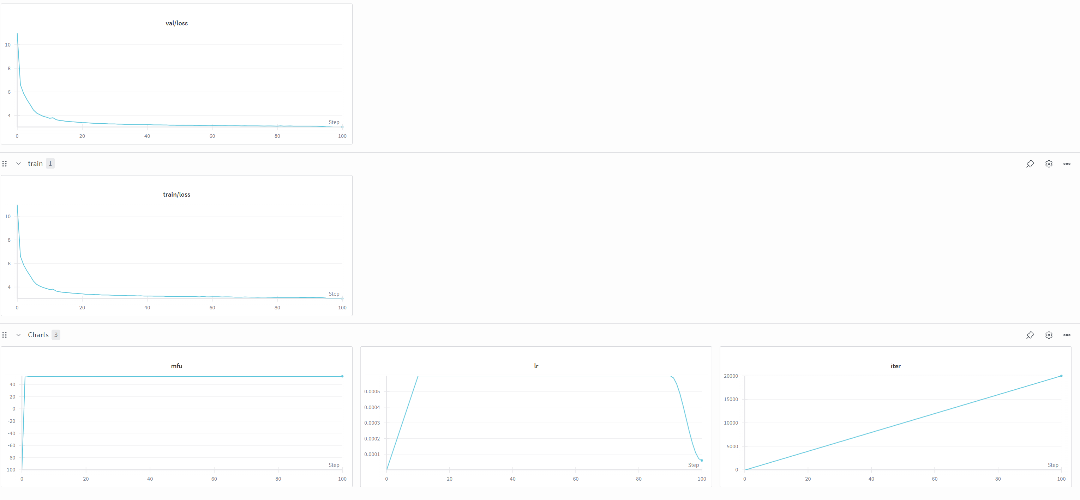
iter 20000: loss 3.0375, time 20087.40ms, mfu 48.73%
What is the answer to life, the universe, and everything?”

This question is easy to answer for so many reasons, but it is also very hard to answer for many reasons. Who knows?

The most important ones are the last one. How can I answer this question? Well, I’m not 100% sure I can answer it, but what I’m going to try is to explain how I came to accept this answer.

I didn’t come to accept this answer, but I believed that
---------------
What is the answer to life, the universe, and everything? Probably the answer is none – and unfortunately, there's absolutely no answer to this question. All it takes is some basic understanding of what the problem is, some basic background and some deeper understanding of what the problem is, and the fundamental nature of life, and the basic understanding of what's possible.

Perez is not the only Nobel laureate to answer this, however. In 2005, the group that won a Nobel Prize in physics, Stephen Hawking, said, "In time, there
---------------
What is the answer to life, the universe, and everything?

Can's one man defy the laws of nature?

"Sleeping in" is a song by American hip-hop group Pavement, which was released in 2003 by R&B artist L.E.M.H.

Can's sense of humor flows from his musical career:

"Sleeping in" is the song that brought fame to the music industry's most successful rap group, the rap group Nasty Kickers

Can's style is
---------------
What is the answer to life, the universe, and everything? Just as the question "Why?" can't be answered, the answer is no.

*We use the terms "diseases," which are to do with human life. Any negative number -- I mean, the number of years -- that we keep getting. But the numbers are very small!

*We don't care whether the world is in a vacuum or not. Any single, single, variable number can be expressed in any number as long as it's defined by a series
---------------
What is the answer to life, the universe, and everything? This question has been asked many times before, by people who believe that there is a God, a supreme being, and a very sacred mystery, but that it is a mystery. If the Truth is unknown, that is the answer to life and everything. This is what I will discuss on this site.

If you have ever wondered why you have to have to be a Christian, you know that it is the fact that’s all around us, and that there is a God.

问题（3）：比较Adam/AdamW和（2）中算法的效果，分析原因，总结为什么（2）中的方法可以发顶会顶刊，为将来科研打下基础。

答：从效果上看，WSD策略在相同迭代次数下，loss下降了0.1，收敛趋势上相较于基础实验，使用了LRS后下降更快，后期更稳定。
原因分析：基础实验采用余弦衰减，学习率在预热后持续缓慢下降，可能导致后期学习率过低，模型更新缓慢，在训练中期可能陷入局部最优。
而WSD策略分为“预热——稳定高学习率——快速衰减”三阶段：
稳定高学习阶段：允许模型在较长周期内保持较强的参数更新能力，有助于跳出局部最优，探索最优解；
快速衰减阶段：在训练末尾迅速降低学习率，使模型能平稳收敛，避免震荡。

为什么（2）中的方法能发顶刊？
答：WSD策略提供了一种更符合训练动力学的调度方式，尤其在模型规模增大时表现更好。
论文在多个模型和数据集上验证了WSD的有效性，在学生的实验报告中，仅通过修改几行代码就实现了明显提升，说明方法易于实现且通用性强。
理论支撑与直觉一致：策略符合前期探索（高学习率）到后期收敛（快速衰减）的实验直觉；实验验证了该策略在多种规模模型上的有效性，具备一定的理论解释性。
论文对社区有启发意义：大多数研究聚焦于模型结构或优化算法，而WSD关注学习率调度策略这一相对被忽视的方向，展示了即使不改变模型，仅通过优化训练策略也能显著提升性能。
总结：作者探索了小语言模型的技术边界和提升可能性，通过大量实验去验证batchsize，learning-rate随着模型容量增加的变化趋势，并探索了一种新的learning-rate的实现方法，LRS这种方法确实很自然，也解释的通：维持一个比较高的学习率可以让模型更好探索，通过实验也比较好验证。

三、代码解析：我觉得主要还是train.py和model.py两个文件值得解析。
以下是对model.py的解析：
变量定义：这里比较注意的点是：GPT-2的实际词汇表大小是50257，但这里用了50304，原因是GPU内存访问效率最高的是对齐到特定字节边界（如64、128），现代GPU（如NVIDIA的Tensor Core）在某些维度上效率更高，矩阵乘法在特定维度上性能更好。添加了47个"虚拟"token位置，这些位置不会被使用，但在内存中占用空间，计算时会忽略这些位置。
@dataclass
class GPTConfig:
block_size: int = 1024 # 上下文长度/序列长度
vocab_size: int = 50304 # 词汇表大小（GPT-2是50257，补到64的倍数）
n_layer: int = 12 # Transformer层数
n_head: int = 12 # 注意力头数
n_embd: int = 768 # 嵌入维度
dropout: float = 0.0 # Dropout率
bias: bool = True # 是否在线性层使用偏置
Attention模块：
1.这里将QKV三个矩阵合并为一个矩阵方便运算。2.使用下三角矩阵实现掩蔽效果。3.3.这里有使用一个flash attention模块，可以分块计算，无需存储完整矩阵，加快训练速度，减小内存消耗，直接调用也非常方便。
4..注意维度变化：
输入 x: [B, T, 768]
↓ c_attn线性层
QKV: [B, T, 2304] # 768×3
↓ split分割
Q: [B, T, 768], K: [B, T, 768], V: [B, T, 768]
↓ reshape + transpose（多头化）
Q: [B, 12, T, 64], K: [B, 12, T, 64], V: [B, 12, T, 64]
↓ 注意力计算（两种路径）
注意力输出: [B, 12, T, 64]
↓ transpose + view（合并多头）
多头合并: [B, T, 768]
↓ c_proj线性层（输出投影）
投影后: [B, T, 768]
↓ resid_dropout
最终输出: [B, T, 768]

class CausalSelfAttention(nn.Module):

def __init__(self, config):
super().__init__()
assert config.n_embd % config.n_head == 0
# key, query, value projections for all heads, but in a batch
self.c_attn = nn.Linear(config.n_embd, 3 * config.n_embd, bias=config.bias)
# output projection
self.c_proj = nn.Linear(config.n_embd, config.n_embd, bias=config.bias)
# regularization
self.attn_dropout = nn.Dropout(config.dropout)
self.resid_dropout = nn.Dropout(config.dropout)
self.n_head = config.n_head
self.n_embd = config.n_embd
self.dropout = config.dropout
# flash attention make GPU go brrrrr but support is only in PyTorch >= 2.0
self.flash = hasattr(torch.nn.functional, 'scaled_dot_product_attention')
if not self.flash:
print("WARNING: using slow attention. Flash Attention requires PyTorch >= 2.0")
# causal mask to ensure that attention is only applied to the left in the input sequence
self.register_buffer("bias", torch.tril(torch.ones(config.block_size, config.block_size))
.view(1, 1, config.block_size, config.block_size))

def forward(self, x):
B, T, C = x.size() # batch size, sequence length, embedding dimensionality (n_embd)

# calculate query, key, values for all heads in batch and move head forward to be the batch dim
q, k, v = self.c_attn(x).split(self.n_embd, dim=2)
k = k.view(B, T, self.n_head, C // self.n_head).transpose(1, 2) # (B, nh, T, hs)
q = q.view(B, T, self.n_head, C // self.n_head).transpose(1, 2) # (B, nh, T, hs)
v = v.view(B, T, self.n_head, C // self.n_head).transpose(1, 2) # (B, nh, T, hs)

# causal self-attention; Self-attend: (B, nh, T, hs) x (B, nh, hs, T) -> (B, nh, T, T)
if self.flash:
# efficient attention using Flash Attention CUDA kernels
y = torch.nn.functional.scaled_dot_product_attention(q, k, v, attn_mask=None, dropout_p=self.dropout if self.training else 0, is_causal=True)
else:
# manual implementation of attention
att = (q @ k.transpose(-2, -1)) * (1.0 / math.sqrt(k.size(-1)))
att = att.masked_fill(self.bias[:,:,:T,:T] == 0, float('-inf'))
att = F.softmax(att, dim=-1)
att = self.attn_dropout(att)
y = att @ v # (B, nh, T, T) x (B, nh, T, hs) -> (B, nh, T, hs)
y = y.transpose(1, 2).contiguous().view(B, T, C) # re-assemble all head outputs side by side

# output projection
y = self.resid_dropout(self.c_proj(y))
return y
之后的模块代码并非GPT的主要创新点，代码不呈现了，一些小发现：
1.词嵌入矩阵其实占用了很大的参数量，词嵌入层：50257 × 768 = 38,597,376 参数，所有Transformer块：84,971,520 参数（≈ 8500万）比例：词嵌入 ≈ 31% 的总参数，每个token需要丰富的表示，所以词嵌入矩阵挺大的，但在现代神经网络中，由于transformer块参数量大，所以词嵌入矩阵占比没那么大了。另外在nanoGPT中，输入嵌入和输出层共享权重。
2. Linear / Embedding：正态分布 N(0, 0.02²) 初始化，偏置全部初始化为0。注意力输出投影和MLP输出投影的初始化方式略有不同，$σ=\frac{0.02}{\sqrt{2×L}}$，其中 $L=\text{n_layer}$，这里考虑到了残差连接。
3. 在推理时只计算最后一个 token 的 logits。
4. 采用融合Adam优化器：将多个优化器操作合并为单个CUDA内核，减少内存访问，提升训练速度（10-40%）
5.只对2D权重矩阵应用权重衰减，偏置、LayerNorm参数不应用。

针对train.py中代码的部分重点：
train.py这份代码是工业级的，有很多很细小的考量，尤其是对硬件层面的优化让我非常惊叹。
以下代码检测是否在 DDP（Distributed Data Parallel）环境中运行，若是：初始化进程组，设置每个进程的 GPU 设备，调整梯度累积步数（因为总 batch size = micro_batch × grad_acc × world_size）。
重点有三个：1.如何检测是否是DDP呢，是通过rank来检测的，使用torchrun启动时，系统自动设置环境变量，分配给每个设备一个rank。2. master_process：只有 rank=0 的进程负责日志、保存 checkpoint。这样就可以防止不同process反复写入导致内存的冲突。3.DDP工作原理：每个 GPU 上都有一份完整的模型副本，每个 GPU 处理不同的数据子集（mini-batch），每次 backward 后，自动同步各 GPU 的梯度（通过 All-Reduce），然后各自独立更新自己的模型副本（因为梯度相同，所以模型保持一致）。
ddp = int(os.environ.get('RANK', -1)) != -1
if ddp:
init_process_group(backend=backend)
ddp_rank = int(os.environ['RANK'])
ddp_local_rank = int(os.environ['LOCAL_RANK'])
ddp_world_size = int(os.environ['WORLD_SIZE'])
device = f'cuda:{ddp_local_rank}'
torch.cuda.set_device(device)
master_process = ddp_rank == 0
seed_offset = ddp_rank
gradient_accumulation_steps //= ddp_world_size
else:
master_process = True
seed_offset = 0
ddp_world_size = 1

使用 np.memmap 直接从磁盘读取预处理好的二进制 token 文件。每次调用都重新创建 memmap，避免内存泄漏。节省内存：10GB 的 token 文件无需全载入内存，训练时每次随机采样一个位置（如 ix = torch.randint(0, len(data)-block_size)），memmap 能快速定位并读取，可以避免 I/O 瓶颈：配合 SSD 可实现接近内存速度的读取。
数据被 pin 到 page-locked memory，再异步传输到 GPU。这里用到了锁页内存： GPU 可直接通过 PCIe 总线拉取 ，non_blocking=True：启动异步拷贝，CPU 不等待 GPU 完成，可继续准备下一批数据。
data_dir = os.path.join('data', dataset)
def get_batch(split):
# We recreate np.memmap every batch to avoid a memory leak, as per
# https://stackoverflow.com/questions/45132940/numpy-memmap-memory-usage-want-to-iterate-once/61472122#61472122
if split == 'train':
data = np.memmap(os.path.join(data_dir, 'train.bin'), dtype=np.uint16, mode='r')
else:
data = np.memmap(os.path.join(data_dir, 'val.bin'), dtype=np.uint16, mode='r')
ix = torch.randint(len(data) - block_size, (batch_size,))
x = torch.stack([torch.from_numpy((data[i:i+block_size]).astype(np.int64)) for i in ix])
y = torch.stack([torch.from_numpy((data[i+1:i+1+block_size]).astype(np.int64)) for i in ix])
if device_type == 'cuda':
# pin arrays x,y, which allows us to move them to GPU asynchronously (non_blocking=True)
x, y = x.pin_memory().to(device, non_blocking=True), y.pin_memory().to(device, non_blocking=True)
else:
x, y = x.to(device), y.to(device)
return x, y

三种初始化方式，注意这里还修复state_dict键名（有时会有_orig_mod.前缀），真的是很细心了。
if init_from == 'scratch':
# 从头开始训练
model_args['vocab_size'] = meta_vocab_size if meta_vocab_size is not None else 50304
gptconf = GPTConfig(**model_args)
model = GPT(gptconf)

elif init_from == 'resume':
# 从检查点恢复训练
checkpoint = torch.load(ckpt_path, map_location=device)
# 修复state_dict键名（有时会有_orig_mod.前缀）
unwanted_prefix = '_orig_mod.'
for k,v in list(state_dict.items()):
if k.startswith(unwanted_prefix):
state_dict[k[len(unwanted_prefix):]] = state_dict.pop(k)
model.load_state_dict(state_dict)

elif init_from.startswith('gpt2'):
# 加载预训练GPT-2权重
override_args = dict(dropout=dropout)
model = GPT.from_pretrained(init_from, override_args)

混合精度训练：工作流：
前向：权重转为 BF16 → 加速计算 + 节省内存
反向：梯度用 BF16 计算
更新：GradScaler 将梯度转回 FP32 → 优化器更新 → 权重存为 FP32
下一轮：FP32 权重转回 BF16 用于计算
# 自动混合精度上下文
ctx = nullcontext() if device_type == 'cpu' else torch.amp.autocast(device_type=device_type, dtype=ptdtype)

# GradScaler用于float16训练
scaler = torch.cuda.amp.GradScaler(enabled=(dtype == 'float16'))

训练循环核心代码，
梯度累积期间禁用 DDP 自动同步，仅在完整梯度就绪时触发一次同步，通信量减少 75%，显著提升吞吐。
当val_loss < best_val_loss保存checkpoint。
# 评估函数（关闭梯度，多轮平均）
@torch.no_grad()
def estimate_loss():
out = {}
model.eval()
for split in ['train', 'val']:
losses = torch.zeros(eval_iters)
for k in range(eval_iters):
X, Y = get_batch(split)
with ctx: # ctx = nullcontext() if device_type == 'cpu' else torch.amp.autocast(device_type=device_type, dtype=dtype)
logits, loss = model(X, Y)
losses[k] = loss.item()
out[split] = losses.mean()
model.train()
return out

# 学习率调度（线性 warmup + 余弦衰减）
def get_lr(it):
if not decay_lr:
return learning_rate
if it < warmup_iters:
return learning_rate * it / warmup_iters
if it > lr_decay_iters:
return min_lr
decay_ratio = (it - warmup_iters) / (lr_decay_iters - warmup_iters)
coeff = 0.5 * (1.0 + math.cos(math.pi * decay_ratio))
return min_lr + coeff * (learning_rate - min_lr)

# ===== 主训练循环 =====
X, Y = get_batch('train')
t0 = time.time()
local_iter_num = 0
raw_model = model.module if ddp else model

while True:
lr = get_lr(iter_num) if decay_lr else learning_rate
for param_group in optimizer.param_groups:
param_group['lr'] = lr

# 定期评估
if iter_num % eval_interval == 0 and master_process:
losses = estimate_loss()
print(f"step {iter_num}: train loss {losses['train']:.4f}, val loss {losses['val']:.4f}")
if losses['val'] < best_val_loss or always_save_checkpoint:
best_val_loss = losses['val']
checkpoint = {
'model': raw_model.state_dict(),
'optimizer': optimizer.state_dict(),
'model_args': model_args,
'iter_num': iter_num,
'best_val_loss': best_val_loss,
'config': config,
}
torch.save(checkpoint, os.path.join(out_dir, 'ckpt.pt'))

# 梯度累积循环
for micro_step in range(gradient_accumulation_steps):
if ddp:
model.require_backward_grad_sync = (micro_step == gradient_accumulation_steps - 1)
with ctx:
logits, loss = model(X, Y)
loss = loss / gradient_accumulation_steps
scaler.scale(loss).backward()
# 梯度裁剪
if grad_clip != 0.0:
scaler.unscale_(optimizer)
torch.nn.utils.clip_grad_norm_(model.parameters(), grad_clip)
# 优化器步进
scaler.step(optimizer)
scaler.update()
optimizer.zero_grad(set_to_none=True)

# 计时与日志
t1 = time.time()
dt = t1 - t0
t0 = t1
if iter_num % log_interval == 0 and master_process:
lossf = loss.item() * gradient_accumulation_steps
print(f"iter {iter_num}: loss {lossf:.4f}, lr {lr:.2e}, time {dt*1000:.2f}ms")

iter_num += 1
local_iter_num += 1
if iter_num > max_iters:
break
X, Y = get_batch('train') # 加载下一批数据（与计算重叠）

# 清理 DDP
if ddp:
destroy_process_group()

参考文献：
1. Hu, S. et al. MiniCPM: Unveiling the Potential of Small Language Models with Scalable Training Strategies. Preprint at https://doi.org/10.48550/arXiv.2404.06395 (2024).

