**Software Engineering**

**Department Library Automation**

|  |  |
| --- | --- |
| **Roll No** | **Name** |
| CB.EN.U4CSE19305 | ASHWANTH K |
| CB.EN.U4CSE19317 | D T SUVANESH |
| CB.EN.U4CSE19318 | DHARUN NARAYANAN L K |
| CB.EN.U4CSE19338 | NITHUNA N |
| CB.EN.U4CSE19354 | SWETHA J |

**USE CASE DIAGRAM:**

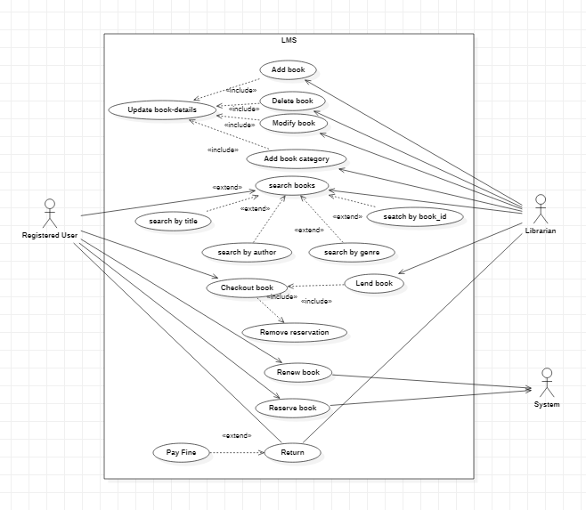

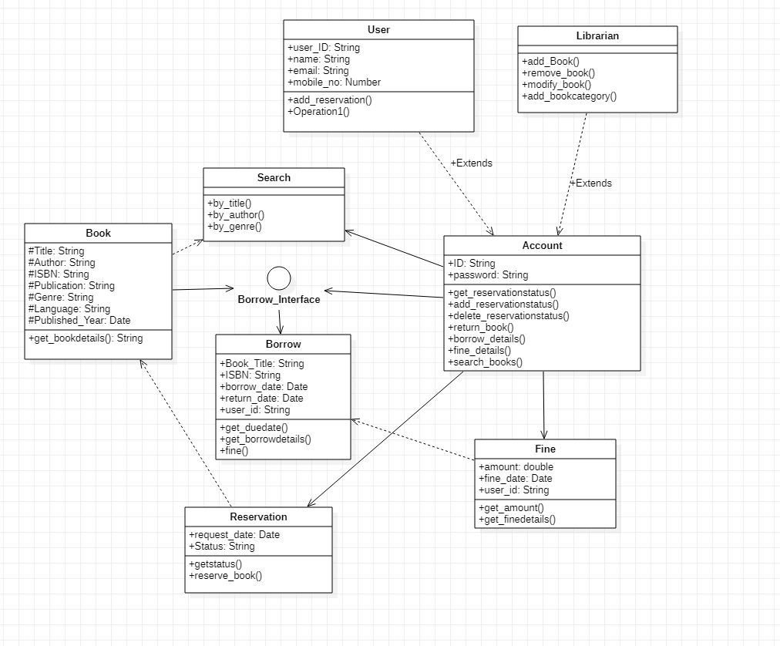**CLASS DIAGRAM:**

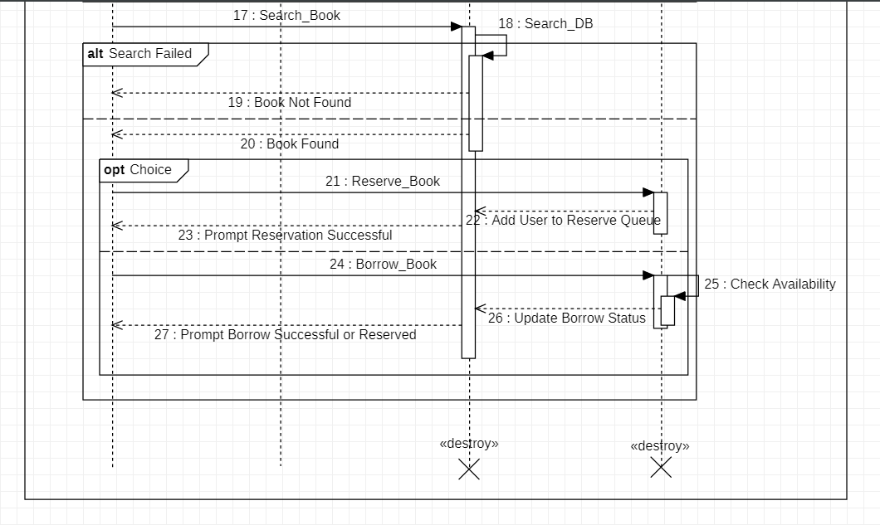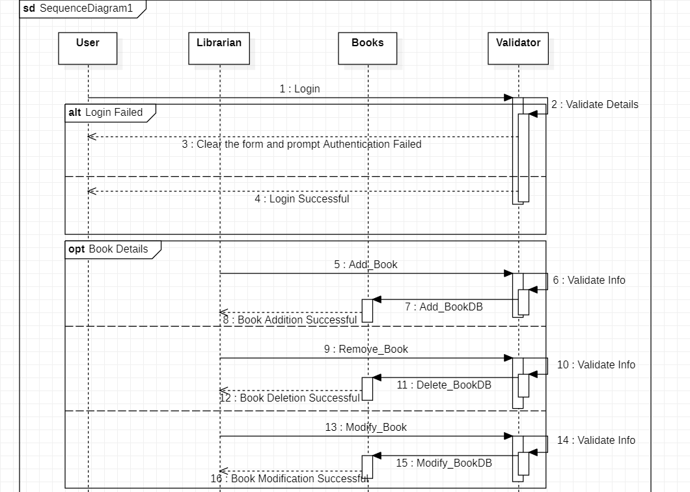**SEQUENCE DIAGRAM:**

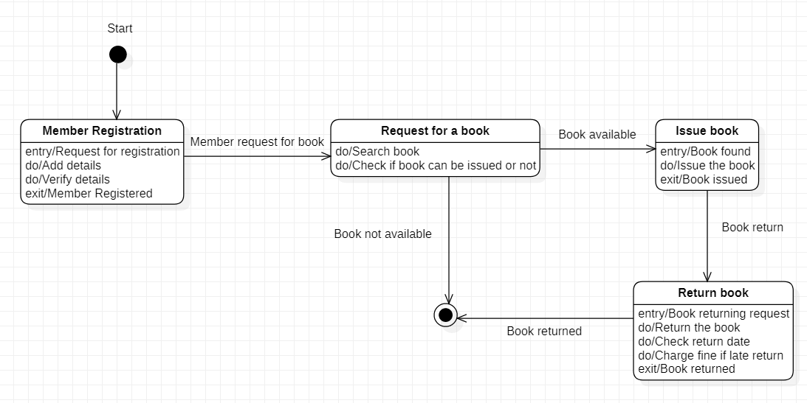**STATE DIAGRAM:**

**ACTIVITY DIAGRAM:**

**BORROW A BOOK:**

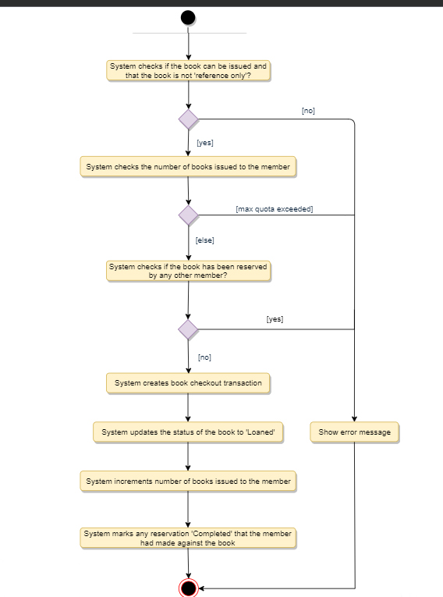

**RETURN A BOOK:**

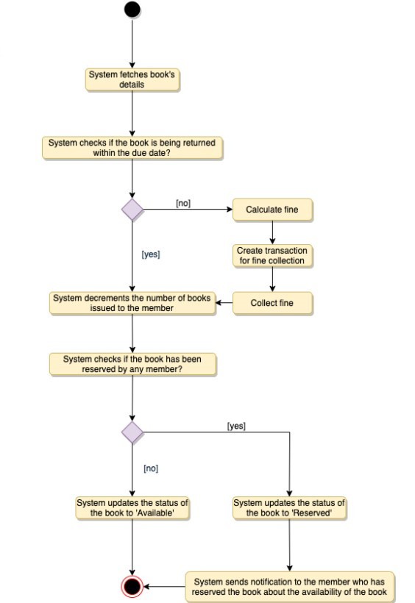

**RENEW A BOOK:**

