# DBMS Mini Project Synopsis

**MIS: 111903142 111903153**

**Name: Dhruva Kapadia Sameer Kavthekar**

**Division: 2**

**Batch: T4**

**Problem Statement:** Prison database

**Objectives:**

* Keep records of Criminals inside cells and details about them like the crimes they committed
* Keep records of the different prisons present in the city
* Keep records of Police Personnel and all officials working for the prisons
* Keep Offence Records such as the description of the crime committed by any current or past inmate
* Give functionalities for personnel to be the administrator for all the prisons, inmates and personnel
* Maintain a record for the different timetables followed in the prison
* Maintain records for FIRs coming into the prison
* Allow functionalities for releasing prisoner early and/ or medical leave from prison
* Maintain records of visitors to prisoners

**Functional Requirements:**

* User data should be fed into the system.
* The user can add the prisoners: Admins and guards can add prisoners
* Writing FIR: The user can write the FIR and other complaint reports that the user came to know about.
* Able to add and delete guards: The admin can add the guards and their details and if required he or she can also delete the details of guards of prison.

**Stack:**

* PostgreSQL database
* React frontend
* FastAPI (Pyhon) backend

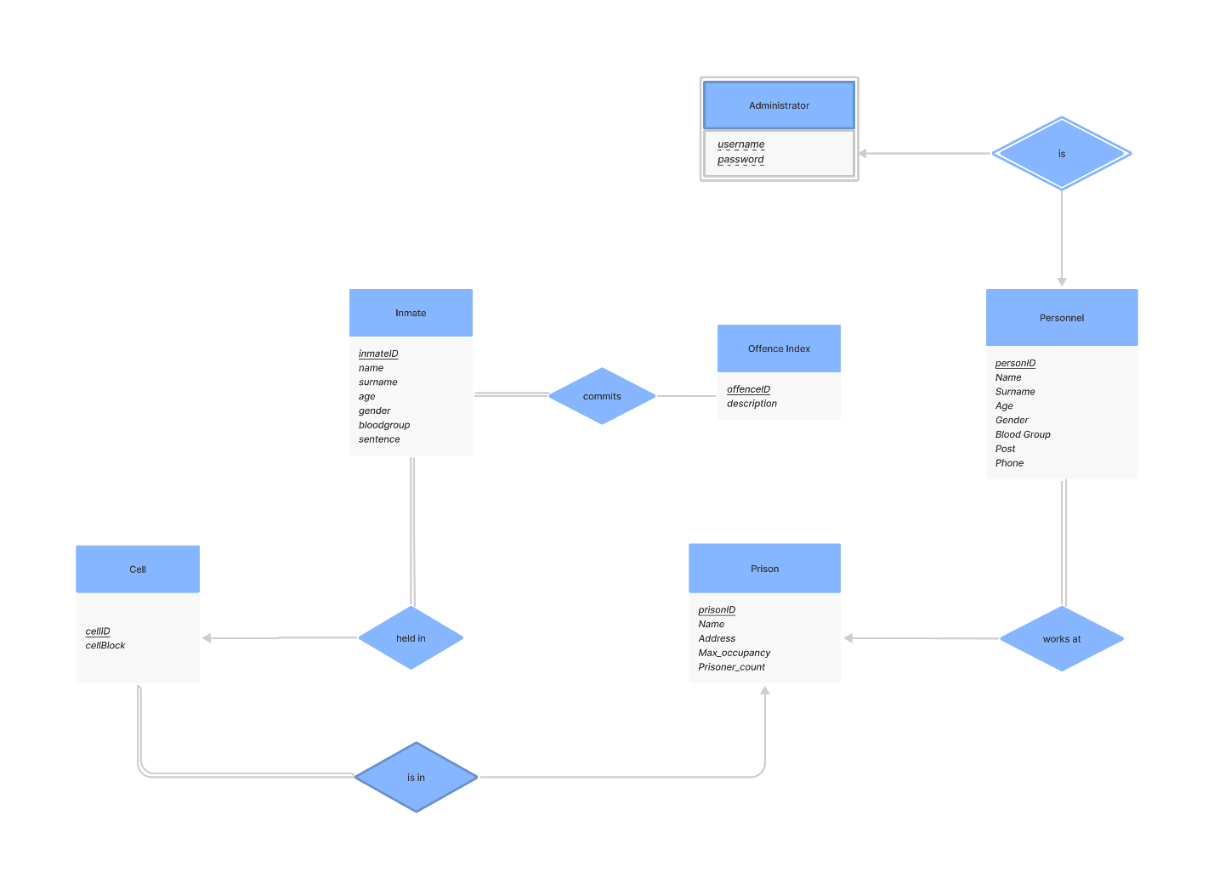**ER Diagram:**

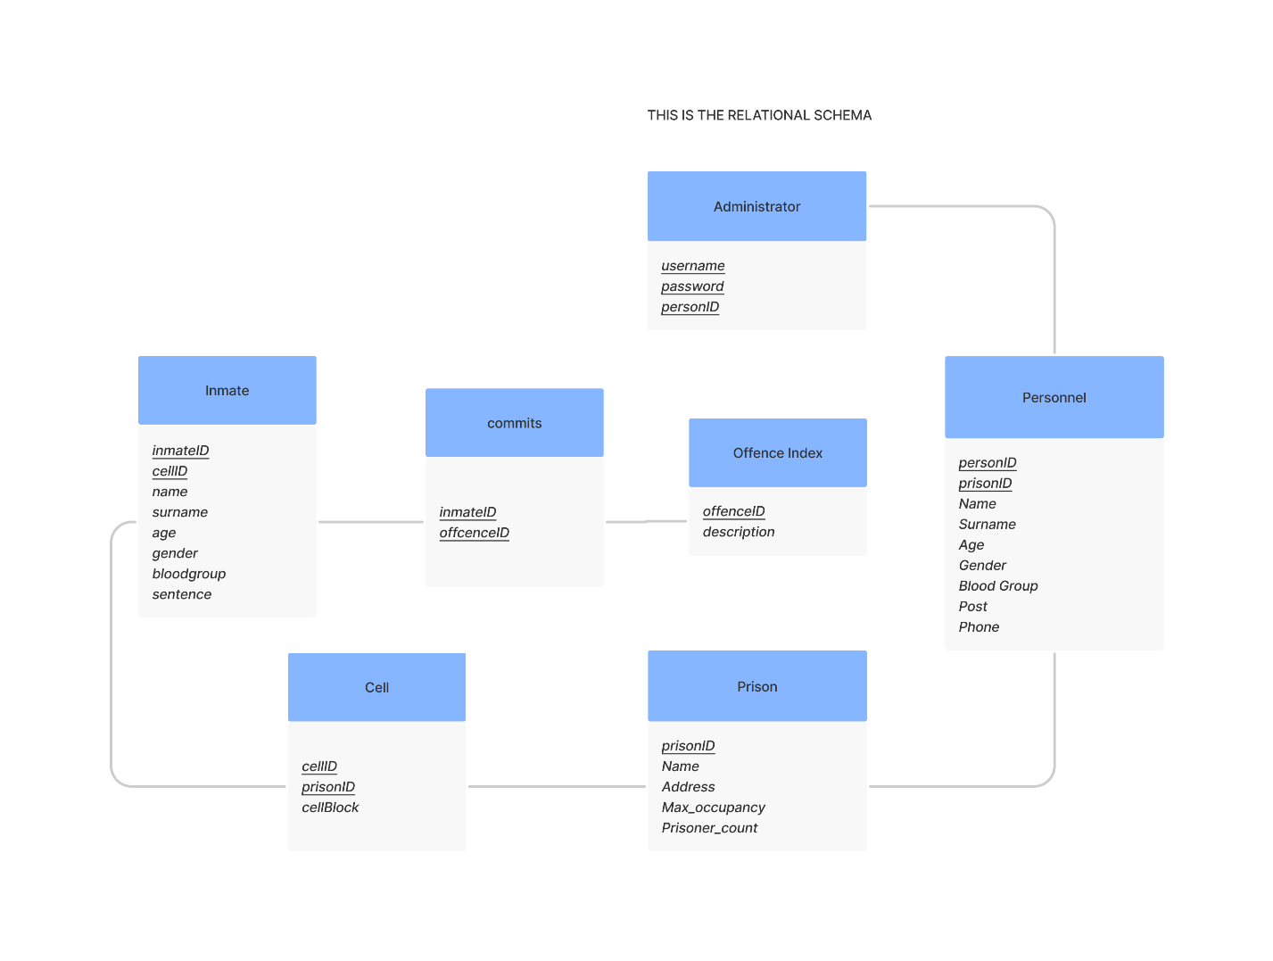**Relational Schema:**