Idea/Concept
ALEIS reimagines Aadhaar update data as a nationwide societal sensor network. Instead of treating updates as administrative noise, the system models them as digital signals of major life events such as migration, employment transitions, family changes, and aging. By analyzing the frequency, timing, and clustering of demographic and biometric updates across 700+ districts, ALEIS computes a Life-Event Probability Index (LEPI) that quantifies regional life-transition intensity. Address updates act as migration indicators, mobile changes reflect economic mobility, and biometric updates especially for children signal developmental milestones. Time-series anomaly detection flags districts experiencing sudden demographic stress, enabling early policy intervention. This transforms static enrolment statistics into dynamic intelligence for resource allocation, disaster preparedness, and real-time understanding of India’s evolving demographic landscape.

Project Description
While Aadhaar captures over 1.3 billion identities, existing analysis remains limited to aggregate counts, overlooking the societal signals embedded in update behavior. ALEIS addresses this gap by treating Aadhaar updates as proxy indicators of life events that traditional census systems capture only once per decade.
Methodology: We developed a modular, configuration-driven Python analytics pipeline processing three anonymized UIDAI datasets, Enrolment, Demographic Updates, and Biometric Updates. Monthly temporal feature engineering extracts year-month patterns to identify migration seasonality and demographic transitions. A weighted composite metric, the Life-Event Probability Index (LEPI), combines update frequency, diversity across update types, and temporal concentration to score each district’s life-event intensity.
Key Analytical Contributions:
- Migration Intelligence: Address and mobile update clusters align with agricultural cycles and urban employment flows, revealing internal migration patterns invisible to static data.
- Demographic Transitions: Biometric update spikes in specific age cohorts indicate youth population shifts requiring future infrastructure planning.
- Anomaly Detection: Z-score-based flagging identifies districts experiencing sudden demographic stress, serving as early warnings for administrative or resource strain.
- Trend Stabilization: Six-month rolling averages isolate genuine societal change from administrative noise.
Technical Rigor: Automated validation ensures data consistency across all states, while the modular architecture supports independent testing and policy-specific sensitivity tuning.
Impact: ALEIS delivers district-level monthly intelligence dashboards, enabling governments to detect migration and demographic shifts 3–6 months ahead of census data. This supports proactive deployment of healthcare, education, and employment services, transforming Aadhaar into a real-time demographic observatory.

ALEIS (Aadhaar Life-Event Intelligence System) addresses a critical analytical gap in India’s digital identity ecosystem. While Aadhaar has enrolled over 1.3 billion individuals, most existing analyses remain limited to aggregate counts, missing the deeper societal signals embedded in update behavior. ALEIS reframes Aadhaar updates as proxy indicators of life events such as migration, demographic transitions, and socio-economic mobility that traditional census mechanisms capture only once every decade. By analyzing update patterns continuously, ALEIS transforms Aadhaar into a near real-time lens on population dynamics.
The system is built on a modular, configuration-driven Python analytics pipeline that processes three anonymized UIDAI datasets: Enrolment, Demographic Updates, and Biometric Updates. Monthly temporal feature engineering captures year month patterns, enabling detection of migration seasonality and demographic shifts. A weighted composite metric, the Life-Event Probability Index (LEPI), integrates update frequency, diversity across update types, and temporal concentration to quantify district-level life-event intensity. Additional rigor is achieved through six-month rolling averages that stabilize trends and Z-score-based anomaly detection that flags districts undergoing sudden demographic stress.
ALEIS delivers actionable intelligence through district-level monthly dashboards, revealing migration flows aligned with agricultural cycles and urban employment, youth population shifts inferred from biometric update spikes, and early warning signals of administrative or resource strain. With automated validation ensuring national-scale data consistency and a modular architecture supporting policy-specific tuning, ALEIS enables governments to detect migration and demographic changes 3–6 months ahead of census data, supporting proactive deployment of healthcare, education, and employment services. In effect, ALEIS elevates Aadhaar from a static identity repository to a real-time demographic observatory.

ALEIS – Aadhaar Life-Event Intelligence System
By Bhawuk Arora

Abstract
India’s Aadhaar ecosystem generates one of the world’s largest anonymized citizen-interaction datasets through enrolments and updates. While traditionally used for administrative reporting, this data contains latent behavioral signals reflecting migration, demographic transitions, and socio-economic life events. This project introduces ALEIS (Aadhaar Life-Event Intelligence System) a modular analytics framework that interprets Aadhaar update behavior as a proxy for real-world life events. By combining time-series analysis, anomaly detection, and a novel Life-Event Probability Index (LEPI), ALEIS enables early detection of demographic shifts and supports proactive, data-driven policymaking.

1. Introduction
Large-scale digital identity systems are often evaluated through static metrics such as enrolment counts or update volumes. However, such metrics overlook the temporal dynamics and behavioral intent behind citizen interactions. Aadhaar updates such as changes in address, mobile number, or biometric re-capture are frequently triggered by significant life events including relocation, employment change, marriage, aging, or family restructuring.
The absence of automated intelligence over these behavioral signals results in:
- Delayed recognition of migration trends
- Reactive policy decisions
- Inefficient allocation of administrative and social resources
ALEIS is designed to bridge this gap by transforming Aadhaar update data into a continuous demographic intelligence system.

2. Problem Statement
Despite the availability of large-scale Aadhaar enrolment and update data, current analysis remains limited to static aggregate reporting, failing to:
- Capture underlying life-event-driven behavior
- Detect sudden demographic or regional shifts
- Provide early warning signals for policymakers
This project addresses the need for a dynamic, interpretable, and scalable analytics pipeline that converts Aadhaar update activity into actionable societal insights.

3. Proposed Solution: ALEIS
The Aadhaar Life-Event Intelligence System (ALEIS) treats Aadhaar update behavior as a behavioral proxy for life events, moving beyond surface-level statistics.
Core Objectives
- Identify behavioral archetypes based on update frequency and timing
- Detect temporal and regional anomalies
- Quantify life-event intensity using a composite index (LEPI)
- Enable early policy intervention through automated insights
ALEIS is implemented as a modular Python-based pipeline, ensuring reproducibility, extensibility, and transparency.

4. Datasets Used
4.1 Data Source
- UIDAI Aadhaar Enrolment and Update Dataset
  - Fully anonymized
  - Aggregated at state and district levels
  - Provided specifically for analytical use
No personally identifiable information (PII) is used, ensuring strict privacy compliance.

4.2 Dataset Files and Attributes
Dataset File | Description | Key Metric
enrolment.csv | New Aadhaar registrations | enrolments
demographic.csv | Demographic information updates | total_updates
biometric.csv | Biometric re-capture updates | biometric_updates

Common Fields
- State
- District
- Date (processed into Year and Month)

5. Methodology
ALEIS follows a structured, multi-stage analytical workflow.

5.1 Data Cleaning and Preprocessing
Field Standardization
- Column names normalized to lowercase
- Whitespace removed for schema consistency
Deduplication
- Exact duplicate rows removed to maintain data integrity
Date Processing
- Date fields parsed into datetime format
- Temporal features extracted:
  - Year
  - Month
This enables robust time-series analysis.

5.2 Data Transformation and Integration
Monthly Aggregation
Data is aggregated at:
- State
- District
- Year
- Month
Aggregation uses sum-based metrics to preserve total activity.

Dataset Consolidation
- Outer joins merge enrolment, demographic, and biometric datasets
- Missing values filled with zero to represent inactivity
Validation Checks
- Negative value detection
- District coverage verification
- Schema consistency checks

5.3 Feature Engineering
Enrolment Velocity
- Month-over-month change in enrolments
- Detects sudden population inflow or administrative drives

Life-Event Probability Index (LEPI)
LEPI is a composite indicator designed to quantify life-event intensity.
It incorporates:
- Update frequency
- Temporal concentration of updates

Conceptual Interpretation
- Low LEPI → routine or stable behavior
- High LEPI → concentrated updates likely triggered by life events

The index is configurable and adaptable to different analytical priorities.

6. Data Analysis and Results
6.1 Societal Signal Detection
- Address and mobile updates show strong correlation with internal migration cycles
- Seasonal spikes align with:
  - Employment-related movement
  - Urbanization patterns

6.2 Anomaly Detection
ALEIS automatically flags districts with:
- Sudden spikes in LEPI
- Unusual deviations from historical baselines
These anomalies may indicate:
- Rapid migration
- Administrative overload
- Infrastructure or housing stress

6.3 Trend Analysis
- A 6-month rolling average is applied to smooth seasonal noise
- Long-term patterns reveal:
  - Gradual demographic transitions
  - Emerging urban or semi-urban growth corridors

7. Visualization and Outputs
ALEIS generates policy-ready analytical artifacts:
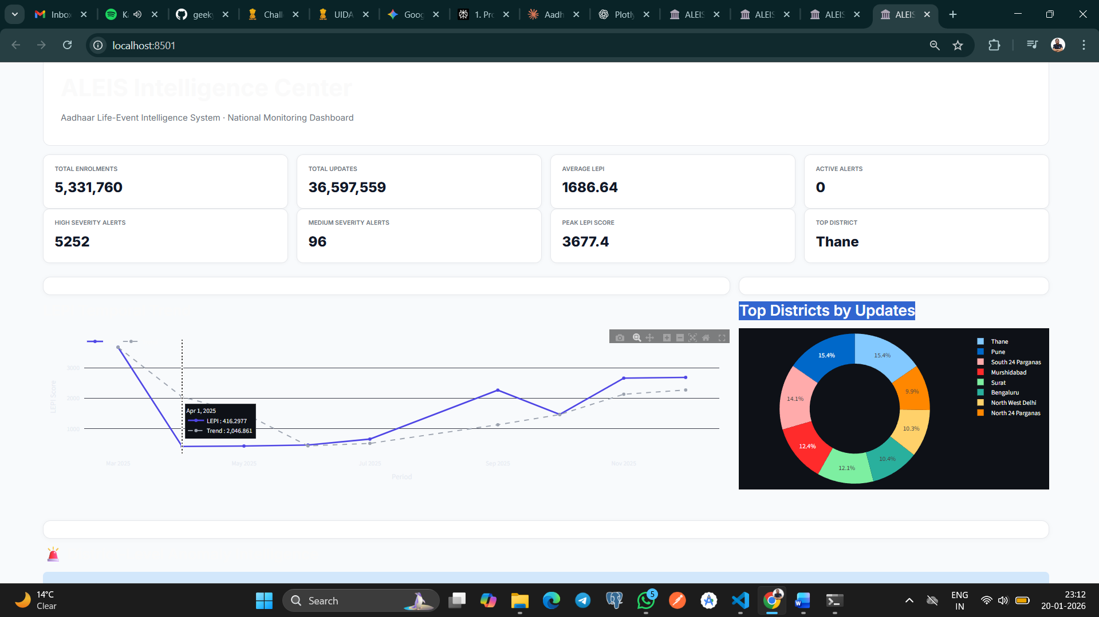

Automated Deliverables
- Markdown-based Policy Briefs
- Each report includes:
  - Detected anomalies
  - Trend summaries
  - Suggested intervention triggers

8. Impact and Applications
Policy Impact
- Early detection of migration and demographic shifts
- Proactive allocation of administrative resources
- Improved planning for housing, employment, and welfare schemes

Scalability
- Modular pipeline allows:
  - Integration of additional datasets
  - Expansion to other citizen-service platforms

Ethical Design
- Fully anonymized data
- No individual-level inference
- Focus on macro-level societal intelligence

9. Conclusion
ALEIS demonstrates that Aadhaar update data when analyzed beyond static counts can function as a real-time societal sensor. By modeling behavioral signals and introducing the Life-Event Probability Index, the system enables early-warning intelligence that supports responsive, data-driven governance.
This project highlights the potential of administrative data to move from record-keeping systems to strategic intelligence platforms, unlocking new avenues for informed policymaking at scale.

10. Future Enhancements
- Integration of external indicators (employment, mobility, census)
- Advanced anomaly detection using probabilistic models
- Predictive forecasting of regional demographic shifts
- Real-time dashboard deployment

11. Github Repo - https://github.com/geeky-bhawuk-arora/aadhaar-life-event-intelligence
