Exercise 4 – Permissions, cut, paste, sort

- In this exercise you will use the many file-processing tools you’ve learned.

  - Create a file called vendors.txt consisting of two colon-separated fields: the vendor number and vendor name:

1201:Cromwell Interiors 1221:Design Extras Inc. 1320:Piedmont Plastics Inc 1340:Morgan Catering Service Ltd. 1350:Pullman Elevators 1360:Johnson Office Products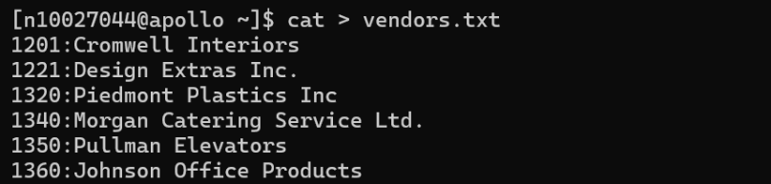

  - Create another file called products.txt consisting of three colon-separated fields: the product number, the product description, and the vendor number:

S0107:Lobby Furniture:1201 S0109: Ballroom Specialties:1221 S0110:Poolside Carts:1320 S0130:Formal Dining Specials:1340 S0201:Reservation Logs:1410

  - Use the cut, paste, and sort commands as follows to create a single-example vendor report:

    - Use the cut command to extract product descriptions and vendor numbers from the products files and store them in separate files called p1 and p2.
    - Extract vendor number and vendor names from the vendors file and store them in separate files called v1 and v2.
    - Use the paste command to combine v1 and v2 in v3
    - Use the paste command to combine p1 and p2 in p3
    - Sort and merge the v3 and p3 files using the sort command and send their output to the vrep file (which is the report)

  - Create two files called corp_phones1 and corp_phones2 consisting content below:
    - Type the following lines of text in corp_phones1, exactly as they appear. Press Enter at the end of each line:

219:432:4567:Harrison:Joel:M:4540:Accountant:09-12-1985 219:432:4587:Mitchell:Barbara:C:4541:Admin Asst:12-14-1995 219:432:4589:Olson:Timothy:H:4544:Supervisor:06-30-1983 219:432:4591:Moore:Sarah:H:4500:Dept Manager:08-01-1978 219:432:4527:Polk:John:S:4520:Accountant:09-22-1998

    - Type the following lines of text in corp_phones2, exactly as they appear. Press Enter at the end of each line:
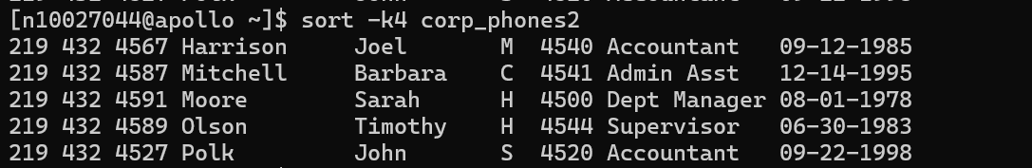

219 | 432 | 4567 Harrison Joel M 4540 Accountant 09-12-1985
219 | 432 | 4587 Mitchell Barbara C 4541 Admin Asst 12-14-1995
219 | 432 | 4589 Olson Timothy H 4544 Supervisor 06-30-1983
219 | 432 | 4591 Moore Sarah H 4500 Dept Manager 08-01-1978
219 | 432 | 4527 Polk John S 4520 Accountant 09-22-1998
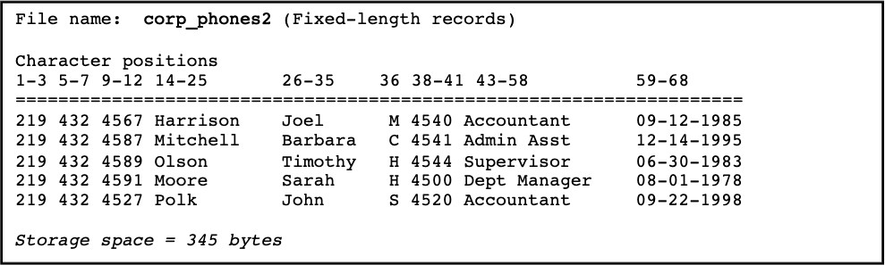

    - Sort corp_phones2 based on 4th column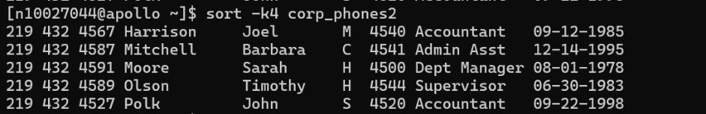
    - Sort corp_phones1 based on 5th column (put -t: to indicate the fields are delimited by colon) 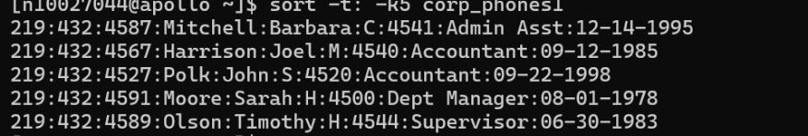
    - Output the number of lines, words and bytes contained in corp_phones1 and corp_phones2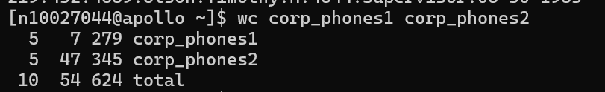

    - Cut the last_name and first_name from corp_phones2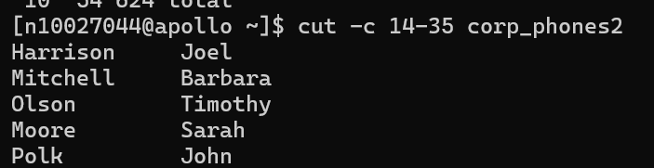

    - Cut the last-name and first_name from corp_phones1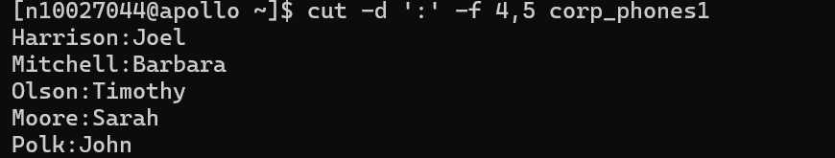

- Consider the following file listings.

  - What information does each listing provide?
  - if the file is a directory, explain how the permissions will affect its subdirectories.

- drwxr-xr-x 5 adeeb staff 4096 Mar 26 2014 public_html

d-directory
rwxr-xr-x-the owner can read, write and execute inside it, groups and others can read and execute but cannot create or modify.
5- 5 hard links
adeeb-owner, staff-group
4096- size in bytes
Mar 26 2014-last modified
public_html-name

- dr-x 6 adeeb staff 4096 Nov 18 2013 twelve
d-directory
r-x - owner can read and execute only while the group and others cannot access
6- 6 hard links
adeeb-owner, staff-group
4096- size in bytes
Nov 18 2013-last modified
twelve- name

- -rw 1 adeeb staff 2495 Sep 10 2013 who.txt
Regular file
1-1 hard link
adeeb-owner, staff-group
2495- size in bytes
Sep 10 2013 – last modified
who.txt - name

