Exercise 4a CPAN133- FALL 2026

- Create a directory called permissions_labs. Inside this directory, create these three files: file1.txt, file2.txt, and script.sh.
  - Check the permissions of the files.
  - What is the octal representation of each file's permission?
  - Use the chmod command to assign "-rw-r--r--" to file1.txt.
  - Make the file2.txt readable and writable only by the owner.
  - Make script.sh, executable by everyone and readable by everyone.
  - After each chmod command, run ls -l to verify the permissions.
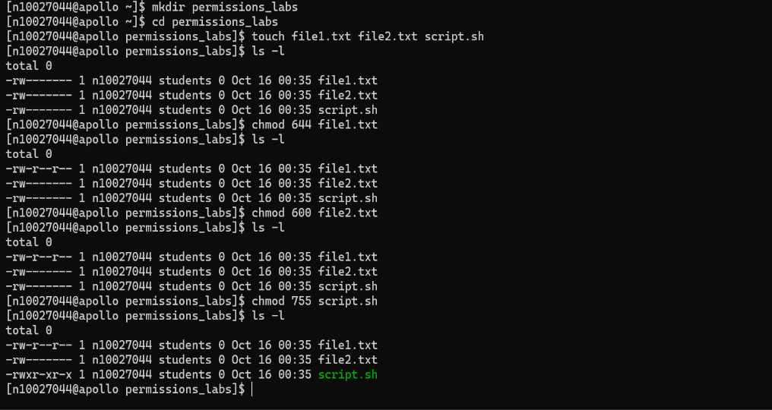
  - For each of above tasks, provide both an octal and symbolic chmod command.

- Assume that you want all users to have access to the corp_phones file. In this project, you first grant access to your home directory. Next, you allow access to the corp_db directory, and then set the permissions for everyone to read the corp_phones file. You use the chmod command with the x argument to grant access to directories.

To change file and directory permissions:
  - Make certain that you are in your home directory.
  - Type clear and press Enter to clear the screen.
  - Type chmod go+x ~ and press Enter to allow access to your home directory.
  - Type chmod ugo+x ~/corp_db and press Enter to allow access to the corp_db directory.
  - Type chmod o+w ~/corp_db/* and press Enter to set permissions so that others can write to the files in the corp_db directory.
  - Type ls -l ~/corp_db to check the permissions you have set.
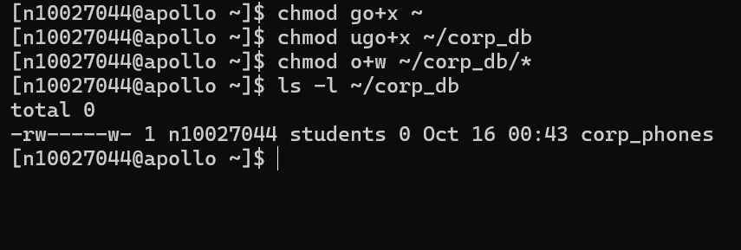

- Convert the following symbolic permissions to octal notation.

Symbolic Numeric

rwxr-xr-x 755
rw-r--r-- 644
rwx------ 700
rwxrwxr-- 774
r--r----- 440

