KWAME NKRUMAH UNIVERSITY OF SCIENCE AND TECHNOLOGY COLLEGE OF SCIENCE
FACULTY OF PHYSICAL AND COMPUTATIONAL SCIENCE


PROJECT DOCUMENTATION FOR CONSIDERATION UNDER
BACHELOR OF COMPUTER SCIENCE (BSc) PROGRAMME

PROJECT TITLE

Volunteer Matching Platform For Non-Profit Organizations SUBMITTED BY
Name Index Number

Dr. Supervisor (Supervisor)

Table of Contents

DECLARATION 4
ACKNOWLEDGEMENT 5
DEDICATION 6
ABSTRACT 7
CHAPTER ONE 8
INTRODUCTION 8
  - Problem Statement 8
  - Project Aims 8
  - Project objectives 8
    - Main Objective 8
    - Specific Objectives 8
  - Scope of project 9
  - Limitations of the project 9
  - Approach to Project summary of methodology 9
CHAPTER TWO 11
REVIEW OF LITERATURE AND TOOLS 11
  - Literature Review 11
  - Background Review 13
  - Review of Existing Applications 14
  - Problem Identification 14
  - Project Evaluation 14
    - System Functionalities 14
    - Results 15
  - Software Development Model 15
. 15
CHAPTER THREE 17
REQUIREMENTS SPECIFICATIONS 17
  - Requirements Gathering 17
  - Functional Requirements 17
  - Non-Functional Requirements 19
  - Development Requirements 19
  - System requirement 20
CHAPTER FOUR 21
SYSTEM DESIGN AND METHODOLOGY 21
  - Design 21
Fig 4.1 Workflow of System 23
  - Logical Diagrams 24
Fig 4.2 Entity Relation Diagram 24
CHAPTER FIVE 26
IMPLEMENTATION AND TESTING 26
  - Development Environment 26
    - Why Apache Server? 26
    - Why MySQL? 27
    - PHP Hypertext Preprocessor (PHP) as Server-side scripting language 28
Server-side scripting 29
  - Testing Methodology 31
  - Unit Testing 31
  - Integration Testing 32
  - Deployment 32
  - Summary 33
  - Conclusion 33
  - Recommendations 33
References 38

DECLARATION
Except for appropriately acknowledged specific references, we affirm that this work stems from our own research and has not been submitted, either in part or whole, for any other degree elsewhere.

Signature …………………………………….. Date …………………………………… (Candidate)

Signature …………………………………….. Date …………………………………… (Candidate)

Signature …………………………………….. Date …………………………………… (Supervisor)

ACKNOWLEDGEMENT
We express our gratitude to the Almighty God for granting us the strength and wisdom to successfully complete this project.
We also extend heartfelt appreciation to our project supervisor, Prof. Yaw Marfo Missah, for providing us with the opportunity to pursue this project with his approval and support.
We also want to extend a special thank you to all who supported us during this challenging period.

DEDICATION
We dedicate this project to our supervisor, Prof. Yaw Marfo Missah. May God Almighty reward him abundantly.

ABSTRACT

The Volunteer Matching System was created as an interactive tool to connect volunteers with non- profit organizations. Volunteers can use the system to discover and apply for opportunities that match their skills, interests, and availability. Likewise, non-profit organizations can utilize the system to post and oversee volunteer opportunities, making it easier to attract and recruit volunteers for their various projects.
Through this system, volunteers are able to easily find ways to contribute meaningfully to their communities, while non-profit organizations can streamline their volunteer recruitment processes, ultimately strengthening their ability to accomplish their goals. This ongoing engagement creates a cooperative environment where both volunteers and organizations can prosper.

CHAPTER ONE

INTRODUCTION

Problem Statement

Non-profit organizations often face challenges in recruiting and managing volunteers due to a lack of resources, time, and efficient systems. Volunteers, on the other hand, struggle to find suitable opportunities that align with their skills, interests, and availability. This disconnects results in underutilized volunteer potential and unmet needs within non-profits.

Project Aims

A Volunteer matching platform for non-profit organizations is needed:

- to connect non- profit organizations and volunteers.

- to provide a varied opportunities for volunteers.

- to promote volunteering opportunities.

Project objectives:

Main Objective

The main objective of this project is to create a volunteer matching platform that will connect volunteers to organizations. The platform allows non-profit organizations to sign-up and upload their volunteer opportunities.

Specific Objectives

- To allow non-profit organizations to publish their opportunities.

- To make it easier for volunteers to find opportunities.

- To host many non-profit organizations to provide varied opportunities to volunteers.

Scope of project

The initial scope includes the development of a web-based platform with core features for user registration, opportunity posting, and matching. Future expansions may include mobile app development, additional languages, and advanced analytics for non-profits.

Limitations of the project

The system does not have a search facility and advanced filter which can be considered in future enhancement.

Approach to Project summary of methodology

Agile development methodology, which is typified by iterative cycles of planning, development, testing, and review, will be applied to the project. Because of its adaptability to changing requirements and the rapid speed at which software is developed, this approach is preferred.
Feedback from stakeholders will be integrated on a regular basis to make sure the platform fulfills user needs and expectations. Gathering requirements is the first step in the process, during which user needs for the software are gathered and prioritized. The development team then moves on to planning, where they lay out a schedule for software delivery that includes the features that will be included in each iteration. During the development phase, the software is

built iteratively and frequently. The software is rigorously tested after development is finished to make sure it satisfies user needs and maintains a high standard.

CHAPTER TWO

REVIEW OF LITERATURE AND TOOLS

Literature Review

Platforms for matching volunteers with nonprofit organizations in need of assistance have grown to be indispensable resources for bringing together people looking to give their time and talents. These platforms use technology to make this connection easier, resulting in a productive and successful volunteer ecosystem.

As previously mentioned, the Volunteer Matching System is an interactive tool that helps close the gap between volunteers and nonprofit organizations. The platform is used by volunteers to find and apply to opportunities that fit their schedules, interests, and skill set. In turn, nonprofit organizations have the ability to advertise and oversee volunteer opportunities, which helps them draw in and find volunteers for a variety of initiatives. This dual functionality facilitates a mutually beneficial relationship by streamlining the recruitment process for organizations as well as making it easier for volunteers (Volunteer Matching System, n.d.).

According to research, volunteer matching platforms offer a centralized and intuitive interface for finding opportunities, which greatly improves the volunteer experience (Gottlieb & Gillespie, 2008).

Volunteers can make sure their time and efforts are put to good use by filtering opportunities according to their preferences. Higher satisfaction and retention rates among volunteers are frequently the result of this accessibility and compatibility with personal interests (Handy & Srinivasan, 2005)

Volunteers can make sure their time and efforts are put to good use by filtering opportunities according to their preferences. Higher satisfaction and retention rates among volunteers are frequently the result of this accessibility and compatibility with personal interests.

A 2009 study by Brudney and Meijs found that these kinds of systems can greatly lessen an organization's administrative workload, freeing them up to concentrate more on their primary goals. Furthermore, focusing on volunteers with particular skills improves the efficacy of volunteer programs and raises the possibility that a project will be completed successfully (Cnaan & Cascio, 1998).

Platforms for matching volunteers are also essential for encouraging community involvement. These systems encourage more people to engage in community service by removing obstacles to volunteerism. In addition to helping the organizations and people directly involved, this increased participation makes the community as a whole more cohesive and engaged (Snyder & Omoto, 2008). Stronger community ties and a more active civil society result from the continuous involvement that these platforms enable, which fosters a cooperative environment where volunteers and organizations can flourish (Volunteer Matching System, n.d.).

In conclusion, volunteer matching platforms are revolutionary instruments that boost the effectiveness of nonprofit organizations and the volunteer experience. These platforms increase the ability of both organizations and volunteers to accomplish their objectives by making it simpler for volunteers to find opportunities that fit their needs and for organizations to find qualified volunteers. The community as a whole gains from the cooperative atmosphere that results, encouraging increased participation and cooperation.

Background Review

Many volunteer organizations want ways to connect to people and one way to achieve that is by utilizing an online platform that allows users to explore various volunteer opportunities. Such platforms can be built as web applications that run on the internet. A web application is a program that is stored on a remote server and delivered over the internet with the use of a web browser. It consists of web pages that are created using scripting tools and markup languages.
The web pages are often made user friendly and interactive. A good web design is a very important feature of a good website. At present, volunteer organizations and volunteering opportunities are increasing with increase in people who are looking for volunteer opportunities. However, volunteering organizations find it difficult to reach out to a wide range of people since there are not enough online platforms that connect a lot of volunteers to a particular platform.
Volunteers on the other hand sometimes do not know where to go to get access to these opportunities. The system will help them get varied access to many organizations for opportunities.
There seems to be a gap between organizations finding volunteers and volunteers finding opportunities and hence the need to bridge them through our system.

Review of Existing Applications

Major challenges of existing systems are outlined below:

- Most systems are specific to a particular organization.

- Some organizations do not have online means of getting people.

- There are not many platforms to connect many organizations on one platform.

- Volunteers are limited in their access to opportunities.

Problem Identification

In the modern era of technology, volunteer groups are increasingly looking for effective methods to engage with potential volunteers. Despite the growing availability of volunteer positions and the increasing number of individuals interested in volunteering, there remains a significant disconnect between organizations and volunteers. Existing online platforms often have limited scope, focusing mainly on individual organizations rather than providing a central space for a variety of opportunities. Many organizations do not have an online presence at all, further limiting their ability to reach a wider audience. As a result, volunteers encounter difficulties in finding a diverse range of opportunities. This discrepancy highlights the necessity for a comprehensive web application that can bridge the gap between volunteers and organizations, offering a user-friendly, interactive platform that connects multiple organizations and enables easy access to volunteering opportunities.

Project Evaluation

System Functionalities

The Volunteer matching platform will perform the following functions:

      - Users can access the system from anywhere through the internet.

      - Non-profit organizations can publish their volunteer opportunities.

      - Volunteers can search for volunteer opportunities and can apply for them.

      - Users can sign-up as volunteers or volunteering organization.

      - Users would login with their username and password.

Results

When the system is successfully developed, tested and deployed;

Users can create an account and login with their predefined authentication. Users can search or apply for volunteer opportunities. Admins (non- profit organizations) can publish their volunteer opportunities.

Software Development Model

The project will follow an Agile development methodology, with iterative cycles of planning, development, testing, and review. This is because agile development is widely used by software development teams and is considered to be a flexible and adaptable approach to software development that is well-suited to changing requirements and the fast pace of software development. Regular feedback from stakeholders will be incorporated to ensure the platform meets user needs and expectations.

Requirements gathering
Planning

15

Development

Agile Software Development

- Requirements gathering: the user’s requirements for the software are gathered and prioritized.

- Planning: The development team creates a plan for delivering the software, including the features that will be delivered in each iteration.

- Development: The development team works to build the software, using frequent and rapid iterations.

- Testing: The software is thoroughly tested to ensure that it meets the customer’s requirements and is of high quality.

- Deployment: The software is deployed and put into use.

- Maintenance: The software is maintained to ensure that it continues to meet the customer’s needs and expectations.

CHAPTER THREE

REQUIREMENTS SPECIFICATIONS

Requirements Gathering

These are requirements derived from research and represent the functionality that needs to be included in the Volunteer matching platform. These requirements have been selected when:
- The functions found have been in the majority of existing volunteering platforms.

- If a function can be logically combined with another.

- When a requirement or function is a logical choice for inclusion.

Functional Requirements

- The platform must be easy to use for non-expert users

This can be achieved by having a simplified back-end, combining functions where possible. A WYSIWYG editor also allows users to edit a Webpage as if they are using word processing software such as Microsoft Word.

Have a login system for administrative users of the platform.

Protecting the back-end of the volunteer matching platform is vital to ensure that unauthorized changes are not made. This will be done by having a PHP script that checks the session of the user when accessing the back-end. The user will not be able to view any of the management area without being logged in. They will also be redirected to a login page if they are not logged in.

Users must be able to logout of their current session

Logging out of the session is equally as important because without it, the user has to wait for the session to finish. In that time they could leave their machine logged in and unattended. A logout PHP script will be included that ends the user’s session when they logout.

Create other administrative users of the platform

Being able to create new users is another requirement that is necessary in order to allow for organizations and individuals to join. More users will then mean that there are more organizations and individuals, increasing volunteer opportunities on the platform. This will be done by entering values for: first name and last name/ organization name, email, and password. These values are taken and stored in a database.

Ability to change own password on user account

Two user accounts (volunteer account and organization account) page will be included that displays the user’s details and allows them to edit their password.

Input and edit volunteer opportunities

Organizations will be able publish a new volunteer opportunities to be displayed on the website. This will be done by populating text boxes and text areas in a form. When created, the opportunities can be updated by the organizations by editing a populated form.

Delete volunteering opportunities

The option to delete a finished volunteering project will be made possible in the back-end. When the option to delete has been selected, the entry will be deleted from the database. This will allow organizations to delete out of date volunteer opportunities.

Create a basic and minimalistic design website

The website will not be too complex to interact with. It will provide the basic and minimalistic design.

Non-Functional Requirements

- Usability: Non-expert users must find the platform easy to use. This can be accomplished by streamlining the back end and, when practical, merging functions. To enable users to edit web pages as though they were using word processing software like Microsoft Word, a WYSIWYG editor ought to be included.

- Security: To guarantee that unauthorized changes are not made, the platform needs an encrypted administrative user login process. When a user accesses the back end, a PHP script will verify their session. Users who are not authorized will be sent to a login page.

Development Requirements

1. Content to be accessed from and stored in a Database

The content will be stored separately from the presentation using a Relational Database Management System (RDBMS) MySQL which is administered using phpMyAdmin. This is a widely used RDBMS that is also free to use.

System requirement

Software Requirement | Specification
Operating System | Windows 7 or later
Interpretation language | HTML5
RDBMS | MySQL administered by phpMyAdmin
Server-side Scripting  language | PHP
Web Server | Apache Web Server
Integrated Development  Environment | Adobe Dreamweaver Creative Cloud  Visual Studio Code
Package | Cross Platform Apache MySQL PHP Package (XAMPP Server Package)
Browser | Mozilla Firefox, Google Chrome, Edge, Safari
Hardware Requirement | Specification
Processor | 2.4GHz
RAM | 2 GB
Hard Drive | 40 GB HDD

CHAPTER FOUR

SYSTEM DESIGN AND METHODOLOGY

Design

The purpose of System Design is to create a technical solution that satisfies the functional requirements for the system.
This project mainly aims to deal with the operations of a Volunteer Matching Platform. It consists of two modules.
- Admin Area for opportunities upload

- Public View for exploring volunteer opportunities

The following elements are created for the Admin Area:

- Login page: A login page is provided to ensure authentication with username and password.

- Content creation form: This page allows the creation of content cards. Content contains a descriptive image, volunteer opportunity title, duration, description, volunteer type and volunteer category.
- Logout Option: This allows users to logout after performing desired operations.

The following elements are created for the Public View.

The front-end is the part of the web application that is visible to the public through the page’s Uniform Resource Locator (URL).

- Navigation: To allow users access pages, the page was organized into various parts. It consists of a navigation bar, content area and footer. A logo is displayed on the top left of the page that links the site home page. This allows users to quickly navigate to the home page from anywhere in the site.

Volunteer View Admin Area

-Homepage

- Sign Up page

- Sign in as volunteer

- Logout
Sign up as volunteer

- first name field

- last name field

- email

- password field

- country
- Homepage

- Sign Up page

- Sign in as organization
Successful login
Volunteer Opportunities
Content Creation
Sign up as volunteer

- first name field

- last name field

- email

- password field

- country

- organizati2o2n
- Volunteer opportunity creation form

Fig 4.1 Workflow of System

  - Database Design

The database is designed using the mysql database. The database consists of the users, subjects and pages tables.
    - Data Dictionary Table 4.1 project table
Column | Type | Null | Default | Links to
project_id (Primary) | int(6) | No
project_image | varchar(255) | Yes | NULL
project_title | varchar(255) | No
project_type_id | varchar(2) | No |  | project_type -> project_type_id
project_duration | varchar(10) | No
project_category_id | varchar(2) | No |  | project_category -> project_category_id
project_description | text | No
project_cause_id | varchar(2) | No |  | project_cause -> project_cause_id

Table 4.2 project_category table

Column | Type | Null
project_category_id (Primary) | varchar(2) | No
project_category_name | varchar(40) | No

Table 4.3 project_cause table

Column | Type | Null
project_cause_id (Primary) | varchar(2) | No
project_cause_name | varchar(40) | No

Table 4.4 project_type table

Column | Type | Null
project_type_id (Primary) | varchar(2) | No
project_type_name | varchar(12) | No

Table 4.5 users table

Column | Type | Null
user_id (Primary) | int(11) | No
first_name | varchar(40) | No
last_name | varchar(40) | No
email | varchar(40) | No
phone | varchar(13) | No
pwd | varchar(40) | No
country | varchar(40) | No
user_type | varchar(12) | No

Logical Diagrams

Fig 4.2 Entity Relation Diagram

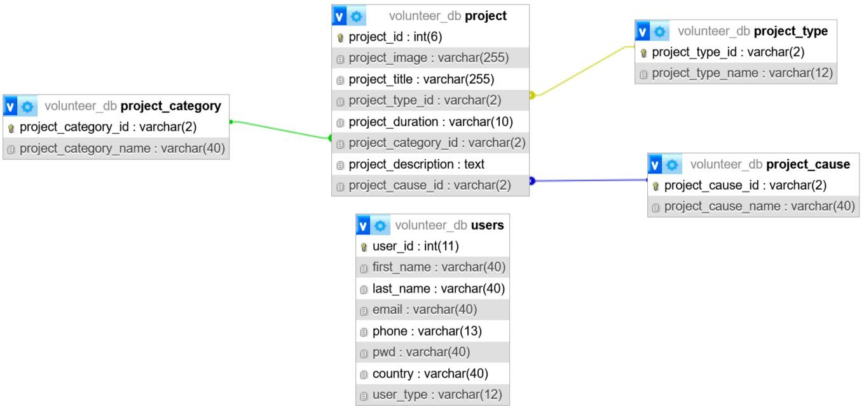

Volunteer Matching
System
CONTENT
AUTHOR
SITE VISITORS

CHAPTER FIVE

IMPLEMENTATION AND TESTING

Development Environment

There are several tools and methods that are required in order to develop a web application. Few of the major web development platforms available are the LAMP (Linux Apache MySQL PHP) stack, WAMP (Windows Apache MySQL PHP), XAMPP (Cross-Platform Apache MySQL PHP Perl), Microsoft's .NET framework and Java's J2EE. Among the choices, XAMPP Server package stands out as the popular cross-platform option and free open-source platform that is not limited to one particular operating system. Its cross-platform support makes it the best option for teams or individuals working across different operating systems.
XAMPP Server is a cross-platform development environment which stands for Cross-Platform Apache MySQL PHP Perl.
XAMPP Server package consist of Apache server, MySQL database with PHP as a server-side scripting language.

Why Apache Server?

There are several web server software available and these include the Apache server, Microsoft’s IIS amongst others. The Apache Server has been chosen as the server software for this project.
The Apache HTTP Server commonly referred to as Apache, is web server software notable for playing a key role in the initial growth of the World Wide Web. In 2009, it became the first web server software to surpass the 100 million website milestone. Apache was the first viable alternative to the Netscape Communications Corporation web server (currently named Oracle

iPlanet Web Server), and since has evolved to rival other web servers in terms of functionality and performance.
Apache is developed and maintained by an open community of developers under the auspices of the Apache Software Foundation. The application is available for a wide variety of operating systems, including Unix, FreeBSD, Linux, Solaris, Novell NetWare, Mac OS X, Microsoft Windows, OS/2, TPF, and eComStation. Released under the Apache License, Apache is open- source software. As of May 2023, Apache was estimated to serve 26.8% of all active websites which comes in second place after nginx 38.77%.
Apache remains a platform upon which individuals and institutions can build reliable systems, both for experimental purposes and for mission-critical purposes [1].

Why MySQL?

MySQL will be used create the database at the backend. MySQL has been chosen as the backend database. This is due to the reasons outlined below.
The MySQL database has become the world's most popular open source database because of its high performance, high reliability and ease of use. It is also the database of choice for a new generation of applications built on the LAMP stack (Linux, Apache, MySQL, PHP / Perl / Python). Many of the world's largest and fastest-growing organizations including Facebook, Google, Adobe, Alcatel Lucent and Zappos rely on MySQL to save time and money powering their high- volume web sites, business-critical systems and packaged software. MySQL runs on more than 20

platforms including Linux, Windows, Mac OS, Solaris, IBM AIX, giving you the kind of flexibility that puts you in control. Whether you're new to database technology or an experienced developer or Database Administrator (DBA), MySQL offers a comprehensive range of database tools, support, training and consulting services to make you successful [2].

PHP Hypertext Preprocessor (PHP) as Server-side scripting language

The server-side scripting language that would be used in this project is PHP.

PHP is a widely used general-purpose scripting language that is especially suited for Web development and can be embedded into HTML.
PHP is a general-purpose scripting language that is especially suited to server-side web development where PHP generally runs on a web server. Any PHP code in a requested file is executed by the PHP runtime, usually to create dynamic web page content or dynamic images used on Web sites or elsewhere.
PHP is mainly focused on server-side scripting, so you can do anything any other CGI program can do, such as collect form data, generate dynamic page content, or send and receive cookies and much more.
There are three main areas where PHP scripts are used: server-side, command line scripting, and writing desktop applications. For the purpose of this project, emphasis will be laid on server-side scripting

Server-side scripting

This is the most traditional and main target field for PHP. Three things are needed to make this work. The PHP parser (CGI or server module), a web server and a web browser. You need to run the web server, with a connected PHP installation. You can access the PHP program output with a web browser, viewing the PHP page through the server. All these can run on your home machine if you are just experimenting with PHP programming.

Reasons for using PHP
PHP is available free of charge, and the PHP Group provides the complete source code for users to build, customize and extend for their own use.
PHP can be used on all major operating systems, including Linux, many Unix variants (including HP-UX, Solaris and OpenBSD), Microsoft Windows, Mac OS X, RISC OS, and probably others.
PHP also has support for most of the web servers today. This includes Apache, IIS, and many others.
With PHP, you have the freedom of choosing an operating system and a web server. Furthermore, you also have the choice of using procedural programming or object oriented programming (OOP), or a mixture of them both.
With PHP you are not limited to output HTML. PHP's abilities include outputting images, PDF files and even Flash movies (using libswf and Ming) generated on the fly. You can also output easily any text, such as XHTML and any other XML file. PHP can autogenerate these files, and save them in the file system, instead of printing it out, forming a server-side cache for your dynamic content.

One of the strongest and most significant features in PHP is its support for a wide range of databases. Writing a database-enabled web page is incredibly simple using one of the database specific extensions (e.g., for mysql), or using an abstraction layer like PDO, or connect to any database supporting the Open Database Connection standard via the ODBC extension. Other databases may utilize cURL or sockets, like CouchDB [3].
For the front-end , HTML, CSS, and Boostrap would be used

HTML (HyperText Markup Language) is fundamental to web development as it provides the structure and content of a web page. It allows developers to define elements like headings, paragraphs, links, images, and other multimedia content, ensuring that web pages are both readable and navigable [4].
CSS (Cascading Style Sheets) is used to control the presentation and layout of web pages. It allows developers to apply styles such as fonts, colors, spacing, and positioning, ensuring that websites are visually appealing and user-friendly. According to W3Schools, CSS is essential for defining the visual presentation of web content, making it easier to create visually attractive and responsive web designs.
Using Bootstrap for web design provides a responsive grid system that automatically adjusts the responsive layout based on the screen size, ensuring your website looks great on various devices.
Bootstrap offers a wide range of pre-built components, such as navigation bars, forms, buttons, and more, saving you time and effort in coding from scratch.
Bootstrap is easy to learn and implement, making it accessible to both beginners and experienced developers.

Bootstrap's extensive customization options also allow you to personalize the appearance and style of your website.
Being open-source and free, Bootstrap provides a cost-effective solution for web designers [5].

Testing Methodology

There are many strategies that can be used to test software. At one extreme, software team could wait until the system is fully constructed and then conduct test on overall system in hopes of finding errors. This approach, although appealing, simply does not work. It will result in buggy software that disappoints the customer and end-user. At the other extreme, a software engineer could conduct tests on a daily basis, whenever any part of the system is conducted. This approach, although less appealing to many, can be very effective.
A testing strategy that is chosen by most software teams falls between the two extremes. It takes an incremental view of testing, beginning with the testing of individual program units, moving to tests designed to facilitate the integration of the units, and culminating with tests that exercise the constructed system.

Unit Testing

Unit testing focuses verification effort on the smallest unit of software design-the software component or module. Using the component-level design description as a guide, important control paths are tested to uncover errors within the boundary of the module. The relative complexity of tests and the errors those tests uncover is limited by constrained scope established for unit testing. The unit test focuses on the internal processing logic and data structures within the boundaries of a component. This type of testing can be conducted in parallel for multiple components.

Integration Testing

It is a systematic technique for constructing the software architecture while at the same time conducting tests to uncover errors interfacing. The objective is to take unit tested components and build a program structure that has been dictated by design.
In ‘volunteer matching platform, following the top down integration, all pages are integrated by moving downward through the control hierarchy, beginning with the main control page.
In ‘volunteer matching platform, following the bottom up integration, low-level components is combined into clusters that perform a specific software sub function, these clusters are then tested and combined moving upward in the programmed structure.

Deployment

- Overview of Deployment: The Volunteer Matching System is deployed by putting it into use in a real-world setting after extensive testing to make sure it satisfies quality requirements. This plan describes the testing procedures, roles, and deployment methods to guarantee a seamless transfer from development to live operation.

Objectives for Deployment:

  - to successfully implement the Volunteer Matching System in a production setting.

  - to confirm that every system component is in good working order and complies with the criteria.
  - to offer an organized method for post-deployment support, integration, and testing.

Summary

The volunteer matching platform for non-profit organizations is a web application that can be easily adopted by non-profit organizations to help them with publishing volunteer opportunities. The volunteer matching platform provides a simple to use, secured, reliable and efficient system that can be used in order to ensure effective content management.

Conclusion

In conclusion, this project has been a success. This is because all of the project objectives have been completed. Firstly, requirements for a volunteer matching platform were derived by researching into required functionality. This research was done by analyzing existing websites. A set of requirements were then created and implemented in the development of the system. The system was then tested against the requirements and found to be successful when compared to the test cases and requirements.

Recommendations

    - Future Enhancement

The system will be provided with enhanced filtering and search facility.

Sample Screenshots Homepage
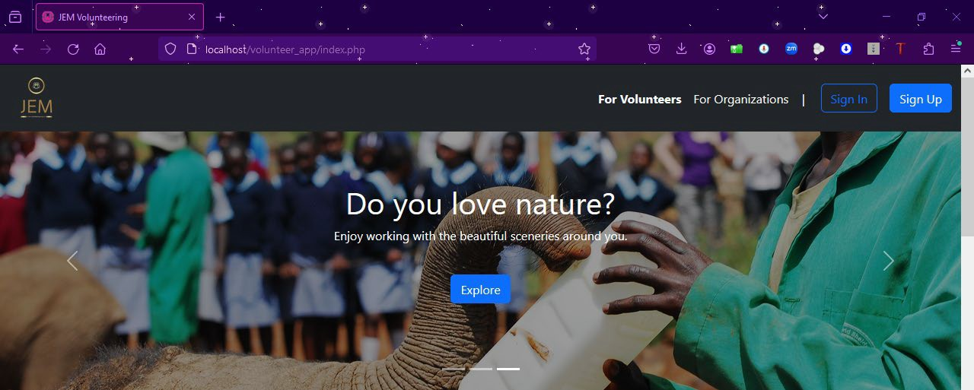
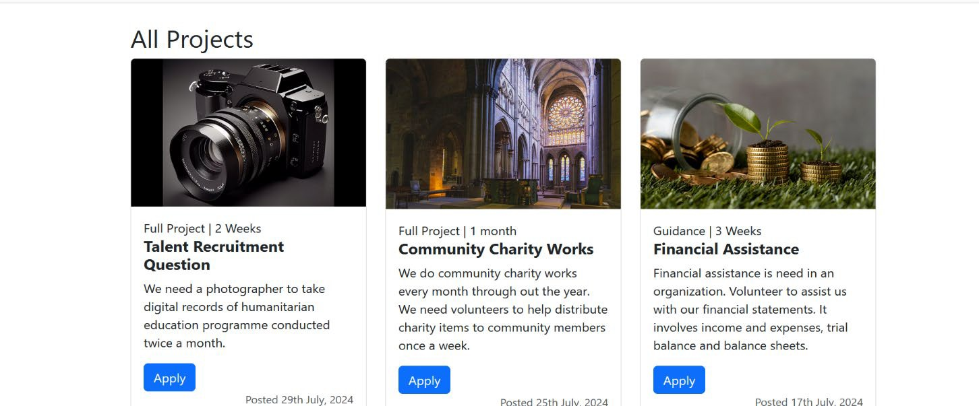

Sign Up Page
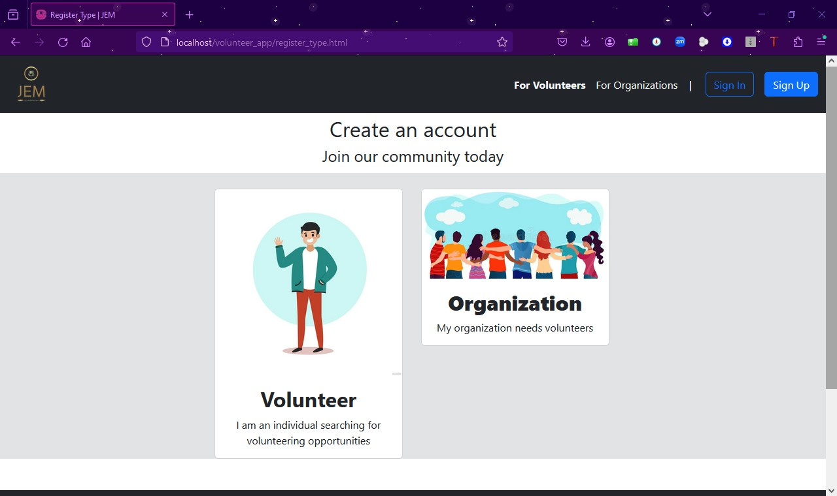

Volunteer Sign Up
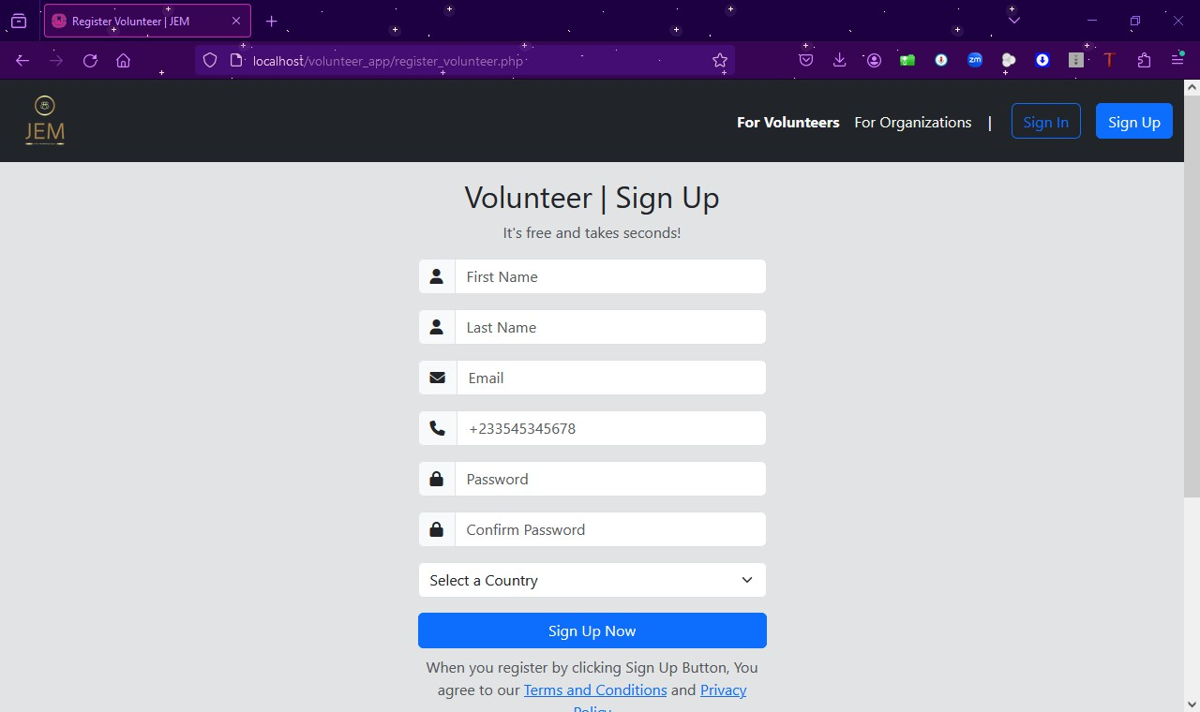

Organization Sign Up

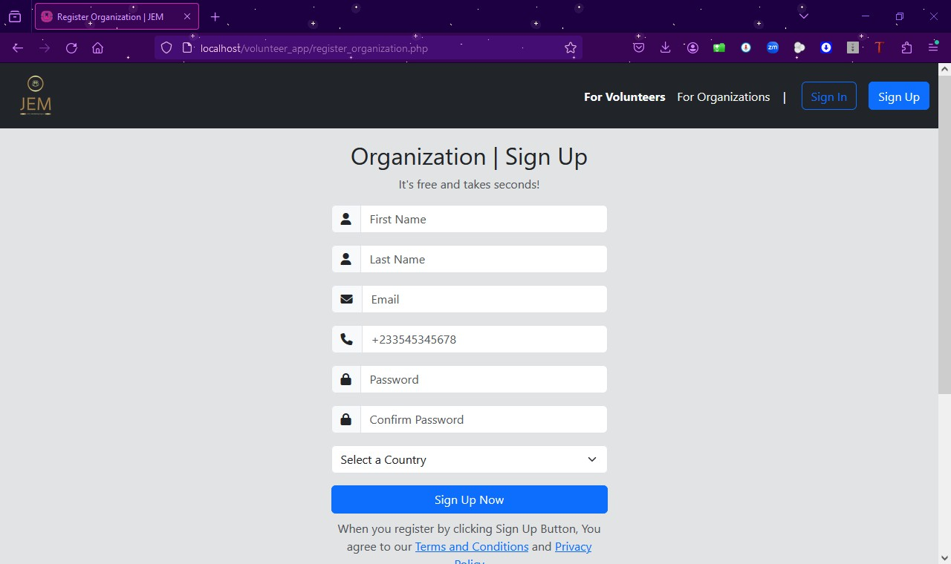

Upload Volunteering Opportunities Page
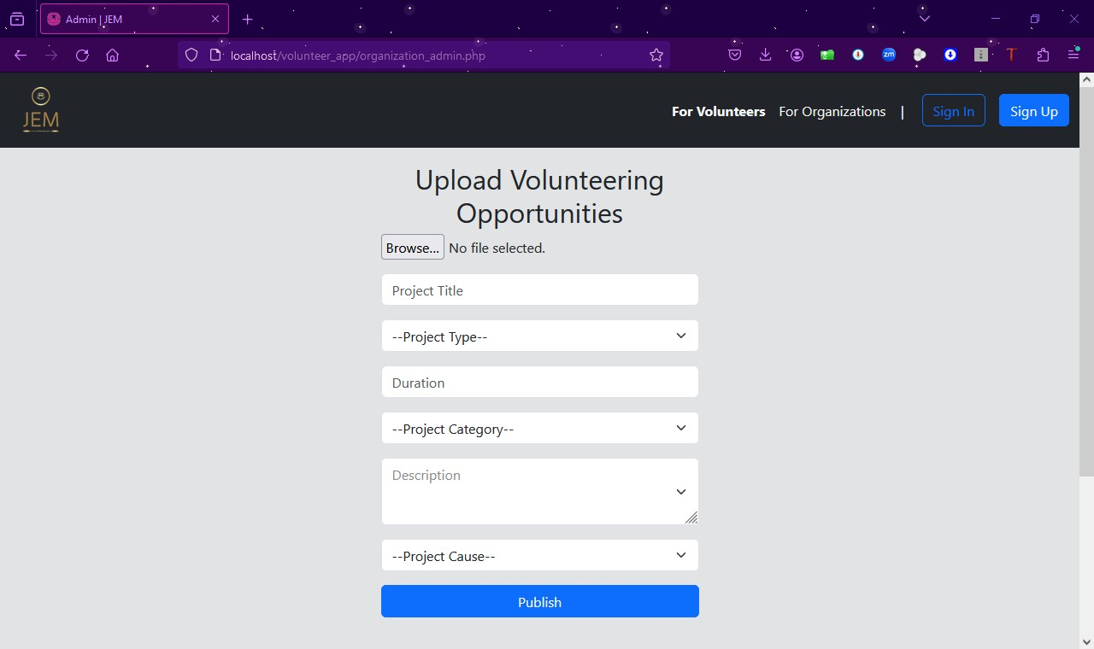

References

      - https://webhostinggeeks.com/blog/apache-http-server-explained/ , accessed July 2024

      - https://www.mysql.com/why-mysql/, accessed July 2024

      - https://www.php.net/ and https://en.wikipedia.org/wiki/PHP, accessed July 2024

      - https://developer.mozilla.org/en-US/, accessed July 2024

      - https://www.clarity-ventures.com/blog/benefits-of-using-bootstrap-for-web-design,

accessed July 2024

      - Brudney, J. L., & Meijs, L. C. P. M. (2009). It Ain't Natural: Toward a New (Natural) Resource Conceptualization for Volunteer Management. Nonprofit and Voluntary Sector Quarterly, 38(4), 564-581. https://doi.org/10.1177/0899764009333828
      - Cnaan, R. A., & Cascio, T. A. (1998). Performance and Commitment: Issues in Management of Volunteers in Human Service Organizations. Journal of Social Service Research, 24(3-4), 1-37. https://doi.org/10.1300/J079v24n03_01
      - Gottlieb, H., & Gillespie, D. F. (2008). Volunteer Match: Recruiting and Managing Volunteers for Service. Human Service Organizations: Management, Leadership & Governance, 32(4), 274-286. https://doi.org/10.1080/23303131.2008.9686122
      - Handy, F., & Srinivasan, N. (2005). The Demand for Volunteer Labor: A Study of Hospital Volunteers. Nonprofit and Voluntary Sector Quarterly, 34(4), 491-509. https://doi.org/10.1177/0899764005278037
      - Snyder, M., & Omoto, A. M. (2008). Volunteerism: Social Issues Perspectives and Social Policy Implications. Social Issues and Policy Review, 2(1), 1-36. https://doi.org/10.1111/j.1751-2409.2008.00009.x

