Part of the code: Error handling

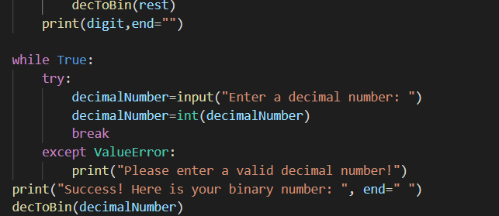

OUTPUT

