Michael Wood
Southern New Hampshire University
CS-210-11204-M01 Programming Languages 2024 C-3
Barbara Hecker
05/15/2024
1-5 Comparing Programming Languages

1. C++ / Visual Studio:
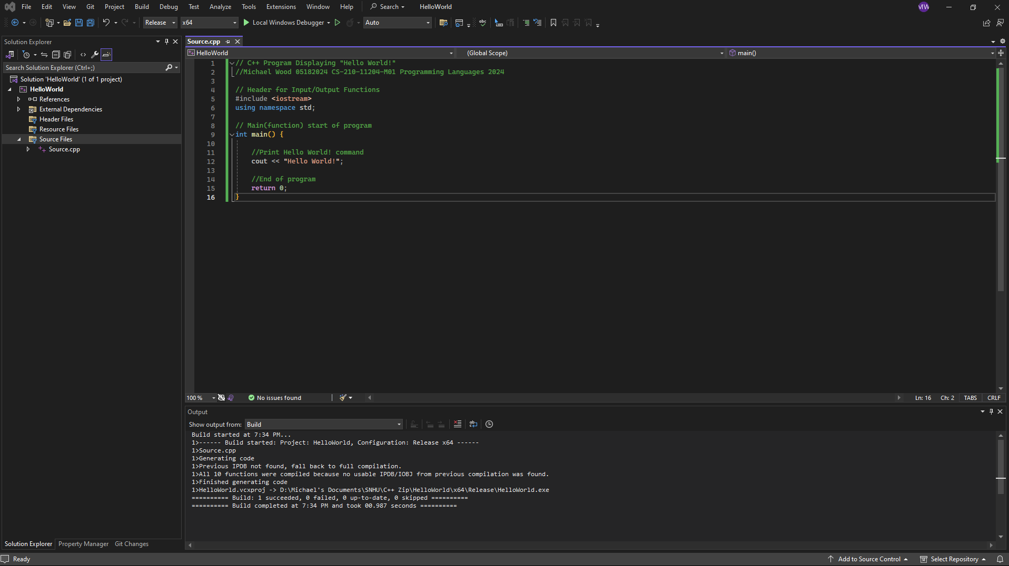
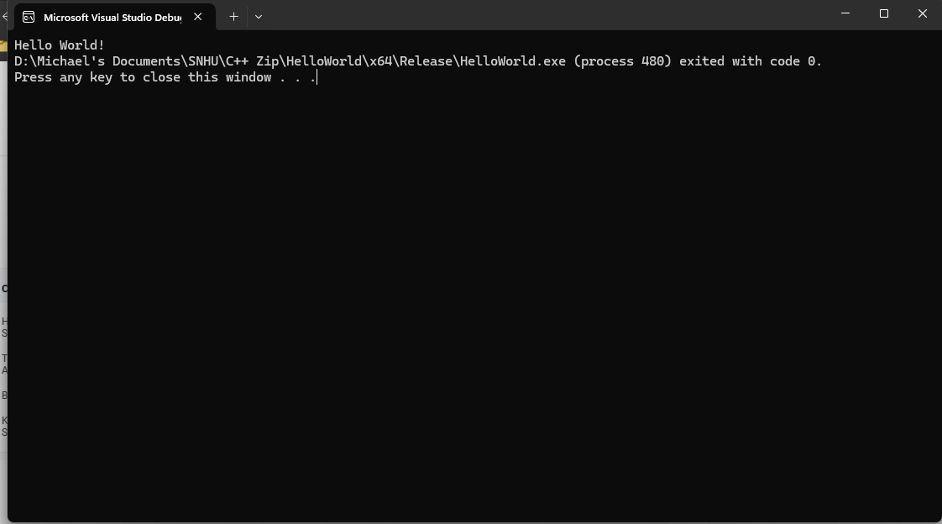

2. Python / PyCharm:

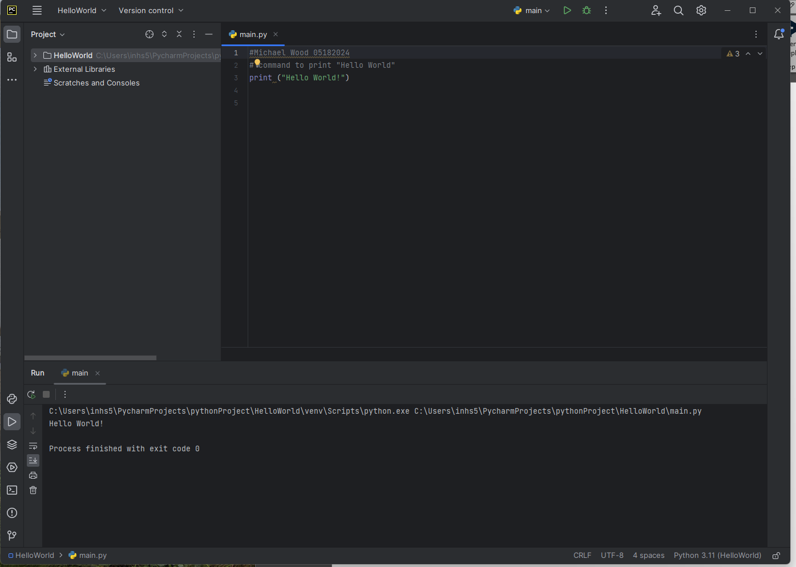

3. Reflection:
1. C++:
Advantages:
- High Performance: The C++ programming language enables efficient memory management and direct interaction with hardware, leading to the development of high-performance applications.
- Wide range of libraries: C++ is known for its extensive range of libraries that serve various purposes, enabling developers to utilize pre-existing code and expedite the development process.
- Object-oriented programming: The C++ programming language provides support for object-oriented programming paradigms, allowing developers to create code that is modular and can be reused.
- Platform Independence: C++ programs can be compiled and executed on different operating systems, making it a versatile language.
Disadvantages:
- Complexity: The programming language C++ possesses complex syntax and intricate concepts, thereby necessitating a significant learning curve for individuals who are new to it.
- Memory Management: The absence of automatic garbage collection in C++ presents a challenge in terms of manual memory management, which can lead to difficulties in preventing memory leaks and segmentation faults.
- Lack of built-in tools: When compared to certain other programming languages, C++ lacks a comprehensive standard library and often depends on third-party libraries to provide common functionalities.
- Debugging difficulties: The process of debugging C++ code can present significant challenges, despite the availability of advanced debugging features offered by tools such as Visual Studio.
2. Java:
Advantages:
- Robust ecosystem: Java provides a wide range of libraries, frameworks, and tools that facilitate the process of developing applications quickly.
- Platform independence: Java programs can run on any platform that has a Java Virtual Machine (JVM), which guarantees a high level of portability.
- Strong community support: The extensive developer community of Java offers a wide range of resources, tutorials, and libraries that are driven by the community.
- Integrated Development Environment (IDE): Eclipse provides a robust integrated development environment (IDE) that encompasses various functionalities, including code completion, debugging tools, and project management capabilities.
Disadvantages:
- Slower Execution: Java programs are known to exhibit slower startup times and consume more memory when compared to lower-level languages such as C++.

3. Python (Used with PyCharm):
Advantages:
- Readability and simplicity: Python's clean syntax and high level of readability make it a highly suitable option for individuals who are new to programming.
- Rich ecosystem: Python offers a diverse array of libraries and frameworks that cater to a wide range of tasks.
- Dynamic typing: Python’s dynamic typing allows flexible development.
- Community support: Python is known for its active community and extensive availability of resources.
Disadvantages:
- Slower execution: Python is classified as an interpreted programming language, which can result in relatively slower execution times when compared to languages that are compiled.
- Global interpreter lock (GIL): The Global Interpreter Lock (GIL) in Python has the potential to restrict the performance of multi-threading.

Source: Conversation with Bing, 5/18/2024
On a personal note, with so many different languages, I believe that they all have their advantages and disadvantages. I believe that each serve their purposes depending upon the required needs of the coder or programmer. Knowing multiple languages gives us more options to do what we need to do by prospective employers or clientele. I firmly believe that the more versatile that we are in our knowledge of a multitude of programming languages, the more opportunities will be opened for us in future endeavors.

