5-2 Coding Assignment: Certification Generation
Michael Wood
SNHU
Course Number: CS-305 Software Security 2025
Instructor: Dr. Albanie Bolton
Due Date: 08/03/2025

5-2 Coding Assignment: Certification Generation
Let us begin with “What is “What Is a Certificate Authority (CA)”? A Certificate Authority (CA) is a trusted organization that issues digital certificates to verify the identity of websites, individuals, or organizations. These certificates enable secure, encrypted communication over the internet by authenticating the parties involved. (Coclin, 2021)
We now understand what a Certificate Authority (CA) comprises. What are the advantages of using a CA? As it enables users to verify the legitimacy and identity of websites and organizations they interact with online, a Certificate Authority (CA) improves security. Verifying the legitimacy of a website, domain, or business is the primary responsibility of a certified public accountant. A digital certificate that verifies the entity's legitimacy and identity is issued by a CA to accomplish this. Users can safely share their data because this certificate connects the entity to cryptographic keys, allowing for secure and encrypted communication.
Certificate Generation: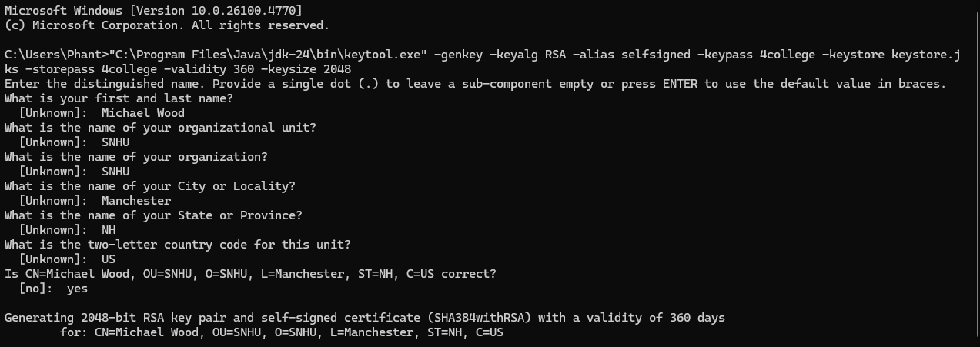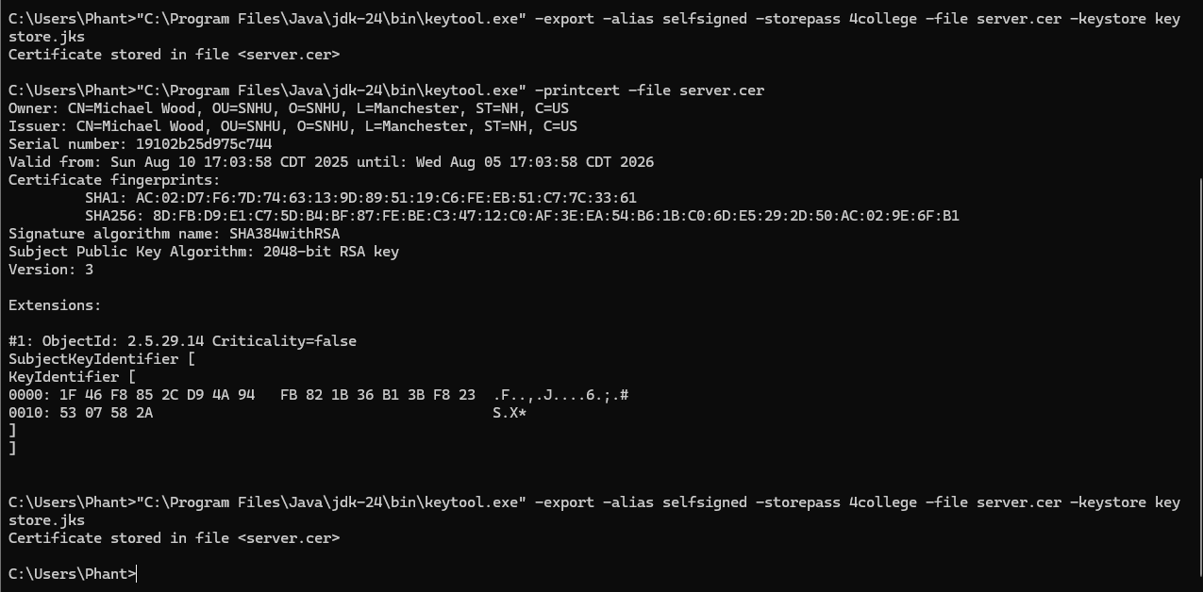

References
- Coclin, D. (2021, June 26). What Is a Certificate Authority? | CA’s Explained | DigiCert. Www.digicert.com. https://www.digicert.com/blog/what-is-a-certificate-authority
- Awati, R. (2021, September). What is a certificate authority (CA)? SearchSecurity. https://www.techtarget.com/searchsecurity/definition/certificate-authority

