6-1 Coding Assignment: Modifying Vulnerability Reporting

Michael Wood
Institution Name: SNHU
Course Number: Course Name
Instructor: Dr. Albanie Bolton
Due Date: 08/10/2025

6-1 Coding Assignment: Modifying Vulnerability Reporting
This is the original report before any alterations including updating version:
C:\Users\Phant\eclipse-workspace\Module2.1\target\dependency-check-report.html
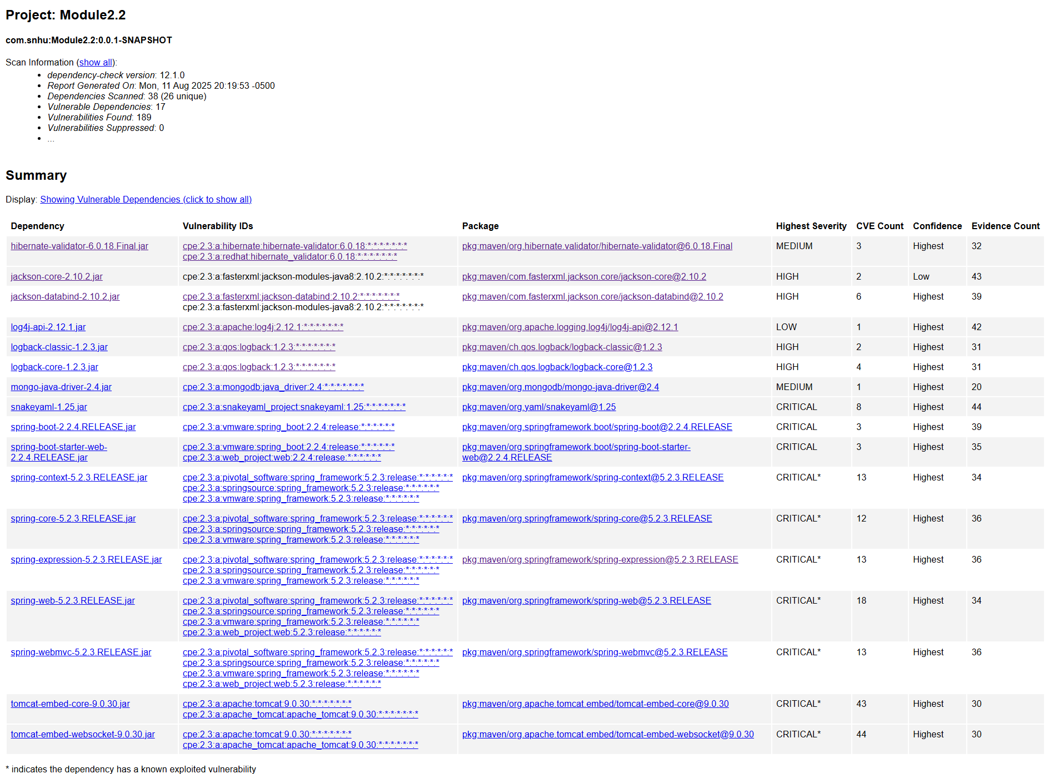

After updating pom.xml file to latest version 12.1.0 these are the results:
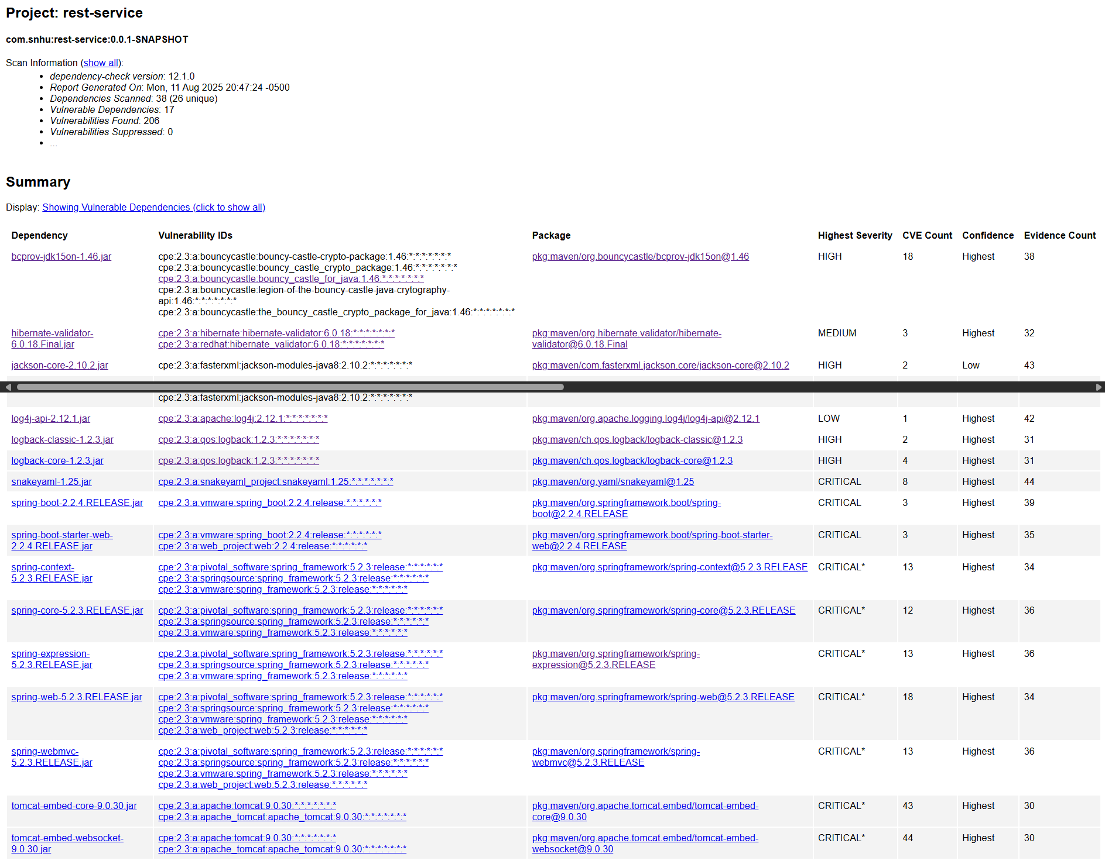
If you notice Vulnerable Dependencies has increased by 17. This is proof of how important it is to stay on top of updates.
This last two screenshots show CVE-2016-1000338 being suppressed:
The first screenshot shows 1 vulnerability whereas before there was none.
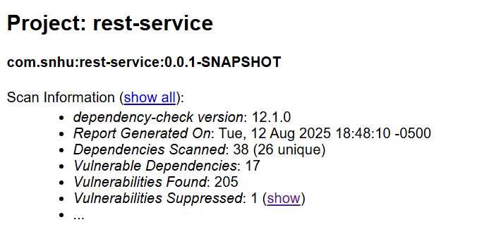

The second show the actual suppressed vulnerability.
