2-1 Milestone Interviews and User Personas
Michael B. Wood
SNHU
Course Number: CS-319
Instructor: Hazem Morsy
01/19/2025

2-1 Milestone Interviews and User Personas
Primary Goal
The fundamental objective here is to gain a deeper understanding of potential consumers' needs, challenges, preferences, and requirements.

Interview Topics
- Relevance
  - Would an app help you ensure your loved one's safety?
  - Do you currently use an app? If so, what is it? Does it meet your current needs?
  - What are some of the biggest challenges you face when assisting with your relative or loved one?
  - What kind of interaction would you like to see with the app? Which would you prefer, a feature-rich, intricate interface or one that is straightforward and minimalistic?
- Features
  - What features do you believe would be the most useful in your situation?
  - Would you be willing to use trackers such as a smart watch, cameras, or shut off devices such as a smart plug for a stove or other electronic devices to accomplish the safety that you require?
  - Would you be interested in the feature of voice activation? If your loved one fell and called for assistance, you would be contacted right away.
- Expectations
  - What kind of expectations do you have for the application?
  - Do you expect goals to be included within the app, such as milestones?
  - Did you try any other apps? If yes, were they up to your standards? If not, what was needed to make it live up to your expectations?

Interview Notes
- Interview 1:
    - 70-year-old-year female
    - Seamstress at a Drapery shop
    - Primary Caregiver for 90-year-old husband who suffered from a massive stroke several years back.
    - He forgets where he is but likes to wander
    - His mobility is very limited due to stroke
    - Tried tracking his phone but he would forget to carry his phone with him
    - Stove is natural gas and is turned off when he is home alone
    - Meals are pre-prepared from him to be able to use the microwave with daily instructions on white board on the refrigerator, would prefer some kind of tablet to attach to fridge to change daily instructions.
    - Features that might be useful in the application: Real-time tracking with use of a watch or some kind of wearable. Being able to communicate with each other through wearable through some kind of voice activation would be ideal because he does forget to carry his phone with him quite often.
- Interview 2:
    - 50-year-old male
    - Software Tester at Blizzard
    - Part-time care giver to 83-year-old mother with dementia
    - Shares responsibility with brother for managing mother’s care.
    - His brother and himself have never tried any apps or products other than Life Alert
which is not detailed enough for either of them to feel safe leaving her by herself
    - Have tried camera monitoring, which he said did help but did not help outside the home
    - They now use Life 360 to track her whereabouts outside the home
    - He would like an app that would be simplistic in design and would incorporate visual access to the camera, outside the home, and smart plugs for dangerous electrical products such as the stove.
    - He and his brother both want to allow their mother to have all the freedom that she can still enjoy before the disease gives them no other choice but to put her in a assisted living facility.
    - The features that he would like to see the most are alarms when loved one leaves home and/or yard with real-time monitoring and the ability to shut-off appliances after a 30 minute time period that does not reset until it is proven that no danger exists.

Interview Analysis
It is clear from closely examining the interviewers' comments that such an application is desperately needed. This observation raises the possibility that the app could be useful not only for people with dementia but also for people with any type of disability who wish to live independent lives while also having the protection of their family support system in case of emergencies or need for help. People desire the ability to manage the health of their loved ones while also pursuing their own personal goals.
Target Audience
People of all ages living with disabilities in any part of the world would be the main target audience for my research. Everyone with relatives with special needs. Anyone looking for a smartphone app to track the location of family members or people with disabilities. The application focuses on people with impairments, but it may also be used to keep an eye on kids and seniors who go around independently to go anywhere outside their home and monitor activities within the home also.
User Personas
Persona | Team Lead
Photo | 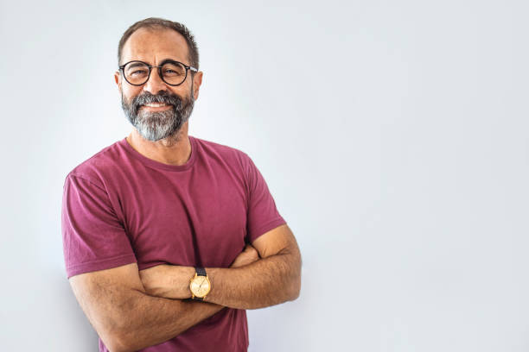
Fictional Name | Juan Habanero
Job Title | Warehouse Leader
Demographics | 49 years old  Married  Construction Background
Goal | Finding help to provide the safest alternative care for his mother that has been diagnosed with beginning stages of Alzheimer’s
Needs | Reliability and simplicity

Persona | Cleaning Lady
Photo | 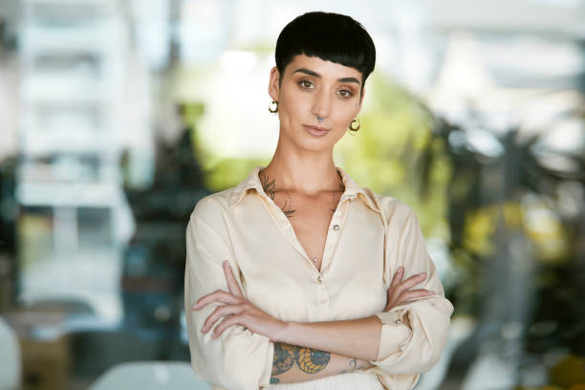
Fictional Name | Jill Harper
Job Title | Housekeeper
Demographics | 34  Single  Mother of 2 boys
Goal | Finding help to keep track of her grandmother’s whereabouts / Grandmother has tendencies to get it lost in public
Needs | Tracking and alerts

Persona | The Businessman
Photo | 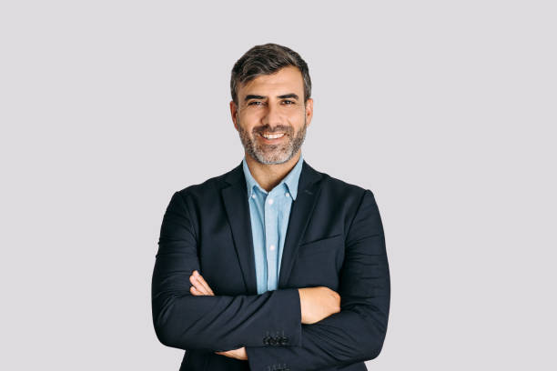
Fictional Name | Jack Holden
Job Title | CEO
Demographics | 53  Married  Financially Stable
Goal | Being able to keep up with his father suffering from dementia
Needs | Wanting to track father’s activities and trying to still leave father with much freedom

