3-3 Milestone: Paper Prototype

Michael B. Wood
SNHU
Course Number: CS-319
Instructor: Hazem Morsy
01/26/2025

3-3 Milestone: Paper Prototype
This is my paper prototype and interviews about the prototype. The scaling is not correct and would need to be on finished app. The colors and sound are not available either and would need to be inserted later within the working app. The buttons are also not completely correct for placement or size, which would also need to be corrected. I hope you enjoy the prototype as much as I enjoyed designing it.

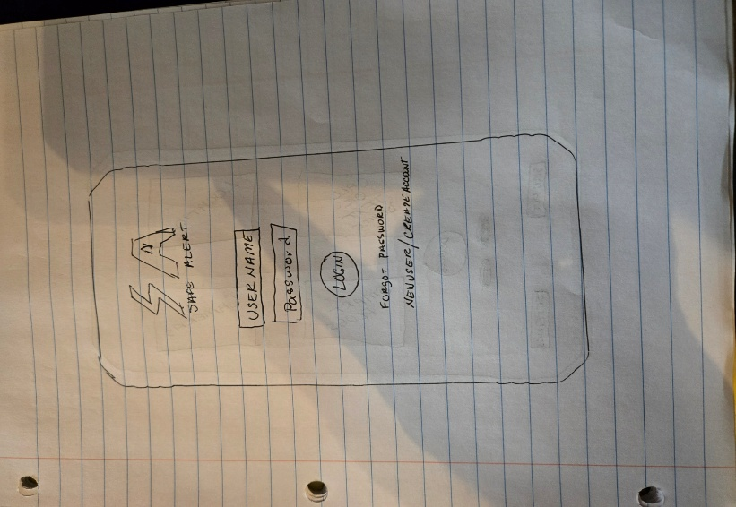
This is the start page or login page. This is where you would sign-in with an existing account or be rerouted to the webpage to create a new account or recover a lost password. The login page will always be the first page that you see when you first open the app. It will also be the last page that you see when you log out.

Once you log in it will take you to the Home page featured below:
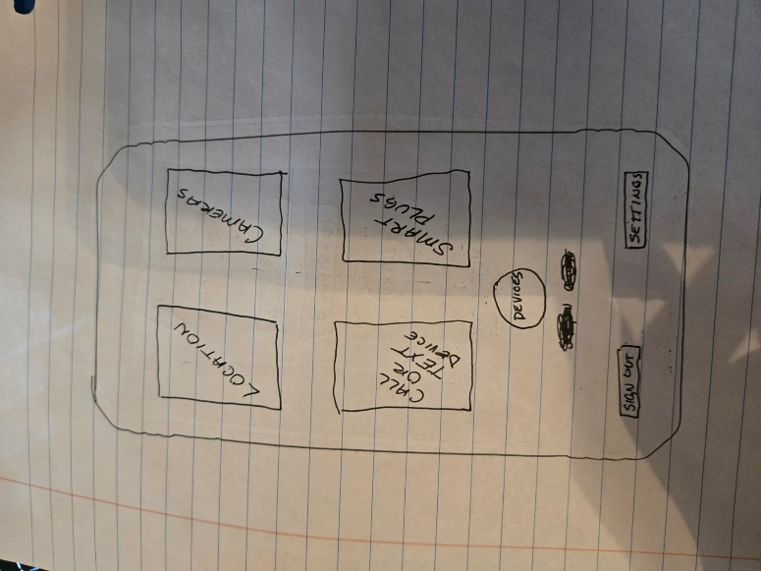
From this page you can go to the location, camera, call or text, smart plugs, devices, or settings pages. The settings page is not drawn up currently. If you are done using the app then you can always sign out here, in which case you will be taken to the login page. From this point on I will show the existing pages mentioned above minus the settings page. I did not think about it until just now that I did not add a drop-down menu that would include all pages, account information, and settings that would be in the upper left-hand corner of every page. I will rectify that soon.
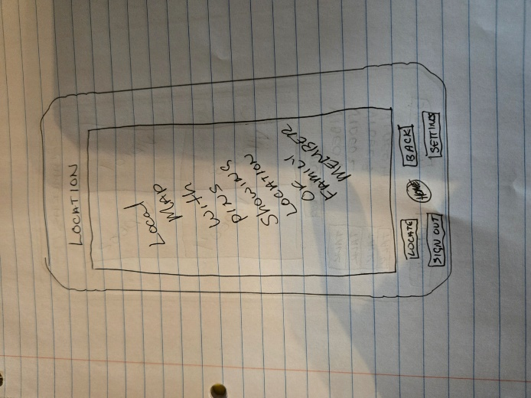
The drawing above is a basic sketch of the location page. On this page, there will be detailed map similar to google maps or possibly combined to work with google maps or another similar map provider. The home will be a colored dot, and the family members will be different colored dots. Under the settings will be an option to set an alarm to notify you when a family member moves too far away from home. A notification will be sent to the admin if the battery is low, or the tracking device is no longer being worn. Once again there is a sign out and settings button. Now, I have added a home button for quick and easy access to the home page.
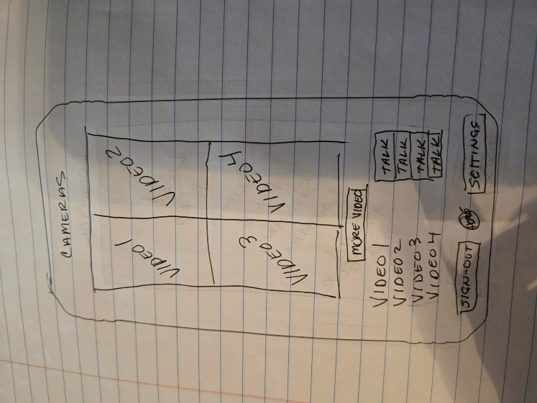
The drawing above is the video screen for those who have connected cameras to the app. It is set up to show 4 cameras at once or tap on camera to choose just one. If there are more than 4 cameras connected to the system, then push the more video box to open another 4 cameras. As of right now the design is only for 8 cameras and possibly and upgrade in the future to be able to add more. If you notice there are boxes with talk placed within, these boxes are for those who have cameras with microphone and speaker functions. Here again are the settings and sign-out buttons.
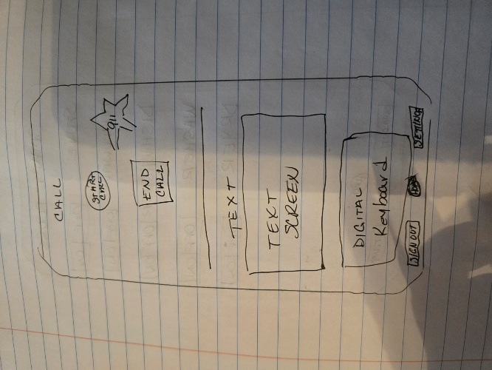
This is a split communication screen the top part will access you phone and be able to make calls not only to you family member and their tracker device but also to 9-1-1 in case of an emergency. The lower part of the screen will be for texting your family members wearable device. The split screen will be adjustable for user’s size preference between the lower and upper parts of the screen. The sign-out and setting buttons are also displayed here at the bottom of the screen.
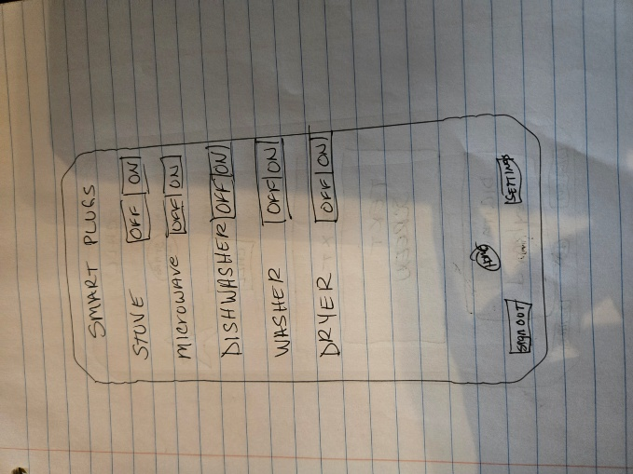
And here is the smart plug or smart device control panel. If you believe that your loved one is in harm’s way you can shut off any device that is compatible with this app. You can also set up timers for certain appliances or electronic devices that have the option of being controlled remotely through the settings page.
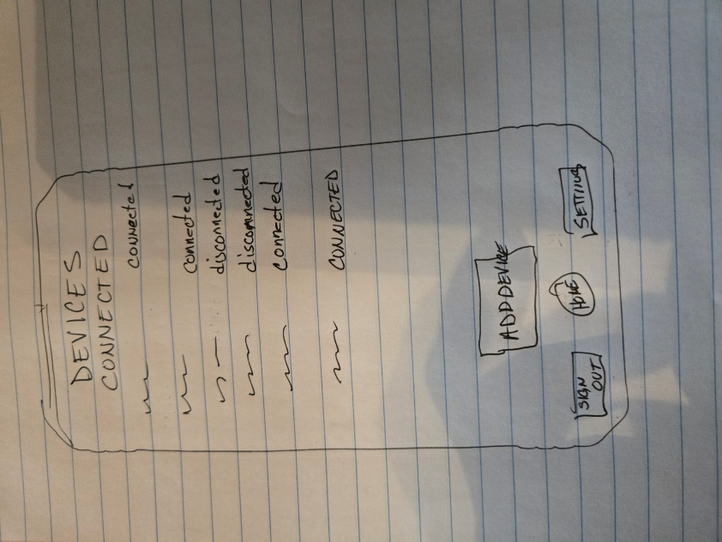
Finally, the device page. This is where you can see what devices are connected to the app and are connected properly. This is also where you can add new devices.
I have a million and one designs in my head for this entire app. I have designs for each screen and add-ons. I think about upgrades as technology continues to excel into the future.
When it comes to our loved ones, you can never be too safe.
Follow-up Interviews:
The setup was not explained completely to either of my participants. All they know is that I have an idea for an app to help keep track and monitor our loved ones. My first interview took place over the phone and text. I texted the participant first and sent pictures of the paper prototype then gave them approximately 30 minutes to look them over and collect their thoughts on them. We began when I called and asked for her thoughts. I walked her through each page and pretended to push the appropriate buttons to work the prototype. I explained how the app would work and even made up a couple scenarios that a loved one could encounter and how the app could help them help their loved one or ones. The other applicant was interviewed in my home face-to-face, but the process was the same.
Both applicants had similar thoughts and ideas. They both believed that this was an app that anyone could use not just for dementia patients but for people and children with and without disabilities. They did say that it was lacking a few things that they would have liked to have seen that they thought would make the app easier to use. The first thing was a drop-down menu and the second was a device settings button next to the devices connected with smart plugs or smart devices compatible with the app was being able set the settings for each device such as allowed operating time length or the hours that the device could be used.
I tried to interview a third individual in their mid-twenties, but they didn’t seem to be interested in participating, I even tried to interview a fifteen-year-old sophomore but the only thing she wanted to know was if the app worked with Facebook, Twitter, or Snapchat. When I said no but possibly in the future, she lost interest quickly.

Interview Notes:
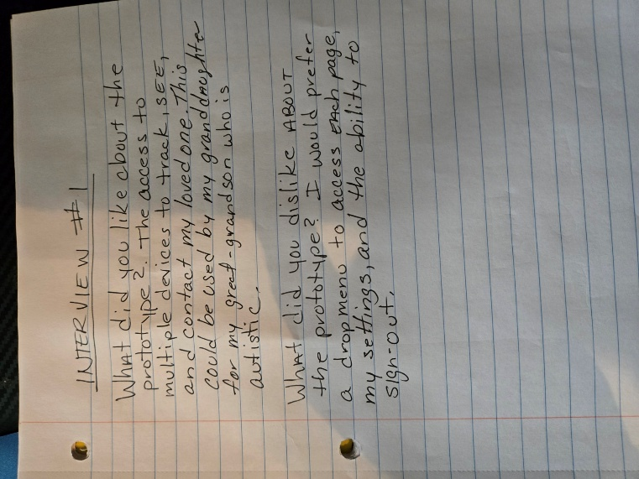
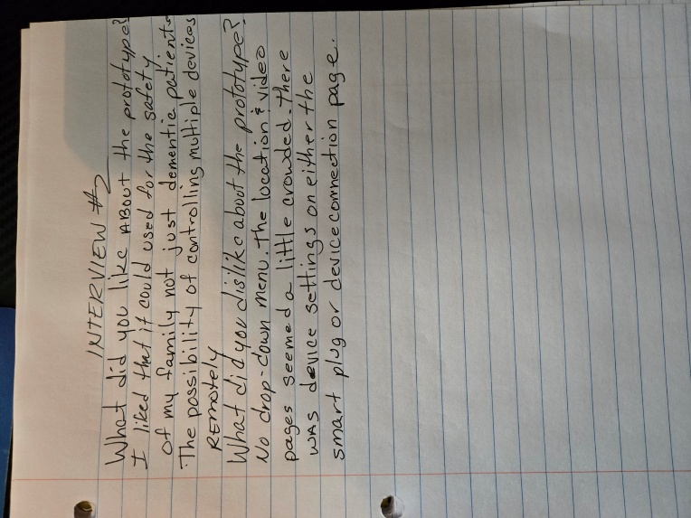
Conclusion:
I was surprised that both applicants knew more about apps and software than I thought. They both helped me think outside the box that this app could be used for multitude of people. I have two grandsons that are autistic and just leaving the room sometimes can be an issue. They have no fear, and both love to run. My great-grandmother had Alzheimer’s when I was young, but I remember how hard it was on my family to try to take care of her and how much an app like this could have helped my family all those years ago. This Project is the reason I wanted to become a software engineer. I wanted to create and design software to help people not only help themselves but to help others too.
Looking back at my design and the input from the interviews there are many things that I would like to change. I want to keep some aspects but also incorporate a drop-down menu. I would change the layout a little bit by redesigning the button shapes, size and placement. Combine the smart plug page and the device page and add an options button to be able to set up the settings on each device. Always listen to the clientele they will tell you they want or need; they never have an issue telling you where you went wrong or what they don’t like.

