7-1 Project Two
Michael Wood
SNHU
Course Number: CS-319
Instructor: Professor Morsy
Due Date: 02/23/1975

7-1 Project Two
UI/UX Prototype for Main Screen and Current Loan Screen:
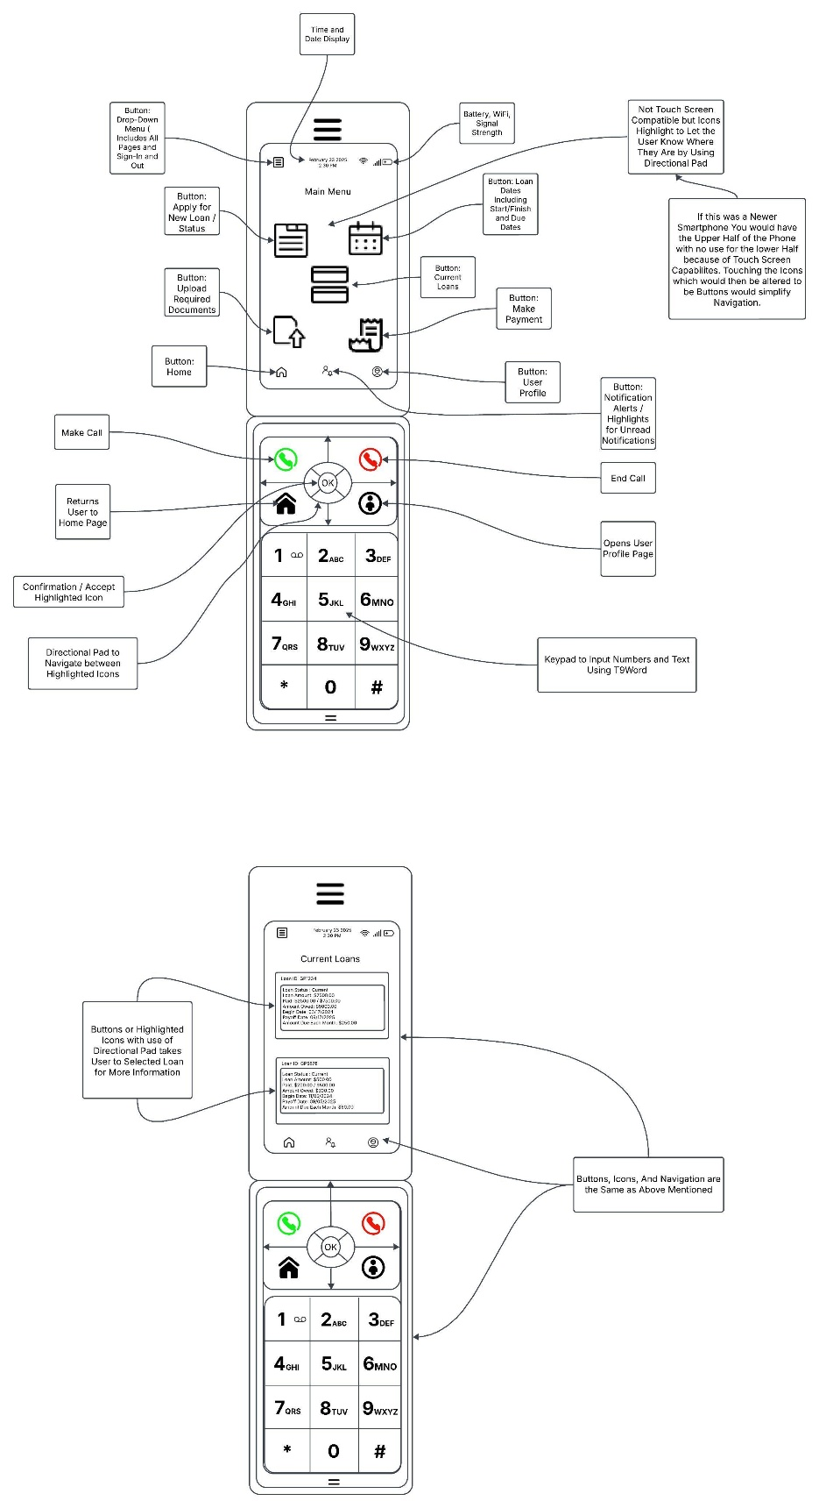
I attempted to make the design basic and user-friendly. I did learn that many of the people that use Kiva for loans are low-income individuals from all around the world. As a result, I used a flip-phone wireframe design template that I prepared for future use. Adapting the screen to a newer or more costly smartphone would be simple if buttons on a touch screen were used instead of a directional pad with highlighted icons. Having access to a digital keyboard would also be beneficial, but for those who do not have one, I have incorporated T9Word support in the design.
The directional pad and the OK button in the center of the pad allow the user to effortlessly navigate the screen to the desired page. The application will use the two buttons below and to the left and right of the directional pad to quickly navigate to the Home page when the left button is pressed and the User Profile page when the right button is hit.The directional pad and the OK button in the center of the pad allow the user to effortlessly navigate the screen to the desired page. The application will use the two buttons below and to the left and right of the directional pad to quickly navigate to the Home page when the left button is pressed and the User Profile page when the right button is hit.
Once again, simplicity is crucial. As the user navigates the icons on the screen, the appropriate icon will illuminate to indicate what they are selecting or where they are on the screen. Being this is a mock version and improvements will stil be made before the fianl product is released, it is not complete. Such as I used larger icons/buttons but did not place a name of the icon/button for better understanding that would have to be addressed in a later version.Once again, simplicity is key. As the user moves among the icons on the screen, the corresponding icon illuminates to signify what they are picking or where they are on the screen. This is a dummy version, and changes will be made before the final product is released, so it is incomplete. For example, I used larger icons/buttons but did not provide a name for each icon/button for better understanding, which will need to be addressed in a subsequent version.Once again, simplicity is key. As the user moves among the icons on the screen, the corresponding icon illuminates to signify what they are picking or where they are on the screen. This is a dummy version, and changes will be made before the final product is released, so it is incomplete. For example, I used larger icons/buttons but did not provide a name for each icon/button for better understanding, which will need to be addressed in a subsequent version.
This design was created for older flip phones, however it is easily adaptable to a current smartphone by utilizing the touch screen compatibility. The Main screen displays the basic pages contained in the application and can be customized for future use. I've included a drop-down menu in the upper left corner for simple navigation and logging out. There are also Apply for New Loan/Status, Calendar buttons for start/end and due dates, Current Loans, Make Payment, Home, User Profile, and Notification buttons/icons depending on the type of phone being used.
The design of this software serves to increase Kiva's accessibility to low-income clients while also concentrating on potential restrictions. Having an easy-to-use and understandable app for making loan requests, managing loans, being updated via notifications, and conveniently repaying loans would help customers remain on top of their debts. This software will assist raise awareness about Kiva, with the goal of expanding its reach.
After doing further research on the people who use Kiva, I determined that a fip-phone prototype was probably required. As a result, I modified my design to meet that need, understanding that transitioning to a more current phone would be easier than converting a touchscreen smartphone to a cellphone without touchscreen capabilities or the usage of a digital keyboard.
Kiva lenders will have some of the same information as borrowers, but they will be able to study data on loans they granted as well as loans they are considering. A cloud-based system will enable near-instantaneous updates to loan requests, loan payments, lending statistics, and forecasting future loans/repayments. This will let lenders keep track of how much and how frequently repayments are received, allowing them to assess when they can back another loan. The design will contain an easy-to-use interface that will allow the lender to browse numerous open loans while filtering out areas and needs or searching for specific organizations that they wish to assist.

