1-3 Assignment: Intro to MongoDB
Michael Wood
SNHU
Course Number: CS-340 Client/Server Development
Instructor: Hari Paruchuri
Date Due: 09/07/2025

1-3 Assignment: Intro to MongoDB
Verification of environment access and importation of databases for enron:
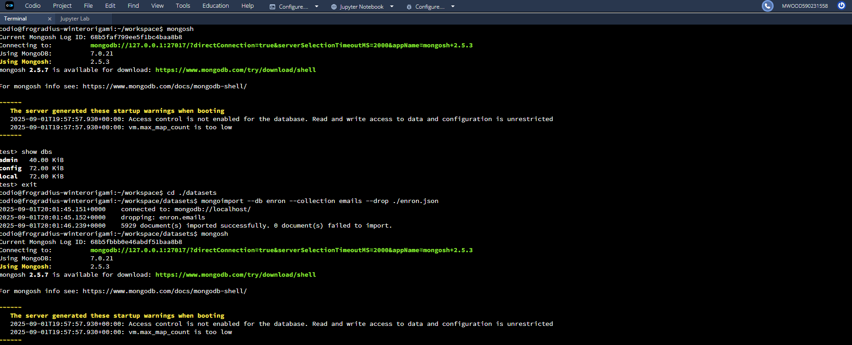
Execution of commands: 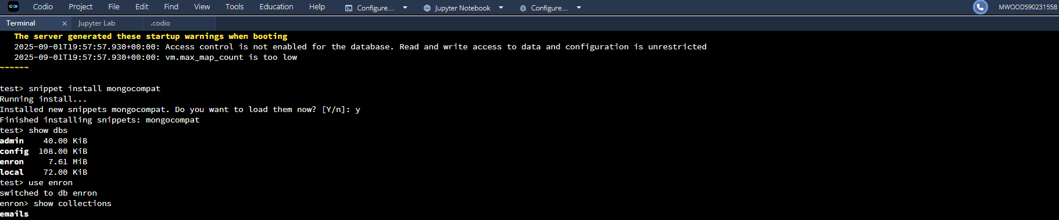

Execution of the retrieval of a document and size of the collection of documents:
