2-1 Assignment: CRUD in MongoDB
Michael Wood
SNHU
Course Number: CS-340 Client/Server Development
Instructor: Hari Paruchuri
Date Due: 09/14/2025

2-1 Assignment: CRUD in MongoDB
Mongoimport:
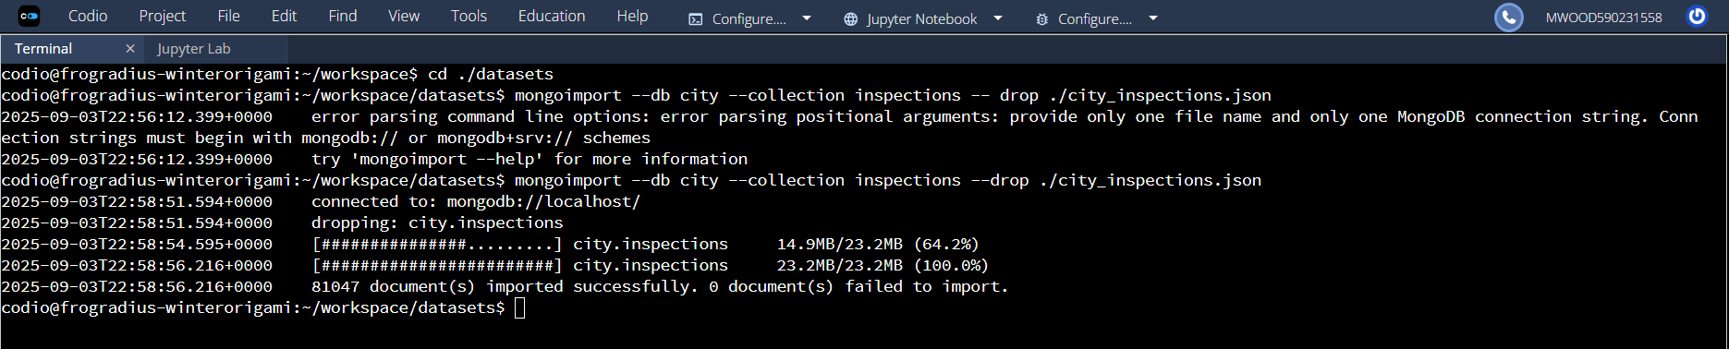
show dbs
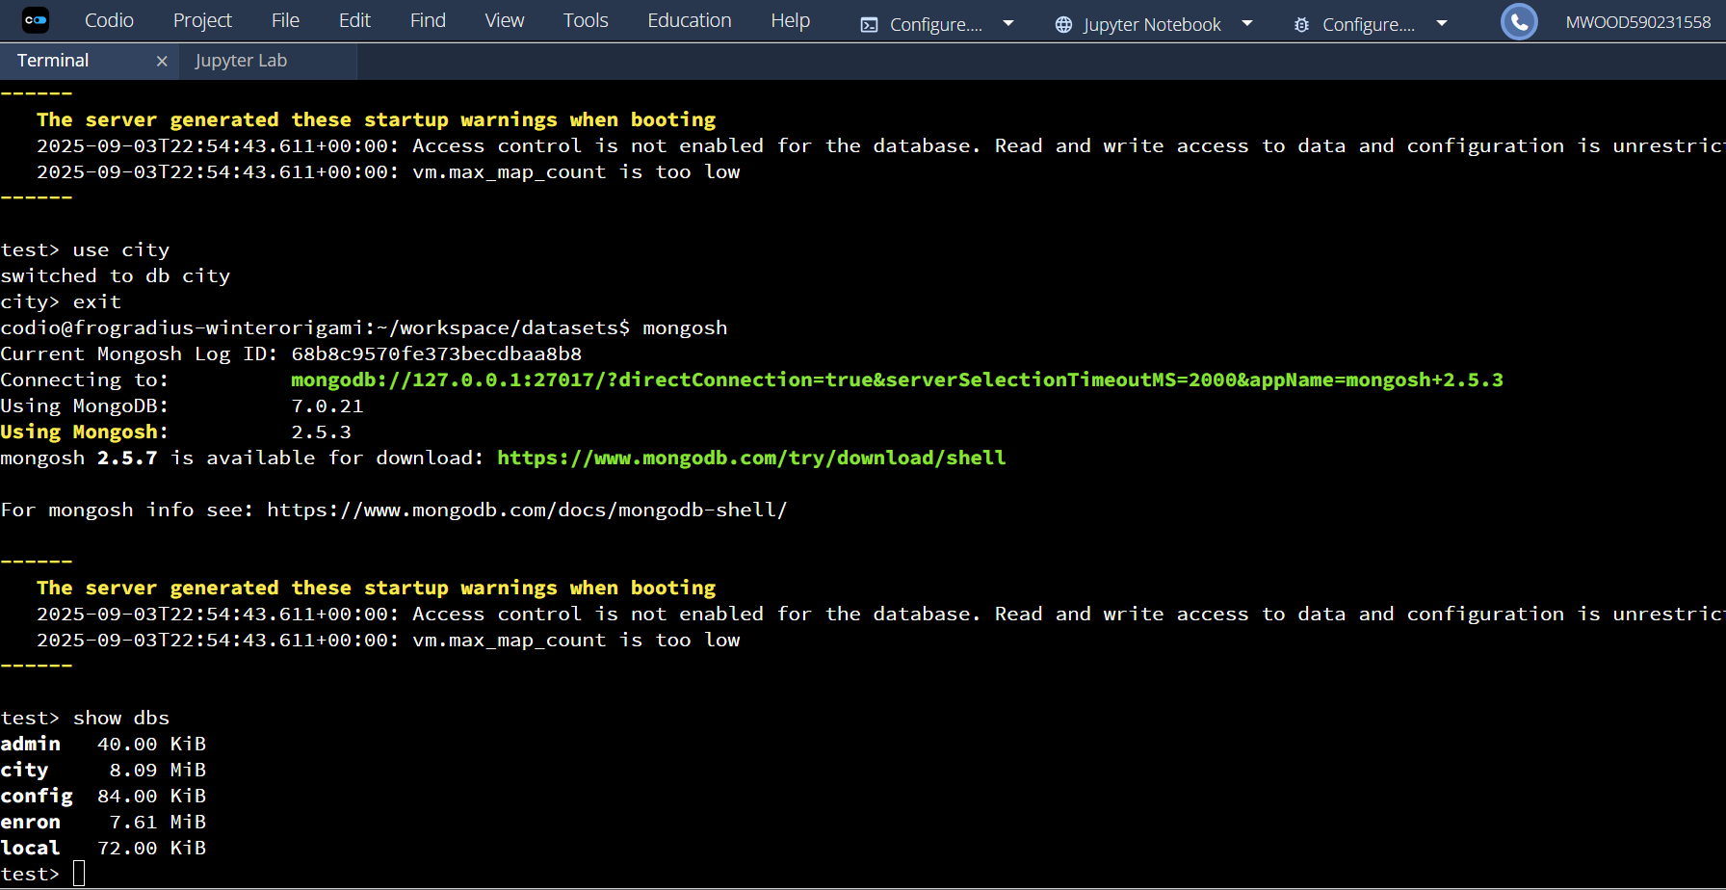
Load Verification
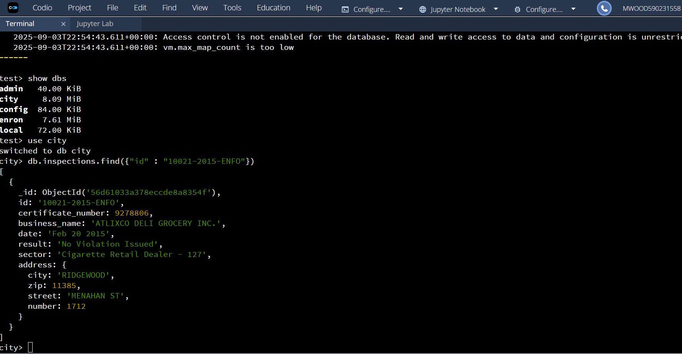
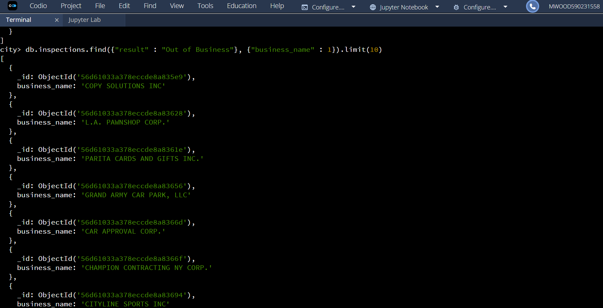
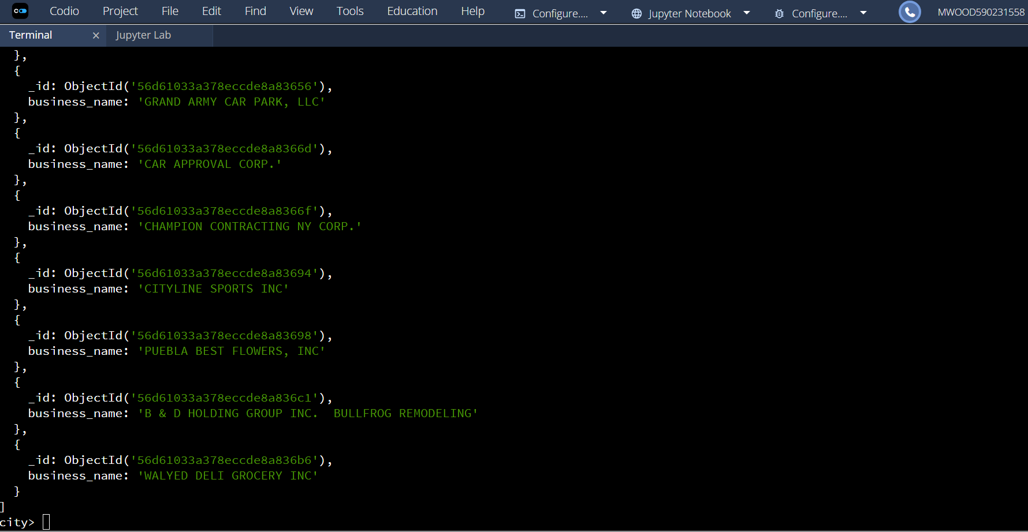
Document Insertion
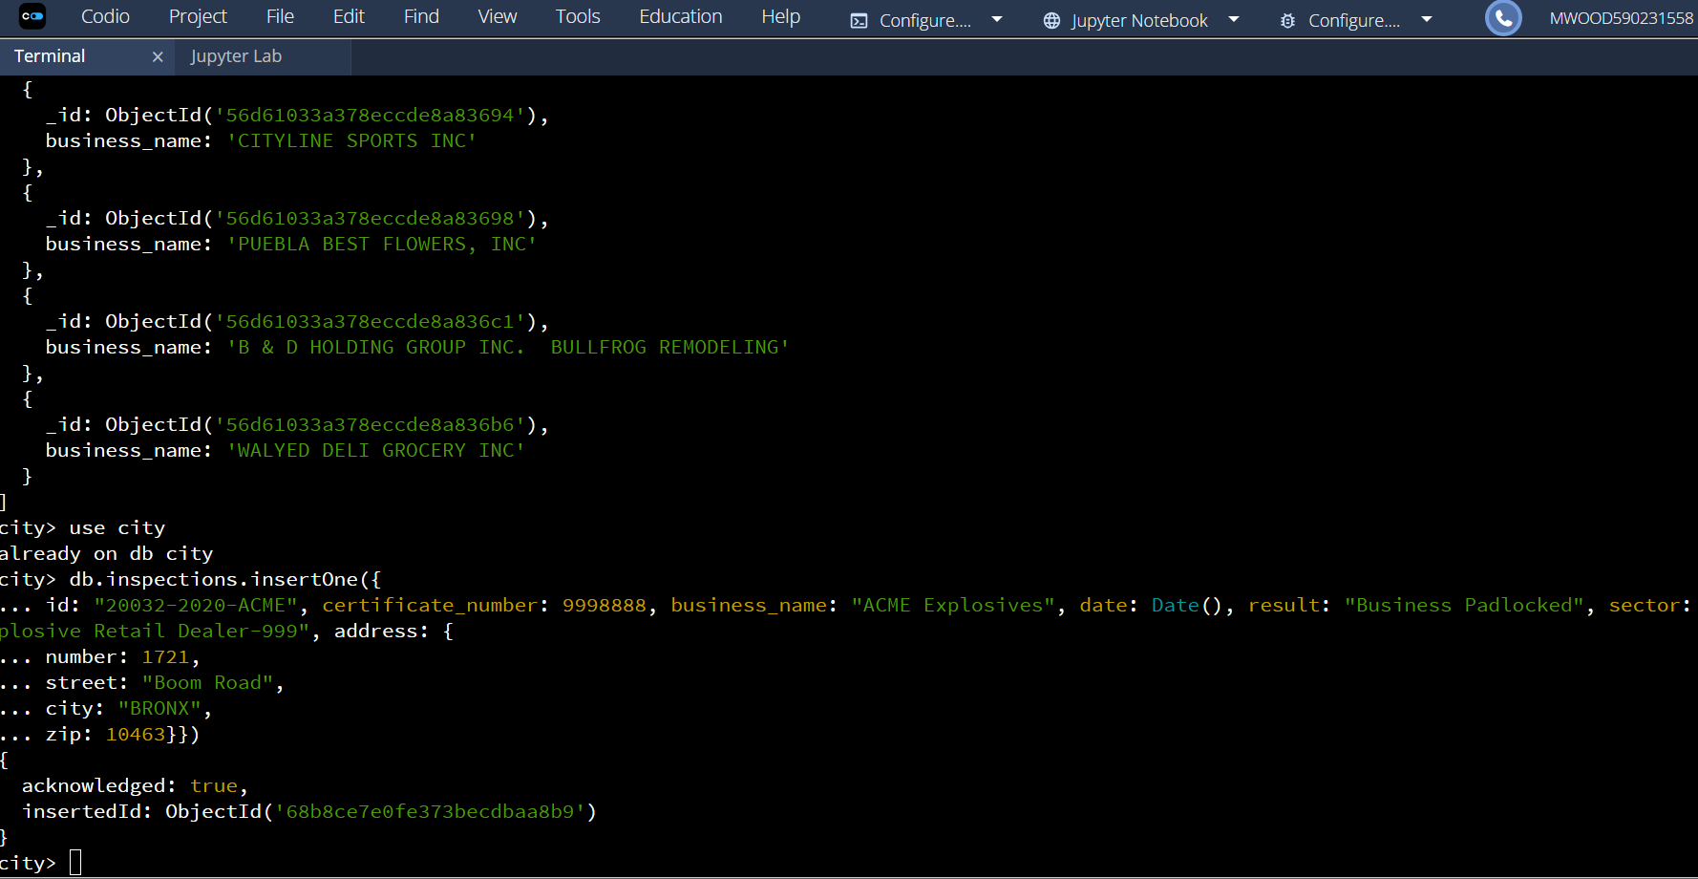
Insertion Proof of Document
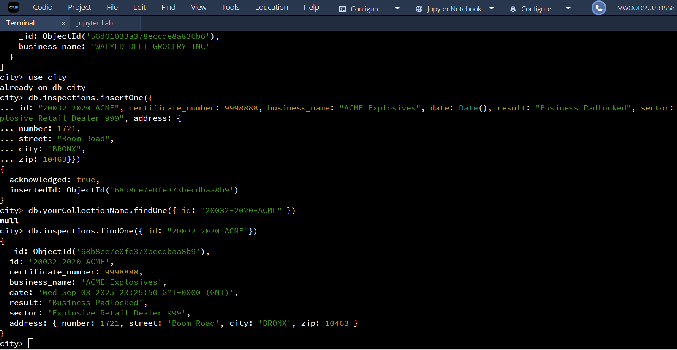
Distinct List and Count Total
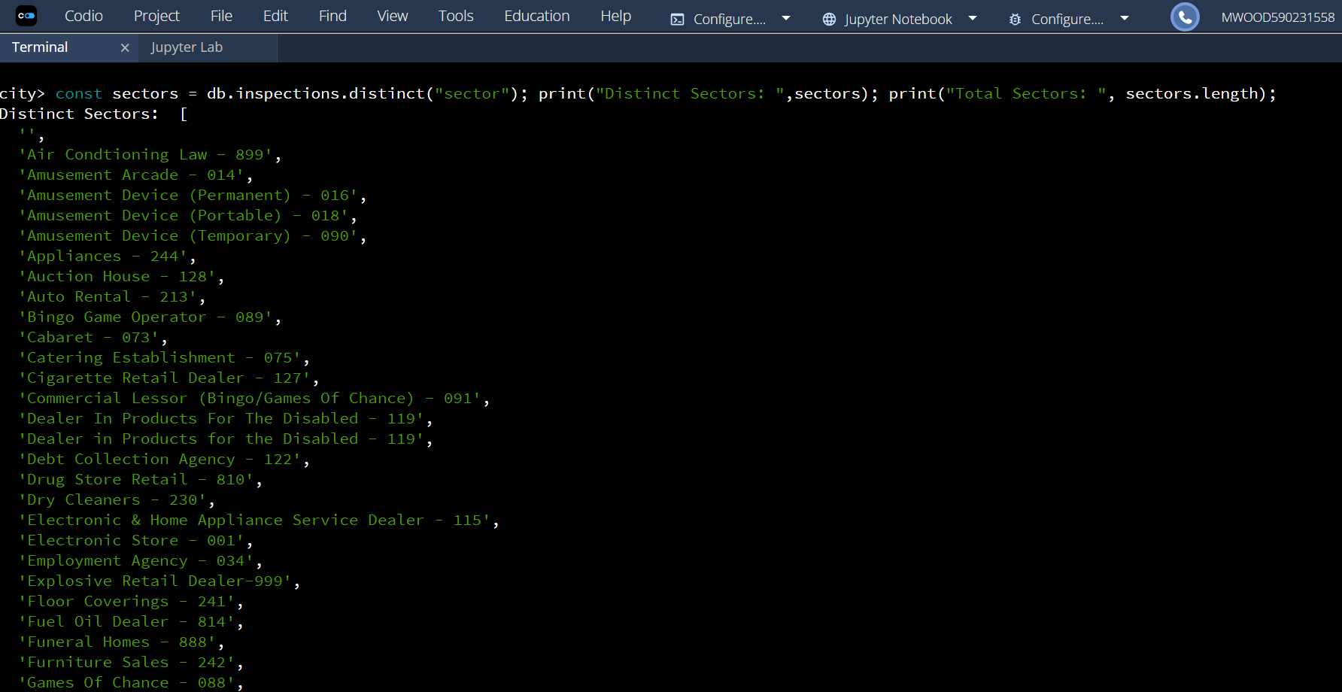
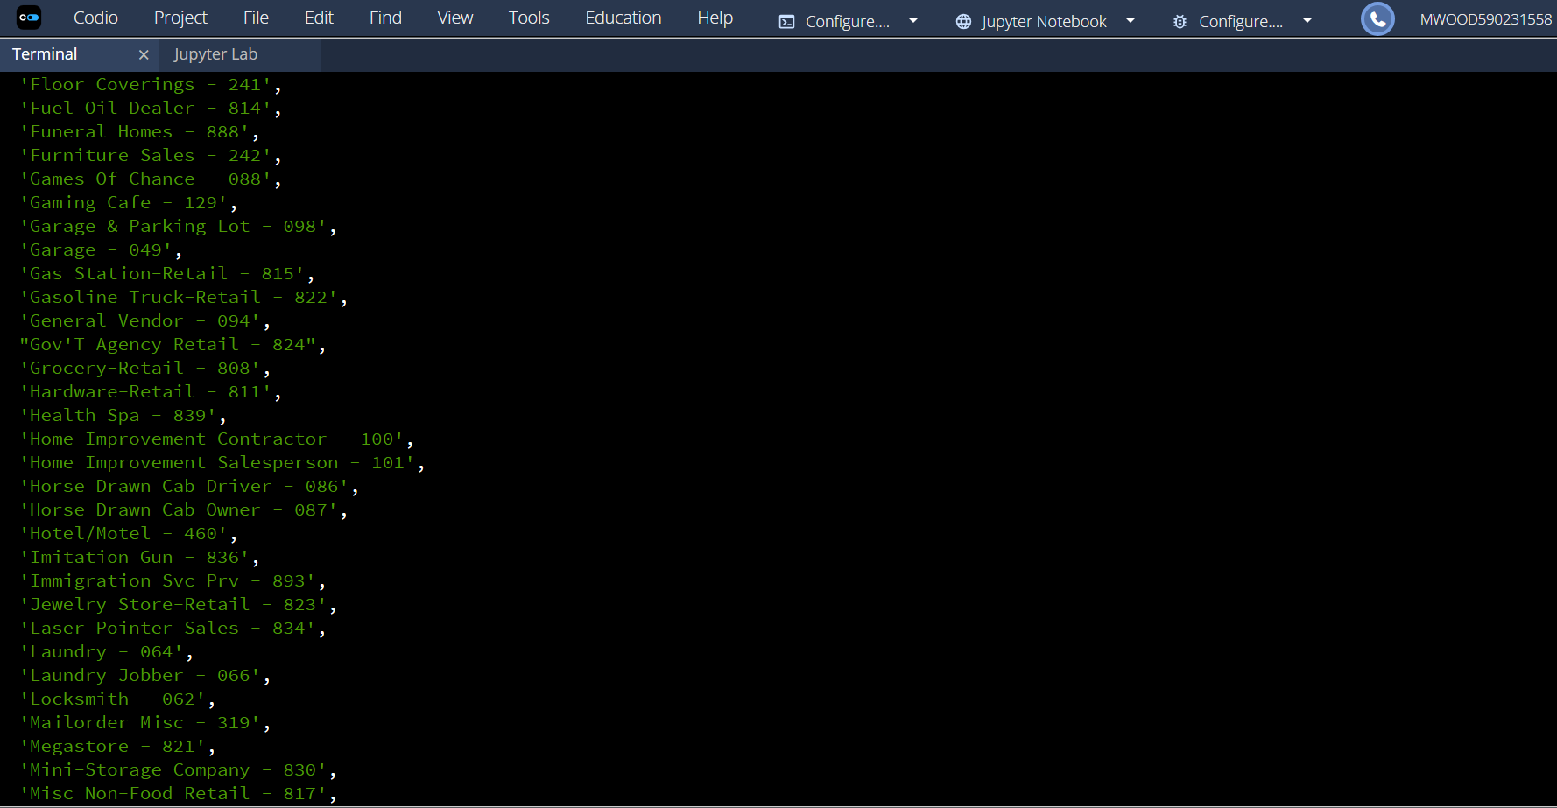
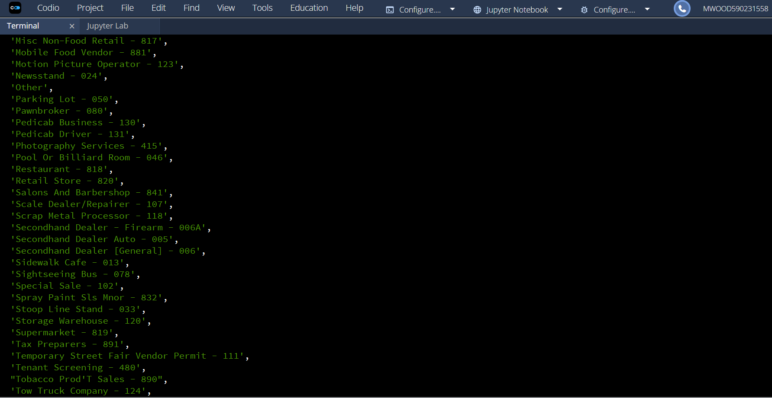
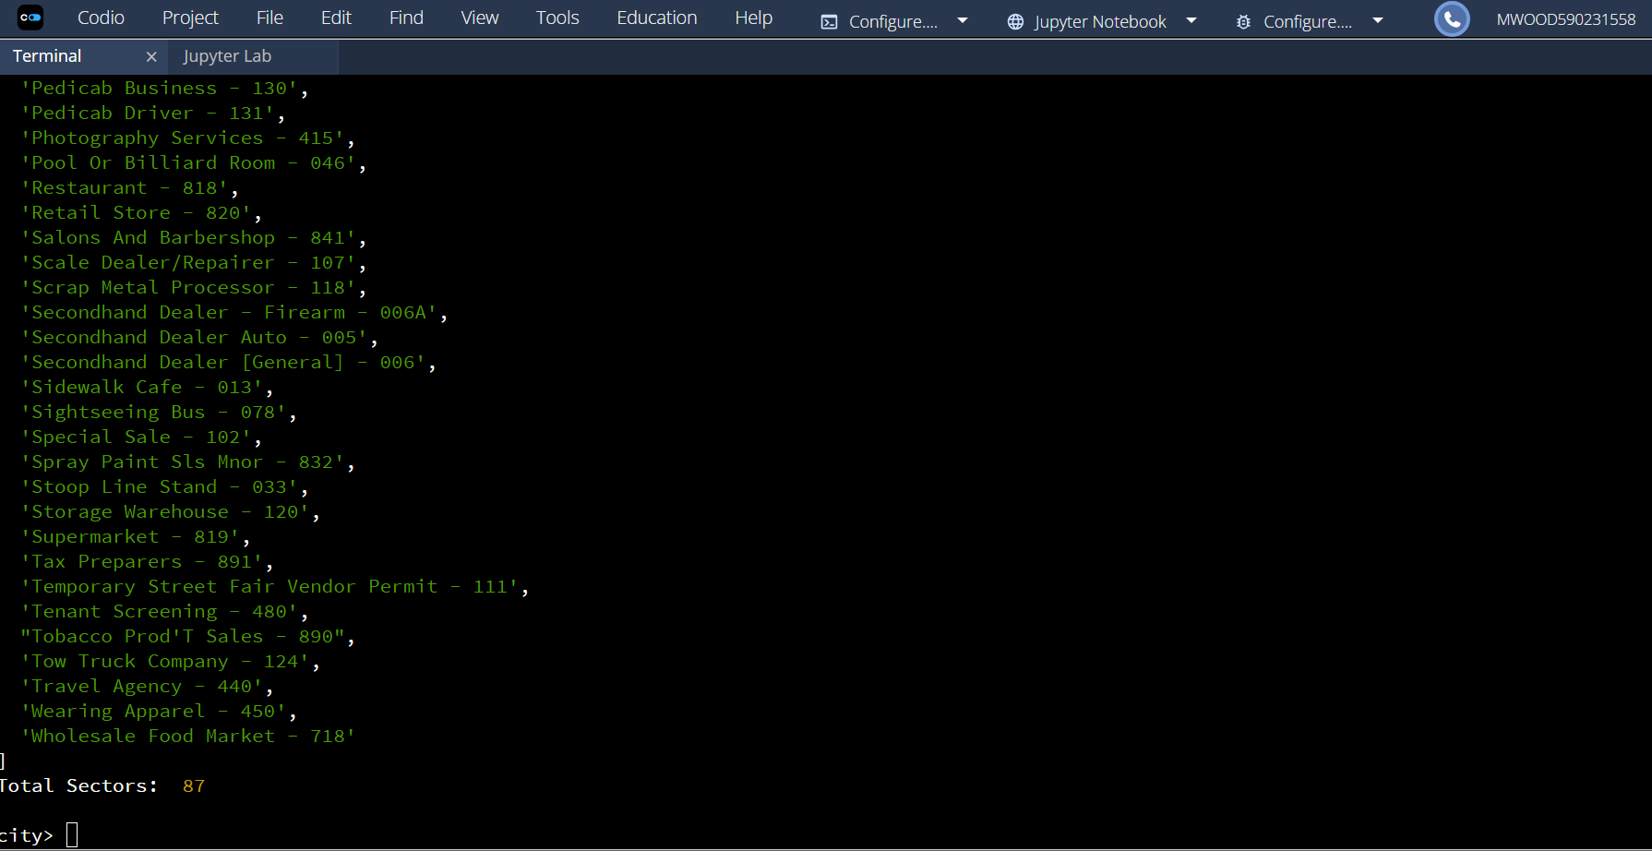
Date and Time Difference – I used Data() which inserts today’s date, whereas “AUSTIN 2012” is a fixed date of Jan 22 2016
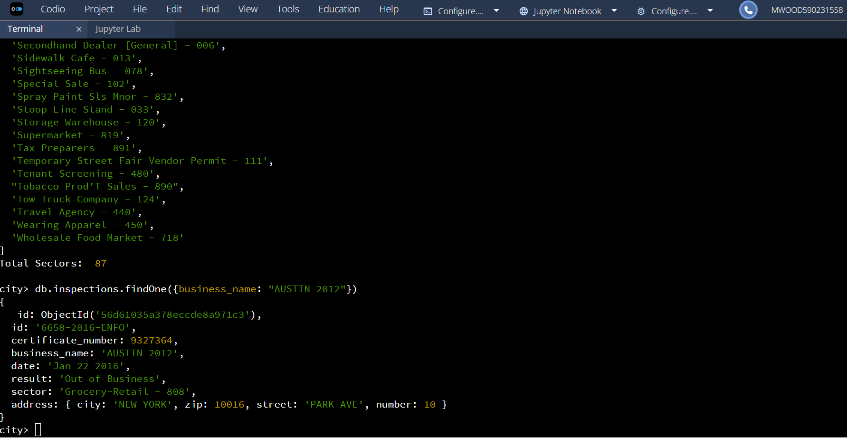
Violation Issued Count: 13823
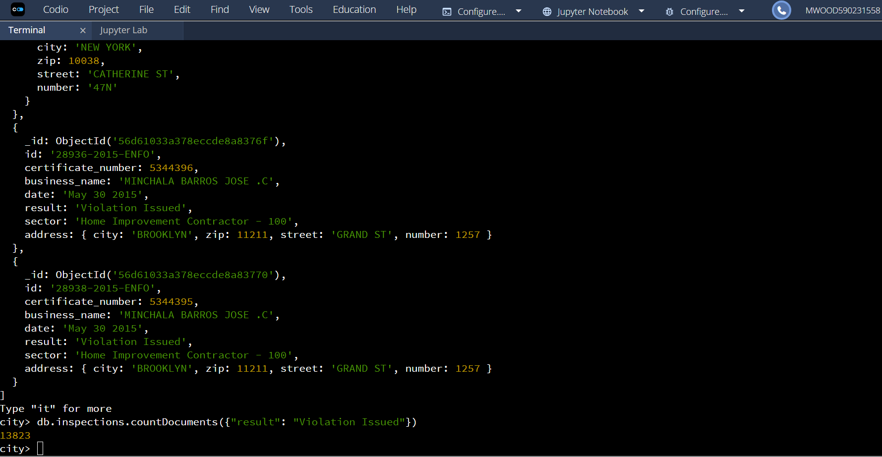
Updated ACME Flowers
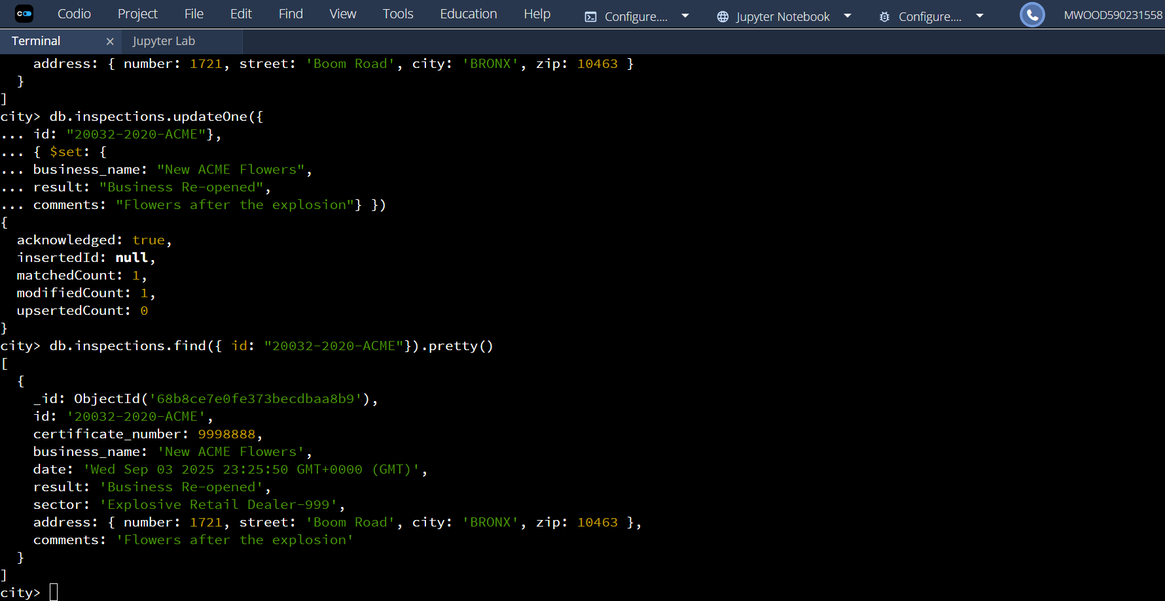
Updated Zip before first document deletion
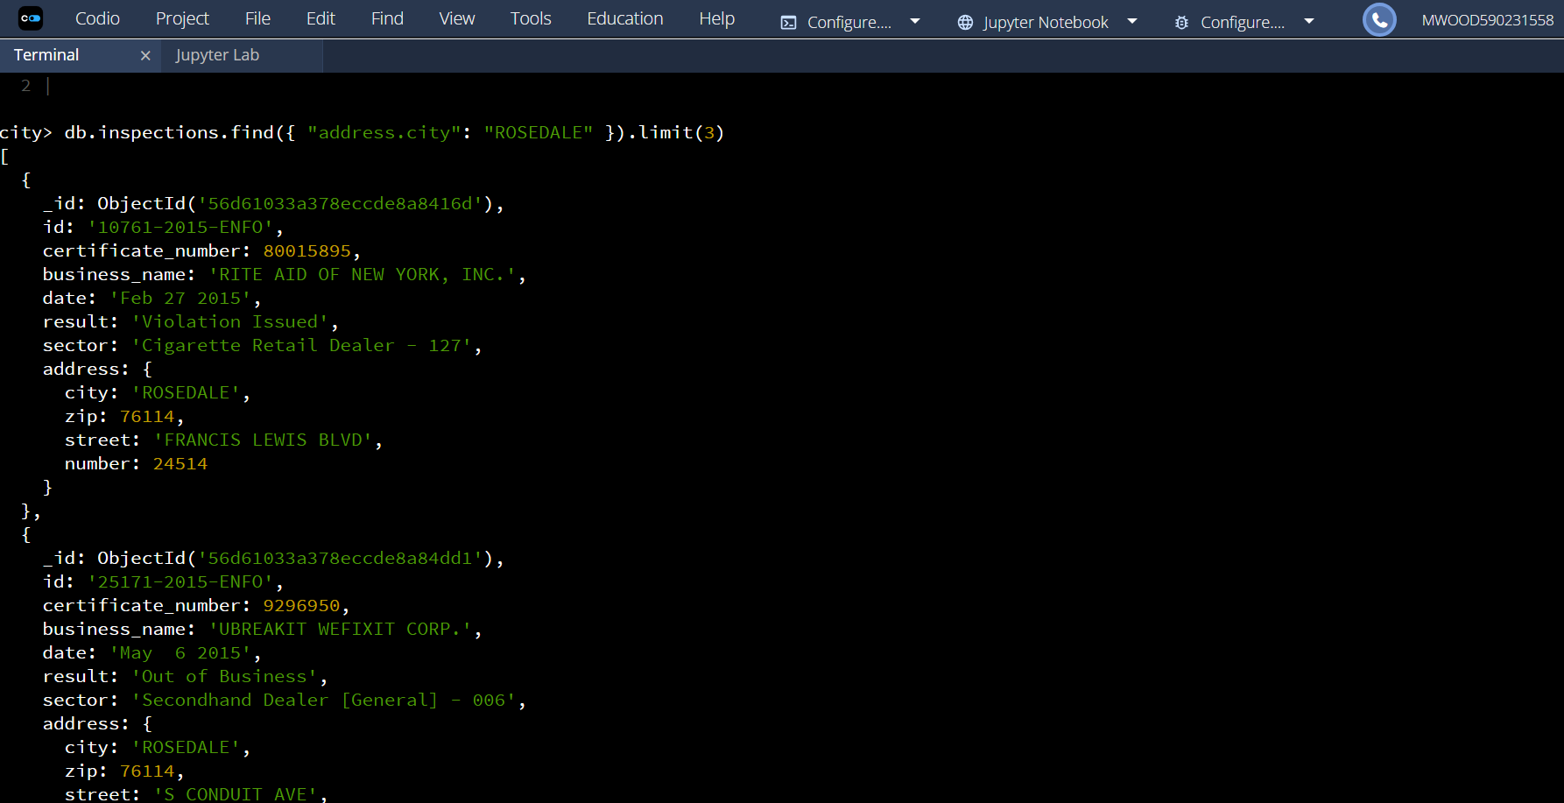
After changes
