3-1 Milestone Database Indexing and Authentication
Michael Wood
SNHU
Course Number: CS-340 Client/Server Development
Instructor: Hari Paruchuri
Date Due: 09/21/2025

3-1 Milestone Database Indexing and Authentication
Prompt: Part I
Mongo import command:
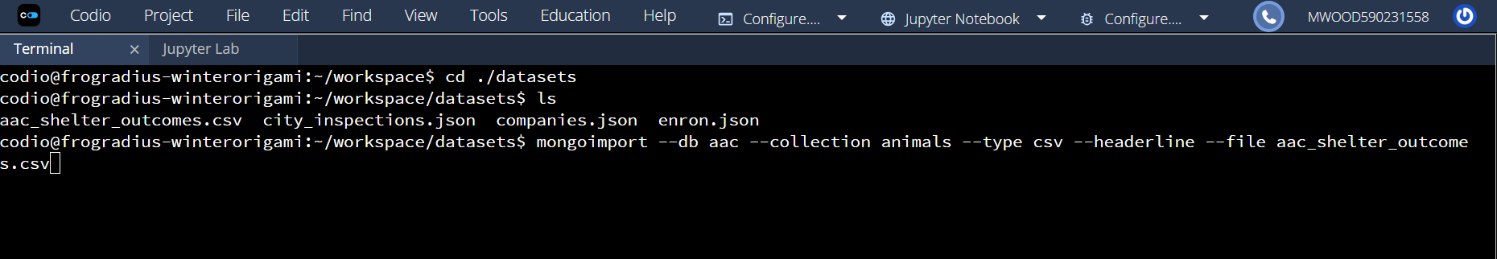
Success of import command:
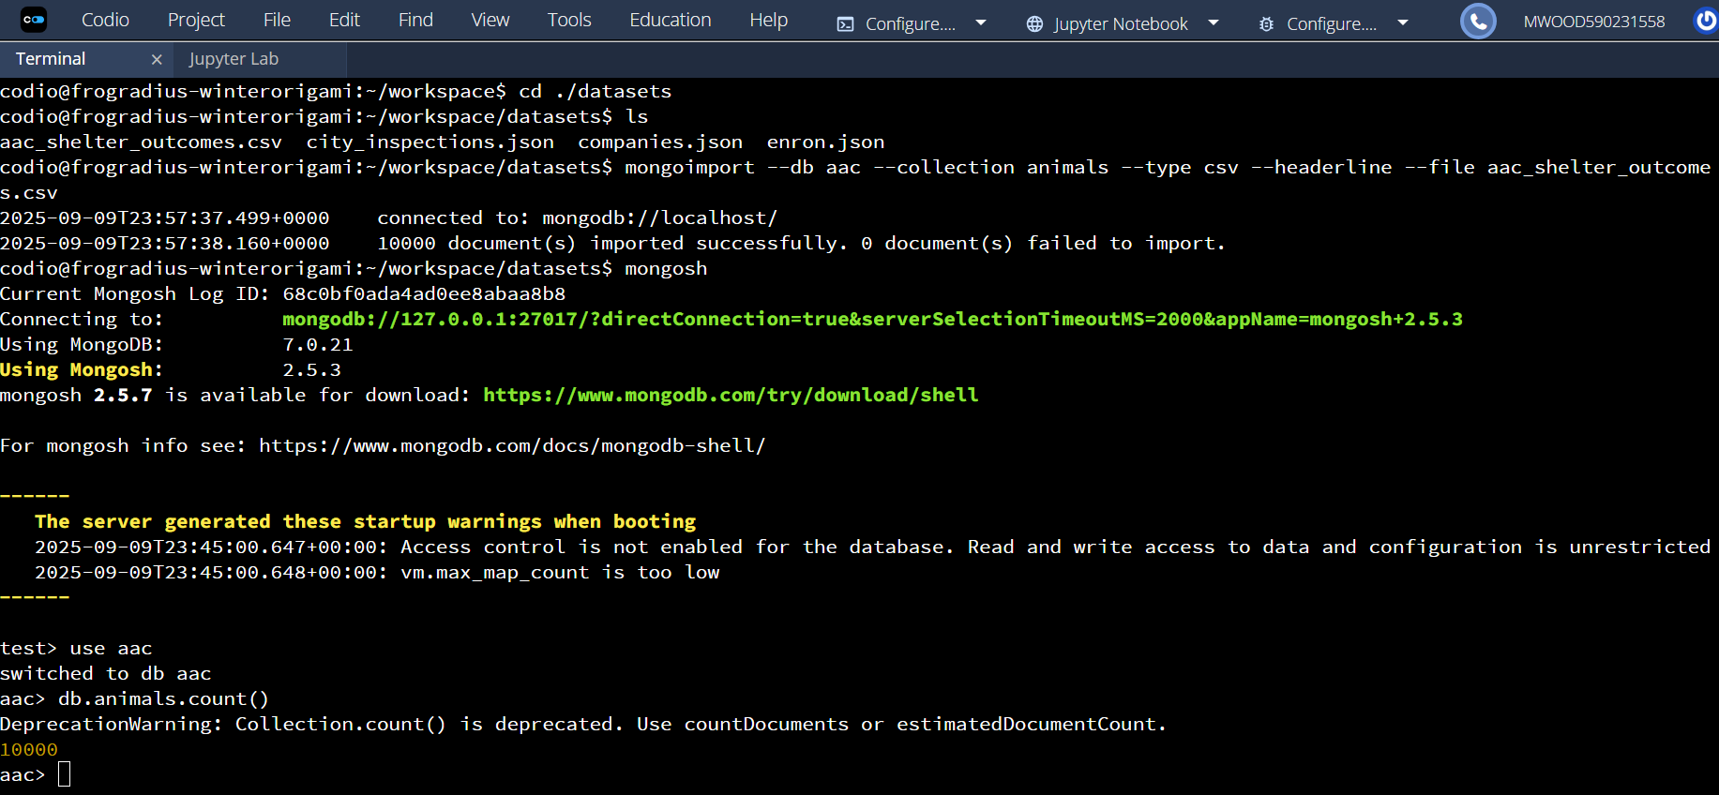
Example Query:
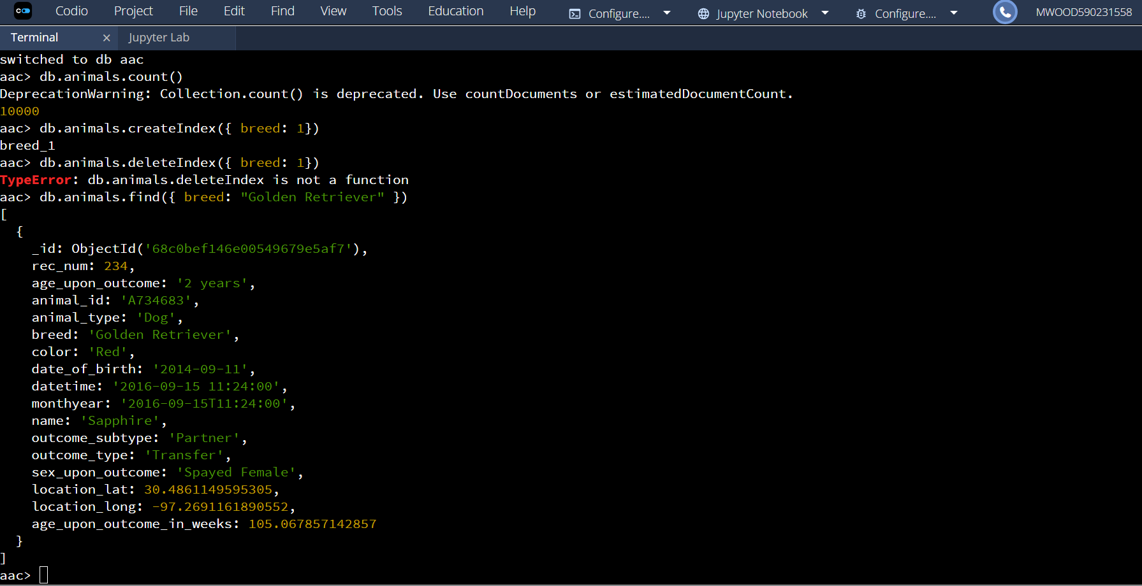

Use of explain() Confirming Usage:
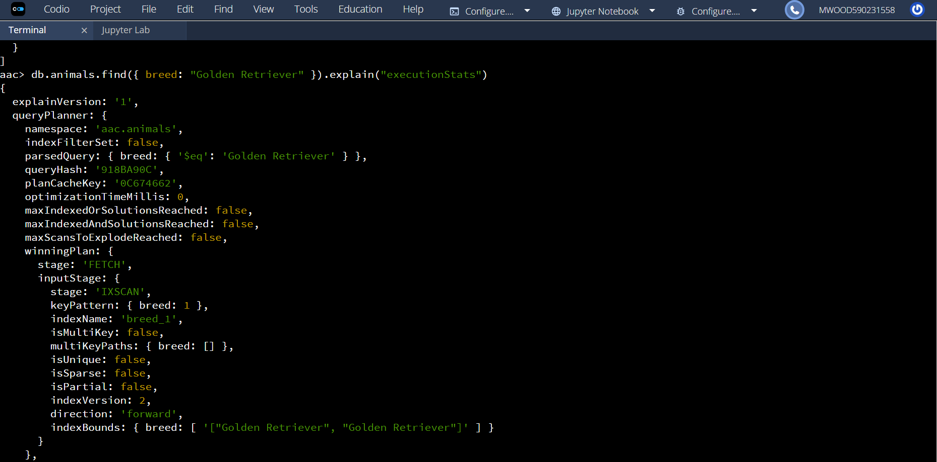
Looking at the above screenshot. Look at stage: IXSCAN this shows that the index is being used, if it was COLLSCAN that would mean that the index was not being used.

Creation of Compound Index and Example Query:
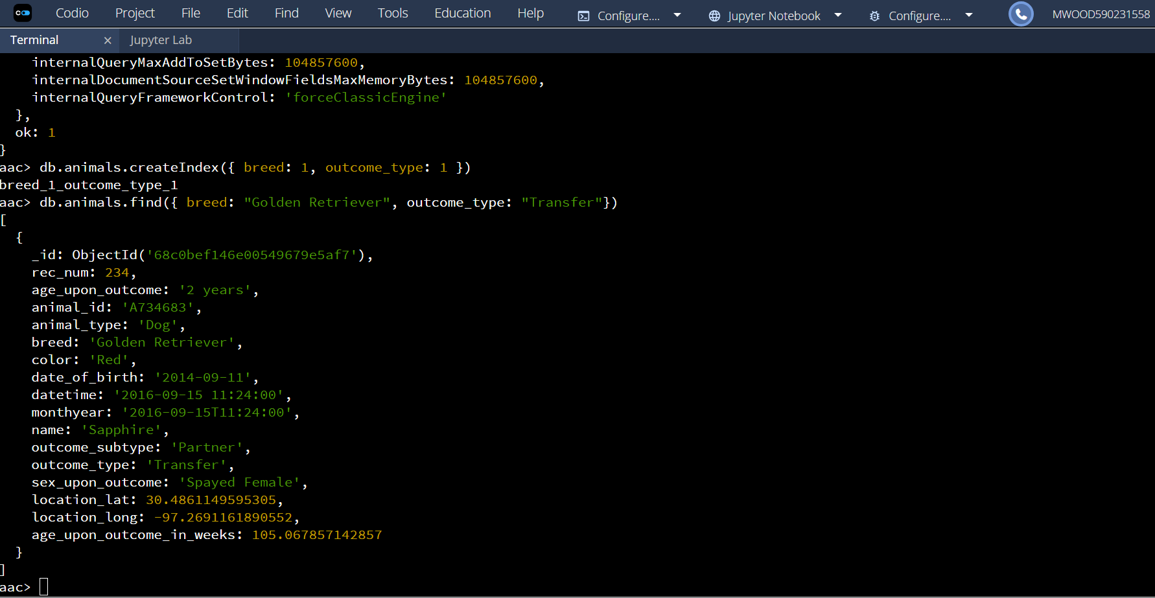

Confirmation of Usage using explain():
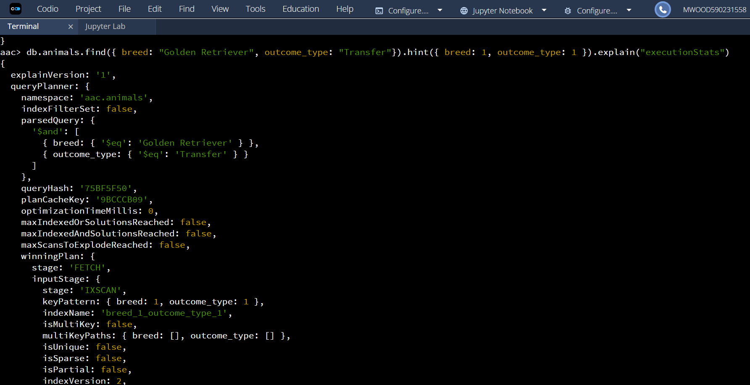
Once again look at stage: ‘IXSCAN’ proof of usage.

Continued query:
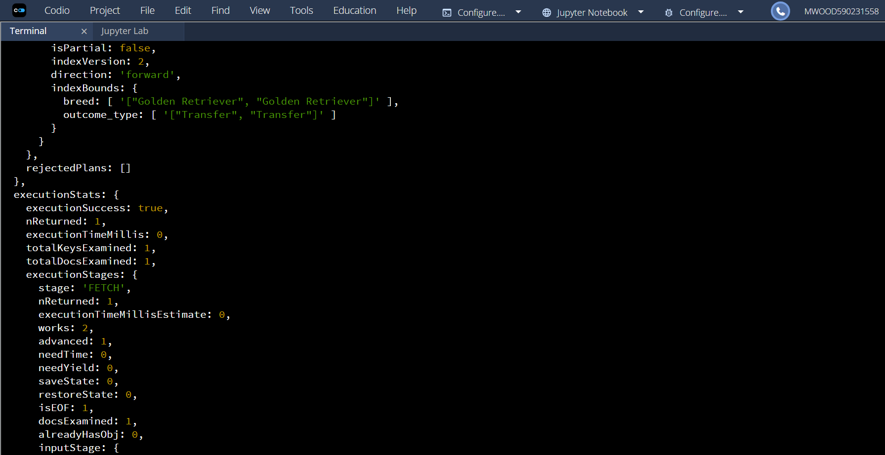
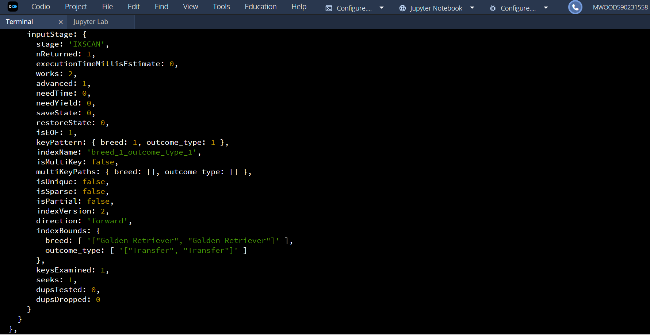
Last Screenshot of explain() Query:
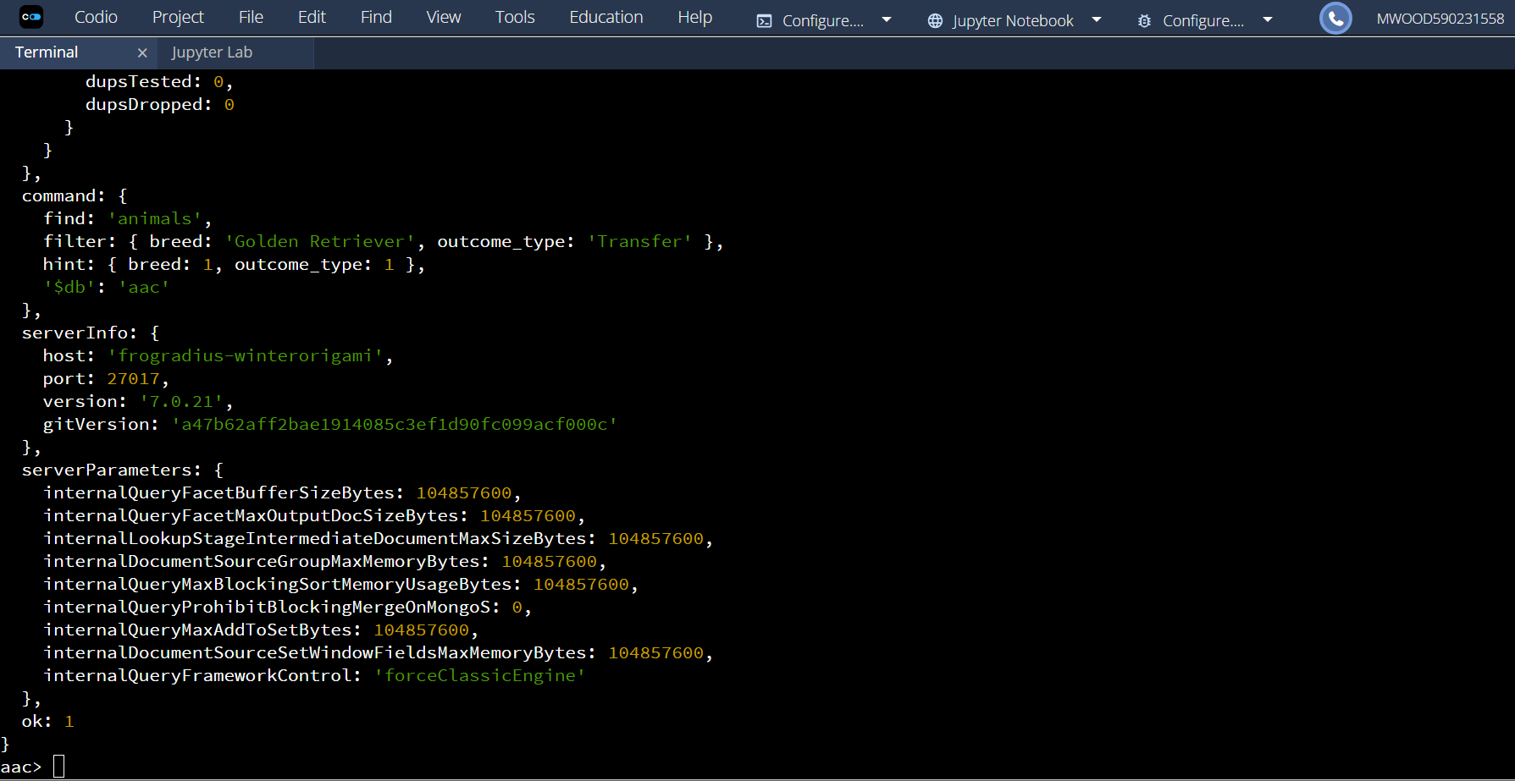

Part II: User Authentication
Creation of New User and Authentication:
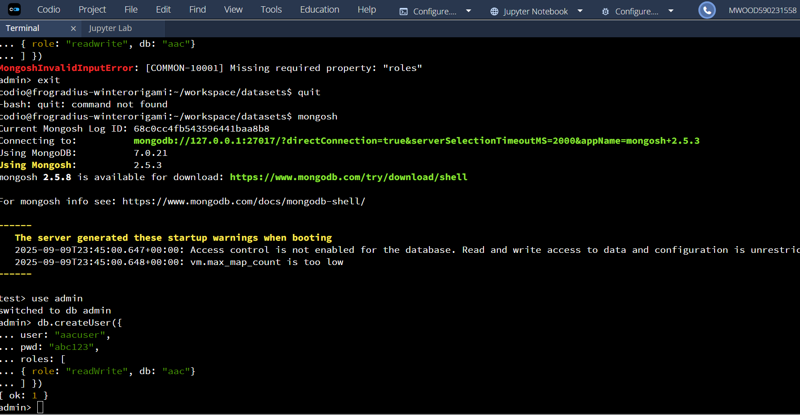
Login Process:
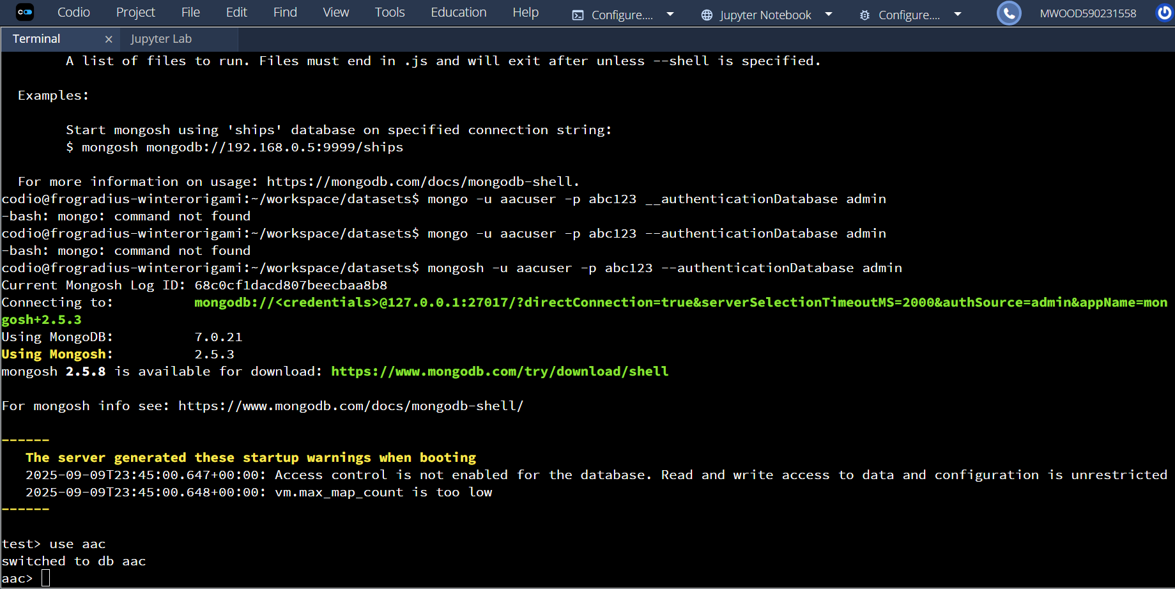

Access to MongoDB and Database List:
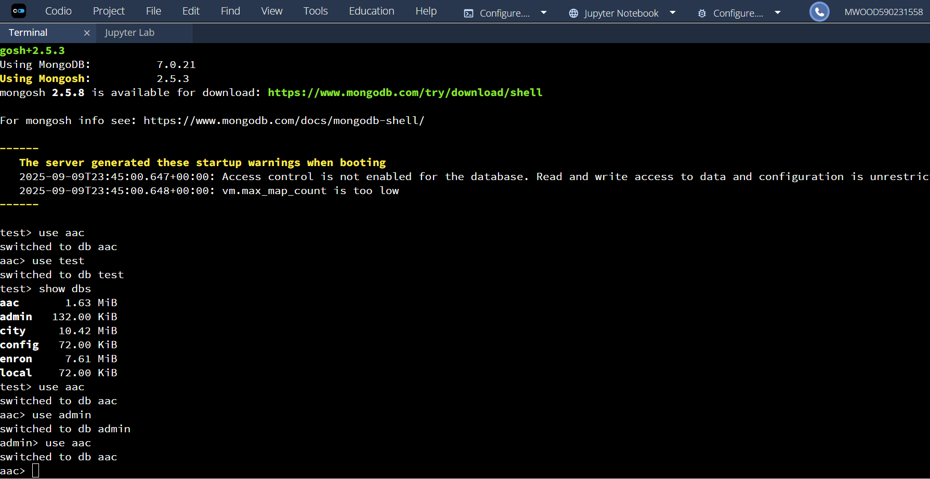
Connection Status:
