4-1 Milestone: Create and Read in Python
Michael Wood
SNHU
Course Number: CS-340 Client/Server Development
Instructor: Hari Paruchuri
Date Due: 09/28/2025

4-1 Milestone: Create and Read in Python
Use of Prompt showing database ‘aac’ and collection ‘animals’ were created:
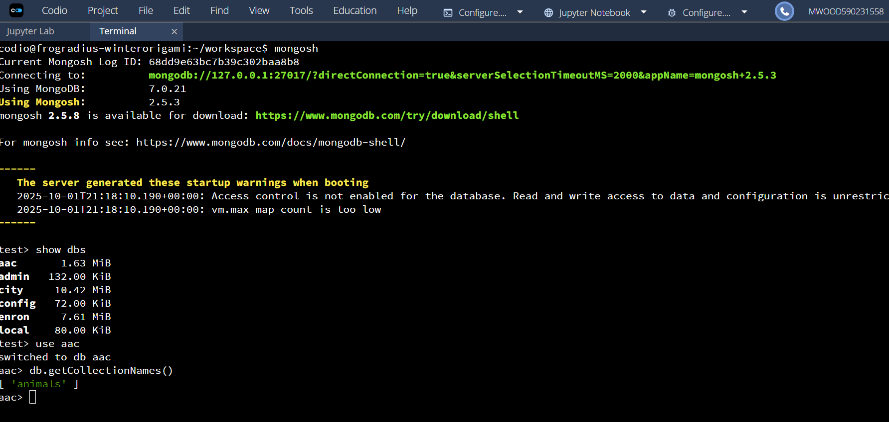
Here are the screenshots for Step 3: 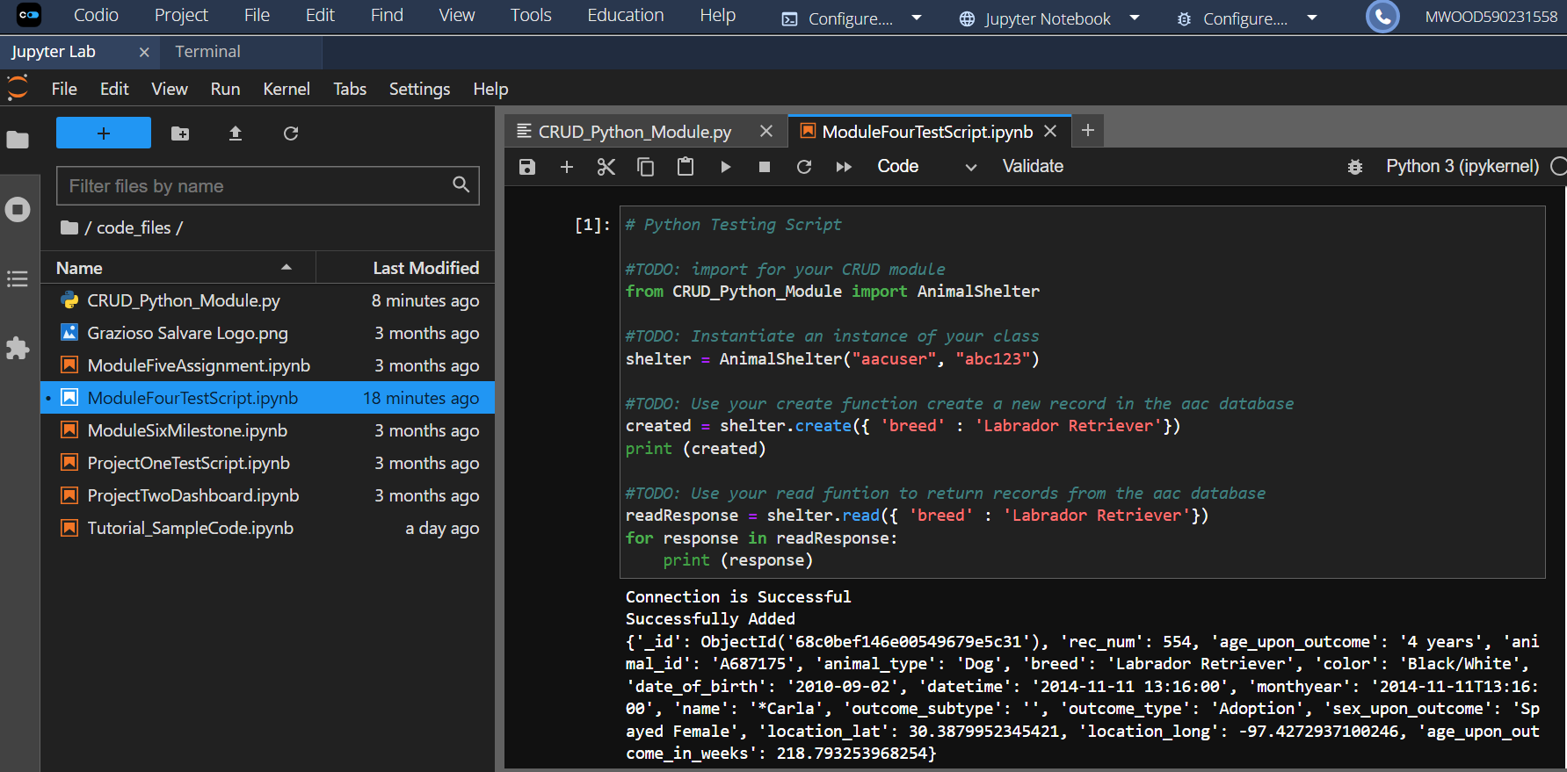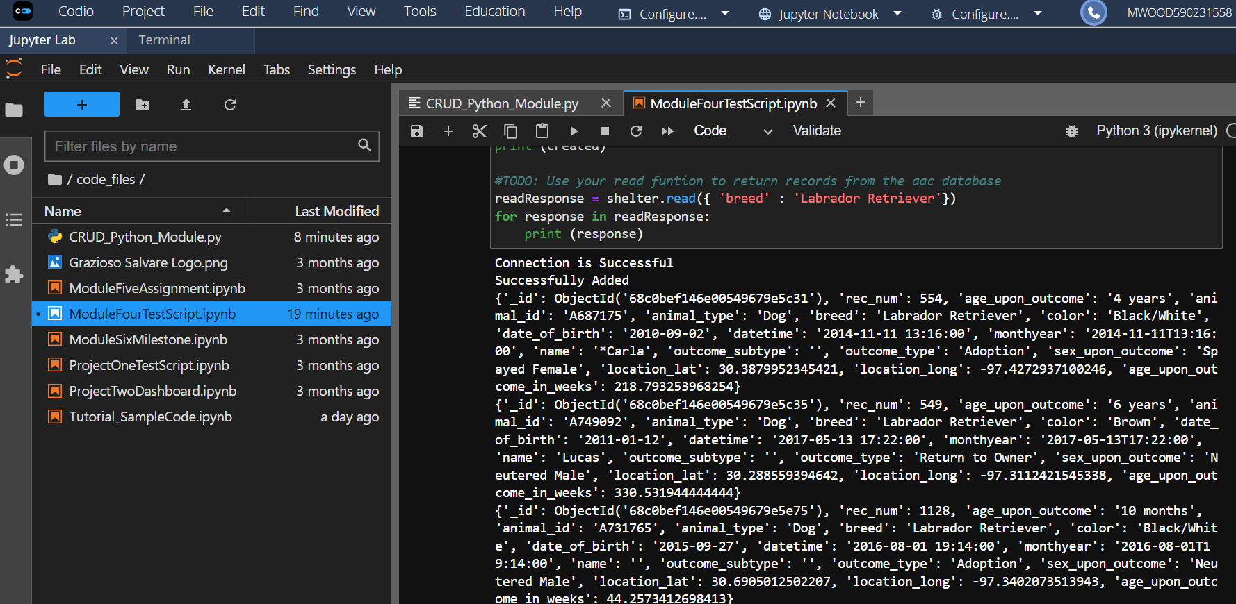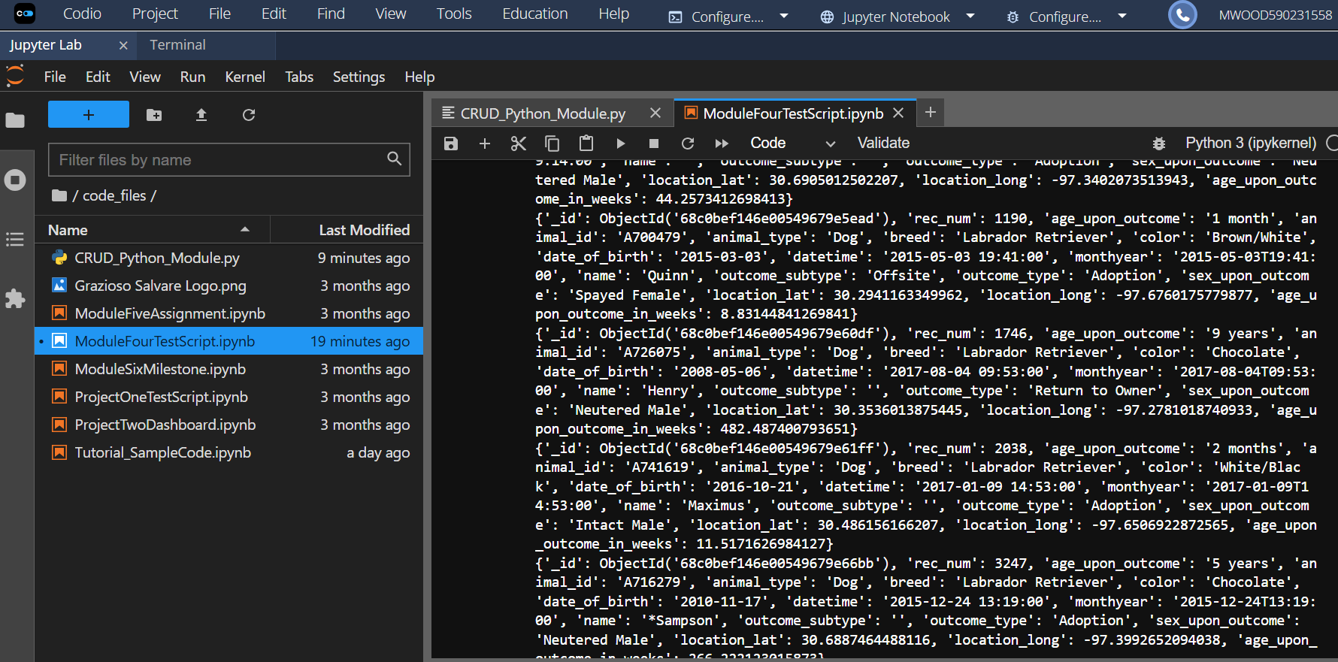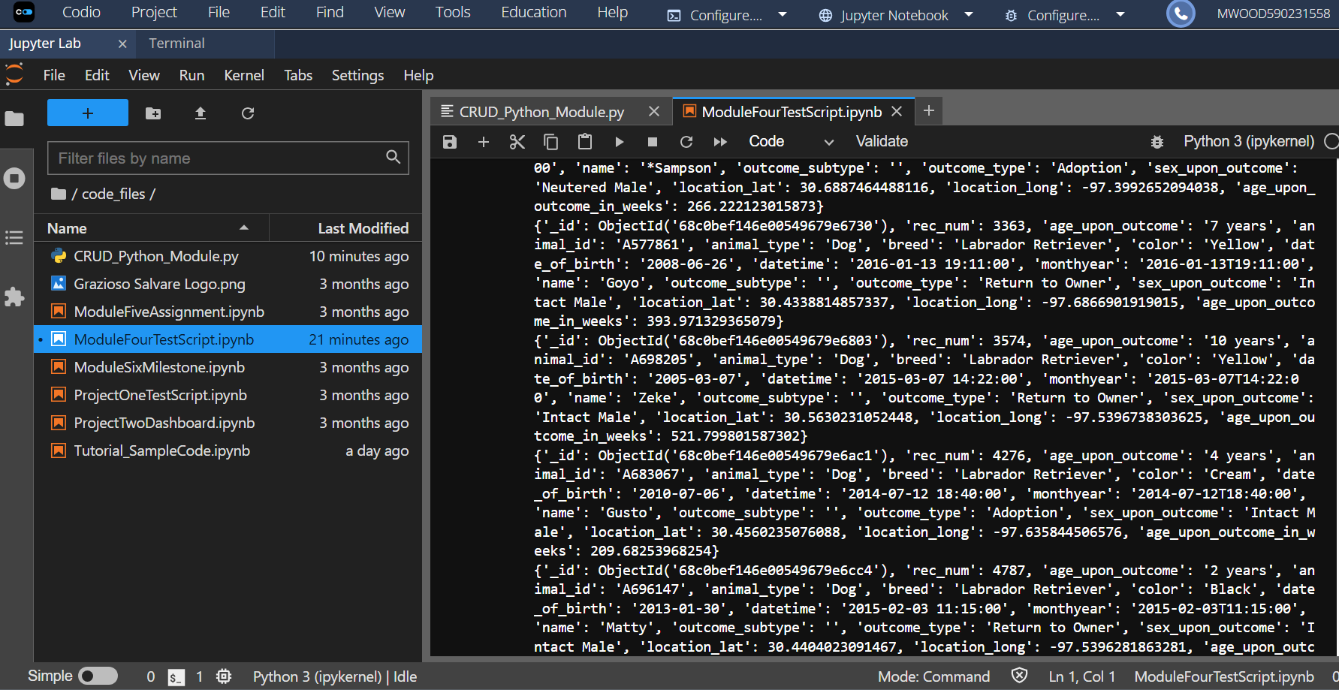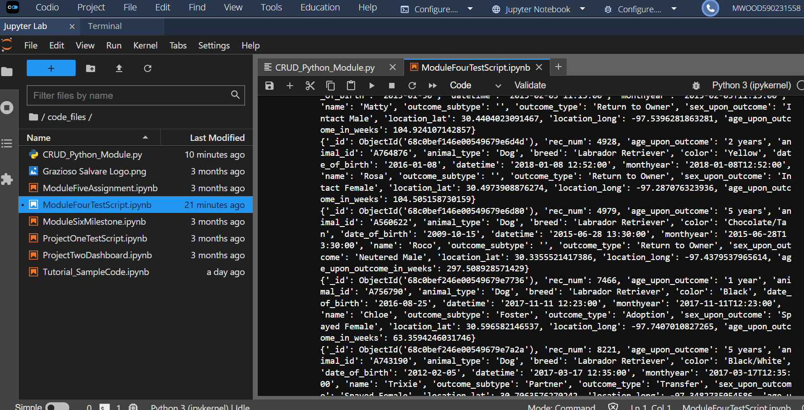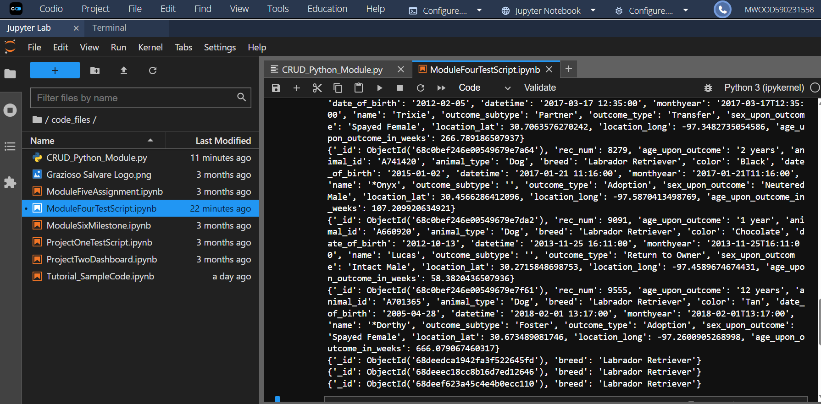
As you can see the test followed the query parameters as designed and only returned results for breed.

