5-1 Project One
Wood Michael
SNHU
Course Number: CS-340 Client/Server Development
Instructor: Hari Paruchuri
Due Date: 10/05/2025

README
About the Project/Project Title
Project Salvare Grazioso. This project was created to enable Create, Read, Update, and Delete (CRUD) capability for Grazioso Salvare's MongoDB database, resulting in supporting their animal rescue activities. It makes it easier for staff to keep, access, and edit documents pertaining to animal intake, training status, and adoption readiness for rescued animals.
Module Usage
The MongoDB Python Driver was chosen for the following reasons:
- Integrated support for MongoDB functionality
- Comprehensive documentation and community assistance
- Integration with Python data structures is smooth.
- Adaptability in managing authentication, updates, and queries
CRUD Operations
        - CREATE
          - Adds new animals to database
          - Client inputs details (such as name, breed, or age) information is then saved into database
        - READ
          - Finds animals within the database by setting the search parameters
          - Shows the results within the search parameters (such as breed, age, or name)
        - UPDATE
          - Updates information about animals already within the database
          - Client chooses which animal/animals’ information to be changed or updated
        - DELETE
          - Removes animals from the database
          - Client chooses which animal/animals’ information to be deleted
Screenshots of Functional Operations
- Screenshot of the MongoDB import execution
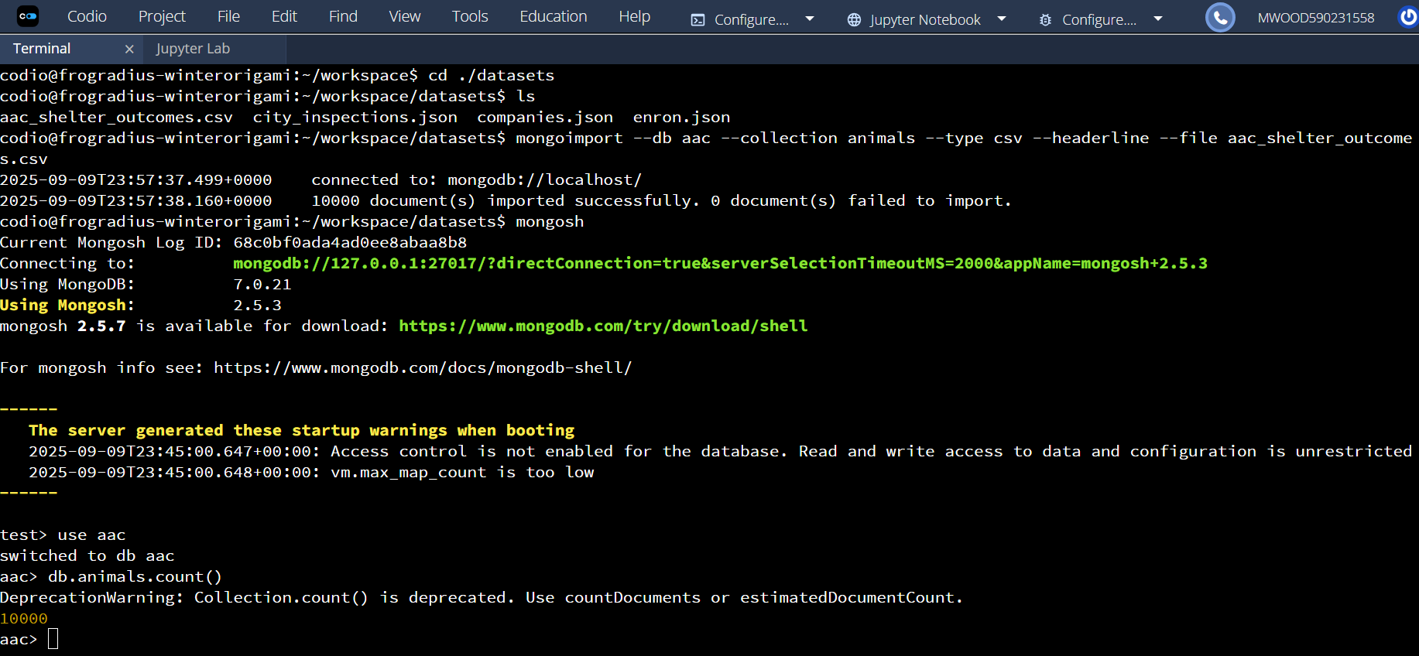

- Screenshot of Authentication Execution
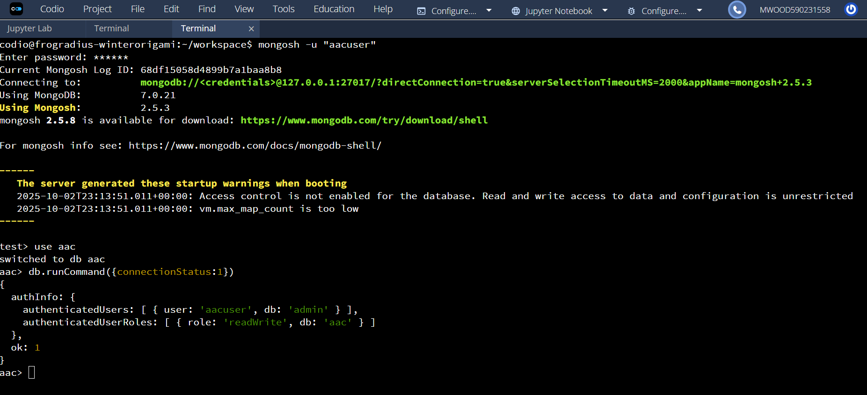

- Screenshots of CRUD functionality test execution
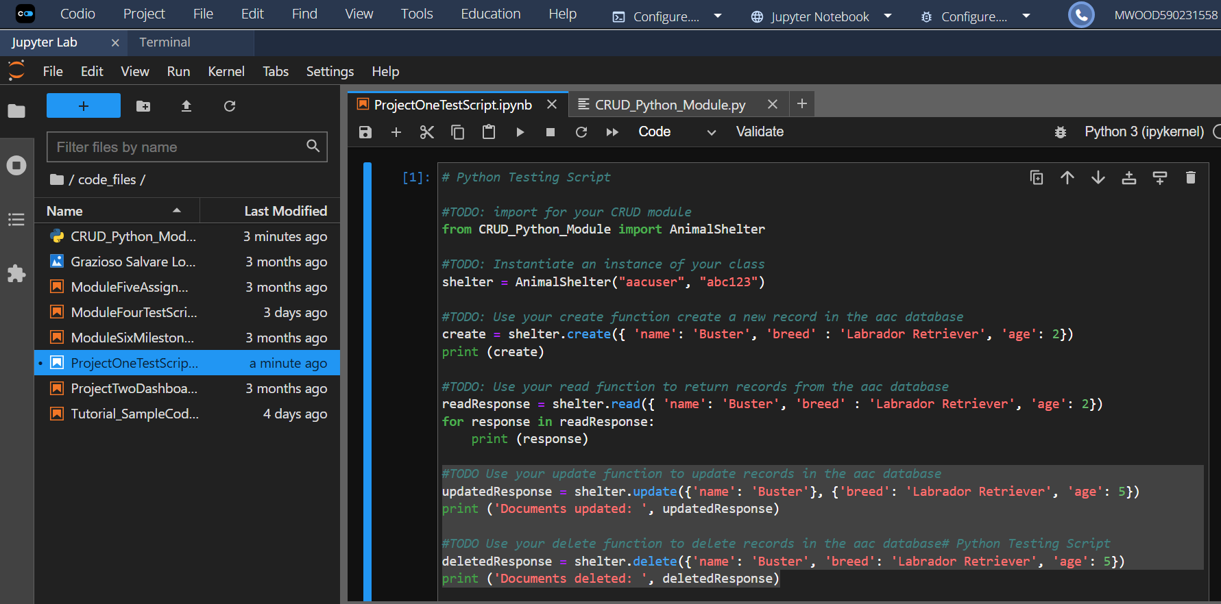
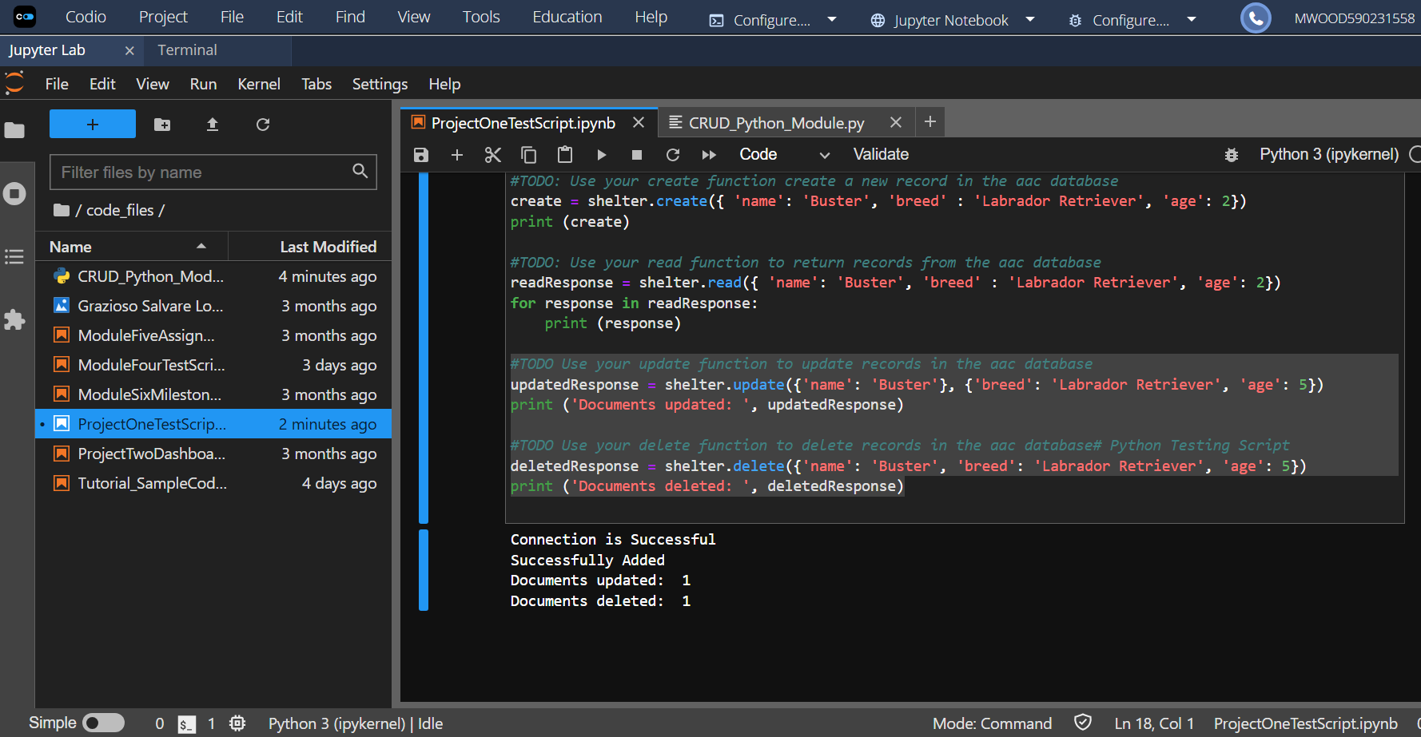
Software/Programs Needed
- Latest Updated Version of Python
- PyMongo
- MongoDB
- Jupyter Notebook
Contact
Michael Wood

