8-1 Assignment: Data Aggregation Pipeline
Michael Wood
SNHU
Course Number: CS-340 Client/Server Development
Instructor: Hari Paruchuri
Date Due: 10/25/2025

8-1 Assignment: Data Aggregation Pipeline
Import Dataset:
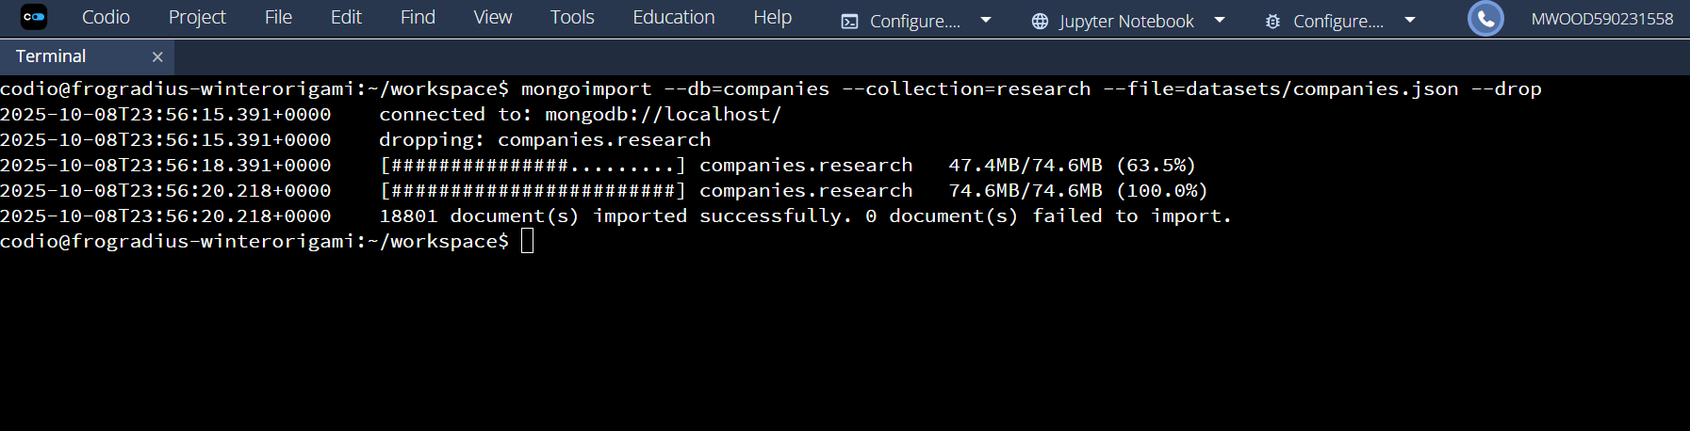
Verify Import:
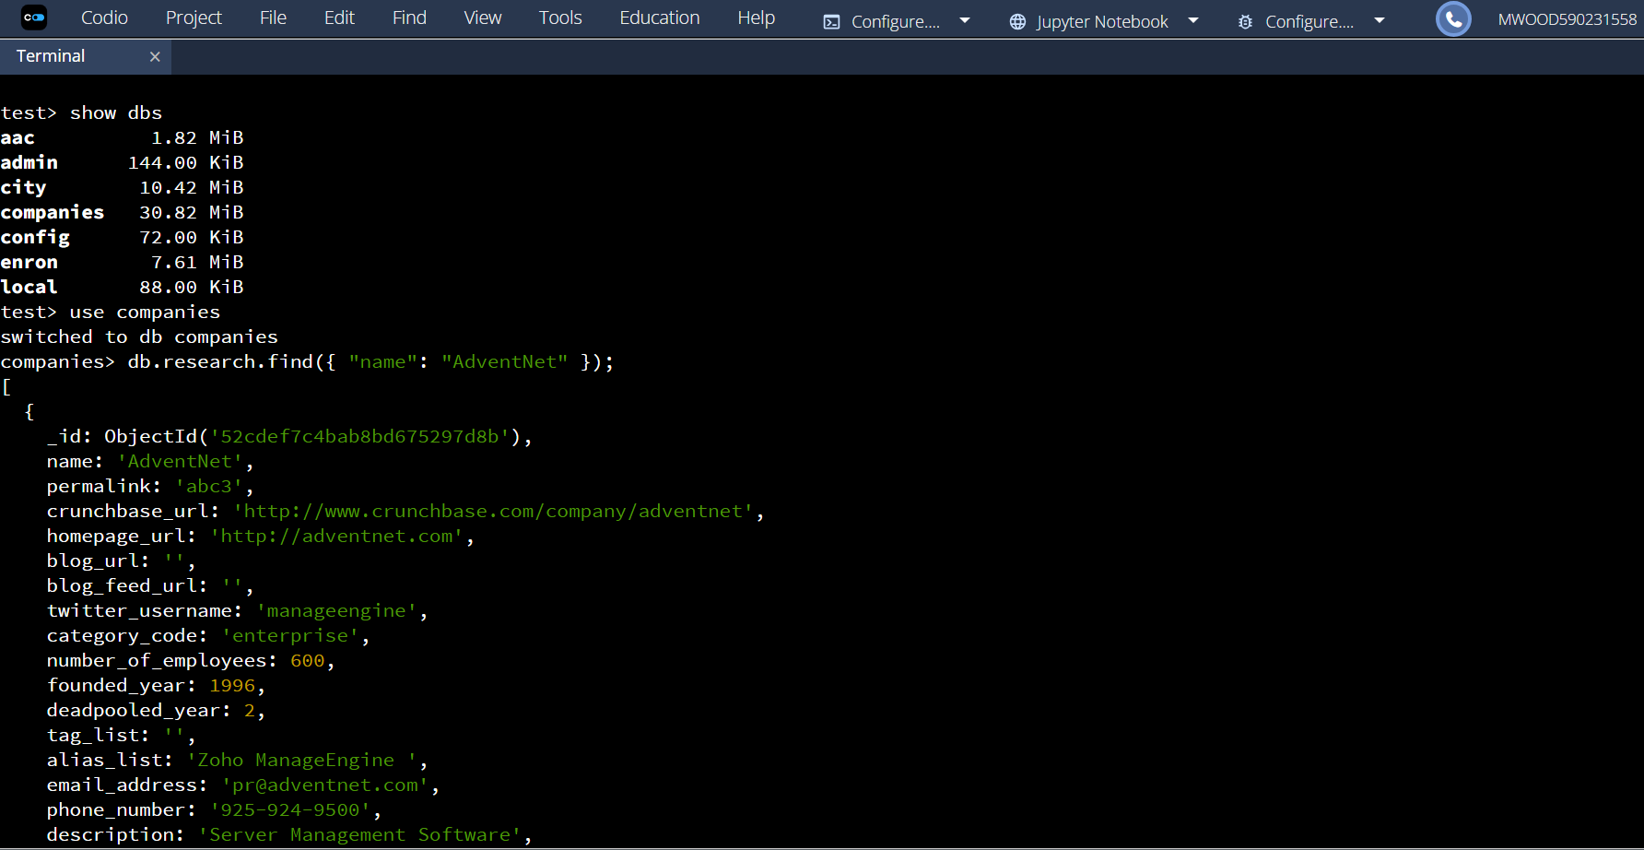
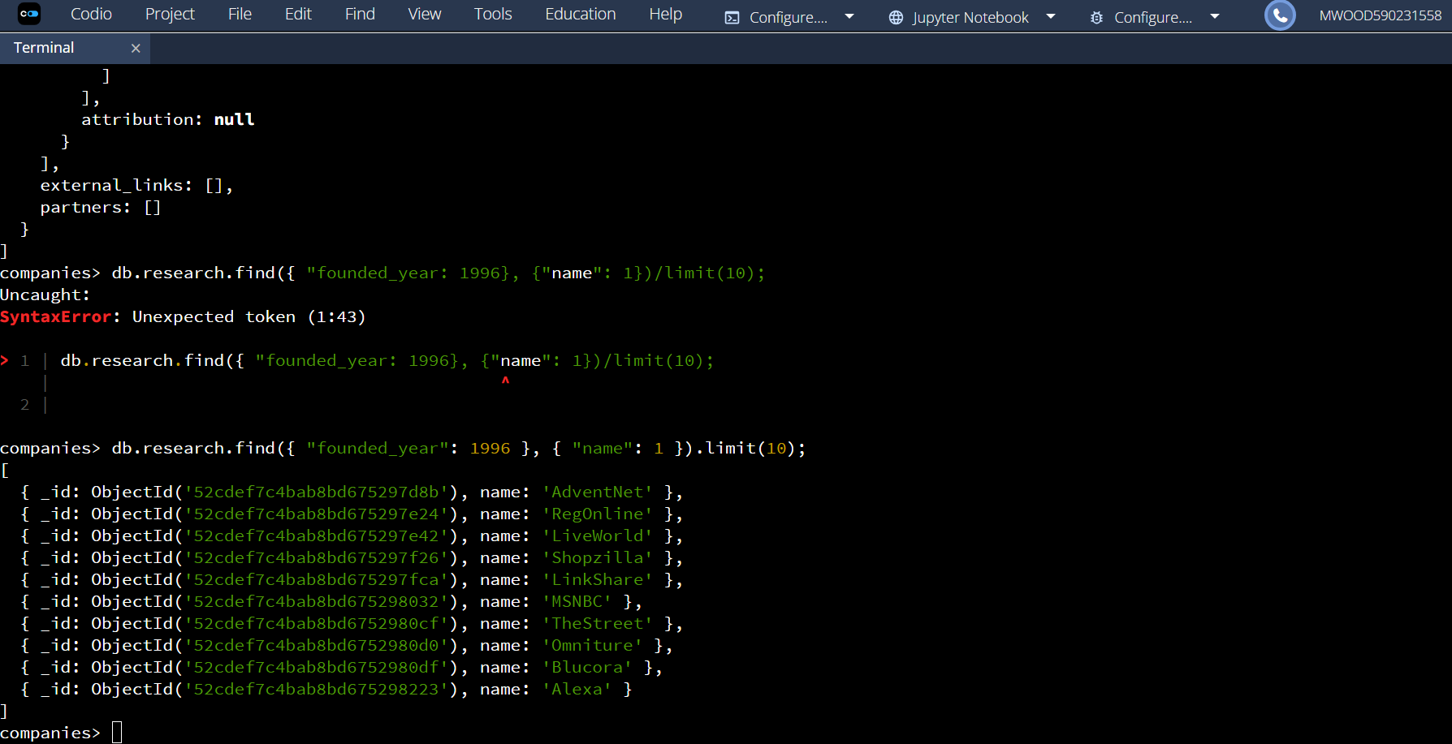
MongoDB Queries:
- First 20 Companies Founded After 2010(Alphabetical):
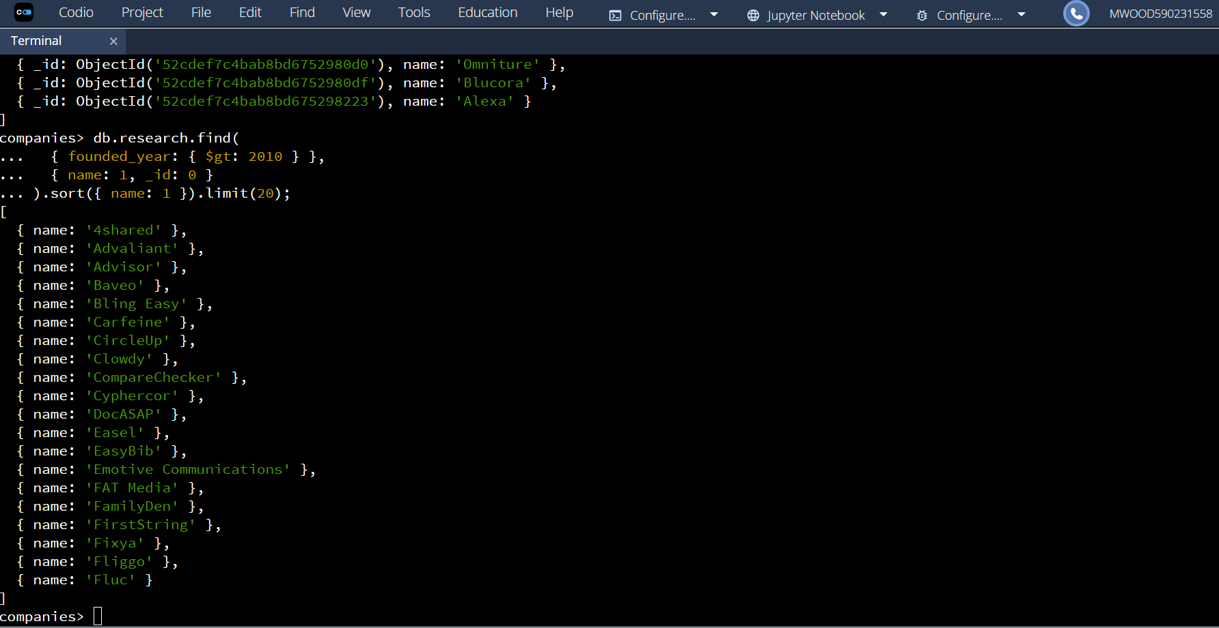
- First 20 Companies with Offices in California or Texas (Sorted by Employees):
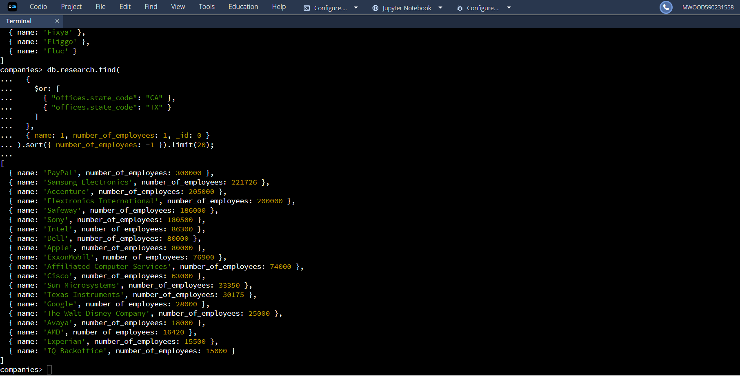
Aggregation Pipeline (Total Offices by U.S. State):
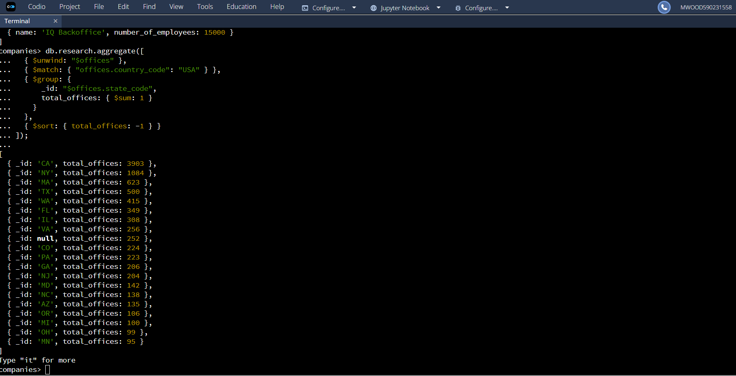
Continuation:
