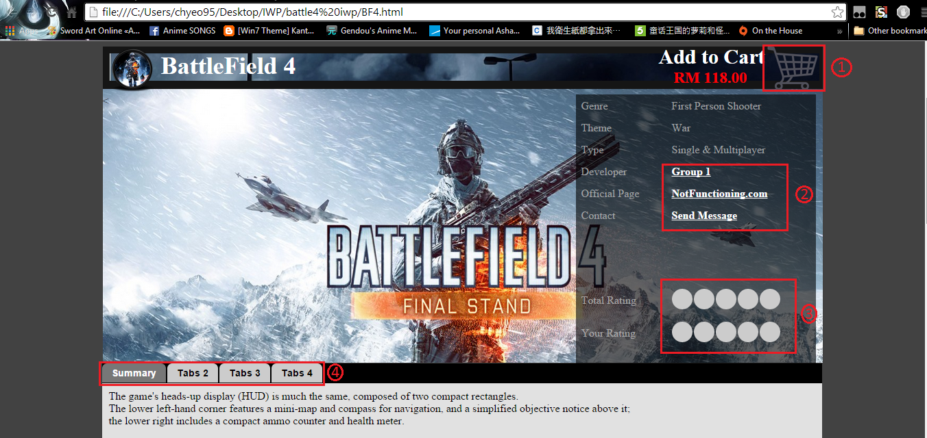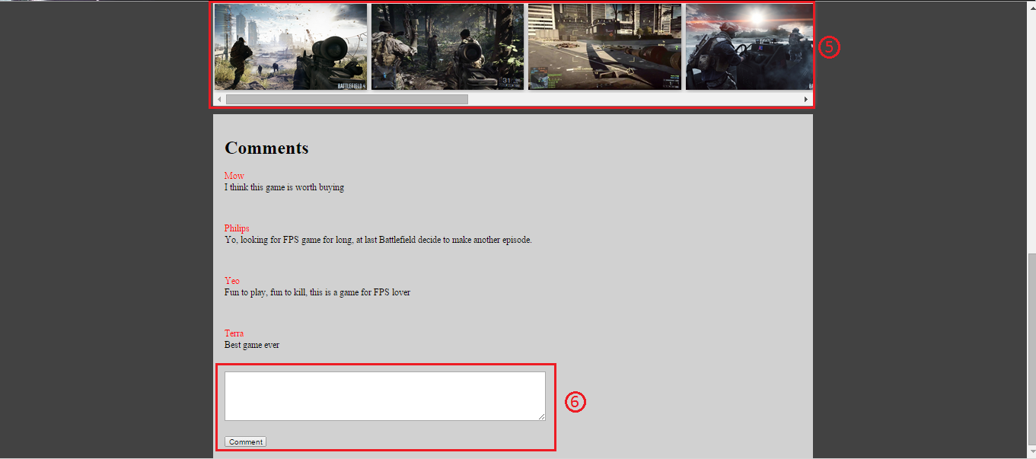

1. Add to cart function

If user want to buy that game, user could click that shopping cart picture to add the current game into their shopping cart, which they could view later in shopping cart to edit how many copies they want, or to delete the order.

1. Game Description

The developer page that developer this game.  
The game homepage  
And to contact the developer that responsible of this game

1. Rating of Game

User could give rating to this game, and total rating is shown to user.

1. Navigation Tab

User could use the navigation tab to view the game information such as summary, game media, game articles and more.

1. Media

Video and screenshot of the games is shown here, user could scroll to view all the media

1. Comment Section

User can comment here for this game, which other user could view next time they visit.

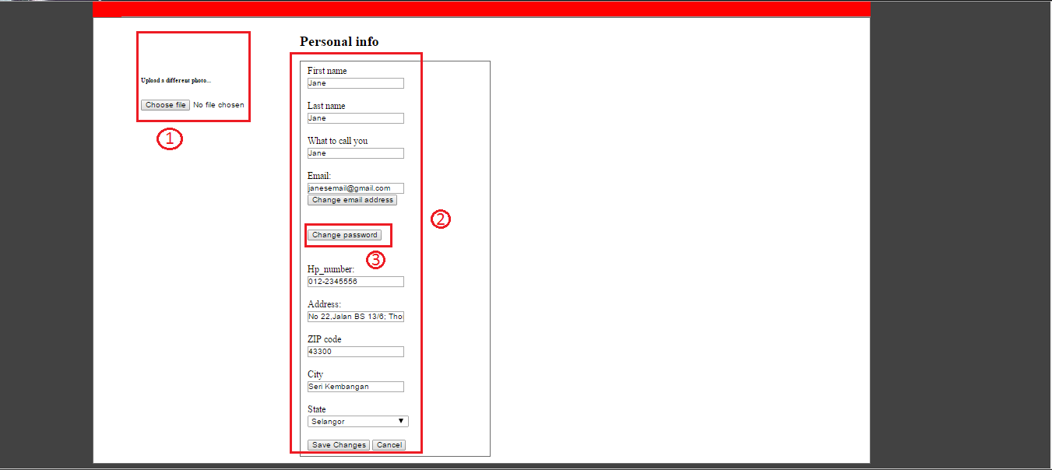

1. Profile Picture

User could upload their profile picture here, by clicking choose file, then later on click save changes in personal info in section 2.

1. Personal Info

User could change their personal information here, like Name, Email, hand phone number and others.

1. Password

Password is sensitive information so there are no information shown there, if user want to change password, user could click that change password button, which redirect them to the link.

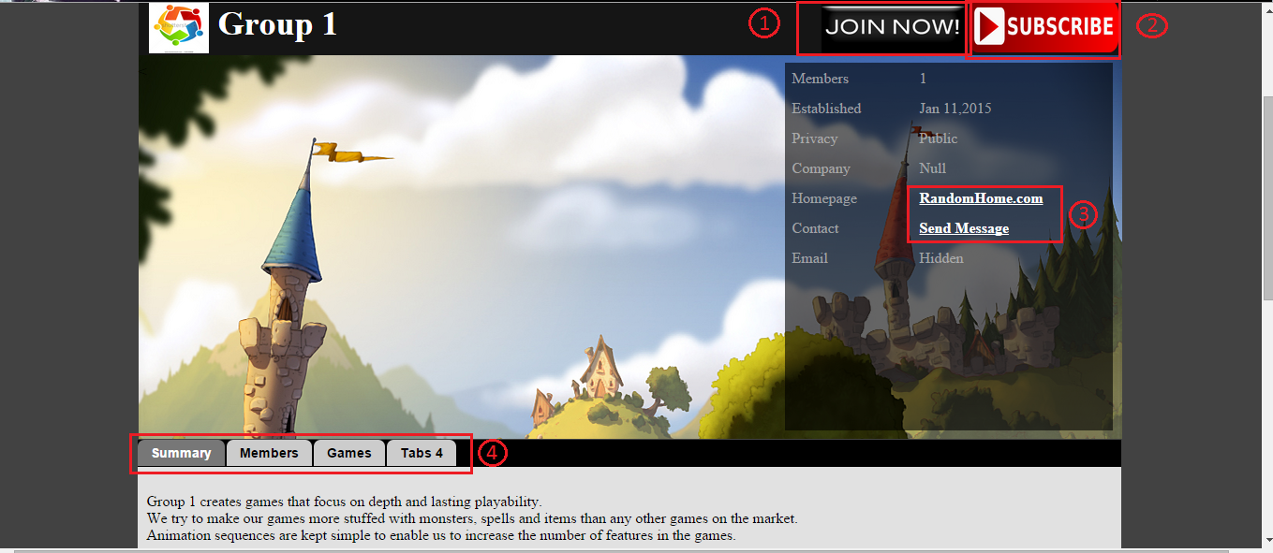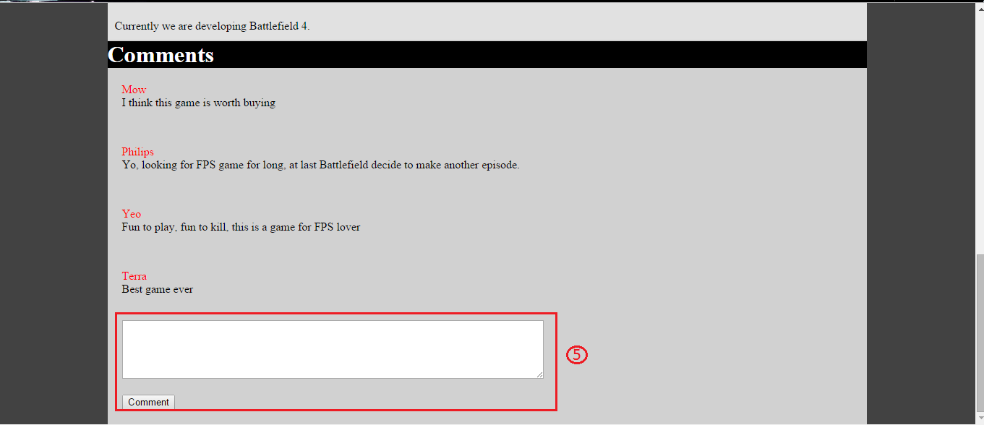

1. Join Group

User could click that JOIN NOW button to request to join the group which group admin approval.

1. Subscribe

User could click SUBSCRIBE button to subscribe to the group, so if the group post new games or news user will know through their email provided.

1. Group description

Group homepage, and contact them by sending message is here

1. Navigation tab

To view group summary, games the group already created, member of the groups or more by using this navigation tab.

1. Comment section

To let user or group member to comment in this section.