Abstract
It is a very brief but clear description of what the report is all about, summarising your plan and your progress so far. Keep your abstract to 100 to 150 words or in one page.

List of Tables
Table 1.1: Division of tasks ………………………………………………… 11

If the table exists in Part 1, it should be referred as Table 1.x where x is an integer based on the order of appearance.

List of Figures
Figure 1.1: Sample website screenshot ……………………………………………… 22

If the figure exists in Part 2, it should be referred as Figure 2.x where x is an integer based on the order of appearance.

Table of Contents

ABSTRACT 1
LIST OF TABLES 2
LIST OF FIGURES 3
TABLE OF CONTENTS 4

PART 1: INTRODUCTION 6
1.1 Overview 7
1.2 Project Objectives 8
1.3 Target User 9
1.4 Project Scope 10
1.5 Gantt Chart 11
1.6 Division of Work 12

PART 2: CASE STUDY AND LITERATURE REVIEW 13
2.1 Primary Study 14
2.2 Problem Statement 15

PART 3: PROPOSED SYSTEM DESIGN 16
3.1 System Features 17
3.2 Hardware/Software Requirements 18
3.2.1 For Developer 19
3.2.2 For User 19
3.3 Context Diagram & Data Flow Diagram 20
3.4 Entity Relationship Diagram 21
3.5 Data Dictionary 22

PART 4: PROPOSED SYSTEM PREVIEWS 23
4.1 View of Prototype and Explanations 24
PART 5: REFERENCES 25

PART 6: APPENDIX 28
Appendix A: Minutes of Meeting 29
Appendix B: Website Samples/Questionnaire/Forms 29
Appendix C: Request Interview Letter 30
Appendix D: Interview Questions 30

Part I:
Introduction

  - Overview
The overview describes the current technologies or trends (e.g: online business, online ordering) related to your project. This section describes a general understanding about the system.

  - Project Objectives
This section focuses on outcomes of your project. State what you would like to achieve from the system. The objectives must be measurable and achievable.
(Objectives MUST be between THREE to FIVE points)
1. To reduce …
2. To improve …
3. To increase …

Example:
- To provide better convenience for users towards this system
Fast loading, good and clean layout by making sure that it is not crowded with too many unwanted text of images. Easy to find links. Most of the important links can be seen in one view without scrolling down the webpage. Making sure visitors can get the information that they wanted within 3 clicks of the mouse.

  - Target Users
Target users are people who can interact with your system (e.g: E-Learning: target user: students, lecturers). However, you may want to narrow down your target users based on the accessability of your project.

Example:
- Teenagers
State the reasons why you target teenagers to use your system.
- Music lovers
State the reasons why you target music lovers to use your system.

  - Project Scope
This section refers to the coverage of your system (area, time, payment, delivery, cancellation). The project scope and concept is also related your target users.

Example: For a shopping cart system, visitors must register and become a member before being allowed to purchase products online.
It also states the limitation, or what are the areas that the system is limited to. Example: For a shopping cart system, the limitation may be no delivery is provided. Only credit card payments is accepted.

  - Gantt Chart
A Gantt chart outlines what aspects of the project will be completed by when. The Gantt chart must show the duration taken from selecting group members until delivering the Interim Report/Presentation. You can refer to the sample report to see what Gantt chart looks like. You can create Gantt chart in MS Project, SmartDraw or other project management software.

  - Division of Work
Division of work is very important make sure every member participates in the project development. Some of the tasks such as preparing documentation and background study must be done by all group members. However certain tasks must be delegated to each group member by the group leader.
You can divide the tasks based on modules you have drawn in the data flow diagram. You can also divide tasks based on types of resources needed for the project. Below is an example of division of tasks (just a format).
TASKS | STUDENTS
 | Ali | Chong | Kumar
Preparing project proposal | X
Overview |  | X | X
Objectives | X
Target Users | X
Project Scope
Gantt chart
Primary Study
Problem Statements
System Features
Hardware/Software Requirements
Data flow diagram & Context Diagram
Entity relationship diagram
Data dictionary
Prototype/System Interface Design
Compilation of Interim Report
Presentation and Demo
Meeting Minutes

Table 1.1: Division of tasks

Part II:
Primary Study/
Literature Research

  - Primary Study / Literature Research
Students need to conduct a research for two or three existing/similar system on the market. Explain the aspects of design, features and functions of the systems (you may includes advantages and disadvantages of the systems).
Primary study refers to background information or technical knowledge that is critical to develop your project. Primary study also includes feasibility study on your system given the time constraint and resources available.
Snapshot or screenshots of the webpages or sections are required.
Example
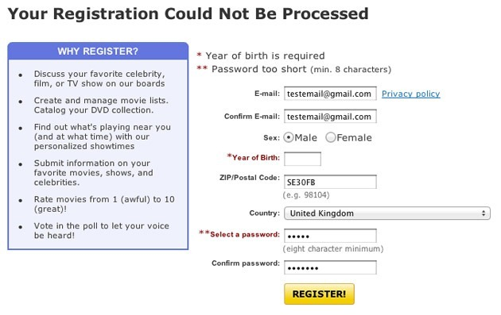
Figure 2.1 ABC Registration Page

The example above shows how the registration section lists out all the errors above the form, which then forces the user to scroll and scan down to the rest of the form to fix the errors. This will be troublesome for longer forms and frustrating as the user has to scroll up and down to fix each error. It would be much easier if the errors could be seen next to the form field.

  - Problem Statement
The problem statement refers to the problem area that your proposed system aims to solve. It should reflect the objectives and primary study.
Example: (Explain your point in proper sentences)

Example:
Objective:
To provide better convenience for users towards this system

Problem Statement:
Current websites do not implement a user-friendly concept. Tend to drag the visitors all over the place before displaying the information that the visitors are searching for, this might be one of their advertising strategies. Some of the websites also has a cluttered design with large amount of unnecessary images that makes the loading time longer.

It is not regarding the problems that encountered during your project/system development (e.g: Communication problem with group members, time management).

Part III:
Proposed System Design

  - System Features

List down all features of the proposed system for each type of user.
Example:

- Admin
  - Can add new staff.
  - Can add and edit bulletin.

- Member
  - Can register and log into the system.
  - Can edit profile.

  - Hardware/Software Requirements
    - For Developer
This section list the hardware components (if any), software or any tools you (as the programmer/designer) plan to use to develop your project. You may also include the price, how and where do you plan to get them. This information may be presented in point form or table.
    - For User
This section describes the hardware (if any) and/or software requirement for the user to run your new project. This information may be presented in point form or table.

  - Context Diagram & Data Flow Diagram
For Web Based/Standalone project, students need to draw Context Diagram and Data Flow Diagram (DFD) Level 0 to model the process and data flow your system. You may use any diagramming tool which is related. It is advisable to follow Gane & Sarson model.
Example: Gane & Sarson Model
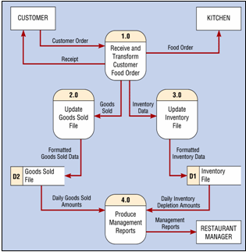

  - Entity Relationship Diagram

This section is for Web-based or Standalone project. The diagram describes data entities in the system requirements, and relationships or associations among those entities. You may present it using Chen model or Crow’s-foot model. You may use also any diagramming tool which is related.
Example: Chen Model

Example: Crow’s Foot Model
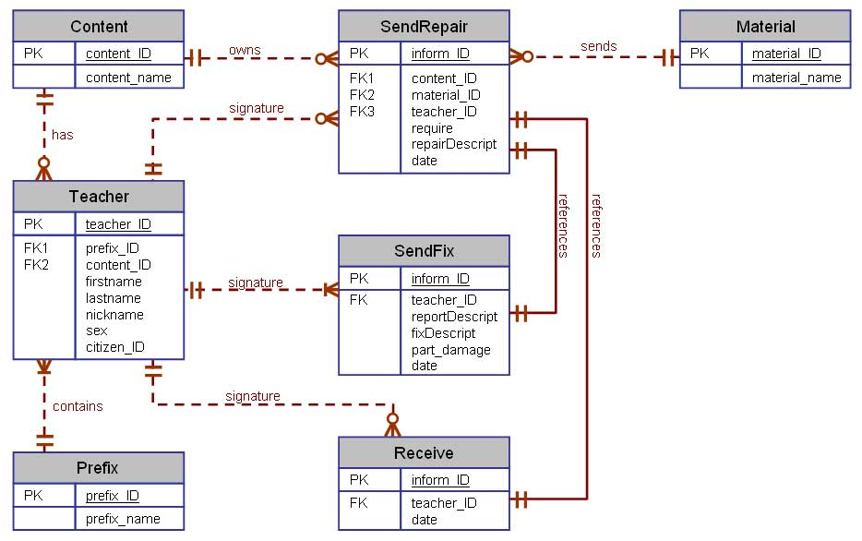

  - Data Dictionary

This section describes in details the attributes and tables used in developing the project. This section is for Web-based or Standalone project.

Sample:

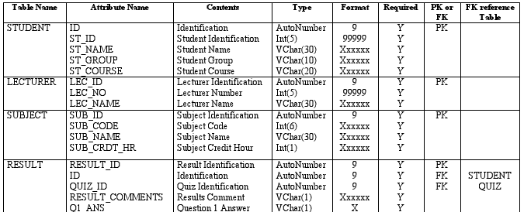

Part IV:
Proposed System Previews

4.1 View of Prototype and Explanations

This section explains screenshots of the major features of your proposed project. Please label each figure with appropriate numbering and title. You must provide the explanations too. Please check the minimum requirements for Prototype Project for each project in FYP Guidelines.

Example:

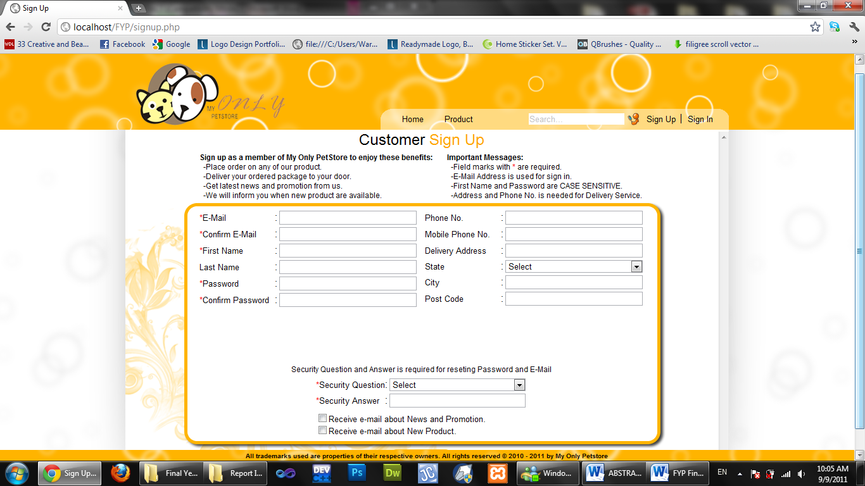

Figure 4.1 Customer Sign up Page
In Figure 4.1, customer sign up page shows that customer needs to fill in the required fields in order to complete the registration process.

Part V:
References

List of URL addresses, reference books or bibliography entries
Books:
Anti, J.M. and Ryan, P.V.S., “Civil Engineering Construction”, 3rd Ed., Sydney, Angus and Robertson, London, 1967, 631 pages

Journal:
Downs, R.B., “The Military Approach to Soil Stabilization”, Journal of the Institute of Highway Engineers, London, Volume XIX, No. 3, March, 1972, pg 19-23

Monograph:
Body, D.M., “Flood Estimation”. Water Res. Board of Australia. No.4, 1959, 41 pages

Thesis:
Marques, J.L.G.,”A Study of Anchorage Capacities of Confined Bentbar Reinforcement”. Ph.D. Thesis, Rice University, Houston Texas May, 1988

Conf.
Lea, F.M., “Cement Research: Retrospect and Prospect” in Proc. 4th Proceedings: International Symposium on the Chemistry of Cement , Washington DC, 1960, pg 5-6

Web Page:
Smith, A. B., “Description of the Intel P6 Processor”, Intel Corp.,
http://www.intel.com/pentium/p6/description.htm

Working Paper:
Kuo, C and Sayer, P, “Education of Engineers in Marine Technology”, presented at the World Conference on Education in Applied Engineering & Engineering Technology Cologne German, 16-19 April, 1984

Standards:
British Standard Institute, “BS 6000:1972, Guide to the use of BS 6001, sampling procedures and tables for inspection by attributes”, London, 50 pages

Part VI:
Appendix

Appendix A: Meeting minutes
All meeting minutes must be included in the report in the appendix section.

Appendix B: Website Samples/Questionnaire/Forms
Any website screen shots, questionnaires and forms used as reference to your project will be included in this section.

Figure 4.1: Sample website screenshot

Appendix C: Request Interview Letter

Students need to include the request interview letter if they have conducted an interview session.

Appendix D: Interview Questions
Students need to include the interview questions if they have conducted an interview session.

