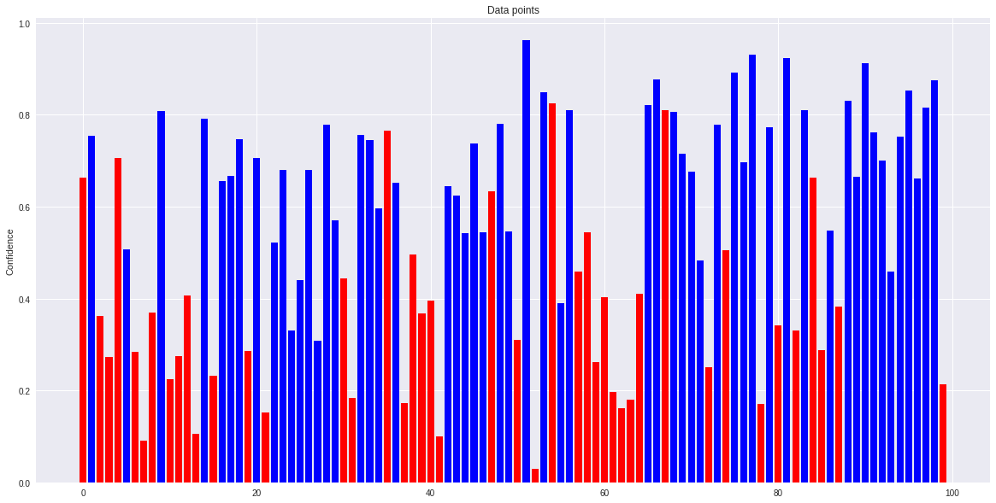
Given a multiclass multilabel classifier, we consider the prediction probabilities and groundtruth labels for 10,000 examples.
Threshold at 0.83
Precision: 9(true) predicted positives/9(total) predicted positives = 1.0
Recall: 9(true) predicted positives/56 ground truth positives = 0.16
Threshold at 0.6
Precision: 42(true) predicted positives/49(total) predicted positives = 0.85
Recall: 42(true) predicted positives/56 ground truth positives = 0.75
Increase threshold to increase precision
Fig.1 A sample of 100 data from label 1. Blue bar represents ground truth positive and red bar represents otherwise for that data point.

● Can you explain the precision-recall tradeoff?
There are many answers online, but I will try my best using my own interpretation.
In layman terms,
1) Precision is rate of predicted positives matching GROUND TRUTH given all predicted positives.
2) Recall is rate of predicted positives matching GROUND TRUTH given all GROUND TRUTH positives.

It is understood that Precision & Recall are inversely related to each other (hence tradeoff), but why?
Say to increase precision, one could increase the threshold for decision boundary such that only high confidence levels are considered as true for a label. Refering to the figure below:

For example, at threshold 0.6 meaning that any confidence level above 0.6 for that data point is considered positive for a particular label. When compared to a higher threshold of 0.83, a lower threshold of 0.6 means that more data points are considered positive, however, at a cost that there will be more false results amongst these positives. Hence at lower threshold, precision is lower.

At very high thresholds, only data with high confidence are considered positive for that label. This drastically reduces false positives since the ‘quality’ of predicted positive data is now higher, but at the expense of capturing lesser data that is actually true (capturing 9 ‘quality’ positive data out of the 56 ‘actual’ positive data out there) .

Hence, at a mathematical level, this Precision/Recall tradeoff is explained.

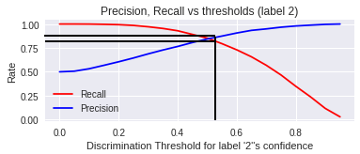
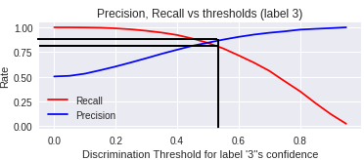
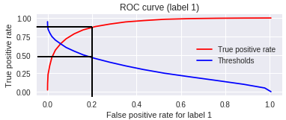
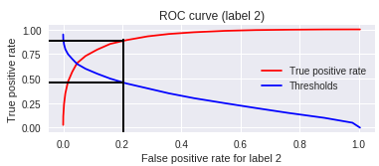
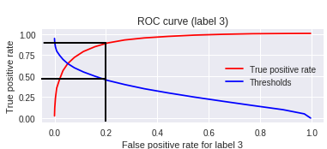
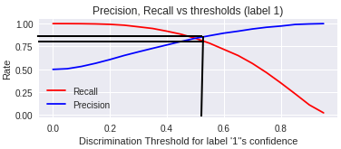
● What prediction threshold should we set to have the best true positive rate (​ ie. ​ recall) at
a maximum false positive rate of 20%?

label | Minimum threshold at maximum 0.2 false positive rate (Answer) | Minimum true positive rate at maximum 0.2 false positive rate
1 | 0.461875 | 0.872468
2 | 0.463665 | 0.880633
3 | 0.453081 | 0.883661

ans
ans

ans

● What prediction threshold should we set to have the best precision at a minimum recall
of 80%?

label | Maximum threshold at minimum 0.8 recall  (Answer) | Maximum precision at minimum 0.8 recall
1 | 0.536455 | 0.861369
2 | 0.544426 | 0.870560
3 | 0.539088 | 0.870598

ans
ans

ans

Please include plots (eg. ROC curve, Precision-Recall curves...) to illustrate your answers. Also,feel free to state any hypothesis you may want to use.
You can use basic numerical libraries (​ ie. ​ `numpy`, `scipy`) but not Machine Learning packages (​ eg. ​ `sklearn`). You may use plotting libraries like `matplotlib` to render your graphs. Colab​ is Google Suite’s hosted version of Jupyter Notebook.
Please provide a Colab link that shows your work on the above questions.
Thank you and good luck !

Resources:
Github code: https://github.com/PhantomV1989/heweq34t56rtew3T2QW32423qwe4.git
Google Colab file: https://drive.google.com/open?id=17zNLXg3sKaC8yYavpAWqV1iZCtW8paxP

