

Pune Vidyarthi Griha’s
College of Science & Commerce, Pune-9
Department of Computer Science
AY 2025-26

A
PROJECT REPORT ON
College ERP - Notification System
Submitted to
Savitribai Phule Pune University for
M.Sc. (Computer Science)-II, Semester – IV

Submitted by
Anushka Ravindra Kamble
Under the Guidance of
Mr. Prashant Deshmukh & Mr. Swapnil Jadhavrao



P.V.G’s College of Science & Commerce, Pune-9

Department of Computer Science

Project Certificate

This is to certify that Anushka Ravindra Kamble of S.Y.M.Sc. (Computer Science) Semester-IV has satisfactorily completed the Industrial Training / Institutional Project under the course CS 651-MJP, in the academic year 2025-2026, as prescribed by Savitribai Phule Pune University.
The title of the project is :

“ College ERP - Notification System”


Project Guide HOD

Internal Examiner Industry Expert External Examiner

Acknowledgement

We express our sincere gratitude to Pune Vidyarthi Griha's College of Science and Commerce for providing us with the opportunity and platform to undertake this Industrial Training / Institutional Project successfully.
We would like to convey our heartfelt thanks to our project guides, Mr. Prashant Deshmukh and Mr. Swapnil Jadhavrao, along with all our respected faculty members, for their continuous guidance, valuable suggestions, motivation, and support throughout the completion of this project.
We extend our special thanks to Mr. Mahadeo Pisal, Head of the Department of Computer Science, and Mrs. Rekha Joshi, Vice-Principal of the college, for their encouragement, inspiration, and administrative support during the internship/project work.
We are also highly thankful to our organization/company/institute for giving us the valuable opportunity to work on this project and gain practical exposure in the industry. Our sincere appreciation goes to the technical experts and mentors from the company/institute who provided us with continuous technical support, guidance, and cooperation, which helped us accomplish this internship/project successfully.
Finally, we would like to thank everyone who directly or indirectly contributed to the successful completion of this project work.

DECLARATION

I, the undersigned, hereby declare that the project titled "College ERP - Notification System " is a record of independent work carried out by me. This project is being submitted for the award of the degree of M.Sc. (Computer Science) to Pune Vidyarthi Gruh’s College of Science, affiliated with Savitribai Phule Pune University.
I further declare that this project was conducted under the guidance of Mr. Prashant Deshmukh and Mr. Swapnil Jadhavrao and is a result of my own original effort. This work has not been previously submitted, in part or in full, to this or any other institution for the award of any degree or diploma.

Date: __/__/____
Place: Pune

(Signature of the Student)
[Anushka Ravindra Kamble]
Seat No / Roll No: 2373

INDEX

Chapter No. | Title | Page No.
1 | Introduction
 | 1.1 Company Certificate & Internship Certificate
 | 1.2 Acknowledgement
 | 1.3 Declaration
 | 1.4 Project Motivation
 | 1.5 Problem Statement
2 | System Analysis
 | 2.1 System Objective
 | 2.2 Scope of the System
 | 2.3 Limitations of the Existing System
3 | System Requirements
 | 3.1 Functional Requirements
 | 3.2 Non- Functional Requirements
4 | System Design (Diagrams)
 | 4.1 System Architecture
 | 4.2 Entity Relationship Diagram (ERD)
 | 4.3 UML Diagrams (Use Case, Class, Sequence, Activity Diagram)
5 | Database Design
 | 5.1 Table Structures
6 | Screen Designing (Input/Output)
 | 6.1 Dashboard Screens
 | 6.2 Backend API
 | 6.3 Notification Delivery Output
7 | Testing And Debugging
 | 7.1 Test Plan
 | 7.2 Black Box Testing
 | 7.3 White Box Testing
 | 7.4 API Testing
 | 7.5 Notification Delivery Testing (Email, SMS, WhatsApp)
9 | Conclusion
10 | Future Scope
11 | References

Project Motivation:
In many colleges, important information such as attendance updates, examination schedules, fee reminders, placement notices, and academic announcements are often shared manually through notice boards, messaging groups, or separate communication platforms. This traditional communication process is time-consuming, inefficient, and may result in delays or missed notifications for students and staff. Managing communication separately across multiple ERP modules also increases manual effort and creates coordination issues within the institution.
The motivation behind developing the College ERP Notification System is to create a centralized and automated communication platform that delivers real-time notifications through Email, SMS, and WhatsApp. The system aims to improve communication efficiency, reduce manual work, provide timely updates, and ensure that important information reaches the right users quickly and reliably.
Problem Statement:
Educational institutions often face difficulties in managing communication between students, faculty members, staff, and administrators due to the absence of a centralized notification system. Existing methods such as notice boards, manual messaging, and separate communication channels are inefficient, time-consuming, and unreliable for delivering urgent information. Important updates related to attendance, examinations, fee payments, placements, and timetable changes may not reach all users on time.
The College ERP Notification System is designed to solve these issues by providing a centralized notification platform integrated with multiple ERP modules. The system automates notification delivery through Email, SMS, and WhatsApp, supports bulk and role-based communication, tracks delivery status, and maintains notification history, thereby improving communication efficiency and institutional management.
System Analysis
- System Objective:
The main objective of the Notification System for the College ERP System is to develop a centralized platform for managing and delivering important notifications within the institution. The system aims to provide real-time updates related to attendance, examinations, assignments, fee reminders, placement activities, and college events. It is designed to improve communication among students, faculty, and administrators by ensuring timely and accurate information delivery. The system also reduces manual effort and delays in communication while enhancing efficiency, user engagement, and the overall effectiveness of the College ERP platform.
- Scope of the System:
The College ERP Notification System provides a centralized communication platform for managing and delivering notifications across different ERP modules within an educational institution. The system supports real-time notification delivery through Email, SMS, and WhatsApp, ensuring fast and reliable communication between administrators, faculty members, staff, and students. It can be integrated with modules such as Attendance Management, Examination System, Fees and Billing, Admission Process, Placement Activities, Academic Planning, and Feedback Management.
The system supports bulk notifications, role-based notifications, department-wise communication, notification history tracking, delivery status monitoring, and real-time dashboard analytics. It also provides secure API-based integration for ERP modules using FastAPI and PostgreSQL. The system is scalable and can be further enhanced with mobile applications, push notifications, cloud deployment, AI-based analytics, and multilingual communication features in the future.
- Limitations of the Existing System:
The existing communication system used in many colleges mainly depends on manual methods such as notice boards, phone calls, emails, or separate messaging groups for sharing information. These methods are time-consuming, inefficient, and difficult to manage when dealing with large numbers of students and staff. There is no centralized platform for handling notifications across different ERP modules, which leads to communication delays and inconsistency in information delivery.
Traditional systems also lack real-time notification delivery, delivery status tracking, notification history management, and automated communication workflows. Important announcements related to attendance, examinations, fee reminders, and placements may not reach all users on time. Existing systems generally do not support multi-channel communication like SMS and WhatsApp integration, resulting in reduced communication efficiency and poor coordination within the institution.
System Requirements
- Functional Requirements:
- The system shall accept notification requests from ERP modules through a secure REST API using predefined API keys.
- The system shall validate API keys and identify the source module before processing any notification.
- The system shall support three delivery channels: Email (SMTP), SMS (Twilio), and WhatsApp (Twilio WhatsApp API).
- The system shall fetch recipient contact details (email, phone) from the PostgreSQL members table based on role, department, or specific email list.
- The system shall support bulk notifications targeting all users, department-wise users, or role-based users.
- The system shall record each notification in the database with its status (pending, sent, failed) and per-channel delivery counts.
- The system shall maintain a notification log for every individual recipient message, including channel, status, timestamp, and error messages.
- The system shall provide a dashboard with real-time statistics including student count, faculty count, staff count, admin count, total notifications sent, and failed counts.
- The system shall display a notification history table with filtering and search functionality.
- The system shall support priority-based notifications (low, medium, high).

- NON-FUNCTIONAL REQUIREMENTS
- Performance: The system should process and dispatch bulk notifications within an acceptable time frame using background task processing.
- Scalability: The system must be able to handle growing numbers of users and notification requests without degradation in performance.
- Security: API key validation must be enforced for all external module requests. Sensitive configuration such as SMTP credentials and Twilio tokens must be stored in environment variables.
- Reliability: The system must handle failures in individual delivery channels gracefully and continue processing remaining recipients.
- Usability: The React dashboard must be intuitive and provide clear visual feedback on notification status.
- Portability: The system must be containerized using
Docker so it can be deployed on any machine or cloud platform.
- Maintainability: The code must be modular and well-documented to allow easy updates and additions of new ERP modules.

System Design
- System Architecture Diagram:
The College ERP Notification System follows a three-tier client-server architecture with an additional API gateway layer for module integration. The architecture is organized as follows:At the top layer, various ERP modules such as Academic Planning, Admission, Attendance, Fees, Examination, Placement, Student Information System, and Feedback Module send notification requests to the central system. Each module is identified by a unique API key issued at the time of registration.
The API Gateway, built using FastAPI, acts as the entry point for all incoming notification requests. It validates the API key, extracts the notification payload, and passes it to the Notification Processing Engine. The engine fetches the recipient list from the PostgreSQL database based on the target audience (role-based, department-wise, or specific email list), formats the notification message for each channel, and dispatches it using the respective service.The delivery layer consists of three services: the SMTP Email Service for sending formatted HTML emails, the Twilio SMS Service for text messages, and the Twilio WhatsApp Service for WhatsApp messages. Each service operates independently and logs its delivery result back to the database.
The React frontend dashboard connects to the backend APIs to display live statistics, notification history, and system health. Administrators can monitor the system and view delivery reports in real time.
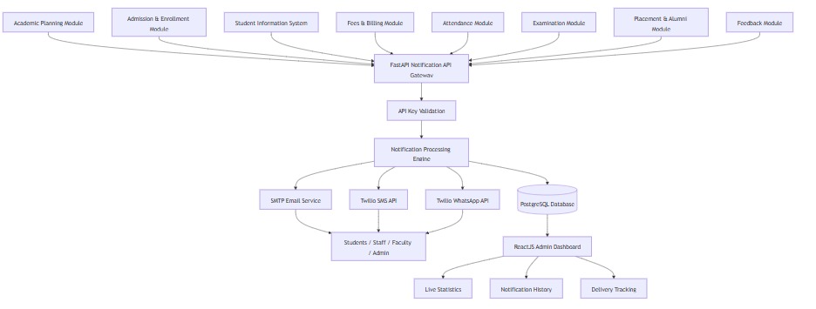

Database Design (ER Diagram / Tables)

The Entity Relationship Diagram (ERD) represents the database structure of the College ERP Notification System. It shows how users, ERP modules, notifications, delivery status, and communication logs are interconnected. ERP modules generate notifications, which are delivered to users through Email, SMS, and WhatsApp. The system also maintains notification history, delivery tracking, and dashboard analytics using separate log and statistics tables. This database design ensures centralized, secure, and efficient notification management within the ERP system.
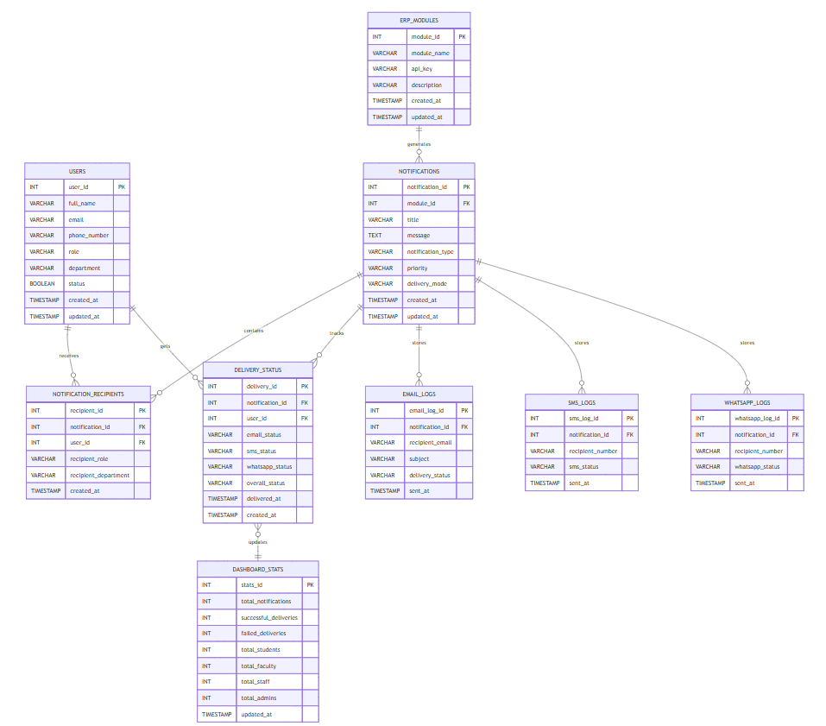

UML Diagrams

- Use Case Diagram:

The Use Case Diagram illustrates how different users and ERP modules interact with Notification System. Administrators creates and monitor the system using the dashboard, track notification delivery statuses, manage notification history, and perform role-based or department-wise notification filtering. The diagram demonstrates centralized communication between ERP modules and users.
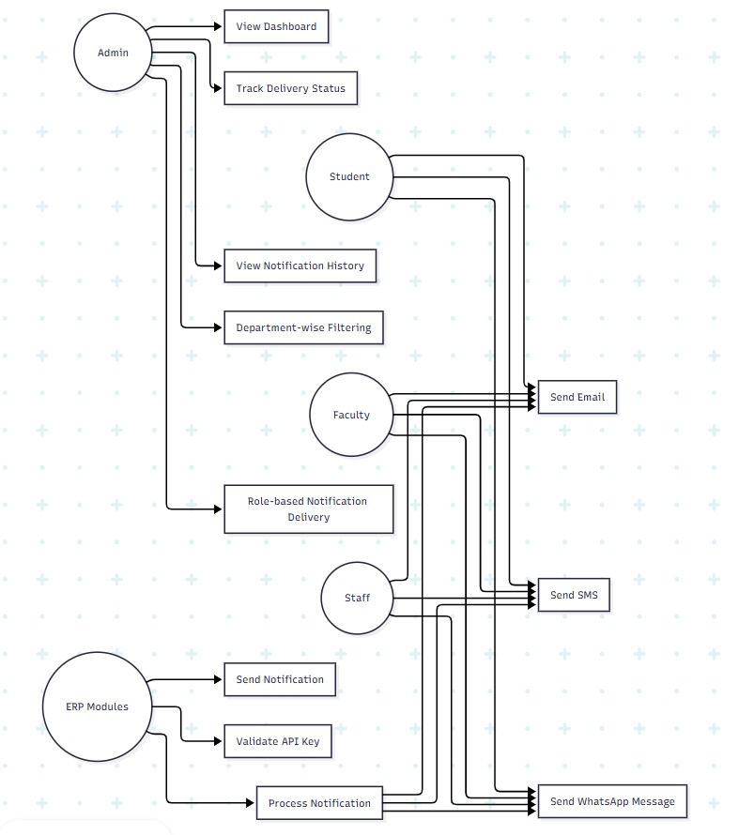

Class Diagram:

The User class stores information related to students, faculty, staff, and administrators. The Notification class stores notification content, type, creation details. The Notification Service class contains the core business logic responsible for validating API keys, processing notifications, initiating delivery. Notification Log stores delivery records and statuses. Dashboard Analytics generates real-time notification statistics and analytics. This design follows modular and scalable object-oriented architecture.
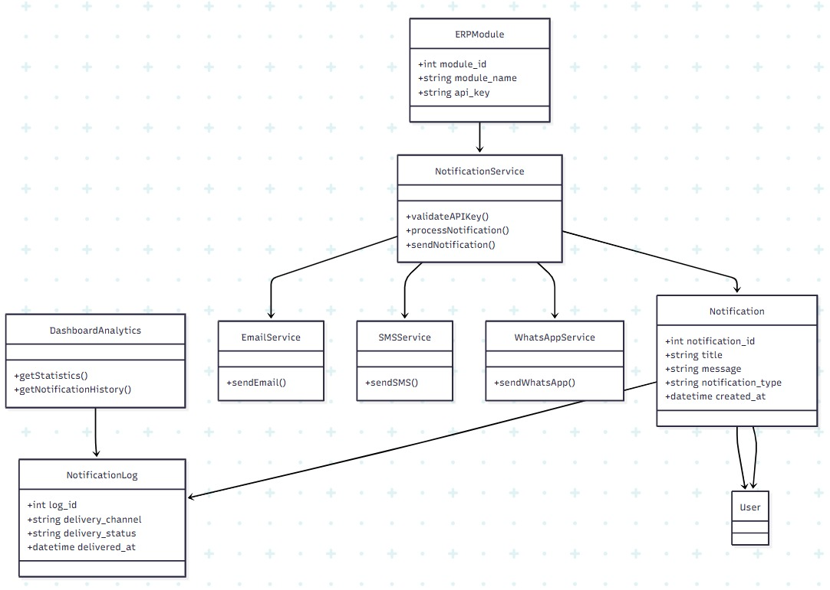
3)Sequence Diagram:
The Sequence Diagram illustrates the complete notification delivery process. An ERP module sends a notification request to the FastAPI Gateway. The gateway validates the API key and forwards the request to the Notification Processing Engine. The engine retrieves recipient details from PostgreSQL and sends notifications through SMTP Email Services, Twilio SMS API, and Twilio WhatsApp API. After successful delivery, notification logs and delivery statuses are stored in the database. Finally, the system returns a success response to the ERP module. This sequence ensures secure and efficient multi-channel notification delivery.
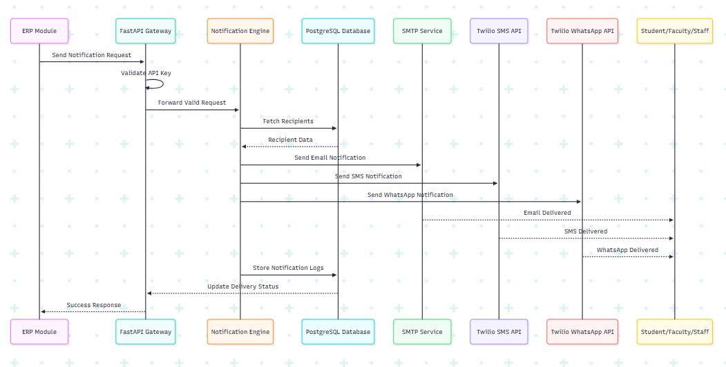

4)Activity Diagram:
The Activity Diagram explains the workflow of the notification processing system. The process starts when a notification request is received from an ERP module. If validation fails, an unauthorized error is returned. If validation succeeds, the system processes notification data, fetches recipient details, formats the notification message, and selects the appropriate delivery channel Notifications are then sent using Email, SMS, or WhatsApp services. After delivery, notification logs are stored in PostgreSQL and dashboard statistics are updated.
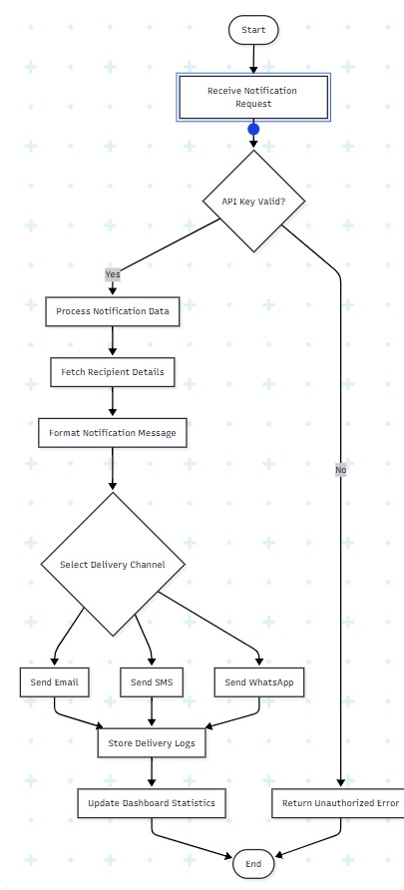
Database Design

Table Structures:

- USERS Table

Field Name | Data Type | Description
user_id | INT (PK) | Unique ID of the user
full_name | VARCHAR | Name of student/staff/faculty
email | VARCHAR | User email address
phone_number | VARCHAR | Mobile number of user
role | VARCHAR | User role (Student/Faculty/Admin)
department | VARCHAR | Department name
status | BOOLEAN | Active or inactive status
created_at | TIMESTAMP | Record creation time
updated_at | TIMESTAMP | Last updated time
- ERP_MODULES

Field Name | Data Type | Description
module_id | INT (PK) | Unique module ID
module_name | VARCHAR | ERP module name
api_key | VARCHAR | Secure API key
description | VARCHAR | Module description
created_at | TIMESTAMP | Record creation time
updated_at | TIMESTAMP | Last updated time

- NOTIFICATIONS Table
Field Name | Data Type | Description
notification_id | INT (PK) | Unique notification ID
module_id | INT (FK) | Reference to ERP module
title | VARCHAR | Notification title
message | TEXT | Notification content
notification_type | VARCHAR | Type of notification
priority | VARCHAR | Notification priority
delivery_mode | VARCHAR | Email/SMS/WhatsApp
created_at | TIMESTAMP | Notification creation time
updated_at | TIMESTAMP | Last updated time

- DASHBOARD_STATS Table

Field Name | Data Type | Description
stats_id | INT (PK) | Unique statistics ID
total_notifications | INT | Total notifications sent
successful_deliveries | INT | Successful notifications
failed_deliveries | INT | Failed notifications
total_students | INT | Total student count
total_faculty | INT | Total faculty count
total_staff | INT | Total staff count
total_admins | INT | Total admin count
updated_at | TIMESTAMP | Statistics update time

Screen Designing
1)Admin Dashboard
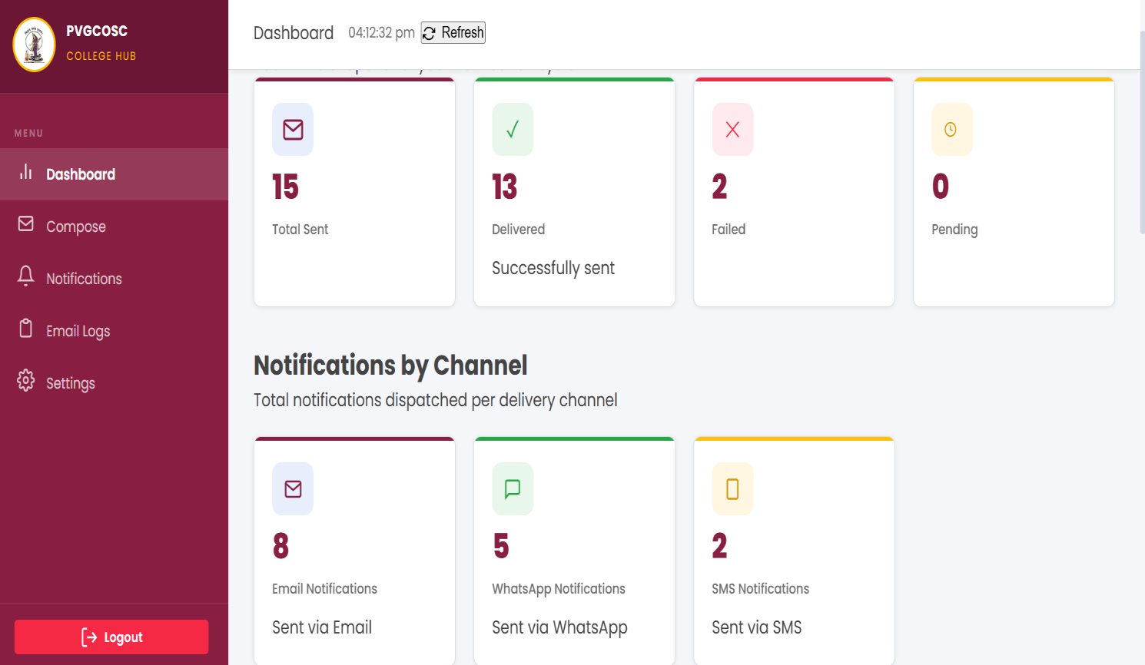

2)Admin Compose Notification

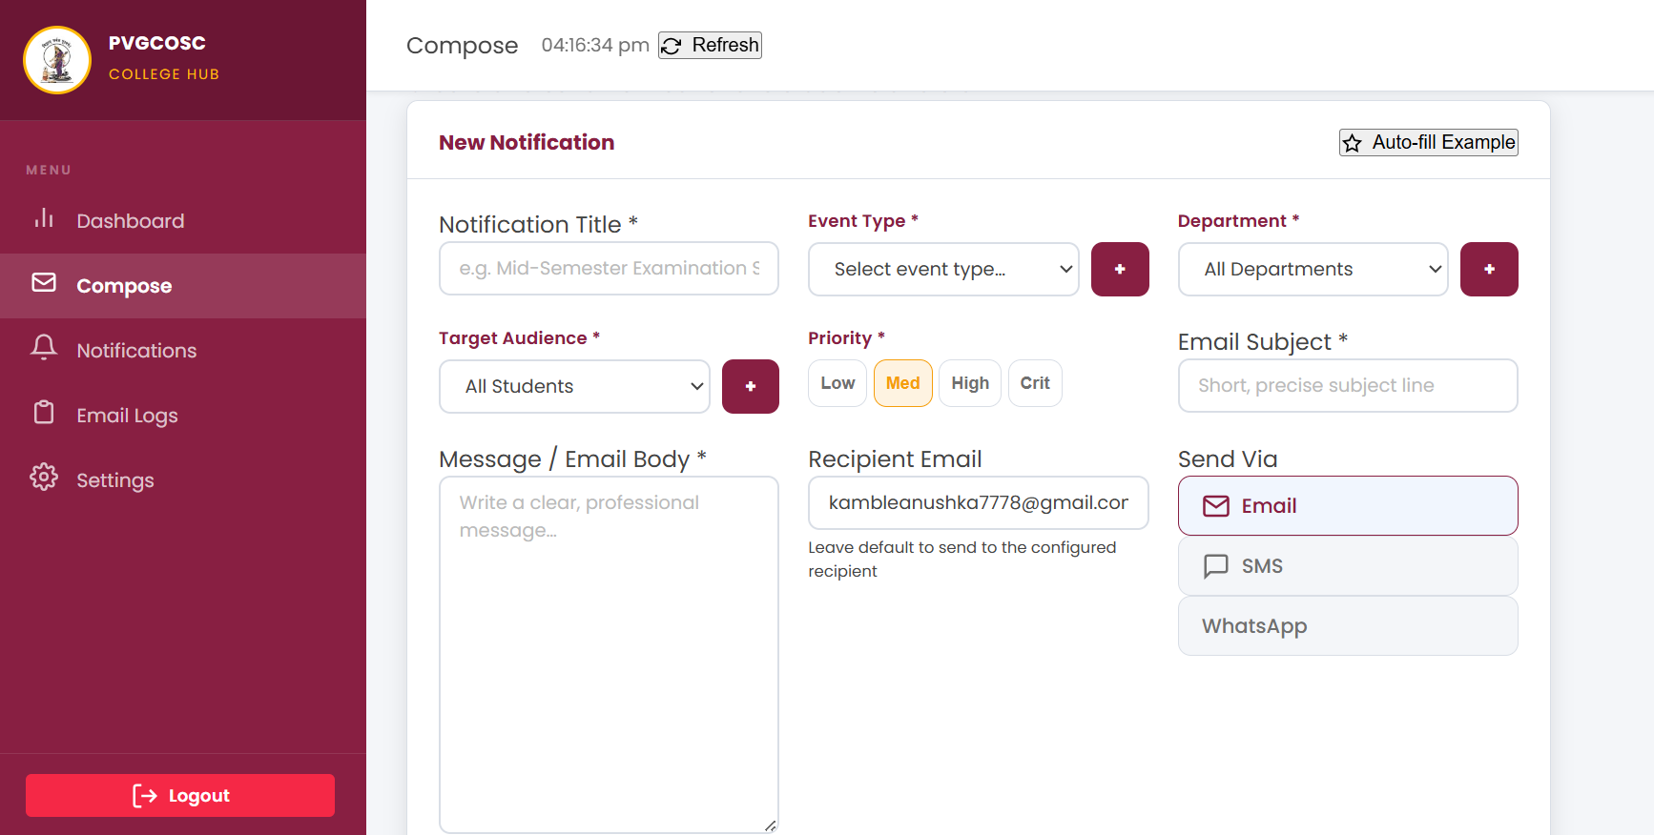

3)Notification History
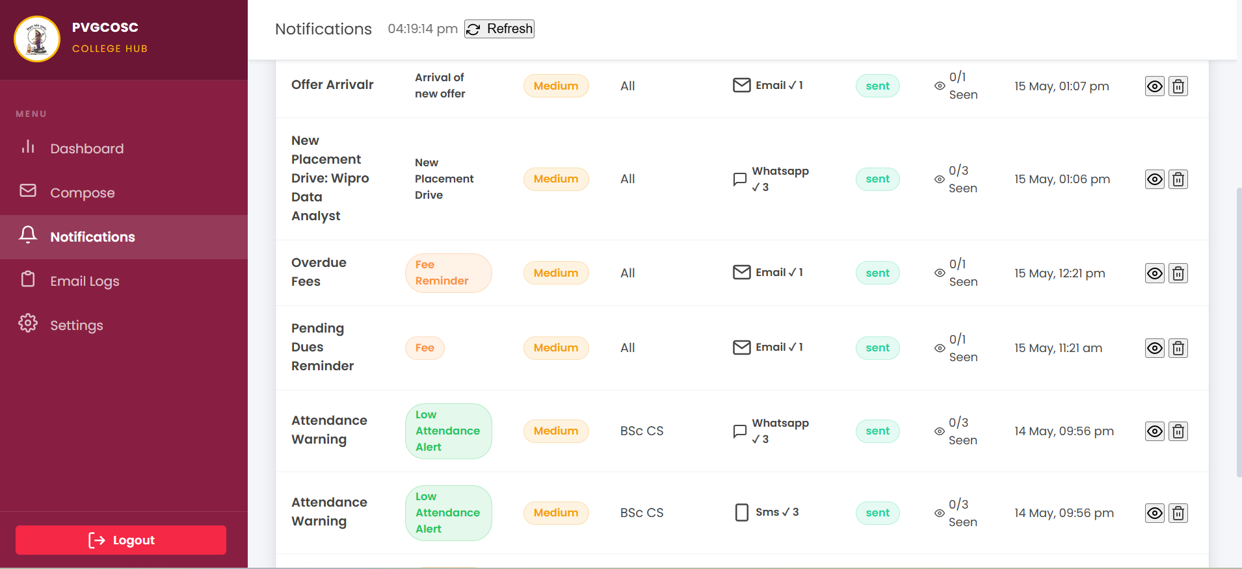

4)Email Logs
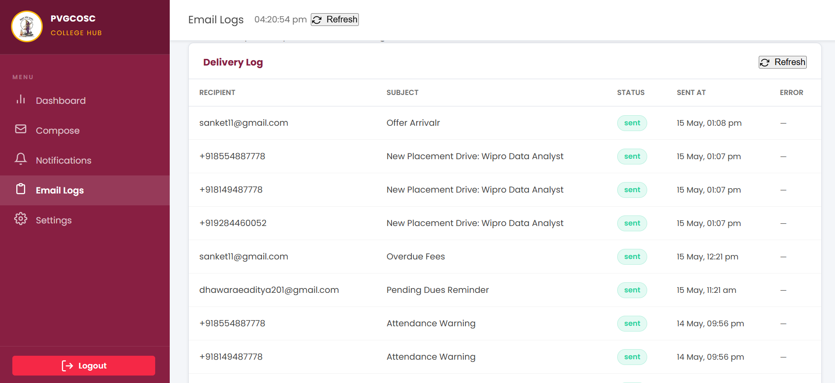

5)Backend Api
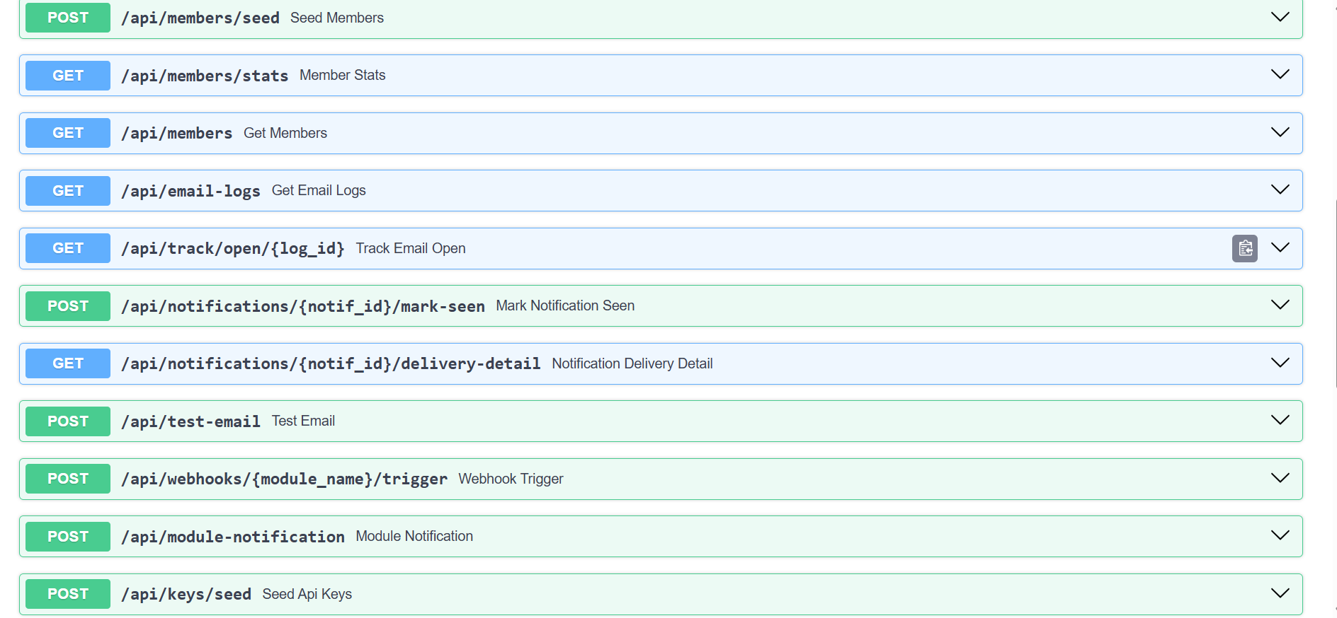
6)Api which other module calls
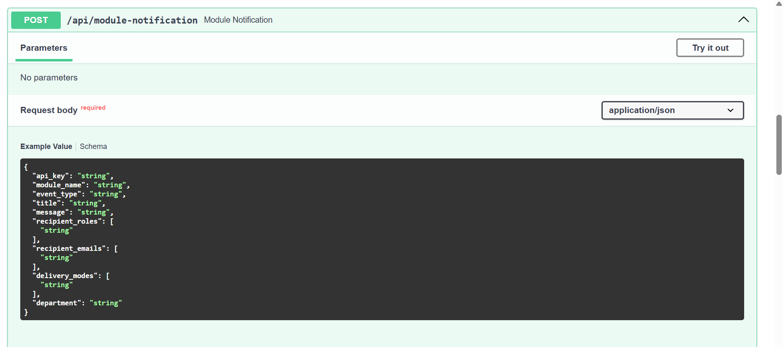
Notification Delivery Output
7) Email Notification Delivery
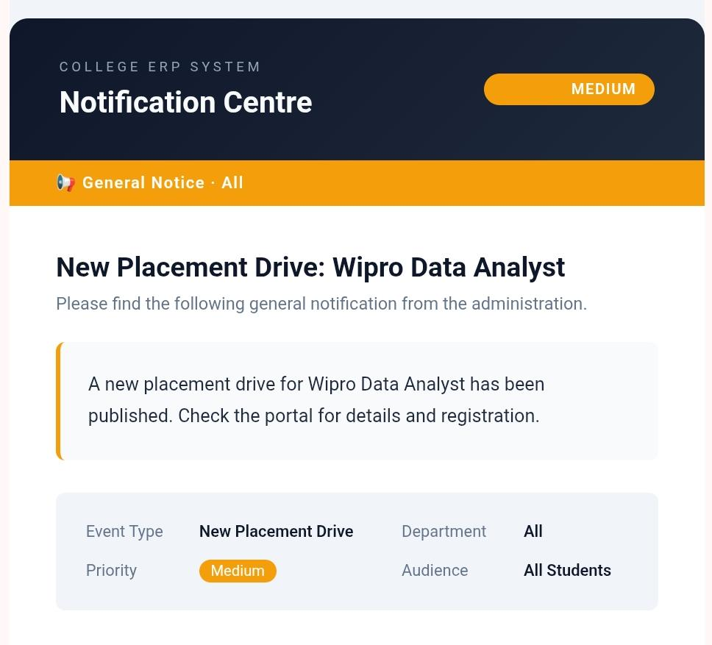

8) SMS Notification Delivery
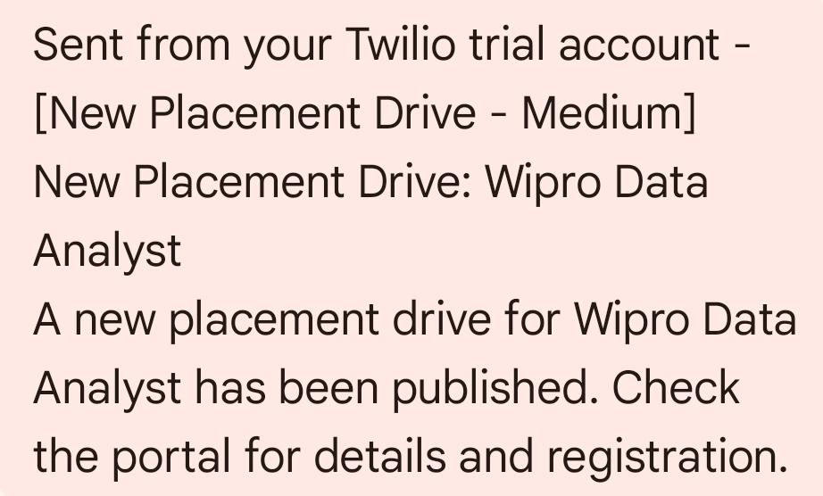

9) WhatsApp Notification Delivery
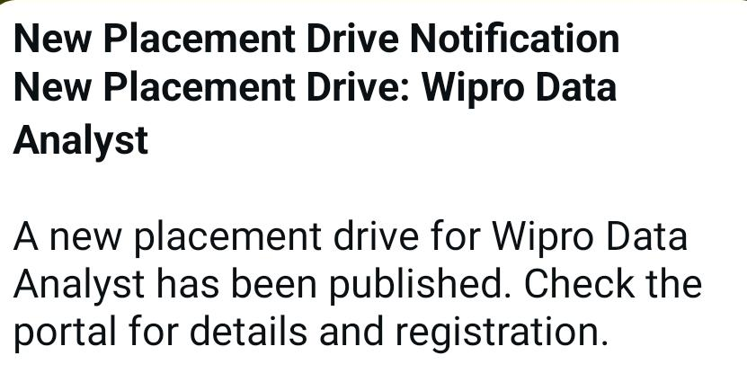
Testing & Debugging
- Test Plan
Testing is a critical phase of any software development project, and the College ERP Notification System underwent thorough testing to ensure that all components function as intended. The testing process covered the backend APIs, notification delivery through all three channels, database integrity, and the React dashboard's data accuracy.
The testing strategy included Black Box Testing to validate inputs and outputs from a user perspective, White Box Testing to verify internal logic and code paths, API Testing using Postman and Swagger UI, and end-to-end delivery testing for Email, SMS, and WhatsApp channels.
- Black Box Testing (Data Validation Test Cases)
Black Box Testing was conducted to verify that the system behaves correctly for various valid and invalid inputs, without examining the internal implementation.
Test Case ID | Input | Expected Output | Actual Output | Status
TC01 | Valid Email Notification | Email Sent Successfully | Same as Expected | Pass
TC02 | Invalid API Key | Unauthorized Access Error | Same as Expected | Pass
TC03 | Bulk Notification Request | Notifications Sent to All Users | Same as Expected | Pass
TC04 | Invalid Phone Number | SMS Delivery Failed | Same as Expected | Pass
TC05 | WhatsApp Notification Request | WhatsApp Message Delivered | Same as Expected | Pass
TC06 | Empty Notification Message | Validation Error | Same as Expected | Pass
TC07 | Department Filter Notification | Notification Sent to Selected Department | Same as Expected | Pass

- White Box Testing (Functional Test Cases)
White Box Testing was performed to verify the internal logic of the notification processing engine, API key validation, recipient fetching, and delivery services.
Test Case ID | Function | Description | Expected Result | Status
TC08 | API Key Validation | Validate ERP module key | Valid API accepted | Pass
TC09 | Notification Formatting | Check message formatting | Proper format generated | Pass
TC10 | SMTP Integration | Verify email service | Email delivered | Pass
TC11 | Twilio SMS API | Verify SMS sending | SMS delivered | Pass
TC12 | WhatsApp API | Verify WhatsApp sending | Message delivered | Pass
TC13 | Database Logging | Verify notification logs | Logs stored correctly | Pass
TC14 | Dashboard Analytics | Verify statistics update | Dashboard updated | Pass
- Api Testing

Test Case ID | API Endpoint | Method | Expected Result | Status
API01 | /send-notification | POST | Notification Sent | Pass
API02 | /notification-history | GET | History Retrieved | Pass
API03 | /dashboard-stats | GET | Statistics Displayed | Pass
API04 | /delivery-status | GET | Delivery Status Returned | Pass

- Notification Delivery Testing
- Email Testing

Test Case ID | Input | Expected Output | Status
EMAIL01 | Valid Email | Email Delivered | Pass
EMAIL02 | Invalid Email Address | Delivery Failed | Pass
- SMS Testing

Test Case ID | Input | Expected Output | Status
SMS01 | Valid Mobile Number | SMS Delivered | Pass
SMS02 | Invalid Number | Delivery Failed | Pass

- WhatsApp Testing

Test Case ID | Input | Expected Output | Status
WA01 | Valid WhatsApp Number | Message Delivered | Pass
WA02 | Unregistered Number | Delivery Failed | Pass

Conclusion
The College ERP Notification System successfully addresses the communication challenges faced by educational institutions by providing a centralized, automated, and multi-channel notification platform. The system seamlessly integrates with multiple ERP modules and delivers timely notifications to students, faculty, staff, and administrators through Email, SMS, and WhatsApp in a reliable and trackable manner.
By replacing manual communication methods with an API-driven notification engine, the system significantly reduces the time and effort required to broadcast important information across the institution. Bulk notifications that would previously require individual messages or physical notice boards can now be dispatched to hundreds of recipients simultaneously with a single API call, and the results are immediately visible on the real-time dashboard.
The technical implementation demonstrates the practical application of modern web technologies including FastAPI for backend development, ReactJS for the frontend dashboard, PostgreSQL for data management, Twilio for SMS and WhatsApp integration, and Docker for containerization. The system is designed to be modular and scalable, allowing new ERP modules and delivery channels to be integrated without disrupting existing functionality.
Overall, the College ERP Notification System represents a significant step towards digitizing and streamlining institutional communication, and it provides a strong foundation for further enhancements in the future.

Future Scope
The College ERP Notification System has been designed with extensibility in mind, and several significant enhancements are planned for future versions:
1. Scheduled Notifications: A scheduling engine that allows administrators and ERP modules to schedule notifications for a future date and time, useful for examination reminders, fee due date alerts, and recurring announcements.
2. AI-Based Notification Recommendations: Integration of a machine learning model that analyzes user engagement patterns and

suggests the best time and channel to send notifications for maximum reach and effectiveness.
3. Notification Analytics Dashboard: A dedicated analytics page showing delivery rate trends over time, channel-wise performance comparisons, peak notification hours, and department-wise engagement statistics.
4. Multi-Language Support: Adding support for regional languages such as Marathi and Hindi in notification messages, making the system more accessible to all users.
5. Voice Call Alerts: Integration with Twilio Voice API to send automated voice call alerts for critical notifications such as examination cancellations or emergency announcements.
6. Cloud Deployment: Deployment of the system on cloud platforms such as AWS, Azure, or Google Cloud using managed database services and container orchestration through Kubernetes for production-grade reliability and scalability.
10. Advanced Security: Implementation of rate limiting, IP whitelisting for API key usage, end-to-end encryption for notification content, and comprehensive audit logging for all system activities.

REFERENCES
1. FastAPI Official Documentation- Used for backend API development, dependency injection, background tasks, and middleware configuration.
2. PostgreSQL Official Documentation- Used for database design, query optimization, and relational data management.
3. Twilio Python SDK Documentation- Used for SMS and WhatsApp API integration and delivery.
4. Twilio WhatsApp API Guide- Reference for WhatsApp sandbox setup and production message templates.
5. Python smtplib Documentation- Used for SMTP email delivery with TLS authentication.
6. Docker Official Documentation- Used for containerization, Docker Compose multi-service configuration, and deployment.
7. MDN Web Docs- Reference for web technologies, HTTP methods, and REST API concepts.

Student Signature Guide Signature

Date: / /

