Project Document
- Title Page
• Project Title:
Authentication & Authorization Module for College ERP System
• Developed By:
Sai Rajesh Phapale , Varad Karve , Swaraj Bhagat
• Course:
S.Y.M.Sc. Computer Science
• College Name:
PVG’s College of Science & Commerce, Pune-9
• University:
Savitribai Phule Pune University
• Academic Year:
2025–26
• Guide/Mentor Name:
Rekha joshi Mam
- Introduction to ERP
A College ERP system is a software that manages student, faculty, and administrative activities in one place.
It helps handle attendance, marks, fees, hostel, and transport efficiently.
The system uses secure login and role-based access so each user can see only relevant data.Overall, it improves data management, transparency, and saves time for the college. It also provides real-time updates and reports for better decision-making by college authorities.The system reduces manual work and errors by automating daily academic and administrative tasks.
It ensures smooth communication between students, teachers, and management.

- Certificate

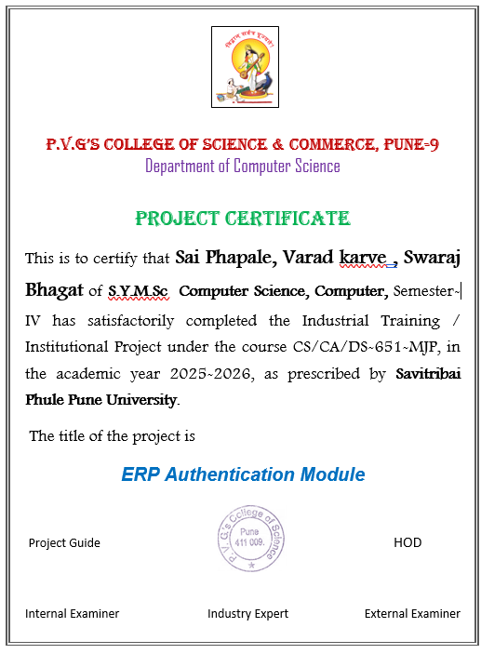

3. Abstract
- Brief summary
The College ERP system is designed to manage academic and administrative activities such as student data, attendance, fees, hostel, and transport in a centralized platform. The main focus of our project is the Authentication and Authorization Module, which ensures secure access to the system using modern security techniques. The system is developed using React for the frontend, FastAPI for the backend, and PostgreSQL as the database, making it scalable and efficient.The problem addressed in this project is the lack of secure and structured access control in traditional college systems, which can lead to unauthorized access and data breaches. To solve this, we implemented JWT-based authentication, where each user is verified through secure login credentials, and a token is generated for session management. Passwords are securely stored using bcrypt hashing, ensuring data protection.The methodology includes Role-Based Access Control (RBAC), where users are assigned roles such as Guest, Student, or Admin, and each role has limited permissions. By default, new users are assigned a Guest role to follow the principle of least privilege. The system also tracks token activity and includes audit fields like created_at and updated_at for better monitoring.The key outcome of this project is a secure, scalable, and modular authentication system that enhances data security, improves user management, and provides a strong foundation for future ERP development.

Problem
In many traditional college systems, there is a lack of proper security mechanisms and structured access control. Users often access the system without strong authentication, which increases the risk of unauthorized access to sensitive data such as student records, academic performance, and financial information. Additionally, there is no clear separation of roles, which can lead to misuse of privileges and data inconsistency. Manual or semi-digital systems also suffer from errors, duplication of data, and lack of transparency.
Another major issue is the absence of session management and activity tracking. Without proper logging or token-based validation, it becomes difficult to monitor who accessed the system and what actions were performed. As the number of users increases, managing permissions and maintaining system scalability becomes challenging. Therefore, there is a need for a secure, scalable, and role-driven authentication system.
Methodology
To address these challenges, we designed and developed a secure Authentication and Authorization module as part of the College ERP system. The backend is implemented using FastAPI, which provides high performance and efficient API handling, while the frontend is built using React for a simple and interactive user interface. PostgreSQL is used as the database to store structured and relational data.
We implemented JSON Web Token (JWT)-based authentication to ensure secure login and session handling. When a user logs in, the system verifies credentials using bcrypt for password hashing and generates a secure token containing user information such as user ID, role, and expiration time. This token is then used to authenticate all subsequent API requests.
The system follows Role-Based Access Control (RBAC), where each user is assigned a role such as Guest, Student, or Admin. By default, new users are assigned the Guest role to ensure minimal access and follow the principle of least privilege. The database is designed with separate tables for users, roles, and tokens, allowing flexible and scalable management of permissions. Additionally, audit fields like created_at and updated_at are included to track data changes, and token records are stored to monitor user sessions and enhance security.
Key Outcomes
- Secure and efficient authentication system for College ERP
- JWT enables stateless and scalable session management
- bcrypt ensures strong password security
- Role-Based Access Control restricts unauthorized access
- Users can access only role-specific data
- Reduced risk of data breaches and misuse
- Token tracking improves session monitoring
- Audit fields enhance transparency and accountability
- Easy tracking of user activity and data changes
- Scalable design for future ERP modules integration
- Supports modules like attendance, fees, and exams
- Implements real-world web security practices
- Provides a strong foundation for full ERP development

4. Introduction

Problem Statement

In many colleges, existing systems are either manual or not fully secure, which creates problems in managing student and administrative data. Sensitive information such as student details, marks, and financial records can be accessed without proper control. There is often no strong authentication system, and user roles are not clearly defined, leading to misuse of data and unauthorized access.

Additionally, traditional systems do not track user activity properly, making it difficult to monitor who accessed or modified data. As the number of users increases, managing permissions becomes complex and inefficient. Therefore, there is a need for a secure and structured system that ensures only authorized users can access specific data.

Objectives and Goals

The main objective of this project is to develop a secure Authentication and Authorization module for a College ERP system. The goal is to ensure that only verified users can log in and access the system. Another important goal is to implement Role-Based Access Control (RBAC) so that users can only access information relevant to their role.

The project also aims to protect user credentials using bcrypt hashing and manage sessions using JWT tokens. Additionally, the system is designed to maintain audit information such as created_at and updated_at for better tracking. A default Guest role is assigned to new users to ensure minimum access and improve security.

Purpose of the Study

The purpose of this study is to understand and implement modern security techniques in web applications, especially in the context of educational institutions. It focuses on how authentication and authorization can be designed to protect sensitive data and improve system reliability.

This study also helps in learning how to design scalable systems using technologies like FastAPI, React, and PostgreSQL. It provides practical knowledge of handling real-world problems such as user management, session handling, and data security in ERP systems.

Literature Survey

Many existing ERP systems and research studies highlight the importance of secure authentication and role-based access control in managing institutional data. Traditional systems mainly rely on basic login methods without advanced security features, which increases the risk of cyber threats.

Modern systems use techniques like JWT (JSON Web Tokens) for stateless authentication and bcrypt hashing for password security. Studies also show that RBAC (Role-Based Access Control) is an effective method for managing user permissions in large systems. These concepts inspired the design of our project, where we implemented secure login, token-based authentication, and structured role management.

Project Scope

The scope of this project is focused on developing the Authentication and Authorization module of a College ERP system. It includes user registration, login, secure password storage, token generation, and role-based access control.The system is designed to be scalable so that it can be extended in the future to include other ERP modules such as attendance management, fee management, hostel management, and examination systems. It also supports integration with modern technologies and can be deployed using Docker for easy setup.

Limitations

This project mainly focuses on the authentication and authorization module, so other ERP functionalities are not fully implemented. The system currently supports basic roles and may require more detailed permission levels in real-world scenarios.

Advanced features like multi-factor authentication (MFA), real-time monitoring dashboards, and detailed audit analytics are not fully implemented in this version. Additionally, the UI is kept simple for demonstration purposes and may need further enhancement for production use.

5. System Analysis
5.1 Existing System Study

• Overview of Current Systems
In many colleges, the existing systems are either completely manual or partially computerized. Manual systems involve maintaining records in registers or files, which increases the chances of data loss and errors. In semi-digital systems, different departments use separate software for managing attendance, fees, and student data, which leads to lack of integration.
Most of these systems do not follow strong security practices. User authentication is limited to simple login credentials without encryption, and there is no proper mechanism to verify user identity beyond that. Also, there is no centralized system to manage all operations, making data handling inefficient and time-consuming.
Another major issue is the absence of proper session management and monitoring. Once logged in, user activities are not tracked, and there is no way to identify misuse of data. As the number of users increases, these systems become difficult to manage and maintain.

• Comparative Study
When comparing traditional systems with modern ERP systems, several differences can be observed.
Traditional systems lack advanced security features and structured access control. They do not use encryption techniques like bcrypt for password protection or token-based authentication like JWT. Data is often stored in separate systems, which leads to redundancy and inconsistency.
On the other hand, modern ERP systems provide a centralized platform where all data is stored and managed securely. They use advanced authentication methods, role-based access control, and proper session management. These systems are designed to be scalable and can handle a large number of users efficiently.
Our proposed system improves upon traditional systems by integrating secure authentication, structured role management, and centralized data storage, making it more reliable and efficient.

5.2 Limitations of Existing System

• Drawbacks and Gaps
The existing systems have several limitations that affect their performance and security. One of the major drawbacks is weak authentication, where simple passwords are used without encryption, making the system vulnerable to attacks.
There is no proper role-based access control, which means users may access data that is not relevant to them. This increases the risk of data misuse and unauthorized access. Additionally, the absence of audit logs makes it difficult to track user activities and identify any suspicious behavior.
Data duplication is another common issue, as different departments maintain separate records. This leads to inconsistency and confusion. Manual processes also increase the chances of human error and consume more time.
Moreover, these systems are not scalable, meaning they cannot efficiently handle increasing data and user load. This makes them unsuitable for modern educational institutions.

5.3 Proposed System

• Project Perspective
The proposed system aims to solve the problems of existing systems by developing a secure and scalable Authentication and Authorization module. This module acts as the entry point of the ERP system, ensuring that only verified users can access the system.
It is designed using modern technologies such as FastAPI for backend, React for frontend, and PostgreSQL for database management. The system follows a modular approach, which means additional ERP functionalities can be added easily in the future.
The main focus is on improving security, managing user roles efficiently, and providing a structured way to control access to data. This ensures better data protection and system reliability.

• Key Features

The proposed system includes several important features that enhance security and usability. It uses JWT-based authentication to provide secure and stateless session management. Passwords are stored using bcrypt hashing, which ensures that sensitive information is protected.
The system implements Role-Based Access Control, where each user is assigned a role such as Guest, Student, or Admin. New users are assigned the Guest role by default, ensuring minimal access and improved security.
It also includes token tracking, which allows monitoring of user sessions, and audit fields such as created_at and updated_at to track data changes. The system is containerized using Docker, making deployment simple and efficient.

• Stakeholders
The system is designed for multiple stakeholders within the college. Students can access their personal information such as attendance and marks. Faculty members can manage academic data and monitor student performance.
Administrative staff are responsible for managing users and system settings, while accountants handle financial data such as fees. Higher authorities like Principal and HOD can view reports and make decisions based on data insights.
The IT Administrator plays a key role in maintaining system security, managing infrastructure, and ensuring smooth operation of the system.

5.4 Requirement Analysis

• Functional Requirements
The system must provide user registration and login functionality with secure authentication. It should encrypt passwords using bcrypt and generate JWT tokens for session management.
It must support role assignment and enforce access control based on roles. Users should only be able to access data relevant to their role. The system should include APIs for authentication, token validation, and protected data access.
Additionally, it should track tokens and user sessions in the database and provide a personalized response after login, such as displaying user-specific information.

• Non-Functional Requirements

Performance Requirements
The system should provide fast response times for API requests and handle multiple users efficiently. It should use optimized database queries to reduce delays and ensure smooth performance.
The backend should be lightweight and capable of handling concurrent requests without affecting system performance. The system should also be scalable to support increasing users and data in the future.

Security Requirements
Security is a major focus of the system. Passwords must be stored in encrypted form using bcrypt. JWT tokens should be used for secure authentication and must include expiration time.
Access to system resources should be controlled using Role-Based Access Control. The system should prevent unauthorized access and ensure data confidentiality. Token expiration, logout mechanisms, and audit tracking should be implemented for better security.

Usability Requirements
The system should be simple and easy to use for all users, including non-technical users. The interface should be clean and user-friendly, with clear navigation.
The login and signup process should be straightforward, requiring minimal steps. Error messages should be clear and helpful, allowing users to understand and correct issues easily. The system should provide a smooth and responsive user experience.

6. System Design
1. Design Constraints
Design constraints are the limitations and conditions under which the system is developed. For this College ERP Authentication Module, the system is designed mainly for demonstration purposes, so it focuses only on authentication and authorization features.
The project must use specific technologies such as React for the frontend, FastAPI for the backend, and PostgreSQL for the database. The system follows JWT-based authentication, which requires stateless communication between client and server. Another constraint is the use of Docker and Docker Compose to ensure easy deployment without manual database setup.
The UI is kept simple with only three pages (Signup, Login, Welcome), which limits advanced user interaction features. Security is a major constraint, so bcrypt hashing and role-based access control must be implemented. Performance is optimized for small-scale usage, and the system is designed to be extendable in the future.
2. System Architecture
The system follows a three-tier architecture consisting of frontend, backend, and database layers. The frontend is developed using React, which handles user interaction and sends API requests. The backend is built using FastAPI, which processes requests, performs authentication, and manages business logic.
The backend communicates with the PostgreSQL database to store and retrieve user data, roles, and token information. JWT tokens are generated during login and are used to authenticate further requests. This architecture is stateless, meaning no session data is stored on the server, improving scalability.
The use of Docker ensures that all components run in isolated environments, making the system portable and easy to deploy.
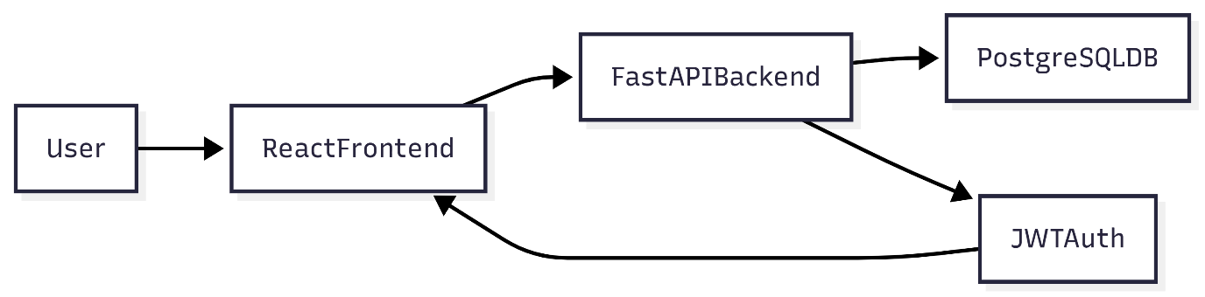

3. UML Diagrams
Use Case Diagram
The use case diagram shows how different users interact with the system. In this project, the primary user is the student who can register, log in, and view the welcome page. Admin users can manage roles and users. The system handles authentication and authorization processes
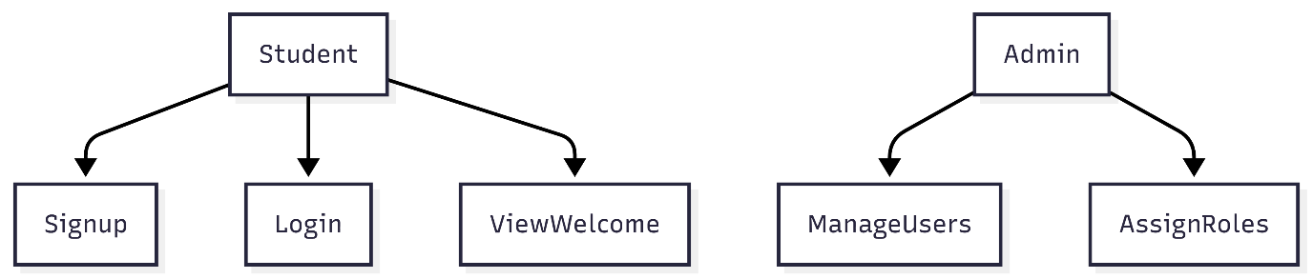
Class Diagram
The class diagram represents the overall structure of the system and shows how different components interact with each other. It mainly consists of core entities such as User, Role, and Token, along with supporting classes like AuthService and Database, which help in managing authentication logic and data storage.The User class stores all the essential details of a user, including personal information such as name, class, phone number, and login credentials like username and password. The password is securely stored in hashed format to ensure data protection. This class also includes methods such as register, login, and updateProfile, which define the main operations a user can perform in the system.The Role class is used to define different types of users in the system, such as Guest, Student, and Admin. Each user is assigned a role using the role_id, which helps in implementing Role-Based Access Control (RBAC). This ensures that users can only access data and functionalities permitted to their role.
The Token class is responsible for managing authentication tokens. When a user logs in, a JWT token is generated and stored with details such as issued time, expiry time, and status (active/inactive). Each user can have multiple tokens, which allows proper session management and tracking of user activity.The AuthService class handles all authentication-related operations such as user login, signup, password hashing, and JWT creation and validation. This separation of logic improves system design and maintainability.
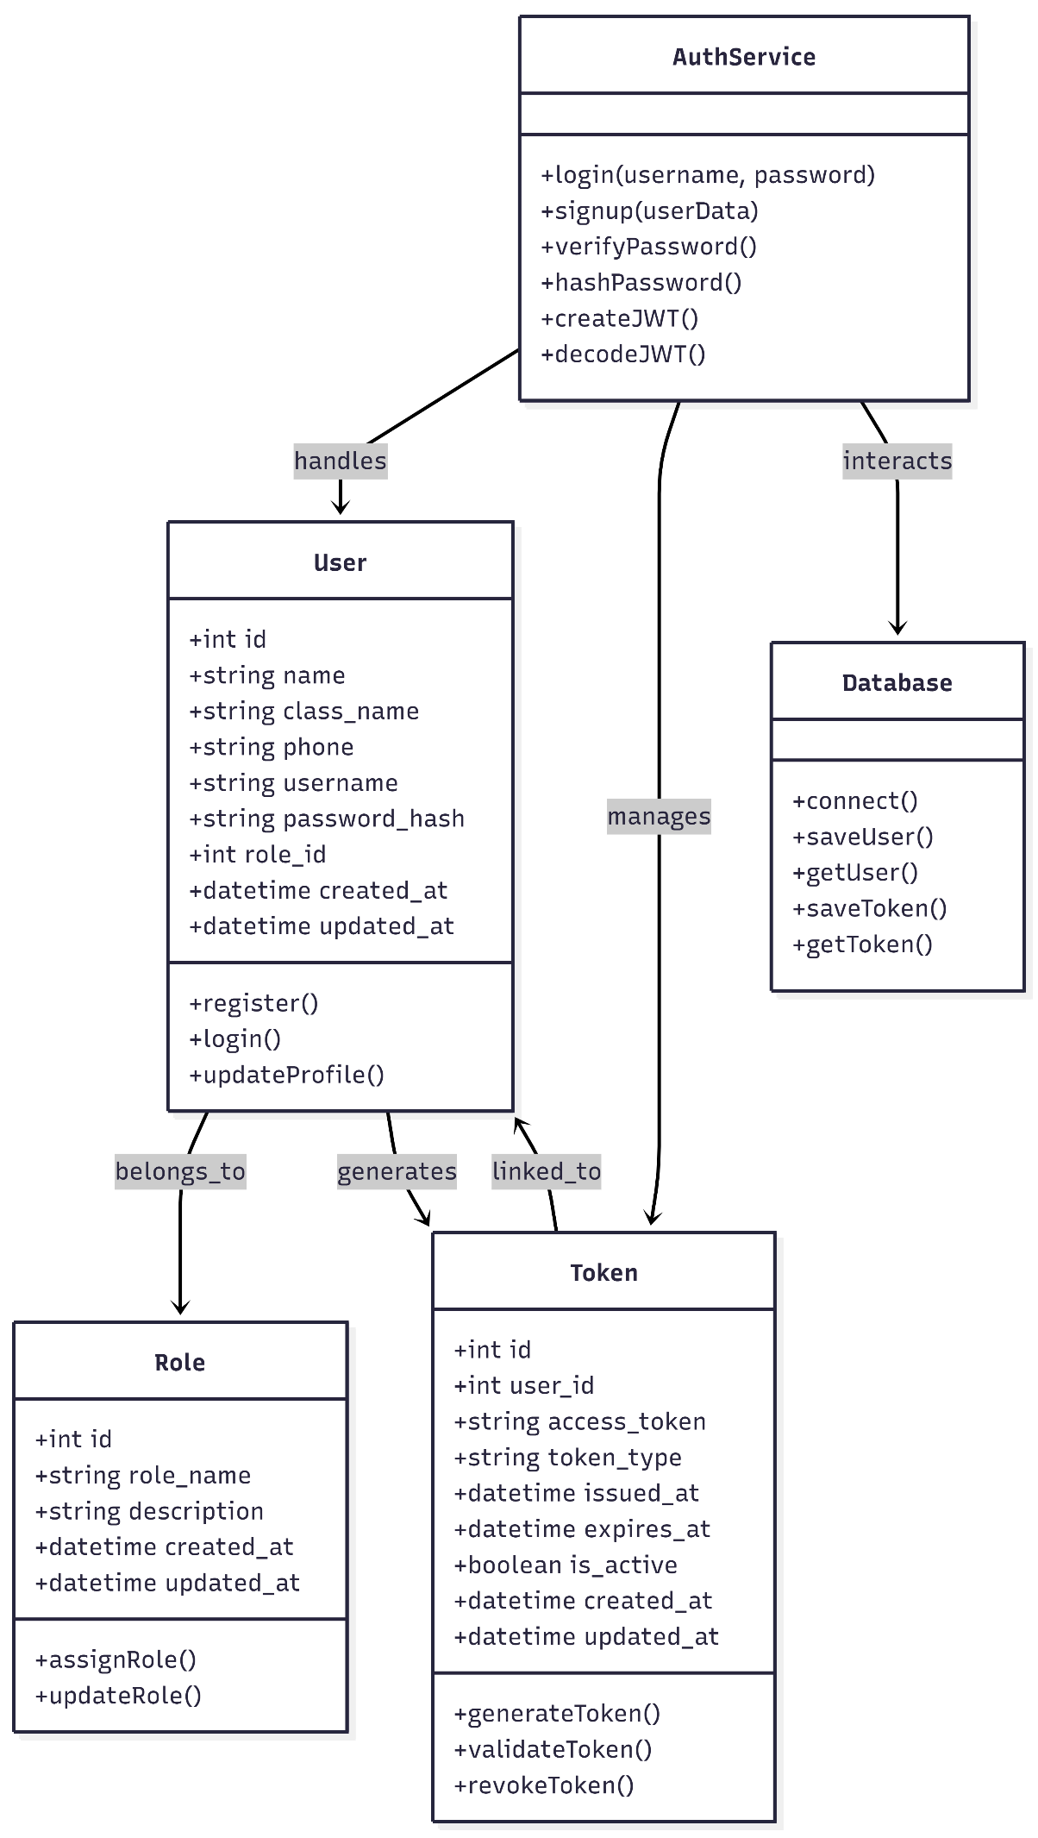
Sequence Diagram
The sequence diagram shows the step-by-step process of user login. It includes interaction between user, frontend, backend, and database
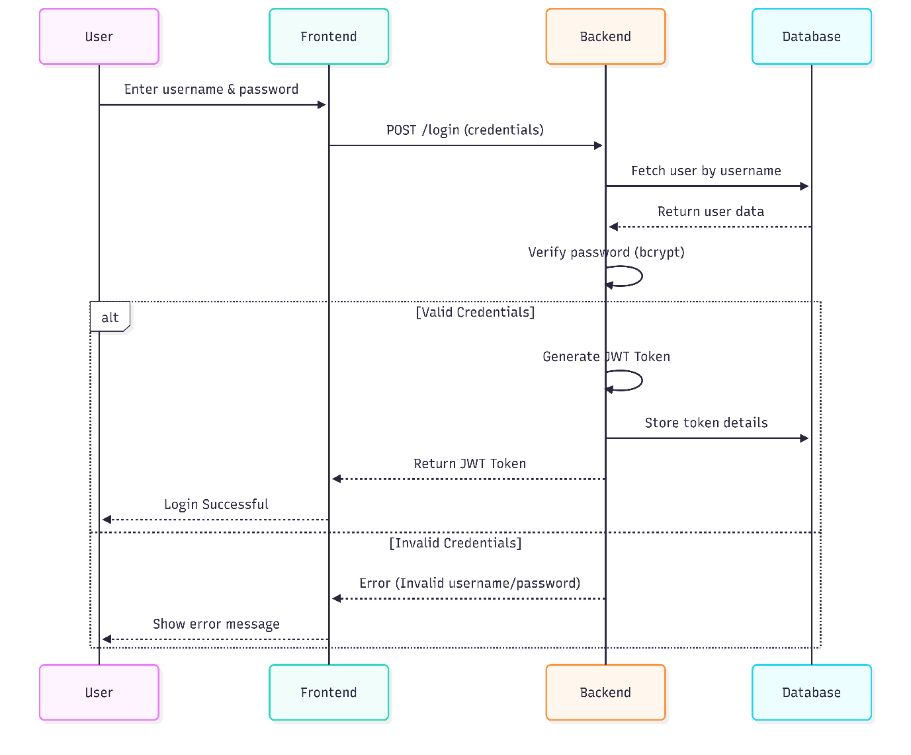

Activity Diagram
The activity diagram illustrates the step-by-step workflow of the authentication process in the system. It begins when the user enters their login credentials on the interface. The system then validates the entered details by checking them against the stored data in the database. If the credentials are correct, the system generates a JWT token and stores it for session management. After successful token generation, access is granted to the user. If the credentials are invalid, an error message is displayed and the process ends without granting access.

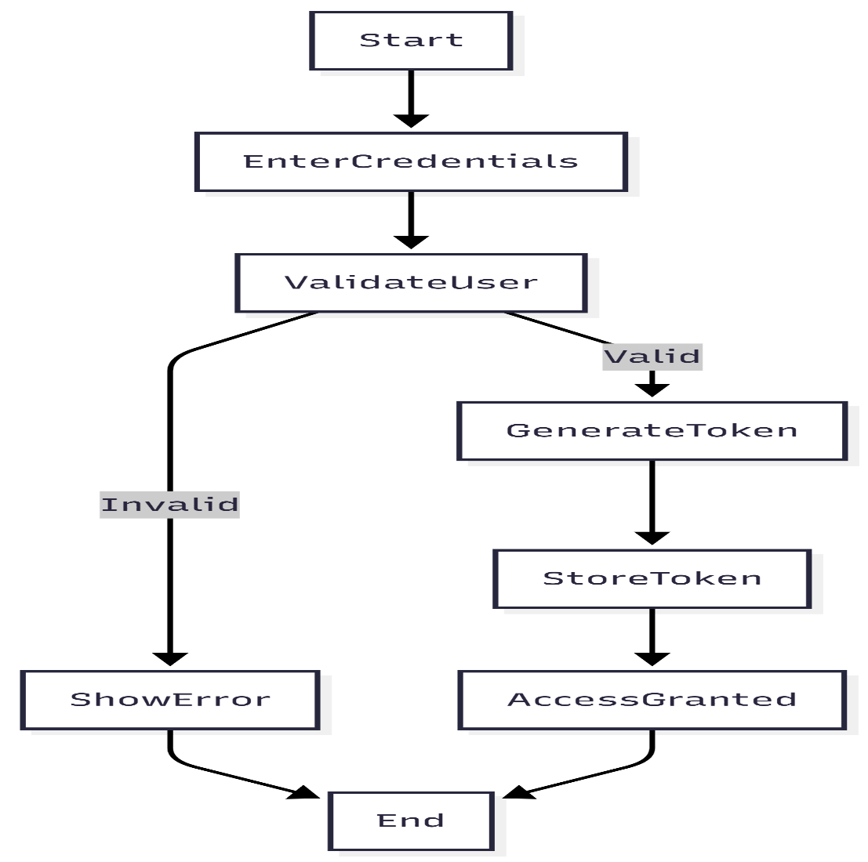

4. Data Model (ER Diagram / Database Design)
The data model represents how data is stored and related in the system. It includes three main tables: Users, Roles, and Tokens. The Users table stores user details, Roles table manages role information, and Tokens table tracks authentication tokens.Each user is assigned one role, and each user can have multiple tokens. The database also includes audit fields to track creation and updates. The ER diagram shows three main entities: Users, Roles, and Tokens. Each user is assigned one role, and one role can be assigned to multiple users. Each user can have multiple tokens for managing login sessions. The Tokens table stores JWT details like issued time, expiry time, and status, which helps in secure session tracking. It also ensures data integrity and consistency by maintaining proper relationships between tables. The inclusion of audit fields like created_at and updated_at helps in tracking data changes over time. This design supports scalability, allowing new roles or features to be added easily in the future Overall, the data model provides a secure, structured, and efficient way to manage users and authentication in the ERP system.

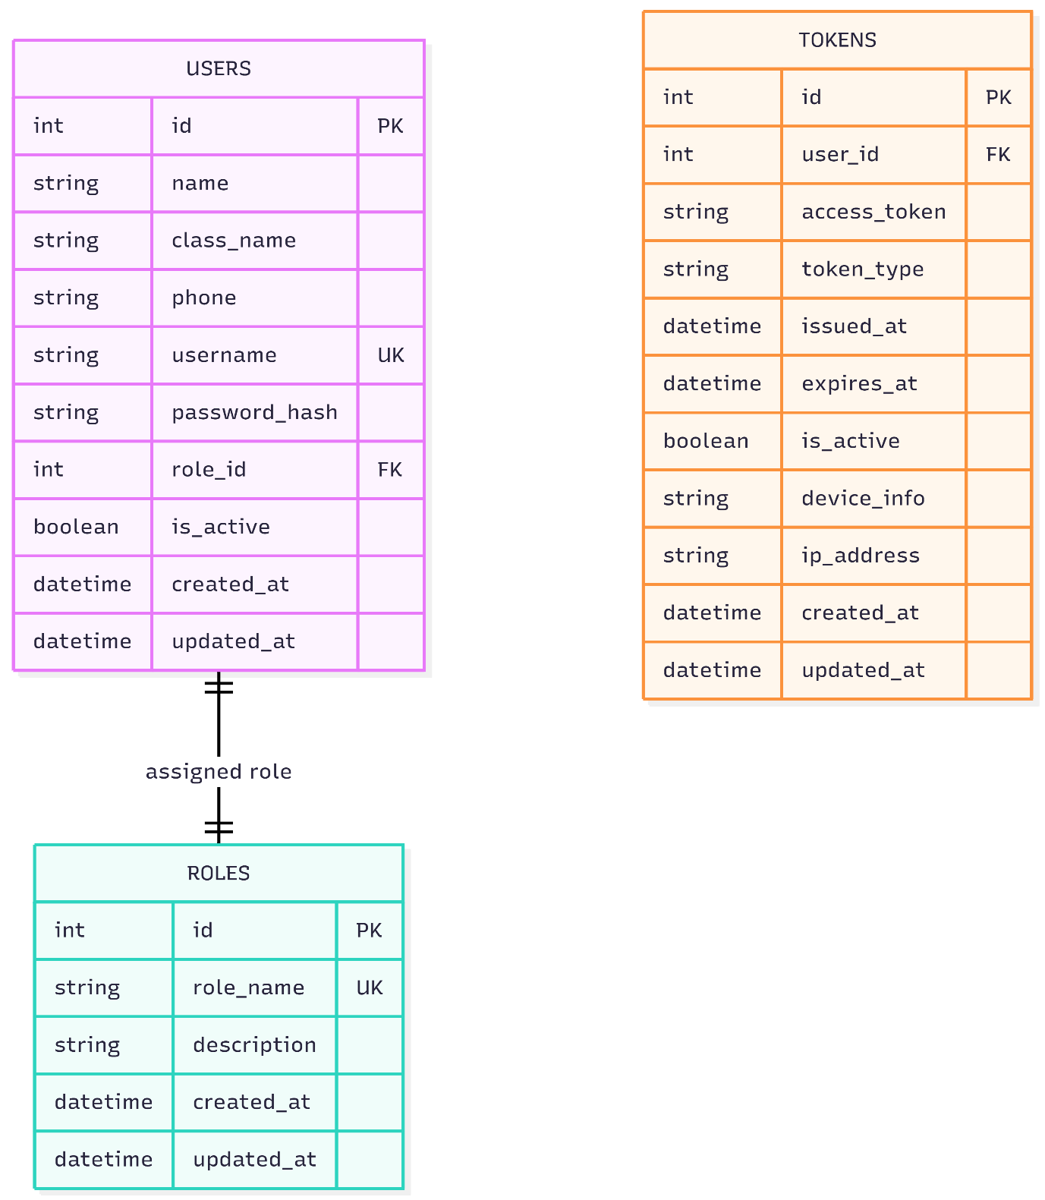

5. User Interface Design
The user interface is designed to be simple, clean, and easy to use, allowing even non-technical users to interact with the system without difficulty. It focuses on providing a smooth experience while performing basic authentication tasks. The system includes three main pages: Signup, Login, and Welcome. The Signup page allows users to enter their details with proper validation, while the Login page securely verifies user credentials and generates a JWT token on successful authentication. In case of invalid input, clear error messages are displayed. After login, the Welcome page shows a personalized message to the user. Overall, the interface is minimal, responsive, and ensures easy navigation across devices.

7. Implementation Details
• Software Specifications
The system is developed using modern web technologies to ensure performance, scalability, and security. The frontend is built using React, which provides a responsive and interactive user interface. The backend is developed using FastAPI, a high-performance Python framework that supports asynchronous programming and fast API execution.
For database management, PostgreSQL is used as it provides strong support for relational data and ensures data consistency. Authentication is implemented using JSON Web Tokens (JWT) for secure and stateless session handling. Passwords are encrypted using bcrypt hashing to enhance security.
The system is containerized using Docker and Docker Compose, which simplifies deployment and ensures that the application runs consistently across different environments. The development is done using tools like Visual Studio Code and Git for version control.

• Hardware Requirements
The system does not require high-end hardware and can run efficiently on standard systems. The minimum hardware requirements are:
- Processor: Intel i3 or above
- RAM: 4 GB (8 GB recommended for smooth performance)
- Storage: 20 GB free disk space
- Operating System: Windows, Linux, or macOS
- Internet: Required for installation and dependency management
These requirements ensure that the system can be easily developed and tested on commonly available machines.

• Tools & Technologies Used
The project uses a combination of modern tools and technologies:
- Frontend: React (for UI development)
- Backend: FastAPI (for API development)
- Database: PostgreSQL (for structured data storage)
- Authentication: JWT (for secure login and session management)
- Security: bcrypt (for password hashing)
- Containerization: Docker & Docker Compose (for deployment)
- Version Control: Git & GitHub
- Editor: Visual Studio Code
These technologies are chosen for their performance, scalability, and ease of integration.

• Module Description
The project mainly focuses on the Authentication and Authorization Module of the College ERP system.
1. Signup Module
This module allows new users to register by entering their details such as name, class, phone number, username, and password. The password is securely hashed using bcrypt before storing it in the database. By default, the user is assigned a Guest role to ensure minimal access.
2. Login Module
The login module verifies user credentials. When a user enters their username and password, the system checks the data against the database. If the credentials are valid, a JWT token is generated and returned to the user. This token is used for authentication in further requests.
3. Token Management Module
This module handles the creation, validation, and storage of JWT tokens. Each token contains user details, role information, and expiration time. Tokens are stored in the database to track user sessions and enhance security.
4. Authorization Module (RBAC)
This module ensures that users can only access resources based on their role. For example, a Guest user has limited access, while other roles may have extended permissions. This improves system security and prevents unauthorized access.
5. Welcome Module
After successful login, the system displays a personalized welcome message to the user. This confirms that authentication is successful and the user has access to the system.
8. Testing

• Test Plan
The testing process is carried out to ensure that the system functions correctly, securely, and efficiently. The main objective of testing is to verify that all modules, especially the Authentication and Authorization module, work as expected without errors.
The testing strategy includes both Black Box Testing and White Box Testing. Black Box Testing is used to validate user inputs and outputs without considering internal code structure, while White Box Testing focuses on verifying internal logic and functionality.
The system is tested under different scenarios such as valid and invalid inputs, login attempts, token validation, and role-based access. The testing ensures that the system meets all functional and non-functional requirements.

• Black Box Testing (Data Validation Test Cases)
Test Case ID | Input | Expected Output | Actual Output | Status
TC01 | Valid signup details | User registered successfully | Same as expected | Pass
TC02 | Missing required fields | Error message displayed | Same as expected | Pass
TC03 | Invalid phone number | Validation error | Same as expected | Pass
TC04 | Valid login credentials | Login successful, JWT token generated | Same as expected | Pass
TC05 | Invalid username/password | Error message displayed | Same as expected | Pass
TC06 | Empty login fields | Validation error | Same as expected | Pass

• White Box Testing (Functional Test Cases)
Test Case ID | Function | Description | Expected Result | Status
TC07 | Password Hashing | Check bcrypt hashing of password | Password stored in encrypted form | Pass
TC08 | JWT Generation | Verify token creation on login | Token generated successfully | Pass
TC09 | Token Validation | Verify token for protected routes | Access granted with valid token | Pass
TC10 | Role Assignment | Check default role assignment | User assigned "Guest" role | Pass
TC11 | Token Storage | Check token stored in DB | Token saved correctly | Pass
TC12 | Session Handling | Verify token expiry | Session expires after time limit | Pass

• Test Results and Analysis
The testing results show that the system performs as expected under all tested conditions, with all test cases passing successfully, indicating that the authentication and authorization module is functioning correctly. The system effectively validates user inputs, prevents invalid data entry, and securely handles user credentials using bcrypt hashing. JWT tokens are generated and validated properly, ensuring secure session management and controlled access. Role-Based Access Control is implemented efficiently, with users assigned appropriate roles, and the default Guest role ensures minimal access for new users, enhancing security. The system also handles error scenarios by providing clear and user-friendly messages, improving overall usability. During testing, the system remained stable without crashes and handled multiple login attempts consistently. Token expiration and session management worked correctly, preventing unauthorized access after session timeout. Database operations such as storing user and token data were performed accurately, and audit fields were properly maintained for tracking changes. The modular design made it easier to test individual components, and Docker ensured consistent performance across environments. Overall, the system is reliable, secure, and ready for integration with other ERP modules, with scope for future enhancements like multi-factor authentication and advanced logging.

9. Reports / Output Screens
These are some Screenshots of Project’s UI:-
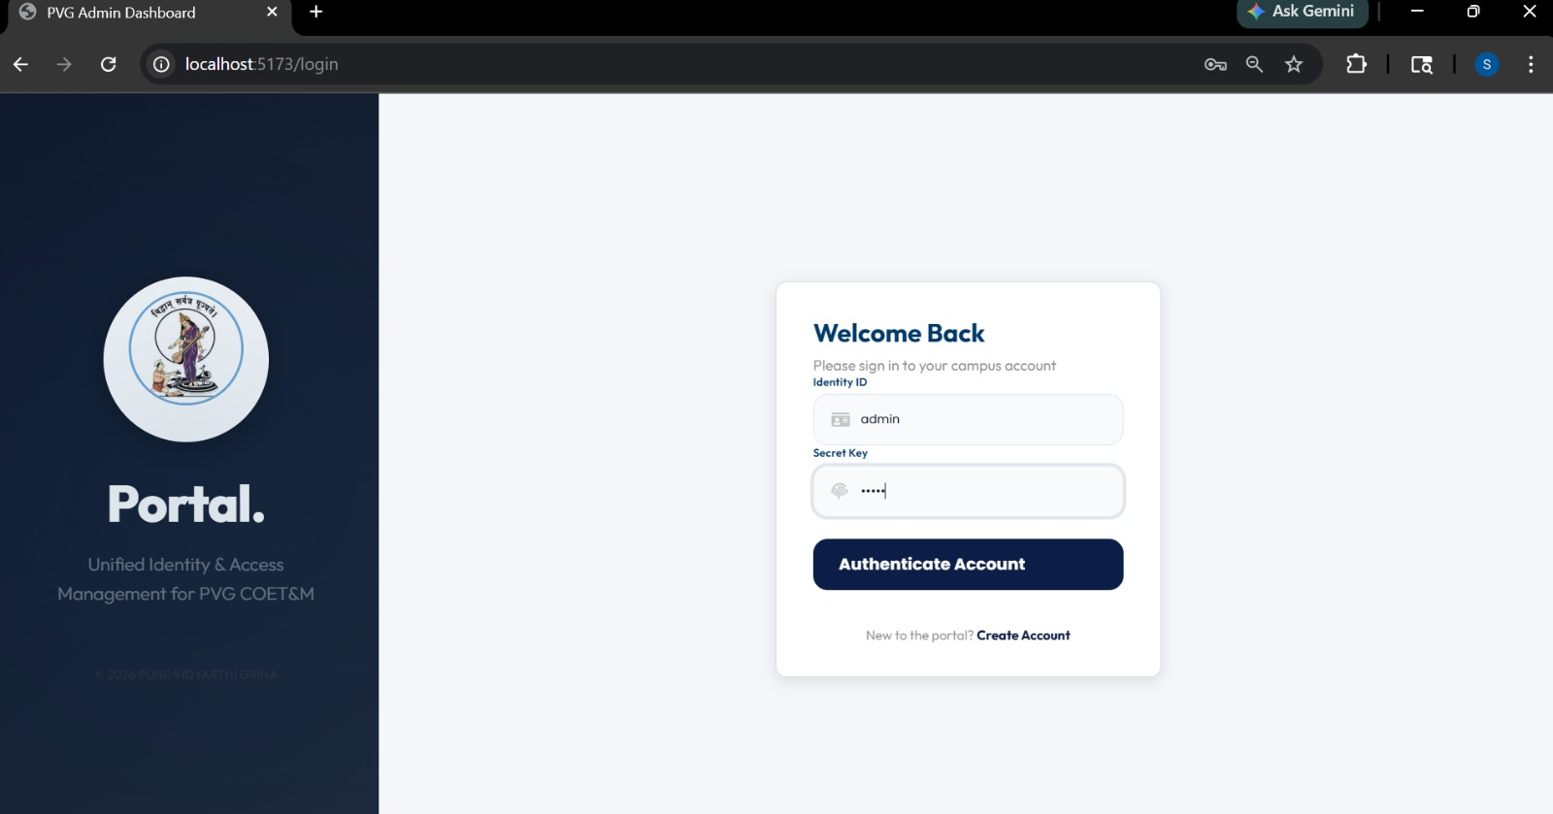
1)Login Portal

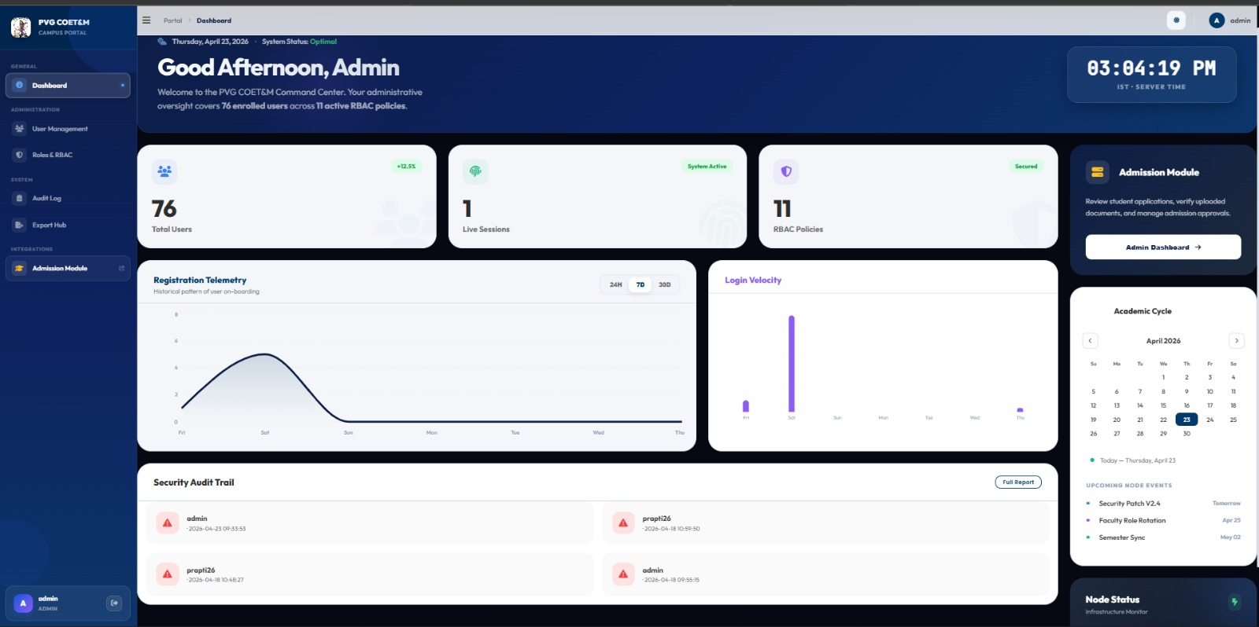
2)Admin Dashboard

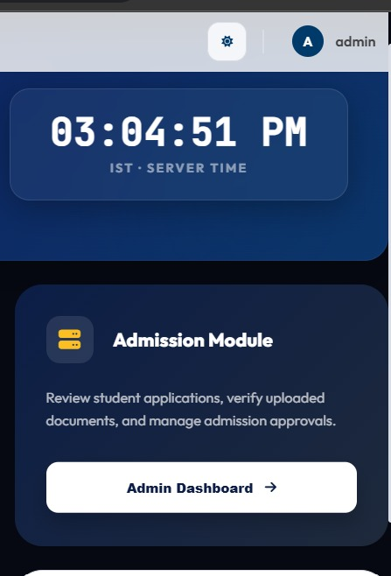
3)link to Admission button
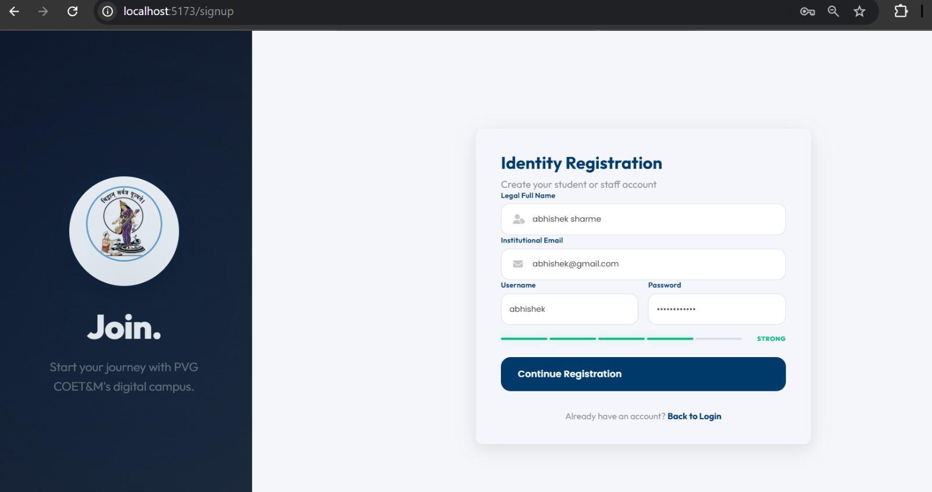
4) New User Sign up page
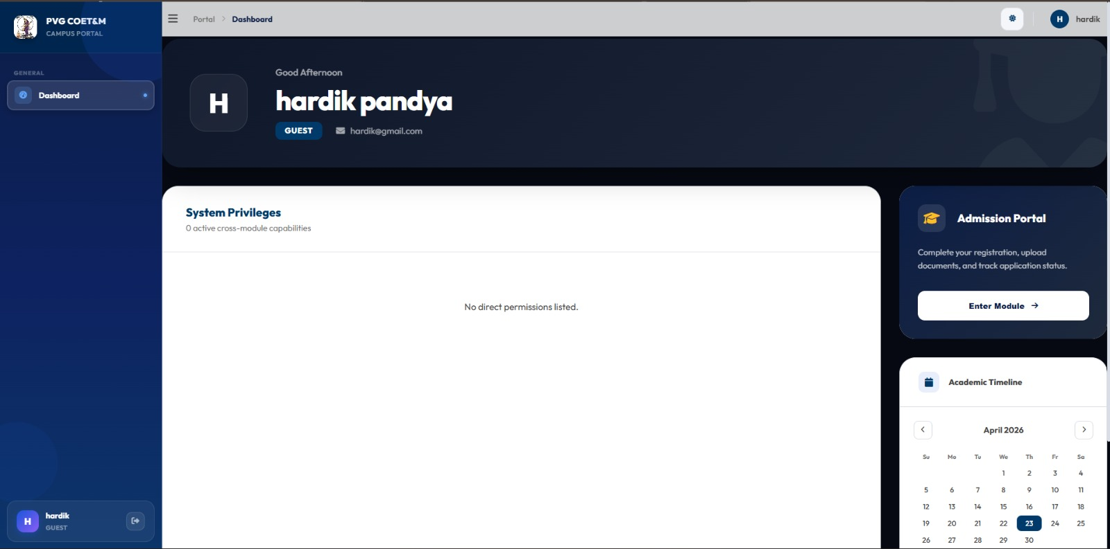
5)When user login as Guest into portal this is shown.

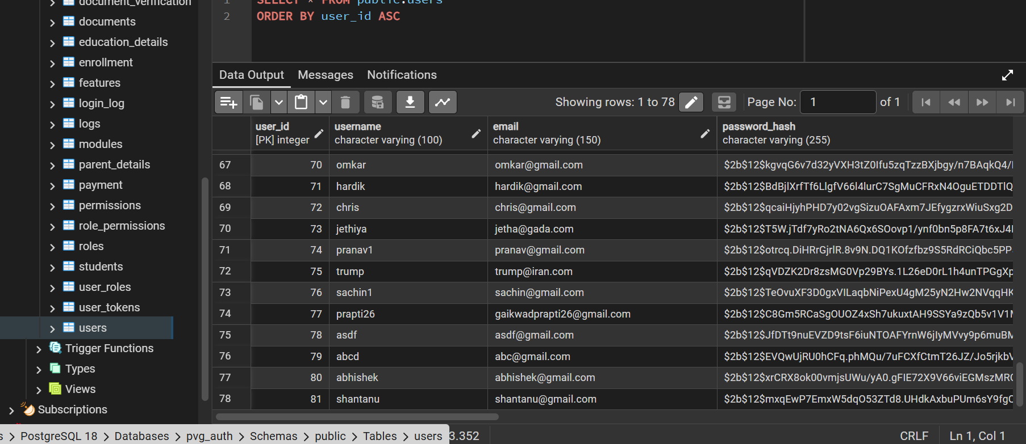

6)Database and the when user register’s its entries get save into user’s table.

10. Conclusion and Recommendations
• Summary of Work Done

In this project, a secure and scalable Authentication and Authorization module for a College ERP system was successfully designed and implemented. The system was developed using modern technologies such as React for the frontend, FastAPI for the backend, and PostgreSQL for database management. The module includes essential features like user registration, login, password encryption using bcrypt, and JWT-based authentication for secure session handling.
Role-Based Access Control (RBAC) was implemented to ensure that users can only access data and functionalities based on their assigned roles. By default, new users are assigned a Guest role to maintain minimal access and enhance security. The system also includes token tracking and audit fields to monitor user activity and data changes.
Additionally, the authentication module was successfully integrated with the Admission Module APIs using ngrok for secure API exposure. This integration demonstrates the system’s ability to connect with other ERP modules and work in a distributed environment. The merged implementation is available in the GitHub repository, showing the combined working of authentication and admission functionalities.

• Key Findings

The project demonstrates that implementing secure authentication mechanisms like JWT and bcrypt significantly improves system security. The use of Role-Based Access Control ensures proper data access management and reduces the risk of unauthorized usage.
The system performed efficiently during testing, handling user authentication, token generation, and validation without errors. The database design with Users, Roles, and Tokens tables provided a structured and scalable way to manage data. The inclusion of audit fields improved transparency and accountability.
Integration with external modules using APIs (via ngrok) showed that the system is flexible and can be extended easily. The use of Docker further simplified deployment and ensured consistency across different environments.
Overall, the project confirms that a modular and secure approach is effective for building a reliable College ERP system.

•Suggestions for Improvement

Although the system is functional and secure, several enhancements can be made in future versions. Multi-Factor Authentication (MFA) can be added to provide an additional layer of security during login. A refresh token mechanism can also be implemented to improve session management.
The system can be extended by adding a fine-grained permission system instead of basic role-based access. Advanced audit logging and monitoring dashboards can be included to track user activities in real time.
UI improvements can be made to enhance user experience, including better design, responsiveness, and accessibility features. Performance optimization can also be considered for handling a large number of users.
Further integration with additional ERP modules such as attendance, fees, examination, hostel, and transport can make the system more comprehensive. Finally, deploying the system on a cloud platform would improve availability and scalability.

11. Future Scope
Enhancements and Scalability
The current project mainly focuses on developing a secure Authentication and Authorization Module for the College ERP system. Although the system is functional and provides strong security using JWT authentication, bcrypt password hashing, and Role-Based Access Control (RBAC), there are several opportunities for future improvements and expansion.
One of the major enhancements that can be added is Multi-Factor Authentication (MFA). Currently, the system uses username and password-based login, but adding OTP verification through email or mobile number would provide an extra layer of security. This would reduce the chances of unauthorized access and improve user trust.
Another important enhancement is the implementation of a Refresh Token Mechanism. At present, JWT tokens are generated for authentication, but adding refresh tokens would improve session management by allowing secure token renewal without forcing the user to log in repeatedly. This will improve both security and user experience.
The RBAC system can also be upgraded by introducing fine-grained permission management. Instead of only assigning broad roles such as Guest, Student, or Admin, permissions can be controlled at a deeper level such as view, edit, delete, approve, and export. This would provide better control over user actions and improve system administration.
Advanced Audit Logs and Monitoring Dashboards can also be developed in the future. These features would help administrators track user activities, login attempts, data changes, and suspicious actions in real time. This improves transparency, accountability, and system security.
Since the project uses a scalable technology stack including React, FastAPI, PostgreSQL, and Docker, it can easily support a larger number of users and future modules. Cloud deployment using platforms like AWS or Azure can also be implemented for better performance, backup, and availability. This would make the system suitable for large institutions and multi-campus operations.
Performance optimization is another area of future enhancement. Features like caching, database optimization, and load balancing can improve speed and efficiency when the number of users increases.

• Possible Extensions
The most important future scope of this project is the complete integration of the Authentication and Authorization Module with all other College ERP modules. At present, the Authentication Module has already been integrated with the Admission Module APIs using ngrok, which proves that the system can successfully communicate with external modules and work as part of a larger ERP environment.
In the future, this integration can be extended to include modules such as Attendance Management, Fee Management, Examination System, Hostel Management, Transport Management, Library Management, Sports Management, Placement Cell, and Parent/Guardian Portal. This will create a fully centralized ERP system where all departments and users work under one secure platform.
For example, when a student logs in, the same authentication system can allow secure access to attendance records, exam results, fee status, hostel requests, transport approvals, and placement information without requiring separate logins for each module. This creates a seamless and efficient user experience.
A Parent and Guardian Portal can also be added in the future, where parents can monitor student attendance, fee payments, academic progress, and approval requests such as leave applications. Separate permissions for Parent and Guardian roles can improve accountability and communication.
Another possible extension is the development of a Mobile Application for Android and iOS platforms. This would allow students, faculty, and administrators to access the ERP system anytime and anywhere, making the system more practical and user-friendly.
Real-time notifications through email, SMS, or mobile push notifications can also be introduced for important events such as fee due reminders, attendance alerts, exam schedules, placement updates, and approval confirmations.
Dashboard analytics and automated report generation can be added for management-level users such as Principal, HOD, and Admin. These dashboards can provide useful insights about student performance, departmental reports, fee collection, and institutional decision-making.
Overall, the long-term vision of this project is to transform the current Authentication Module into the security foundation of a complete and intelligent College ERP ecosystem, where all academic and administrative processes are connected through one secure, scalable, and efficient platform.

12. Bibliography and References
1. FastAPI Official Documentation – Used for learning backend API development, routing, authentication, and FastAPI project structure.

2. PostgreSQL Official Documentation – Referred for database design, table creation, queries, and relational database management.

3. React Official Documentation – Used for frontend development, component structure, state management, and UI implementation.

4. Docker Official Documentation – Helped in understanding Docker, Docker Compose, and containerized deployment of the project.

5. JWT Introduction – Auth0 – Referred for implementing JWT-based authentication, token generation, and secure session handling.

6. bcrypt Documentation – PyPI – Used for password hashing and secure storage of user credentials in the database.

7. GitHub Repository for Project Integration – Contains the merged Authentication and Admission Module implementation using API integration and ngrok.

8. GitHub Repository for Authentication Module – Contains the complete Authentication and Authorization module with JWT and RBAC implementation.

9. Dribbble – Used for frontend UI design inspiration and modern layout ideas for login and signup pages.

10.Figma– Referred for professional UI/UX design inspiration and project presentation ideas.

11. Pinterest – Used for simple UI design references, color combinations, and layout inspiration for frontend screens.
Special thanks to Rajesh Darak Sir for your valuable guidance, support, and important suggestions. Without your help, we would not have reached this stage. Your encouragement and mentorship played a very important role in the successful completion of our project. Thank you for always guiding us in the right direction.

