

**International School**

**Capstone Project 2**

**CMU-SE 451 – C2SE.12**

**Project Proposal**

**Version 1.1**

**Date: March 6th, 2021**

**Learn English Together**

**Submitted by**

**Ha, Le Thanh**

**Hieu, Le Xuan**

**My, Ngo Ngoc**

**Thong, Doan Trung**

**Approved by**

**MSc Huy, Truong Dinh**

**Proposal Review Panel Representative:**

Name Signature Date

**Capstone Project 2- Mentor:**

Name Signature Date

**PROJECT INFORMATION**

|  |  |  |  |
| --- | --- | --- | --- |
| **Project acronym** | LET | | |
| **Project Title** | Learn English Together | | |
| **Start Date** | 26 Feb 2021 | **End Date** | 08 Jun 2021 |
| **Lead Institution** | International School, Duy Tan University | | |
| **Project Mentor** | MSc Huy, Truong Dinh | | |
| **Scrum master / Project Leader & contact details** | Ha, Le Thanh  Email: lethanhhadtu@gmail.com  Tel: 0334002818 | | |
| **Partner Organization** | Duy Tan University | | |
| **Project Web URL** |  | | |
| **Team members** | Name | Email | Tel |
|  | Ha, Le Thanh | lethanhhadtu@gmail.com | 0334002818 |
|  | Hieu, Le Xuan | xuanhieu.le.1999@gmail.com | 0399706614 |
|  | My, Ngo Ngoc | ngongocmy851999@gmail.com | 0764497391 |
|  | Thong, Doan Trung | doanthong002@gmail.com | 0886428208 |

**DOCUMENT APPROVALS**

The following signatures are required for approval of this document.

|  |  |  |
| --- | --- | --- |
| Ha, Le Thanh  Student ID: 2321122516  *Scrum Master* | Signature | Date |
| Hieu, Le Xuan  Student ID: 2321124665  *Team Member* | Signature | Date |
| My, Ngo Ngoc  Student ID: 2321124970  *Team Member* | Signature | Date |
| Thong, Doan Trung  Student ID: 2321124144  *Team Member* | Signature | Date |

REVISION HISTORY

| **Version** | **Date** | **Comments** | **Author** |
| --- | --- | --- | --- |
| 1.0 | March 6th, 2021 | Initial Release | H2MT Team |
| 1.1 | March 13th, 2021 | Update Current Status of Art | H2MT Team |

TABLE OF CONTENT

1. Introduction 5

**1.1. Purpose Of Document 5**

**1.2. Project Goal 5**

2. Problem Definition 5

**2.1. Business need 5**

**2.2. Solution 6**

3. Current Status of Art 6

4. Engineering Approach 7

**4.2. System context description 7**

**4.3. Technical Constraints 8**

5. Tasks and Deliverables 10

6. Project Management 11

**6.1. Cost/Budget for Project 11**

**6.2. Tentative Schedule 12**

**6.2.1. Master Plan 12**

**6.2.3. Scrum Process 13**

7. Project Constraints 14

8. Conclusion 16

9. References 16

10. Attachment 16

1. Introduction

1.1. Purpose of Document

* The document provides an overview of the project includes the purpose and scope of the project.
* Identify business needs, problems or situations related to the initialization and construction projects.
* Provide solutions for business needs and give the overview of system architecture.
* Provide overview about resources, schedule, solution and budget for the project.

1.2. Project Goal

LET is an application system that supports and helps lost learners learn English in a natural and exciting way. Learning a new language is like learning your mother tongue, language needs to come naturally. The system will be a community of people with similar interests in learning English, helping and supporting each other to learn English. Good people will tutor friends who are weaker than me to learn English. From there will create a community together to learn and improve English.

2. Problem Definition

In a globalized economy, learning English is more urgent than ever. So, learning English is essential for everyone. But many learners do not make progress or give up halfway because the methodology is ineffective, has no mentor, no support, or no motivation. There are many others who have good English proficiency, they want to share support, inspire others to learn from the experiences they have learned in learning English. In addition, some people want to open teaching centers but do not have experience in teaching, have not shown their quality and prestige and they need a place where they can teach, improve the quality of their lesson’s curriculum, and build trust with others.

2.1. Business need

- Community helps each other learn English.

- Application can learn vocabulary, listen for beginners.

- Application that make learning more efficient by learning in groups.

- The application can interact with others and support each other in learning.

- The application can help, share and inspire others to learn English.

2.2. Solution

Group C2SE.12 system is a community that makes learning English of everyone easier by learning to interact with others through forms such as group learning of 5-7 members and in groups. Those who learn English well will teach English to those who are most afraid of learning English in a natural way. Studying together with others creates motivation, feeling comfortable for English learners, learning English in the most exciting way. In addition to those study groups, users can randomly search for someone with English skills in the system to help them. And people with English proficiency can create events and seminars to share experiences and inspire others.

3. Current Status of Art

|  |  |  |  |
| --- | --- | --- | --- |
|  | **LET** | **myenglishonline.ca** | **www.learnenglish.de** |
| **Community** | **X** |  |  |
| **Group** | **X** | **X** |  |
| **Event** | **X** | **X** |  |
| **Dashboard** | **X** | **X** | **X** |
| **Vocabulary** | **X** |  | **X** |
| **Test, Mini Test** | **X** |  | **X** |
| **Message** | **X** |  | **X** |

Our website overcomes disadvantages that competitors inconvenience users such as:

• Create a community for people to interact with each other to learn English.

• Feeling comfortable learning English.

• Users can learn and talk directly on the system when they have questions that need to be answered.

• Users take the initiative in learning English.

4. Engineering Approach

**4.1**. **System context diagram**

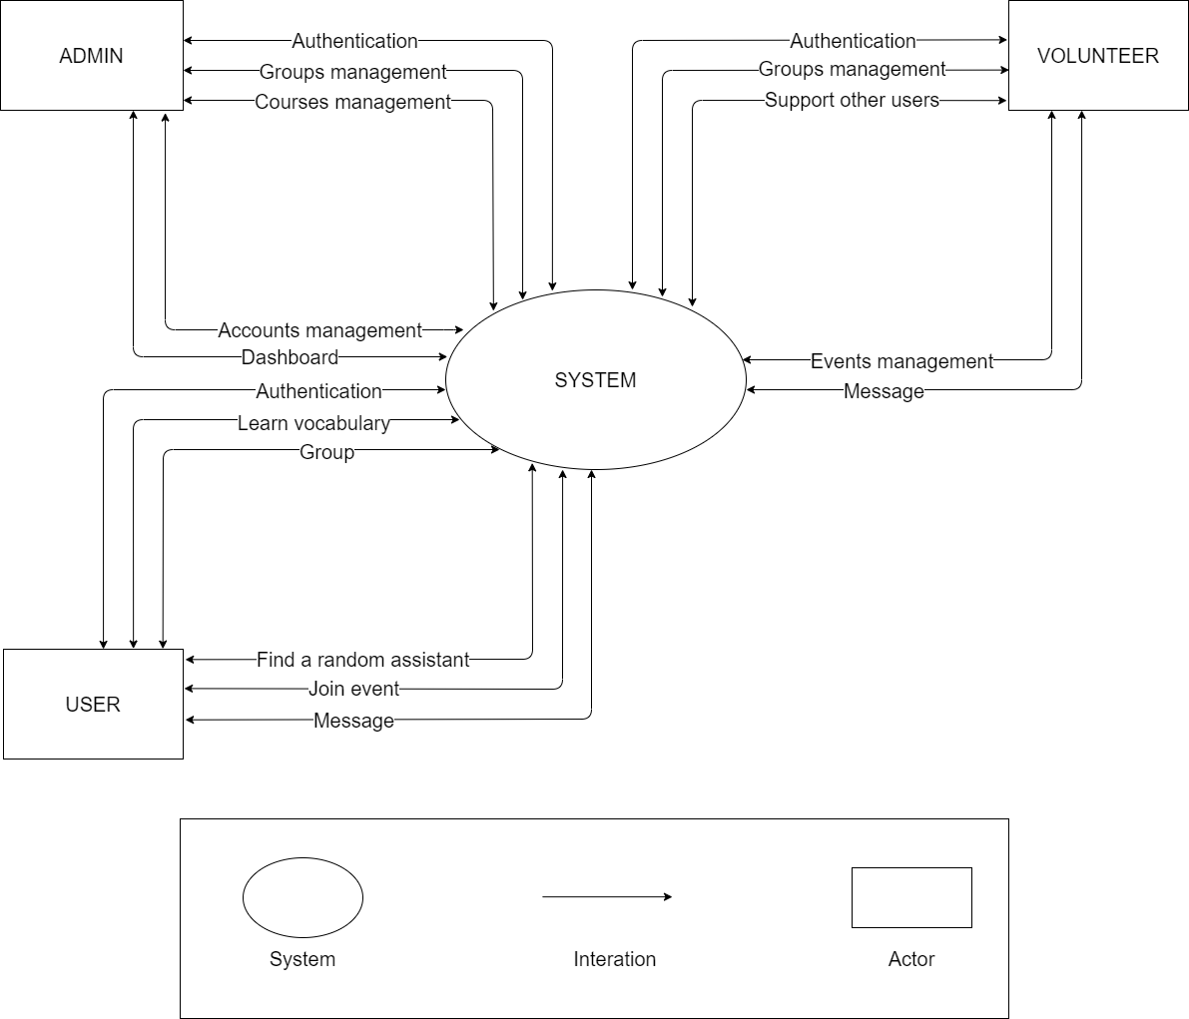

4.2. System context description

* **Admin:**
  + Admin can authenticate identity (login / logout)
  + Admin can manage groups in the system.
  + Admin can manage accounts in the system (Add, change roles, lock accounts)
  + Admin can create management courses (add default course, edit default courses, block course)
  + Admin can view dashboard chart statistics
* **Volunteer:**
  + Volunteer can authenticate identity (login / logout)
  + Volunteer can manage groups created by them (create, teaching online, create quiz, manage users in group, change group, delete group)
  + Volunteer can receive random assistance from the user in need of assistance (video, audio, text)
  + Volunteers can manage their events (create event, online conference, change event, delete event)
  + Volunteers can interact privately with other users through message
* **User:**
  + User can authenticate identity (login / logout)
  + User can learn vocabulary
  + User can join groups (Study online, take quizzes, review old lesson transcripts, interact with team members)
  + User can find random helpers (video, audio, text)
  + User can join events
  + User can interact privately with other users through message

4.3. Technical Constraints

**Technical to develop:**

* Programming language: JavaScript
* Library: Hook, Redux, React hook form, Font awesome, Material ui, Express.js.
* Technology: Reactjs, Nodejs, Polling, Elasticsearch, Redis, WebSocket, Mail gun.
* Database: Mongo dB.
* Version Control System: GitHub
* Team Management: Trello, Zalo, Google drive
* Develop tools: Visual Studio Code

**Environments:**

* Internet Connection
* Operation System: Google Chrome, Microsoft Edge, CocCoc, Firefox

**Other Constraints:**

* Resource: 4 people.
* Budget: Limited.
* Time: The project must be completed within 03 months.
* These features are not available in the first version of the product.

5. Tasks and Deliverables

|  |  |  |
| --- | --- | --- |
| No. | Task name | Description |
| **1.** | **Start up** |  |
| 1.1 | Project kick off meeting | Encountering the developer team and stakeholder to clear out the goal, defining of the base elements for the project and other project planning activities |
| 1.2 | Discuss about project | Brighten up the current ideal to both developer  team and stakeholder |
| 1.3 | Create Document | Release the artifacts or schematics related to project to product owner, include Proposal, User story, Product backlog, Project plan… |
| **2.** | **Development** |  |
| 2.1 | Sprint Planning | A Sprint begins with a sprint planning session that sets goals and plans details for the work to be done |
| 2.2 | Sprint 1 | Release the first look of the product (ver1.0) with functions which have been committed in the contract |
| 2.3 | Sprint 2 | Release the update for ver1.0 (ver1.1) with functions which have been approved by product owner |
| 2.4 | Sprint 3 | The next update (ver1.2) for previous phase |
| **3.** | **Project ‘s meeting** | Private meeting between members to make plan what will be presented to customer in the final release |
| **4.** | **Final Release** | Release the final version to product owner with complete function |

6. Project Management

6.1. Cost/Budget for Project

|  |  |  |
| --- | --- | --- |
| **Full Name** | **Role** | **Salary Rate (USD/hour)** |
| Ha, Le Thanh | Scrum Master | 2 |
| Hieu, Le Xuan | Team Member | 2 |
| My, Ngo Ngoc | Team Member | 2 |
| Thong, Doan Trung | Team Member | 2 |

***Table 1. Cost person/hours***

|  |  |  |  |
| --- | --- | --- | --- |
| **No** | **Criteria** | **Price** | **Total (USD)** |
| 1 | Working hours | 2 | 2700 |
| 2 | Other cost | 100 | 400 |
|  |  |  | 3100 |

***Table 2. Total cost estimation***

|  |  |  |
| --- | --- | --- |
| **Description** | **Amount** | **Unit** |
| Number of members | 4 | Person |
| Number of working hours per day | 3 | Hours |
| The cost per hour per member | 2 | USD |
| The number of working days | 90 | Days |

***Table 3. Description***

**-** The explanation for the table

* Amount of working hours = 4 members * 3 hours * 90 days
* Other cost = 4 members * 100 USD

6.2. Tentative Schedule

6.2.1. Master Plan

|  |  |  |  |  |
| --- | --- | --- | --- | --- |
| **NO** | **Task Name** | **Duration** | **Start** | **Finish** |
| **1.** | **Initial** | **8 days** | **26 – Feb - 2021** | **06– Feb – 2021** |
| 1.1 | Gathering Requirement | 2 days | 26 – Feb – 2021 | 28 – Feb – 2021 |
| 1.2 | Create Proposal Document | 6 days | 01 – Mar – 2021 | 06 – Mar – 2021 |
| **2** | **Start Up** | **8 days** | **07 – Mar – 2021** | **14 – Mar – 2021** |
| 2.1 | Project Kick-off Meeting | 2 days | 07 – Mar – 2021 | 08 – Mar – 2021 |
| 2.2 | Create Document | 6 days | 09 – Mar – 2021 | 14 – Mar – 2021 |
| **3** | **Development** | **84 days** | **15 – Mar – 2021** | **01 – Jun– 2021** |
| 3.1 | Sprint 1 | 28 days | 15 – Mar – 2021 | 12 – Apr – 2021 |
| 3.2 | Sprint 2 | 28 days | 13 – Apr – 2021 | 10 – May – 2021 |
| 3.3 | Sprint 3 | 21 days | 11 – May – 2021 | 01 – Jun – 2021 |
| **4** | **Project’s Retrospective Meeting** | **03 days** | **05 – Jun – 2021** | **07 – Jun – 2021** |
| **5** | **Final Release** | **01 days** | **08 – Jun – 2021** | **08 – Jun – 2021** |

6.2.3. Scrum Process

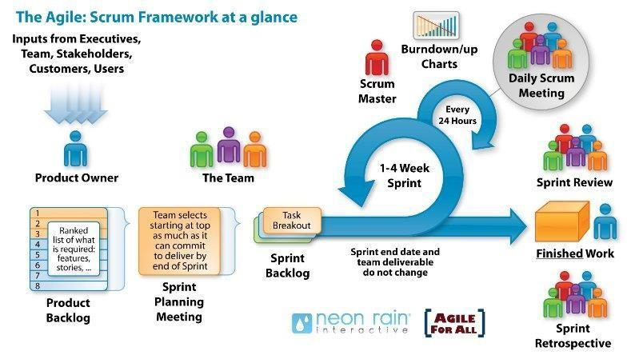

* Scrum is an iterative and incremental agile software development framework for

managing software projects and product or application development.

* Scrum focuses on project management institutions where it is difficult to plan ahead.
* Mechanisms of empirical process control, where feedback loops that constitute

the core management technique is used as opposed to traditional command-and

-control management.

* Its approach to planning and managing projects is by bringing decision-making

authority to the level of operation properties and certainties.

* Benefit of the methodology:
  + - Project can respond easily to change.
    - Problems are identified early.
    - Customers get the most beneficial work first.
    - Work done will better meet the customer’s needs.
    - Improved productivity.
    - Ability to maintain a predictable schedule for delivery.

7. Project Constraints

|  |  |  |
| --- | --- | --- |
| **Constraint** | **Constraints Description** | **Guidelines for Acceptance** |
| **Economic** | • Start trial (1 month free)  • Trial period has ended  + Renew monthly: 4.99 $ per month  + Renew by year: 2.99 $ per month  + Lifetime: 99.99 $ once | Elements for consideration are design costs, production costs, maintenance costs, operating costs, and sales price |
| **Environmental** | The system does not affect the environment | Impact of the design on the environment as well as impact of the environment (e.g, temperature range, humidity, vibration, electromagnetic interference immunity, and shock) on the design should be considered. Design for recycling and design to use recycled materials should also be considered |
| **Ethical** | -User information after registration will be encrypted, and we will not share with any organization.  - Respecting user privacy settings  - Working to ensure the security of our users’ information  - Do not tracking users | Ethical considerations can be broad. Areas that are typically addressed include intellectual property, reverse- engineering, privacy, security, and the conflict between cost and safety. |
| **Public health, safety, and welfare** | The application works on web platform, so when using, users will look at the screen of laptop, pc, tablet, mobile device. So, we recommend not to use the application for more than 180 minutes, to protect the eyes and health of the user. | Includes safety standards as well as impact of the design on users (for example, electrical or physical hazards) |
| **Social and Global** | Making it easier for beginners, students, or employees who want to learn language, children help them increase their communication skills, and make friends with many others. | Addresses aspects such as benefits, risks, the man-machine interface, the acceptance of products by the intended user or by society at large, global and socially responsible engineering. |
| **Cultural** | - This application is for Vietnamese people to learn English, so the website will use Vietnamese.  - To remove this barrier, we can add a function to choose to display English or Vietnamese language websites. | Which cultural characteristics could influence the approach?  How do the design from different cultures differ? |
| **Sustainability** | Human resources include 4 members of Duy Tan University.  The app is written in javascript, using reactjs technology that breaks the components of the system into separate operations for easier maintenance. | Refers to sustainability of resources, including material, energy, supplies, manufacturing techniques, personnel, operation, and the need for additional infrastructure, as well as sustainability of the design including reliability, lifetime, durability, reusability, maintainability. |

8. Conclusion

This product creates a community that promises to help everyone have an effective English learning environment. Bring a new feeling of learning English, with no barriers between good learners and poor English learners. Help improve English skills. The project is expected to be completed within 3 months at a cost of not more than $ 3100.

9. References

**[1]. Software Development Standards for the Guidance and Control Software Project:** [*https://sw-eng.larc.nasa.gov*](https://sw-eng.larc.nasa.gov)

**[2]. General Software Coding Standards and Guidelines**: [*https://www.nws.noaa.gov/oh/hrl/developers_docs/General_Software_Standards.pdf*](https://www.nws.noaa.gov/oh/hrl/developers_docs/General_Software_Standards.pdf)

**[3]. Scrum and best practices*:*** *https://docs.microsoft.com/en- us/azure/devops/boards/sprints/best-practices-scrum?view=azure-devops*

**[4]. The Scrum Guide:** [*https://www.scrum.org/resources/scrum-guide*](https://www.scrum.org/resources/scrum-guide)

**[5]. The ISO/IEC & IEEE/EIA Standard 12207, IEEE standards: IEEE-829 [3], IEEE-1008 [5], IEEE-1012**

**[6] React documentation:** <https://reactjs.org/docs/getting-started.html>

10. Attachment