**TRACING:**

BOOKING.JAVA

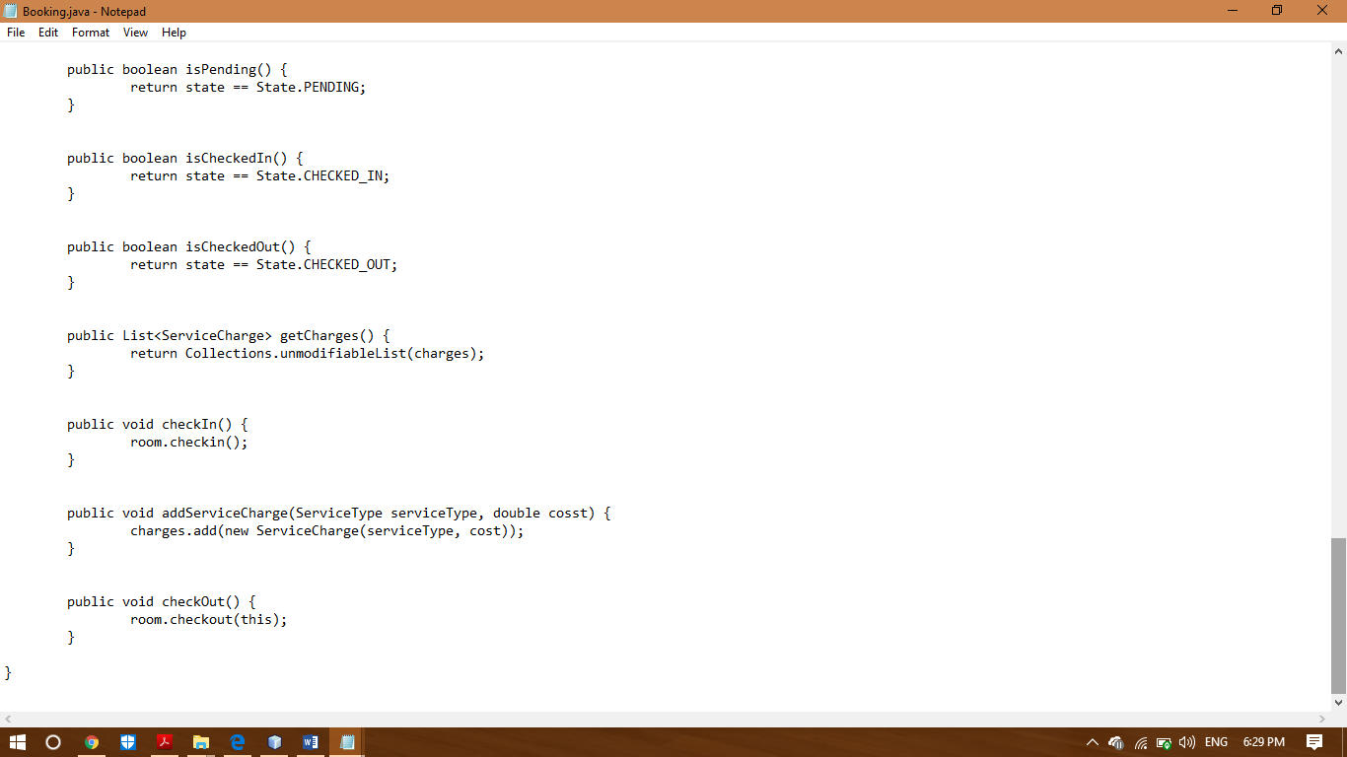

The above screenshot shows the first bug in the code which is in the first line of screenshot. The author used ‘cosst’ instead of cost that’s why the system isn’t calculating the charges while checking out.

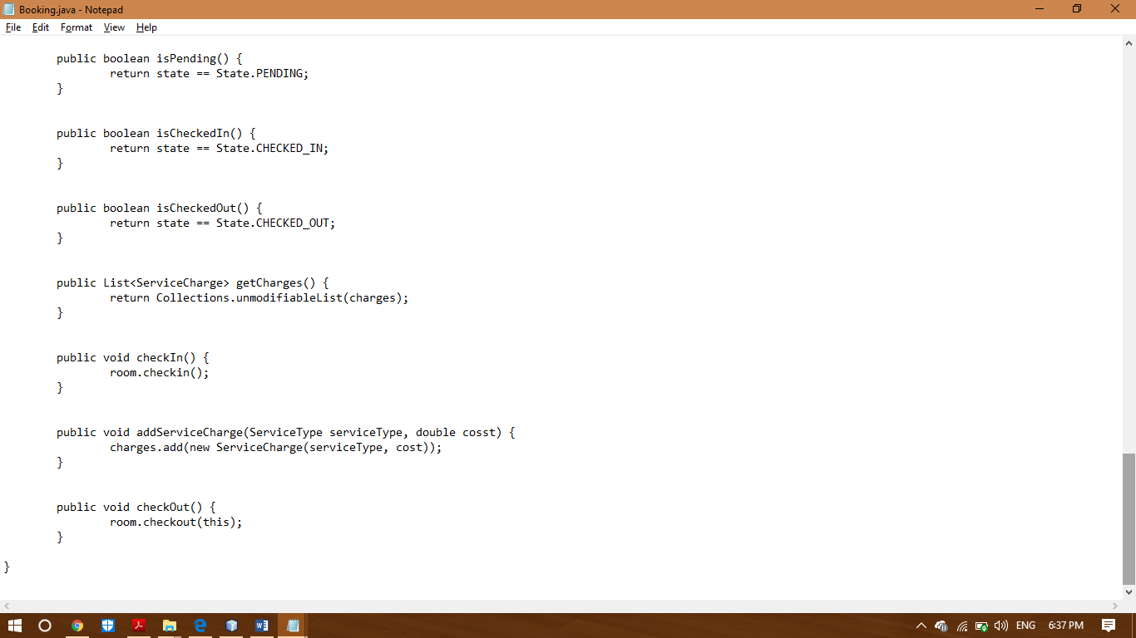

The above screenshot shows the second bug in the code, there’s a missing statement in the code which will help the code to change the state after every check in which is the code not doing now.

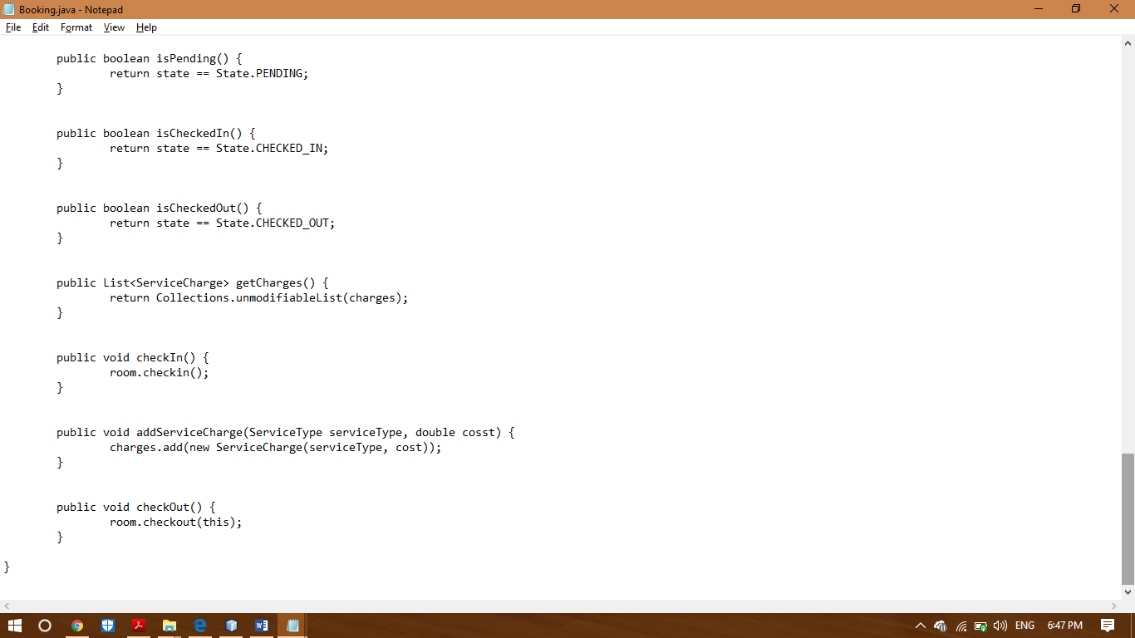

The above screenshot shows the third bug in the code, there’s a missing statement in the code which will help the code to change the state after every check out which is the code not doing now. That’s why the system is still able to charge money even after the checkout.

ROOM.JAVA

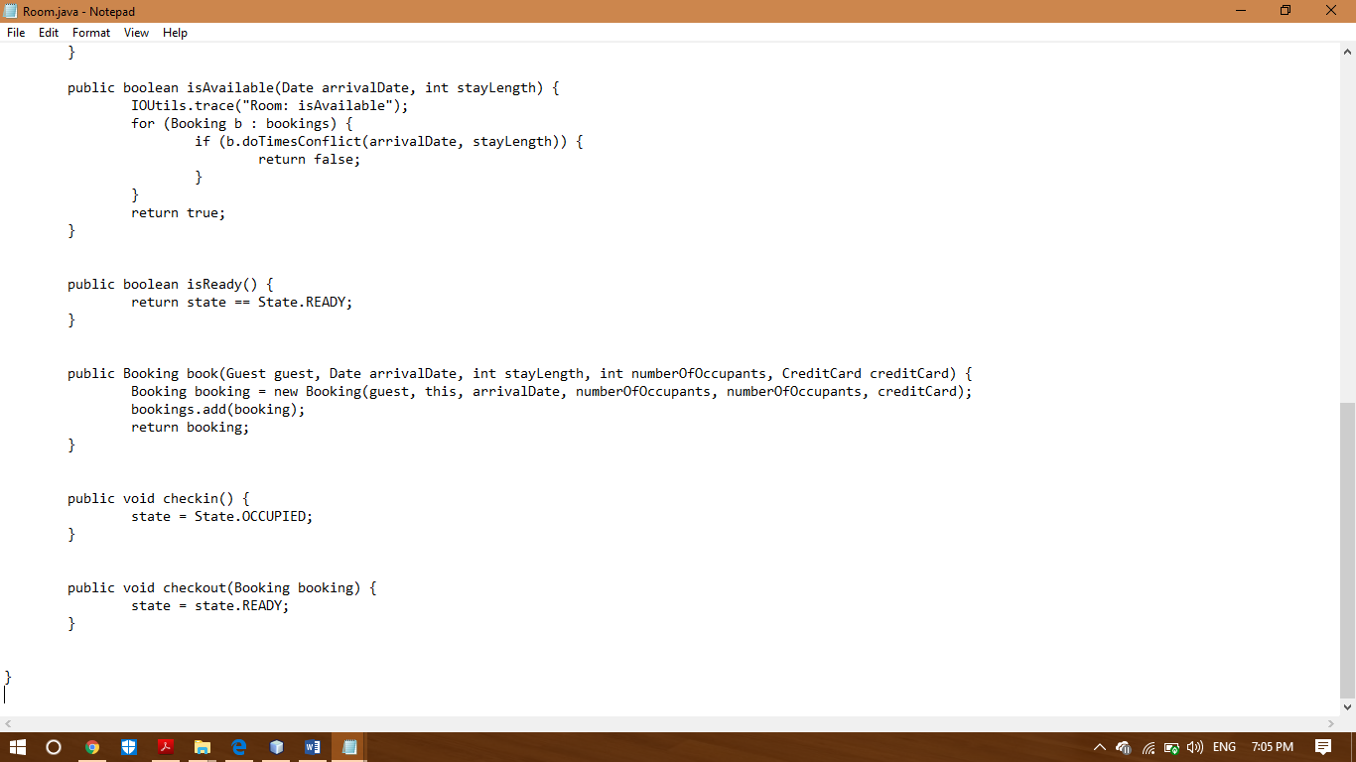

The above screenshot shows the fourth bug in the code, there’s a missing statement in the code which will help the code to change the state after every check out which is the code not doing now. That’s why the system is still able to charge money even after the checkout.

HOTEL.JAVA

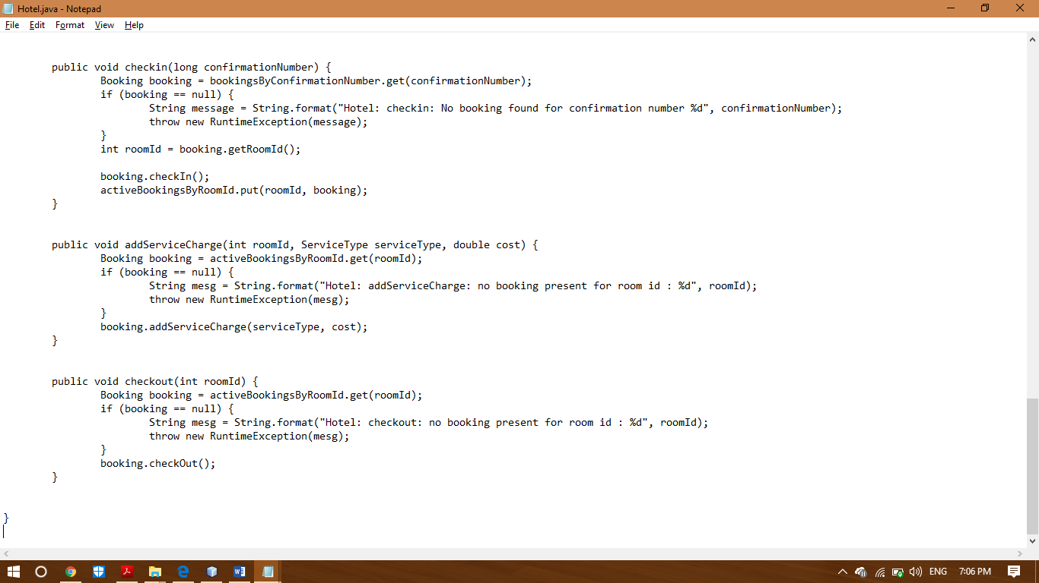

The above screenshot shows the fifth bug in the code, there’s a missing statement in the code which will help the code to change the state after every check out which is the code not doing now. That’s why the system is still able to charge money even after the checkout.