**REPLICATION:**

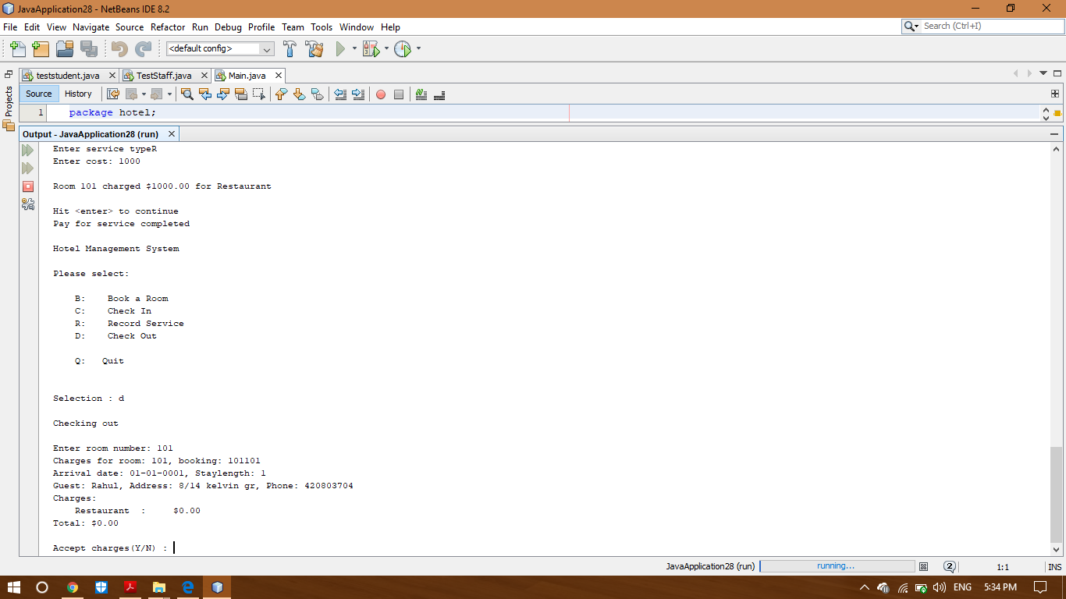

The above screenshot shows the bug in the code that is given to us. This code doesn’t add up the chargers of services at the checkout. It supposed to add the room charges and the services that a customer opts at the checkout.

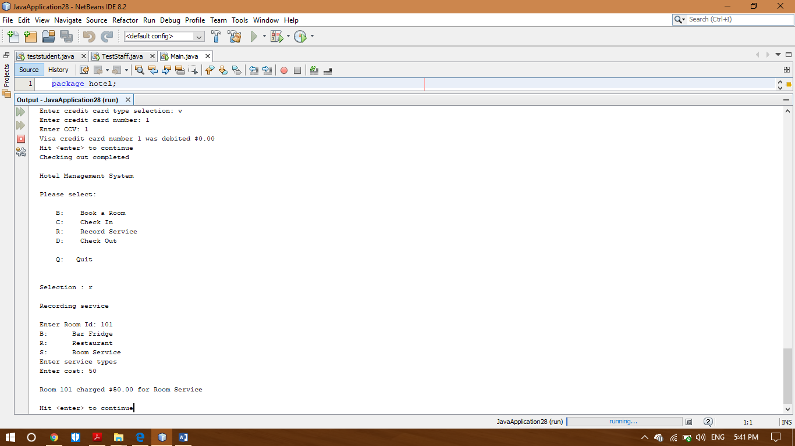

The above screenshot shows the second bug in the code, In the output the system still can charge the customers even after they checked out. It supposed to show that no booking found for this room number.