武汉纺织大学

Java应用开发课程设计

**简单在线考试系统**

**学 院： 数学与计算机学院**

**班 级： 物联网11801**

**姓 名： 黄文韬**

**学 号： 1804240310**

**指导老师： 聂刚**

**成 绩：**

**完成日期： 2020年6月20日**

目 录

1 需求分析

1.1用户登陆

1.2主菜单

1.3各项功能

1.3.1 收银

1.3.2 查询统计

1.3.3 商品维护

1.3.4 修改密码

1.3.5 数据导出

1.3.6 退出

1.3.7 ****

2 系统设计

2.1用户用例图

2.2 ER图

2.3 UML类图（Class Diagram）

2.4 UML时序图（Sequence Diagram）

2.4.1 系统登录

2.4.2 ******模块

2.4.3 ******模块

2.5 UML活动图（Activity Diagram）

2.5.1 登陆

2.5.1 收银

3 系统实现

3.1 项目结构

3.2 配置文件

3.2.1 jdbc.properties文件

3.2.2 log4j.properties文件

3.2.3 mybatis-config.xml文件

3.3 VO类User.java

3.4 DAO接口类IUserDAO.java

3.5 接口映射文件UserMapper.xml

3.6 工具包Util

3.6.1 MybatisUtils.java

3.6.2 MD5Util.java

3.7 服务层UserService.java

3.8 用户界面Driver.java

3.9 ******.java

4 系统测试

5 系统总结

# 1 需求分析

从数据库题库中随机抽取一定数量的题目（题型只有单选或多选）组合成试卷，学生对试卷

进行作答，答题完毕后程序自动完成阅卷，并给出成绩。教师用户可以对题库进行增加，删除、修改，设置试卷题目的数量，考试开始时间，自动生成试卷，对所有学生的成绩进行查询、统计（最高分，最低分，平均分，各分数段成绩百分比等）等功能。

具体要求如下：

## 1.1用户登陆

共有两种不同登录方式，学生登陆和后台登录，只有教师有后台登录的账号

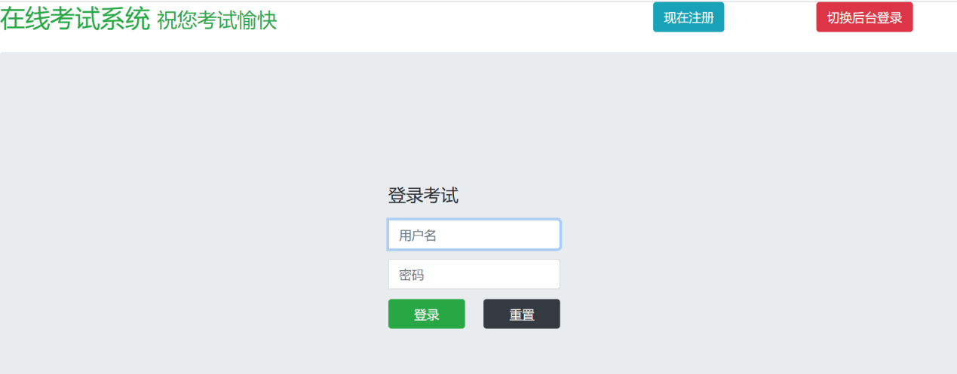

普通登录



教师登录

## 1.2主菜单

当用户名及密码正确时，学生只能进行考试，老师才能进入系统主界面，如下：

## 1.3各项功能

### 1.3.1 进入考试

学生在登录之后可进入考试，每次考试均由老师生成试卷，规定分值，考试时长等相关设定

学生仅能进行答题，交卷后可返回初始界面。

### 1.3.2 题库管理

老师可对题库进行管理，例如增加/减少题库数量，更改题库内已有的题目描述，也可查看题库内已有题目的相关信息。

### 1.3.3 考试管理

老师可提前生成试卷并进行预设，老师可以选择从多套预设试卷中选择一套进行考试。老师可对已预设的试卷进行修改，增加/删除题目。

### 1.3.4 成绩查询

老师和学生可对学生成绩进行查询。学生只能查看自己一个人的成绩。

### 1.3.5 成绩统计

老师可对学生的成绩进行统计，得出及格率，平均分等相关数据。

### 1.3.6 退出

学生和老师完成操作后可退出程序。

# 2 系统设计

## 2.1设计导图

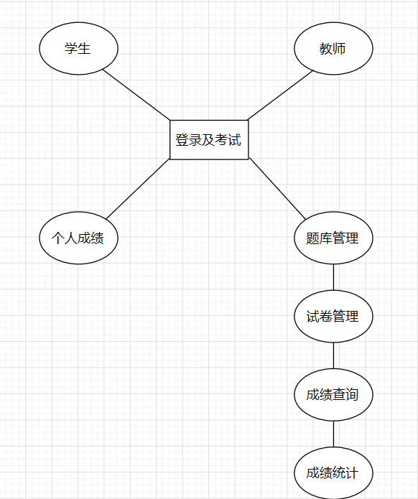

## 2.2 ER图

数据库设计3张表，用户表，商品表，销售记录表，对应的ER图如图3-1所示。

%3CmxGraphModel%3E%3Croot%3E%3CmxCell%20id%3D%220%22%2F%3E%3CmxCell%20id%3D%221%22%20parent%3D%220%22%2F%3E%3Cmysql.table%20entity.table.tableName%3D%22uses%22%20label%3D%22uses%22%20id%3D%222%22%3E%3CmxCell%20style%3D%22swimlane%3BfontStyle%3D0%3BchildLayout%3DstackLayout%3Bhorizontal%3D1%3Bhtml%3D1%3BstartSize%3D26%3BfillColor%3D%23b0e3e6%3BhorizontalStack%3D0%3BresizeParent%3D1%3BresizeParentMax%3D0%3BresizeLast%3D0%3Bcollapsible%3D1%3BmarginBottom%3D0%3BswimlaneFillColor%3D%23ffffff%3Balign%3Dcenter%3BfontSize%3D13%3BstrokeColor%3D%230e8088%3Brounded%3D0%3Bshadow%3D1%3Bcomic%3D0%3Bglass%3D0%3BgradientDirection%3Dsouth%3BgradientColor%3D%23ffffff%3B%22%20vertex%3D%221%22%20connectable%3D%220%22%20parent%3D%221%22%3E%3CmxGeometry%20x%3D%2260%22%20y%3D%2250%22%20width%3D%22310%22%20height%3D%22130%22%20as%3D%22geometry%22%2F%3E%3C%2FmxCell%3E%3C%2Fmysql.table%3E%3Cmysql.column%20entity.column.tableName%3D%22uses%22%20entity.column.name%3D%22userName%22%20entity.column.dataType%3D%22VARCHAR%22%20entity.column.PK%3D%22true%22%20label%3D%22%26lt%3Bimg%20title%3D%26quot%3BPrimary%20Key%26quot%3B%20src%3D%26quot%3Bimg%2Fdb%2Fkey1.png%26quot%3B%20width%3D%26quot%3B16%26quot%3B%20height%3D%26quot%3B16%26quot%3B%20align%3D%26quot%3Btop%26quot%3B%26gt%3B%26amp%3Bnbsp%3B%26lt%3Bfont%20size%3D%26quot%3B1%26quot%3B%20face%3D%26quot%3BTahoma%26quot%3B%26gt%3B%26lt%3Bspan%20style%3D%26quot%3Bfont-size%3A%2013px%26quot%3B%26gt%3B%26lt%3Bb%26gt%3Bid%20int%20primary%20key%26lt%3B%2Fb%26gt%3B%26lt%3B%2Fspan%26gt%3B%26lt%3B%2Ffont%26gt%3B%22%20entity.column.oldName%3D%22id%22%20entity.column.datalen%3D%2220%22%20entity.column.decimals%3D%22%22%20entity.column.autoIncreament%3D%22%22%20entity.column.unsigned%3D%22%22%20entity.column.bin%3D%22%22%20entity.column.ascii%3D%22%22%20entity.column.unicode%3D%22%22%20entity.column.unique%3D%22%22%20entity.column.isNotNull%3D%22NOT%20NULL%22%20entity.column.defaultValue%3D%22%22%20entity.column.comment%3D%22%22%20entity.column.enum%3D%22%22%20entity.column.set%3D%22%22%20entity.column.enumSetValue%3D%22%22%20id%3D%223%22%3E%3CmxCell%20style%3D%22text%3Bhtml%3D1%3BstrokeColor%3Dnone%3BfillColor%3Dnone%3BspacingLeft%3D4%3BspacingRight%3D4%3Boverflow%3Dhidden%3Brotatable%3D0%3BportConstraint%3Deastwest%3BfontSize%3D12%3BverticalAlign%3Dmiddle%3B%22%20vertex%3D%221%22%20parent%3D%222%22%3E%3CmxGeometry%20y%3D%2226%22%20width%3D%22310%22%20height%3D%2226%22%20as%3D%22geometry%22%2F%3E%3C%2FmxCell%3E%3C%2Fmysql.column%3E%3Cmysql.column%20entity.column.tableName%3D%22uses%22%20entity.column.name%3D%22chrName%22%20entity.column.datalen%3D%2220%22%20entity.column.dataType%3D%22VARCHAR%22%20label%3D%22%26lt%3Bimg%20title%3D%26quot%3BPrimary%20Key%26quot%3B%20src%3D%26quot%3Bimages%2Fspacer.gif%26quot%3B%20width%3D%26quot%3B16%26quot%3B%20height%3D%26quot%3B16%26quot%3B%20align%3D%26quot%3Btop%26quot%3B%26gt%3B%26amp%3Bnbsp%3B%26lt%3Bfont%20size%3D%26quot%3B1%26quot%3B%20face%3D%26quot%3BTahoma%26quot%3B%26gt%3B%26lt%3Bspan%20style%3D%26quot%3Bfont-size%3A%2013px%26quot%3B%26gt%3B%26lt%3Bb%26gt%3Bname%20varchar(10)%26lt%3B%2Fb%26gt%3B%26lt%3B%2Fspan%26gt%3B%26lt%3B%2Ffont%26gt%3B%22%20entity.column.oldName%3D%22name%22%20entity.column.decimals%3D%22%22%20entity.column.autoIncreament%3D%22%22%20entity.column.unsigned%3D%22%22%20entity.column.bin%3D%22%22%20entity.column.ascii%3D%22%22%20entity.column.unicode%3D%22%22%20entity.column.PK%3D%22false%22%20entity.column.unique%3D%22%22%20entity.column.isNotNull%3D%22%22%20entity.column.defaultValue%3D%22%22%20entity.column.comment%3D%22%22%20entity.column.enum%3D%22%22%20entity.column.set%3D%22%22%20entity.column.enumSetValue%3D%22%22%20id%3D%224%22%3E%3CmxCell%20style%3D%22text%3Bhtml%3D1%3BstrokeColor%3Dnone%3BfillColor%3Dnone%3BspacingLeft%3D4%3BspacingRight%3D4%3Boverflow%3Dhidden%3Brotatable%3D0%3BportConstraint%3Deastwest%3BfontSize%3D12%3BverticalAlign%3Dmiddle%3B%22%20vertex%3D%221%22%20parent%3D%222%22%3E%3CmxGeometry%20y%3D%2252%22%20width%3D%22310%22%20height%3D%2226%22%20as%3D%22geometry%22%2F%3E%3C%2FmxCell%3E%3C%2Fmysql.column%3E%3Cmysql.column%20entity.column.tableName%3D%22uses%22%20entity.column.name%3D%22password%22%20entity.column.datalen%3D%2250%22%20entity.column.dataType%3D%22VARCHAR%22%20label%3D%22%26lt%3Bimg%20title%3D%26quot%3BPrimary%20Key%26quot%3B%20src%3D%26quot%3Bimages%2Fspacer.gif%26quot%3B%20width%3D%26quot%3B16%26quot%3B%20height%3D%26quot%3B16%26quot%3B%20align%3D%26quot%3Btop%26quot%3B%26gt%3B%26amp%3Bnbsp%3B%26lt%3Bfont%20size%3D%26quot%3B1%26quot%3B%20face%3D%26quot%3BTahoma%26quot%3B%26gt%3B%26lt%3Bspan%20style%3D%26quot%3Bfont-size%3A%2013px%26quot%3B%26gt%3B%26lt%3Bb%26gt%3Bname%20varchar(10)%26lt%3B%2Fb%26gt%3B%26lt%3B%2Fspan%26gt%3B%26lt%3B%2Ffont%26gt%3B%22%20entity.column.oldName%3D%22chrName%22%20entity.column.decimals%3D%22%22%20entity.column.autoIncreament%3D%22%22%20entity.column.unsigned%3D%22%22%20entity.column.bin%3D%22%22%20entity.column.ascii%3D%22%22%20entity.column.unicode%3D%22%22%20entity.column.PK%3D%22false%22%20entity.column.unique%3D%22%22%20entity.column.isNotNull%3D%22%22%20entity.column.defaultValue%3D%22%22%20entity.column.comment%3D%22%E5%AF%86%E7%A0%81%22%20entity.column.enum%3D%22%22%20entity.column.set%3D%22%22%20entity.column.enumSetValue%3D%22%22%20id%3D%225%22%3E%3CmxCell%20style%3D%22text%3Bhtml%3D1%3BstrokeColor%3Dnone%3BfillColor%3Dnone%3BspacingLeft%3D4%3BspacingRight%3D4%3Boverflow%3Dhidden%3Brotatable%3D0%3BportConstraint%3Deastwest%3BfontSize%3D12%3BverticalAlign%3Dmiddle%3B%22%20vertex%3D%221%22%20parent%3D%222%22%3E%3CmxGeometry%20y%3D%2278%22%20width%3D%22310%22%20height%3D%2226%22%20as%3D%22geometry%22%2F%3E%3C%2FmxCell%3E%3C%2Fmysql.column%3E%3Cmysql.column%20entity.column.tableName%3D%22uses%22%20entity.column.name%3D%22role%22%20entity.column.datalen%3D%2220%22%20entity.column.dataType%3D%22VARCHAR%22%20label%3D%22%26lt%3Bimg%20title%3D%26quot%3BPrimary%20Key%26quot%3B%20src%3D%26quot%3Bimages%2Fspacer.gif%26quot%3B%20width%3D%26quot%3B16%26quot%3B%20height%3D%26quot%3B16%26quot%3B%20align%3D%26quot%3Btop%26quot%3B%26gt%3B%26amp%3Bnbsp%3B%26lt%3Bfont%20size%3D%26quot%3B1%26quot%3B%20face%3D%26quot%3BTahoma%26quot%3B%26gt%3B%26lt%3Bspan%20style%3D%26quot%3Bfont-size%3A%2013px%26quot%3B%26gt%3B%26lt%3Bb%26gt%3Bname%20varchar(10)%26lt%3B%2Fb%26gt%3B%26lt%3B%2Fspan%26gt%3B%26lt%3B%2Ffont%26gt%3B%22%20entity.column.oldName%3D%22chrName%22%20entity.column.decimals%3D%22%22%20entity.column.autoIncreament%3D%22%22%20entity.column.unsigned%3D%22%22%20entity.column.bin%3D%22%22%20entity.column.ascii%3D%22%22%20entity.column.unicode%3D%22%22%20entity.column.PK%3D%22false%22%20entity.column.unique%3D%22%22%20entity.column.isNotNull%3D%22%22%20entity.column.defaultValue%3D%22%22%20entity.column.comment%3D%22%E8%A7%92%E8%89%B2%22%20entity.column.enum%3D%22%22%20entity.column.set%3D%22%22%20entity.column.enumSetValue%3D%22%22%20id%3D%226%22%3E%3CmxCell%20style%3D%22text%3Bhtml%3D1%3BstrokeColor%3Dnone%3BfillColor%3Dnone%3BspacingLeft%3D4%3BspacingRight%3D4%3Boverflow%3Dhidden%3Brotatable%3D0%3BportConstraint%3Deastwest%3BfontSize%3D12%3BverticalAlign%3Dmiddle%3B%22%20vertex%3D%221%22%20parent%3D%222%22%3E%3CmxGeometry%20y%3D%22104%22%20width%3D%22310%22%20height%3D%2226%22%20as%3D%22geometry%22%2F%3E%3C%2FmxCell%3E%3C%2Fmysql.column%3E%3Cmysql.table%20entity.table.tableName%3D%22product%22%20label%3D%22product%22%20id%3D%227%22%3E%3CmxCell%20style%3D%22swimlane%3BfontStyle%3D0%3BchildLayout%3DstackLayout%3Bhorizontal%3D1%3Bhtml%3D1%3BstartSize%3D26%3BfillColor%3D%23b0e3e6%3BhorizontalStack%3D0%3BresizeParent%3D1%3BresizeParentMax%3D0%3BresizeLast%3D0%3Bcollapsible%3D1%3BmarginBottom%3D0%3BswimlaneFillColor%3D%23ffffff%3Balign%3Dcenter%3BfontSize%3D13%3BstrokeColor%3D%230e8088%3Brounded%3D0%3Bshadow%3D1%3Bcomic%3D0%3Bglass%3D0%3BgradientDirection%3Dsouth%3BgradientColor%3D%23ffffff%3B%22%20vertex%3D%221%22%20connectable%3D%220%22%20parent%3D%221%22%3E%3CmxGeometry%20x%3D%2260%22%20y%3D%22210%22%20width%3D%22310%22%20height%3D%22130%22%20as%3D%22geometry%22%2F%3E%3C%2FmxCell%3E%3C%2Fmysql.table%3E%3Cmysql.column%20entity.column.tableName%3D%22product%22%20entity.column.name%3D%22barcode%22%20entity.column.dataType%3D%22VARCHAR%22%20entity.column.PK%3D%22true%22%20label%3D%22%26lt%3Bimg%20title%3D%26quot%3BPrimary%20Key%26quot%3B%20src%3D%26quot%3Bimg%2Fdb%2Fkey1.png%26quot%3B%20width%3D%26quot%3B16%26quot%3B%20height%3D%26quot%3B16%26quot%3B%20align%3D%26quot%3Btop%26quot%3B%26gt%3B%26amp%3Bnbsp%3B%26lt%3Bfont%20size%3D%26quot%3B1%26quot%3B%20face%3D%26quot%3BTahoma%26quot%3B%26gt%3B%26lt%3Bspan%20style%3D%26quot%3Bfont-size%3A%2013px%26quot%3B%26gt%3B%26lt%3Bb%26gt%3Bid%20int%20primary%20key%26lt%3B%2Fb%26gt%3B%26lt%3B%2Fspan%26gt%3B%26lt%3B%2Ffont%26gt%3B%22%20entity.column.oldName%3D%22id%22%20entity.column.datalen%3D%2210%22%20entity.column.decimals%3D%22%22%20entity.column.autoIncreament%3D%22%22%20entity.column.unsigned%3D%22%22%20entity.column.bin%3D%22%22%20entity.column.ascii%3D%22%22%20entity.column.unicode%3D%22%22%20entity.column.unique%3D%22%22%20entity.column.isNotNull%3D%22NOT%20NULL%22%20entity.column.defaultValue%3D%22%22%20entity.column.comment%3D%22%22%20entity.column.enum%3D%22%22%20entity.column.set%3D%22%22%20entity.column.enumSetValue%3D%22%22%20id%3D%228%22%3E%3CmxCell%20style%3D%22text%3Bhtml%3D1%3BstrokeColor%3Dnone%3BfillColor%3Dnone%3BspacingLeft%3D4%3BspacingRight%3D4%3Boverflow%3Dhidden%3Brotatable%3D0%3BportConstraint%3Deastwest%3BfontSize%3D12%3BverticalAlign%3Dmiddle%3B%22%20vertex%3D%221%22%20parent%3D%227%22%3E%3CmxGeometry%20y%3D%2226%22%20width%3D%22310%22%20height%3D%2226%22%20as%3D%22geometry%22%2F%3E%3C%2FmxCell%3E%3C%2Fmysql.column%3E%3Cmysql.column%20entity.column.tableName%3D%22product%22%20entity.column.name%3D%22productName%22%20entity.column.datalen%3D%2250%22%20entity.column.dataType%3D%22VARCHAR%22%20label%3D%22%26lt%3Bimg%20title%3D%26quot%3BPrimary%20Key%26quot%3B%20src%3D%26quot%3Bimages%2Fspacer.gif%26quot%3B%20width%3D%26quot%3B16%26quot%3B%20height%3D%26quot%3B16%26quot%3B%20align%3D%26quot%3Btop%26quot%3B%26gt%3B%26amp%3Bnbsp%3B%26lt%3Bfont%20size%3D%26quot%3B1%26quot%3B%20face%3D%26quot%3BTahoma%26quot%3B%26gt%3B%26lt%3Bspan%20style%3D%26quot%3Bfont-size%3A%2013px%26quot%3B%26gt%3B%26lt%3Bb%26gt%3Bname%20varchar(10)%26lt%3B%2Fb%26gt%3B%26lt%3B%2Fspan%26gt%3B%26lt%3B%2Ffont%26gt%3B%22%20entity.column.oldName%3D%22name%22%20entity.column.decimals%3D%22%22%20entity.column.autoIncreament%3D%22%22%20entity.column.unsigned%3D%22%22%20entity.column.bin%3D%22%22%20entity.column.ascii%3D%22%22%20entity.column.unicode%3D%22%22%20entity.column.PK%3D%22false%22%20entity.column.unique%3D%22%22%20entity.column.isNotNull%3D%22%22%20entity.column.defaultValue%3D%22%22%20entity.column.comment%3D%22%22%20entity.column.enum%3D%22%22%20entity.column.set%3D%22%22%20entity.column.enumSetValue%3D%22%22%20id%3D%229%22%3E%3CmxCell%20style%3D%22text%3Bhtml%3D1%3BstrokeColor%3Dnone%3BfillColor%3Dnone%3BspacingLeft%3D4%3BspacingRight%3D4%3Boverflow%3Dhidden%3Brotatable%3D0%3BportConstraint%3Deastwest%3BfontSize%3D12%3BverticalAlign%3Dmiddle%3B%22%20vertex%3D%221%22%20parent%3D%227%22%3E%3CmxGeometry%20y%3D%2252%22%20width%3D%22310%22%20height%3D%2226%22%20as%3D%22geometry%22%2F%3E%3C%2FmxCell%3E%3C%2Fmysql.column%3E%3Cmysql.column%20entity.column.tableName%3D%22product%22%20entity.column.name%3D%22price%22%20entity.column.datalen%3D%229%22%20entity.column.dataType%3D%22DECIMAL%22%20label%3D%22%26lt%3Bimg%20title%3D%26quot%3BPrimary%20Key%26quot%3B%20src%3D%26quot%3Bimages%2Fspacer.gif%26quot%3B%20width%3D%26quot%3B16%26quot%3B%20height%3D%26quot%3B16%26quot%3B%20align%3D%26quot%3Btop%26quot%3B%26gt%3B%26amp%3Bnbsp%3B%26lt%3Bfont%20size%3D%26quot%3B1%26quot%3B%20face%3D%26quot%3BTahoma%26quot%3B%26gt%3B%26lt%3Bspan%20style%3D%26quot%3Bfont-size%3A%2013px%26quot%3B%26gt%3B%26lt%3Bb%26gt%3Bname%20varchar(10)%26lt%3B%2Fb%26gt%3B%26lt%3B%2Fspan%26gt%3B%26lt%3B%2Ffont%26gt%3B%22%20entity.column.oldName%3D%22price%22%20entity.column.decimals%3D%222%22%20entity.column.autoIncreament%3D%22%22%20entity.column.unsigned%3D%22%22%20entity.column.bin%3D%22%22%20entity.column.ascii%3D%22%22%20entity.column.unicode%3D%22%22%20entity.column.PK%3D%22false%22%20entity.column.unique%3D%22%22%20entity.column.isNotNull%3D%22%22%20entity.column.defaultValue%3D%22%22%20entity.column.comment%3D%22%22%20entity.column.enum%3D%22%22%20entity.column.set%3D%22%22%20entity.column.enumSetValue%3D%22%22%20id%3D%2210%22%3E%3CmxCell%20style%3D%22text%3Bhtml%3D1%3BstrokeColor%3Dnone%3BfillColor%3Dnone%3BspacingLeft%3D4%3BspacingRight%3D4%3Boverflow%3Dhidden%3Brotatable%3D0%3BportConstraint%3Deastwest%3BfontSize%3D12%3BverticalAlign%3Dmiddle%3B%22%20vertex%3D%221%22%20parent%3D%227%22%3E%3CmxGeometry%20y%3D%2278%22%20width%3D%22310%22%20height%3D%2226%22%20as%3D%22geometry%22%2F%3E%3C%2FmxCell%3E%3C%2Fmysql.column%3E%3Cmysql.column%20entity.column.tableName%3D%22product%22%20entity.column.name%3D%22supply%22%20entity.column.datalen%3D%2220%22%20entity.column.dataType%3D%22VARCHAR%22%20label%3D%22%26lt%3Bimg%20title%3D%26quot%3BPrimary%20Key%26quot%3B%20src%3D%26quot%3Bimages%2Fspacer.gif%26quot%3B%20width%3D%26quot%3B16%26quot%3B%20height%3D%26quot%3B16%26quot%3B%20align%3D%26quot%3Btop%26quot%3B%26gt%3B%26amp%3Bnbsp%3B%26lt%3Bfont%20size%3D%26quot%3B1%26quot%3B%20face%3D%26quot%3BTahoma%26quot%3B%26gt%3B%26lt%3Bspan%20style%3D%26quot%3Bfont-size%3A%2013px%26quot%3B%26gt%3B%26lt%3Bb%26gt%3Bname%20varchar(10)%26lt%3B%2Fb%26gt%3B%26lt%3B%2Fspan%26gt%3B%26lt%3B%2Ffont%26gt%3B%22%20entity.column.oldName%3D%22price%22%20entity.column.decimals%3D%22%22%20entity.column.autoIncreament%3D%22%22%20entity.column.unsigned%3D%22%22%20entity.column.bin%3D%22%22%20entity.column.ascii%3D%22%22%20entity.column.unicode%3D%22%22%20entity.column.PK%3D%22false%22%20entity.column.unique%3D%22%22%20entity.column.isNotNull%3D%22%22%20entity.column.defaultValue%3D%22%22%20entity.column.comment%3D%22%22%20entity.column.enum%3D%22%22%20entity.column.set%3D%22%22%20entity.column.enumSetValue%3D%22%22%20id%3D%2211%22%3E%3CmxCell%20style%3D%22text%3Bhtml%3D1%3BstrokeColor%3Dnone%3BfillColor%3Dnone%3BspacingLeft%3D4%3BspacingRight%3D4%3Boverflow%3Dhidden%3Brotatable%3D0%3BportConstraint%3Deastwest%3BfontSize%3D12%3BverticalAlign%3Dmiddle%3B%22%20vertex%3D%221%22%20parent%3D%227%22%3E%3CmxGeometry%20y%3D%22104%22%20width%3D%22310%22%20height%3D%2226%22%20as%3D%22geometry%22%2F%3E%3C%2FmxCell%3E%3C%2Fmysql.column%3E%3Cmysql.table%20entity.table.tableName%3D%22saleDetail%22%20label%3D%22saleDetail%22%20id%3D%2212%22%3E%3CmxCell%20style%3D%22swimlane%3BfontStyle%3D0%3BchildLayout%3DstackLayout%3Bhorizontal%3D1%3Bhtml%3D1%3BstartSize%3D26%3BfillColor%3D%23b0e3e6%3BhorizontalStack%3D0%3BresizeParent%3D1%3BresizeParentMax%3D0%3BresizeLast%3D0%3Bcollapsible%3D1%3BmarginBottom%3D0%3BswimlaneFillColor%3D%23ffffff%3Balign%3Dcenter%3BfontSize%3D13%3BstrokeColor%3D%230e8088%3Brounded%3D0%3Bshadow%3D1%3Bcomic%3D0%3Bglass%3D0%3BgradientDirection%3Dsouth%3BgradientColor%3D%23ffffff%3B%22%20vertex%3D%221%22%20connectable%3D%220%22%20parent%3D%221%22%3E%3CmxGeometry%20x%3D%22480%22%20y%3D%2280%22%20width%3D%22280%22%20height%3D%22208%22%20as%3D%22geometry%22%2F%3E%3C%2FmxCell%3E%3C%2Fmysql.table%3E%3Cmysql.column%20entity.column.tableName%3D%22saleDetail%22%20entity.column.name%3D%22lsh%22%20entity.column.dataType%3D%22VARCHAR%22%20entity.column.PK%3D%22true%22%20label%3D%22%26lt%3Bimg%20title%3D%26quot%3BPrimary%20Key%26quot%3B%20src%3D%26quot%3Bimg%2Fdb%2Fkey1.png%26quot%3B%20width%3D%26quot%3B16%26quot%3B%20height%3D%26quot%3B16%26quot%3B%20align%3D%26quot%3Btop%26quot%3B%26gt%3B%26amp%3Bnbsp%3B%26lt%3Bfont%20size%3D%26quot%3B1%26quot%3B%20face%3D%26quot%3BTahoma%26quot%3B%26gt%3B%26lt%3Bspan%20style%3D%26quot%3Bfont-size%3A%2013px%26quot%3B%26gt%3B%26lt%3Bb%26gt%3Bid%20int%20primary%20key%26lt%3B%2Fb%26gt%3B%26lt%3B%2Fspan%26gt%3B%26lt%3B%2Ffont%26gt%3B%22%20entity.column.oldName%3D%22id%22%20entity.column.datalen%3D%2220%22%20entity.column.decimals%3D%22%22%20entity.column.autoIncreament%3D%22%22%20entity.column.unsigned%3D%22%22%20entity.column.bin%3D%22%22%20entity.column.ascii%3D%22%22%20entity.column.unicode%3D%22%22%20entity.column.unique%3D%22%22%20entity.column.isNotNull%3D%22NOT%20NULL%22%20entity.column.defaultValue%3D%22%22%20entity.column.comment%3D%22%22%20entity.column.enum%3D%22%22%20entity.column.set%3D%22%22%20entity.column.enumSetValue%3D%22%22%20id%3D%2213%22%3E%3CmxCell%20style%3D%22text%3Bhtml%3D1%3BstrokeColor%3Dnone%3BfillColor%3Dnone%3BspacingLeft%3D4%3BspacingRight%3D4%3Boverflow%3Dhidden%3Brotatable%3D0%3BportConstraint%3Deastwest%3BfontSize%3D12%3BverticalAlign%3Dmiddle%3B%22%20vertex%3D%221%22%20parent%3D%2212%22%3E%3CmxGeometry%20y%3D%2226%22%20width%3D%22280%22%20height%3D%2226%22%20as%3D%22geometry%22%2F%3E%3C%2FmxCell%3E%3C%2Fmysql.column%3E%3Cmysql.column%20entity.column.tableName%3D%22saleDetail%22%20entity.column.name%3D%22barcode%22%20entity.column.datalen%3D%2210%22%20entity.column.dataType%3D%22VARCHAR%22%20label%3D%22%26lt%3Bimg%20title%3D%26quot%3BPrimary%20Key%26quot%3B%20src%3D%26quot%3Bimages%2Fspacer.gif%26quot%3B%20width%3D%26quot%3B16%26quot%3B%20height%3D%26quot%3B16%26quot%3B%20align%3D%26quot%3Btop%26quot%3B%26gt%3B%26amp%3Bnbsp%3B%26lt%3Bfont%20size%3D%26quot%3B1%26quot%3B%20face%3D%26quot%3BTahoma%26quot%3B%26gt%3B%26lt%3Bspan%20style%3D%26quot%3Bfont-size%3A%2013px%26quot%3B%26gt%3B%26lt%3Bb%26gt%3Bname%20varchar(10)%26lt%3B%2Fb%26gt%3B%26lt%3B%2Fspan%26gt%3B%26lt%3B%2Ffont%26gt%3B%22%20entity.column.oldName%3D%22barcode%22%20entity.column.decimals%3D%22%22%20entity.column.autoIncreament%3D%22%22%20entity.column.unsigned%3D%22%22%20entity.column.bin%3D%22%22%20entity.column.ascii%3D%22%22%20entity.column.unicode%3D%22%22%20entity.column.PK%3D%22false%22%20entity.column.unique%3D%22%22%20entity.column.isNotNull%3D%22%22%20entity.column.defaultValue%3D%22%22%20entity.column.comment%3D%22%22%20entity.column.enum%3D%22%22%20entity.column.set%3D%22%22%20entity.column.enumSetValue%3D%22%22%20id%3D%2214%22%3E%3CmxCell%20style%3D%22text%3Bhtml%3D1%3BstrokeColor%3Dnone%3BfillColor%3Dnone%3BspacingLeft%3D4%3BspacingRight%3D4%3Boverflow%3Dhidden%3Brotatable%3D0%3BportConstraint%3Deastwest%3BfontSize%3D12%3BverticalAlign%3Dmiddle%3B%22%20vertex%3D%221%22%20parent%3D%2212%22%3E%3CmxGeometry%20y%3D%2252%22%20width%3D%22280%22%20height%3D%2226%22%20as%3D%22geometry%22%2F%3E%3C%2FmxCell%3E%3C%2Fmysql.column%3E%3Cmysql.column%20entity.column.tableName%3D%22saleDetail%22%20entity.column.name%3D%22productName%22%20entity.column.datalen%3D%2250%22%20entity.column.dataType%3D%22VARCHAR%22%20label%3D%22%26lt%3Bimg%20title%3D%26quot%3BPrimary%20Key%26quot%3B%20src%3D%26quot%3Bimages%2Fspacer.gif%26quot%3B%20width%3D%26quot%3B16%26quot%3B%20height%3D%26quot%3B16%26quot%3B%20align%3D%26quot%3Btop%26quot%3B%26gt%3B%26amp%3Bnbsp%3B%26lt%3Bfont%20size%3D%26quot%3B1%26quot%3B%20face%3D%26quot%3BTahoma%26quot%3B%26gt%3B%26lt%3Bspan%20style%3D%26quot%3Bfont-size%3A%2013px%26quot%3B%26gt%3B%26lt%3Bb%26gt%3Bname%20varchar(10)%26lt%3B%2Fb%26gt%3B%26lt%3B%2Fspan%26gt%3B%26lt%3B%2Ffont%26gt%3B%22%20entity.column.oldName%3D%22productName%22%20entity.column.decimals%3D%22%22%20entity.column.autoIncreament%3D%22%22%20entity.column.unsigned%3D%22%22%20entity.column.bin%3D%22%22%20entity.column.ascii%3D%22%22%20entity.column.unicode%3D%22%22%20entity.column.PK%3D%22false%22%20entity.column.unique%3D%22%22%20entity.column.isNotNull%3D%22%22%20entity.column.defaultValue%3D%22%22%20entity.column.comment%3D%22%22%20entity.column.enum%3D%22%22%20entity.column.set%3D%22%22%20entity.column.enumSetValue%3D%22%22%20id%3D%2215%22%3E%3CmxCell%20style%3D%22text%3Bhtml%3D1%3BstrokeColor%3Dnone%3BfillColor%3Dnone%3BspacingLeft%3D4%3BspacingRight%3D4%3Boverflow%3Dhidden%3Brotatable%3D0%3BportConstraint%3Deastwest%3BfontSize%3D12%3BverticalAlign%3Dmiddle%3B%22%20vertex%3D%221%22%20parent%3D%2212%22%3E%3CmxGeometry%20y%3D%2278%22%20width%3D%22280%22%20height%3D%2226%22%20as%3D%22geometry%22%2F%3E%3C%2FmxCell%3E%3C%2Fmysql.column%3E%3Cmysql.column%20entity.column.tableName%3D%22saleDetail%22%20entity.column.name%3D%22price%22%20entity.column.datalen%3D%229%22%20entity.column.dataType%3D%22DECIMAL%22%20label%3D%22%26lt%3Bimg%20title%3D%26quot%3BPrimary%20Key%26quot%3B%20src%3D%26quot%3Bimages%2Fspacer.gif%26quot%3B%20width%3D%26quot%3B16%26quot%3B%20height%3D%26quot%3B16%26quot%3B%20align%3D%26quot%3Btop%26quot%3B%26gt%3B%26amp%3Bnbsp%3B%26lt%3Bfont%20size%3D%26quot%3B1%26quot%3B%20face%3D%26quot%3BTahoma%26quot%3B%26gt%3B%26lt%3Bspan%20style%3D%26quot%3Bfont-size%3A%2013px%26quot%3B%26gt%3B%26lt%3Bb%26gt%3Bname%20varchar(10)%26lt%3B%2Fb%26gt%3B%26lt%3B%2Fspan%26gt%3B%26lt%3B%2Ffont%26gt%3B%22%20entity.column.oldName%3D%22productName%22%20entity.column.decimals%3D%222%22%20entity.column.autoIncreament%3D%22%22%20entity.column.unsigned%3D%22%22%20entity.column.bin%3D%22%22%20entity.column.ascii%3D%22%22%20entity.column.unicode%3D%22%22%20entity.column.PK%3D%22false%22%20entity.column.unique%3D%22%22%20entity.column.isNotNull%3D%22%22%20entity.column.defaultValue%3D%22%22%20entity.column.comment%3D%22%22%20entity.column.enum%3D%22%22%20entity.column.set%3D%22%22%20entity.column.enumSetValue%3D%22%22%20id%3D%2216%22%3E%3CmxCell%20style%3D%22text%3Bhtml%3D1%3BstrokeColor%3Dnone%3BfillColor%3Dnone%3BspacingLeft%3D4%3BspacingRight%3D4%3Boverflow%3Dhidden%3Brotatable%3D0%3BportConstraint%3Deastwest%3BfontSize%3D12%3BverticalAlign%3Dmiddle%3B%22%20vertex%3D%221%22%20parent%3D%2212%22%3E%3CmxGeometry%20y%3D%22104%22%20width%3D%22280%22%20height%3D%2226%22%20as%3D%22geometry%22%2F%3E%3C%2FmxCell%3E%3C%2Fmysql.column%3E%3Cmysql.column%20entity.column.tableName%3D%22saleDetail%22%20entity.column.name%3D%22count%22%20entity.column.datalen%3D%229%22%20entity.column.dataType%3D%22INT%22%20label%3D%22%26lt%3Bimg%20title%3D%26quot%3BPrimary%20Key%26quot%3B%20src%3D%26quot%3Bimages%2Fspacer.gif%26quot%3B%20width%3D%26quot%3B16%26quot%3B%20height%3D%26quot%3B16%26quot%3B%20align%3D%26quot%3Btop%26quot%3B%26gt%3B%26amp%3Bnbsp%3B%26lt%3Bfont%20size%3D%26quot%3B1%26quot%3B%20face%3D%26quot%3BTahoma%26quot%3B%26gt%3B%26lt%3Bspan%20style%3D%26quot%3Bfont-size%3A%2013px%26quot%3B%26gt%3B%26lt%3Bb%26gt%3Bname%20varchar(10)%26lt%3B%2Fb%26gt%3B%26lt%3B%2Fspan%26gt%3B%26lt%3B%2Ffont%26gt%3B%22%20entity.column.oldName%3D%22price%22%20entity.column.decimals%3D%22%22%20entity.column.autoIncreament%3D%22%22%20entity.column.unsigned%3D%22%22%20entity.column.bin%3D%22%22%20entity.column.ascii%3D%22%22%20entity.column.unicode%3D%22%22%20entity.column.PK%3D%22false%22%20entity.column.unique%3D%22%22%20entity.column.isNotNull%3D%22%22%20entity.column.defaultValue%3D%22%22%20entity.column.comment%3D%22%22%20entity.column.enum%3D%22%22%20entity.column.set%3D%22%22%20entity.column.enumSetValue%3D%22%22%20id%3D%2217%22%3E%3CmxCell%20style%3D%22text%3Bhtml%3D1%3BstrokeColor%3Dnone%3BfillColor%3Dnone%3BspacingLeft%3D4%3BspacingRight%3D4%3Boverflow%3Dhidden%3Brotatable%3D0%3BportConstraint%3Deastwest%3BfontSize%3D12%3BverticalAlign%3Dmiddle%3B%22%20vertex%3D%221%22%20parent%3D%2212%22%3E%3CmxGeometry%20y%3D%22130%22%20width%3D%22280%22%20height%3D%2226%22%20as%3D%22geometry%22%2F%3E%3C%2FmxCell%3E%3C%2Fmysql.column%3E%3Cmysql.column%20entity.column.tableName%3D%22saleDetail%22%20entity.column.name%3D%22operator%22%20entity.column.datalen%3D%2220%22%20entity.column.dataType%3D%22VARCHAR%22%20label%3D%22%26lt%3Bimg%20title%3D%26quot%3BPrimary%20Key%26quot%3B%20src%3D%26quot%3Bimages%2Fspacer.gif%26quot%3B%20width%3D%26quot%3B16%26quot%3B%20height%3D%26quot%3B16%26quot%3B%20align%3D%26quot%3Btop%26quot%3B%26gt%3B%26amp%3Bnbsp%3B%26lt%3Bfont%20size%3D%26quot%3B1%26quot%3B%20face%3D%26quot%3BTahoma%26quot%3B%26gt%3B%26lt%3Bspan%20style%3D%26quot%3Bfont-size%3A%2013px%26quot%3B%26gt%3B%26lt%3Bb%26gt%3Bname%20varchar(10)%26lt%3B%2Fb%26gt%3B%26lt%3B%2Fspan%26gt%3B%26lt%3B%2Ffont%26gt%3B%22%20entity.column.oldName%3D%22count%22%20entity.column.decimals%3D%22%22%20entity.column.autoIncreament%3D%22%22%20entity.column.unsigned%3D%22%22%20entity.column.bin%3D%22%22%20entity.column.ascii%3D%22%22%20entity.column.unicode%3D%22%22%20entity.column.PK%3D%22false%22%20entity.column.unique%3D%22%22%20entity.column.isNotNull%3D%22%22%20entity.column.defaultValue%3D%22%22%20entity.column.comment%3D%22%22%20entity.column.enum%3D%22%22%20entity.column.set%3D%22%22%20entity.column.enumSetValue%3D%22%22%20id%3D%2218%22%3E%3CmxCell%20style%3D%22text%3Bhtml%3D1%3BstrokeColor%3Dnone%3BfillColor%3Dnone%3BspacingLeft%3D4%3BspacingRight%3D4%3Boverflow%3Dhidden%3Brotatable%3D0%3BportConstraint%3Deastwest%3BfontSize%3D12%3BverticalAlign%3Dmiddle%3B%22%20vertex%3D%221%22%20parent%3D%2212%22%3E%3CmxGeometry%20y%3D%22156%22%20width%3D%22280%22%20height%3D%2226%22%20as%3D%22geometry%22%2F%3E%3C%2FmxCell%3E%3C%2Fmysql.column%3E%3Cmysql.column%20entity.column.tableName%3D%22saleDetail%22%20entity.column.name%3D%22saleTime%22%20entity.column.datalen%3D%22%22%20entity.column.dataType%3D%22DATETIME%22%20label%3D%22%26lt%3Bimg%20title%3D%26quot%3BPrimary%20Key%26quot%3B%20src%3D%26quot%3Bimages%2Fspacer.gif%26quot%3B%20width%3D%26quot%3B16%26quot%3B%20height%3D%26quot%3B16%26quot%3B%20align%3D%26quot%3Btop%26quot%3B%26gt%3B%26amp%3Bnbsp%3B%26lt%3Bfont%20size%3D%26quot%3B1%26quot%3B%20face%3D%26quot%3BTahoma%26quot%3B%26gt%3B%26lt%3Bspan%20style%3D%26quot%3Bfont-size%3A%2013px%26quot%3B%26gt%3B%26lt%3Bb%26gt%3Bname%20varchar(10)%26lt%3B%2Fb%26gt%3B%26lt%3B%2Fspan%26gt%3B%26lt%3B%2Ffont%26gt%3B%22%20entity.column.oldName%3D%22count%22%20entity.column.decimals%3D%22%22%20entity.column.autoIncreament%3D%22%22%20entity.column.unsigned%3D%22%22%20entity.column.bin%3D%22%22%20entity.column.ascii%3D%22%22%20entity.column.unicode%3D%22%22%20entity.column.PK%3D%22false%22%20entity.column.unique%3D%22%22%20entity.column.isNotNull%3D%22%22%20entity.column.defaultValue%3D%22%22%20entity.column.comment%3D%22%22%20entity.column.enum%3D%22%22%20entity.column.set%3D%22%22%20entity.column.enumSetValue%3D%22%22%20id%3D%2219%22%3E%3CmxCell%20style%3D%22text%3Bhtml%3D1%3BstrokeColor%3Dnone%3BfillColor%3Dnone%3BspacingLeft%3D4%3BspacingRight%3D4%3Boverflow%3Dhidden%3Brotatable%3D0%3BportConstraint%3Deastwest%3BfontSize%3D12%3BverticalAlign%3Dmiddle%3B%22%20vertex%3D%221%22%20parent%3D%2212%22%3E%3CmxGeometry%20y%3D%22182%22%20width%3D%22280%22%20height%3D%2226%22%20as%3D%22geometry%22%2F%3E%3C%2FmxCell%3E%3C%2Fmysql.column%3E%3CmxCell%20id%3D%2220%22%20value%3D%221..n%22%20style%3D%22edgeStyle%3DentityRelationEdgeStyle%3BfontSize%3D12%3Bhtml%3D1%3BendArrow%3DERoneToMany%3BstrokeWidth%3D2%3BstrokeColor%3D%236c8ebf%3BexitX%3D1%3BexitY%3D0.25%3BentryX%3D0%3BentryY%3D0.5%3B%22%20edge%3D%221%22%20source%3D%224%22%20target%3D%2214%22%20parent%3D%221%22%3E%3CmxGeometry%20relative%3D%221%22%20as%3D%22geometry%22%2F%3E%3C%2FmxCell%3E%3CmxCell%20id%3D%2221%22%20value%3D%221..n%22%20style%3D%22edgeStyle%3DentityRelationEdgeStyle%3BfontSize%3D12%3Bhtml%3D1%3BendArrow%3DERoneToMany%3BstrokeWidth%3D2%3BstrokeColor%3D%236c8ebf%3BexitX%3D1%3BexitY%3D0.5%3BentryX%3D0%3BentryY%3D0.5%3B%22%20edge%3D%221%22%20source%3D%228%22%20target%3D%2216%22%20parent%3D%221%22%3E%3CmxGeometry%20relative%3D%221%22%20as%3D%22geometry%22%2F%3E%3C%2FmxCell%3E%3C%2Froot%3E%3C%2FmxGraphModel%3E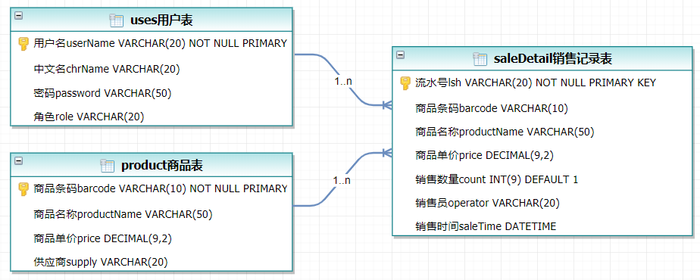

## 2.3 UML类图（Class Diagram）

对于用户功能模块，共设计如下6个类。

* 数据库连接类DatabaseConnection：连接数据库并获取连接对象，关闭连接对象。
* VO实体类User：与数据库结构进行映射的类。主要由属性，setter, getter方法组成，VO类中的属性与表中的字段相对应，每一个VO类的对象都表示表中的每一条记录
* DAO接口IUserDAO：主要定义操作的接口，定义一系列数据库的原子性操作，例如增删改查（通常称为CRUD）等。
* DAO实现类UserDAOImpl：DAO接口的真实实现类，主要完成具体数据库操作，但不负责数据库的打开和关闭。
* DAO工厂类DAOFactory：通过工厂类取得一个DAO的实例化对象
* 业务逻辑实现类UserService：对于数据层的原子操作进行整合。还要负责数据库的打开与关闭（不管是否出异常，数据库都要关闭）
* *******************：

各类的结构及类之间的关系如图所示：

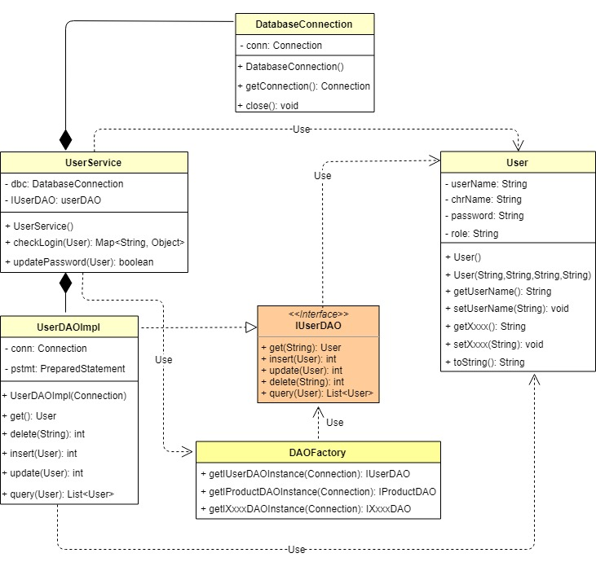

## 2.5 UML活动图（Activity Diagram）

### 2.5.1 登陆

注册账号，登录进入主页面

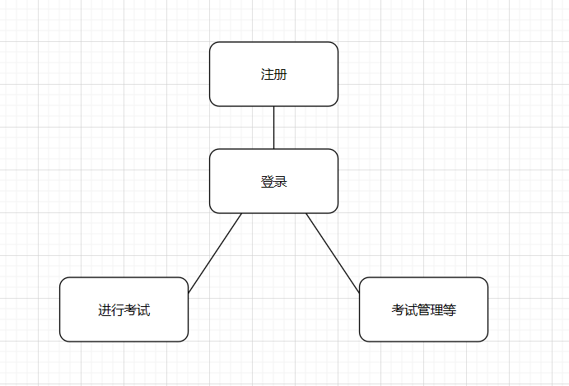

**2.5.2 题库管理**

# 选择单独某题进行修改，也可单独/批量删除或者增加题目

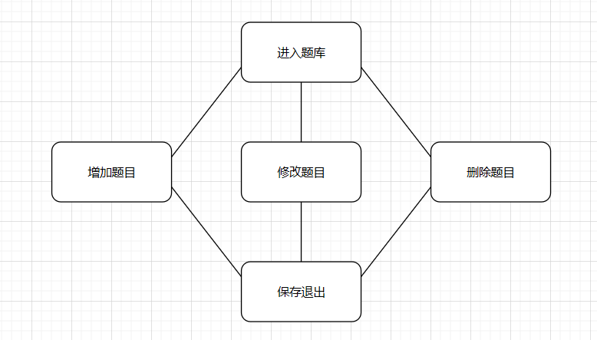

**2.5.3 考试管理**

选择预设好的试卷或者即时生成试卷

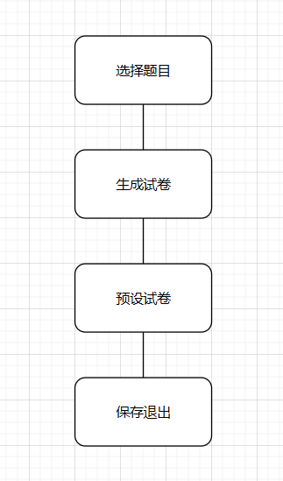

**2.5.4 成绩统计**

查看学生成绩的相关数据

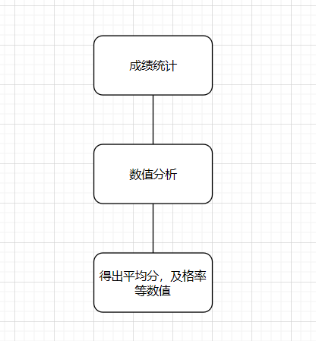

# 3 系统实现

## 3.1 项目结构

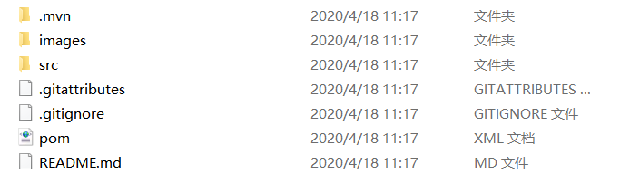

**4 系统测试**

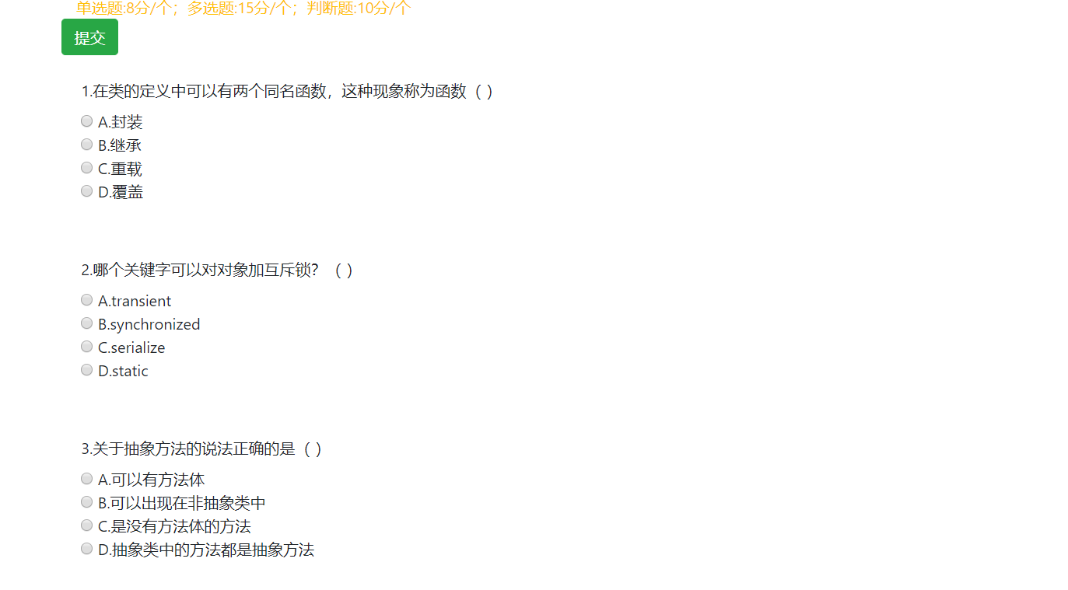

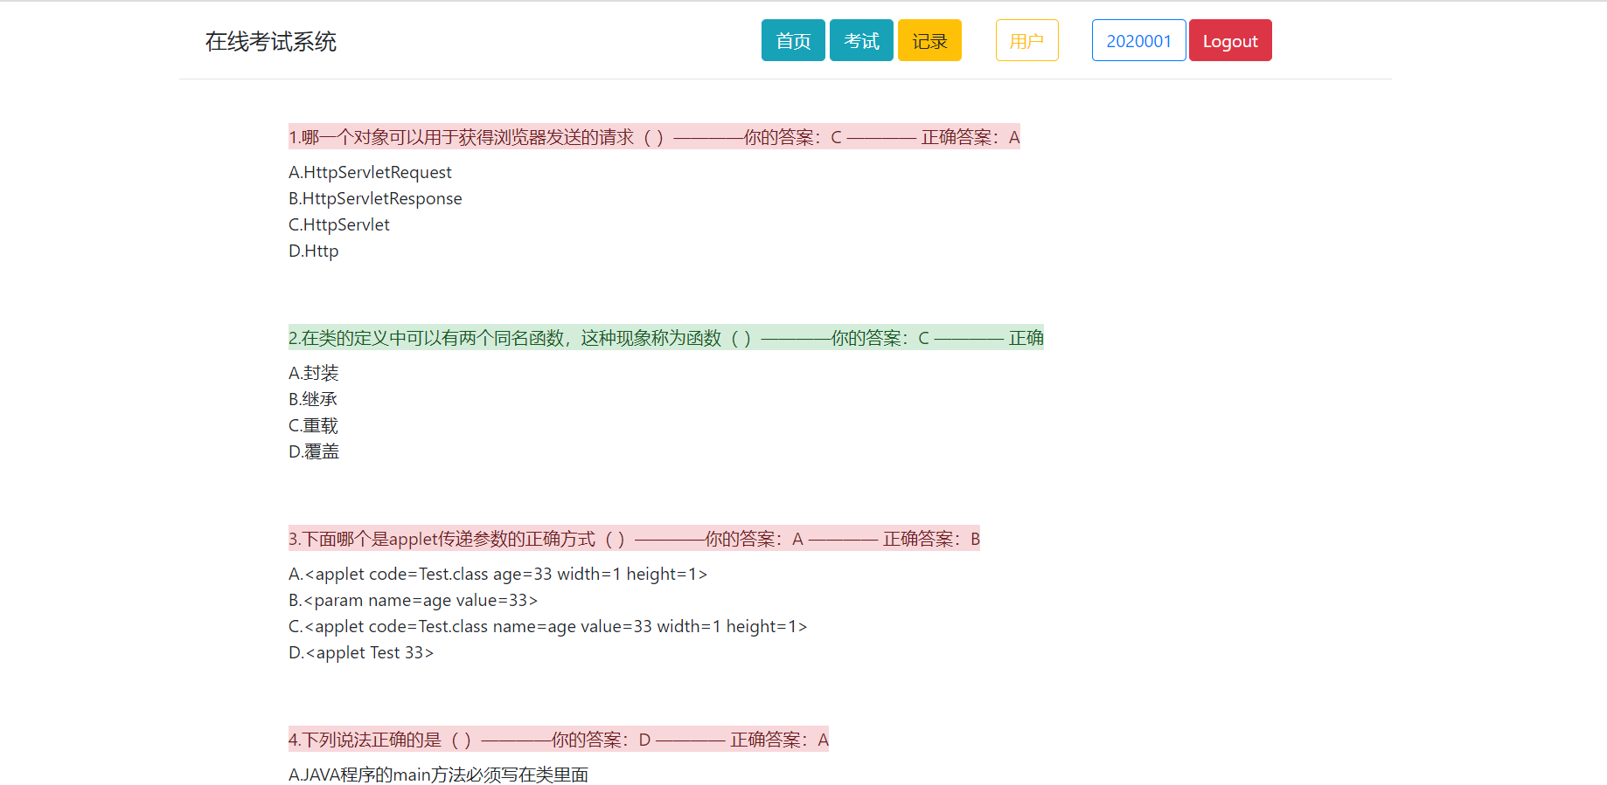

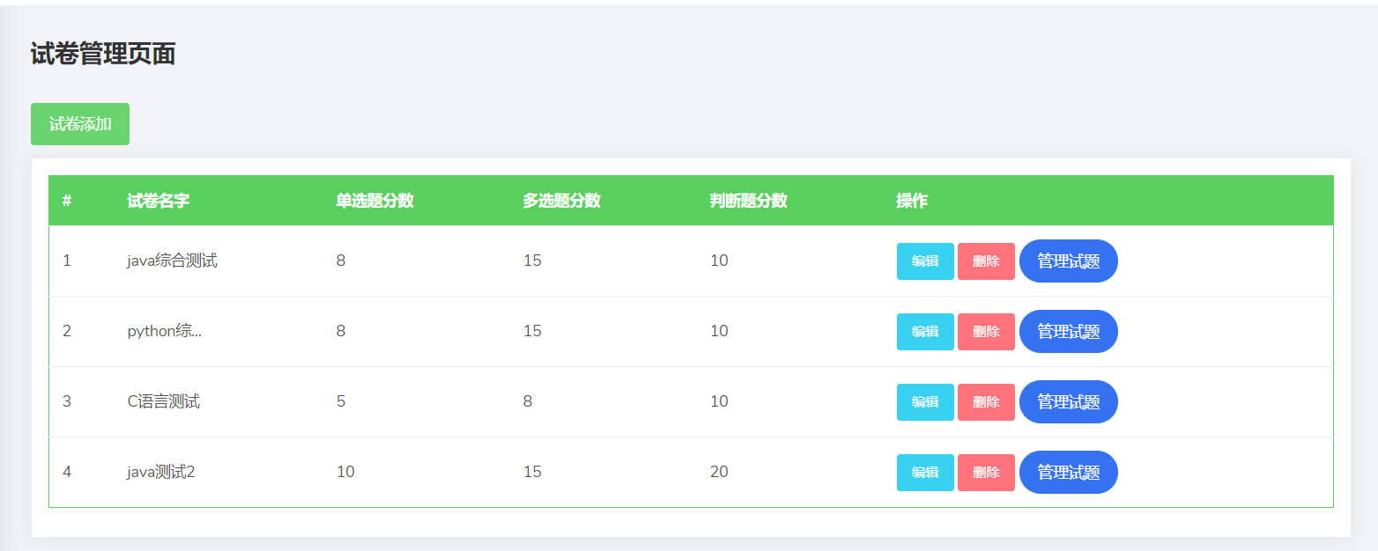

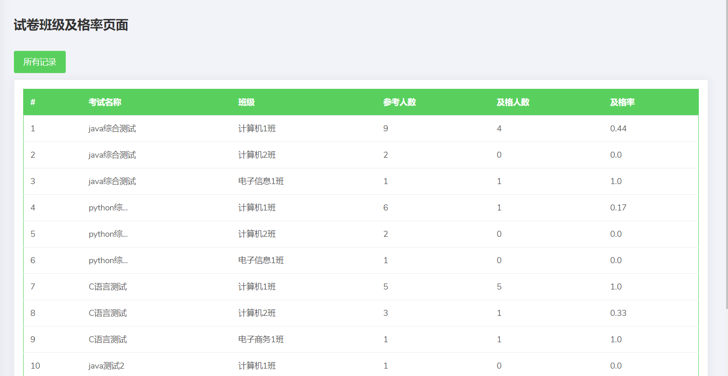

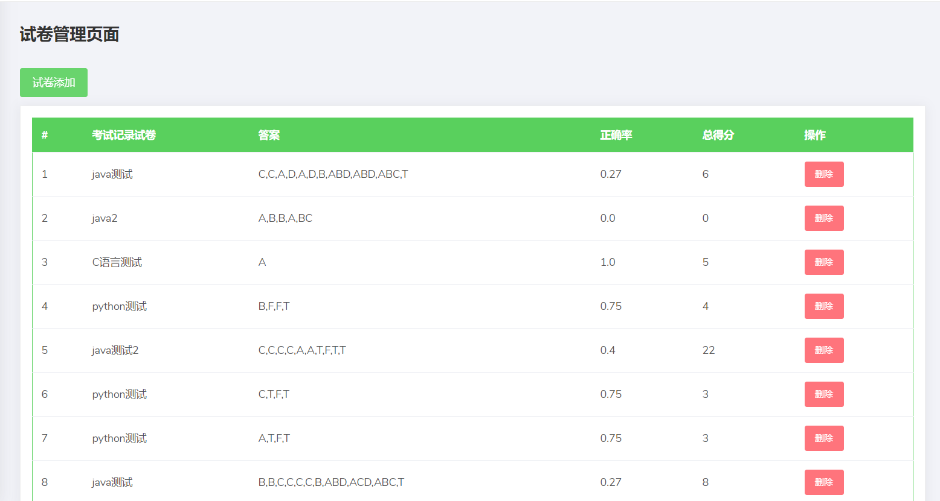

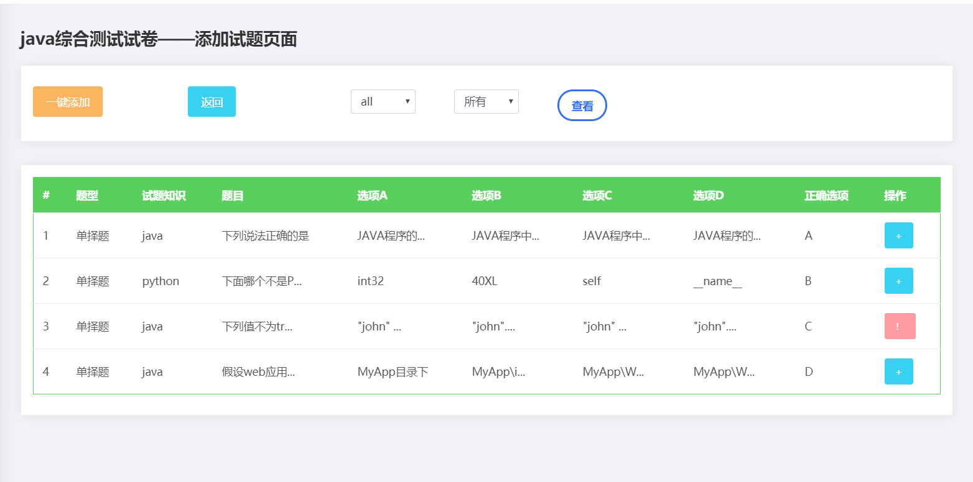

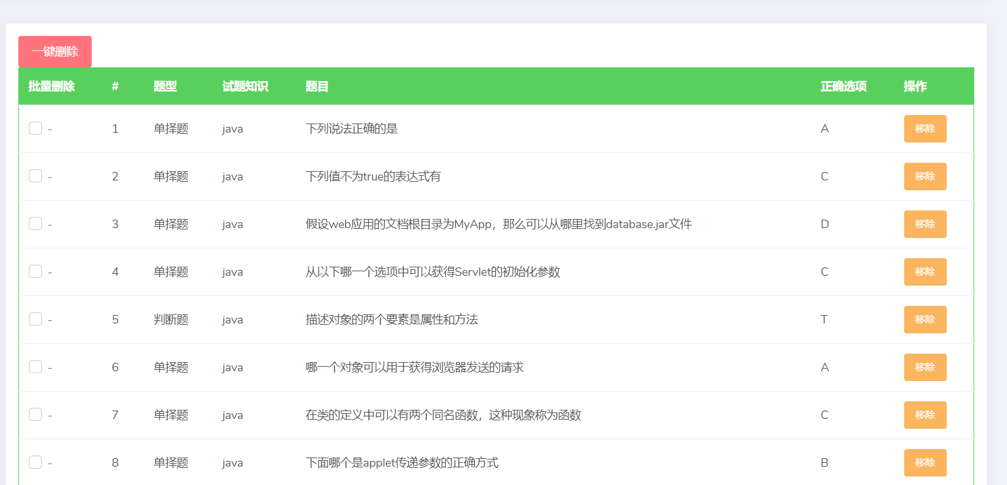

# 5 系统总结

主要问题就是知识掌握的还是不够熟练，导致完成作业时困难还是很多的，代码这东西还是要自己多动手练习练习，自己还是实践少了，不能仅仅停留在java表层，不是抄书上的例子运行出结果就可以，还是要有耐心去琢磨、调试、改动。

这门课程的收获就是又多学习了一门编程语言，开辟了一个新的知识天地，也希望自己在这之后能够继续学习下去，能让编程能力提升。

自评成绩：75

感谢老师在这段时间对我们的悉心教导，老师辛苦了！