The goal of this project is to create a model that recognizes fruits and vegetables among 36 different types of fruits and vegetables. I worked on a raw RGB dataset available on the kaggle platform available below:

https://www.kaggle.com/datasets/kritikseth/fruit-and-vegetable-image-recognition?resource=download

Context
(from kaggle)
This dataset contains images of the following food items:
- fruits- banana, apple, pear, grapes, orange, kiwi, watermelon, pomegranate, pineapple, mango.
- vegetables- cucumber, carrot, capsicum, onion, potato, lemon, tomato, raddish, beetroot, cabbage, lettuce, spinach, soy bean, cauliflower, bell pepper, chilli pepper, turnip, corn, sweetcorn, sweet potato, paprika, jalepeño, ginger, garlic, peas, eggplant.
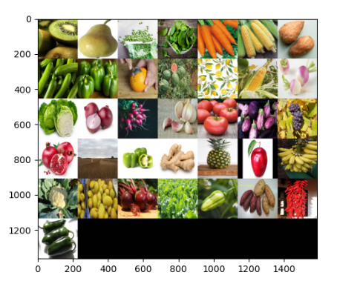

Content
(from kaggle)
This dataset contains three folders:
- train (100 images each) = 3600 images
- test (10 images each) = 360 images
- validation (10 images each) = 360 images
The images are of very different resolutions from each other:

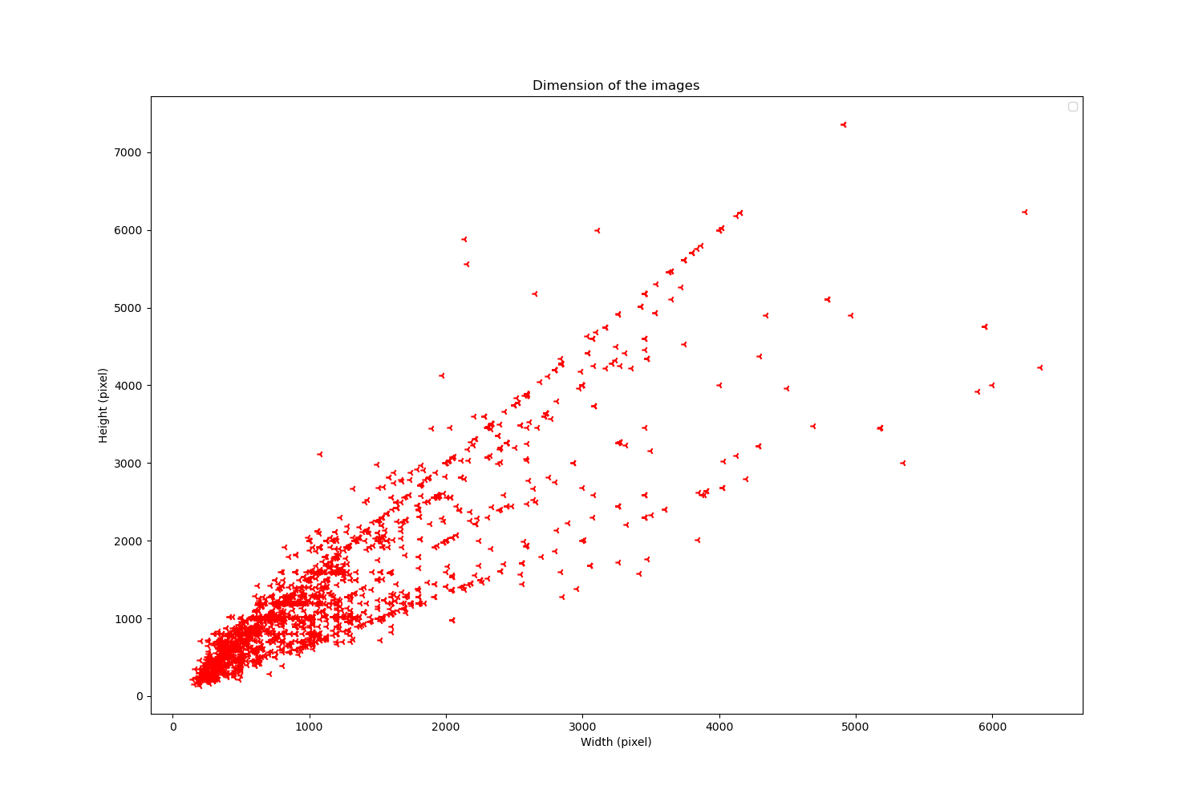
This data was initially present in 3 different directories (test, training and validation) without any csv file.
In order to facilitate the processing of these images, I have to centralize them in a single folder, from which I can process them by creating new datasets of normalized characteristics.
It is also at this step that I mixed the photos, initially extracted by label. It turns out that the data in validation set and testing are almost the same. That’s why, randomize datas are necessary in order to prevent problem during comparaison of my result from my model with the testing set.
The dataset_creation.py file allows me to create a csv file that groups and mixes the names of the photos as well as their respective labels. Their labels are defined from the name of the folder from which they initially comed from.
Then, manually I merged the different datasets by merging the csv files and grouping all the photos in the same folder.
At this stage, the label remains the name of the target fruit or vegetable in text format.
Once the photos are centralized, I normalized :
- the colorimetry
- the resolutions
- the dimensions.
The dataset_normalisation.py file aims to fulfill this objective. These images are then saved in 2 separate folders:
- train dataset : 80%
- test testdataset: 20%
After processing, you will find below sample of 5 photos respectively in
- 24x24 black and white
- 100 x 100 RGB
- 250 x 250 black and white with contrast
For example the Dataset_full_227_227_RGB folder contains all images of 227x227 dimensions in RGB format.

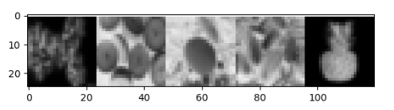

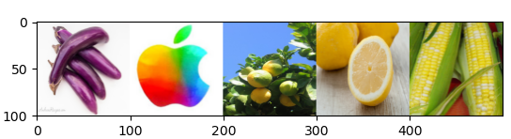

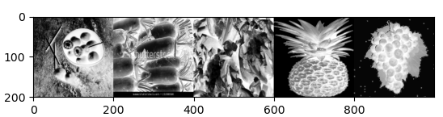

I used matplotlib to display multiple images at once. After converting the normalized images into a matrix, I concatenated the row and column images before displaying the whole (cf. function_dataset.py).

My final dataset is thus composed of a number of images evenly distributed by class:

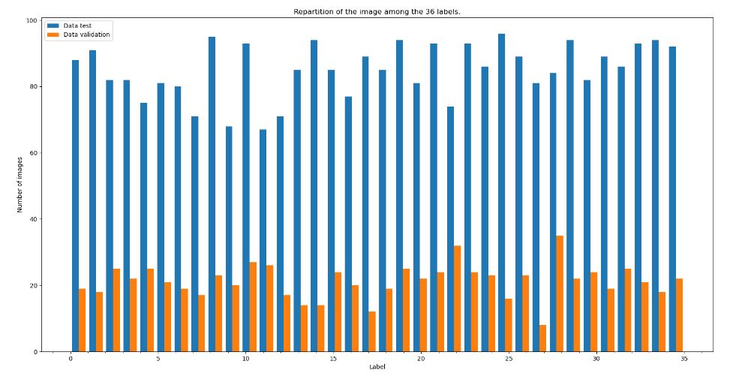

To analyze these photos, I base myself on a system of convolutional neural networks (CNN), on the same architecture as that of Alexnet which has shown its effectiveness for similar tasks.

Type | Number of convolutions | Size of the image | Core / value | Padding/stride | Activation
Conv2D | 96 | 227 x 227 | 11, 11 | Same / 4 | Relu
Pooling |  | 55 x 55 | 3, 3 | Valid / 2
Conv2D | 256 | 27 x 27 | 5, 5 | Same / 1 | Relu
Pooling |  | 13 x 13 | 3, 3 | Valid / 2
Conv2D | 384 | 13 x 13 | 3, 3 | Same / 1 | Relu
Conv2D | 384 | 13 x 13 | 3, 3 | Same / 1 | Relu
Conv2D | 256 | 13 x 13 | 3, 3 | Same / 1 | Relu
Pooling |  | 6 x 6 | 3, 3 | Valid / 2
Dense | 4096 |  |  |  | Relu
Dropout |  |  | 0,3
Dense | 4096 |  |  |  | Relu
Dropout |  |  | 0,3
Dense | 36 |  |  |  | sigmoid

The Dataset_normalisation.py file also contains the function which extracts the data from my normalized dataset in order to make them readable for my neural network (transforms the images into a matrix). It is at this level that the labels are transformed from text name format to Onehot vector. The correspondence between text and vector is kept in a csv format dictionary (dictionary_label.csv)

Afin d’optimiser mon modele un specifique work flow est mis en place,
In order to optimize my model a specific work flow is set up,
The model is trained many times over a variable number of epochs depending on the learning rate used. I have therefore widely used callbacks to resume my training in order to optimize them.
I also followed my training with tensorboard (in order to easily visualize and prevent overlearning).

I explored the different possibilities by varying:
- The resolution of the dataset
- Colorimetry
- The models (notably on the completely connected part)
- The labeling method: (an integer between 0 and 35 VS onehotvector of dimension 36)
- Activation layers (Relu/leakyRelu)
- Optimizer: Adammax, RSMprop, Adam
- Weight initialization methods
- The regularization of the model (l1, l2 or drop out between 30% and 50% for Dense layers
- The batch size
- The learning rate

In particular, I wrote functions allowing to enter lists of parameters to come out of them lists of combinations of unique parameters to train my network. This facilitates the exploration of the various optimal parameters, by carrying out numerous simulations in sequence. This is the Mutli_learning.py file. An example result is shown below to estimate the optimal image size:

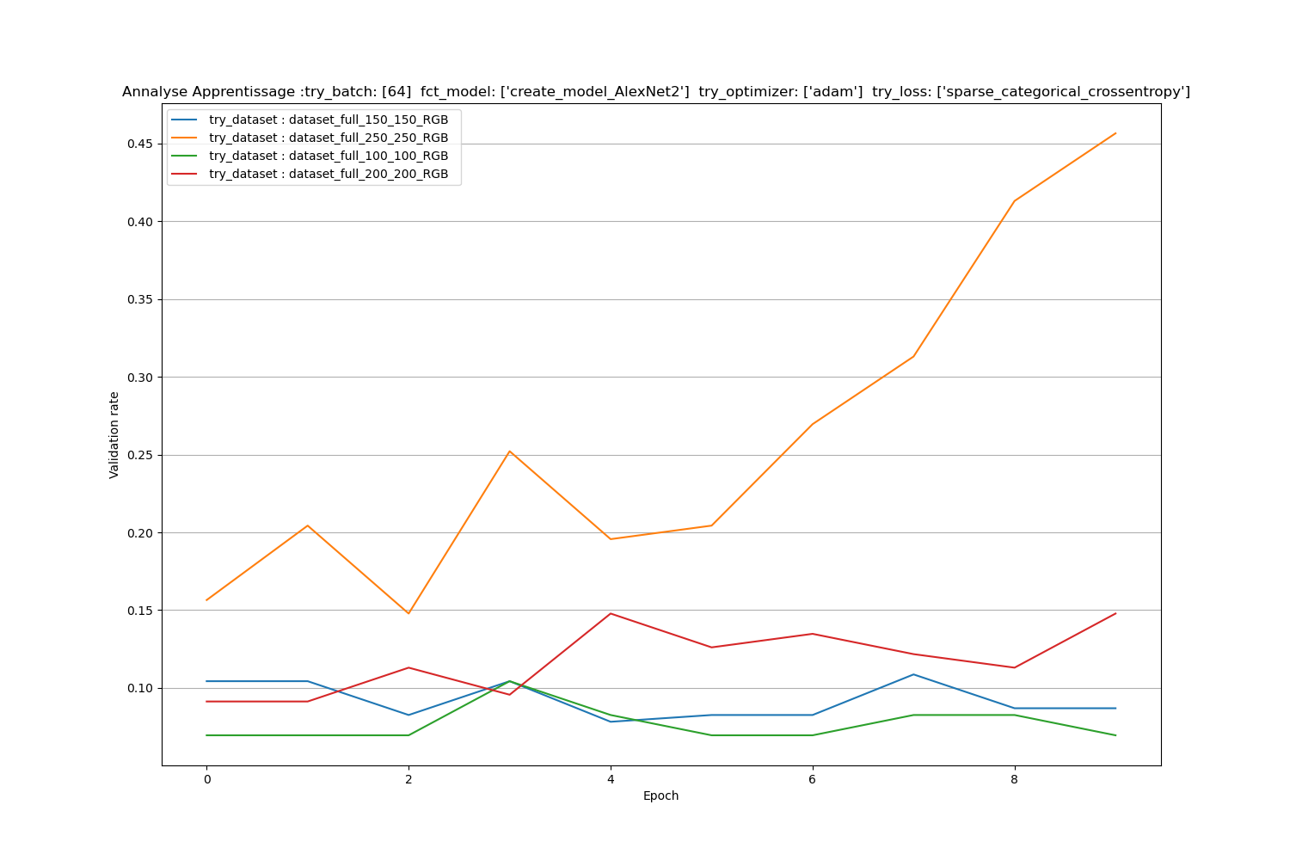
This result is not surprising since the network was designed to initially analyze images of the size 227 x 227.

I also set up a cross validation which turned out to be useless because my basic network is quite long to train. So I deleted it

Despite many attempts, I had great difficulty training a model that don’t exceed 45% accuracy on the test sample.

The best set of parameters turned out to be images in
- RGB 227x227
- with a little dropout
- regularization l1 and l2, because my network over-adjusted quickly
- Adam has proven to be the most effective in optimizing my loss function

Score on the testing datset : 0.474509805440902%

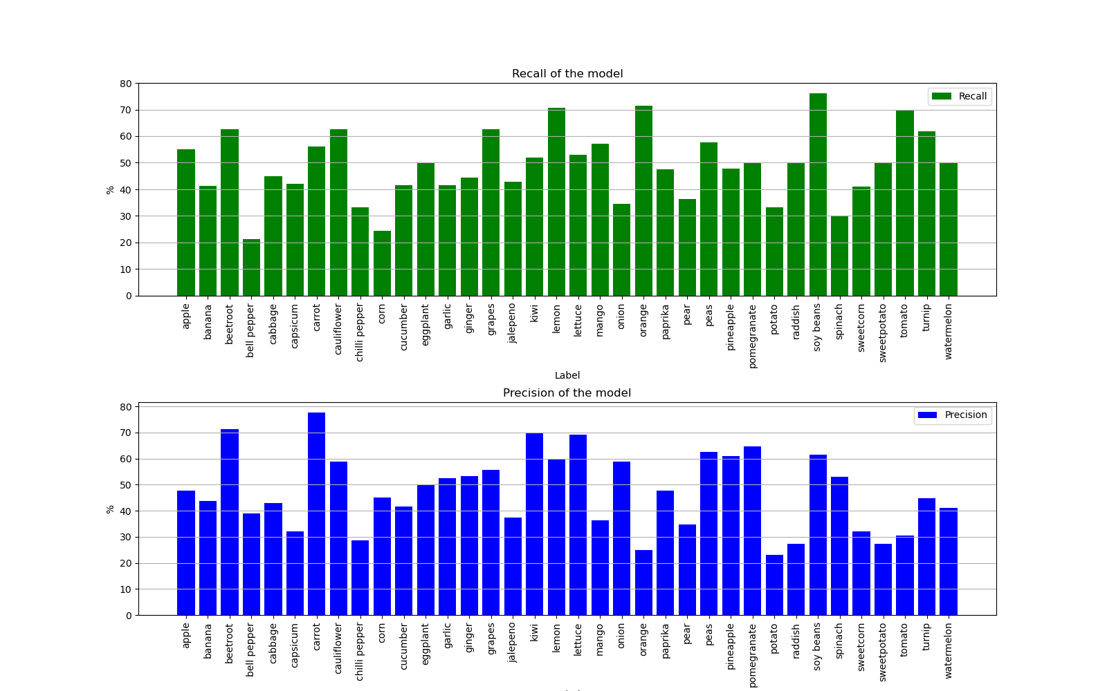
Below an analysis of the precision and the recall per class shows us that even if the precision and the callback are not high, they are at least homogeneous between the different classes.

My training took place on 3000 data for 36 classes. This corresponds to less than 90 images per class. The dataset is therefore probably one of the reasons for the low recall of the model. It would be worth retraining it with more data.

