Validation Report
OncoPlotter (Version 0.5.1)
Ryo Nakaya
03APR2026
General Information
OncoPlotter is a SAS macro package designed to easily generate key figures typically required in oncology clinical trials. It supports Kaplan-Meier plots, Swimmer plots, Waterfall plots, Forest Plot and Spider Plot ready for both clinical study reports and publications. The package also provides dummy datasets, allowing you to test each macro without preparing your own data. This makes it especially useful for both beginners and advanced users in the oncology data field.
Validation Environment
OS: WIN
SAS: 9.04.01M7P080520
Required Packages: -
Execution Datetime: 03APR2026:16:09:19
Authors
[Yutaka Morioka],[Hiroki Yamanobe],[Ryo Nakaya]
Requirements
- %kaplan_meier_plot :
- Creates survival curves by treatment group
- Displays censoring marks and number-at-risk below the plot
- Fully customizable axis labels, line colors, patterns, and plot titles
- Option to output generated SAS code via the `MFILE` option
- Includes internal dummy dataset (`dummy_adtte`) for quick testing
- %swimmer_plot :
- Visualizes individual treatment durations, responses, ongoing treatments, and death
- Accepts ADSL and ADRS-format input datasets
- Color grouping by disease stage and response categories (e.g., CR, PR, SD, PD)
- Allows customization of plot size, subjects per page, and theme colors
- Supports predefined color styles like `OncoPlotter`, `Kyoto`, `Osaka`, and more
- %waterfall_plot :
- Displays percentage tumor size change for each subject as bars
- Bars are grouped and color-coded by response or treatment group
- Includes threshold lines for PR/PD classification
- Suitable for visualizing best overall response
- %forest_plot :
- Create a forest plot using `PROC SGPLOT`.
- Draw point estimates and confidence intervals.
- Optional reference line and code generation (mprint dump) are supported.
- Includes internal dummy dataset (`dummy_forest_test`) for quick testing.
- %spider_plot :
- Create a spider (subject profile) plot using `PROC SGPLOT`.
- Draw a series line (with markers) for each subject across the specified X variable and Y variable.
- Optional reference lines, custom axis labels/values, and code generation (mprint dump) are supported.
- Includes internal dummy dataset (`dummy_spider`) for quick testing.
Validation Records

Test Description | Result | Comments
(%kaplan_meier_plot)[test01] Default parameter test | CHECK | MP_ASSERTGRAPH: An output graph to be visually reviewed. See appendix.
(%kaplan_meier_plot)[test02] Help Example parameter test | CHECK | MP_ASSERTGRAPH: An output graph to be visually reviewed. See appendix.
(%swimmer_plot)[test01] Default parameter test (1/3) | CHECK | MP_ASSERTGRAPH: Two graphs to be visually compared. See appendix.
(%swimmer_plot)[test01] Default parameter test (2/3) | CHECK | MP_ASSERTGRAPH: Two graphs to be visually compared. See appendix.
(%swimmer_plot)[test01] Default parameter test (3/3) | CHECK | MP_ASSERTGRAPH: Two graphs to be visually compared. See appendix.
(%swimmer_plot)[test02] Standard parameters test (1/2) | CHECK | MP_ASSERTGRAPH: Two graphs to be visually compared. See appendix.
(%swimmer_plot)[test02] Standard parameters test (2/2) | CHECK | MP_ASSERTGRAPH: Two graphs to be visually compared. See appendix.
(%swimmer_plot)[test03] colorStyle=Salmon Vertically oriented (portrait) chart (1/2) | CHECK | MP_ASSERTGRAPH: Two graphs to be visually compared. See appendix.
(%swimmer_plot)[test03] olorStyle=Salmon Vertically oriented (portrait) chart (2/2) | CHECK | MP_ASSERTGRAPH: Two graphs to be visually compared. See appendix.
(%swimmer_plot)[test04] colorStyle=Kawaii interval=Day parameter test (1/2) | CHECK | MP_ASSERTGRAPH: Two graphs to be visually compared. See appendix.
(%swimmer_plot)[test04] colorStyle=Kawaii interval=Day parameter test (2/2) | CHECK | MP_ASSERTGRAPH: Two graphs to be visually compared. See appendix.
(%swimmer_plot)[test05] colorStyle=Kyoto interval=week (1/2) | CHECK | MP_ASSERTGRAPH: Two graphs to be visually compared. See appendix.
(%swimmer_plot)[test05] colorStyle=Kyoto interval=week (2/2) | CHECK | MP_ASSERTGRAPH: Two graphs to be visually compared. See appendix.
(%swimmer_plot)[test06] colorStyle=Osaka interval=Day (1/2) | CHECK | MP_ASSERTGRAPH: Two graphs to be visually compared. See appendix.
(%swimmer_plot)[test06] colorStyle=Osaka interval=Day (2/2) | CHECK | MP_ASSERTGRAPH: Two graphs to be visually compared. See appendix.
(%swimmer_plot)[test07] colorStyle=null Individually specify the colors and symbols (1/2) | CHECK | MP_ASSERTGRAPH: Two graphs to be visually compared. See appendix.
(%swimmer_plot)[test07] colorStyle=null Individually specify the colors and symbols (2/2) | CHECK | MP_ASSERTGRAPH: Two graphs to be visually compared. See appendix.
(%swimmer_plot)[test08] groupvar colorStyle=null Individually specify the colors and symbols (1/3) | CHECK | MP_ASSERTGRAPH: Two graphs to be visually compared. See appendix.
(%swimmer_plot)[test08] groupvar colorStyle=null Individually specify the colors and symbols (2/3) | CHECK | MP_ASSERTGRAPH: Two graphs to be visually compared. See appendix.
(%swimmer_plot)[test08] groupvar colorStyle=null Individually specify the colors and symbols (3/3) | CHECK | MP_ASSERTGRAPH: Two graphs to be visually compared. See appendix.

Additional comments
NA
References
https://github.com/PharmaForest/oncoplotter

Appendix

Previous | Current
 | 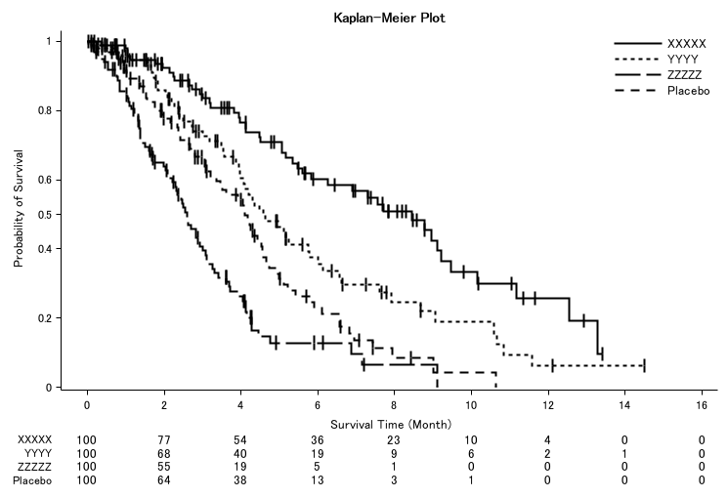 (%kaplan_meier_plot) [test01]
 | 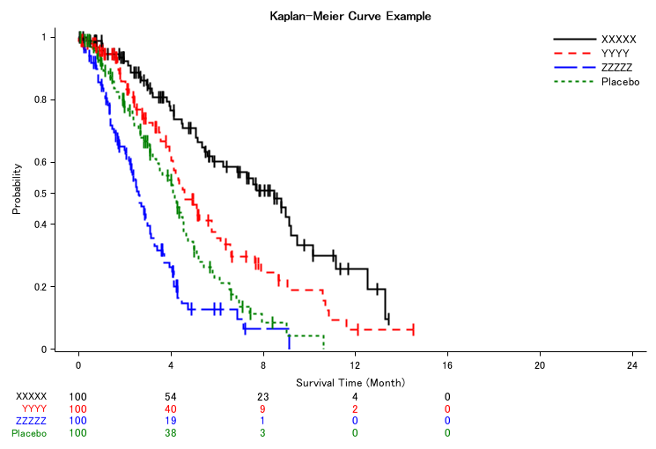 (%kaplan_meier_plot) [test02]
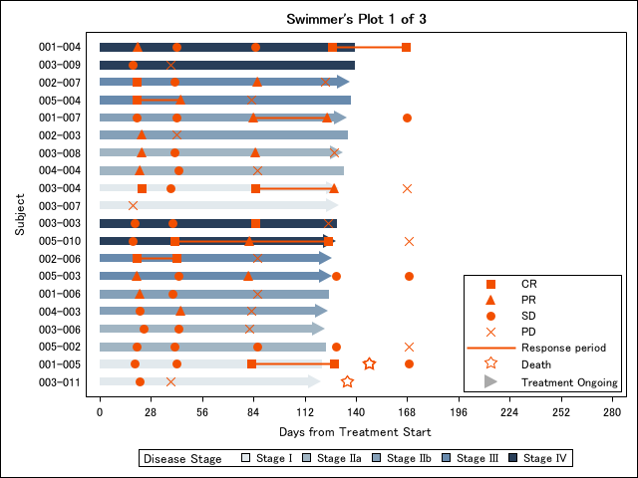 (%swimmer_plot) [test01] | (%swimmer_plot) [test01]
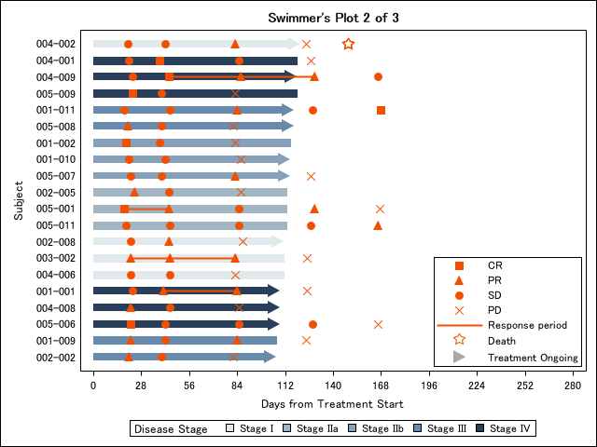 (%swimmer_plot) [test01] | (%swimmer_plot) [test01]
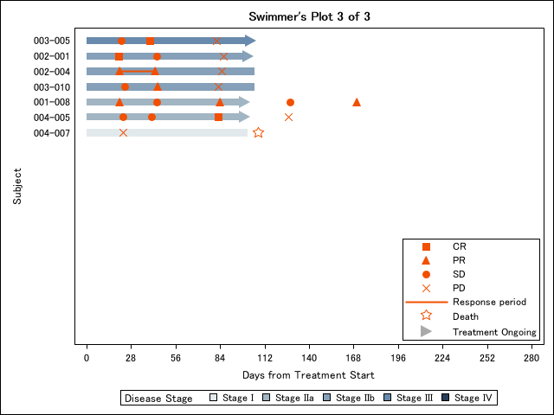 (%swimmer_plot) [test01] | (%swimmer_plot) [test01]
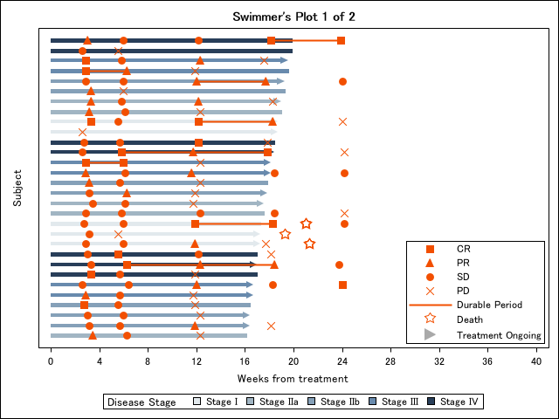 (%swimmer_plot) [test02] | (%swimmer_plot) [test02]
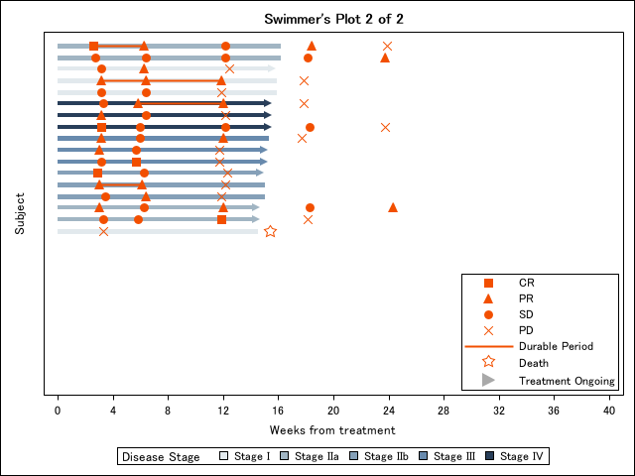 (%swimmer_plot) [test02] | (%swimmer_plot) [test02]
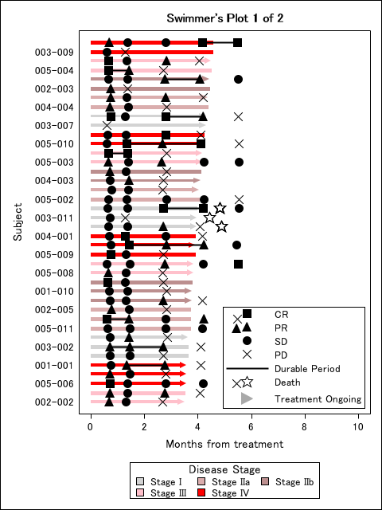 (%swimmer_plot) [test03] | (%swimmer_plot) [test03]
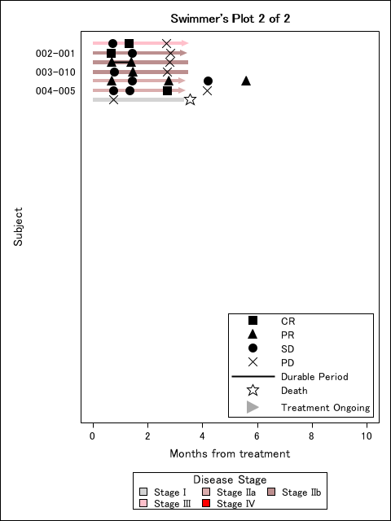 (%swimmer_plot) [test03] | (%swimmer_plot) [test03]
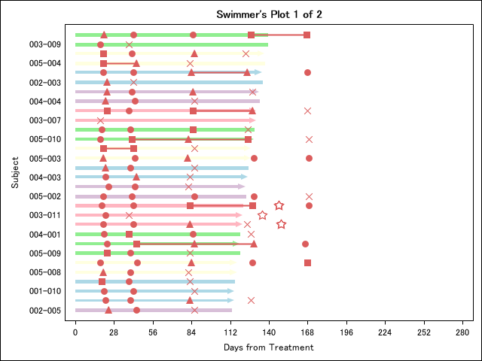 (%swimmer_plot) [test04] | (%swimmer_plot) [test04]
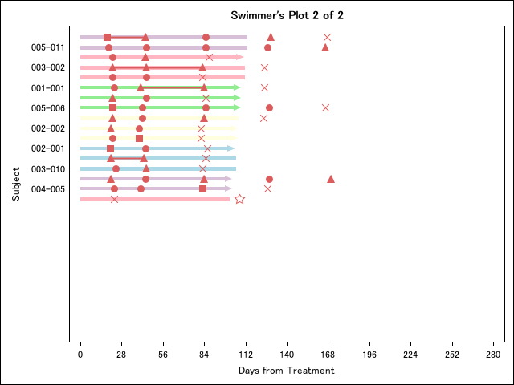 (%swimmer_plot) [test04] | (%swimmer_plot) [test04]
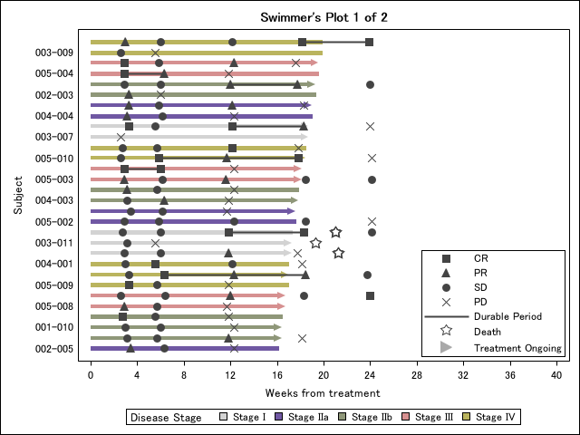 (%swimmer_plot) [test05] | (%swimmer_plot) [test05]
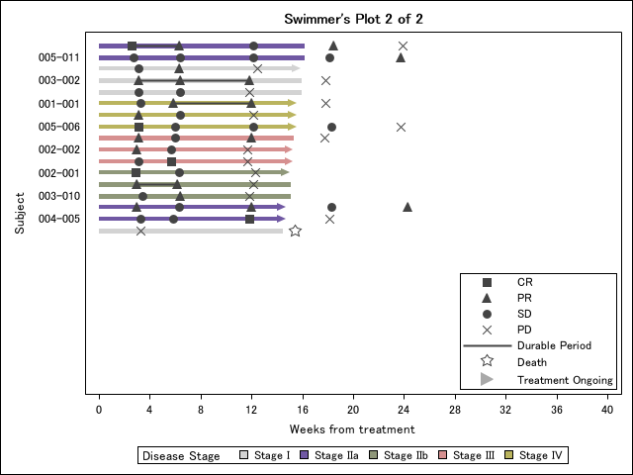 (%swimmer_plot) [test05] | (%swimmer_plot) [test05]
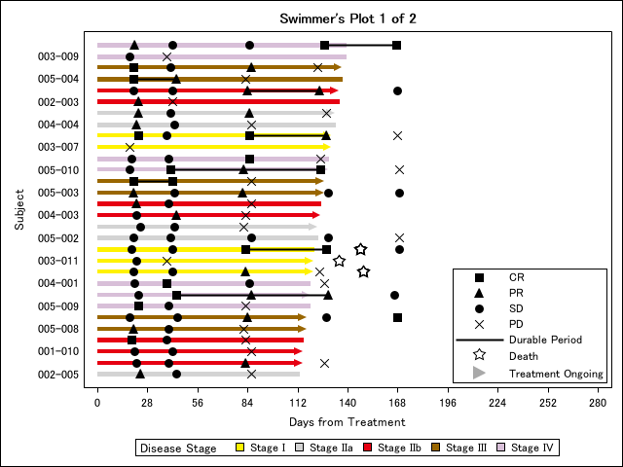 (%swimmer_plot) [test06] | (%swimmer_plot) [test06]
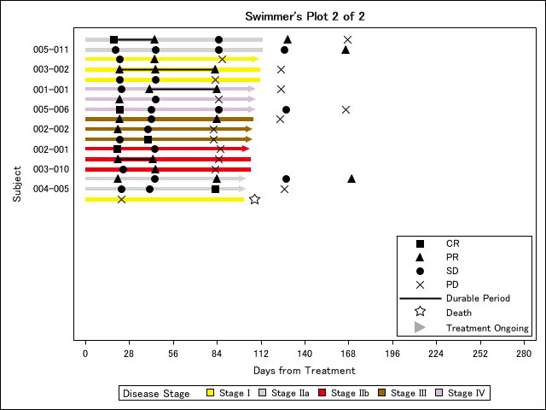 (%swimmer_plot) [test06] | (%swimmer_plot) [test06]
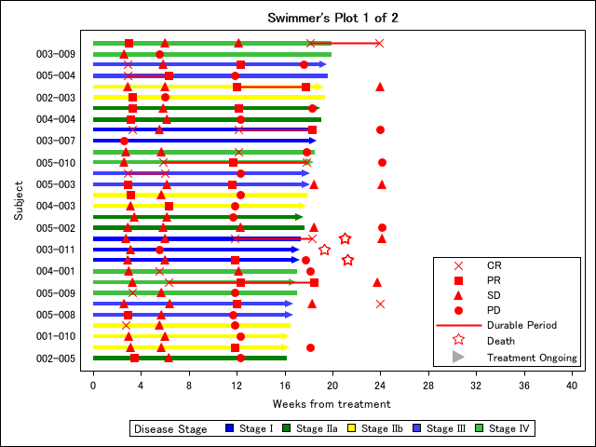 (%swimmer_plot) [test07] | (%swimmer_plot) [test07]
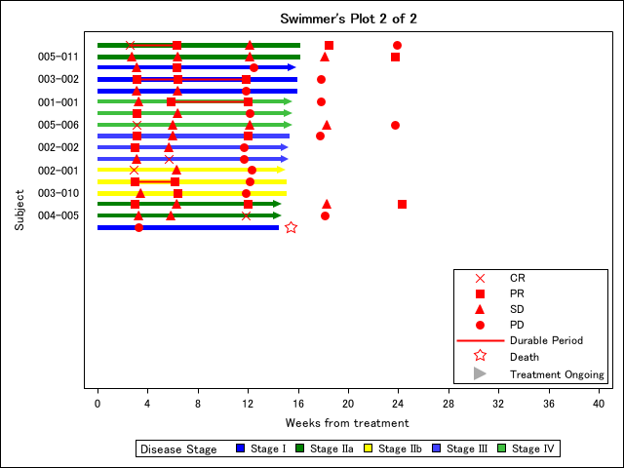 (%swimmer_plot) [test07] | (%swimmer_plot) [test07]
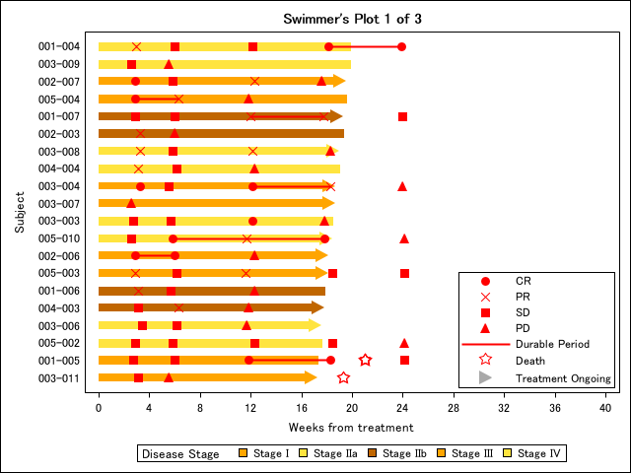 (%swimmer_plot) [test08] | (%swimmer_plot) [test08]
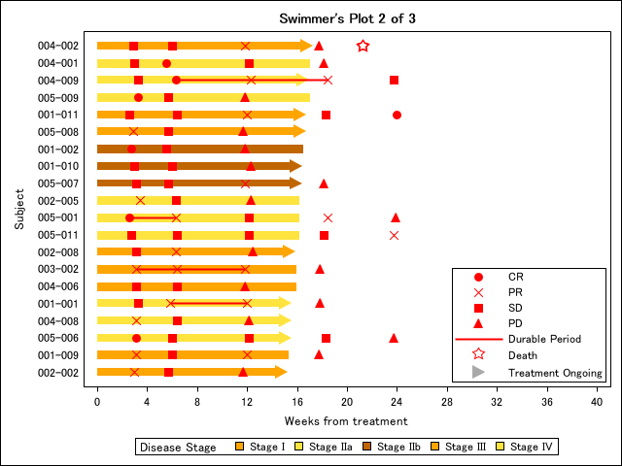 (%swimmer_plot) [test08] | (%swimmer_plot) [test08]
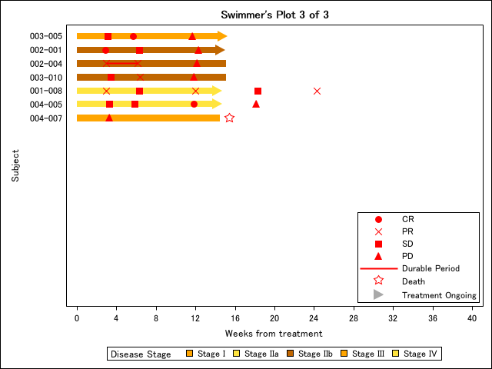 (%swimmer_plot) [test08] | (%swimmer_plot) [test08]

