This is a dummy page that should not be printed. Do not start printing till next page.

UNIT 1
BASIC ARITHMETIC

What is arithmetic?

Arithmetic or arithmetics (from the Greek word arithmētikē which literally means the art of counting) is the oldest and most elementary branch of mathematics, used by almost everyone, for tasks ranging from simple daily counting to advanced science and business calculations. In common usage, the word refers to a branch of (or the forerunner of) mathematics which records elementary properties of certain operations on numbers. Professional mathematicians sometimes use the term higher arithmetic as a synonym for number theory, but this should not be confused with elementary arithmetic.

What will be learned/reviewed in this unit?

- roman numerals
- decimal places
- rounding
- significant figures
- addition, subtraction, multiplication and division of decimals
- parts of a fraction
- addition, subtraction, multiplication and division of fractions
- percentages
- 24 hour clocks
- exponents
- scientific notation
- ratios
- proportions
- dimensional analysis
- 5 step problem solving method

Math is usually taught as all scales and no music.

-- Persis Herold


CHAPTER 1
NUMERAL SYSTEMS USED IN PHARMACY
There are two major number systems used in pharmacy :
- Arabic Numbers – these are the symbols we use every day for enumeration, such as 1, 16, and 1337.
- Roman Numerals – this is a numeral system originating in ancient Rome. Roman numerals are expressed by letters of the alphabet.

The following is a chart showing how to convert back and forth between Arabic numbers and Roman numerals:
i | 1 | xxi | 21 | xli | 41 | lxi | 61 | lxxxi | 81
ii | 2 | xxii | 22 | xlii | 42 | lxii | 62 | lxxxii | 82
iii | 3 | xxiii | 23 | xliii | 43 | lxiii | 63 | lxxxiii | 83
iv | 4 | xxiv | 24 | xliv | 44 | lxiv | 64 | lxxxiv | 84
v | 5 | xxv | 25 | xlv | 45 | lxv | 65 | lxxxv | 85
vi | 6 | xxvi | 26 | xlvi | 46 | lxvi | 66 | lxxxvi | 86
vii | 7 | xxvii | 27 | xlvii | 47 | lxvii | 67 | lxxxvii | 87
viii | 8 | xxviii | 28 | xlviii | 48 | lxviii | 68 | lxxxviii | 88
ix | 9 | xxix | 29 | xlix | 49 | lxix | 69 | lxxxix | 89
x | 10 | xxx | 30 | l | 50 | lxx | 70 | xc | 90
xi | 11 | xxxi | 31 | li | 51 | lxxi | 71 | xci | 91
xii | 12 | xxxii | 32 | lii | 52 | lxxii | 72 | xcii | 92
xiii | 13 | xxxiii | 33 | liii | 53 | lxxiii | 73 | xciii | 93
xiv | 14 | xxxiv | 34 | liv | 54 | lxxiv | 74 | xciv | 94
xv | 15 | xxxv | 35 | lv | 55 | lxxv | 75 | xcv | 95
xvi | 16 | xxxvi | 36 | lvi | 56 | lxxvi | 76 | xcvi | 96
xvii | 17 | xxxvii | 37 | lvii | 57 | lxxvii | 77 | xcvii | 97
xviii | 18 | xxxviii | 38 | lviii | 58 | lxxviii | 78 | xcviii | 98
xix | 19 | xxxix | 39 | lix | 59 | lxxix | 79 | xcix | 99
xx | 20 | xl | 40 | lx | 60 | lxxx | 80 | c | 100
 |  |  |  |  |  |  |  | d | 500
 |  |  |  |  |  |  |  | m | 1000

Most people that have previously learned Roman numerals learned them using all capital letters; but in health care you will usually see them written in lower case letters (although either way is acceptable). Roman numerals consist of a basic set of seven symbols:

I or i 1 C or c 100
V or v 5 D or d 500
X or x 10 M or m 1000
L or l 50

Here is how to count from 1 to 10 using Roman numerals:

I or i for one
II or ii for two
III or iii for three
IV or iv for four*
V or v for five
VI or vi for six
VII or vii for seven
VIII or viii for eight
IX or ix for nine
X or x for ten

* four strokes seemed like too many to the Romans, so they limited letter repetition to three

The principles for reading Roman numerals are:

- A letter repeated once or twice repeats its value that many times (XXX = 30, CC = 200, etc.).

- One or more letters that are placed after another letter of greater value increases the greater value by the amount of the smaller(VI = 6, LXX = 70, MCC = 1200, etc).

- A letter placed before another letter of greater value decreases the greater value by the amount of the smaller (IV = 4, XC = 90, CM = 900, etc.).*

* Rules regarding Roman numerals often state that a symbol representing 10^{x} may not precede any symbol larger than 10^{x+1}. For example, C cannot be preceded by I or V, only by X (or, of course, by a symbol representing a value equal to or larger than C). Thus, one should represent the number "ninety-nine" as XCIX, not as the "shortcut" IC

Convert the following Roman numerals to Arabic numbers:  - VII  - xxii  - XXVII  - iv  - XIX  - xiv  - XII  - ii  - XXIV  - vi  - IV  - iii | Convert the following Arabic numbers to Roman numerals:  - 28  - 13  - 17  - 15  - 9  - 12  - 50  - 41  - 89  - 2007  - 1776  - 1337
1) 7 2) 22 3) 27 4) 4 5) 19 6) 14 7) 12 8) 2 9) 24 10) 6 11) 4 12) 3
13) xxviii 14) xiii 15) xvii 16) xv 17) ix 18) xii 19) l 20) xli 21) lxxxix
22) mmvii 23) mdcclxxvi 24) mcccxxxvii

Worksheet 1-1
Name:

Date:

Convert the following Arabic numerals to Roman numerals:

- 1 =

- 2 =

- 3 =

- 4 =

- 5 =

- 6 =

- 7 =

- 8 =

- 9 =

- 10 =

- 20 =

- 40 =

- 45 =

- 100 =

- 400 =

- 1,000 =

- 900 =

- 69 =

- 24 =

- 1,999 =

Convert the following Roman numerals to Arabic numerals:

- ix =

- xviii =

- xxiv =

- xxxvi =

- iii =

- ccxl =

- lv =

- dlv =

- mcxi =

- cmxcix =

- iv =

- vii =

- xii =

- xvi =

- xxii =

- xlii =

- xxxi =

- mcccxxxvii =

- mmviii =

- mdcclxxxiii =

Worksheet 1-2
Name:

Date:

Perform the indicated operations and record the results in Arabic numbers.

- VII + XXII =
- xxvii – iv =
- XIX – XIV =
- XII × II =
- xxiv ÷ vi =
- IV × III =
Perform the indicated operations and record the results in Roman numerals.

- 5 × 4 =
- 18 + 12 =
- 16 ÷ 4 =
- 4 × 3 =
- 625 ÷ 125 =
- 17 + 14 – 11 + 4 =
- 6 + 3 =
- 20 – 16 + 3 =
Fill in the following multiplication table using Roman numerals.

 | I | II | III | IV | V | VI | VII | VIII | IX | X
I
II
III
IV
V
VI
VII
VIII
IX
X

XXIV

The following pages include a card game that can help students become more comfortable working rapidly with Roman numerals. If you've ever played 24 Game®, the rules are very similar.

How to play:
- First someone will need to use a pair of scissors to cut out their XXIV cards.
- Then, students will need to pair up in groups of three to six.
- Then all the students in a group will look at the card on the top of the pile and try to solve it. In order to solve it you must use all four numbers on the card once and only once. You can use any combination of multiplying, dividing, adding, and subtracting to make the card total '24'.
- After the card is solved, flip the card and work on the other side as a group. Once both sides of the card have been solved, discard it and work on the next card in the deck.

This game is not about who scores the most points, instead it is about working collaboratively to better everyones' understanding of Roman numerals.

example card:

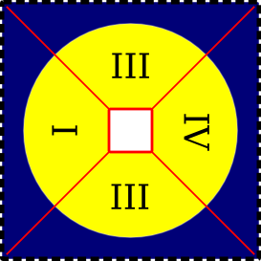
The Roman numerals on this card are III, IV, III, and I which translate into the Arabic numbers 3, 4, 3, and 1. I can solve this card any of the following ways:

(3 × 4) × (3 – 1) = 24

[(3 – 1) × 4] × 3 = 24

(3 + 3) × 4 × 1 = 24

Despite the fact that each card can usually be solved numerous ways, it only needs to be solved once.

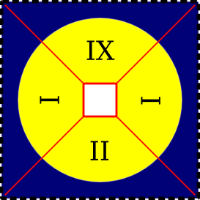

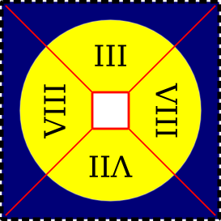
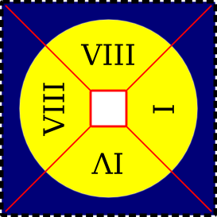

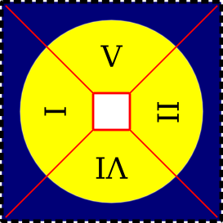
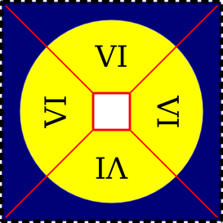

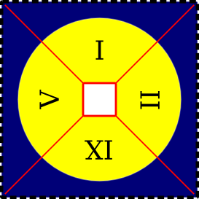
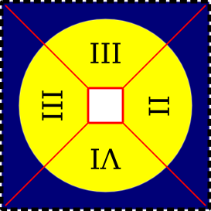

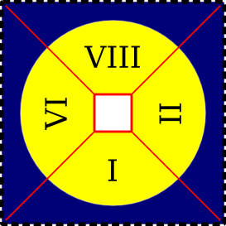
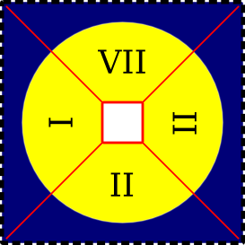

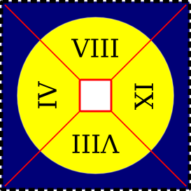
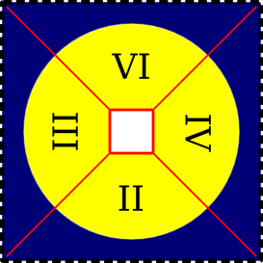

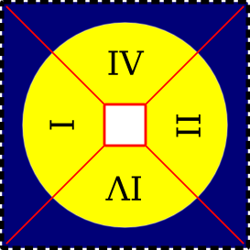
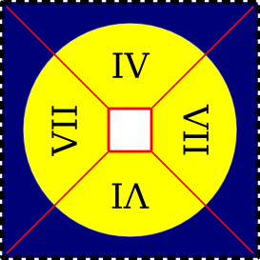

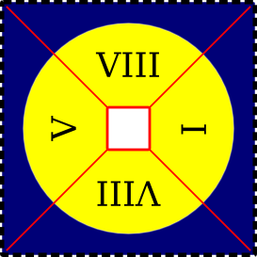
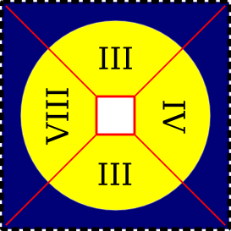

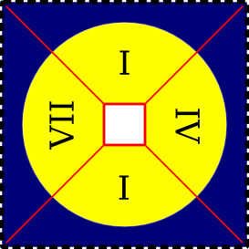
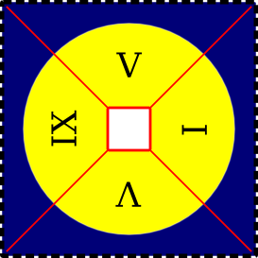

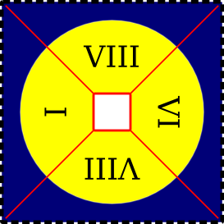
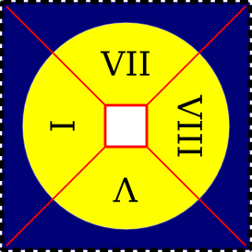

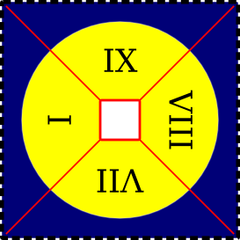
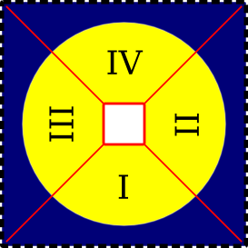

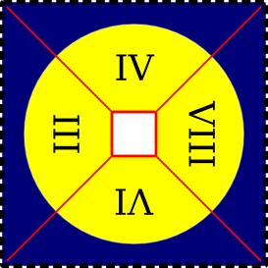
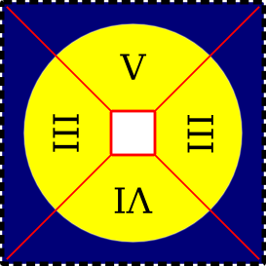

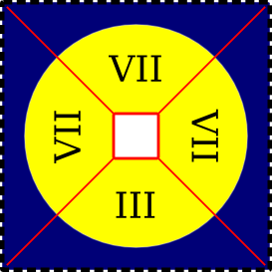
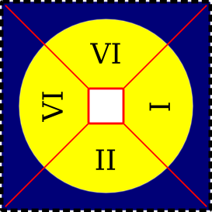

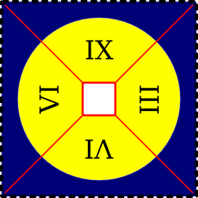
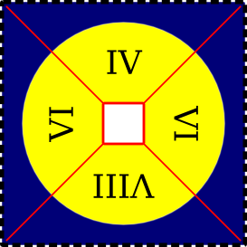

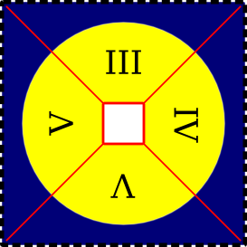
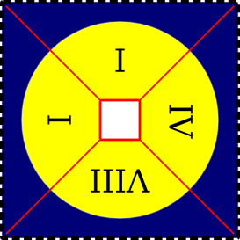

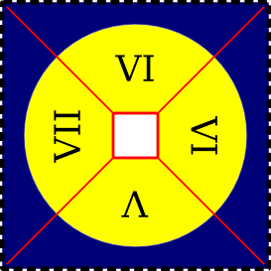
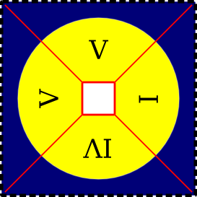

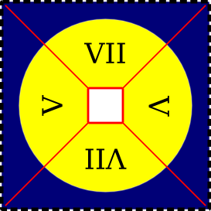
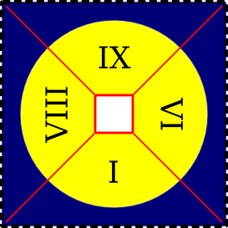

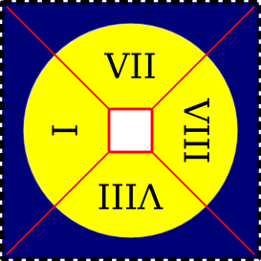
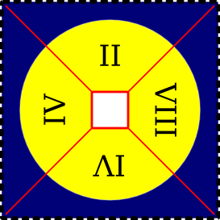

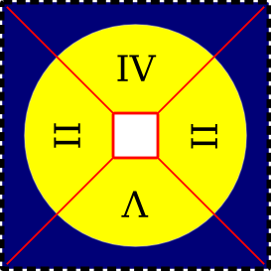
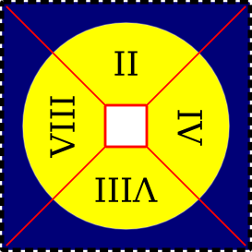

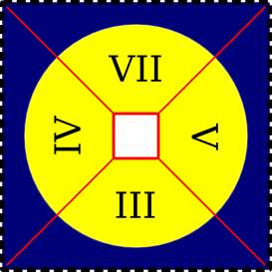
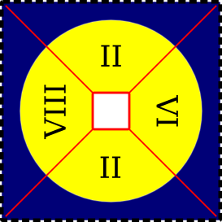

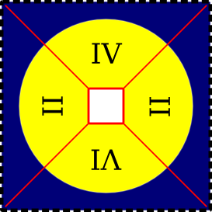
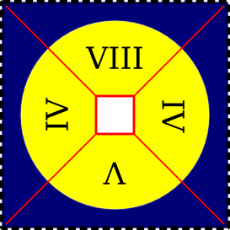

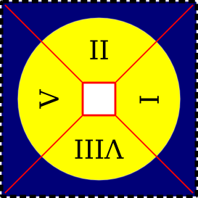
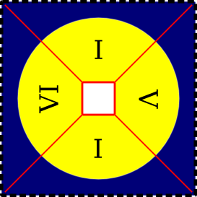

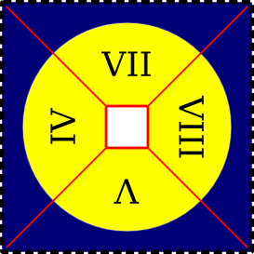
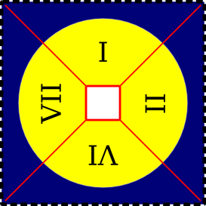

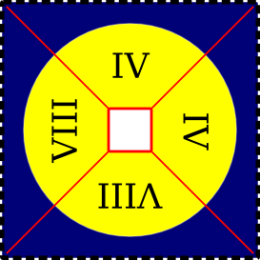
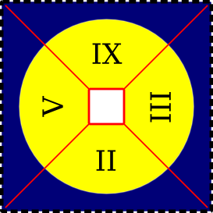

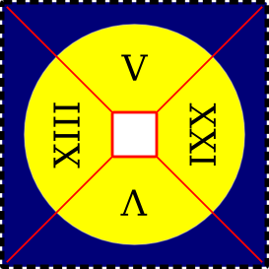
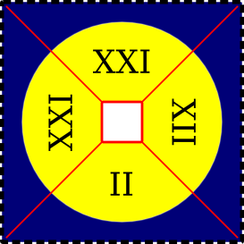

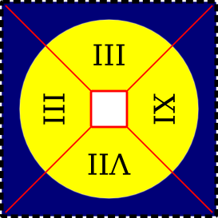
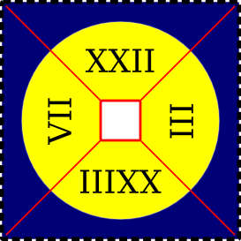

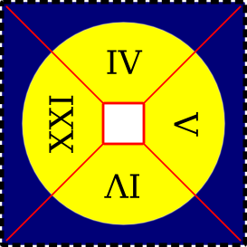
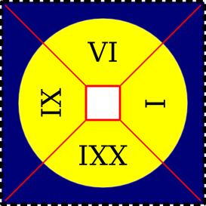


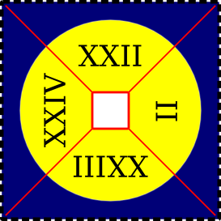

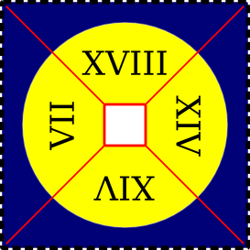
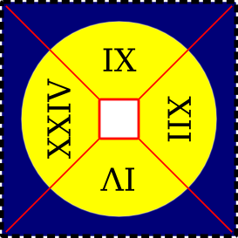

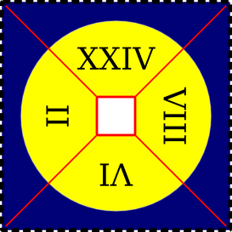
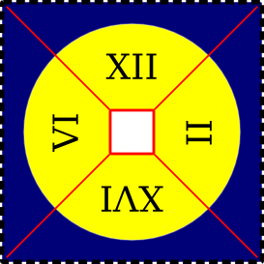

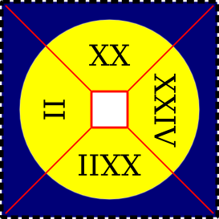
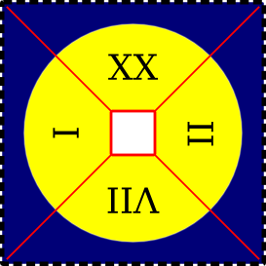

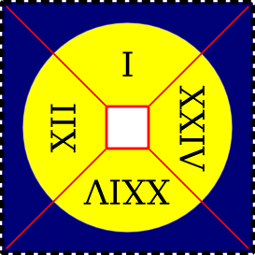
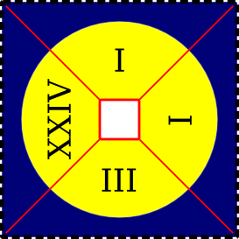

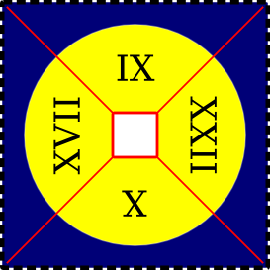
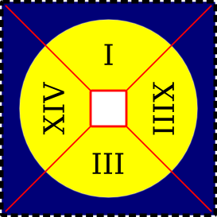

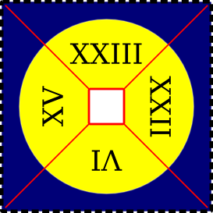
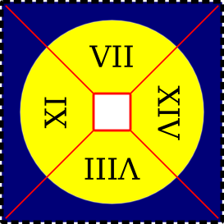

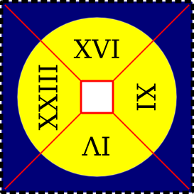
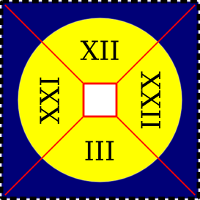

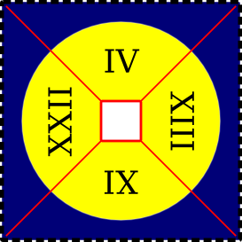
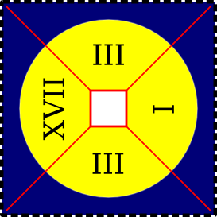

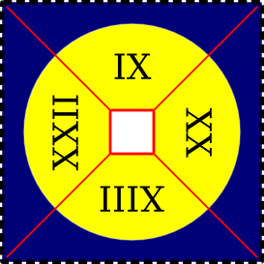
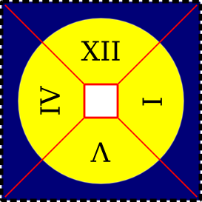

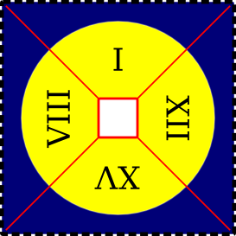
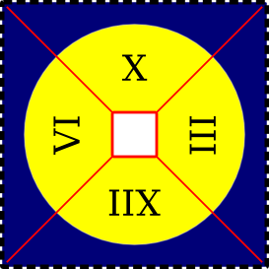

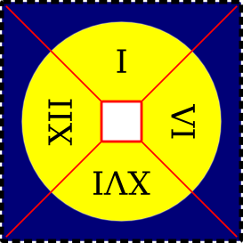
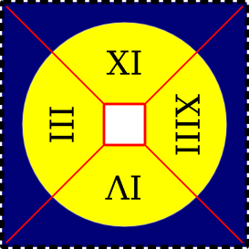

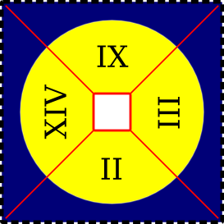
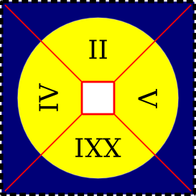


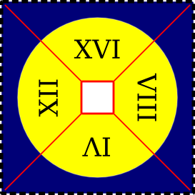

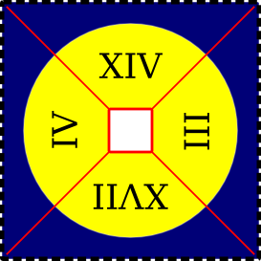
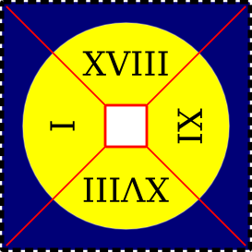

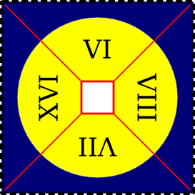
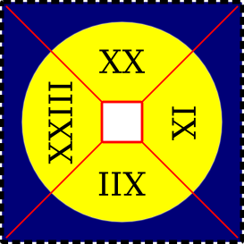

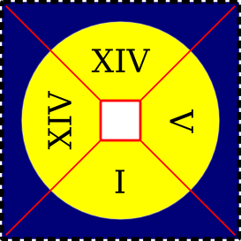
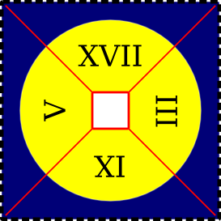

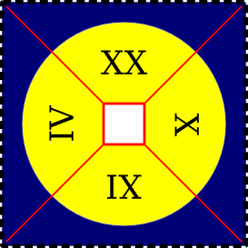
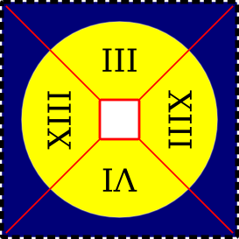

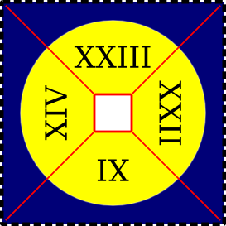
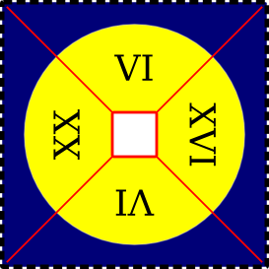

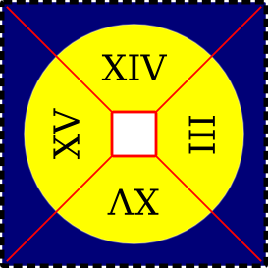
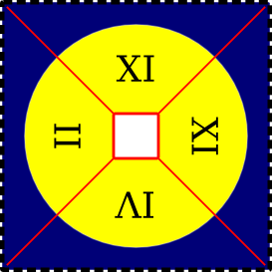

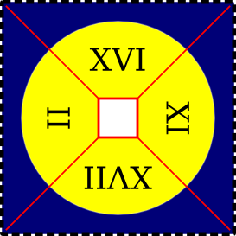
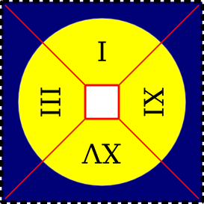

Decimal Places

Now that we've spent some time reviewing Roman numerals, we are going to spend some time reviewing Arabic numbers. With respect to this, I would like to start with working on writing fractions in decimal form. The following two lists represent whole number places and decimal places.

Whole Numbers  1 = one  10 = ten  100 = one hundred  1,000 = one thousand  10,000 = ten-thousand  100,000 = one hundred-thousand  1,000,000 = one million | Decimal Numbers  1/10 = 0.1 = one tenth  1/100 = 0.01 = one hundredth  1/1,000 = 0.001 = one thousandth  1/10,000 = 0.0001 = one ten-thousandth  1/100,000 = 0.00001 = one hundred-thousandth  1/1,000,000 = 0.000001 = one millionth

So, based on the information above 9876.5432

The 9 is in the thousands position
The 8 is in the hundreds position
The 7 is in the tens position
The 6 is in the ones position
The 5 is in the tenths position
The 4 is in the hundredths position
The 3 is in the thousandths position
The 2 is in the ten-thousandths position

If you were to write it as a fraction, it would be:

You could read it as nine thousand eight hundred seventy six and five thousand four hundred thirty two ten-thousandths

Let's look at a decimal number and decide which position each number is in.

167.2543

- 1 is in the place.
- 2 is in the place.
- 3 is in the place.
- 4 is in the place.
- 5 is in the place.
- 6 is in the place.
- 7 is in the place.
a) hundreds b) tenths c) ten-thousandths d) thousandths e) hundredths f) tens g) ones

On the following page is a worksheet to practice writing fractions in decimal form.
Worksheet 1-3
Name:

Date:

What is the place name of the 7 in each of these numbers?

- 743
- 5,763,482
- 2,178,000,013
- 26.74
- 0.0007
- 17.054
Write the following numbers in decimal format.

- twelve million four thousand twenty-five
- thirty-one thousand three hundred thirty-seven
- five million three hundred eighteen thousand eight
- seven tenths
- thirty-nine hundredths
- fifteen and seven tenths
- six and seven hundredths
- seven hundred five and one hundred seven ten-thousandths
Write the following fractions in decimal format.

- 95

- 406
- 507
Change the following decimals into fractions (but do not reduce your fractions).

- 0.6
- 0.85
- 0.006
- 0.0574
- 13.000013
- 80.08135

The following are the answers to the odd problems.

1) hundreds place
3) ten-millions place
5) ten-thousandths place
7) 12,004,025
9) 5,318,008
11) 0.39
13) 6.07
15) 0.7
17) 0.57
19) 406.0214
21)
23)
25) 13

Rounding Decimals & Significant Figures

Sometimes when you are working with numbers, you will find them to large to be manageable. In these scenarios, you should round.
- Rounding makes numbers that are easier to work with in your head.
- Rounded numbers are only approximate.
- An exact answer generally can not be obtained using rounded numbers.
- Use rounding to get a answer that is close but that does not have to be exact.

How to round numbers
For whole numbers:
- Make the numbers that end in 1 through 4 into the next lower number that ends in 0. For example 74 rounded to the nearest ten would be 70.
- Numbers that end in a digit of 5 or more should be rounded up to the next even ten. The number 88 rounded to the nearest ten would be 90.
For decimal numbers:
- When looking to round a significant figure that is proceeded by a 1 through 4, you may stop your decimal there. For example 0.74 rounded to the nearest tenth would be 0.7
- When looking to round a significant figure that is proceeded by a 5 or more should be rounded up. The number 0.88 rounded to the nearest tenth would be 0.9

Significant Figures
A significant figure is one that is actually measured.

Rules for assigning significant figures:
- Digits other than zero are always significant. For example, 34.12 has four significant figures.
- Zeros used only to space the decimal are never significant. For example, 0.007 has one significant figure and 16,000 only has two significant figures.
- Final zeros after a decimal point are always significant. For example, 0.0070 has two significant figures.
- Zeros between two other significant digits are always significant. For example, 50.04 has four significant figures.

Practice Problem

Determine the number of significant figures in 0.20 ml of Lantus insulin.

0.20 ml of Lantus insulin has two significant figures

On the following page is a worksheet to attain some practice with determining significant figures and rounding numbers.

Worksheet 1-4
Name:

Date:

Round the following numbers to the nearest whole number.

- 102.5
- 1.0
- 88.1
- 99.7
- 187.4999
- 29,001.501
Round the following numbers to the nearest tenth.

- 1.0
- 99.7
- 2.54
- 29,001.501
- 187.4999
- 12.99
Round the following numbers to the nearest hundredth.

- 187.4999
- 12.99
- 29,001.501
- 1234567.8901
- 66.666667
- 5,454.5454

Determine the number of significant figures in each measurement.

- 64.8 mg significant figures
- 1.609 km significant figures
- 0.25 mL significant figures
- 4.06 mEq significant figures
- 0.454 kg significant figures
- 0.06 mL significant figures
- 0.20 mcm significant figures
- 220 lb significant figures
- 0.001 kg significant figures

Adding & Subtracting Decimal Numbers

Adding and subtracting decimals is the same as adding and subtracting whole numbers.

To add decimal numbers:
- Put the numbers in a vertical column, aligning the decimal points.
- Add each column of digits, starting on the right and working left.
- Place the decimal point in the answer directly below the decimal points in the terms.

9817.543
+ 0.123
9817.666

Practice Problems

Solve the following practice problems.

1) 324.5678  + 2.3456 | 3) 32.255  + 1.0123 | 5) 6.6663  + 12.0007
2) 0.6  + 0.4  + 1.5 | 4) 4.0068  + 0.06  + 43.667 | 6) 5.004  + 17  + 12.02

1) 326.9134 2) 2.5 3) 33.2673 4) 47.7338 5) 18.6670 6) 34.024
To subtract decimal numbers:
- Put the numbers in a vertical column, aligning the decimal points.
- Subtract each column, starting on the right and working left. If the digit being subtracted in a column is larger than the digit above it, “borrow” a digit from the next column to the left.
- Place the decimal point in the answer directly below the decimal points in the terms.

9817.544
- 5.123
9812.421

Practice Problems

Do the following practice problems.

1) 324.5678  - 2.3456 | 3) 32.255  - 1.0123 | 5) 6.6663  - 2.0007
2) 0.6  - 0.5 | 4) 4.0068  - 0.06 | 6) 5.004  - 2.02

1) 322.2222 2) 0.1 3) 31.2427 4) 3.9468 5) 4.6656 6) 2.984
Worksheet 1-5
Name:

Date:

Perform the following addition problems.

1) | 28,291  + 27,595 | 2) | 5.08  + 0.17 | 3) | 25.09  + 18.7 | 4) | 97.07  + 0.09 | 5) | 31.05  + 4.7 | 6) | 85.2  + 1.764

- 31 + 24 + 18 =
- 4951 + 3287 =
- 35.07 + 19.1 =
- 88.08 + 0.02 =
- 1.28 + 31.05 + 4.7 =
- 18 + 0.042 + 16.3 =
Perform the following subtraction problems.

13) | 28,291  - 27,595 | 14) | 5.08  - 0.17 | 15) | 25.09  - 18.7 | 16) | 97.07  - 0.09 | 17) | 31.05  - 4.7 | 18) | 85.2  - 1.764

- 4951 – 3287 =
- 35.07 – 19.1 =
- 88.08 – 0.02 =
- 0.97 – 0.012 =
- 4.5 – 4.05 =
- 0.951 – 0.112 =
Perform the following applied problems.

- A neonate initially weighed 4.03 kg at birth. Three days later, he weighed 3.944 kg. How many kg did the neonate lose?

- Normal body temperature is 37.0° C. What temperature is 0.4° above normal?

Multiplying Decimal Numbers

To multiply decimal numbers:
- Multiply the numbers just as if they were whole numbers.
- Line up the numbers on the right.
- Starting on the right, multiply each digit in the top number by each digit in the bottom number.
- Add the products.
- Place the decimal point in the answer by starting at the right and moving the point the number of places equal to the sum of the decimal places in both number that were multiplied.

36.3 ← one decimal place
× 0.21 ← + two decimal places
363
+ 7260
7.623 ← three decimal places

Let's try a few practice problems.

Practice Problems

1) | 2020  × 1.1 | 2) | 5.08  × 0.17 | 3) | 25.09  × 18.7 | 4) | 97.07  × 0.09 | 5) | 31.05  × 4.7 | 6) | 1.764  × 85.2

1) 2222 2) 0.8636 3) 469.183 4) 8.7363 5) 145.935 6) 150.2928

Worksheet 1-6
Name:

Date:

Solve the following multiplication problems.

1) | 28,291  × 27,595 | 2) | 4.06  × 0.25 | 3) | 22.33  × 16.4 | 4) | 69.09  × 0.06 | 5) | 50.13  × 7.4 | 6) | 1.337  × 31.3

- 4951 × 3287 =
- 35.07 × 19.1 =
- 88.08 × 0.02 =
- 0.012 × 0.97 =
- 4.05 × 4.5 =
- 0.951 × 0.112 =
Perform the following applied problems.

- Sal is to take 1.25 grains of aspirin every day. Each grain weighs 64.8 mg, so how many mg of aspirin is Sal to take every day?

- Nauseous Nancy bought 12 vials of ondansetron at a cost of $17.56 per vial. How much did she spend on ondansetron?

- Theophylus Monk is to receive 81.6 mg of theophylline three times per day for the next three days. How many mg of theophylline should he receive in total?

Dividing Decimal Numbers

The statement “4 divided by 2” can be written several ways:

  2 4 | 4 ÷ 2

Write the statement “48 divided by 6” three different ways (use the above example as a template if necessary):

The names of the numbers in a division problem are shown below:


8
6 48

- The 6 is called the divisor
- The 48 is called the dividend
- The 8 is called the quotient

The most common method of per forming long division is called the long-division algorithm.

Example
Solve the following problem:


6 3108

The pattern in the long division algorithm is:

- Divide
- Multiply back
- Subtract
- Bring down the next number

You can check how to solve the above example on the next two pages.

Solution to example on previous page:

5  6 3108 | Divide  6 can not go into 3, but it can go into 31 a total of 5 times.
5  6 3108  30 | Multiply back  5 times 6 is 30.
5  6 3108  - 30  1 | Subtract  31 minus 30 equals 1
5  6 3108  - 30  10 | Bring down the next number
51  6 3108  - 30  10 | Divide  6 can go into 10 a total of 1 time.
51  6 3108  - 30  10  6 | Multiply back  1 times 6 is 6.
51  6 3108  - 30  10  - 6  4 | Subtract  10 minus 6 equals 4
51  6 3108  - 30  10  - 6  48 | Bring down the next number
518  6 3108  - 30  10  - 6  48 | Divide  6 can go into 48 a total of 8 times.
518  6 3108  - 30  10  - 6  48  48 | Multiply back  8 times 6 is 48.
518  6 3108  - 30  10  - 6  48  - 48  0 | Subtract  48 minus 48 equals 0.  There is nothing else to bring down; therefore, the final answer to “3,108 divided by 6” is 518.

Division of decimal numbers also use long division.

- If the problem does not have a whole-number divisor, it is necessary to change the problem to an equivalent division with a whole number divisor.
- This is done by shifting the decimal point to the right in both the divisor and the dividend.
- The decimal point is shifted as many places as needed to make the divisor a whole number.
- The new place that the decimal is at in the dividend is directly below where the decimal point in the quotient should be.
- Now you may use the long division algorithm like you normally would.

Example
8.2 73.8 | Our initial problem is “73.8 divided by 8.2”.  The divisor is 8.2  The dividend is 73.8
.      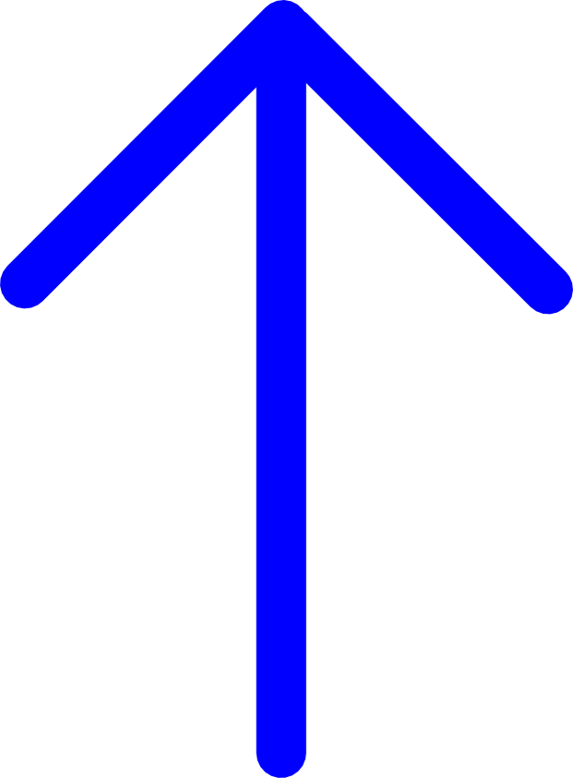  8.2. 73.8. | The divisor must be a whole-number. To achieve this, shift the decimal one spot to the right.  Since you shifted the decimal in the divisor one spot, you should shift the decimal the same number of spots in the dividend.  Now move the decimal straight up from the dividend to where it will be in the quotient.
9.  82 738  - 738  0 | Now, use the long division algorithm like you would normally to solve the problem.

Practice Problems

Solve the following practice problems.

- 9 7.2
- 0.18 36
- 0.06 5.85

1) 0.8 2) 200 3) 97.5

Worksheet 1-7
Name:

Date:

Solve the following problems and round answers to the thousandths position when necessary.

1) | 27 2,835 | 2) | 0.25 4.06 | 3) | 16.4 22.33 | 4) | 0.06 69.09 | 5) | 7.4 50.13 | 6) | 31.3 1.337

- 49.51 ÷ 3287 =
- 35.07 ÷ 19.1 =
- 88.08 ÷ 0.2 =
- 0.97 ÷ 0.012 =
- 4.05 ÷ 4.5 =
- 0.951 ÷ 0.112 =
Perform the following applied problems.

- A dispensary has 256 ounces of rubbing alcohol on hand; how many 8 oz bottles can be filled with alcohol?

- The average dose of a drug is 7.5 mg daily. If a vial contains 1,500 mg, how many days' supply are in the vial?

- You receive a prescription for 6.25 mg capsules of metoprolol tartrate that you will have to compound. If you have 750 mg of metoprolol tartrate on hand, how many capsules will you be able to compound?

- Four capsules of ampicillin are to be administered daily. How many days' supply would 32 capsules be?

Worksheet 1-8
Name:

Date:

Write the following Arabic numerals as Roman numerals.

- 38
- 551
- 24
Write the following Roman numerals as Arabic numerals.

- xxi
- cd
- xlviii
What is the place name of the 3 in each of these numbers.

- 2,432,484
- 24.032
- 107.3
Write the following numbers.

- Two million fifteen thousand six hundred

- Four thousand four ten-thousandths

- Nine thousand eight hundred seventy six and five thousand four hundred thirty two ten-thousandths

Perform the following additions.

13) | 19,867  + 12,482 | 14) | 82.07  + 0.18 | 15) | 23  + 0.7 | 16) | 38  0.042  + 2.8 | 17) | 107.3  + 4.65 | 18) | 81.9  + 52.89

Perform the following subtractions.

19) | 19,867  - 12,482 | 20) | 82.07  - 0.18 | 21) | 23  - 0.7 | 22) | 93.8  - 0.9 | 23) | 107.3  - 4.65 | 24) | 81.9  - 52.89

Perform the following multiplications.

25) | 48  × 5 | 26) | 9.3  × 8 | 27) | 0.41  × 0.27 | 28) | 3.94  × 2.64 | 29) | 2.8  × 0.042 | 30) | 31.337  × 0.67

Perform the following division and round your answers to the hundredths place.

31) | 369 ÷ 6 | 32) | 1.5 156.5 | 33) | 16.4 22.33 | 34) | 2.04 84 | 35) | 33 6.6 | 36) | 12.3 ÷ 100

Solve the following word problems.

- Find the total weight of two objects if one weighs 255.4 grams and the other weighs 198.6 grams.

- If a patient weighs 75 kg one month and 72.7 kg the next month, how much weight did the patient lose?

- What is the total cost of a dozen items at $2.49 each?

- A patient is given 210 mL of medication to take. They are to take 15 mL of the medication daily till all of it is used. How many days should the medication last?

