
CHAPTER 8
WORKING WITH PRESCRIPTIONS
A doctor is to give a speech at the local AMA dinner. He jots down notes for his speech. Unfortunately, when he stands in front of his colleagues later that night, he finds that he can't read his notes. So he asks, "Is there a pharmacist in the house?"
--Author Unknown

Have you ever seen a prescription and wondered, "What the heck does that mean?", and even thought, "That doesn't even look like English!". Now it is time to owe up to the truth...much of it is not English. Prescriptions have been obfuscated by a combination of Latin and English abbreviations (sometimes they even throw in Greek words). They are commonly used on prescriptions to communicate essential information on formulations, preparation, dosage regimens and administration of the medication. Our goal is to demystify this drug nomenclature. Our goals in this chapter include:

- learning common medical abbreviations,
- learning the parts of a prescription and how to incorporate medical abbreviations,
- and the additional prescription requirements and limitations when dealing with controlled substances.

Common Medical Abbreviations

In total there are nearly 20,000 medical abbreviations; instead of providing an exhaustive and meaningless list, we will present you with the most common medical abbreviations that are necessary for interpreting prescriptions and performing calculations.

There are several key things to point out about the tables on the next several pages.

categories – for ease of memorization, the abbreviations have been broken up into five categories: route, form, time, measurement, and other.

abbreviations – the abbreviations can often be written with or without the 'periods' and in upper or lower case letters (e.g., p.o. and PO both mean 'by mouth').

meaning – sometimes you will need to place an abbreviation in context to know its meaning (e.g., IV could mean a dosage form as in an 'IV bag', it could mean a route of administration as in 'to give a medication IV', or it could even be the roman numeral meaning 'four').

Latin root – not all the words on this list are derived from Latin words, nor is it necessary to know the Latin root words to be able to understand the abbreviations, but it is simply provided to help you understand how some of these abbreviations were derived.

Route
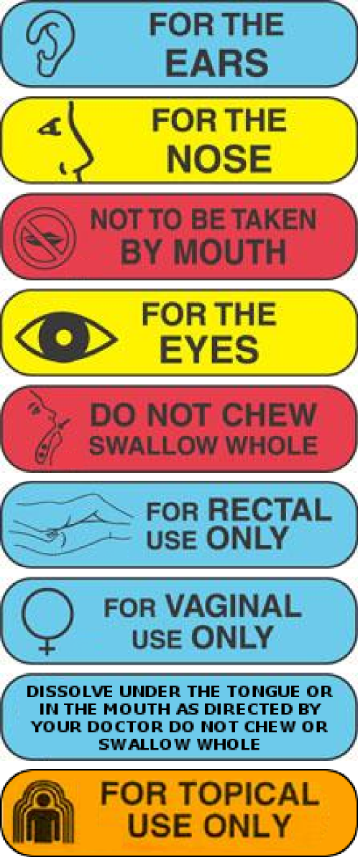
Abbreviation | Meaning | Latin Root
a.d. | right ear | auris dexter
a.s. | left ear | auris sinister
a.u. | each ear | auris utro
IM | intramuscular
IV | intravenous
IVP | intravenous push
IVPB | intravenous piggyback
KVO | keep vein open
n.g.t. | naso-gastric tube
n.p.o. | nothing by mouth | nasquam per os
nare | nostril
o.d. | right eye | oculus dexter
o.s. | left eye | oculus sinister
o.u. | each eye | oculus utro
per neb | by nebulizer
p.o. | by mouth | per os
p.r. | rectally | per rectum
p.v. | vaginally
SC, SQ | subcutaneously
S.L. | sublingually (under the tongue)
top. | topically

Form

Abbreviation | Meaning | Latin Root
amp. | Ampule
aq, aqua | water | aqua
caps | capsule | capsula
cm. | cream
elix. | elixir
liq. | liquid | liquor
sol. | solution
supp. | suppository | suppositorum
SR, XR, XL | slow/extended release
syr. | syrup | syrupus
tab. | tablet | tabella
ung., oint | ointment | ungentum

Time

Abbreviation | Meaning | Latin Root
a.c. | before food, before meals | ante cibum
a.m. | morning | ante meridian
atc | around the clock
b.i.d., bid | twice a day | bis in die
b.i.w., biw | twice a week
h, ° | hour | hora
h.s. | at bedtime | hora somni
p.c. | after meals | post cibum
p.m. | evening | post meridian
p.r.n., prn | as needed | pro re nata
q.i.d., qid | four times a day | quarter in die
q | each, every | quaque
q.d. | every day | quaque die
q_h, q_° | every__hour(s)
qod | every other day
stat | immediately | statim
t.i.d., tid | three times a day | ter in die
t.i.w., tiw | three times a week

Measurement

Abbreviation | Meaning | Latin Root
i, ii, ... | one, two, etc.
a.a., aa | of each | ana
ad | to, up to | ad
aq. ad | add water up to
BSA | body surface area
cc | cubic centimeter
dil | dilute | dilutus
f, fl. | fluid
fl. oz. | fluid ounce
g, G, gm | gram
gr. | grain
gtt | drop(s) | guttae
l, L | liter
mcg, µg | microgram
mEq | milliequivalent
mg | milligram
ml, mL | milliliter
q.s. | a sufficient quantity | quantum sufficiat
q.s. ad | add sufficient quantity to make | quantum sufficiat ad
ss | one-half
Tbs, T | tablespoon
tsp, t | teaspoon
U | unit
> | greater than
< | less than

Other

Abbreviation | Meaning | Latin Root
c | with | cum
disp. | dispense
f, ft | make, let it be made | fac, fiat, fiant
n/v | nausea and vomiting
neb | nebulizer
NR | no refill
NS | normal saline
s | without | sine
Sig | write, label | signatura
SOB | shortness of breath
T.O. | telephone order
ut dict, u.d. | as directed | ut dictum
V.O. | verbal order

Practice Problems

Translate the following abbreviation statements to provide proper household directions.
- i gtt ou bid x7d

- i tab po q6h prn pain

- i tab po qid pc

- iss tsp po tid prn cough

- iii gtt ad q4h x5d

- i supp pr q4h prn n/v

- i cap po tid ac + hs

- i tab sl q5 minutes prn chest pain, may repeat up to 3 times.

- ii tabs stat, then i tab po qid x10d
Worksheet 8-1
Name:

Date:

Your assignment for tonight is two fold. One, you must make a set of flash cards using the abbreviations presented to you on the preceding pages. Two, in the space provided below, you must make up ten abbreviation statements similar to the ones you just did, but this time do not translate them.

1)

2)

3)

4)

5)

6)

7)

8)

9)

10)

Learning the Parts of a Prescription and how to incorporate Medical Abbreviations

The word "prescription" stems from two Latin word parts, prae-, a prefix meaning before, and scribere, a word root meaning to write. Putting it all together, prescription means "to write before," which reflects the historical fact that a prescription traditionally had to be written before a drug could be mixed and administered to a patient.
Many ancient prescriptions were noted for their multiple ingredients and complexity of preparation. The importance of the prescription and the need for complete understanding and accuracy made it imperative that a universal and standard language be used. Thus, Latin was adopted, and its use was continued until approximately a generation ago.

Present day prescriptions are written in English, with doses usually being given in the metric system, but often you still find contracted Latin words and Roman numerals intertwined. The ancient "Rx" and the Latin "Signatura," abbreviated as Sig., the occasional Roman numeral, and a hand full of apothecary symbols are all that remain of the ancient art of the prescription.

Traditionally, a prescription is a written order for compounding, dispensing, and administering drugs to a specific client or patient and once it is signed by the physician it becomes a legal document! Prescriptions are required for all medications that require the supervision of a physician, those that must be controlled because they are addictive and carry the potential of being abused, and those that could cause health threats from side effects if taken incorrectly, for example, cardiac medications, controlled substances, and antibiotics.

The following is a list of the parts of a prescription, and in bold are the most significant portions:
- Patient Information
- Superscription
- Inscription
- Subscription
- Signatura
- Date
- Signature lines, signature, degree, generic substitution
- Prescriber information
- DEA# if required
- Refills
- Warnings

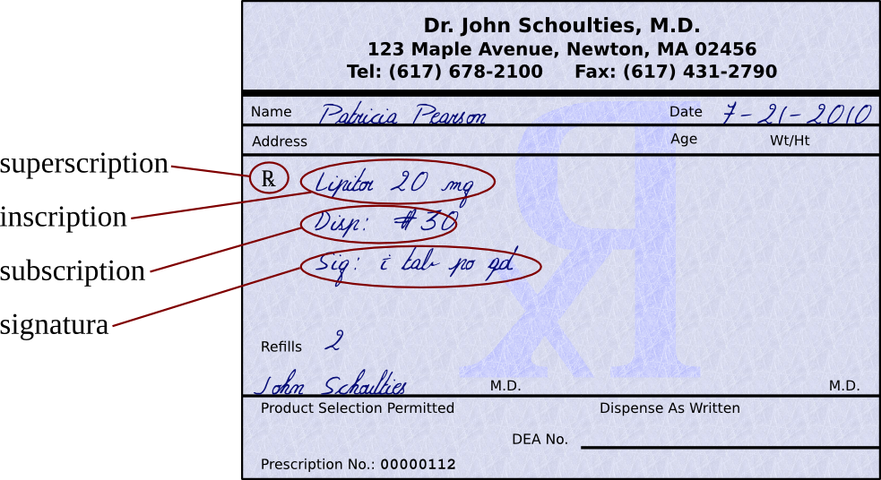
The superscription which consists of the heading where the symbol Rx (an abbreviation for recipe, the Latin for take thou ) is found. The Rx symbol comes before the inscription.

The inscription is also called the body of the prescription, and provides the names and quantities of the chief ingredients of the prescription. Also in the inscription you find the dose and dosage form, such as tablet, suspension, capsule, syrup.

The subscription, which gives specific directions for the pharmacist on how to compound the medication. These directions to the pharmacist are usually expressed in contracted Latin or may consist of a short sentence such as: "make a solution," "mix and place into 10 capsules," or "dispense 10 tablets." However, that was in the old days. Today... doctors just name the pill!

The signatura (also called sig, or transcription), gives instructions to the patient on how, how much, when, and how long the drug is to be taken. These instructions are preceded by the symbol “S” or “Sig.” from the Latin, meaning "write" or "label." Whenever translating the signatura into instructions for a patient, begin it with an action verb such as take, inhale, spray, inject, place, swish, or whatever other verb seems appropriate for the medication.

Below the Sig line is room for special instructions, such as the number of times the prescription may be refilled, if any. You will also find the purpose of the prescription, special instructions, and warnings, followed by the signature of the prescriber.

You should also know and understand:
- The date and patient information, which consists of the name of the party for whom it is designated and the address, usually occupies the upper part of the prescription. Sometimes age or weight is also added, though rarely.
- The instruction, "take as directed" is not satisfactory and should be avoided. The directions to the patient should include a reminder of the intended purpose of the medication by including such phrases as "for pain," "for relief of headache," or "to relieve itching"
- And if the patient is to receive a brand name medication, rather then generic, the physician enters NO SUBSTITUTIONS at the end of the prescription.
- If there are no refills to be dispensed, it is advisable not to enter the number 0, because it can be altered by adding numbers before the zero, thus making it a 10 to receive ten refills (or more!). Always write out the word None, or No Refills!!!
- The Drug Enforcement Administration (DEA) registration number system was implemented as a way to successfully track controlled substances from the time they are manufactured until the time they are dispensed to the patient.
- The DEA opposes use of the DEA number for other than its intended purpose, which is tracking controlled substances, and strongly opposes insurance company practice of requiring that a DEA number be placed on prescriptions for non-controlled substances.
- Not all medications require prescriptions. There are certain medications on the market that can be purchased over the counter, thus their name, over-the-counter drugs (OTC.)

Now to put it all together, let's look at the previous example and translate the information on it:

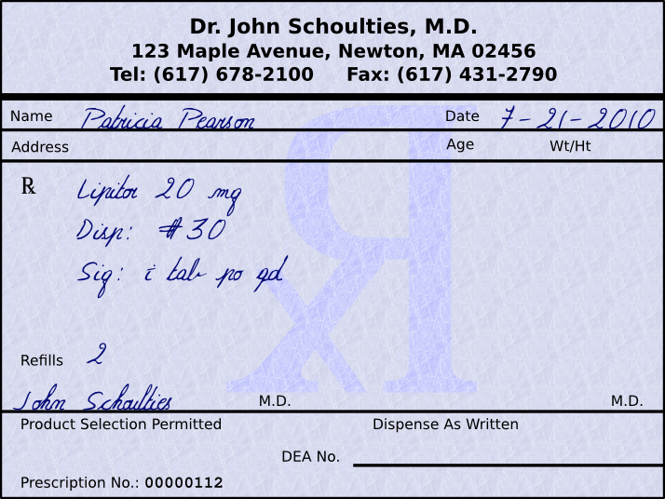
So, if we look at this script for Patricia Pearson, we can see that it is for Lipitor (atorvastatin Ca) 20 mg tablets, and that the patient is to receive 30 of them with 2 refills. The instructions to the patient would be, “Take 1 tablet by mouth daily.”

Other things of note include the date that the prescription is written for is July 21, 2010. Prescriptions for non-controlled substances are only good for one year, so Ms. Beaty will need a new script if she still needs this medication past July 21, 2011, irregardless of how many refills were written for. Another noteworthy item is that the physician signed permitting product selection (i.e., generic substitution). The last significant item on this label is that the physician did not include their DEA number. A DEA number should only be used for controlled substances.

This brings us to one last major concept in this chapter:

The Additional Prescription Requirements and Limitations when dealing with Controlled Substances

Besides over the counter medications (OTC) such as aspirin and ibuprofen, behind the counter medications (BTC) such as Allegra-D (fexofenadine with pseudoephedrine), and prescription medications (Rx legend) such as amoxicillin and digoxin, there is another group of medications to be concerned with called controlled substances. Controlled substances are medications with further
restrictions due to abuse potential. There are 5 schedules of controlled substances with various prescribing guidelines based on abuse potential, as determined by the Drug Enforcement Administration and individual state legislative branches. Let's look at the table on the next page.

Schedule | Characteristics | Examples
CI | Unaccepted medical use  Highest potential for abuse  Not available by a prescription | Heroin and LSD
CII | High potential for abuse or misuse | oxycodone, morphine, and amphetamines
CIII | Potential risk for abuse, misuse, and dependence | Tylenol with Codeine tablets and Vicodin
CIV | Low potential for abuse and limited risk of dependence | phenobarbital, benzodiazepines, and other sedatives and hypnotics
CV | Low potential for abuse or misuse | Cough medicines that contain a limited amount of codeine, and antidiarrheal medications that contain a limited amount of an opiate such as Lomotil
- CI medications are not available via a prescription.
- CII medications may be written for a maximum 90 day supply excluding hospice patients. No refills are allowed on schedule II medications.
- CIII-IV medications may only be written for a 6 month supply.
- CV medications may be written for up to I year. Many states limit this to 6 months.

Many problems associated with drug abuse are the result of legitimately-manufactured controlled substances being diverted from their lawful purpose into the illicit drug traffic. Many of the narcotics, depressants and stimulants manufactured for legitimate medical use are subject to abuse, and have therefore been brought under legal control. The goal of controls is to ensure that these "controlled substances" are readily available for medical use, while preventing their distribution for illicit sale and abuse.

Under federal law, all businesses which manufacture or distribute controlled drugs, all health professionals entitled to dispense, administer or prescribe them, and all pharmacies entitled to fill prescriptions must register with the DEA. Authorized registrants receive a "DEA number". Registrants must comply with a series of regulatory requirements relating to drug security, records accountability, and adherence to standards. Any properly licensed medical professional that wishes to prescribe a controlled substance must include their DEA number on the prescription.

A physician's DEA number is a two letter seven digit number designed in such a way that a pharmacy can verify it via a mathematical algorithm. An example of a DEA number would be:

BP4567890

Let's go to the next several pages and practice thoroughly translating some prescriptions.
Worksheet 8-2
Name:

Date:

Translate the following prescriptions, and make note of anything that you find interesting. I will be breaking you into teams that are responsible for thorough translations on specific scripts. I've provided two examples of what I'm looking for.

Example 1:
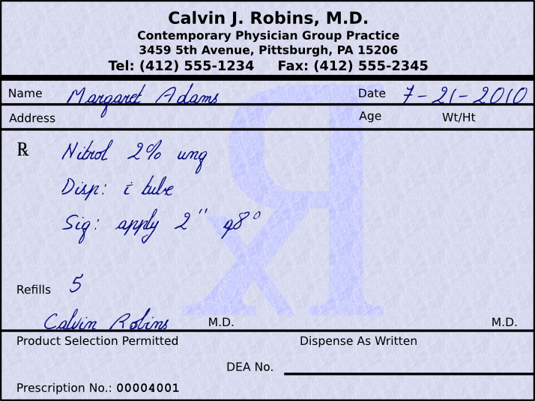
This script for Margaret Adams is for one tube of Nitrol 2% ointment (nitroglycerin 2% ointment) and the patient is allowed 5 refills. The instructions to the patient would be, “Apply 2 inches every 8 hours.”

Things to note: This is interesting because NTG ung is usually measured in inches. A patient should know to rotate sites and apply to well cleaned areas that have minimal hair. Also, you should probably check with the physician to see if they want the patient to receive a nitrate free interval or not.

Example 2:
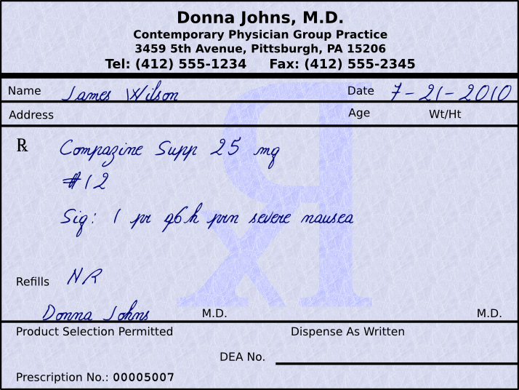
Mr. James Wilson's script is for twelve 25 mg Compazine (prochlorperazine) suppositories with no refills. The instructions to the patient would be “Insert 1 suppository rectally every 6 hours as needed for severe nausea.”

Things to note: Female patients may need to be informed to only use this suppository rectally as it will not have the correct systemic effects if given vaginally.

Prescription 1
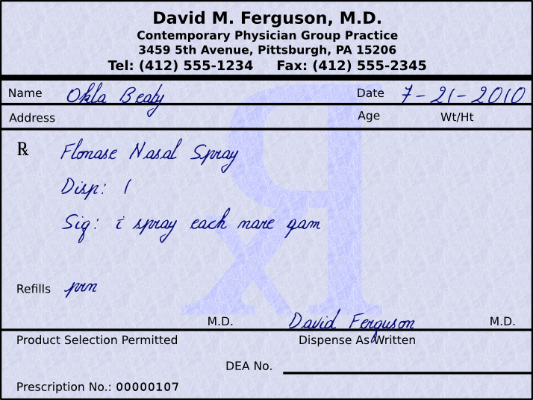

Prescription 2
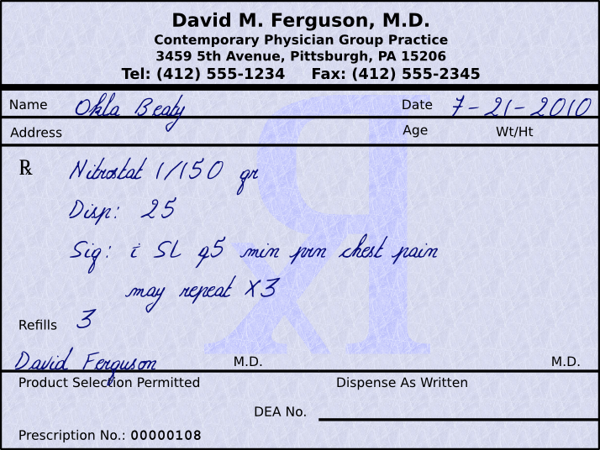
Prescription 3
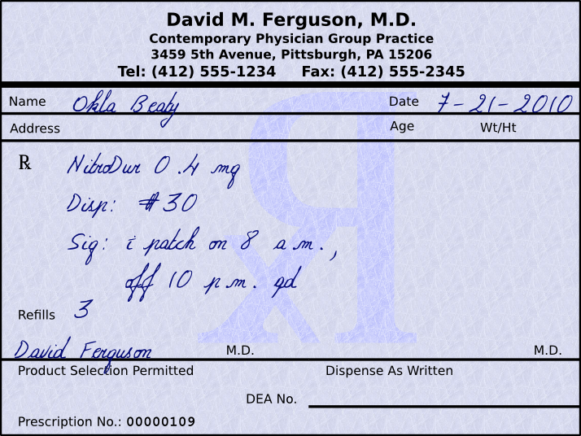

Prescription 4
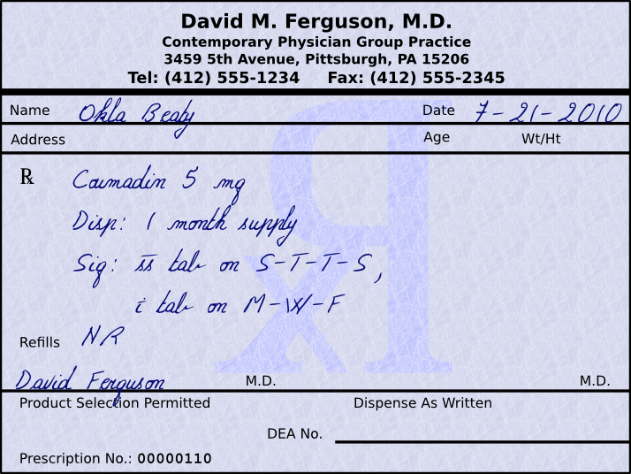

Prescription 5
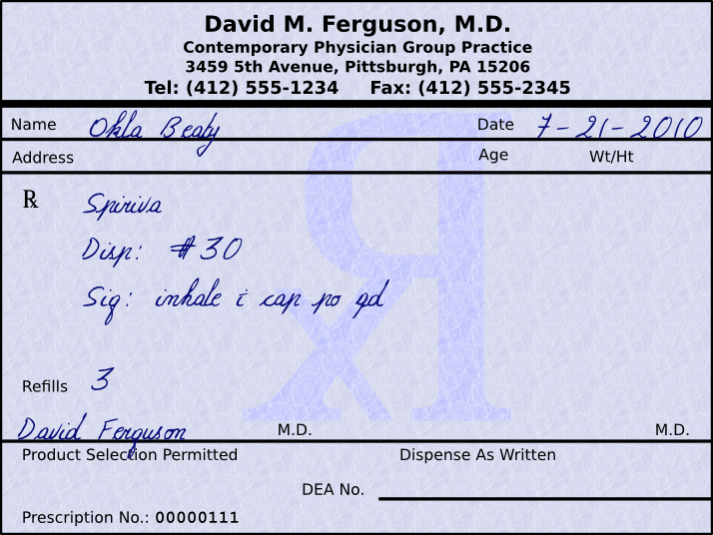

Prescription 6
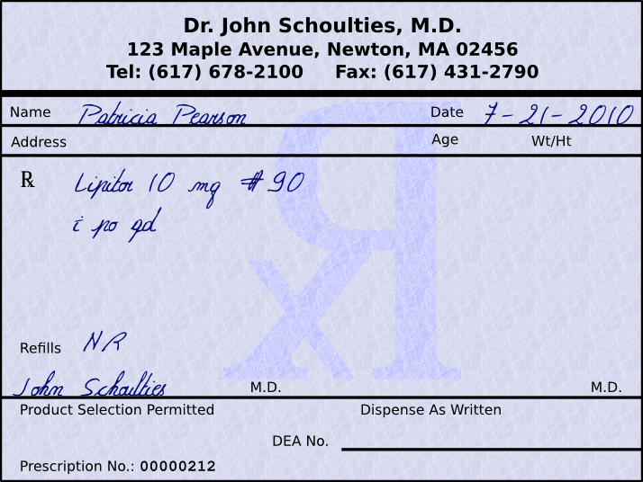

Prescription 7
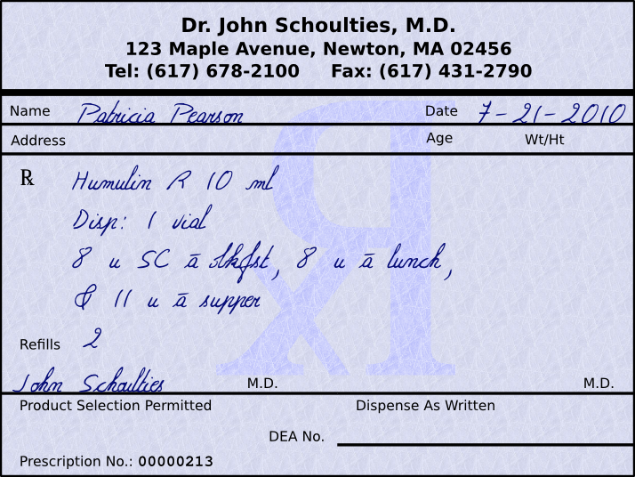

Prescription 8
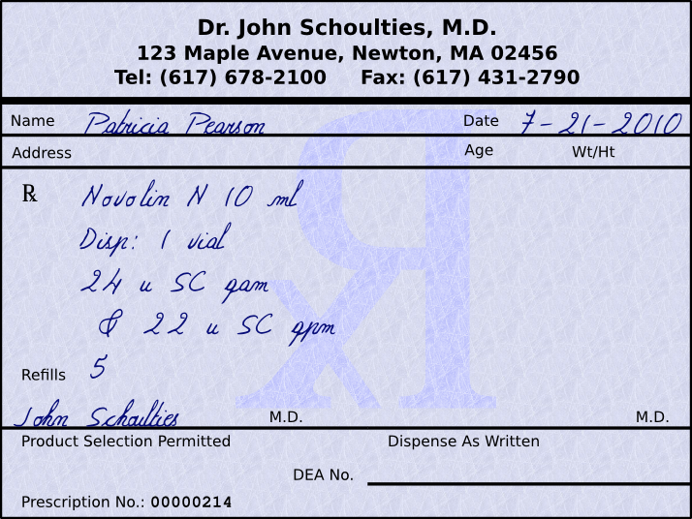

Prescription 9
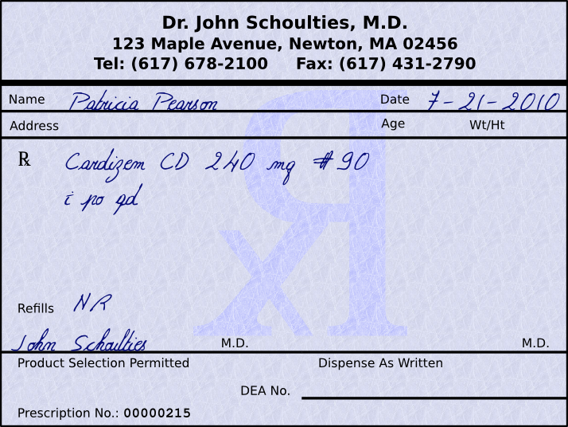

Prescription 10
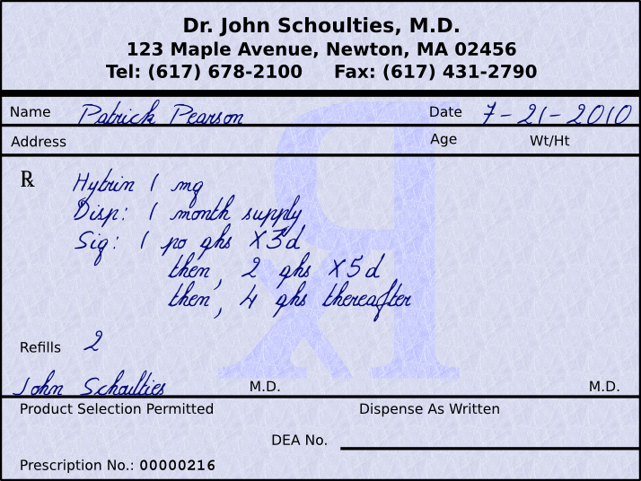

Prescription 11
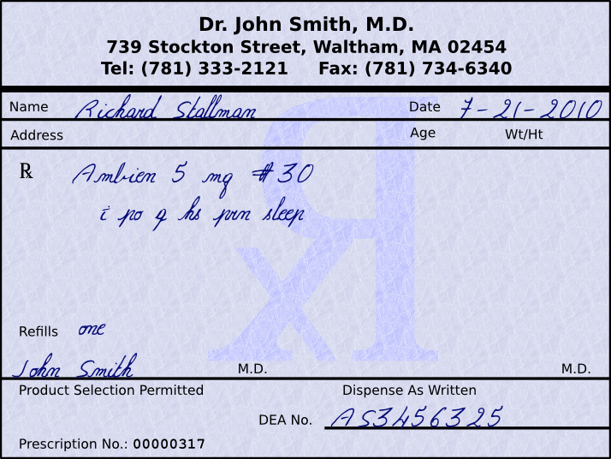

Prescription 12
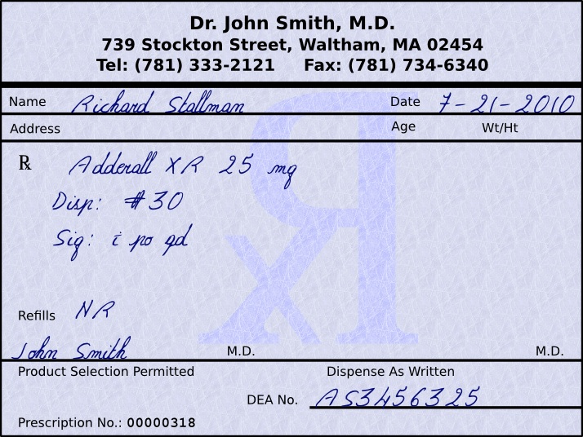

Prescription 13
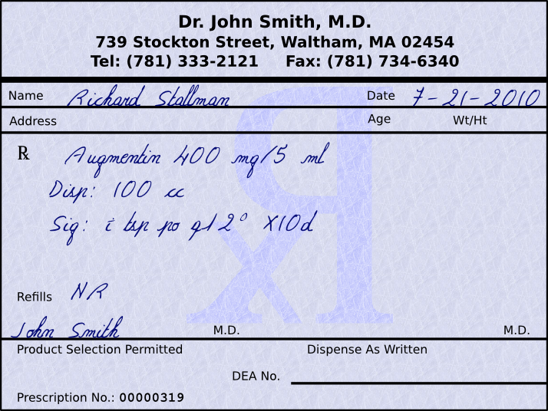

Prescription 14
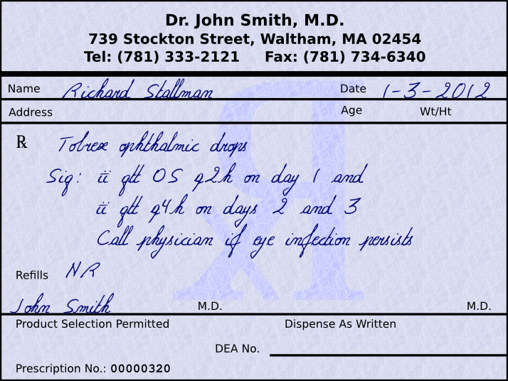

Prescription 15
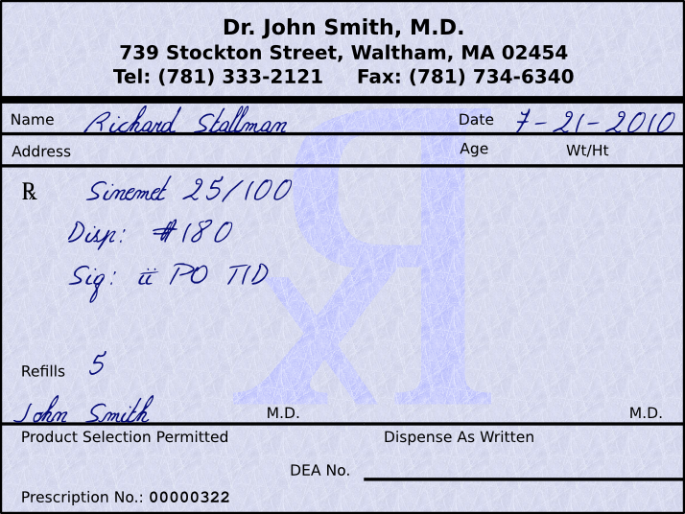

Prescription 16
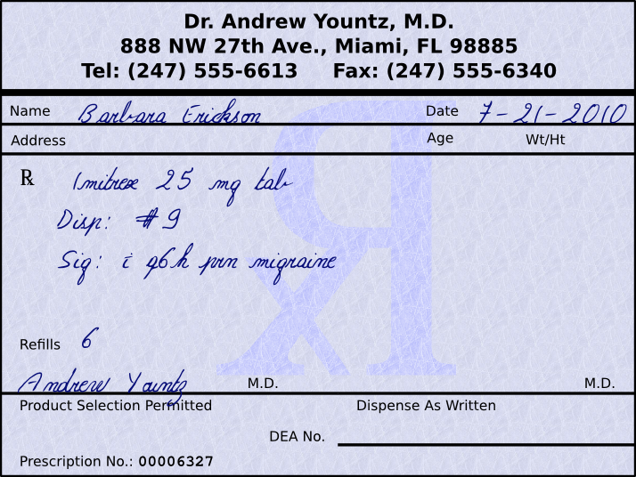

Prescription 17
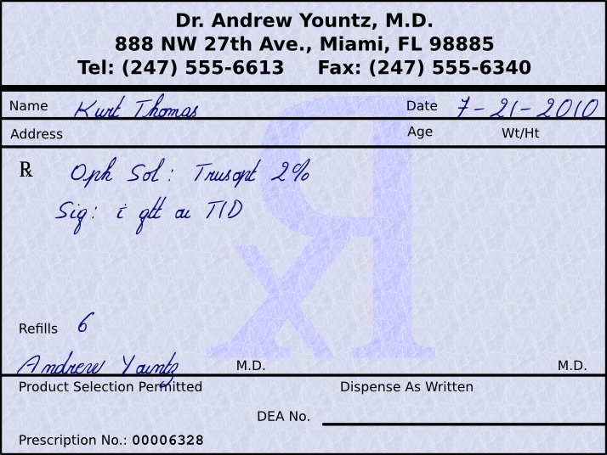

Prescription 18
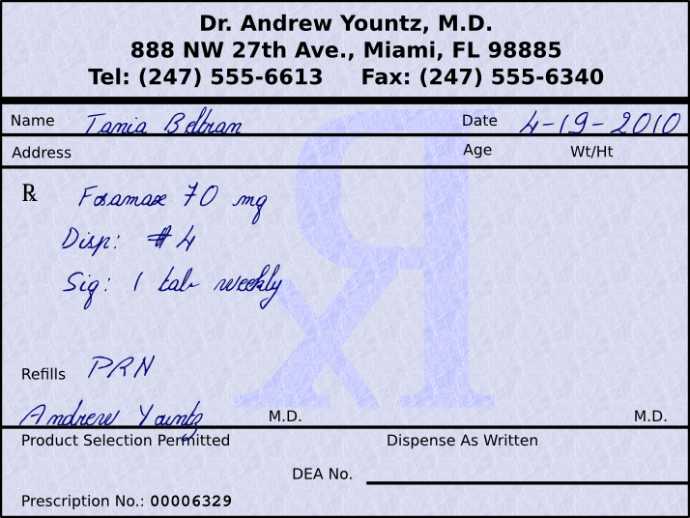

ISMP’s List of Error-Prone Abbreviations, Symbols, and Dose Designations

The abbreviations, symbols, and dose designations found on the following tables have been reported to the Institute for Safe Medication Practices (ISMP) through the ISMP Medication Error Reporting Program (MERP) as being frequently misinterpreted and involved in harmful medication errors. According to the ISMP, they should NEVER be used when communicating medical information. This includes internal communications, telephone/verbal prescriptions, computer-generated labels, labels for drug storage bins, medication administration records, as well as pharmacy and prescriber computer order entry screens. The truth is that all the items we are about to discuss ARE ACTUALLY USED and with that in mind we should look over these to help us not make errors in interpreting these abbreviations.

Abbreviations | Intended Meaning | Misinterpretation | Correction
μg | Microgram | Mistaken as “mg” | Use “mcg”
AD, AS, AU | Right ear, left ear, each ear | Mistaken as OD, OS, OU (right eye, left eye, each eye) | Use “right ear”, “left ear”, or “each ear”
OD, OS, OU | Right eye, left eye, each eye | Mistaken as AD, AS, AU (right ear, left ear, each ear) | Use “right eye”, “left eye”, or “each eye”
BT | Bedtime | Mistaken as “BID” (twice daily) | Use “bedtime”
cc | Cubic centimeter | Mistaken as “u” (units) | Use “mL”
D/C | Discharge or discontinue | Premature discontinuation of medications if D/C (intended to mean “discharge”) has been misinterpreted as “discontinued” when followed by a list of discharge medications | Use “discharge” and “discontinue”
IJ | Injection | Mistaken as “IV” or “intrajugular” | Use “injection”
IN | Intranasal | Mistaken as “IM” or “IV” | Use “intranasal” or “NAS”
HS  hs | Half-strength  At bedtime, hours of sleep | Mistaken as bedtime  Mistaken as half-strength | Use “half-strength” or “bedtime”
IU | International unit | Mistaken as IV (intravenous) or 10 (ten) | Use “units”
o.d. Or OD | Once daily | Mistaken as “right eye” (OD – oculus dexter), leading to oral medications administered in the eye | Use “daily”
OJ | Orange juice | Mistaken as OD or OS (right or left eye); drugs meant to be diluted in orange juice may be given in the eye | Use “orange juice”
Per os | By mouth, orally | The “os” can be mistaken as “left eye” (OS – oculus sinister) | Use “PO,” “by mouth,” or “orally”
q.d. Or QD | Every day | Mistaken as q.i.d., especially if the period after the “q” or the tail of the “q” is misunderstood as an “i” | Use “daily”
qhs | Nightly at bedtime | Mistaken as “qhr” or every hour | Use “nightly”
qn | Nightly or at bedtime | Mistaken as “qh” (every hour) | Use “nightly” or “at bedtime”
q.o.d. or QOD | Every other day | Mistaken as “q.d.” (daily) or “q.i.d.” (four times daily) if the “o” is poorly written | Use “every other day”
q1d | Daily | Mistaken as q.i.d. (four times daily) | Use “daily”
q6PM, etc. | Every evening at 6 PM | Mistaken as every 6 hours | Use “daily at 6 PM” or “6 PM daily”
SC, SQ, sub q | Subcutaneous | SC mistaken as SL (sublingual); SQ mistaken as “5 every;” the “q” in “sub q” has been mistaken as “every” | Use “subcut” or “subcutaneously”
ss | Sliding scale (insulin) or ½ (apothecary) | Mistaken as “55” | Spell out “sliding scale;” use “one-half” or “½”
SSRI  SSI | Sliding scale regular insulin  Sliding scale insulin | Mistaken as selective-seritonin reuptake inhibitor  Mistaken as Strong Solution of Iodine (Lugol's) | Spell out “sliding scale (insulin)”
i/d | One daily | Mistaken as “tid” | Use “1 daily”
TIW or tiw | 3 times a week | Mistaken as “3 times a day” or “twice in a week” | Use “3 times weekly”
U or u | Unit | Mistaken as the number 0 or 4, causing a 10-fold overdose or greater (e.g., 4U seen as “40” or 4u seen as “44”); mistaken as “cc” so dose given in volume instead of units (e.g., 4u seen as 4cc) | Use “unit”
UD | As directed (“ut dictum”) | Mistaken as unit dose (e.g., diltiazem 125 mg IV infusion “UD” misinterpreted as meaning to give entire infusion as unit [bolus] dose) | Use “as directed”
Dose Designations and Other Information | Intended Meaning | Misinterpretation | Correction
Trailing zero after decimal point (e.g., 1.0 mg) | 1 mg | Mistaken as 10 mg if the decimal point is not seen | Do not use trailing zero for doses expressed in whole numbers
No leading zero before a decimal point (e.g., .5 mg) | 0.5 mg | Mistaken as 5 mg if the decimal point is not seen | Use zero before a decimal point when the dose is less than a whole unit
Drug name and dose run together (especially problematic for drug names that end in “l” such as Inderal40 mg; Tegretol300 mg) | Inderal 40 mg  Tegretol 300 mg | Mistaken as Inderal 140 mg  Mistaken as Tegretol 1300 mg | Place adequate space between the drug name, dose, and unit of measure
Numerical dose and unit of measure run together (e.g., 10mg, 100mL) | 10 mg  100 mL | The “m” is sometimes mistaken as a zero or two zeros, risking a 10- to 100-fold overdose | Place adequate space between the drug name, dose, and unit of measure
Abbreviation such as mg. or mL. With a period following the abbreviation | mg  mL | The period is unnecessary and could be mistaken as the number 1 if written poorly | Use mg, mL, etc. without a terminal period
Large doses without properly placed commas (e.g., 100000 units; 1000000 units) | 100,000 units  1,000,000 units | 100000 has been mistaken as 10,000 or 1,000,000; 1000000 has been mistaken as 100,000 | Use commas for dosing units at or above 1,000, or use words such as 100 “thousand” or 1 “million” to improve readability
Drug Name Abbreviations | Intended Meaning | Misinterpretation | Correction
ARA A | vidarabine | Mistaken as cytarabine (ARA C) | Use complete drug name
AZT | zidovudine (Retrovir) | Mistaken as azathioprine or aztreonam | Use complete drug name
CPZ | Compazine (prochlorperazine) | Mistaken as chlorpromazine | Use complete drug name
DPT | Demerol-Phenergan-Thorazine | Mistaken as diptheria-pertusis-tetanus (vaccine) | Use complete drug name
DTO | Diluted tincture of opium, or deodorized tincture of opium (Paregoric) | Mistaken as tincture of opium | Use complete drug name
HCl | Hydrochloric acid or hydrochloride | Mistaken as potassium chloride (the “H” is misinterpreted as “K”) | Use complete drug name unless expressed as salt of drug
HCT | hydrocortisone | Mistaken as hydrochlorothiazide | Use complete drug name
HCTZ | hydrochlorothiazide | Mistaken as hydrocortisone (seen as HCT250 mg) | Use complete drug name
MgSO₄ | magnesium sulfate | Mistaken as morphine sulfate | Use complete drug name
MS, MSO₄ | morphine sulfate | Mistaken as magnesium sulfate | Use complete drug name
MTX | methotrexate | Mistaken as mitoxantrone | Use complete drug name
PCA | procainamide | Mistaken as patient controlled analgesia | Use complete drug name
PTU | propylthiouracil | Mistaken as mercaptopurine | Use complete drug name
T3 | Tylenol with codeine No. 3 | Mistaken as liothyronine | Use complete drug name
TAC | triamcinolone | Mistaken as tetracaine, adrenalin, cocaine | Use complete drug name
TNK | TNKase | Mistaken as “TPA” | Use complete drug name
ZnSO₄ | zinc sulfate | Mistaken as morphine sulfate | Use complete drug name
Stemmed Drug names | Intended Meaning | Misinterpretation | Correction
“Nitro” drip | Nitroglycerin infusion | Mistaken as sodium nitroprusside infusion | Use complete drug name
“Norflox” | norfloxacin | Mistaken as Norflex | Use complete drug name
“IV Vanc” | intravenous vancomycin | Mistaken as Invanz | Use complete drug name
Symbols | Intended Meaning | Misinterpretation | Correction
 | Dram  Minim | Symbol for dram mistaken as “3”  Symbol for minim mistaken as “mL” | Use metric system
x3d | For three days | Mistaken as “3 doses” | Use “for three days”
> and < | Greater than and less than | Mistaken as opposite of intended of intended; mistakenly use incorrect symbol; “<10” mistaken as “40” | Use “greater than” or “less than”
/ (slash mark) | Separates two doses or indicates “per” | Mistaken as the number 1 (e.g., “25 units/10 units” misread as “25 units and 110 units”) | Use “per” rather than a slash mark to separate doses
@ | At | Mistaken as “2” | Use “at”
& | And | Mistaken as “2, 3, 4, or 8” | Use “and”
+ | Plus or and | Mistaken as “4” | Use “and”
° | Hour | Mistaken as a zero (e.g., q2° seen as q 20) | Use “hr,” “h,” or “hour”

Worksheet 8-3
Name:

Date:

Match the following abbreviations with their English translations.

Route

1) | _____ | a.d. | a. by mouth
2) | _____ | a.s. | b. by nebulizer
3) | _____ | a.u. | c. each ear
4) | _____ | IM | d. each eye
5) | _____ | IV | e. intramuscular
6) | _____ | IVP | f. intravenous
7) | _____ | IVPB | g. intravenous push
8) | _____ | KVO | h. intravenous piggyback
9) | _____ | n.g.t. | i. keep vein open
10) | _____ | n.p.o. | j. left ear
11) | _____ | nare | k. left eye
12) | _____ | o.d. | l. naso-gastric tube
13) | _____ | o.s. | m. nostril
14) | _____ | o.u. | n. nothing by mouth
15) | _____ | per neb | o. rectally
16) | _____ | p.o. | p. right ear
17) | _____ | p.r. | q. right eye
18) | _____ | p.v. | r. subcutaneously
19) | _____ | SC, SQ | s. sublingually
20) | _____ | S.L. | t. topically
21) | _____ | top. | u. vaginally

Form

22) | _____ | amp | a. ampule
23) | _____ | aq, aqua | b. capsule
24) | _____ | caps | c. cream
25) | _____ | cm. | d. elixir
26) | _____ | elix. | e. liquid
27) | _____ | liq. | f. ointment
28) | _____ | sol. | g. slow/extended release
29) | _____ | supp. | h. solution
30) | _____ | SR, XR, XL | i. suppository
31) | _____ | syr. | j. syrup
32) | _____ | tab. | k. tablet
33) | _____ | ung., oint | l. water

Measurement

34) | _____ | i, ii | a. a sufficient quantity
35) | _____ | a.a. or aa | b. add sufficient quantity  to make
36) | _____ | ad | c. add water up to
37) | _____ | aq. ad | d. body surface area
38) | _____ | BSA | e. cubic centimeter
39) | _____ | cc | f. dilute
40) | _____ | dil. | g. drops
41) | _____ | f, fl. | h. fluid
42) | _____ | fl. oz. | i. fluid ounce
43) | _____ | g, G, gm | j. grain
44) | _____ | gr. | k. gram
45) | _____ | gtt | l. greater than
46) | _____ | l, L | m. less than
47) | _____ | mcg, µg | n. liter
48) | _____ | mEq. | o. microgram
49) | _____ | mg | p. milliequivalent
50) | _____ | ml, mL | q. milligram
51) | _____ | q.s. | r. milliliter
52) | _____ | q.s. ad | s. of each
53) | _____ | ss | t. one, two, etc
54) | _____ | tbsp., T | u. one-half
55) | _____ | tsp., t | v. tablespoon
56) | _____ | U | w. teaspoon
57) | _____ | > | x. to, up to
58) | _____ | < | y. unit

Time

59) | _____ | a.c. | a. after meals
60) | _____ | a.m. | b. around the clock
61) | _____ | atc | c. as needed
62) | _____ | b.i.d., bid | d. at bedtime
63) | _____ | b.i.w., biw | e. before food, before  meals
64) | _____ | h | f. each, every
65) | _____ | h.s. | g. evening
66) | _____ | p.c. | h. every __ hour(s)
67) | _____ | p.m. | i. every day
68) | _____ | p.r.n., prn | j. every other day
69) | _____ | q.i.d., qid | k. four times a day
70) | _____ | q | l. hour
71) | _____ | q.d. | m. immediately
72) | _____ | q_h | n. morning
73) | _____ | qod | o. three time a day
74) | _____ | stat | p. three times a week
75) | _____ | t.i.d., tid | q. twice a day
76) | _____ | t.i.w., tiw | r. twice a week

Other

77) | _____ | c | a. as directed
78) | _____ | disp. | b. dispense
79) | _____ | f, ft. | c. make, let it be made
80) | _____ | neb | d. nausea and vomiting
81) | _____ | n/v | e. nebulizer
82) | _____ | NR | f. no refill
83) | _____ | NS | g. normal saline
84) | _____ | s | h. shortness of breath
85) | _____ | Sig. | i. telephone order
86) | _____ | SOB | j. verbal order
87) | _____ | T.O. | k. with
88) | _____ | ut dict., u.d. | l. without
89) | _____ | V.O. | m. write, label

Choose the best answer for the following multiple choice questions.

- The directions for use of a medication are “gtt ii os bid.” The route of administration is:

a) right eye
b) left eye
c) right ear
d) left ear

- The directions for use of a medication are “Tylenol 80 mg pr q6h prn.” What dosage form should be dispensed?

a) chew tab
b) syrup
c) suppository
d) enema

- The directions for use are “Nitrostat 1/200 gr S.L. prn.” How should this medication be administered?

a) in the left ear
b) very slowly
c) under the tongue
d) under the skin

- Which of the following ways would be the best way for a physician to write a prescription for levothyroxine?

a) levothyroxine .1 mg qam
b) levothyroxine 0.100 mg qam
c) levothyroxine .100 mg qam
d) levothyroxine 0.1 mg qam

Answer the following questions.

- Why is a physician supposed to avoid using the abbreviation “U” for units?

- Why should physicians not use apothecary symbols when writing prescriptions?

- Should you have a trailing zero after a decimal point? Why or why not?

- Should you place a lead zero before a number that is less than one? Why or why not?

Always keep context in mind. In some prescriptions that require compounding, 'ad' without the periods could mean to or up to.
Always keep context in mind as 'cm' can also mean centimeter.
Always keep context in mind, as 'aa' can also mean affected area when applying topical medications.
Always keep context in mind, as 'ad' can also refer to the right ear.
Sometimes, it is easier to think of 'ss' as meaning 0.5 instead of one-half.
Be careful with this abbreviation, as 'f' could also mean fluid and 'ft' could also mean feet.

