
CHAPTER 7
UNITS OF MEASUREMENT
You can't control what you can't measure.
--Tom DeMarco

We will need to know three major systems of measurement thoroughly.

- The English/Household System
- The Metric System
- The Apothecary System

Health care has been combining science into its repertoire long before the majority of the world standardized on the metric system; therefore, many directions and recipes will still call for knowledge of all three systems, and how to convert between them.

The English/Household System

The household system (sometimes referred to as the English system) is the measurement system most commonly used in the United States today and is nearly the same as that brought by the colonists from England. These measures had their origins in a variety of cultures –Babylonian, Egyptian, Roman, Anglo-Saxon, and Norman French. The ancient "digit," "palm," "span" and "cubic" units of length slowly lost preference to the length units "inch," "foot," and "yard."

Because this is the system of measurement we are most familiar with, we tend to be capable of making conversions within this system very rapidly for length, volume, and weight (the term weight is more commonly used in health care than mass).

Some common conversions within this system include:

Length
12 inches = 1 foot
3 feet = 1 yard
5,280 feet = 1 mile

Weight
16 ounces = 1 pound

Volume
3 teaspoon = 1 tablespoon
2 tablespoon = 1 fluid ounce
8 fluid ounces = 1 cup
2 cup = 1 pint
2 pints = 1 quart
4 quarts = 1 gallon

Along with knowing their relationship to each other, you should also be aware of accepted abbreviations and symbols.:

inch ~ in., "
foot ~ ft., '
yard ~ yd.
ounce ~ oz.,
pound ~ lb., lbs, #
teaspoon ~ tsp , t
tablespoon ~ Tbsp , T
fluid ounce ~ fl. oz., f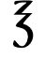
pint ~ pt.
quart ~ qt.
gallon ~ gal.

Example:

Using the aforementioned conversions we can use dimensional analysis to figure out how many inches are in one mile.

Practice Problem

How many teaspoons are in one gallon?

768 teaspoons

Review

- The system of measurement most commonly used in the United States is the __________ or __________ system.

- Quart and fluid ounce are household units that measure __________.

- Pound and ounce are household units that measure __________.

- Yard and inch are household units that measure __________.
1) household or English 2) volume 3) weight 4) length 5) fluid ounce 6) teaspoon 7) pint 8) pound 9) foot 10) ounce
Interpret these abbreviations

- f = __________
- tsp = __________
- pt. = __________
- lbs. = __________
- ' = __________
- oz. = __________
The Metric System

In 1790, in the midst of the French Revolution, the National Assembly of France requested the French Academy of Sciences to "deduce an invariable standard for all the measures and all the weights."

The Commission appointed by the Academy created a system that was, at once, simple and scientific. The unit of length was to be a portion of the Earth's circumference. Measures for capacity (volume) and mass were to be derived from the unit of length, thus relating the basic units of the system to each other and to nature. Furthermore, larger and smaller multiples of each unit were to be created by multiplying or dividing the basic units by 10 and its powers. This feature provided a great convenience to users of the system, by eliminating the need for such calculations as dividing by 16 (to convert ounces to pounds) or by 12 (to convert inches to feet). Similar calculations in the metric system could be performed simply by shifting the decimal point Thus, the metric system is a "base-10" or "decimal" system.

The metric system is based on three basic units, meter(m) for length, gram(g) for weight, and liter(L) for volume. You can use the following prefixes to describe larger and smaller units of meters, grams, and liters:

Factor | Name | Symbol
10⁹ | giga | G
10⁶ | mega | M
10³ | kilo | k
10² | hecto | h
10¹ | deka | da
1 | base unit | (m, g, L)
10⁻¹ | deci | d
10⁻² | centi | c
10⁻³ | milli | m
10⁻⁶ | micro | mc, µ
10⁻⁹ | nano | n
10⁻¹² | pico | p

Based on the table above, 1.1 gigaliters would equal 1.1 × 10⁹ liters or 1,100,000,000 liters.

Some common conversions within the metric system include:

Length
10 mm = 1 cm
1,000 mm = 1 m
100 cm = 1 m
1,000 m = 1 km
Weight
1,000 mcg = 1 mg
1,000 mg = 1 g
1,000 g = 1 kg
Volume
1 mL = 1 cc
1,000 mL = 1 L
1,000 cc = 1 L
Example:

Using the aforementioned conversions we can use dimensional analysis to figure out how many centimeters are in one kilometer.

Practice Problem

How many micrograms are in one kilogram?

1,000,000,000 micrograms

Review

- The measurement system most commonly used in prescribing and administering medication is the __________ system.

- Liter and milliliter are metric units that measure __________.

- Gram and milligram are metric units that measure __________.

- Meter and millimeter are metric units that measure __________.
Interpret these abbreviations

- mcg = __________

- mL = __________

- cc = __________

- g = __________

- mm = __________

- kg = __________
1) metric 2) volume 3) weight 4) length 5) microgram 6) milliliter 7) cubic centimeter 8) gram 9) millimeter 10) kilogram

Converting between household units and metric units

One of the common challenges of health care is that we are often given units in the English (or household) system, but we will need to convert them to metric to do our jobs. The following are some of the more common conversions:

Length
1 in. = 2.54 cm
1 m = 1.09 yds.

Weight
1 lb. = 454 g
1 kg = 2.2 lbs
1 oz. = 28.4 g

Volume
1 tsp = 5 mL
1 Tbsp = 15 mL
1 fl. oz. = 29.6 mL (usually approximated to 30 mL)
1 pt. = 473 mL (usually approximated to 480 mL)

Practice Problem

Your instructor is 6' 1” and weighs 165 lbs. What is his height in meters, and his weight in kilograms?

Height: 1.85 m Weight: 75 kg

Worksheet 7-1
Name:

Date:

Make the following conversions.

- 1 L = ________ ml
- 10 cc = ________ ml
- 697 ml = ________ L
- 2.6 L = ________ ml
- 0.25 L = ________ cc
- 2.5 kg = ________ g
- 415 g = ________ kg
- 2,160 mg = ________ g
- 8.9 mg = ________ mcg
- 200 g = ________ lb
- 4 liters = ________ qt
- 50 miles = ________ km
- 5 m = ________ in
- 3 in = ________ cm
- 4 lb = ________ kg
- 50 g = ________ oz
- 5 fl oz = ________ cc
- 2 qt = ________ ml
- 2 kg = ________ oz
- 2.5 L = ________ fl oz
- 20 oz = ________ kg
- 5' 3” = ________ m
Solve the following word problems.

- A neonatal patient needs to receive a medication based on their weight in grams. The patient weighs 4 lbs 6 oz. How many grams does the baby weigh?

- If Richard Stallman weighs 220 lbs, how much does he weigh in kg?

- A physician writes for 137 mcg of levothyroxine by mouth once a day. All the levothyroxine tablets on your shelves are measured in mg. How many mg will each tablet need to be?

Worksheet 7-2
Name:

Date:

Make the following conversions. Feel free to use the estimated numbers for milliliters to fluid ounces and pints.

- 205 lb = kg
- 9,080 g = lb.
- 5' 10” = inches = cm = m
- 4 lb 8 oz. = oz. = g = kg
- 960 mL = fl. oz. = pt.
- 1,920 mL = qt.
- 3 tsp = mL = Tbl = f
- 2 pt. = cups = oz. = mL
- 0.75 gal = qt. = pt. = mL = L
- 7 lb 6 oz. = kg
- 6' 2” = m
- 1.5 cups = cc
- 5 L = gal
- 172 lb. = kg
- 1/3 tsp = mL

Solve the following word problems.

- If you purchased one-half ounce of papaverine hydrochloride and fill two prescriptions, one for 1.50 g and one for 0.125 oz., how many grams of papaverine hydrochloride do you have left in stock?

- You're working in a pharmacy and receive the following prescription:

Rx Cefaclor 250 mg/5mL
Disp: 150 mL
Sig.: Take 375 mg by mouth two
times a day for 10 days.

a) How many tsp should the patient take for each dose.

b) Did the physician write for you to dispense enough to cover a 10 day supply?

- You're working in a pharmacy and receive the following prescription:

Rx Erythromycin 200 mg/5mL
Sig.: Take 200 mg by mouth three
times a day for 5 days.

a) How many tsp should the patient take for each dose.

b) How many mL should you dispense to cover a 5 day supply?

The Apothecary System

Although fast becoming obsolete, the apothecary system for weighing and calculating pharmaceutical preparations is still used and must be taken into consideration. It has two divisions of measurement: weight and volume. In this system, the basic unit of weight is the grain, and the basic unit of volume is the minim. Some common conversions within the apothecary system are:

Weight
ounce () = 8 drams = 480 grains
dram () = 3 scruples = 60 grains
scruple (Э) = 20 grains
grain (gr) = 1 grain
Volume
fluid ounce (f ) = 8 fluid drams = 480 minims
fluid dram (f ) = 3 fluid scruples = 60 minims
fluid scruple (f Э) = 20 minims
minim (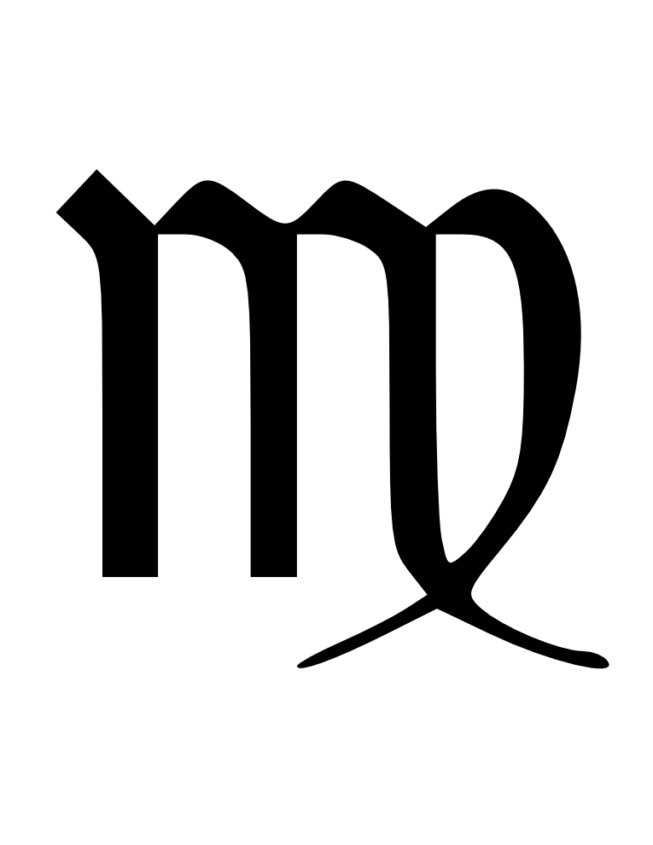) = 1 minim
drop (gtt) = 1 minim

How apothecary units are written

In metric you write units of measurement in this order:

number of units + unit wanted

Examples:

350 mg = three hundred fifty milligrams
1.8 m = one point eight meters

But in the apothecary system you write units of measurements in this order:

unit wanted + number of units (often written in Roman numerals)

Examples:

gr ii = two grains
gtt xii = twelve drops

While this is the order in which these systems of measurement are usually written, you will see them in other orders.

Another item worth noting is that apothecary units frequently add in a Latin abbreviation with the Roman numerals to gain a subdivision between units. This Latin abbreviation is ss, which equals 0.5 and is often read as the fraction one-half.

Example:

gr iiss = two and one-half grains

Practice Problems

Let's write the meaning or symbols of the given dosages:

- f iiiss
- ix
- five drams
- three drops
- three and one-half grain
- two hundred fifty cubic centimeters
1) three and one-half fluid ounces 2) nine minims 3) v 4) gtt iii 5) gr iiiss 6) 250 cc

Now, let's look at using dimensional analysis to make some conversions within the apothecary system.

Example:

Convert iiiss to gr.

or

Practice Problems:

- Convert f xvi to f.

- Convert 90 gr to .

1) f ii 2) iss

Review

- The measurement system dating back to the 11th century and still occasionally used in prescribing and administering medication is the __________ system.

- Fluid dram and minim are apothecary units that measure __________.

- Dram and grain are apothecary units that measure __________.

Provide the appropriate symbol for each unit.

- ounce = __________

- scruple = __________

- grain = __________

- fluid dram = __________

- minim = __________

- drop = __________
1) apothecary 2) volume 3) weight 4) 5) Э 6) gr 7) f 8) 9) gtt
Conversions

Now for some tables with all the pertinent conversions needed for this chapter.

Apothecary  Volume  1 = 1 gtt  60 = 1 f  8 f = 1 f  Weight  60 gr = 1  8 = 1 | Household  Length  12 in = 1 ft  Volume  3 tsp = 1 Tbs  8 fl oz = 1 cup  16 fl oz = 1 pt  Weight  16 oz = 1 lb | Metric  Length  100 cm = 1 m  Volume  1 cc = 1 ml  1000 ml = 1 L  Weight  1000 ng = 1 mcg (μg)  1000 mcg (μg) = 1 mg  1000 mg = 1g  1000 g = 1 kg

 | Apothecary | Household | Metric
Length |  | 1 in. | 2.54 cm
Volume | 1 or 1 gtt |  | 0.06 ml
 | 1 f |  | 3.6 ml (occasionally rounded all the way up to 5 mL)
 |  | 1 tsp | 5 ml
 |  | 1 Tbs | 15 ml
 | 1 f |  | 28.4 ml (usually rounded to 30 ml)
 |  | 1 f | 29.6 ml (usually rounded to 30 ml)
 |  | 1 pt | 473 ml (usually rounded to 480 ml)
Weight | 1 gr |  | 64.8 mg (60 or 65 mg is frequently used)
 |  | 1 | 28.4 g (sometimes rounded to 30 g)
 | 1 |  | 31.1 g (sometimes rounded to 30 g)
 |  | 1 lb | 454 g
 |  | 2.2 lb | 1 kg

Something to pay careful attention to is how far many of the apothecary units are rounded. This can be difficult when trying to figure out how many milligrams of thyroid medication to dispense when a physician orders it in grains or how many milliliters to dispense of an antibiotic suspension when a physician doses it in fluid drams.

On the back of this page, we will look at some examples and practice problems.
Example:

Convert iiiss to g.

or

If you used rounded numbers you could have been as low as 12.6 grams or as high as 13.7 grams, which is something that can be difficult to keep track of when looking at the answers that others may achieve.

Practice Problems:

- If someone orders gr v of ferrous sulfate, may I give them a 300 mg tablet of ferrous sulfate?

- If someone orders gr i of thyroid medication, may I give them a 65 mg tablet?

- If I make 120 ml of GI Cocktail, will I be able to fit it in an amber vial marked 'iv f'?

1) Yes, but it requires you to do the calculation using 60 milligrams per grain. 2) Yes, but this time you need to do the calculation using 65 milligrams per grain. 3) Yes, remember that 1 fluid ounce is usually rounded to 30 milliliters.

Worksheet 7-3
Name:

Date:

Perform the appropriate conversions to solve the following problems and also write the appropriate symbol or abbreviation above each problem.

- 1 ounce = _____ drams
- 1 dram = _____ grains
- 1 fluid ounce = _____ fluid drams
- 1 fluid dram = _____ drops
- 1 drop = _____ minim
- 1 meter = _____ centimeters
- 1 meter = _____ millimeters
- 1 kilogram = _____ grams
- 1 gram = _____ milligrams
- 1 milligram = _____ micrograms
- 1 microgram = _____ nanograms
- 1 liter = _____ milliliters
- 1 liter = _____ cubic centimeters
- 1 cubic centimeter = _____ milliliter
- 1 foot = _____ inches
- 1 pound = _____ ounces
- 1 gallon = _____ quarts
- 1 quart = _____ pints
- 1 pint = _____ cups
- 1 pint = _____ fluid ounces
- 1 cup = _____ ounces
- 1 ounce = _____ tablespoons
- 1 tablespoon = _____ teaspoons
- 1 grain = _____ milligrams
- 1 fluid ounce = _____ milliliters
- 1 drop = _____ milliliters
- 1 inch = _____ centimeters
- 1 kilogram = _____ pounds
- 1 pound = _____ grams
- 1 ounce (household) = _____ grams
- 1 pint = _____ milliliters
- 1 tablespoon = _____ teaspoons
- 1 teaspoon = _____ millilters
- 3 teaspoons = _____ fluid ounces
- 960 milliliters = _____ pints
- 20 drops = _____ milliliters
- 6 foot 1 inch = _____ centimeter
- 165 pounds = _____ kilograms
- 8 pounds 13 ounces = _____ kilograms
- 7.5 milliliters = _____ teaspoons
- 4 fluid drams = _____ milliliters
Worksheet 7-4
Name:

Date:

Solve the following problems, and know that when reviewing answers in class or with other students, some problems may have a small range of acceptable answers.

- gr xvi = _____
- 150 gr = _____
- gr iii = _____ mg
- f viii = f_____
- fss = f _____
- 90 mL = f_____
- f viii = _____ pt
- f ss = _____ gtt
- f iii = _____ mL
- 120 mg = gr _____
- ii = _____ g
- 30 mL = f _____
- f iv = _____ mL
- 6 oz. = _____ g
- 97.2 mg = gr _____
- 60 mL = f _____
- 75 mL = f_____
- 15.5 g = _____
- 195 mg = gr _____
- 120 mL = f_____
- f iv = _____tsp
- 125 mL = _____tsp
- 120 mL = _____tsp
- 240 mL = f _____
- 15 mg = gr_____
- gr xv = _____mg
- 10 mg = gr_____
- 2.5 g = gr_____
- 42 kg = _____lb
- 44 lb = _____kg
- f vi = _____mL

Solve the following word problems.

- During the total course of his treatment, a patient will receive 720 mL of medication. How many pints will he receive?
- If an order calls for the patient to receive 2 tsp of cough syrup, how many milliliters of syrup should the patient receive?

- A patient weighs 65 kg. How many pounds does she weigh?

- A patient weighs 187 lbs. How many kilograms does he weigh?

- A physician orders eight fluid drams of liquid medication per dose. How many tablespoons should the patient take.

- A patient drinks 2 pt of liquid during the morning. How many milliliters did the patient drink?

- An order is for gr iii of medication. How many milligrams should the patient be given?

- A physician orders that a patient be given gr ss three times a day. How many milligrams will the patient receive in a day?

- An order calls for 1.5 Tbs of medicated mouthwash. How many milliliters should the patient receive?

Worksheet 7-5
Name:

Date:

Complete the following equivalences.

- 1 m = _____cm
- 1 cm = _____mm
- 1 L = _____ml
- 1 m = _____mm
- 1 cc = _____ml
- 1 kg = _____g
- f i = f _____
- gtt i = _____
- 1 Tbs = _____tsp
- 1 ft = ______in
Change the following measurements to the desired unit (feel free to use approximations for fluid ounces, as this is what you will commonly do in practice and when taking the Pharmacy Technician Certification Exam).

- 3.6 m = ________mm
- 47 cm = ________m
- 9.4 cm = ________mm
- 482 ml = ________L
- 3.9 L = ________ml
- 3.6 g = ________mg
- 2 oz = ________g
- 0.5 lb = ________g
- 2 fl oz = ________cc
- 5.08 cm = ________in
- gr xc = ________
- gr xvss = ________g
- 90 ml = ________Tbs
- 5 tsp = ________ml
- 3 tsp = ________Tbs
- 120 lb = ________kg
- 93 lb = ________kg
- 3 lb 4.5 oz = ________g
- 1 lb 5.2 oz = ________g
- 5'11” = ________m
- 36” = ________cm
- iii = gtt________
- xvii = ________ml
Select the best possible answer for the next two multiple choice problems.

- 1/200 gr nitroglycerin SL = ________mg

You get a prescription for the above. Which product will you dispense?

a) Nitrostat 0.3 mg (nitroglycerin)
b) Nitrostat 0.4 mg (nitroglycerin)
c) Nitrostat 0.6 mg (nitroglycerin)
d) Nitrobid 2.5 mg capsules (nitroglycerin)
- gr v ferrous gluconate = _______mg

A patient tells you her doctor wanted her to take one of these every day. Which product will you recommend?

a) ferrous sulfate 324 mg tablets
b) ferrous fumarate 324 mg tablets
c) ferrous gluconate 240 mg tablets
d) ferrous gluconate 325 mg tablets

Solve the following word problems.

- A physician tells a patient to drink 2400 mL of fluid per day. How many cups of liquid should this patient drink?

- Several months ago, a patient weighed 95 kg. When he comes in for his next appointment, he tells you that he lost 11 lbs. If he is correct, how many kilograms should he weigh?

Worksheet 7-6 (tougher problems)
Name:

Date:

Convert the following recipes to metric

- The following is a historic formula for a cough ball to be used in a horse:
Rx Ipecacuanha (powdered ipecac) i
Codeine sulfate gr x
Powdered digitalis i
Honey qs to form 1 ball (which will weigh ss)

Hint: honey has a specific gravity of 1.425 g/mL according to the U.S.P.

- The following recipe is similar to Vick's VapoRub
Rx Camphor 2/3
Eualyptol gr x
Menthol ss
Petrolatum qs ii

- The following is the real recipe for BC Powder
Rx ASA gr x
Caffeine gr ss
Salicylamide gr iii

- The following is similar to the original Milk of Magnesia (MOM)
Rx Magnesium Hydroxide Powder x
Sodium Hypochlorite Powder i
Purified Water qs pt i

How many mg of magnesium hydroxide are in 2 tbs of this?

- “BROMPTON'S COCKTAIL”
Rx Morphine Powder gr i
Cocaine HCl gr i
Simple Syrup f ss
90% Ethanol qs f ii

How many mg of morphine and how many mg of cocaine are in 1 tsp?
Worksheet 7-7
Name:

Date:

Complete the following equivalences.

- 1 g = ________mg
- 1 m = ________cm
- 1 L = ________mL

Change the following measurements to the desired unit.

- 5.8 m = ________cm
- 92 cm = ________m
- 3.7 L = ________mL
- 247 mL = ________L
- 4.6 L = ________mL
- 1400 mg = ________g
- 4.2 kg = ________g
- 1.4 m = ________in
- 5 oz = ________g
- 0.6 lb = ________g
- 5 qt = ________L
- 3 fl oz = ________cc
- 7.62 cm = ________in
- 5 L = ________qt
- 6.6 lb = ________kg
- 450 g = ________oz
- 150 fl oz = ________mL
- 18 mL of water is ________cc of water.

Write the name or the abbreviation of the following apothecary and household units.

- grain
- ounce
- fluid ounce
- pint
- tablespoon
- tsp
- gtt
- qt
- f

Give the following relationships.

- f i = _______mL
- i = ________mL
- i = ________g
- gtt i = ________mL
- gr i = ________mg
- gtt i = ________
- 1 tsp = ________mL
- 1 Tbs = ________tsp

Make these conversions.

- gr xc = ________
- gr ss = ________mg
- xvi = ________
- f iii = ________
- 150 = f ________
- 0.5 pt = f________
- 2 tsp = ________mL
- gr iii = ________mg
- 40 = ________mL
- 10 g = gr ________
- i = ________mg

