
CHAPTER 10
BASIC INFUSION CALCULATIONS
Who wouldn't want to solve an alligation, after all it's more like playing Tic-Tac-Toe than math.
--Sean Parsons

Now the math starts to get really exciting as we look at calculations involving infusions. We will look at five major concepts in this section:

- diluting stock solutions,
- infusion rates,
- dosages based on body weight,
- body surface area, and
- pediatric dosing.

Diluting Stock Solutions

A stock solution is a concentrated solution from which less-concentrated solutions can be made. The stock solution is diluted with a solvent (sometimes also referred to as a diluent), which may be water or some other liquid substance. Two questions must be answered to solve a dilution problem.

- What volume of the stock solution must be diluted to make the ordered solution?
- What volume of solvent must be added to perform the dilution?

These questions can be answered using ratio-proportions, the dilution formula, or the alligation method . We will review all three possible methods.

Solving dilutions using the ratio-proportion method.

We have previously learned how to solve problems using the ratio-proportion method, but in order to solve dilution problems you will actually need to perform two ratio-proportions. Let's look at an example problem on the next page to demonstrate how this works.

Example

If 500 mL of a 5% solution is ordered, how much of a 25% stock solution is needed to prepare the 5% solution?
QUESTION
How much stock solution is needed (we are looking for a volume)?
DATA
final volume is 500 mL final concentration is 5% and
stock volume is ??? stock concentration is 25% and
MATHEMATICAL METHOD / FORMULA
ratio-proportion
DO THE MATH
First, we need to figure out how much active ingredient is in our final solution:

When you solve for N you will find:

Which means we will need to figure out how much volume of the stock solution is required to provide 25 g of drug.

When you solve for N you will find:
of stock solution is required.
DOES THE ANSWER MAKE SENSE?
Yes

Even though there is an extra problem involved, the ratio-proportion method is convenient because it is building on skills you have previously learned. Looking again at the problem we just solved, you will often also need to know how much solvent or diluent is required. In this scenario since we know what are final volume is, and what volume of stock solution is required we can logically ascertain that are final volume minus are stock volume will equal how much diluent is required:

500 mL – 100 mL = 400 mL of diluent

Try the practice problem on the next page to reinforce these concepts.

Practice Problem

A 500 mL bag of 20% mannitol is ordered. 50% mannitol is the available stock solution. How much of the stock solution is needed to make this bag?

QUESTION

DATA

MATHEMATICAL METHOD / FORMULA

DO THE MATH

DOES THE ANSWER MAKE SENSE?
200 mL of stock solution

Now that you've solve that, also figure out how much diluent would be required to make the above IV bag?
300 mL of diluent

You will have more opportunities to practice this problem solving method shortly, but first I would like to introduce you to two new problem solving methods the dilution formula and the alligation method. We will look at the dilution formula first.

Solving dilutions using the dilution formula.

The dilution formula is exactly what it sounds like, a formula to make it quicker to solve dilutions. Without any further ado, let's concentrate our attention on the formula below:

The Dilution Formula

C₁Q₁ = C₂Q₂

C₁ = concentration of available stock solution
Q₁ = quantity of available stock solution needed
C₂ = concentration of ordered solution
Q₂ = quantity of ordered solution needed

Let's look at our previous example and solve it using the dilution formula.

Example

If 500 mL of a 5% solution is ordered, how much of a 25% stock solution is needed to prepare the 5% solution?
QUESTION
How much stock solution is needed (we are looking for a quantity)?
DATA
C₁ = stock concentration is 25%
Q₁ = stock quantity is ???
C₂ = final concentration is 5%
Q₂ = final quantity is 500 mL
MATHEMATICAL METHOD / FORMULA
dilution formula
DO THE MATH
C₁Q₁ = C₂Q₂

To solve for Q₁ we will need to get is by itself (isolate it) by dividing both side by 25%.

of stock solution
DOES THE ANSWER MAKE SENSE?
Yes, especially since it is the same answer we derived using the ratio-proportion method.

And if we needed to solve for the quantity of diluent required, we would use the same logic as last time, are final volume minus our stock volume will equal how much diluent is required:

500 mL – 100 mL = 400 mL of diluent

Try the practice problem on the following page to reinforce this concept.

Practice Problem

You are instructed to make 1000 cc of a 0.8% solution. You have in stock a 95% solution. How much of the stock solution will you use?

QUESTION

DATA

MATHEMATICAL METHOD / FORMULA

DO THE MATH

DOES THE ANSWER MAKE SENSE?
8.4 cc of stock solution

Now that you've solve that, also figure out how much diluent would be required to make the above solution?
991.6 cc of diluent

Solving dilutions using the alligation method.

The dilution formula is a very useful tool as it is quick and easy, but it will not work in certain circumstances, such as when no diluent is being used but instead multiple stock solutions of varying concentration are being mixed together. One tool that might be useful then is the alligation method. Also, depending on what information is present, the alligation method can also be useful for solving many dilution problems.

Below, we have a diagram explaining the alligation method. Based on the appearance of an alligation, you can see why it is sometimes referred to as the Tic-Tac-Toe method.

- Place the highest concentration in the upper left-hand corner
highest concentration
lowest concentration
desired concentration
parts of highest concentration
parts of lowest concentration
- Place the lower concentration in the lower left-hand corner
- Place the desired concentration in the center
- Find the difference between the highest concentration and the desired concentration to find the parts of lowest concentration
- Find the difference between the lowest concentration and the desired concentration to find the parts of highest concentration
- Add the parts of highest concentration and the parts of lowest concentration to find the total parts
total parts
- This provides you with a ratio that you can use to finish solving the problem.

The alligation method looks very abstract at first, but becomes much easier when we start using real numbers. Let's attempt the same example problem we've previously used with both the ratio-proportion method and the dilution formula on the next page

Example

If 500 mL of a 5% solution is ordered, how much of a 25% stock solution is needed to prepare the 5% solution? How much diluent is needed?

QUESTION
How much stock solution is needed (we are looking for a quantity)?
How much diluent is needed (we are looking for a quantity)?
DATA
high concentration = 25%
desired concentration = 5%
low concentration = 0% (the diluent has no drug in it, therefore it has a 0% concentration)
final quantity = 500 mL
MATHEMATICAL METHOD / FORMULA
alligation method
DO THE MATH
25%
0%
5%
5
20

25

DOES THE ANSWER MAKE SENSE?
Yes, although we may need to look at some more practice problems to help this method make sense.

Let's look to the next page and attempt another problem using this same method.

Practice Problem

200 cc of a 15% solution is ordered. A 30% solution is available. How much stock solution is needed, and how much solvent must be added to prepare the 15% solution?

QUESTION

DATA

MATHEMATICAL METHOD / FORMULA

DO THE MATH

DOES THE ANSWER MAKE SENSE?
100 cc of a 30% solution; 100 cc of solvent

Now, let's try a few more practice problems but use whichever method(s) you wish to perform the necessary calculations. The answers are on the next page.

- 1000 cc of a 2% solution is needed. A 40% stock solution is available. How much stock solution is needed, and how much solvent must be added to prepare the 2% solution?

- Respiratory needs you to make 3 mL of 3% sodium chloride. Your stock solution has a concentration of 14.6% sodium chloride. How many mL of stock solution will you need and how much sterile water will you need to add?

- You are instructed to make 240 mL of a 0.45% solution. You have a 100% stock solution. How much of the stock solution will you use, and how much diluent will be needed?

- Prepare 3 mL of a 1% phenobarbital solution from a 6.5% stock solution. How much stock solution and how much diluent are needed to make the 1% solution?

1) 50 cc of stock solution; 950 cc of solvent 2) 0.62 mL of stock solution; 2.38 mL of sterile water 3) 1.08 mL of stock solution; 238.92 mL of diluent 4) 0.46 mL of stock solution; 2.54 mL of diluent

There will be times when only one of the three methods may be appropriate for solving a particular dilution or alligation, but in this section most of the problems will be written in such a way that any of the three methods (ratio-proportion, dilution formula, or alligation method) will be viable options for solving the problems.

Worksheet 10-1
Name:

Date:

Solve the following dilution problems.

- 40 cc of a 10% solution are ordered. A 50% stock solution is available. How much stock solution is needed, and how much solvent must be added to prepare the 10% solution?

- 1000 cc of a 10% solution is ordered. How much of a 25% stock solution is needed to prepare the 10% solution? How much solvent must be added to prepare the 10% solution?

- 500 mL of a 20% solution is ordered. How much of a 50% stock solution is needed to prepare the 20% solution? How much solvent must be added to prepare the 20% solution?

- 500 cc of a 2% solution is needed. A 40% stock solution is available. How much stock solution is needed and how much solvent must be added to prepare the 2% solution?

- 200 cc of an 8% solution is ordered. A 20% stock solution is available. How much stock solution is needed, and how much solvent must be added to prepare the 8% solution?

- 20 cc of a 10% solution are ordered. A 40% stock solution is available. How much stock solution is needed, and how much solvent must be added to prepare the 10% solution?

- A physician makes a special request for a 500 mL bag of 3% sodium chloride (hypertonic saline solution). How much 14.6% sodium chloride and how much sterile water for injection will you need to fulfill his request?

- You receive an order for a 250 mL bag with 20% mannitol. You have 50% stock bottles of mannitol. How many mL of mannitol and how many mL of diluent will you need to make this order?

- A physician orders 8 fl. oz. of a 1% povidone-iodine wash. You have a 10% povidone-iodine wash in stock. How many mL of stock solution and how many mL of diluent will you need to prepare the physician's order?

- A physician orders a liter of 0.25% sodium hypochlorite solution (often referred to as half-strength Dakin's Solution). On hand in the pharmacy is a 5.95% stock solution of sodium hypochlorite. How many mL of stock solution and how many mL of diluent will you need to prepare the physician's order?

Problem 11 can only be solved by doing three ratio-proportions.

- If you mix 100 mL of a 1% solution with 350 mL of a 0.5% solution, what is the percentage strength of the final solution?

Problem 12 can only be solved using the alligation method.

- You have on hand 70% dextrose stock solution and 40% dextrose stock solution. You are to prepare 1000 mL of 45% dextrose solution. How many mL of each stock solution will you need?

Infusion Rates

Infusion rates can be requested in many different ways:

- Infuse at 125 mL/hr
- Infuse 1000 mL over 8 hours
- Infuse 10 mg per minute
- Infuse at a drip rate of 32 gtt/min

So when discussing parenterals we can define an infusion rate a a quantity of drug per a quantity of time:

When looking at infusion rates, let's start with drip rates. In many modern settings pumps will be used to infuse IV solutions, but sometimes when there are equipment failures, or times of excessively high census, IVs may need to be timed with an old fashioned drip chamber (also called a venoclysis set). You can use factor label to solve these kinds of problems to find your rate of flow. A drip rate is a specific kind of infusion rate, it is the quantity of drops being infused every minute.

drip chamber pictured above
(a.k.a., venoclysis set)

Something to keep in mind is that whenever measuring a drip rate you must use a whole number of drops as you can not cut a drop in half while it is falling. Therefore, you should use general rounding rules. If something calculated out to be 15.5 drops/minute you would set the drip rate to be 16 drops/minute and if another drip rate worked out to be 33.3 drops/minute you would set the drip rate at 33 drops/minute. Another point to make is that the drip rate should seem reasonable, such as you could have a drip rate of 20 drops/minute but not 2,000 drops per minute as you can't accurately count drops that fast.
In order to solve these problems we also need to introduce a new term, drop factor. A drop factor, simply put, is the number of drops that add up to 1 cc; and it is important to note that various administration sets will produce different sizes of drops. So if a particular administration set had a drop factor of 15, it would mean that you would have to count 15 drops in the drip chamber to equal 1 cc.

Common drop factors for standard tubing include 10,15, and 20 drops/mL. Microdrip tubing sets have a drop factor of 60 drops/mL. So, let's look at an example problem where we are solving for the drip rate. You will find that dimensional analysis tends to be a useful method for solving these problems.

Example

A 1000 cc bag of NS is set to run for 5 hours. The infusion set has a drop factor of 20. What is the drip rate?

QUESTION
What is the drip rate?
DATA
1000 cc 5 hours drop factor of 20 = 20 gtt/cc
a potentially useful conversion:
1 hour/60 minute
MATHEMATICAL METHOD / FORMULA
dimensional analysis
DO THE MATH

DOES THE ANSWER MAKE SENSE?
Yes

Notice how we can conveniently divide our amount of solution by the quantity of time it is being infused over and then just start canceling everything out until we arrive at the units we are looking for. Let's use the above example as a template to attempt a practice problem on the next page.

Practice Problem

An I.V. bottle containing 500 cc is set to run for 3 hours with a drop factor of 15 gtt/cc. What is the drip rate?

QUESTION

DATA

MATHEMATICAL METHOD / FORMULA

DO THE MATH

DOES THE ANSWER MAKE SENSE?
42 gtt/minute

Now, lets do a few more practice problems.

Practice Problems

- An IV bottle containing 1000 cc of solution is set to run 5 hours with a drop factor of 10 gtt/cc. What is the drip rate?

- Calculate the drip rate for an I.V. solution containing 2000 cc of solution with a drop factor of 15 set to run 15 hours.

- An I.V. solution of 1200 cc is set to run 8 hours with a drop factor of 20. What is the drip rate?

- An I.V. solution of 500 cc is using microdrip tubing set to run over 10 hours with a drop factor of 15. What is the drip rate?

1) 33 gtt/minute 2) 33 gtt/minute 3) 50 gtt/minute 4) 50 gtt/minute
Continuing with the concept of infusion rates let's look at some other infusion rate examples:

- If a 1 liter bag of D5W is run through an IV over eight hours, what is the rate of infusion in mL/hr?

- An order is for Heparin IV to infuse at 1000 units/hr. What will be the flow rate in mL/hr for a 500 mL bag of D5W with 25,000 units of heparin?

- If a 1 liter bag of D5W is started on a patient at 1400 hours on Tuesday, when will the next bag be needed if it is running at a rate of 50 mL/hr?

This means the next bag won't be needed till 1000 on Wednesday.

Now, lets do a few more practice problems.

Practice Problems

- If a 500 mL bag of 0.9% NaCl is run over 8 hours, what is the rate of infusion in mL/hr?

- A patient is on a heparin drip, 12,500 units in 250 mL of half-normal saline. He is to receive 1500 units per hour. At what rate (mL/hr) should the drug be infused?

- If a 1 liter bag of NSS is started on a patient at 1200 hours on Tuesday, when will the next bag be needed if it is running at a rate of 100 mL/hr?

1) 62.5 mL/hr 2) 30 mL/hr 3) 2200 on Tuesday

Worksheet 10-2
Name:

Date:

Solve the following problems.

- An I.V. solution of 1000 cc is set to run over 8 hours with a drop factor of 15, what is the drip rate?

- The physician orders 3000 mL to be infused over 24 hours and the IV set has a drop factor of 20 gtt/mL, what will the drip rate need to be?

- A medication order calls for 1 L of D5W to be administered over an 8 hour period. Using an IV administration set that delivers 10 gtt/mL, how many drops/minute should be delivered to the patient?

- Ten mL of 10% calcium gluconate injection and 10 mL of multivitamin infusion are mixed with 500 mL of D5W. The IV solution is to be infused over 5 hours. If the administration set has a drop factor of 15 what should the drip rate be? (Hint: don't forget to calculate the total volume that is being infused.)

- A 50 mL IVPB bag of ampicillin 500 mg in Normal Saline is to be run in over 20 minutes. What is the infusion rate in mL/hr?

- What is the flow rate in mL/hr for a TPN containing 500 mL of D10W, 500 mL of 7% amino acids, and 36 mL of micronutrients if it is run in over 16 hours?

- A 50 mL IVPB contains 500,000 units of penicillin G potassium. The rate of infusion ordered by the physician is 120 mL/hr. How long will the IVPB take to infuse?

- If a 1 liter bag of D5W is started on a patient at 2200 hours on Tuesday, when will the next bag be needed if it is running at a rate of 200 mL/hr?

- A 100 mL bag containing 0.5 mg octreotide is to be infused at 50 mcg/hr. How many mL/hr will you need to set the pump to?

- A patient received a 500 mL whole blood transfusion starting at 2113 at a rate of 180 mL/hr. At what time was the transfusion completed?

- A physician orders a 1200 mL hyperalimentaion to infuse over 24 hours. The pharmacy has in stock standard tubing with a drop factor of 10 and microdrip tubing with a drop factor of 60. Which tubing should the pharmacy send with the hyperalimentation and why?

Dosages Based on Body Weight

Many drugs need to be calculated based on body weight. Some of the drugs where you will see this most often include:

- chemotherapy,
- steroids,
- antibiotics,
- heparinoids, and
- drugs for pediatric and geriatric patients

If a medication dose is to be based on a body weight it will usually be requested in mg/kg.

If a medication is ordered as 5mg/kg and the patient weighs 100kg you will need 500mg of drug.

Example

A physician orders cyclophosphamide to be given 5 mg/kg qid in 50mL D5W. The patient weighs 132 pounds. If the concentration of the drug available is 500 mg/10mL, how many mL should be added to each bag?

QUESTION
How many mL should be added to each bag?
DATA
5 mg/kg qid 50 mL of D5W 132 lbs 500 mg/10 mL
a potentially useful conversion:
1 kg/2.2 lbs
MATHEMATICAL METHOD / FORMULA
dimensional analysis
DO THE MATH

DOES THE ANSWER MAKE SENSE?
Yes

Notice that there was a lot of unnecessary information in the problem, and that you needed to use a conversion to solve the problem.
Sometimes you will need to incorporate additional units (such as time) into weight based dosage calculations. Let's look at an example of this.

Example

You are asked to set the infusion rate for a patient's Remodulin, which is being infused via a CAD pump? The physician ordered 104 ng/kg/min. You pull up the patient's profile and verify the troprostenil cassette with 20 mg of troprostenil and 98 mL of NS has a total volume of 100 mL, and you confirm the patients weight of 58 kg that you have on file is correct. How many mL/day will you need to set this pump to?

QUESTION
How many mL/day will you need to set this pump to?
DATA
104 ng/kg/min 20 mg 98 mL NS 100 mL total volume 58 kg
a potentially useful conversion:
1 mcg/1000 ng 1 mg/1000 mcg 60 min/hr 24 hr/day
MATHEMATICAL METHOD / FORMULA
dimensional analysis
DO THE MATH

DOES THE ANSWER MAKE SENSE?
Yes

Notice that minutes from 104 ng/kg/min were kept with the kg for mathematical purposes. Often, when given a value with multiple '/' the unit after the kg will be kept with the unit of time. Besides minutes, you will also see hours, days, and doses kept with the kg.

Let's do a few practice problems.

Practice Problems

To do these next four problems let's create a scenario where the 165 pound author of this textbook is in a terrible car accident and requires the spinal cord protocol for two methylprednisolone infusions.

- First, you need to make a bolus dose of 30 mg/kg in 50 mL of NS. How many mg of methylprednisolone will you need to make the bolus dose? (The bolus dose will be infused over 1 hour)

- If methylprednisolone comes in a double chamber vial with a concentration of 1 g/8 mL, how many mL will you need to add to the 50 mL bag of NS?

- After the bolus dose is infused, your instructor will need a continuous infusion of methylprednisolone at a rate of 5.4 mg/kg/hr for 23 hours. How many mg of methylprednisolone will you need to make the continuous infusion?

- The continuous infusion is to be administered with normal saline as the diluent. If the final bag has to have an exact volume of 1000 mL, how many mL methylprednisolone will be needed since it comes in a double chamber vial with a concentration of 1 g/8 mL and how many mL of NS will be needed?
1) 2,250 mg 2) 18 mL 3) 9,315 mg 4) 74.5 mL of methylprednisolone and 925.5 mL of normal saline

Worksheet 10-3
Name:

Date:

Solve the following problems.

- Ceftazidime is ordered for a 55 pound pediatric patient at a dosage of 150 mg/kg/day to be infused over 24 hours. The drug when reconstituted has a concentration of 100 mg/mL. How many mL of the reconstituted solution will be required?

- Succinylcholine is available in a concentration of 20 mg/ml in a 10 mL vial. The order reads 40 mcg/kg IV push ever 5 to 10 minutes as a maintenance dose for a patient that weighs 198 lbs. How many ml will the CRNA give IV push for each dose?

- A patient, weighing 165 lbs, is ordered phenobarbital 5 mg/kg at bedtime. The phenobarbital is available in a 1 mL vial with a concentration of 65 mg/mL. How many mL will the patient need for this dose.

- Gentamycin is ordered 5 mg/kg for a patient who weighs 220 pounds. Gentamycin is available in a 20 mL MDV with a concentration of 40 mg/mL. How many mL of gentamycin should the patient receive?

- A physician orders a dose of vincristine, based on the patient's body weight, as 25 mcg/kg. The maximum dose of vincristine is capped at 2 mg, so if your calculated dose exceeds that it is automatically reduced to 2 mg. The drug is available as 1 mg/mL vials. The patient weighs 143 pounds. How many mL are used for a dose?

- A 209 pound patient with an acute spinal cord injury is ordered a methylprednisolone bolus and drip.

a) The bolus dose is 30 mg/kg of body weight in 50 ml of normal saline. How many milligrams of methylprednisolone will the patient receive in their bolus?

b) The continuous infusion is 5.4 mg/kg/hour for 23 hours in normal saline with a total volume of 1000 ml. How many milligrams of methylprednisolone will the patient receive in their continuous infusion?

- A physician writes for a 154 pound patient to receive a cyclophosphamide induction dose of 40 mg/kg equally divided into two doses. After that the patient is to receive maintenance dose of 10 mg/kg every seven days.

a) How many mg of cyclophosphamide will the patient receive for each of their induction doses?

b) How many mg of cyclophosphamide will the patient receive for each of their maintenance doses?

- A two day old 5 pound 6 ounce neonate with a severe infection is ordered a continuous infusion of penicillin g potassium at a rate of 4,000 units/kg/hr. The nursing unit wants to hang a new bag every 12 hours, how many units of penicillin g potassium should be in each bag?

Dosage Calculations Based on Body Surface Area

The body surface area (BSA) is the measured or calculated surface of a human body, and it is measured in square meters (m²). For many clinical purposes BSA is a better indicator of metabolic mass than body weight because it is less affected by abnormal adipose mass.

Examples of uses for BSA include:

- renal clearance is usually divided by the BSA to gain an appreciation of the true required glomelular filtration rate (GFR),
- chemotherapy is often dosed according to the patient's BSA, and
- glucocorticoid dosing can also be expressed in terms of BSA for calculating maintenance doses or to compare high dose use with maintenance requirement.

There are number of ways to calculate BSA:

such as various formulas:
- Dubois & Dubois; BSA (m²) = 0.007184 x weight in kg^{0.425} x height in cm^{0.725}
- Mosteller; BSA (m²) =
- Haycock; BSA (m²) = 0.024265 x weight in kg^{0.5378} x height in cm^{0.3964}
using a nomogram (a chart based method pictured on the next page),
or some more peculiar ways:
- geometry,
- thoroughly detailed 3D scans,
- even wrapping patients in aluminum foil.

A nomogram is a common method and is the way we will concentrate on. A nomogram pictured on the next page has three columns:

- height based in both centimeters and inches,
- body surface area in m², and
- weight based in both kilograms and pounds.

How does someone use a nomogram?

The height and the weight of the patient are found on the nomogram and then a straight line is drawn connecting the two values. The BSA for that patient is found where the line intersects the BSA column. As an example find 5' 3" (63 inches) and 110 pounds. If you draw a line connecting the two values you should get a BSA of 1.5 m².
Nomogram for Determination of Body Surface Area from Height and Weight

Height | Body Surface Area | Weight
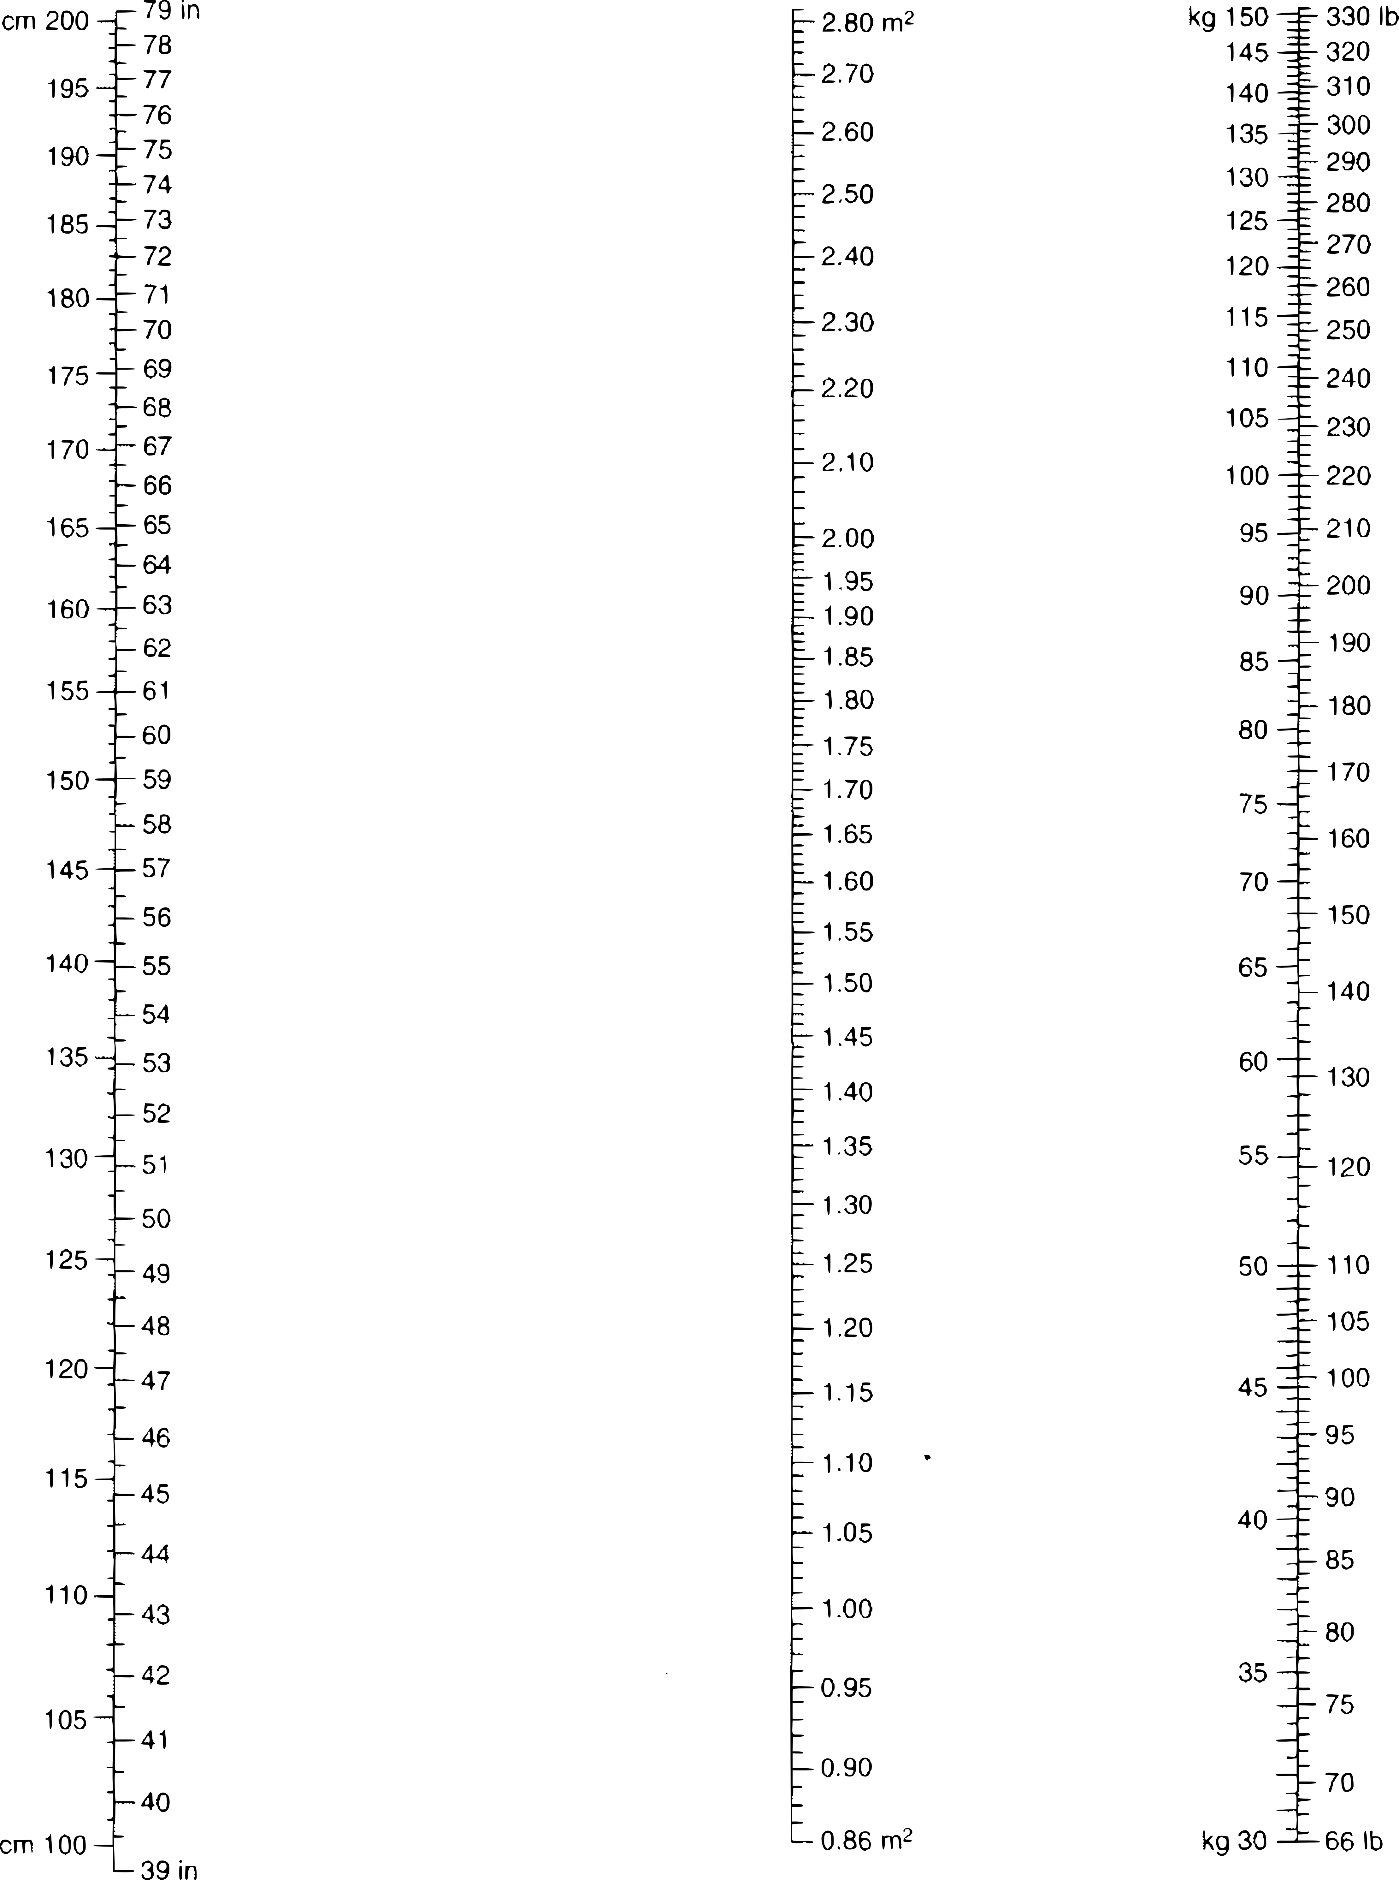

Nomogram is based on the Dubois & Dubois formula.
BSA (m2) = 0.007184 x weight in kg0.425 x height in cm0.725

Let's look at an example problem.

Example

QUESTION
A physician orders a bolus dose of doxorubicin for a 6'1” patient that weighs 165 lbs. The drug dose is 75 mg/m². What is the bolus dose in mg?
DATA
6'1”
165 lbs
75 mg/m²
FORMULA/METHOD
Use a nomogram to find BSA then use factor label to do the calculation.
MATH
BSA = 1.98 m²

DOES THE ANSWER MAKE SENSE?
Yes

Now you should attempt a practice problem.

Practice Problem

If the dose of Taxol (paclitaxel) in the treatment of metastatic ovarian cancer is 135 mg/m², what would be the dose for a patient 155 cm tall and weighing 53 kg?

202.5 mg

Worksheet 10-4
Name:

Date:

Solve the following problems.

1) Leukine (a drug used to increase neutrophils in patients receiving chemotherapy for Leukemia) is to be administered by IV at 250 mcg/m²/day for 21 days. How many mcg will a patient receive each day if they are 5'10” and weigh 156 lbs.

- A patient weighs 176 lbs and is 71 inches tall. Their physician orders doxorubicin (an antineoplastic agent) 25 mg/m² in 50 ml of NS. The doxorubicin is supplied as 50 mg vials with a concentration of 4 mg/ml.

a) How many mg will the patient need?

b) How many mL of doxorubicin will you add to the NS bag?

c) How many vials of doxorubicin will you need to gather to make this IV?

3) Methotrexate when reconstituted has a concentration of 25 mg/mL. A patient being treated for osteosarcoma has a BSA of 1.60 m². The patient is ordered methotrexate 12 g/m² by IV infusion every week. How many mL of the reconstituted solution will the patient receive?

4) A physician orders bleomycin in a dose of 20 units/m² twice weekly. The reconstituted bleomycin has a concentration of 30 units/mL. The patient is 5'3” tall and weighs 110 lbs. How many mL will the patient need for a single dose.

5) An order is received in the pharmacy for 5-FU IV for a 5'6” patient weighing 125 lbs. The 5-FU solution is available in a 50mg/mL concentration. The dosage schedule is as follows:

Initial dose: 800 mg/m²/day for 5 days IV push
How many grams of 5-FU has the patient received after the first 5 days?

Pediatric Dosing

We will be reviewing a multitude of ways to calculate a pediatric patient's medication dose.

Some pediatric doses may simply be calculated based on body weight or body surface area (BSA). Those kinds of problems are fairly straight forward in problems like:

A neonate weighing 4000 g is ordered tobramycin q8h at 2.5 mg/kg/dose, how many mg of tobramycin should the neonate receive?

A medication is dosed as 100 mg/m², what would be the dose if a pediatric patient had a BSA of 0.87 m²?

But, both of the aforementioned ways treat pediatric dosing as if children were simply miniature adults. We will take some time and look at other ways to calculate pediatric doses.

Clark's Rule
(based on weight for children ages 2-17)

Young's Rule
(based on age for all children)

Fried's rule
(based on age up to 24 months)

Cowling's rule

Pediatric nomogram, when adult dose is known
(based on BSA for all children while treating the average adult BSA as 1.73 m²)

You will need this nomogram to help you solve the problems on the next page.

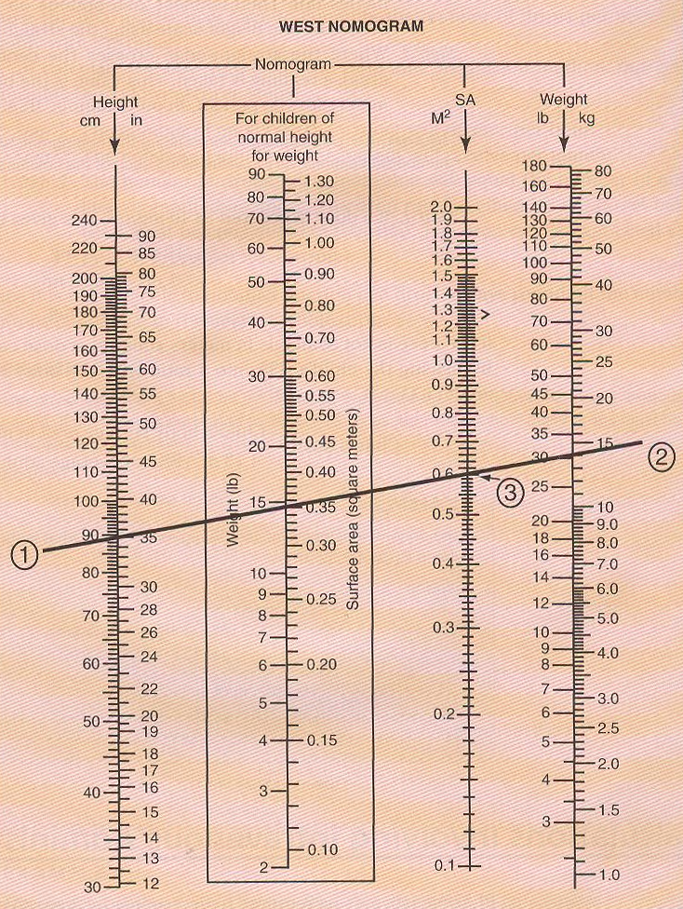
In the example above we have a (1) 90 cm tall patient that weighs (2) 30 lbs, and their BSA is (3) 0.6 m².
Worksheet 10-5
Name:

Date:

Solve the following questions.

- A newborn (we'll count them as 1 month for calculation purposes) weighs 5.6 lbs, has a height of 17 inches and is ordered gentamicin to treat a meningitis infection they've contracted.

  - If based strictly on body weight, premature and full-term neonates should receive gentamicin 2.5 mg/kg every 12 hours. Based only on body weight how much gentamicin should the neonate receive each day?

  - An average adult dose of gentamicin for treating meningitis is 350 mg/day given in three equally divided doses. Based on this information, what should this neonates daily gentamicin be based on Cowling's rule ?

  - Using the above information, what would be the average daily quantity of gentamicin be based on Fried's rule?

  - Using the above information, what would be the average daily quantity of gentamicin be based on a pediatric nomogram, when the adult dose is known?

- Calculate the dose for a child 4 years of age, 39 in. in height, and weighing 32 lbs for a drug with an adult dose of 100 mg, using the following:

  - Young's rule

  - Cowling's rule

  - Clark's rule

  - Pediatric nomogram when the adult dose is known

- The daily dose of diphenhydramine HCl for a child may be determined on the basis of 5 mg/kg of body weight or on the basis of 150 mg/m². Calculate the dose on each basis for a 4 year old child weighing 55 lbs and measuring 3' 4” in height.

  - Based on weight?

  - Based on BSA?

An average adult dose of injectable diphenhydramine is 400 mg per day (often given in 4 divided doses). Based on this how much diphenhydramine should they receive according to Clark's rule and Young's rule?

- Clark's rule

- Young's rule

Worksheet 10-6
Name:

Date:

Solve the following problems.

- How many milliliters of a 14.6% stock solution of sodium chloride would be required to make a 250 mL bag of 3% sodium chloride. How many mL of sterile water for injection (SWFI) will be required to make this bag?

- How many mL of a 2% stock solution should be used to prepare 1 L of a 0.025% solution?

- How many mL of 95% ethyl alcohol and how many mL of NS will be needed to prepare 2.5 L of 50% ethyl alcohol? (NS will be used as the diluent in this problem)

- How many mL of a 10% cyclosporine solution would be required to make 1 fl. oz. of a 2% cyclosporine solution?

- How many mL of 5% potassium permanganate stock solution and how many mL of diluent will be required to make 180 mL of 0.5% potassium permanganate solution?

- A medication order calls for a 1 liter TPN to be infused over 6 hours. If the infusion set has a drop factor of 20, what drip rate should the drop chamber be set to (in gtt/min)?

- A medication order calls for a 500 mL bag with 20 mEq of potassium chloride to be infused over 4 hours. What will be the infusion rate in mL per hour?

- If the IV bag in the previous problem needed to be infused using a venoclysis set calibrated to 15 gtt/mL, what will be the drip rate?

- If a 50 mL IVPB containing 1 gram of cefazolin is being infused at 200 mL/hr, how long will it take to infuse?

- If a 1,500 mL IV solution is being infused over 24 hours, at what drip rate will you set the drip chamber if it has a drop factor of 20?

- The daily dose of a drug is 12 mcg/kg of body weight. How many mg should be administered each day to a woman who weighs 55 kg?

- If the dose of a drug is 0.25 mg/kg, how many milligrams should be administered to a man weighing 175 lbs?

- The usual dose of lucanthone hydrochloride is 5 mg/kg/dose given t.i.d. for one week. How many g would be required to cover an entire week for a youth weighing 120 lbs?

- Ceftazidime is ordered for a 66 pound pediatric patient at a dosage of 150 mg/kg/day to be infused over 24 hours. The drug when reconstituted has a concentration of 100 mg/mL. How many mL of the reconstituted solution will be required?

- Gentamycin is ordered 5 mg/kg for a patient who weighs 165 pounds. Gentamycin is available in a 20 mL MDV with a concentration of 40 mg/mL. How many mL of Gentamycin should the patient receive?

- A physician orders a bolus dose of doxorubicin for a patient with a BSA of 1.56 m². The drug dose is 75 mg/m². What is the bolus dose in mg?

- A patient weighs 117 lbs and is 5'2” tall. Using the nomogram on page 260 to determine their BSA, find the patient's dose of vincristine if the physician ordered it as 1.4 mg/m². The maximum dose of vincristine is capped at 2 mg, so if your calculated dose exceeds that it is automatically reduced to 2 mg.

- 5FU 750 mg/m² as IVP is ordered for a patient (73” and 165 lbs). 5FU is available as 50 mg/mL in 10 mL vials.

a) What is the patient's dose in mg?

b) How many mL will the patient receive?

c) How many vials will be needed to prepare this dose?

- Methotrexate, when reconstituted, has a concentration of 25 mg/mL. A patient with a BSA of 1.80 m² is ordered 12 g/m² by IV infusion every week. How many mL of the reconstituted solution will the patient receive?

- An injectable medication is available in a 10 cc vial and has a concentration of 100 mg/mL. If a 98 lb, 4'10” tall patient receives an order for 500 mg/m², how many milligrams should the patient receive?

- Is Young's rule or Clark's rule based on age?

Use the following information to solve problems 22-26:

A 9 year old child that is 4'2” and weighs 50 lbs is ordered diphenhydramine. The daily dose of diphenhydramine HCl for a child may be determined on the basis of 5 mg/kg/day of body weight or on the basis of 150 mg/m²/day. Also, an average adult dose of injectable diphenhydramine is 400 mg per day (often given in 4 divided doses).

- Based strictly on body weight, what should she receive daily?

- Based strictly on BSA, what should she receive daily?

- Using Clark's rule, what should she receive daily?

- Using Young's rule, what should she receive daily?

- Using Cowling's rule, what should she receive daily?

