UNIT 3
COMMUNITY PHARMACY MATH

What does community pharmacy math consist of?

Despite popular belief, community pharmacy requires pharmacy technicians to do significantly more than just counting by fives. Pharmacy technicians need to translate the physician's prescribed quantity into the quantity that an insurance provider will cover, extemporaneous compounding requires a significant quantity of mathematical manipulations, thechnicians often need to maintain price databases and work with insurance pricing formulas, they need to maintain inventories, and streamline cash flow. A pharmacy technician can carry a lot of responsibility in today's community pharmacy and the goal of this unit is to provide a solid foundation for those skills.

What are the specific learning objectives in this unit?

- Days' supply,
- Adjusting refills and short-fills,
- Extemporaneous compounding,
- Billing for extemporaneous compounds,
- Calculating usual and customary prices,
- Common insurance reimbursement formulas,
- Gross profits and net profits,
- Medication inventory control,
- Medication storage,
- Daily cash reports,
- Calculating professional/dispensing fees, and
- Depreciating capitol expenditures.


CHAPTER 11
DAYS' SUPPLY
“They should really pay someone to do these calculations.”
“True enough, but the person they're supposed to pay to do these calculations will be you.”
--Classroom discussion between an instructor and one of his students.

In this chapter you'll be learning how to do the following calculations:
- Days' Supply
- Adjusting Refills, and
- Short-fills

Days' Supply

Physicians often write their prescriptions with various time frames in mind. Common prescribing time frames include 5 days, 1 week, 10 days, 2 weeks, 1 month, 50 days, 90 days or even 100 days. Physicians often just include a quantity of medication to dispense and directions on how frequently to use it. They usually don't include the actual intended time frame. As a pharmacy technician you will need to translate that into Days' Supply.

In this chapter Days' Supply is referring to how long a prescription order will last. Often it is not as simple as giving a tablet once a day for 30 days; you will frequently need to do calculations for oral liquid medications, injectables, nasal sprays, and inhalers, and make estimations for PRN's, ointments and creams, lotions, eye and ear drops, and ophthalmic ointments.

Days' Supply for tablets, capsules, and liquid medications

The first things to look at are tablets, capsules, and liquid medications both because they're the most common, and they're the most straight-forward to perform calculations with. Without wanting to over explain this process let's look at some example problems.

Examples:

- A prescription is written for amoxicillin 250 mg capsules #30 i cap t.i.d. What is the days' supply?

- A prescription is written for amoxicillin 250 mg/5 mL 150 mL i tsp tid. What is the days' supply?

Now that you've seen a couple of examples, solve the following practice problems.

Practice Problems

- A prescription is written for cephalexin 250 mg #28 i cap q6h. What is the days' supply?

- A prescription is written for cephalexin 250 mg/5 mL 100 mL i tsp q6h. What is the days' supply?

1) 7 days 2) 5 days

The item to be careful about when it comes to tablets, capsules, and liquid medications are PRN medications, especially ones with variable doses and variable frequencies. In general, you should perform the calculations using the shortest interval with the highest dose. This will provide the shortest span of time in which they could use all the medication dispensed. Let's look at an example problem.

Example:

A prescription is written for Ultram 50 mg #60 i-ii tabs po q4-6h prn pain. What is the days' supply?

Conveniently, this example came out to an even number of days. Sometimes your calculations will come out to a decimal number of days and you may need to use some professional judgment to determine whether to drop the decimal or round up. If you are not sure, it is usually better to drop the decimal. Attempt the following practice problem working with a PRN medication.

Practice Problem

- A prescription is written for hydromorphone 2 mg #30 i-ii tabs po q3-4h prn pain. What is the days' supply?
1) Eventhough the answer comes out to 1.875 days, I would expect the medication to last 2 days based on my own professional judgment
Days' Supply for insulins

Most insulins are called U-100 insulins meaning that each mL contains 100 units. Also most insulin vials are either 10 mL vials or boxes of 5 syringes containing 3 mL in each syringe for a total of 15 mL in a box. A 10 mL vial of U-100 strength insulin would contain 1000 units and a 15 mL box of syringes with U-100 insulin would contain 1500 units. This is good information to help you make quick work of the vast majority of insulin calculations. With insulin problems, whenever you come out with a decimal number of days you should always just drop the decimal as you never want a diabetic patient to run out of their insulin. The last thing to keep in mind with respect to insulin vials is that they should not be kept for longer than 30 days after it has been opened. Determining how long a box will last is different since each syringe is only good for 30 days after it is started but there are five syringes. Let's look at an example problem with insulin.

Example:

A prescription is written for Humulin N U-100 insulin 10 mL 35 units SC qd. What is the days' supply?

which means 28 days either because you dropped the decimal.

Let's look at some practice problems.

Practice Problems

When solving the next two problems, treat them as 10 mL vials with a U-100 concentration.

- A prescription is written for Humulin R 1 vial 8 units SQ before breakfast, 8 units before lunch, and 11 units before supper. What is the days' supply?

- A prescription is written for Novolin N prefilled syringes #1 box Sig: 22 units SC q am and 24 units q pm. What is the days' supply?

1) 30 days 2) 32 days

Days' Supply for inhalers and sprays

Whenever you see instructions on a product for a patient to receive a particular number of sprays or puffs of a given drug, you should stop and actually look at the packaging to discover how many metered inhalations or how many metered sprays are actually in the container. Lets look at an example problem accompanied by a rendering of what the front of the container actually looks like.

Example:

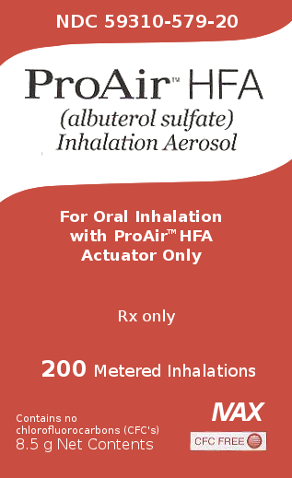
A prescription is written for ProAir HFA 8.5 g inhaler 2 puffs q.i.d. What is the days' supply? (Hint: In order to solve this, you will need to look at the box pictured on the right.)

After looking at the box, you should realize that this particular package contains 200 puffs (metered doses), and you now have enough information to solve this problem

Now that we've looked at an example, attempt the following practice problem.

Practice Problem

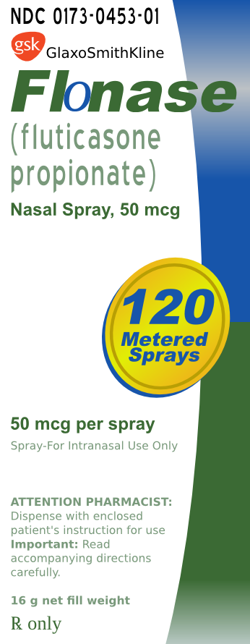
- A prescription is written for Flonase 16 gm 2 sprays per nare qd for a total daily dose of 200 µg. What is the days' supply?

1) 30 days

Days' Supply for ointments and creams

Calculations for creams and ointments are a little more tricky because you usually don't know exactly how much will be used in a dose. The amount will depend on how large of an area is affected and how many areas it needs to be applied to. The amount applied usually does not exceed 500 mg to 1 g, so unless you know otherwise, use 1 gram for the dose for each affected area.

Example:

A prescription is written for Mycolog II cream 15 g apply sparingly bid. What is the days' supply?

Practice Problem

- A prescription is written for Nizoral cream 15 gm apply to the affected and surrounding areas once daily. What is the days' supply?

- A prescription is written for Bactroban ung 15 gm apply a small amount to the affected area tid. What is the days' supply?

1) 7 days 2) 10 days (since the problem said small amount each dose can be treated as 500 mg)

Days' Supply for ophthalmic and otic preparations

To solve this type of problem, you need to know a conversion factor from milliliters to drops. Unfortunately (or fortunately since most students despise the apothecary system), you cannot use the conversion from the apothecary system. The USP in chapter 1101 has written regulations on standardizations of medicine droppers. Unless your specific medication notes something different, a dropper should be calibrated by the manufacturer to deliver between 18 and 22 drops per milliliter. Most people just split the difference and estimate 20 gtt/mL. With that in mind, we can get a good estimate on how long the medication should last.

Another odd thing to keep track of when dealing with eye preparations are ophthalmic ointments. An ophthalmic ointment is typically applied as a very thin strip. Treat each dose of an ophthalmic ointment as 100 mg. Let's look at some example problems with respect to ophthalmic and otic preparations.
Examples:

- A prescription is written for timolol 0.25% Opth. Sol. 5 mL i gtt ou q.d. What is the days' supply?

- A prescription is written for Neosporin Opth. ung 3.5 g apply a thin strip ou q3-4h. What is the days' supply?

Notice that both example problems were written for each eye, requiring the quantity of medication to be doubled in both cases.

Now, you should try a couple of practice problems.

Practice Problems

- A prescription is written for Tobradex Opth. Susp. 5 ml 1-2 gtt os q4-6h. What is the days' supply?

- A prescription is written for tobramycin Opth. Oint. 3.5 g apply od bid. What is the days' supply?

1) 8 days 2) 17 days

Days' Supply for various packs

Many medications (such as birth control, steroids, and antibiotics) may come in packs with very explicit instructions for use. These instructions often explain exactly how many days they will last and require no additional calculations. You must simply read the instructions on the package to know how long it will last. Let's look at an example problem on the next page.

Example:

- A prescription is written for methylprednisolone 4 mg tabs taper pack use as directed. What is the days' supply?

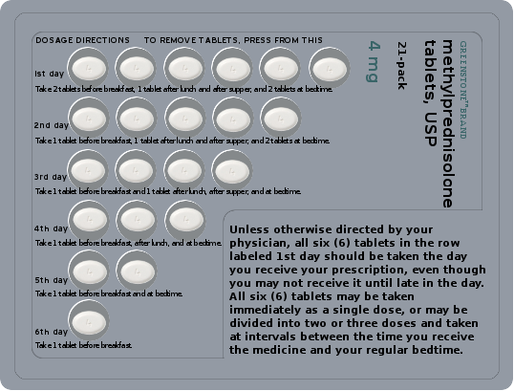
It requires nothing more than observation to realize it will last 6 days.

Days' Supply for other miscellaneous medications

Unfortunately, there are many medications that have there own specific rules, such as estrogens given for hormone replacement therapy are cycled on and off. Either days 1-25 on, followed by five days off or it may be cycled for three weeks on, followed by one week off. Items like a vial of nitroglycerin sublingual tablets or spray are expected to last a patient 30 days. Items, like vaginal preparations, you'll need to know how much is delivered via the applicator. Lotions can be a challenge depending on their viscosity. A good rule of thumb for a lotion is to expect 2 mL to be used on each affected area per application. As you can tell, there are many individual little rules to try and work with when estimating how long a particular medication will last.

Worksheet 11-1
Name:

Date:

Solve how many days each of the following prescriptions will last.

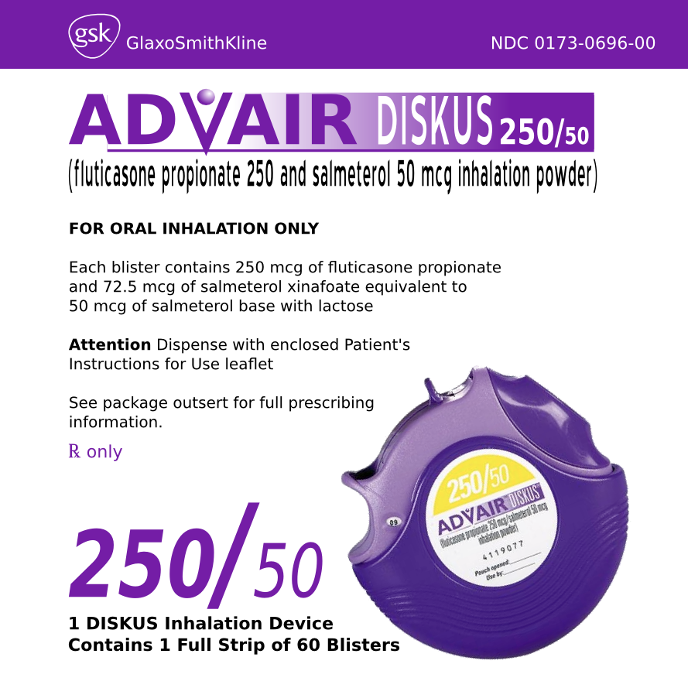
- Advair 250/50 #1 1 puff q12h (Hint: use the image on the right hand side of the page.)

- Atrovent inhalation solution 0.02% 2.5 ml Disp 25 vials Sig: 1 vial per neb q.i.d.

- Rx Augmentin 400 mg-57 mg/5 mL Disp. 100 mL Sig: i tsp po q12h till all of medicine is gone

- Axid 150 mg #60 i cap po bid before meals

- Rx Betoptic 0.5% Disp 10 mL Sig: 2 gtt OS b.i.d.

- Cortisporin Otic 10 mL iv gtt ad qid

- Crestor 10 mg #90 1 tab po qd

- DexPak 13 day TaperPak take u.d.

- Rx Duragesic 50 mcg/hr Disp: 10 patches Sig 1 patch q72h

- E.E.S. 400 mg #42 i tab po tid c meals

- Fentora 100 mcg #28 i tablet in buccal cavity q4-6h prn breakthrough pain

- Fosamax 70 mg #4 i tab po q week

- Rx Glucotrol 10 mg Disp: 120 tabs Sig: 20 mg po bid

- Rx Humulin R 10 mL Disp: 1vial Sig: 11 units SQ before breakfast, 11 units before lunch, and 14 units before supper.

- Ibuprofen 400 mg #60 i tab po q6-8h prn pain

- Januvia 100 mg #30 1 tab po qd

- ketorolac 10 mg #20 1 tab po q4-6h prn pain. Not to exceed 40 mg/day.

- Lac Hydrin 12% Lotion 150 mL aa bid rub in thoroughly. (Hint: Use 1-2 mL for amount used per application unless you know a larger area is being treated; let's treat the patient as having 2 affected areas.)

- Lantus Insulin 10 mL #1 vial 40 units SQ q a.m.

- Levothyroxine 100 mcg #100 i tab po qd

- Rx Lexapro 20 mg Disp: 60 Sig: i cap po qd

- Lipitor 20 mg #30 i tab po qd

- methylprednisolone 4 mg tabs taper pack use ut dict (Hint: Use the image below to determine how long it will last.)

- metoprolol tartrate 50 mg #180 i tab po b.i.d.

- Rx MetroGel-Vaginal 0.75% Disp: 70 g tube Sig: 1 applicatorful pv bid ×5 days (Hint: 1 applicator delivers 5 g of gel containing 37.5 mg of metronidazole.)

- Neosporin ophthalmic ointment 3.5 g apply thin strip od t.i.d ×10 days

- Nexium 20 mg #28 i cap po bid

- NitroDur 0.4 mg #30 i patch on 8 a.m., off 10 p.m. qd

- Nitrostat 0.4 mg #100 i tab SL q5min prn chest pain. May repeat up to 3×.

- ofloxacin otic solution 10 mL 10 gtt as bid ×10 days

- Rx Patanase Disp: 1 bottle Sig: ii sprays each nare bid (Hint: a bottle contains 240 metered sprays.)

- Plavix 75 mg #60 1 tab po qd

- ProAir HFA i-ii puffs q4-6h prn relief of asthma symptoms.

- ProTopic 0.1% 100 g apply minimum amount to aa bid

- Premarin 0.625 mg #63 i tab po qd cyclically (3 weeks on, 1 week off)

- quinine 324 mg #42 2 caps po q8h

- Requip 1 mg #270 1 tab po tid

- simvastatin 20 mg #100 i tab po qd

- Singulair 10 mg #30 i tab po q p.m.

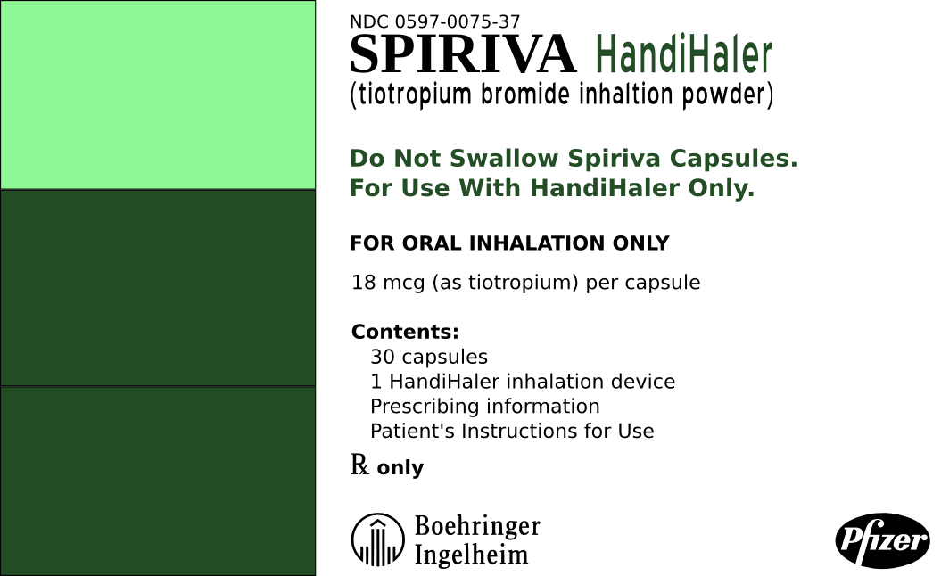
- Spiriva #30 inhale contents of 1 cap qd using HandiHaler

- Terazol-7 cream 45 gm Insert 1 applicatorful (5 gm) hs × 7d

- Rx theophylline elixir 80 mg/Tbs Disp 500 mL Sig: iv tsp po q6h atc

- TobraDex opth. Susp 5 ml Instill 2 drops into the conjunctival sac os q6h

- Valium 5 mg #180 i tab PO BID PRN anxiety

- Vicodin #100 1-2 tabs q6h prn pain

- wellbutrin 100 mg #90 i tab po tid

- Xanax 0.25 mg #30 one t.i.d. prn

- Rx Yaz Disp: 1 pack Sig: i tab po qd starting on first day of menstrual cycle (Hint: look at pack below.)
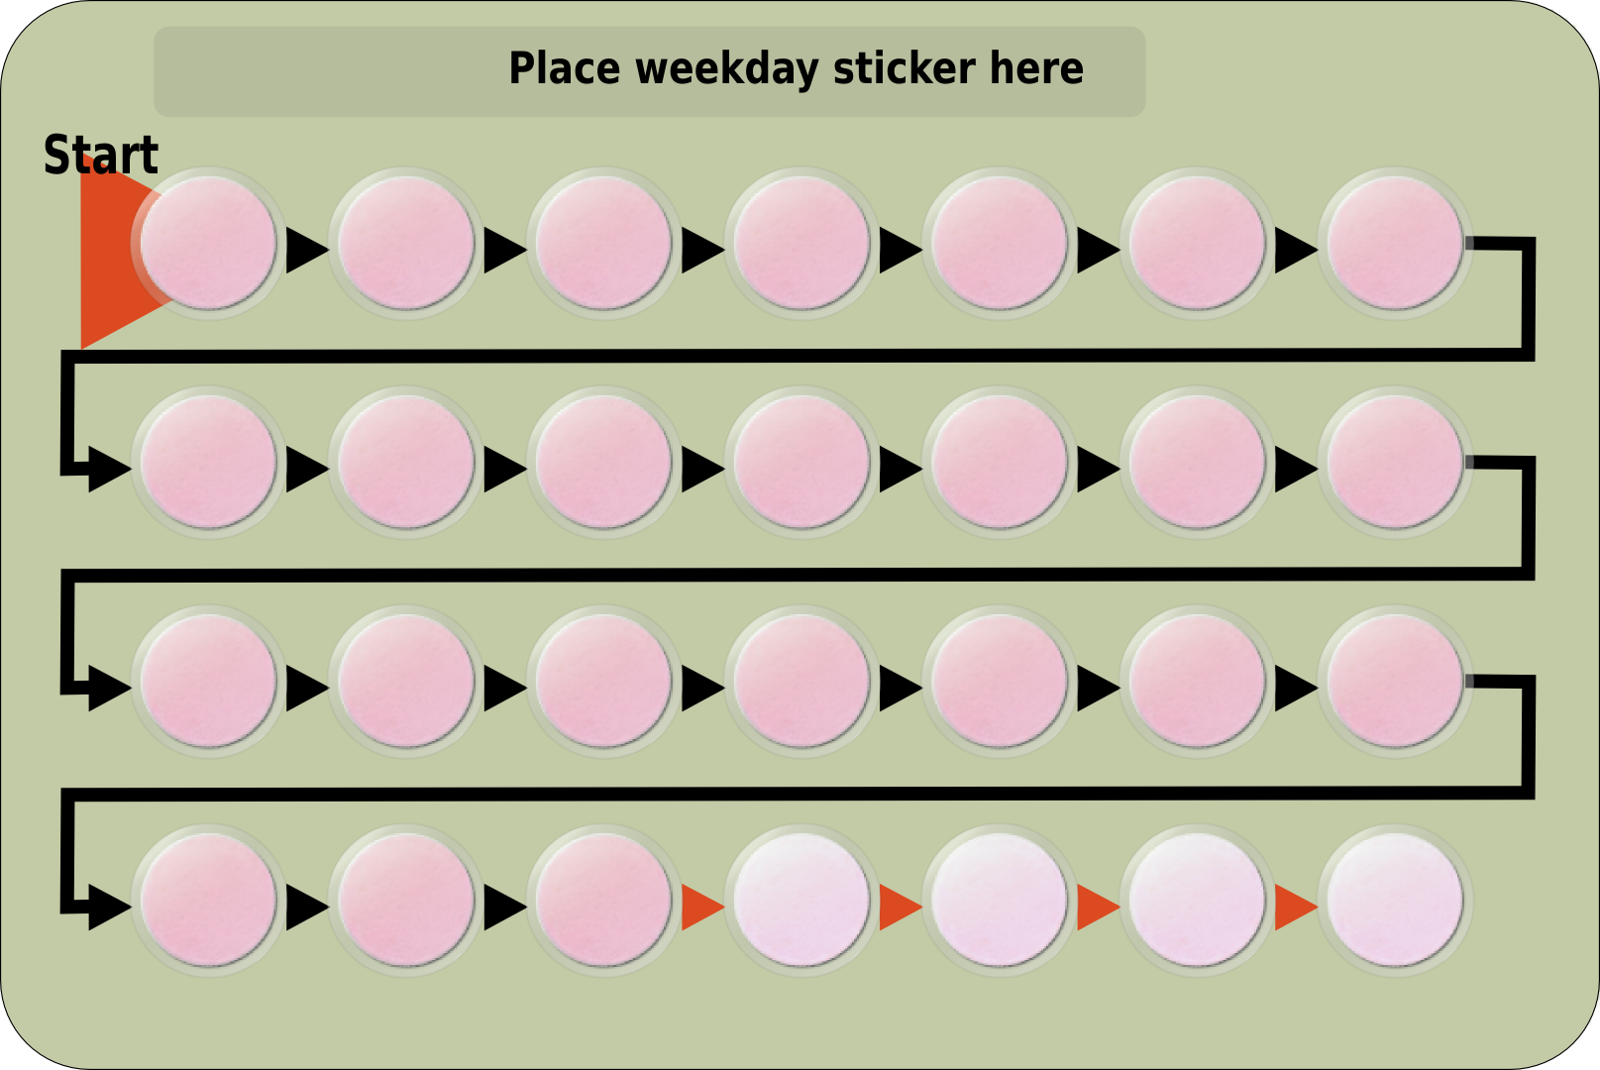

- Z-Pak 500 mg PO on first day of therapy, then 250 mg PO once daily for 4 days. Total cumulative dose 1.5g

- Zantac 150 mg #60 one b.i.d.

Adjusting Refills and Short-Fills

The amount of medication a pharmacy can dispense to a patient is restricted first, by the prescriber's guidelines and second by the insurer's guidelines. As we've previously stated, physicians tend to prescribe for the following time frames: 5 days, 1 week, 10 days, 2 weeks, 1 month, 50 days, 90 days or even 100 days. Meanwhile, insurances and other third party reimbursement plans tend to bill based on different time frames such as: 14 days, 21 days, 30 days, 32 days, 34 days, 90 days, etc. Calculations are often needed to adjust first the quantity dispensed to comply with the insurer's guidelines, and then the number of refills allowed. Pharmacy technicians often need to accurately estimate how long a medication will last with inadequate guidelines. Estimating days' supply is especially tricky when the dosage form is a lotion, cream, ointment, or inhalant.

When dispensing medications that come in handy convenience packages, such as a methylprednisolone dose-pack, estimate the days' supply when you have the package in your hand so you can visually examine how it is packaged and read from the labeling or package insert how long the contents of the package should last.

Let's look at a couple of example problems.

Examples:

- A prescription is written for Dyazide #50 i cap p.o. q.d. + 3 refills. The insurance plan has a 30 day supply limitation. How many capsules can be dispensed using the insurance plan guidelines and how many refills are allowed with the adjusted quantity?

First calculate the total number of capsules allowed by the prescriber:

Then, using dimensional analysis we can figure out how many capsules will be needed for each fill.

Next, using dimensional analysis we can figure out how many fills from the insurer will be required to dispense the quantity written for by the physician.

Therefore, there will be 5 refills after the initial fill is dispensed, but there is still a partial fill left.

Once again using dimensional analysis we will figure out how many capsules to dispense for the partial fill.

Now, let's restate everything in short:

We are dispensing 30 caps for our initial fill.
The patient can have 5 refills of 30 caps,
and a partial fill of 20 caps.

- A prescription is written for Rx Rondec-DM syrup Disp: 1 pint Sig: tsp i h.s. p.o. + 1 refill. The insurance plan has a 30 day supply limit. How many mL can be dispensed using the insurance plan guidelines and how many refills are allowed with the adjusted quantity?

First, calculate the total volume allowed by the prescriber in milliliters.

Then, using dimensional analysis we can figure out how many milliliters we will be needed for each fill.

Next, using dimensional analysis we can figure out how many fills from the insurer will be required to dispense the quantity written for by the physician.

Therefor, there will be 5 refills after the initial fill is dispensed, but there is still a partial fill left.

Once again using dimensional analysis we will figure out how many milliliters to dispense for the partial fill.

Now, let's restate everything in short:

We are dispensing 150 milliliters for our initial fill.
The patient can have 5 refills of 150 milliliters,
and a partial fill of 60 milliliters.

Now let's stop and do a couple of practice problems.

Practice Problems

- A prescription is written for Crestor 10 mg #100 i tab p.o. q.d. + 1 refill. The insurance plan has a 30 day dispensing limit. How many capsules can be dispensed using the insurance plan guidelines and how many refills are allowed with the adjusted quantity? Also, if there is a partial fill, how many tabs will be dispensed in this partial fill?

- A prescription is written for Novolin N 10 mL #1 vial 22 units SC q am and 24 units q pm + 3 refills. The insurance plan has a 28 day supply limitation. How many vials can be dispensed using the insurance plan guidelines and how many refills are allowed with the adjusted quantity? Also, if there is a partial fill, how many vials will be dispensed in this partial fill?

1) We are dispensing 30 tabs for our initial fill. The patient can have 5 refills of 30 tabs, and a partial fill of 20 tabs.
2) We are dispensing 2 vials for our initial fill. The patient can have 1 refill of 2 vials, and there are no partial fills.

Worksheet 11-2
Name:

Date:

Appropriately adjust the following prescriptions to comply with the physician's prescribed quantities and the insurance guidelines in each scenario. In the following scenarios, treat each prescription as having a 30 day dispensing limit. Calculate the initially dispensed quantity, the number of refills, and any partial fills.

- Rx Advair 250/50
Disp: 1
Sig: 1 puff q12h

Refills: 3

- Rx Atrovent inhalation sol. 0.02%
Disp: 10 boxes (25 vials/box)
Sig: 1 vial per neb q.i.d.

Refills: 2

- Rx Axid 150 mg
Disp: 60
Sig: i cap po bid before meals

Refills: 5

- Rx Crestor 10 mg
#90
Sig: i tab po qd

Refills: 3

- Rx Flonase 16 g
#1
Sig: 2 sprays per nare qd for a total daily dose of 200 mcg

Refills: 2

- Rx Fosamax 70 mg
Disp: 4
Sig: i tab po q week

Refills: 2
(Some medications, such as once a week medications and birth control are typically filled on 4 week cycles instead of 30 day cycles)

- Rx Glucotrol 10 mg tabs
Disp: 120
Sig: 20 mg po bid

Refills: 5

- Rx Humulin R 10 mL
Disp: 1 vial
Sig: 11 units SC before breakfast, 9 units before lunch, and 13 units before supper

Refills: 2

- Rx: Januvia 100 mg
#100
Sig: 1 tab po qd

Refills: 2

- Rx Lantus 10 mL
Disp: 3 vials
Sig: 40 units SQ q a.m.

Refills: 1

- Rx levothyroxine 100 mcg
#50
Sig: 1 tab po qd

Refills: 3

- Rx Lexapro 20 mg
Disp: 60
Sig: i cap po qd

Refills: NR

- Rx Lipitor 40 mg
#90
Sig: 1 tab po qd

Refills: 1

- Rx metoprolol tartrate 25 mg tabs
#100
Sig: ss tab po bid

Refills: 2

- Rx Nexium 20 mg
Disp: 112
Sig: i cap po bid

Refills: 1

- Rx NitroDur 0.4 mg
#30 patches
Sig: i patch on 8 a.m., off 10 p.m. qd

Refills: 2

- Rx Nitrolingual pumpspray
#3 bottles
Sig: i-ii spray SL q5min prn chest pain. May repeat up to 3 doses/15 min.

Refills: 3

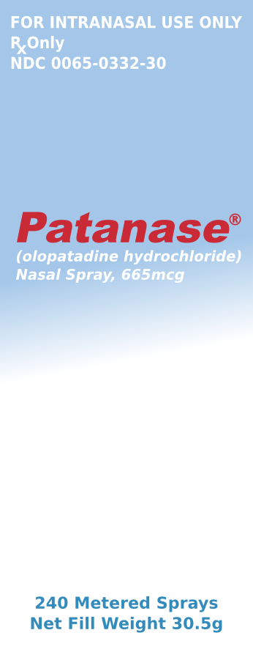
- Rx Patanase
Disp: 1 bottle
Sig: ii sprays each nare bid

Refills: 2

- Rx Plavix 75 mg
#60
Sig: 1 tab po qd

Refills: 4

- Rx Requip 1 mg
#270
Sig: 1 tab po tid

Refills: 1

- Rx simvastatin 20 mg
#100
Sig: i tab po qd

Refills: 2

- Singulair 10 mg
#30
Sig: i tab po q p.m.

Refills: 11

- Rx theophylline elixir 80 mg/Tbs 500 mL bottle
Disp 6 bottles
Sig: iv tsp po q6h atc (Hint: dispense a whole number of bottles for this script.)

Refills 2

- Rx wellbutrin 100 mg
#90
Sig: i tab po tid

Refills: 5

- Rx Zantac 150 mg
#50
Sig: one b.i.d.

Refills: 1

This important standards is contained in a combined publication that is recognized as the official compendium, the United States Pharmacopeia (USP) and the National Formulary (NF)

