
CHAPTER 16
INSULIN
“How did she get the nickname of 'Sweet Pea'?”
“When her class mates discovered the Greek and Latin roots for diabetes mellitus they thought it would be a good pet name for her as a diabetic.”
--A discussion between two instructors.

Insulin therapy is required in type 1 diabetes (insulin dependent diabetes mellitus, IDDM), and may be necessary in some individuals with type 2 diabetes (non-insulin dependent diabetes mellitus). The general objective of insulin replacement therapy is to approximate the physiological pattern of insulin secretion. This requires a basal insulin throughout the day, supplemented by prandial insulin at mealtime. Insulin injections are intended to mimic the natural process shown in the image below:

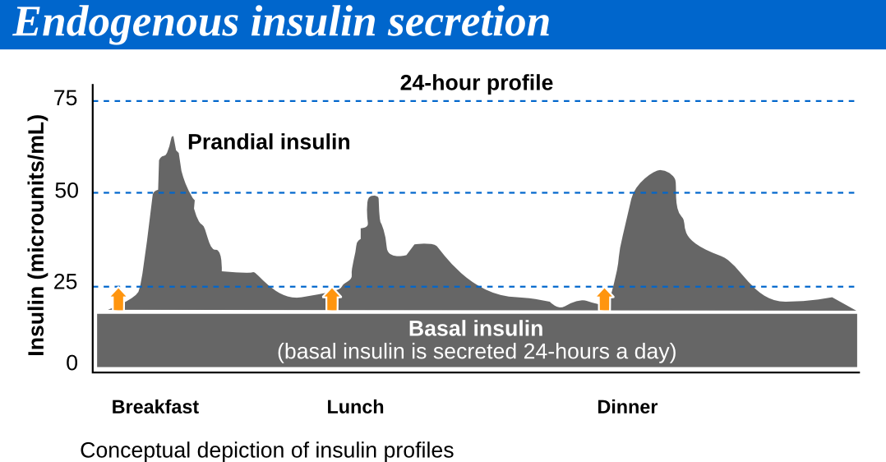
Definitions

Basal insulin may also sometimes be called "background" insulin, that is, the insulin working behind the scenes. Basal insulin may be covered with Lantus (glargine) insulin, or intermediate-acting insulin like NPH.

Prandial insulin, also known as nutritional insulin, is the insulin used to cover the spike in blood sugar from consuming food. Prandial insulin may be covered with regular insulin (a short-acting insulin), or a rapid-acting insulin like Humalog (lispro) insulin.

Multiple daily doses guided by blood glucose monitoring are the standard of diabetes care. Combinations of insulins are commonly used. The number and size of daily doses, time of administration, and diet and exercise require continuous medical supervision. In addition, specific formulations may require distinct administration procedures/timing.

There is solid scientific documentation of the benefit of tight glucose control, either by insulin pump or multiple daily injections (4-6 times daily). However, the benefits must be balanced against the risk of hypoglycemia, the patient's ability to adhere to the regimen, and other issues regarding the complexity of management. Diabetic education and nutritional counseling are essential to maximize the effectiveness of therapy. Patients should also be instructed in administration techniques, timing of administration, and sick day management.

The following chart lists the onset, peak, and duration of various insulin products.

Types of Insulin | Onset  (h) | Peak  (h) | Duration  (h)
Rapid-acting
lispr insulin - Humalog | 0.2-0.5 | 0.5-1.5 | 3-4
aspart insulin - NovoLog | 0.2-0.5 | 1-3 | 3-5
glulisine insulin - Apidra | 0.2-0.5 | 0.5-1.5 | 3-4
Short-acting
regular insulin (clear) - Humulin R, NovolinR | 0.5-1 | 2-4 | 6-8
Intermediate-acting
isophane (NPH) insulin (cloudy) - Humulin N, Novolin N | 1-2 | 6-12 | 18-24
Intermediate to long-acting
detemir insulin - Levemir | 3-4 | 6-8 | 6-23
Long-acting
glargine insulin - Lantus | 3-4 | --- | 24
Combinations
70% isophane (NPH) insulin & 30% regular insulin - Humulin 70/30, Novolin 70/30 | 0.5 | 2-12 | 18-24
aspart protamine insuline & aspart insulin - Humalog Mix 50/50, Homalog Mix 75/25 | 0.2-0.5 | 1-4 | 18-24
lispro protamine insulin & lispro insulin - NovoLog Mix 70/30 | 0.2-0.5 | 2-12 | 18-24

lorem ipsum

