
CHAPTER 23
DOSAGE CALCULATIONS BASED ON BSA
Average BSA is generally taken to be 1.73 m² for an adult (1.6 m² for women and 1.9 m² for men).
--Oxford Journals

The body surface area (BSA) is the measured or calculated surface of a human body, and it is measured in square meters (m²). For many clinical purposes BSA is a better indicator of metabolic mass than body weight because it is less affected by abnormal adipose mass.

Examples of uses for BSA include:

- renal clearance is usually divided by the BSA to gain an appreciation of the true required glomelular filtration rate (GFR),
- chemotherapy is often dosed according to the patient's BSA, and
- glucocorticoid dosing can also be expressed in terms of BSA for calculating maintenance doses or to compare high dose use with maintenance requirement.

There are number of ways to calculate BSA:

such as various formulas:
- Dubois & Dubois; BSA (m²) = 0.007184 x weight in kg^{0.425} x height in cm^{0.725}
- Mosteller; BSA (m²) =
- Haycock; BSA (m²) = 0.024265 x weight in kg^{0.5378} x height in cm^{0.3964}
- Gehan & George; BSA (m²) = 0.0235 x weight in kg^{0.51456} x height in cm^{0.42246}
- Fujimoto; BSA (m²) = 0.008883 x weight in kg^{0.444} x height in cm^{0.663}
- Takahira; BSA (m²) = 0.007241 x weight in kg^{0.425} x height in cm^{0.725}
- Boyd; BSA (m²) = 0.0003207 x weight in g^{(0.7285-0.0188 log}10^{weight in g)} x height in cm^{0.3}
- Schlick for women; BSA (m²) = 0.000975482 x weight in kg^{0.46} x height in cm^{1.08}
- Schlick for men; BSA (m²) = 0.000579479 x weight in kg^{0.38} x height in cm^{1.24}
using a nomogram (a chart method that can be based on any of the above formulas),
or some more peculiar ways including geometry, thoroughly detailed 3D scans, even wrapping patients in aluminum foil.

As you look through the formulas you will find numerous similarities as they are all trying to calculate the same thing in the end. Various formulas have been determined by looking at different segments of the population. Most hospitals and cancer clinics in the United States use either the Dubois & Dubois formula or the Mosteller formula for adults and most pediatricians utilize the Haycock method. The nomograms used in this textbook are based on the Dubois & Dubois formula for calculating adult BSA and the Haycock Method for pediatric BSA.

A nomogram is a common method and is the way we will concentrate on. A nomogram typically has three columns:

- height based in both centimeters and inches,
- body surface area in m², and
- weight based in both kilograms and pounds.

To use a nomogram the height and the weight of the patient are found on the nomogram and then a straight line is drawn connecting the two values. The BSA for that patient is found where the line intersects the BSA column. As an example find 5' 3" (63 inches) and 110 pounds on the nomogram located on the next page. If you draw a line connecting the two values you should get a BSA of 1.5 m².

Example

A reasonable exercise might be to try and plug 63 inches and 110 pounds into the Dubois and Dubois formula and see if you get the same answer. First though we will need to turn thos numbers into their metric equivalents in order to use them in the Dubois & Dubois formula.

Dubois & Dubois; BSA (m²) = 0.007184 x weight in kg^{0.425} x height in cm^{0.725}

0.007184 x 50^{0.425} x 160^{0.725} = 1.50 m²

Practice Problem

Attempt the process of determining the BSA of the author of this textbook using both a nomogram and the Dubois & Dubois formula. The height and weight of this book's author is 6'1” and 165 pounds.

Both answers should come out close to 1.98 m².

If your two answers were slightly different (within 5% of each other) that is considered an acceptable range when dealing with body surface area. This may result in classmates achieving slightly different answers in this chapter, but 5% is considered acceptable. That 5% also allows for the fact that not all oncologists may choose to use the same formulas. For example, if you calculated the BSA of a 6'1” 165 lb individual using the Mosteller formula instead, the BSA is 1.97 m², which is certainly within the 5% range.
Nomogram for Determination of Adult BSA from Height and Weight

Height | Body Surface Area | Weight
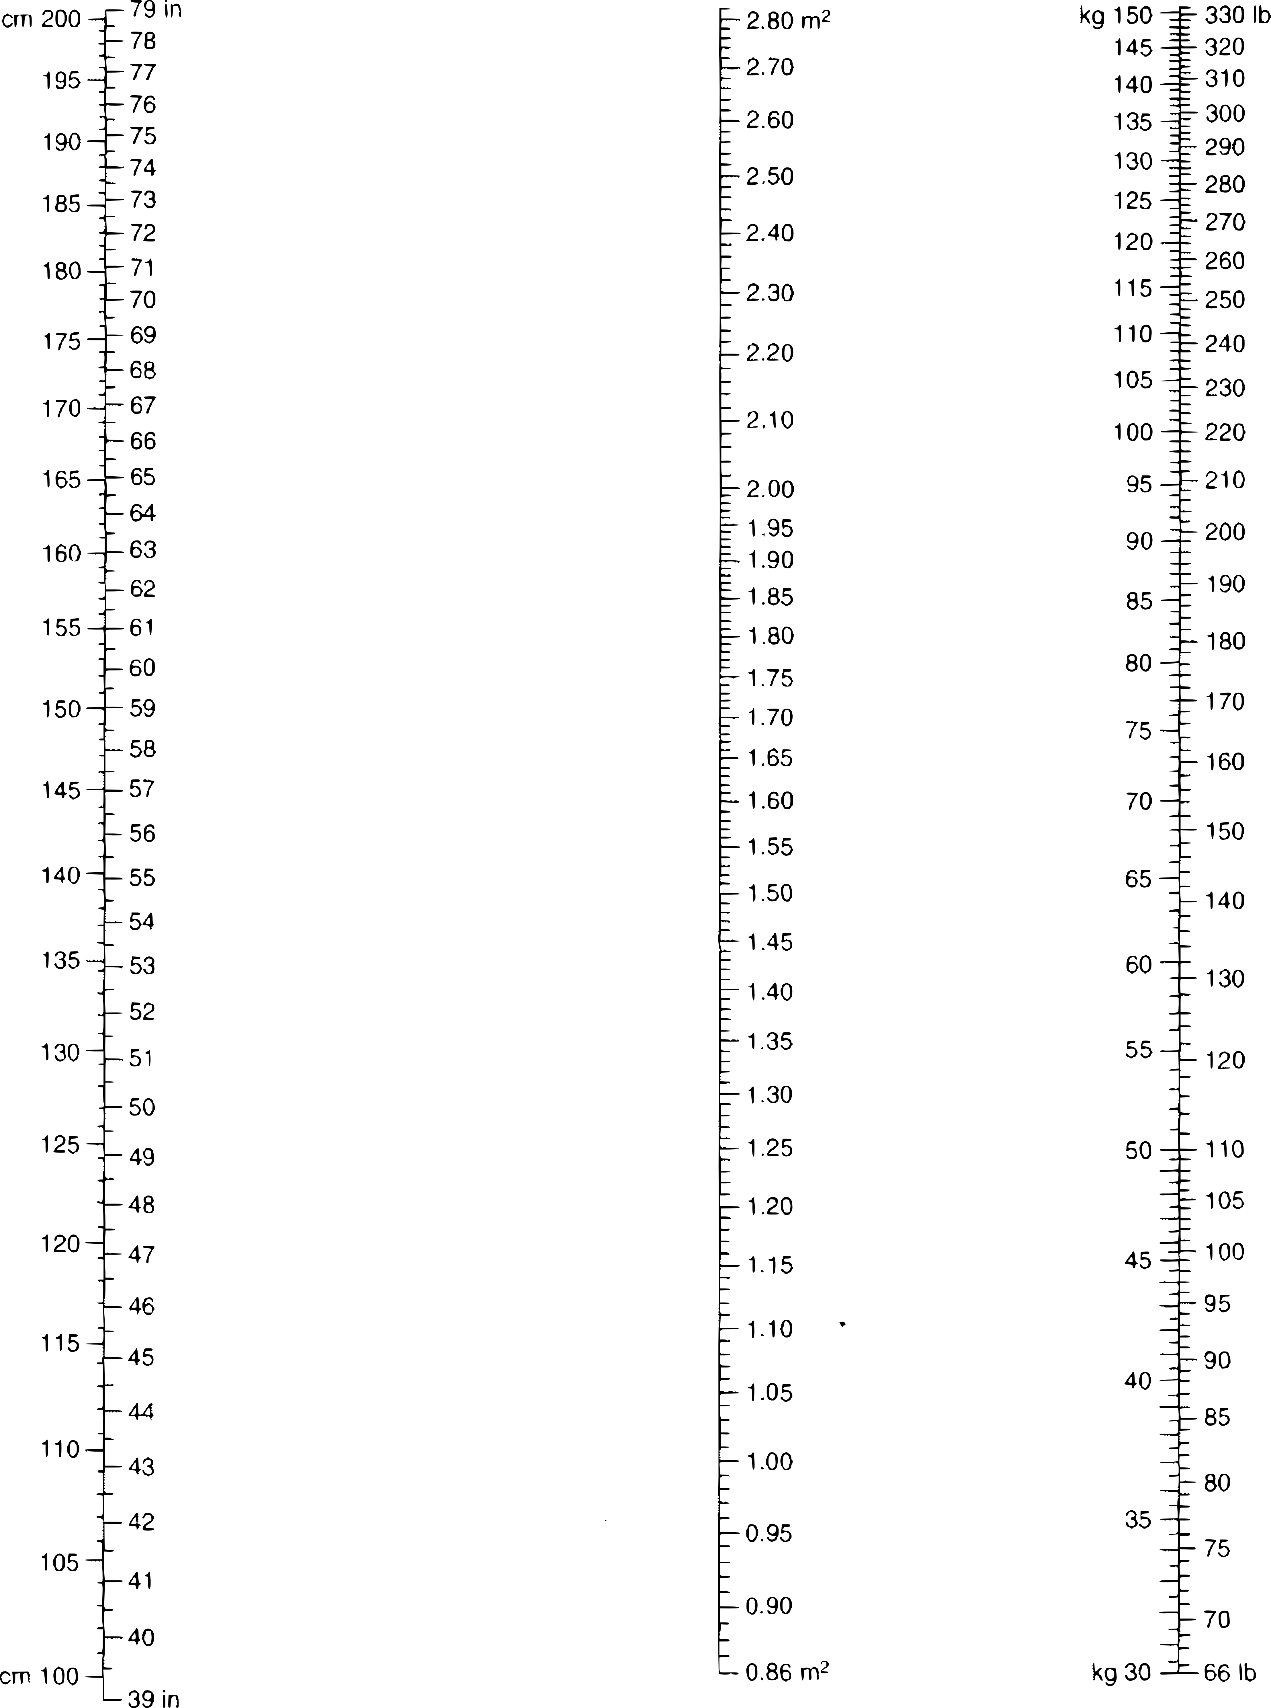

Nomogram is based on the Dubois & Dubois formula.
BSA (m2) = 0.007184 x weight in kg0.425 x height in cm0.725

Nomogram for Determination of Pediatric BSA from Height and Weight
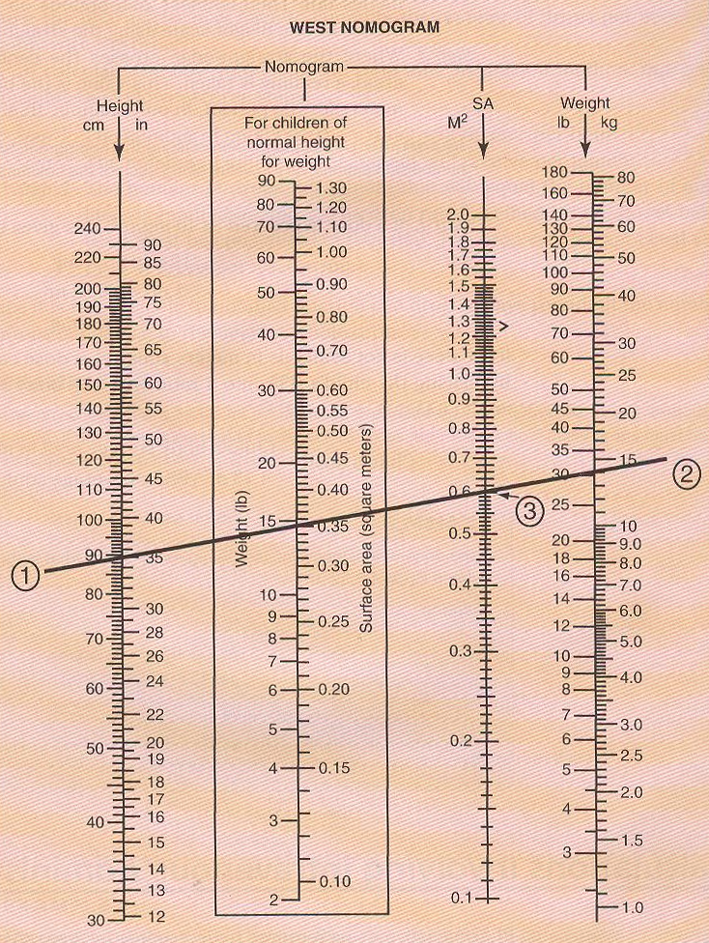
Nomogram is based on the Haycock formula.
BSA (m2) = 0.024265 x weight in kg0.5378 x height in cm0.3964

In the example above we have a (1) 90 cm tall patient that weighs (2) 30 lbs, and their BSA is (3) 0.6 m². An interesting feature on most pediatric nomograms is a separate box used for determining BSA based on the child's body weight if the child is of normal height and weight.

At this point, we should look at some example problems requiring BSA.

Examples

- A 5'3” woman weighing 120 pounds is to receive docetaxel 75 mg/m² every three weeks for breast cancer. How many mg should her dose be?

- A 4'7” 10 year old boy weighing 74 pounds is ordered etoposide IV 150 mg/m²/day to treat acute nonlymphocytic leukemia. How many mg should his dose be?

Practice Problems

- A 5'6” woman weighing 320 pounds is to receive paclitaxel 260 mg/m² every three weeks for breast cancer. How many mg should her dose be?

- A 4'2” 8 year old girl weighing 60 pounds is ordered methotrexate IV 3.3 mg/m² daily to treat leukemia. How many mg should her dose be?

1) 634.4 mg 2) 3.2 mg

While there are still more concepts to learn when dosing chemotherapy medications, this is a good point to reinforce the concepts already discussed with a worksheet.

Worksheet 23-1
Name:

Date:

Solve the following problems. You may need to refer to the nomograms in this book, or you may choose to use the Dubois & Dubois formula for adults and the Haycock Method for pediatrics in order to attain the necessary BSA for these problems.

- To get started, solve the BSA for the following adult patients based on their height and weight:

  - Height 180 cm; Weight 80 kg

  - Height 5' 11”; Weight 176 pounds

  - Height 63”; Weight 143 lb

  - Height 1.5 m; Weight 65 kg

- Let's determine the BSA for several pediatric patients based on their height and weight:

  - Height 39”; Weight 30 lb

  - Height 112 cm; Weight 20 kg

  - Height 4'; Weight 49 pounds

  - Height 1.5 m; Weight 39 kg

- An oncologist orders mitomycin 20 mg/m² for a 5' 9” patient weighing 165 lb. How many mg of mitomycin should the patient receive?

- A patient with Hodkin disease is to receive a maintenance dose of bleomycin of 10 units/m². If the patient is 5' 7” and 160 lb, how many units of bleomycin should they receive?

- An oncologist orders gemcitabine 1,250 mg/m² for a 5' 4” patient weighing 125 lb that has breast cancer.

  - How many mg of gemcitabine should the patient receive?

  - Gemcitabine is available in 200 mg vials and 1 g vials. How many of each vial size will you need to gather to make a dose of gemcitabine for this patient?

  - The package insert instructs you to reconstitute 200 mg vials with 5 mL of diluent and 1 g vials with 25 mL of diluent providing a concentration of 38 mg/mL. How many mL of the reconstituted will you need to dispense this dose?

- A pediatric patient is to receive doxorubicin 60 mg/m². Their height is 48 inches and weighs 54 pounds.

  - How many mg of doxorubicin should this pediatric patient receive?

  - Looking at the vials pictured, how many mL of doxorubicin should the patient receive?

- Adalimumab 24 mg/m² SQ is ordered for a juvenile. The child is 3' 11” and weighs 49 pounds. How many mg of adalimumab should this child receive?

- An oncologist is initiating therapy with rituximab 375 mg/m² on a patient with chronic lymphocytic leukemia. The patient is 68” tall and weighs 140 lb. How many mg of rituximab should the patient receive?

- A four agent dosage regimen, termed MOPP (which is related to the medications used), for the treatment of Hodgkin lymphoma includes the following drugs taken over a 28-day cycle:

Mechlorethamine 6 mg/m2, IV, days 1 & 8
Vincristine 1.4 mg/m2, IV, days 1 & 8
Procarbazine 100 mg/m2/day, po, days 1-14
Prednisone 40 mg/m2/day, po, days 1-14

If the patient is 5' 1” in height and weighs 116 lbs calculate the following:

  - How many mL of mechlorethamine will you need for each dose if it comes in 10 mg vials that need to be reconstituted with either 10 mL of SWFI or NS (powder volume is considered negligible)?

  - If each dose of mechlorethamine is to have an exact volume of 100 mL (diluted in NS) how many mL of NS should be in the bag?

  - How many mL of vincristine will you need for each dose if it comes in a concentration of 1 mg/mL (vincristine dosing is capped at 2 mg/dose)?

  - How many 50 mg tablets of procarbazine should you dispense to cover this treatment cycle?

  - How many 20 mg tablets of prednisone should you dispense to cover this treatment cycle?

- A 36 year old female patient is diagnosed with breast cancer. She weighs 106 kg and is 152 cm tall and she has elected to start a drug regimen known as AC therapy.

  - If the starting dose of doxorubicin is 50mg/m2 and of cyclophosphamide is 25 mg/kg what would be the appropriate dose of each drug for this patient?

  - This patient is later found to have signs of metastatic disease and decides to start Herceptin therapy. The initial dosing for Herceptin is 4mg/kg infused over 90 minutes. Subsequent dosing is 2mg/kg infused over 30 minutes. What dose of Herceptin should she receive on her first day of treatment? What dose should she receive weekly thereafter?

