UNIT 4
INSTITUTIONAL PHARMACY MATH

What does institutional pharmacy math consist of?

In order to explain what institutional pharmacy math is, we should first define what an institutional pharmacy is. An institutional pharmacy is a pharmacy practice that provides drugs, devices, and other materials used in the diagnosis and treatment of patients in any of the following settings: hospitals, long term care facilities, convalescent homes, nursing homes, extended care facilities, mental health facilities, rehabilitation centers, psychiatric centers, developmental disability centers, drug abuse treatment centers, family planning clinics, penal institutions, hospice, public health facilities, and athletic facilities. The technician in this practice setting may need to use math for anything from compounding sterile products and chemotherapy to calculating radioactive decay of an isotope for a stress test.

What are the specific learning objectives in this unit?

- Parenteral routes of administration,
- Parenteral dosage calculations,
- Working with insulins,
- MilliMoles, milliEquivalents, millicuries, and international units,
- Reconstituting lyophilized powders,
- Percentage strength,
- Ratio strength,
- Reducing and enlarging formulas,
- Dosage calculations based on body weight,
- Dosage calculations based on body surface area,
- Infusion rates,
- Dilutions and alligations,
- Parenteral nutrition,
- Aliquots, and
- Pediatric and geriatric dosing.


CHAPTER 15
PARENTERAL DOSAGE CALCULATIONS
“What is it he keeps saying about their parents?”
“He's not talking about parents, he's saying 'parenteral'.”
--A discussion between one of
my students and her spouse.

To get started, we should define the term parenteral. In order to define this we should look at its root words:

para/o = despite, other than, or beside
enteron = meaning the alimentary canal, more commonly referred to as the GI tract
-al = a suffix meaning pertaining to

So, based on that we can define parenteral as a route of administration other than the GI tract. Technically this includes everything from topical medications and inhalation therapies to ear drops and injections, but today the term parenteral is intended to mean various kinds of injections and infusions and generally excludes all other routes of administration.

In this chapter our goals are to learn about:
- parenteral routes of administration,
- perform basic dosage calculations using dimensional analysis and/or ratio proportions,
- and using medication labels to perform necessary calculations.

Parenteral routes of administration

The following is a short list of parenteral routes of administration and is by no means considered comprehensive but is instead intended to make you start thinking about these various routes.

- Intravenous - (IV) into a vein
- Intramuscular - (IM) into a muscle
- Subcutaneous - (SC, SQ) under the skin
- Intraarterial - (IA) into an artery
- Intracardiac - (IC) into the heart
- Intrathecal - (IT) into the spinal canal
- Intradermal - (ID) into the skin itself
- Intraperitoneal - infusion or injection into the peritoneum
- Epidural - infusion or injection into the epidural space (the outermost part of the spinal canal)
- Intravitreal - through the eye
- Intraosseus infusion - through the bone marrow
- Intrahepatic - into the liver
- Intracerebral - into the cerebrum
- Intracerebroventricular - into the cerebral ventricles
- Intravesical infusion - into the urinary bladder
- Intracavernosal injection - into the base of the penis
Additional precautions need to be kept in mind when preparing parenterals because they are able to avoid many of a patient's barriers to absorption due to how they are administered. These special considerations are that:
- solutions for injection must be sterile – i.e., free from bacteria and other microorganisms,
- solutions must be free of all visible particulate material,
- all parenteral solutions must be pyrogen-free,
- the solution must be stable for its intended use,
- the pH of an intravenous solution should not vary significantly from physiological pH (approximately 7.4), and
- intravenous solutions should be formulated to have an osmotic pressure similar to that of blood (isotonic).

Basic dosage calculations

Often, as a pharmacy technician, you will receive a label for a medication you will need to make in the IV room. The medication will request a specific patient dose in milligrams, grams, units, milliEquivalents, etc. You will need to use information on the vial or in the literature to determine how many milliliters you will need to draw up in order to fulfill the requested dose. Conveniently, you already know the problem solving methods you will need to employ to solve these kinds of problems. The challenge is filtering through all the information on the label to decide what you need to use and what you don't need. Let's look at an example.

Example

Magnesium sulfate 2 g in 100 mL of 5% dextrose in water (D5W) is ordered by the physician. How many milliliters magnesium sulfate will be added to the bag that patient receives if the magnesium sulfate vial provides the following information: 50% magnesium sulfate (500 mg/mL), 4.06 mEq/mL, 10 mL single dose vial?
QUESTION
How many milliliters will be added to the bag?
DATA
2 g of magnesium sulfate wanted
medication is being added to a 100 mL bag of D5W
50% magnesium sulfate =
500 mg magnesium sulfate/mL
4.06 mEq magnesium sulfate/mL
10 mL single dose vial
MATHEMATICAL METHOD/FORMULA
dimensional analysis or ratio-proportion
DO THE MATH
dimensional analysis ratio-proportion

N=4 mL
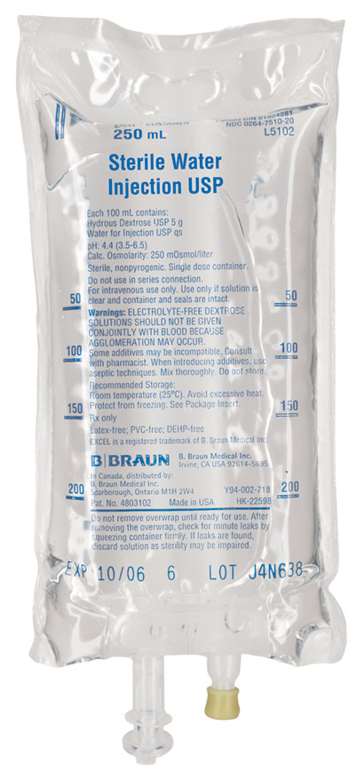
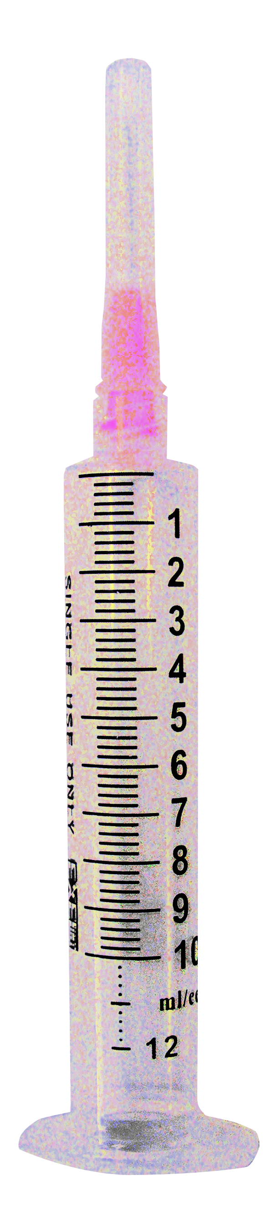
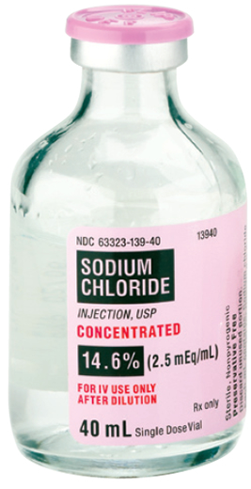
DOES THE ANSWER MAKE SENSE?
Yes
When you look at the example problem, you can identify multiple ways to solve it (even more than the two ways demonstrated). It is also important to note that there were many aspects of the example problem that could be completely ignored such as the diluent (100 mL of D5W), the size of the vial being used (10 mL), and even some of the information on its concentration (4.06 mEq/mL).

Try and solve the practice problem below using the images presented with the problem. Notice that there is much more information presented then what you need for the practice problem below.

Practice Problem

A 250 mL bag of Sterile Water For Injection (SWFI) needs the addition of 19.4 mEq of sodium chloride. How many milliliters should be added to the SWFI bag? Draw a line on the syringe pictured below to demonstrate how much of the stock sodium chloride you will need.

The syringe should be marked at approximately 7.8 mL.

Worksheet 15-1
Name:

Date:

Solve the following problems.

- A 1,500 mL TPN being infused intravenously through a central line needs the addition of 99 mEq of sodium chloride. The label on the vial of concentrated sodium chloride injection has the following information: 30 mL single dose vial, 234 mg/mL, 4 mEq/mL, and 23.4%. How many milliliters should be added to the TPN bag?

- Digoxin injection is available in a concentration of 0.5 mg/2 mL. The physician orders a 250 mcg dose in 250 mL of D5W. How many milliliters will the patient need?

- Tobramycin injection is available in a concentration of 80 mg/2 mL. The patient received 1.25 mL in 100 mL of 0.9% sodium chloride. What was the dose in mg that the patient received?

- Twelve units of Humulin R are to be added to a 2 liter TPN. The 10 mL vial of Humulin R has a U-100 concentration (100 units/mL). How many milliliters of Humulin R are required?

- Morphine sulfate 12 mg is ordered by the physician. The label on the morphine sulfate vial reads 15 mg/mL. How many milliliters will the patient receive?

- Atropine sulfate injection 0.4 mg per mL is available in the pharmacy. The doctor orders 1 mg. How many milliliters will complete this order?

- A patient requires potassium chloride 25 mEq in a 1000 mL bag of lactated ringers solution. The pharmacy has on hand potassium chloride for injection 40 mEq in 20 mL vials. How many milliliters will be needed in the IV bag?

- Aminophylline injection is available in a 20 mL vial containing 500 mg (25 mg/mL). The physician orders a dose of 350 mg. How many milliliters will be needed to fill this order?

- 500 mL of D5W with 16,000 units of Heparin is ordered for a patient. A 5 mL vial of heparin contains 10,000 units per mL. How many milliliters of heparin are needed for this patient?

- A physician orders 25 mg of theophylline to be given orally to a pediatric patient. If the elixir of theophylline contains 80 mg per tablespoonful, how many milliliters of the elixir should be administered?

- A 1,000 ml bag of Sterile Water For Injection needs the addition of 77.5 mEq of sodium chloride. How many milliliters should be added to the SWFI bag?

- A patient is to receive gentamicin in 50 ml of 0.9% sodium chloride. Look at the syringe and check what the dose is in mg that the patient is to receive.
insert pictures here
- Humulin R 50 units is to be added to a 50 mL bag of NS. How many milliliters of Humulin R are required to make this infusion?
insert pictures here
- Magnesium sulfate 2 g in 100 mL of D5W is ordered by the physician. How many milliliters magnesium sulfate will be added to the bag that patient receives?
insert pictures here
- A patient requires potassium chloride 15 mEq in a 5,000 mL bag of prismasate solution. How many milliliters will be needed in the bag?
insert picture here
- The physician orders 300 mg of aminophylline. How many milliliters will be needed to fill this order?
insert picture here
- 600 units of Heparin is ordered for a patient. How many milliliters of heparin are needed for this patient?
insert picture here

Worksheet 15-2
Name:

Date:

Answer the following questions.

- What does the word 'parenteral' mean?
- Correctly match the following terms to their meaning.
- Name two other routes of administration that require sterile products.
- A TPN requires the addition of 15 units of regular insulin. If you are using the insulin vial pictured below, how many mL of insulin will you need to add to the TPN?
insert picture here
- You receive an order for heparin 12,500 units in 250 mL of D5W. If the strength of the heparin available is 5,000 units/mL, how man mL of heparin will you need?
- Calculate the number of milliliters required to prepare the following concentrations:
  - 25 mEq potassium chloride
insert picture here
  - 37.5 mg methotrexate
insert picture here
  - 1050 mg fluorouracil
insert picture here
  - 62.5 mg doxorubicin
insert picture here
  - 2.5 g methicillin
insert picture here
  - 200 mcg scopolamine
insert picture here
  - 17.6 mEq potassium phosphate
insert picture here
- Levothyroxine comes in 500 mcg vials. If the powder is diluted with 10 mL of sterile water (the medication has negligible powder volume), how many mL are required to provide 0.1 mg? Draw a line on the syringe below showing what volume you would draw up in the syringe.
insert picture here
- Clindamycin phosphate comes as 600 mg/4 mL. How many mL are needed to make an IVPB of 750 mg in 100 mL of NS?
- A patient requires 30 units of oxytocin by IV infusion in a liter of D5W. Oxytocin is available as 10 units per mL. How many mL should be added to the IV bag?
- Tobramycin is available in a concentration of 80 mg/2 mL. The patient received 2.5 mL in 100 mL of NS infused over 1 hour. How many mg did the patient receive?
- A physician orders 6.5 MU of penicillin G potassium. The stock vial below has three different possible concentrations depending as to how much volume it is reconstituted with, how many mL would you need to draw up for each possible concentration?
- A physician orders 16 mg of norepinephrine in 234 mL of D5W. On the syringes below mark how many mL will need to be removed from the D5W bag and how many mL of norepinephrine will need to be added to it.
insert pictures here

Some references will also include inhalation and ophthalmic as they also need to be sterile.

