
CHAPTER 12
COMPOUNDING MATH
Oh the things you can fill
For the folks who are ill.
With your bright shiny spatula
Oh, what a thrill.
-- unknown author

The art of pharmaceutical compounding has ancient roots dating back to early hunter gatherer societies. These ancient civilizations utilized pharmaceutical compounding for religion, grooming, keeping the healthy well, treating the ill and preparing the dead. These ancient compounders produced the first oils from plants and animals. They discovered poisons and the antidotes. They made ointments for wounded patients as well as perfumes for customers.

Today compounding is still a necessary skill for many pharmacists and pharmacy technicians. Extemporaneous compounding is required for prescription orders that are not commercially available in the requested strength or dosage form requested. It is part of a technicians responsibility to help facilitate these requests.

In this chapter you will learn about:
- Reconstituting powders for oral suspensions,
- Mixing liquid preparations,
- Compounding ointments, gels, and creams,
- Medications sticks, and
- Advanced compounding calculations.

While these problems will be more complex than what you've previously done, you will find that you already know all the mathematical principles required to solve these. You will find the following skills helpful:
- Dimensional Analysis (Factor Label)
- Ratios / Proportions / Parts
- Percentage Strength
- The '5 Step Method'

Reconstituting powders for oral suspensions

Reconstituting oral suspensions is a good skill to understand as all pharmacy technicians will need to do it at some point and it is good to have forewarning of a common pitfall. It is often very important to reconstitute oral suspensions properly or you will end up with an overfilled bottle with a great deal of medication stuck in the bottom of the bottle. Let's look at an example briefly.

Example

To reconstitute a 150 mL bottle of amoxicillin for oral suspension 250 mg/5 mL, the manufacturer recommends 88 mL of distilled water is added in two divided portions. First loosen the powder in the bottle, then add approximately 1/3 of the total volume of water and shake the suspension. After the powder is wet, add the remaining water. How much water should you add each time?

QUESTION
How much water should you add each time?
DATA
final volume = 150 mL concentration = 250 mg/5 mL total water = 88 mL
add 1/3 of water initially then add the rest of the water
MATHEMATICAL METHOD / FORMULA
Basic Math
DO THE MATH

DOES THE ANSWER MAKE SENSE?
Yes

Now, you should attempt the following practice problem.

Practice Problem

- To reconstitute a 100 mL bottle of Augmentin for oral suspension 400 mg/5 mL, the manufacturer recommends 90 mL of distilled water is added in two divided portions. First loosen the powder in the bottle, then add approximately 1/3 of the total volume of water and shake the suspension. After the powder is wet, add the remaining water. How much water should you add each time?

1) Initially add 30 mL of water, then add another 60 mL.

Mixing liquid preparations

Sometimes you will need to determine how much to use of various products to fulfill a recipe written by a physician, sometimes you may take a recipe for a liquid medication and modify it for a different final volume, and other times you may need to either open up capsules or crush tablets and dissolve or suspend them in a liquid vehicle. Let's look at an example of each scenario.

Examples

- How much clindamycin phosphate (the stock vial concentration is 150 mg/mL) and how much Cetaphil Lotion are needed to make the following compound?

Rx clindamycin phosphate 1200 mg in Cetaphil Lotion
Disp: 120 mL
Sig: aa hs ud

First, we should figure out how many mL of the clindamycin phosphate stock solution we should use:

Then, we should figure out how much Cetaphil Lotion we'll need to qs this to 120 mL:

- A prescription is written for a mouthwash containing 170 mL diphenhydramine elixir, 50 mL lidocaine viscous, 200 mL nystatin suspension, 52 mL erythromycin ethyl succinate suspension, and 28 mL of cherry syrup to make 500 mL of mouthwash. How much of each ingredient would be needed if you only wanted to prepare 240 mL of the mouthwash?

First I would make a ratio comparing each ingredient and specifying the total volume:

170:50:200:52:28 to make 500 mL mouthwash

Then, I would solve for how much of each ingredient is needed to make 240 mL of mouthwash:

- How many 25 mg tablets of metoprolol tartrate and how many milliliters of Ora-Plus and Ora Sweet are needed to compound the following prescription?

Rx metoprolol tartrate 6.25 mg/tsp in a 50:50 mixture of Ora-Plus and Ora-Sweet
Disp: 300 mL
Sig: i tsp po bid

First let's determine how many metoprolol tartrate tablets are needed:

You will often expect the powder volume from crushed tablets and opened capsules to be negligible, but since we don't know exactly we will simply do the math for both liquids as if all the volume was from our two suspending agents and since they are a 50:50 mixture it means that we only need half the volume for each suspension.

Now you should try some practice problems.

Practice Problems

- How much tobramycin (the stock vial concentration is 40 mg/mL) and how much Cetaphil Lotion are needed to prepare the following compound?

Rx tobramycin 800 mg in Cetaphil Lotion
Disp: 60 mL
Sig: aa hs ud

- A prescription is written for a G.I. Cocktail containing 120 mL Donnatal elixir, 120 mL of lidocaine viscous solution, 480 mL of Mylanta to make a total of 720 mL of G.I. Cocktail. How much of each ingredient would be needed if you only need to prepare 120 mL of G.I. Cocktail?

- A prescription is written for allopurinol liquid 20 mg/mL in Ora-Plus:Ora-Sweet 1:1 (label with a shelf life of 60 days). How many tablets of allopurinol 100 mg are needed to prepare 200 mL and approximately how much Ora-Plus and Ora-Sweet are needed as well?

1) 20 mL tobramycin; 40 mL Cetaphil Lotion
2) 20 mL Donnatal elixir; 20 mL lidocaine viscous; 80 mL Mylanta
3) 40 allopurinol tablets; 100 mL Ora-Plus; 100 mL Ora-Sweet

Compounding ointments, gels, and creams

Sometimes compounding a semi-solid mixture (ointment, gel, or cream) can be as straight forward as mixing two semi-solids together and other times it may require incorporating a medication into a semi-solid base. Let's look at an example of each.

Examples

- A prescription is written for equal parts triamcinolone 0.1% cream and Lamisil cream, dispense 30 grams. How many grams of triamcinolone 0.1% cream are needed to fill the prescription? How many grams of Lamisil cream are needed to fill the prescription? What is the final percentage strength of triamcinolone in the compound?

To solve this we need to first recognize that the ratio between the ingredients are 1:1 for a total of 2 parts. With that in mind we know that half the total weight is how many grams of each ingredient we'll need.
Therefore, we will need 15 g of triamcinolone 0.1% cm and 15 g of Lamisil cm
Next, we need to evaluate the final percentage strength of triamcinolone in the compound. There are 2 ways to do it, one is to calculate just how much triamcinolone is in the mixture and then figure out its percentage strength, the other is to also divide by 2 like we did the total weight. Both ways will be demonstrated, but recognize that you only have to do it one way to achieve the correct answer.

or 0.1% ÷ 2 = 0.05% triamcinolone

Obviously the second way was easier, but it is good to know that you will get the same answer either way.

It is also noteworthy that the methodology used in this example will apply to any compounding problem where you are mixing ingredients in equal parts.

- If 50 g of salicylic acid ointment contains 10 grams of salicylic acid, what is the percentage strength of salicylic acid in the ointment?

This problem is just a simple w/w percentage strength problem:

Now we should once again look at some practice problems.

Practice Problems

- How much hydrocortisone powder and how much Eucerin cream must be weighed out to prepare the following compound?

Rx hydrocortisone 2.5% in Eucerin cream
Disp: 60 g
Sig: apply sparingly b.i.d. prn

- A prescription is written for equal parts hydrocortisone 2.5% cream and Lamisil cream, dispense 60 grams. How many grams of hydrocortisone 2.5% cream are needed to fill the prescription? How many grams of Lamisil cream are needed to fill the prescription? What is the final percentage strength of hydrocortisone in this compound?

1) 1.5 g hydrocortisone powder; 58.5 g Eucerin cream
2) 30 g of hydrocortisone cream; 30 g of Lamisil cream; final mixture has 1.25% concentration of hydrocortisone

Medication Sticks

Medication sticks are a solid dosage form used in topical application of local anesthetics, sunscreens, antivirals, antibiotics, and of course cosmetics. Although cosmetic sticks are viewed as tools to improve appearance, they also may contain pharmaceutical active ingredients that serve to heal or protect. For example, a lip balm, which moisturizes the lips, may contain both an antiviral and a sunscreen for use in the treatment and prevention of herpes simplex outbreak. Sticks offer patients, physicians, and pharmacies a unique dosage form that is convenient , relatively stable, and fairly easy to prepare. The convenience comes from the fact that there are several formulas in which all you need to do is add your active ingredients. Let's look at an example problem.

Example

- You receive the following prescription:

Rx Acyclovir 1200 mg
silica gel micronized 0.12 g
PEG 4500 MW 6.5 g
PEG 300 MW 15 mL
Disp: tube i
Sig: Apply to lips tid prn cold sores

How many 200 mg acyclovir caps are needed to prepare this compound?

If we look at this formula you realize all the calculations are done for us other than figuring out how many acyclovir caps we will need to use. This calculation is fairly straight forward:

Now let's look at a practice problem on the next page.

Practice Problem

- A prescription is written for: valacyclovir 1000 mg, Silica gel micronized 0.12 gm, Polyethylene glycol 4500 MW 6.5 gm, Polyethylene glycol 300 MW 15 mL. How many 500 mg tablets of valacyclovir are needed to prepare this compound?

1) 2 valacyclovir tablets

With these basic compounding calculations you are well prepared for the majority of things you will likely come in contact with in a compounding pharmacy, but one of the things that always makes extemporaneous compounding exciting are the constant new and unique challenges.

Worksheet 12-1
Name:

Date:

Solve the following problems.

- A prescription written for a toddler to receive:

Rx cephalexin 125 mg/5 mL susp.
Disp: 100 mL
Sig: tsp ss po qid x10d

When you retrieve the bottle from the shelf you find the following reconstitution instructions: To reconstitute cephalexin 125 mg/5 mL (100 mL after reconstitution) Add 68 mL of water in two equally divided portions to the dry mixture in the bottle. Shake well after each addition. How many mL of water will you add each time?

- How much clindamycin phosphate (the stock vial concentration is 150 mg/mL) and how much Cetaphil Lotion are needed to prepare the following compound?

Rx clindamycin phosphate 600 mg in Cetaphil Lotion
Disp: 60 mL
Sig: Apply aa hs ud

- A prescription is written for a mouthwash containing 170 mL diphenhydramine elixir, 50 mL lidocaine viscous, 200 mL nystatin suspension, 52 mL erythromycin ethyl succinate suspension, and 28 mL of cherry syrup to make 500 mL of mouthwash. How much of each ingredient would be needed if you only wanted to prepare 4 fluid ounces of this mouthwash?

- How many 300 mg rifampin capsules are needed to compound the following solution?

Rx Rifampin 600 mg/60 mL in Simple Syrup
Dispense 240 mL
Sig: 600 mg qd x 4 days

- A SMOG enema is equal parts sorbitol solution, magnesium hydroxide suspension, mineral oil, and glycerin solution. How may mL of each would you need if you received an order for a 1 liter SMOG enema?

- A prescription is written for ibuprofen 7.5% cream. How much ibuprofen powder is needed to prepare 60 grams of this compound?

- A prescription is written for: acyclovir 1000 mg, Silica gel micronized 0.12 gm, Polyethylene glycol 4500 MW 6.5 gm, Polyethylene glycol 300 MW 15 mL. How many 200 mg capsules of acyclovir are needed to prepare this compound?

- How much of each ingredient must be weighed out to prepare the following ointment?

Rx testosterone 2% and
menthol 4.33% in hydrophilic petrolatum
Disp: 120 g
Sig: apply q.i.d.

- After you complete your calculations for the previous problem, you realize you are out of hydrophilic petrolatum. You find the following recipe to make 1000 g of hydrophilic petrolatum: cholesterol 30 g, stearyl alcohol 30 g, white wax 80 g, white petrolatum 860 g. How much of each ingredient will you need if the pharmacist asks you to make only 4 ounces?

- You need to prepare 200 mL of metformin 100 mg/mL suspension in Ora-Plus:Ora-Sweet 1:1. How many metformin 1000 mg/tablet will you need and approximately how much Ora-Plus and Ora-Sweet are needed as well?

Worksheet 12-2
Name:

Date:

Solve the following problems.

- You are given the following recipe for compounding diclofenac gel: diclofenac sodium USP 4.8 g, ethanol 200 proof 4.8 mL, lipoil 28.8 mL, Polox 20% gel qs ad 120 g. What is the percentage strength of diclofenac sodium in this gel?

- You are asked to compound 8 fl. oz. of glycopyrrolate 1% topical solution. Your recipe is as follows: glycopyrrolate 1 g, benzyl alcohol 0.96 mL, purified water qs 100 mL. How much of each ingredient will you need to compound 8 fluid ounces?

- A prescription is written for phenytoin 10% in zinc oxide qs 60 gm. How many phenytoin 50 mg tablets are needed to prepare this compound?

- You need to prepare 100 mL of potassium bromide 250 mg / mL. How much potassium bromide should you weigh?

- You are preparing hydrocortisone 1.6 g in 160 mL Lubriderm lotion. What is the percent strength of the hydrocortisone?

- A prescription for 240 mL of a syrup with a concentration of 10mg of promethazine and 6.25mg of codeine per teaspoonful is ordered. Promethazine is available in 50 mg / mL stock solution and codeine is available 12 mg / 5 mL stock solution. You will q.s. the syrup with cherry syrup. How many mL of codeine will you need. How much promethazine will you need? How much cherry syrup will you need?

- You need to prepare 60 mL of baclofen 10 mg/mL. How many tablets of baclofen 10 mg/tablet will you need?

- You need to prepare 160 mL of amiodarone 5 mg/mL suspension. How many tablets of amiodarone 200 mg/tablet will you need?

- You need to prepare 60 mL of celecoxib 100 mg/5 mL. How many capsules of 200 mg celecoxib/capsule will you need?

- You receive the following script:

Rx Mudd Mixture
Disp: 184 mL
Sig: swish and swallow 23 mL q6h x 2 days

For every 23 mL of Mudd mixture you have 20 mL of nystatin (100,000 units/mL), 2 mL of gentamicin (40 mg/mL), and 1 mL of colistimethate (20 mg/mL). How many milliliters of each ingredient are you going to need to fill this script?

- You receive a prescription requesting 120 mL of an acetazolamide suspension 25 mg/mL in a 50:50 mixture of Ora-Plus and Ora-Sweet. How many 250 mg acetazolamide tablets and and approximately how many mL each of Ora-Plus and Ora-Sweet are needed to compound this prescription?

- You receive a prescription requesting 4 fl oz of a 1 mg/mL amlodipine suspension in a 50:50 mixture of Ora-Plus and Ora-Sweet. How many 5 mg amlodipine tablets and and approximately how many mL each of Ora-Plus and Ora-Sweet are needed to compound this prescription?

- You receive the following prescription for a pediatric patient:

Rx atenolol suspension 2 mg/mL
in Oral Diluent
Disp: 150 mL
Sig; i tsp po qd

How many atenolol 25 mg tablets will you need to compound this prescription?

- You need to prepare 120 mL of azathioprine 50 mg/mL suspension by crushing 50 mg tablets of azathioprine and then qs with cherry syrup. How many azathioprine tablets do you need to prepare this suspension?

- You are asked to make 60 mL of a 5 mg/mL baclofen suspension with 20 mg baclofen tablets, a small amount of glycerin to function as a levigating agent and then qs with simple syrup. How many baclofen tablets are needed?

Worksheet 12-3
Name:

Date:

Solve the following problems.

- Using the directions on the following label, how many mL of water will you add each time?

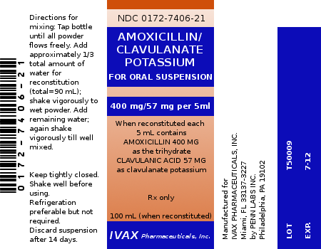
- A prescription is written for a G.I. Cocktail containing 120 mL Donnatal elixir, 120 mL of lidocaine viscous solution, 480 mL of Mylanta to make a total of 720 mL of G.I. Cocktail. How much lidocaine viscous would be needed if you only need to prepare 120 mL of the G.I. Cocktail?

- A prescription is written for ichthammol ointment 2 oz. How much of each ingredient is needed to prepare 2 oz. if you are using the following formula: 100 g of ichthammol, 100 g of lanolin and 800 g of white petrolatum to make 1000 g of ichthammol ointment.

- You are asked to compound a pint of Schamberg's lotion. You are told to base your calculations off of the following formula: zinc oxide 8 g, menthol 0.25 g, phenol 0.5 g, calcium hydroxide solution 46 mL, olive oil qs ad 100 mL. How much of each ingredient will you need to prepare a pint of this compound.

- You receive the following prescription:

Rx diclofenac sodium 8% in Pentravan cream
Disp: 60 grams
Sig: aa bid ut dict

How many grams of each ingredient will be needed to make this compound?

- You receive the following prescription:

Rx tetracycline HCl susp. 125 mg/tsp in
50:50 mixture of Ora-Plus and Ora-Sweet
Disp: 300 mL
Sig: tsp i po bid

How many 250 mg tetracycline capsules and approximately how many mL of Ora-Plus and Ora-Sweet will you need to make this compound?

- You receive the following prescription for hand rolled lozenges:

Rx benzocaine HCl 100 mg
acacia 700 mg
water qs
food coloring and flavoring gtt v aa
Disp: M et Ft 10 lozenges c 10 mg benzocaine each
Sig: dissolve in mouth prn mouth soars

The pharmacists suggests you do your calculations for 12 lozenges and when you're done you can simply discard the heaviest and the lightest lozenge. How much of each ingredient should you measure?

- A prescription is written for: vitamin E 1,000 IU, zinc oxide 100 mg, Silica gel micronized 0.12 gm, Polyethylene glycol 4500 MW 6.5 gm, Polyethylene glycol 300 MW 15 mL. How many mL of vitamin E are needed to prepare this lip balm if your stock vitamin E has a concentration of 100 g/100 mL (1 mg = 1.1 IU)?

- An erythromycin ophthalmic ointment requires you to mix 1 part erythromycin 2% (sterile) concentrate with 3 parts ophthalmic base (sterile) ointment. How many grams of each would you need to dispense 50 g of erythromycin ophthalmic ointment and what would be the percent concentration of erythromycin in the final product?

- The pharmacy receives a prescription requesting 120 mL of a 0.1 mg/mL clonazepam suspension in a 50:50 mixture of Ora-Plus and Ora-Sweet. How many 1 mg clonazepam tablets and and approximately how many mL each of Ora-Plus and Ora-Sweet are needed to compound this prescription?

- You receive a request for 120 mL of 1 mg/mL bethanechol solution and you are to qs it with sterile water for irrigation. How many 10 mg bethanechol tablets are needed to compound this solution?

- The pharmacy receives a prescription requesting 2 fl oz of a 5 mg/mL bethanechol suspension in a 50:50 mixture of Ora-Plus and Ora-Sweet. How many 10 mg clonazepam tablets are needed to compound this prescription?

- The pharmacy recieves the following prescription to prepare a 27 kg pediatric patient for a bone marrow transplant:

Rx busulfan suspension 2 mg/mL in Simple Syrup
Disp: 16 doses
Sig: 30 mg po q6h

  - How many milliliters of busulfan suspension will the patient receive for each dose?

  - How many milliliters of busulfan suspension will be needed to cover all 16 doses?

  - How many 2 mg busulfan tablets are required to make this suspension?

- The pharmacy needs to prepare 300 mL of diltiazem suspension 12 mg/mL using 90 mg diltiazem tablets and a 50:50 mixture of Ora-Plus and Ora-Sweet. How many diltiazem tablets and approximately how many milliliters each of Ora-Plus and Ora-Sweet are needed to make this compound?

- You receive the following prescription for a 9 lb 14 oz feline with lower back pain:

Rx Gabapentin suspension chicken flavor 10 mg/mL
Disp: 180 mL
Sig: Day 1 ~ 20 mg po, Day 2 ~ 20 mg po bid, then 20 mg po tid thereafter

Your recipe for 100 mL of this suspension is as follows: gabapentin 1g, xanthum gum 0.4 g, stevia 0.75 g, acesulfame 0.75 g, sodium saccharin 0.1 g, magnasweet solution 0.2 mL, 1% citric acid approximately 0.1 mL (use to obtain pH of 5.5 to 6.5), sodium chloride 0.5 g, bitter stopping agent flavor 1 mL, glycerin 2 mL, chicken flavor 3 mL, bacteriostatic water q.s. 100 mL. How much of each ingredient will you need to compound the requested 180 mL?

Advanced Compounding Calculations

There are several things to consider with respect to advanced compounding calculations including:
- calculations involving specific gravity,
- accounting for excipients when compounding,
- suppositories and density factors, and
- determining shell sizes for extemporaneously compounded capsules.

Calculations Involving Specific Gravity

Sometimes when compounding mixtures the recipes will provide you with weights of all the various ingredients including liquids. Obviously, it is easier to measure a liquid by volume than mass. Water has the unique advantage that 1 gram of water has a volume of 1 milliliter, but other liquids do not share this convenient conversion. When dealing with liquids other than water you will need to know their specific gravity.

Specific gravity is commonly defined as the mass of 1 milliliter of a particular substance. Therefore, if I stated that a particular liquid had a specific gravity of 0.8 it means that every milliliter of it weighs 0.8 grams. If a particular compound requested 5 grams of a liquid known to have a specific gravity of 0.8 I could determine the volume as follows:

Some common specific gravities that you may end up working with include:

Substance | Specific Gravity  (g/mL)
glycerin | 1.249
honey | 1.40-1.45
mineral oil | 0.845-0.905
olive oil | 0.910-0.915
stearyl alcohol | 0.805-0.815
water | 1

You will notice that with the list above there is often a slight range for specific gravity. When dealing with this range it is generally acceptable to use the average value (add the low value of the range to the high value and divide by 2). As an example if a prescription required 5 grams of honey I would first determine the average specific gravity as follows:

Then I would find the volume as follows:

Now let's attempt a couple of practice problems.

Practice Problems

- A prescription is written for 60 g of zinc oxide ointment, USP. If the formula for zinc oxide ointment, USP is as follows: 200 g of zinc oxide powder, 650 g of white ointment, and 150 gram of mineral oil to make 1000 grams of zinc oxide ointment, USP; how much of each ingredient will you need to fill this order? Using the information from the previous page (mineral oil has a specific gravity of 0.845 to 0.905) determine your quantity of mineral oil required for this prescription in milliliters. (Note, since this preparation is commercially available you would not ordinarily compound it. This problem is intended for educational purposes.)

- Use the prescription below and information from the specific gravity chart on the previous page to determine how many grams of cocoa butter, how many grams of white petrolatum, and how many milliliters of olive oil you'll need to compound this prescription.
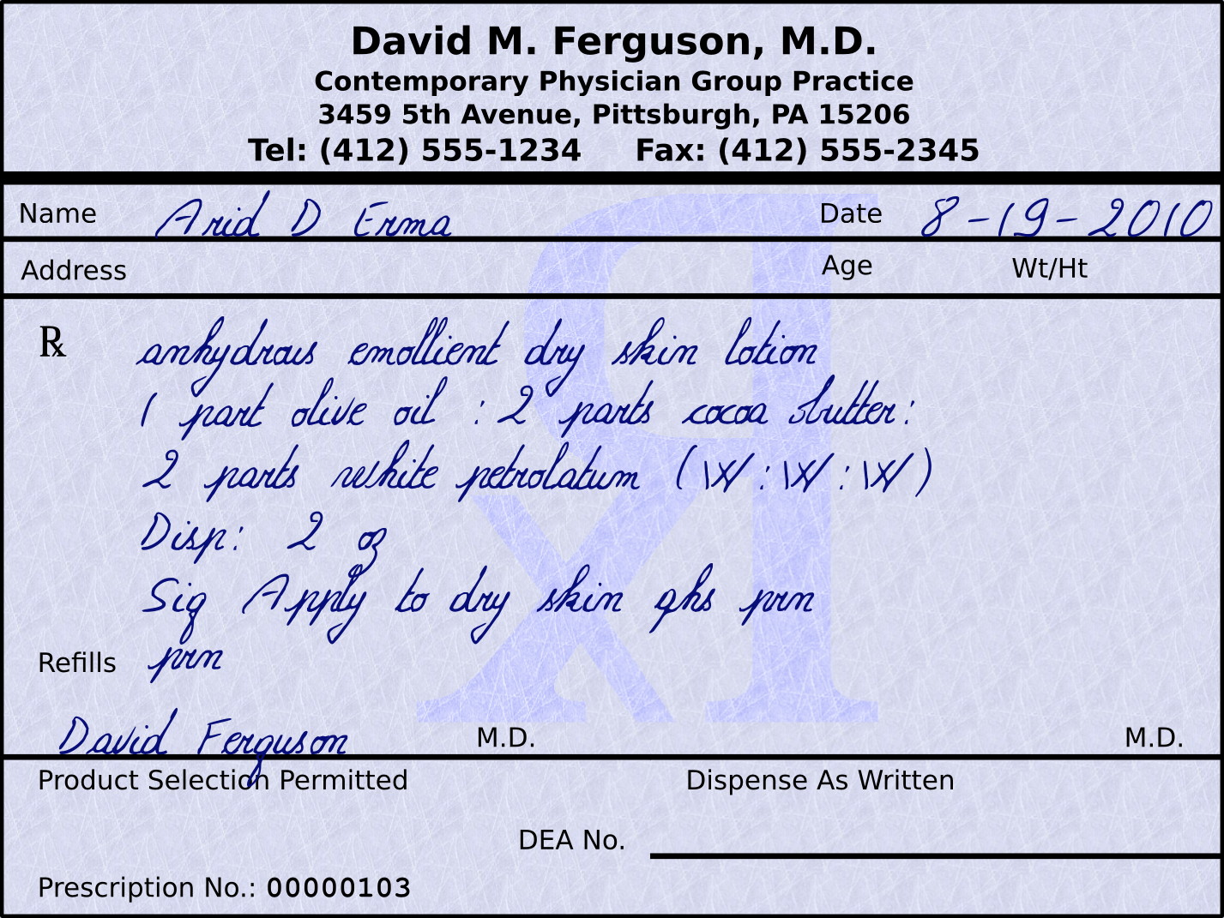

1) 12 g of zinc oxide powder, 39 g of white ointment, and 10.3 mL of mineral oil 2) 22.72 g of cocoa butter, 22.72 g of white petrolatum, 12.4 mL of olive oil
Accounting for Excipients when Compounding

Before we start looking at how to do calculations where we need to account for excipients we should define what excipients are. Excipients are “inert” or inactive ingredients other than the active drug which are included in the manufacturing process or are contained in a finished pharmaceutical dosage form; they allow the proper delivery of the active compounds contained in nearly all over the counter and prescription medications.

At the risk of sounding like 'Mary Poppins', almost every drug needs a few inactive ingredients to help the medicine go down. Depending on the route of administration, and form of medication, various excipients may be used. According to the USP-NF, all excipients fit into one or more of 40 categories. The ingredients are classified by the functions they perform in a pharmaceutical dosage form. Some examples are antiadherents, binders, coatings, colors, disintegrants, fillers, flavors, glidants, lubricants, preservatives, sweeteners, and printing inks.

Example

- A compound prescription order calls for 2200 mg of naproxen. You have available in your pharmacy 500 mg naproxen tablets. Each 500 mg naproxen tablet weighs 630 mg due to all the excipients required to manufacture it. To achieve this, we need to first figure out how many naproxen tablets you will need to pull out of stock to make this (you will need to automatically round up any decimal values). Then, you can triturate the naproxen tablets in a mortar and pestle and weigh out the required quantity of crushed naproxen tablets to provide the desired quantity of medication. Below is the math required to perform this task.

Now that we know we will need 5 tablets from stock, you can crush them up and use a ratio proportion to determine how much you will need to weigh out.

Therefore, after you triturate 5 naproxen tablets in your mortar and pestle, you will need to weigh out 2,772 mg of the crushed powder to acquire 2,200 mg of naproxen.

Let's proceed to the next page where you can do a practice problem involving calculations where you need to account for excipients.

Practice Problem

- You need to prepare 120 mL of metronidazole suspension with a concentration of 59 mg/5 mL. How many 250 mg tablets will you need, and if each tablet weighs 430 mg how will you determine the appropriate weight of the tablets to use after you triturate them for the requested suspension?

You will need to use 6 tablets and after they are crushed you will weigh out 2,436 mg.

Suppositories and Density Factors

Suppositories are defined by the USP-NF as follows:

Suppositories are solid bodies of various weights and shapes, adapted for introduction into the rectal, vaginal, or urethral orifice of the human body. They usually melt, soften, or dissolve at body temperature. A suppository may act as a protectant or palliative to the local tissue at the point of introduction or as a carrier of therapeutic agents for systemic or local action.

Suppositories may be used when a local effect is needed in the rectum, vagina, or urethra.

Rectal suppositories (and to a lesser extent, vaginal suppositories) may also be used as carriers of systemic drugs. Rectal suppositories offer an alternative for the systemic delivery of drugs in patients who can not take drugs orally. Examples include patients who are unconscious, those who are vomiting or having seizures, and those who have obstructions in the upper gastrointestinal tract.

Some drugs that are ineffective orally may be successfully administered rectally or vaginally. Examples include drugs that are extensively metabolized by first-pass effect and drugs that are destroyed in the stomach or intestine. An example of a drug that is usually administered either rectally or vaginally for those reasons include progesterone.

Compounding suppositories is usually done as a last resort. This is because suppositories are, in general, more difficult to prepare than other dosage forms.

Suppositories are usually made of one of two bases:

- polyethylene glycol (PEG) which dissolves, or
- cocoa butter which melts at body temperature.

There are also two common methods for preparing suppositories:

- hand-rolling suppositories which does not require any special equipment but lacks pharmaceutical elegance, or
- fusion suppositories provide much greater pharmaceutical elegance but require either aluminum or disposable molds and also they require more calculations.

In this chapter we are going to look at the more common (although more complex to calculate) cocoa butter based fusion suppositories. When doing these calculations, you will need to know how many grams of your base can be held by the suppository molds and then figure out how much of your base to use when mixed with the active ingredients added to a suppository. Unfortunately I can not just subtract the weight of the active ingredient from the weight of our aforementioned total weight to figure out how much cocoa butter is needed because the active ingredient does not occupy the same volume as that mass of cocoa butter (they have different densities). We can use the table on this page to find the active ingredient's density factor (DF) when compared to cocoa butter.

Density Factors for Cocoa Butter Suppositories compared to the amount of weight (g) required to fill the same volume as 1 gram of cocoa butter.
Medication | Factor | Medication | Factor
Aloin | 1.3 | Iodoform | 4.0
Alum | 1.7 | Menthol | 0.7
Aminophylline | 1.1 | Morphine hydrochloride | 1.6
Aminopyrine | 1.3 | Opium | 1.4
Aspirin | 1.1 | Paraffin | 1.0
Barbital | 1.2 | Pentobarbital | 1.2
Belladonna extract | 1.3 | Perovian balsam | 1.1
Benzoic acid | 1.5 | Phenobarbital | 1.2
Bismuth carbonate | 4.5 | Phenol | 0.9
Bismuth salicylate | 4.5 | Potassium bromide | 2.2
Bismuth subgallate | 2.7 | Potassium iodide | 4.5
Bismuth subnitrate | 6.0 | Procaine | 1.2
Boric acid | 1.5 | Quinine hydrochloride | 1.2
Castor oil | 1.0 | Resorcinol | 1.4
Chloral hydrate | 1.3 | Salicylic acid | 1.3
Cocaine hydrochloride | 1.3 | Secobarbital sodium | 1.2
Codeine phosphate | 1.1 | Sodium bromide | 2.3
Digitalis leaf | 1.6 | Spermaceti | 1.0
Dimenhydrinate | 1.3 | Sulfathiazole | 1.6
Diphenhydramine hydrochloride | 1.3 | Tannic acid | 1.6
Gallic acid | 2.0 | White wax | 1.0
Glycerin | 1.6 | Witch hazel fluid extract | 1.1
Hydrocortisone acetate | 1.5 | Zinc oxide | 4.0
Ichthammol | 1.1 | Zinc sulfate | 2.8

Example

- You receive a prescription requiring you to compound 6 cocoa butter based suppositories with 100 mg of aspirin in each. You know from previous work with these particular suppository molds that they can each hold 2 grams of cocoa butter. How much cocoa butter and how much aspirin powder will you need to compound this order?

First, we should determine how much cocoa butter these six suppositories could hold.

Now we should look at how much aspirin powder is required.

Since cocoa butter and aspirin have different densities, we will need to look at the chart on the previous page to determine how much mass of cocoa butter is displaced by our 600 mg of aspirin powder.

Now we can subtract the 545 mg from our previous number of 12 g to determine how much cocoa butter we actually need.

So now we know how much of each ingredient we need.

11.455 g cocoa butter
600 mg aspirin

Now, you should attempt a practice problem.

Practice Problem

- You receive a prescription requiring you to compound 12 cocoa butter based suppositories with 30 mg of phenobarbital in each. You know from previous work with these particular suppository molds that they can each hold 2.08 grams of cocoa butter. How much cocoa butter and how much phenobarbital powder will you need to compound this order?

You will need to use 24.66 g of cocoa butter and 360 mg phenobarbital.
Determining Shell Sizes for Extemporaneously Compounded Capsules

The gelatin shells used in capsules are made of two parts. The base is the longer end and fits into the shorter end which is referred to as the cap. The cap is designed to fit over the base and then snap or lock into place with added pressure.

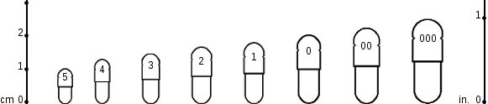
Capsules are oval in shape and available in eight different sizes for human use. These sizes are #5, #4, #3, #2, #1, #0, #00, and #000, with the smallest being a #5 and the largest being #000. The numbers used to designate size have no bearing on the volume that may be contained within. The capacity of a capsule is dependent on the density and physical characteristics of the powders used in the formula. (Larger capsules are available for veterinary use.)

The approximate capacity of various capsules can be found on the following chart:
 | Capsule Size
 | 5 | 4 | 3 | 2 | 1 | 0 | 00 | 000
Drug Substance | Capacity in grams of drug powder
Acetaminophen | 0.13 | 0.18 | 0.24 | 0.31 | 0.42 | 0.54 | 0.75 | 1.10
Aluminum hydroxide | 0.18 | 0.27 | 0.36 | 0.47 | 0.64 | 0.82 | 1.14 | 1.71
Ascorbic acid | 0.13 | 0.22 | 0.31 | 0.40 | 0.53 | 0.70 | 0.98 | 1.42
Aspirin | 0.10 | 0.15 | 0.20 | 0.25 | 0.33 | 0.55 | 0.65 | 1.10
Bismuth subnitrate | 0.12 | 0.25 | 0.40 | 0.55 | 0.65 | 0.80 | 1.20 | 1.75
Calcium carbonate | 0.12 | 0.20 | 0.28 | 0.35 | 0.46 | 0.60 | 0.79 | 1.14
Calcium lactate | 0.11 | 0.16 | 0.21 | 0.26 | 0.33 | 0.46 | 0.57 | 0.80
Corn starch | 0.13 | 0.20 | 0.27 | 0.34 | 0.44 | 0.58 | 0.80 | 1.15
Lactose | 0.14 | 0.21 | 0.28 | 0.35 | 0.46 | 0.60 | 0.85 | 1.25
Quinine sulfate | 0.07 | 0.10 | 0.12 | 0.20 | 0.23 | 0.33 | 0.40 | 0.65
Sodium bicarbonate | 0.13 | 0.26 | 0.32 | 0.39 | 0.52 | 0.70 | 0.97 | 1.43

When looking at the shell capacities for various drugs on the chart above note that the number listed is the maximum quantity that you can pack in a shell that size. For example if you wanted to place 300 mg (0.300 g) of acetaminophen in a capsule you could fit it in a size #2 capsule, but if you wanted to put 325 mg (0.325 g) of acetaminophen, you would need to use a size #1 capsule.

When determining capsule size it becomes more complex when looking at capsules with multiple drug additives. If one additive is going to take the majority of the volume, you may simply want to add the weights of all your drugs and then base your capsule size on the ingredient requiring majority of the room. Let's look at an example problem to demonstrate this.
Example

- You receive an order for a hospice patient requesting compounded capsules with 15 mg of hydrocodone bitartrate and 325 mg of acetaminophen. What size capsule shell will you need?

As acetaminophen is the ingredient that is going to make up the bulk of the capsule we will base our capsule size off that. First we need to determine our total weight.

Based on the chart from the previous page you will need to use a size #1 capsule shell.

Practice Problems

- What size capsule shell will you need if a physician requests 2 grains of aspirin to be dispensed in a capsule for a patient?

- You receive an order for a hospice patient requesting 30 compounded capsules with 20 mg of oxycodone, 120 mg aspirin, and 300 mg acetaminophen. What size capsule shell will you need?

1) Size #4 capsules 2) Size #0 capsules

Worksheet 12-4
Name:

Date:

Solve the following problems.

- You receive a request to make 'Pittsburgh Paste', which gets its name from its golden yellow color. It consists of Aquaphor, cholestyramine powder, and mineral oil (which acts as a levigating agent). You find the following compounding recipe for it:

PITTSBURGH PASTE

Aquaphor 80 g
Cholestyramine Powder 5.9 g
Mineral Oil 20 mL

Auxiliary Labeling: TOPICAL USE ONLY

Expiration: 28 DAYS

Mineral oil has a specific gravity of 0.845-0.905, so what is the percent concentration of cholestyramine powder in this compound?

- A prescription is written for ibuprofen 7.5% cream. You are out of ibuprofen powder and will need to crush 200 mg ibuprofen tablets (each tablet weighs 0.33 g) to prepare this compound. How many tablets are you going to triturate and how much weight of these crushed tablets are needed to prepare 30 grams of this compound?

- A pharmacy receives a prescription for 12 cocoa butter based suppositories with 200 mg of procaine each. The suppository mold in the pharmacy can hold 2.27 g of cocoa butter per suppository. How much cocoa butter and how much procaine will be needed to make these suppositories?

- Based on the prescription below and the capsule chart earlier in this chapter, what size capsule shell should be used when preparing these capsules?
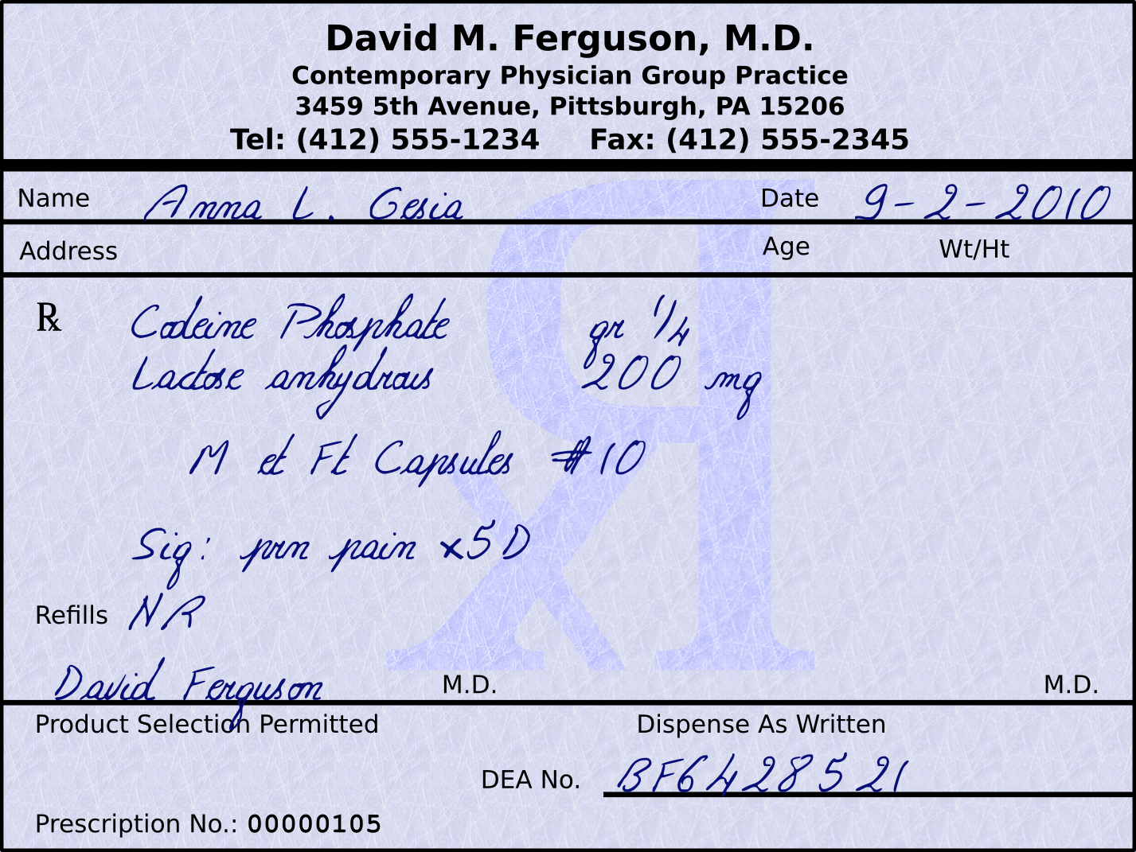

- While rarely seen today, Brompton Cocktails are still occasionally ordered for terminally ill patients, to provide them with comfort and promote sociability at end of life. Brompton Cocktail's received their name from where it was originally created during the early 19th century at the Royal Brompton Hospital in London, England. The recipe for the cocktail tends to vary between institutions. You are working at a hospital with a terminally ill cancer patient and the physician wants to give the patient a Brompton Cocktail. After a brief discussion, the pharmacist and the physician settle on the following recipe:

BROMPTON'S COCKTAIL

Morphine Solution 10 mg/mL 6 mL
Cocaine HCl powder 67.2 mg
Simple Syrup 15 mL
90% Ethanol 39 mL
TOTAL VOLUME 60 mL

Auxiliary Labeling: Keep Refrigerated, Oral Use Only

Expiration: Seven Days

The pharmacist is very busy and needs you to calculate several things for labeling the bottle.

  - What is the new percentage strength of the ethanol?

  - How many mg of morphine are in a dose of 1 teaspoon?

  - You are told that 1.12 g of cocaine HCl equals 1 g of cocaine, so how many mg of cocaine are in 1 teaspoon?

- A prescription is written for a patient that has a hard time swallowing tablets and suffers from hypothyroidism:

Rx: Levothyroxine Na Suspension
Disp: 30 day supply
Sig: 100 mcg po qd

You find the following recipe in your compounding log:

LEVOTHYROXINE NA 25 MCG / mL SUSPENSION

Levothyroxine Na 0.1 mg tablets 25 tabs
Glycerin 40 mL
Distilled Water q.s. 100 mL

Instructions: Crush levothyroxine Na tablets and triturate with glycerin, which act as a levigating agent and rinse for mortar and pestle. Q.S. with distilled water to obtain a total volume of 100 mL.

Auxiliary Labeling: Shake Well, Oral Use Only, Protect From Light, Keep Refrigerated

How would you rewrite the recipe to provide the requested 30 day supply?

- The pharmacist requests that you prepare 500 g of bentonite magma (used as a suspending medium for other drugs). The recipe for bentonite magma NF is as follows:

BENTONITE MAGMA

Bentonite 50 g
Purified Water q.s. ad 1,000 g

Rewrite this recipe for 500 g, and how many mL of water will be needed since water has a specific gravity of 1?

- A compound prescription order calls for 90 g of a 7% naproxen ointment. You have available in your pharmacy 500 mg naproxen tablets. Each 500 mg naproxen tablet weighs 630 mg due to all the excipients required to manufacture it. To achieve this, we need to first figure out how many naproxen tablets you will need to pull out of stock to make this. Then, you can triturate the naproxen tablets in a mortar and pestle and weigh out the required quantity of crushed naproxen tablets to provide the desired quantity of medication to compound this prescription. How many tablets will need triturated and what weight of crushed up tablets will then need to be weighed out?

- A pharmacy receives a prescription for 12 cocoa butter based Rectal Rocket® suppositories with 200 mg of procaine, 100 mg of hydrocortisone acetate, and 60 mg of witch hazel fluid extract (witch hazel has a specific gravity of 0.979-0.983 ) each. These suppository molds can hold 4 g of cocoa butter per suppository.

  - How many grams of procaine will be needed to make these suppositories?

  - How many grams of hydrocortisone acetate will be needed to make these suppositories?

  - How many grams and how many milliliters of witch hazel fluid extract are needed to make these suppositories?

  - How many grams of cocoa butter will be needed to make these suppositories?

- A physician has a patient with legitimate pain issues but also has a history of prescription drug abuse. After a brief discussion between the pharmacist and the patient's physician they decide on dispensing 30 capsules with 5 mg of hydrocodone bitartrate, 325 mg of acetaminophen, and 5 mg of capsaicin each. What size capsule shells will you need to compound this prescription?

Worksheet 12-5
Name:

Date:

Solve the following problems.

- A prescription written for a pediatric patient to receive:

Rx cefadroxil 250 mg/5 mL susp.
Disp: 100 mL
Sig: i tsp po bid x10d

When you retrieve the bottle from the shelf you find the following reconstitution instructions: To reconstitute cefadroxil 250 mg/5 mL (100 mL after reconstitution) tap bottle lightly to loosen powder. Add 61 mL of water in two equally divided portions to the dry mixture in the bottle. Shake well after each addition. How many mL of water will you add each time?

- A prescription written for a pediatric patient to receive:

Rx cefixime 100 mg/5 mL susp.
Disp: 75 mL
Sig: iss tsp po qd x10d

When you retrieve the bottle from the shelf you find the following reconstitution instructions: To reconstitute cefixime 100 mg/5 mL (75 mL after reconstitution) tap bottle lightly to loosen powder. Add 52 mL of water in two equally divided portions to the dry mixture in the bottle. Shake well after each addition. How many mL of water will you add each time?

- How much lidocaine HCl (the stock vial concentration is 40 mg/mL) and how much Cetaphil Lotion are needed to prepare the following compound?

Rx lidocaine HCl 1200 mg in Cetaphil Lotion
Disp: 120 mL
Sig: apply lightly to aa q4h prn itching and burning

- From the following formula, calculate the number of grams of each ingredient required to prepare 60 grams of this ointment:

Precipitated sulfur 10 g
Salicylic acid 2 g
Hydrophilic ointment 88 g

- Using the same formula as in the previous problem, determine how many grams of each ingredient would be required to prepare a pound of this ointment.

- A patient comes in suffering from mouth soars and presents the following prescription:

Rx Magic Swizzle
Disp: 480 mL
Sig: i Tbs swish and spit q6h prn mouth pain

Magic Swizzle is a 1:1:1 ratio of mixing viscous lidocaine, diphenhydramine elixir, and magnesium aluminum hydroxide suspension. How many mL of each are needed to prepare this solution?

- You receive the following script:

Rx Mudd Mixture
Disp: 4 day supply
Sig: swish and swallow 23 mL q6h

For every 23 mL of Mudd Mixture you have 20 mL of nystatin (100,000 units/mL), 2 mL of gentamicin (40 mg/mL), and 1 mL of colistimethate (20 mg/mL).

  - How many milliliters of Mudd Mixture do you need to dispense in total?

  - How many milliliters of each ingredient are you going to need to fill this script?

  - Nystatin is available in 1 pint bottles, gentamicin is available in 20 mL vials, and colistimethate comes as a lyophilized powder with 150 mg/vial. How many bottles of nystatin, vials of gentamicin, and vials of colistimethate will you need to compound this order?

- Due to a product shortage the pharmacist asks you to compound 60 mL of a 15 mg/mL oseltamivir suspension using 75 mg capsules and cherry syrup. How many 75 mg oseltamivir capsules will be needed for compounding this suspension?

- The following is a recipe intended for veterinary use:

METRONIDAZOLE AND SILVER SULFADIAZINE CREAM

Metronidazole 1 g
Silver sulfadiazine 1 g
Glycerin 5 g
Hydrophyllic ointment q.s. 100 g

  - How many grams of each ingredient would be needed to prepare 2 oz of this cream?

  - Considering that glycerin has a specific gravity of 1.249, how many mL of glycerin will be needed for this preparation?

- You receive the following prescription for hand rolled lozenges:

Rx lidocaine HCl 100 mg
acacia 700 mg
water qs
food coloring and flavoring gtt v aa
Disp: M et Ft 10 lozenges c 10 mg lidocaine each
Sig: dissolve in mouth prn mouth soars

The pharmacists suggests you do your calculations for 12 lozenges and when you're done you can simply discard the heaviest and the lightest lozenge.

  - How much of each ingredient should you measure?

  - If your stock lidocaine HCl solution has a concentration of 40 mg/mL how many milliliters will you need?

- A prescription is written for: diphenhydramine 250 mg, Silica gel micronized 0.12 gm, Polyethylene glycol 4500 MW 6.5 g, Polyethylene glycol 300 MW 15 mL. How many 50 mg tablets of diphenhydramine are needed to prepare this compound?

- The pharmacy needs to make a 150 mL of a 0.05 mg/mL alprazolam suspension. If each 2 mg alprazolam tablet weighs 80 mg, how many 2 mg alprazolam tablets will you need to pull out of stock and after they are triturated how many grams of crushed alprazolam tablets will you weigh out?

- Calculate the quantities required to make six cocoa butter based suppositories (each mold can hold 2.17 g of cocoa butter), each containing 100 mg aminophylline (aminophylline has a density factor of 1.1 when compared to 1 g of cocoa butter).

- A physician has a patient with legitimate pain issues but also has a history of prescription drug abuse. Because of other medications the patient may be taking that contain acetaminophen, the physician does not want any additional acetaminophen in this product. After a brief discussion between the pharmacist and the patient's physician they decide on dispensing 30 capsules with 5 mg of hydrocodone bitartrate, 325 mg of aspirin, and 5 mg of capsaicin each. What size capsule shells will you need to compound this prescription?

- A pharmacist asks you to prepare a bottle of “Mile's Solution”. You find the following recipe in the book:

MILE'S SOLUTION

Prednisone Elixir 5 mg/5 mL 120 mL
Tetracycline 500 mg caps 3 caps
Cherry Syrup 60 mL
Nystatin Suspension 100,000 u/mL 30 mL
Diphenhydramine Elixir 12.5 mg/5 mL 75 mL
Sterile Water for Irrigation 240 mL
TOTAL VOLUME 525 mL

Auxiliary Labeling: Shake Well, Oral Use Only, Protect From Light

Expiration: Two Weeks

You gather all the supplies, and find that the only prednisone elixir you have in stock has a concentration of 5 mg/mL. You bring this to the pharmacist's attention and she tells you to adjust how much prednisone you add so that you end up with the correct concentration and change the amount of cherry syrup added to make up the difference in the total volume.

  - How much prednisone elixir 5 mg/mL are you going to add?

  - How much cherry syrup are you going to add?

