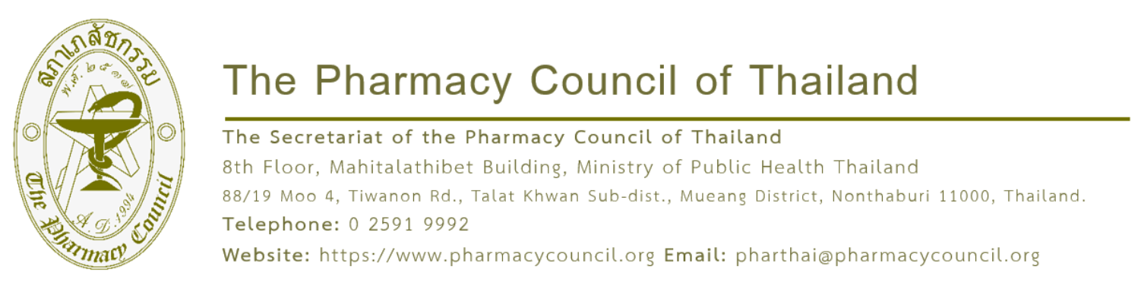

{acceptDate}

Subject: Acceptance of Academic Paper
Dear {participantName}
As the Pharmacy Council of Thailand, operated by the College of Pharmacotherapy of Thailand, is organizing the international conference, "The 25th Asian Conference on Clinical Pharmacy (2026 ACCP)," under the theme "Borderless Pharmacy Practice: The Collaboration for Sustainability and Cultural Integration" from 9 - 11 July 2026 at the Centara Grand & Bangkok Convention Centre at CentralWorld, Pathum Wan District, Bangkok, we acknowledge the submission of your poster titled "{abstractTitle}" for presentation at the conference.
The Steering Subcommittee for Organizing the International Conference: The 25th Asian Conference on Clinical Pharmacy (2026 ACCP) has successfully passed your academic work through the peer-review process. We are pleased to inform you that your academic paper has been accepted for presentation in the format of a poster. To complete your registration and secure
your presentation slot, please register and remit the registration fee via our website at https://accp2026bangkok.pharmacycouncil.org
Please be informed accordingly. Your prompt action in completing the registration will be highly appreciated.

Yours sincerely,


Asst. Prof. Dr. Thanompong Sathienluckana
Chair of the Abstract Review Working Group The 25th Asian Conference on Clinical Pharmacy (2026 ACCP)

