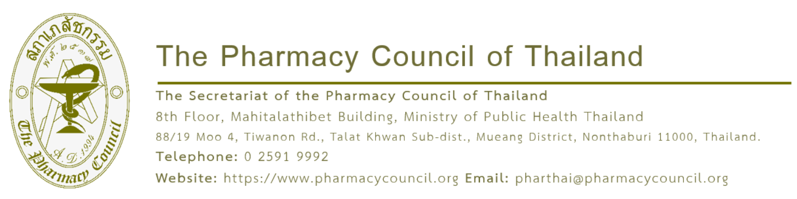

{acceptDate}

Subject: Acceptance of Academic Paper and Registration Details
Enclosure: Registration Fee Schedule
Dear {participantName}
As the Pharmacy Council of Thailand, operated by the College of Pharmacotherapy of Thailand, is organizing the international conference, "The 25th Asian Conference on Clinical Pharmacy (2026 ACCP)," under the theme "Borderless Pharmacy Practice: The Collaboration for Sustainability and Cultural Integration" from 9 - 11 July 2026 at the Centara Grand & Bangkok Convention Centre at CentralWorld, Pathum Wan District, Bangkok, we acknowledge the submission of your {presentationType} titled "{abstractTitle}" for presentation at the conference.
The Steering Subcommittee for Organizing the International Conference: The 25th Asian Conference on Clinical Pharmacy (2026 ACCP) has successfully passed your academic work through the peer-review process. We are pleased to inform you that your academic paper has been accepted for presentation in the format of a {presentationType}. To complete your registration and secure your presentation slot, please register and remit the registration fee via our website at https://accp2026bangkok.pharmacycouncil.org, in accordance with the enclosed registration fee schedule.
Please be informed accordingly. Your prompt action in completing the registration will be highly appreciated.

Yours sincerely,
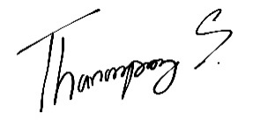

Asst. Prof. Dr. Thanompong Sathienluckana
Chair of the Abstract Review Working Group The 25th Asian Conference on Clinical Pharmacy (2026 ACCP)

Conference Registration Fee Schedule
1. Registration Rates for Thais
No. | Category | Package | Registration fee inclusive of transaction fee
 |  |  | Thai QR Payment  (By 30 April 2026) | Thai QR Payment  (By 9 July 2026) | Credit/Debit Card  (By 30 April 2026) | Credit/Debit Card  (By 9 July 2026)
1 | Thai: Pharmacist, Healthcare Professional, Academic | Main Congress  + (PRE-CONFERENCE)  WORKSHOP  + GALA DINNER | 12,331.95 TH | 13,342.77 TH | 12,576.8 TH | 13,607.68 TH
 |  | Main Congress  + (PRE-CONFERENCE)  WORKSHOP | 10,108.16 TH | 11,118.97 TH | 10,308.86 TH | 11,339.74 TH
 |  | Main Congress  + GALA DINNER | 10,209.24 TH | 11,220.05 TH | 10,411.94 TH | 11,442.83 TH
 |  | Main Congress | 7,985.44 TH | 8,996.26 TH | 8,143.99 TH | 9,174.88 TH
2 | Thai Pharmacy Student | Main Congress  + (PRE-CONFERENCE)  WORKSHOP  + GALA DINNER | 9,299.50 TH | 9,299.5 TH | 9,484.15 TH | 9,484.15 TH
 |  | Main Congress  + (PRE-CONFERENCE)  WORKSHOP | 7,075.71 TH | 7,075.71 TH | 7,216.20 TH | 7,216.2 TH
 |  | Main Congress  + GALA DINNER | 7,176.79 TH | 7,176.79 TH | 7,319.29 TH | 7,319.29 TH
 |  | Main Congress | 4,953 TH | 4,953 TH | 5,051.34 TH | 5,051.34 TH

Conference Registration Fee Schedule
2. Registration Rates for Foreigners
No. | Category | Program | By April 30, 2026 | By July 9, 2026
1 | Health Professionals & Academics | Main Congress  + (PRE-CONFERENCE) WORKSHOP  + GALA DINNER | *530 USD | *545 USD
 |  | Main Congress  + (PRE-CONFERENCE) WORKSHOP | *455 USD | *470 USD
 |  | Main Congress  + GALA DINNER | *460 USD | *475 USD
 |  | Main Congress | *385 USD | *400 USD
2 | Students | Main Congress  + (PRE-CONFERENCE) WORKSHOP  + GALA DINNER | *395 USD | *415 USD
 |  | Main Congress  + (PRE-CONFERENCE) WORKSHOP | *320 USD | *340 USD
 |  | Main Congress  + GALA DINNER | *325 USD | *345 USD
 |  | Main Congress | *250 USD | *270 USD
* Note:
- The above registration fee does not include payment processing fees.
- Payments made via Credit / Debit Card (Visa, Mastercard, JCB) are subject to a 3% fee calculated from the total registration amount.

